SUPPLEMENTARY MATERIAL
Table S1 Baseline patient demographics and clinical characteristics among patients with Itch NRS ≥4 (UNCOVER-2 and 3)
 | PBO  (N=293) | ETN  (N=618) | IXE Q2W  (N=623) | Totalª  (N=2140)
Gender, n (%)
Male | 209 (71.3) | 407 (65.9) | 388 (62.3) | 1401 (65.5)
Female | 84 (28.7) | 211 (34.1) | 235 (37.7) | 739 (34.5)
Race, n (%)
Asian | 10 (3.4) | 17 (2.8) | 20 (3.2) | 64 (3.0)
Black or African American | 16 (5.5) | 21 (3.4) | 10 (1.6) | 64 (3.0)
Caucasian | 262 (89.4) | 567 (92.2) | 582 (93.6) | 1970 (92.3)
Other | 1 (0.3) | 5 (0.8) | 3 (0.5) | 12 (0.6)
Geographic region,
n (%)
Europe | 121 (41.3) | 253 (40.9) | 249 (40.0) | 855 (40.0)
North America | 155 (52.9) | 327 (52.9) | 337 (54.1) | 1154 (53.9)
BMI (kg/m²), mean (SD) | 30.740  (6.6329) | 31.163  (7.5084) | 30.479 (7.3014) | 30.871  (7.2109)
Baseline PSSI Score, mean (SD) | 19.9 (14.21) | 20.4 (14.21) | 20.2 (14.46) | 20.3 (14.76)
Baseline PPASI Score, mean (SD) | 10.1 (12.97) | 8.7 (11.28) | 8.8 (10.69) | 8.8 (11.34)
Baseline sPGA, mean (SD) | 3.6 (0.62) | 3.6 (0.59) | 3.6 (0.61) | 3.6 (0.60)
Baseline PASI score, mean (SD) | 21.4 (8.71) | 2.3 (7.74) | 20.5 (8.09) | 20.7 (8.01)
Baseline DLQI, mean (SD) | 13.7 (6.96) | 13.0 (6.83) | 13.4 (6.69) | 13.2 (6.77)

Age at enrollment (years), mean (SD) | 45.6 (12.18) | 45.5 (13.34) | 44.9 (13.19) | 45.2 (13.10)
Duration of psoriasis (years), mean (SD) | 18.3 (12.62) | 18.4 (12.18) | 17.8 (12.03) | 18.2 (12.35)
Previous use of non-biologic systemic therapy, n (%) | 138 (47.1) | 325 (52.6) | 333 (53.5) | 1120 (52.3)
Previous use of biologic systemic therapy, n (%) | 31 (10.6) | 67 (10.8) | 76 (12.2) | 435 (20.3)
Facial psoriasis, n (%) | 138 (47.1) | 288 (46.6) | 276 (44.3) | 971 (45.4)
Scalp psoriasis, n (%) | 271 (92.5) | 566 (91.6) | 570 (91.5) | 1965 (91.8)
Abbreviations: BMI=body mass index; DLQI=Dermatology Life Quality Index; ETN=etanercept; IXE=ixekizumab; N=total number of patients; PASI=Psoriasis Area and Severity Index; PBO=placebo; PPASI=Palmoplantar Psoriasis Area and Severity Index; PSSI=Psoriasis Scalp Severity Index; Q2W=every 2 weeks; Q4W=every 4 weeks; SD=standard deviation; sPGA=static Physician’s Global Assessment;
ªData for IXE Q4W arm (N=606) not shown.

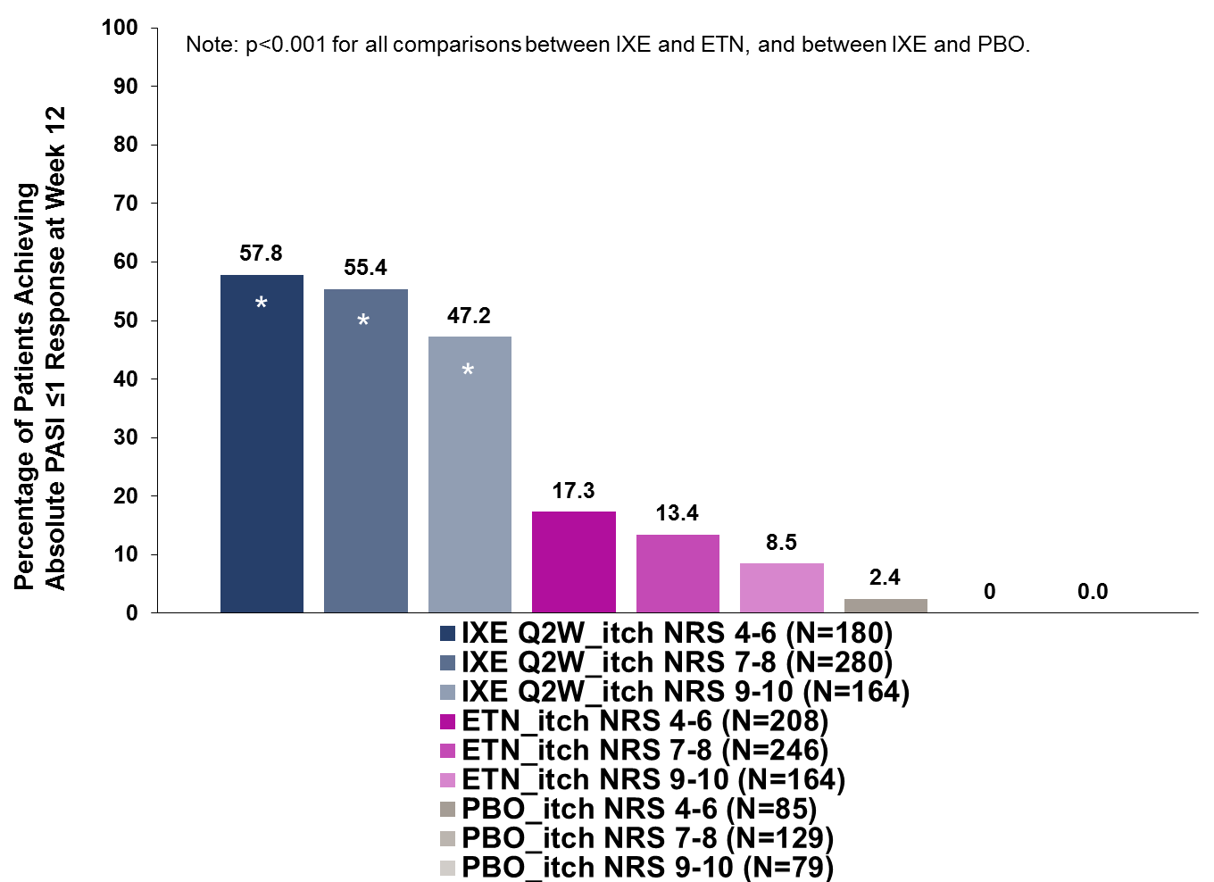
Supplemental Fig. S1 Impact of baseline psoriasis-associated itch severity on response rates for absolute Psoriasis Area and Severity Index scores ≤1 (Treatment p<0.001, Baseline Itch NRS category p=0.167, Treatment*Baseline Itch NRS category p=0.855). Itch NRS 4‒6, 7‒8, and 9‒10 = Itch NRS score of 4‒6, 7‒8, and 9‒10, respectively, at baseline
Abbreviations: ETN=etanercept; IXE=ixekizumab; NRS=numeric rating scale; PASI=Psoriasis Area and Severity Index; PBO=placebo; Q2W=every 2 weeks
*p<0.001 versus ETN and PBO

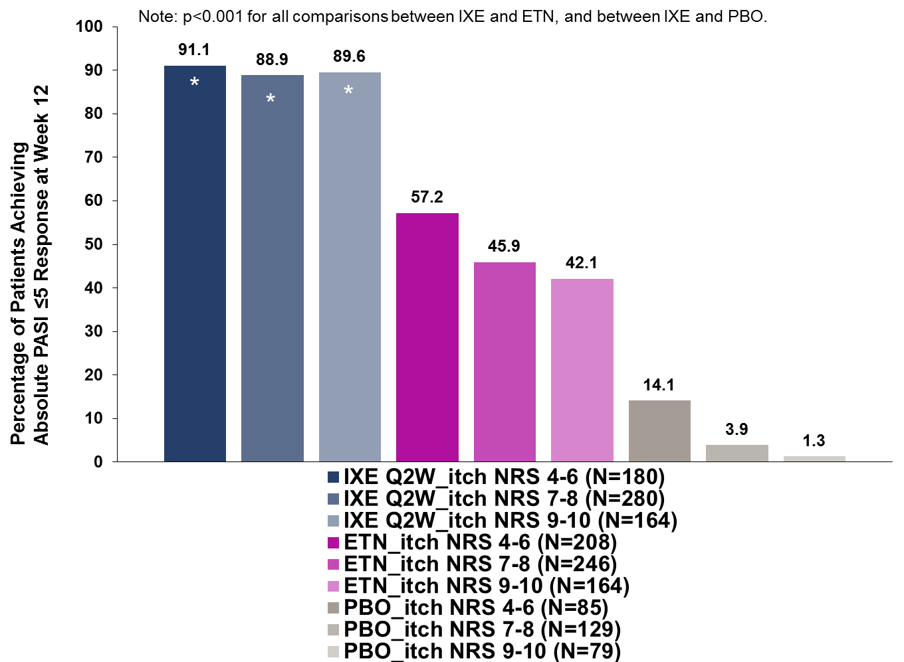
Supplemental Fig. S2 Impact of baseline psoriasis-associated itch severity on response rates for absolute PASI ≤5 (Treatment p<0.001, Baseline Itch NRS category p<0.001, Treatment*Baseline Itch NRS category p=0.260) at end of induction period (pooled data from UNCOVER-2 and 3; NRI). Itch NRS 4‒6, 7‒8, and 9‒10 = Itch NRS score of 4‒6, 7‒8, and 9‒10, respectively, at baseline
Abbreviations: ETN=etanercept; IXE=ixekizumab; NRI=non-responder imputation; NRS=numeric rating scale; PASI=Psoriasis Area and Severity Index; PBO=placebo; Q2W=every 2 weeks
*p<0.001 versus ETN and PBO

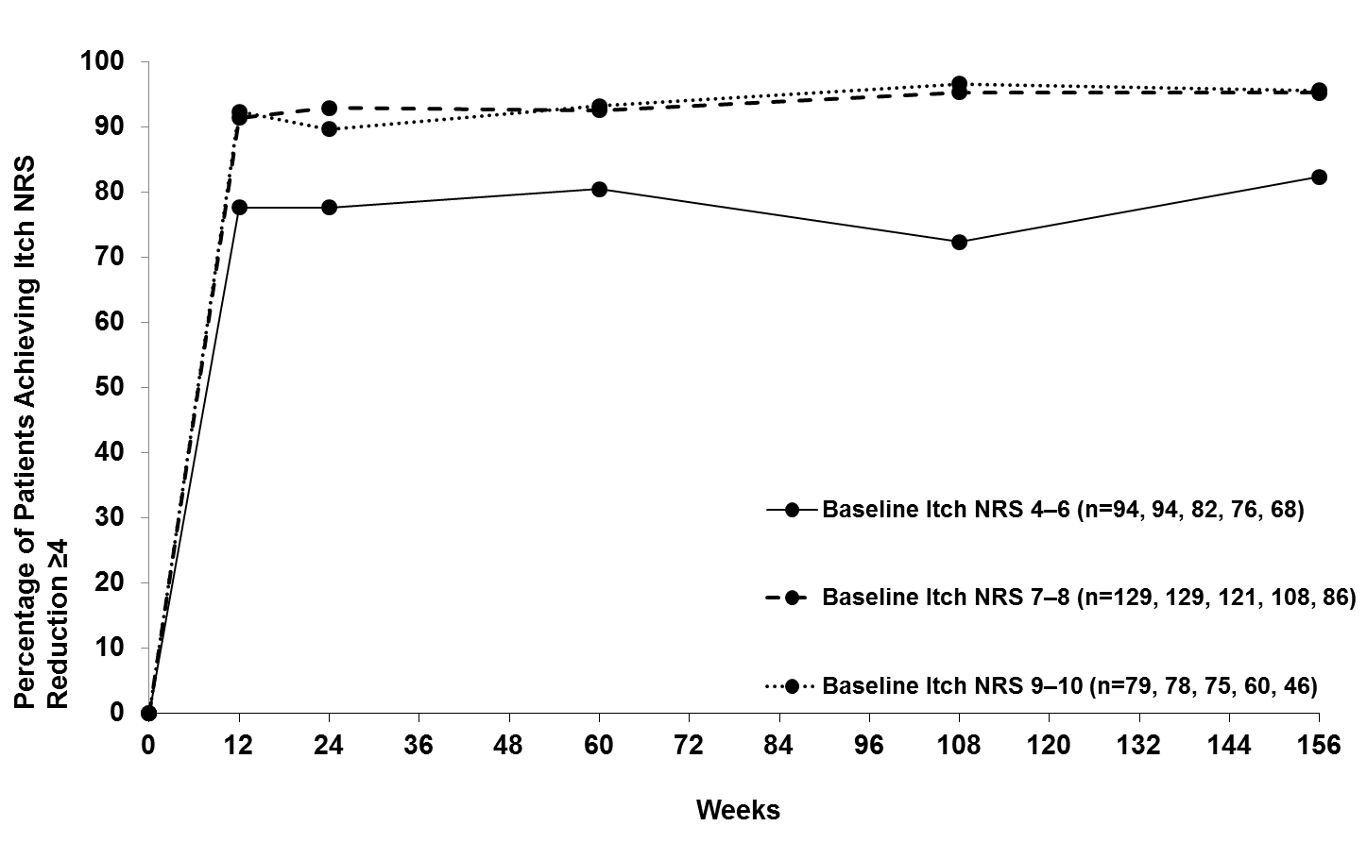
Supplemental Fig. S3 Impact of baseline psoriasis-associated itch severity on response rates for Itch Numeric Rating Scale ≥4 point reduction (in IXE Q2W/IXE Q4W-treated patients with baseline Itch NRS≥4) for induction through long-term extension period (all treatments combined, UNCOVER-3; observed cases). For itch reduction, fewer patients with psoriasis in the Itch NRS 4‒6 baseline itch severity subgroup achieved clinically meaningful improvements compared to those in the Itch NRS 7‒8 subgroup at weeks 12, 24, and 108 and compared to those in the Itch NRS 9‒10 subgroup at weeks 12, and 108. Itch NRS 4‒6, 7‒8, and 9‒10 = Itch NRS score of 4‒6, 7‒8, and 9‒10, respectively, at baseline
Abbreviations: IXE=ixekizumab; n=number of patients with available data at each time point; NRS=numeric rating scale; PBO=placebo; Q2W=every 2 weeks; Q4W=every 4 weeks
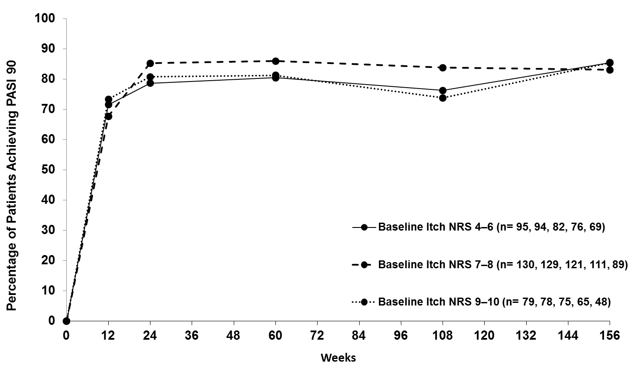
Supplemental Fig. S4 Impact of baseline psoriasis-associated itch severity on response rates for Psoriasis Area and Severity Index 90 for induction through long-term extension period (all treatments combined, UNCOVER-3; observed cases). For itch reduction, fewer patients with psoriasis in the Itch NRS 4‒6 baseline itch severity subgroup achieved clinically meaningful improvements compared to those in the Itch NRS 7‒8 subgroup at weeks 12, 24, and 108 and compared to those in the Itch NRS 9‒10 subgroup at weeks 12, and 108. Itch NRS 4‒6, 7‒8, and 9‒10 = Itch NRS score of 4‒6, 7‒8, and 9‒10, respectively, at baseline
Abbreviations: n=number of patients with available data at each time point; NRS=numeric rating scale; PASI=Psoriasis Area and Severity Index; PASI 90=≥90% improvement in PASI from baseline; PBO=placebo; Q2W=every 2 weeks; Q4W=every 4 weeks

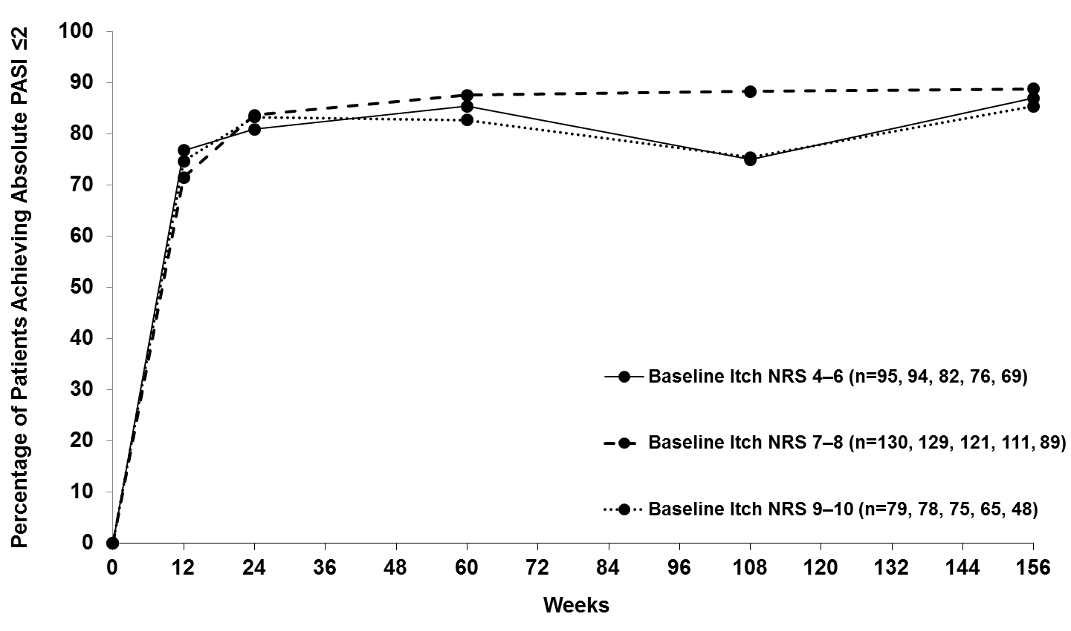
Supplemental Fig. S5 Impact of baseline psoriasis-associated itch severity on response rates for absolute PASI scores ≤2 for induction through long-term extension period (all treatments combined, UNCOVER-3; observed cases). For itch reduction, fewer patients with psoriasis in the Itch NRS 4‒6 baseline itch severity subgroup achieved clinically meaningful improvements compared to those in the Itch NRS 7‒8 subgroup at weeks 12, 24, and 108 and compared to those in the Itch NRS 9‒10 subgroup at weeks 12, and 108. Itch NRS 4‒6, 7‒8, and 9‒10 = Itch NRS score of 4‒6, 7‒8, and 9‒10, respectively, at baseline
Abbreviations: n=number of patients with available data at each time point; NRS=numeric rating scale; PASI=Psoriasis Area and Severity Index

