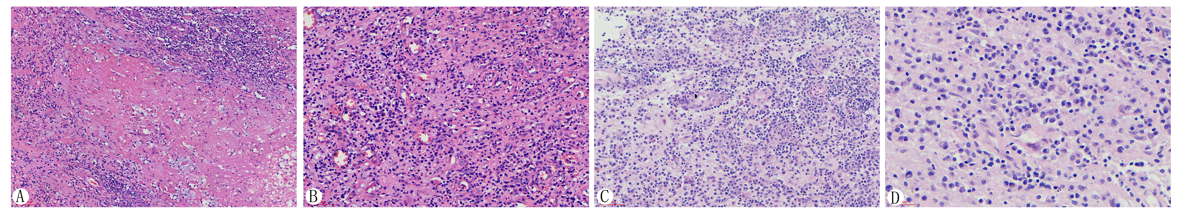

Supplemental Fig.1
Histopathologic examination of removal lesions. Case 2 patient’s HE stained indicates that there is a lot of necrotic tissue (A, 10×), and many inflammatory cells (especially plasmocytes) infiltrating, vascular endothelial cells swelling (B, 20×). Case 3 patient’s HE stained indicates that many cells (especially plasmocytes) infiltrating in the necrosis area (C, 20×), and vascular endothelial cells swelling, proliferating and thickening (D, 40×).

