SUPPLEMENTAL MATERIALS
Figure S1. Distribution of simulation mapping results for EASI percentage change from baseline (at day 29). EASI Eczema Area and Severity Index, LSM least squares mean.
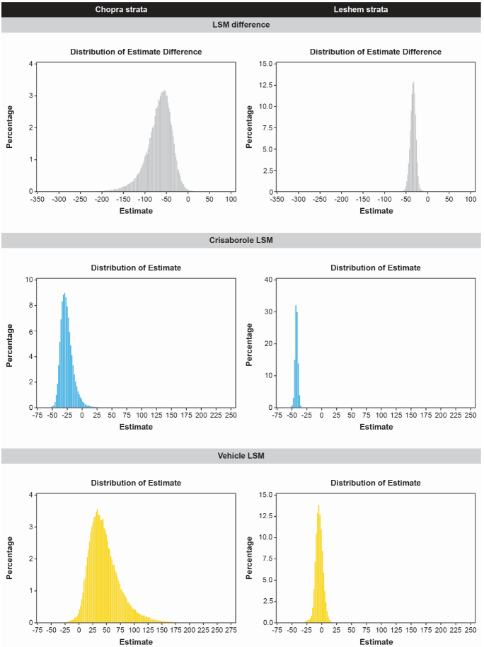
Figure S2. Simulation mapping of EASI-50 distribution (at day 29). EASI Eczema Area and Severity Index.
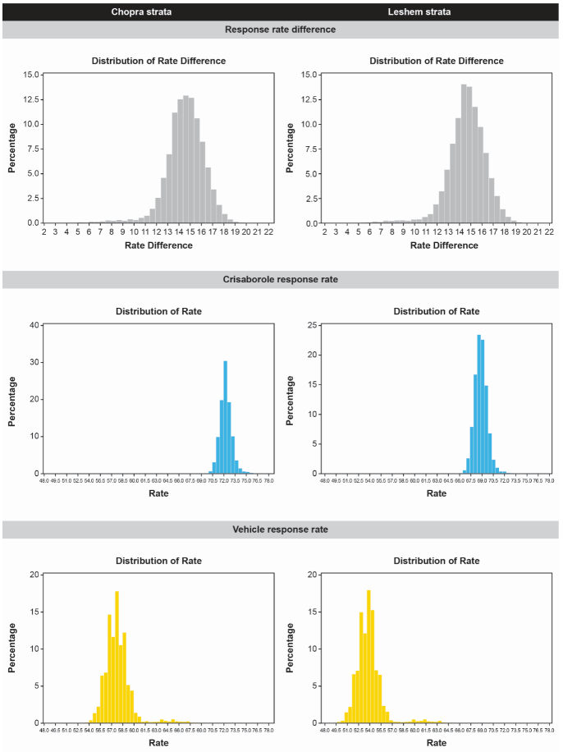

Figure S3. Simulation mapping of EASI-75 distribution (at day 29). EASI Eczema Area and Severity Index.
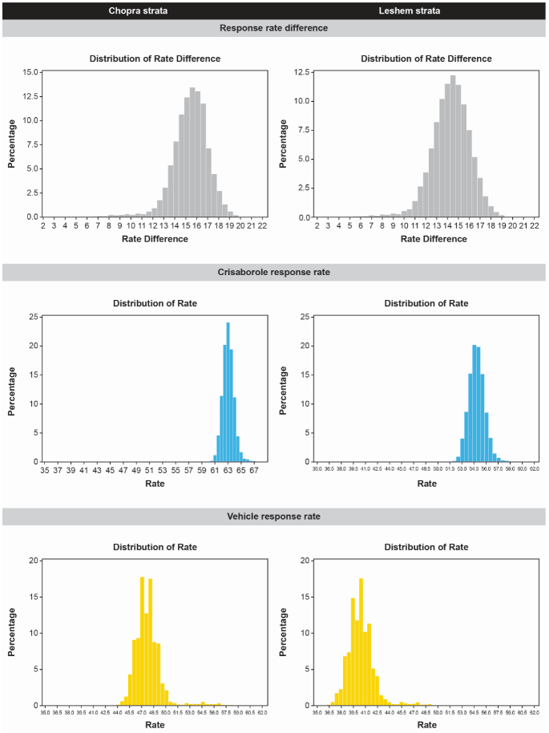

Figure S4. Simulation mapping of EASI-90 distribution (at day 29). EASI Eczema Area and Severity Index.
