Supplementary Appendix
Supplementary Table 1. Expert estimation of rates of plaque psoriasis distributed by BSA. Estimates of lowest possible, most likely, and greatest possible prevalence for each BSA threshold.
 | BSA Thresholds
Estimation: | < 3% | < 10% | < 30% | < 75% | ≥ 75%
Lowest Possible (%)
Most Likely (%)
Greatest Possible (%)

Supplementary Table 2. Mean Expert Disease Severity Estimations using BSA Thresholds for First Expert Estimation
 | BSA Thresholds
 | < 3% | < 10% | < 30% | < 75% | ≥ 75%
Lowest Possible, Mean %, (SD) | 26.44 (16.57) | 25.56 (20.61) | 46.38 (36.91) | 58.73 (38.77) | 0.81 (0.61)
Most Likely, Mean %, (SD) | 41.11 (22.58) | 37.33 (20.67) | 48.00 (35.82) | 54.06 (41.72) | 2.93 (2.15)
Greatest Possible, Mean %, (SD) | 55.00 (25.93) | 50.00 (21.60) | 58.67 (36.02) | 62.61 (43.45) | 5.96 (5.93)

Supplementary Table 3: Normalized Mean Expert Disease Severity Estimations using BSA Thresholds for Second Expert Estimation
 | BSA Thresholds
 | < 3% | 3-10% | 10-30% | 30-75% | 75-85% | >85%
Mean %, (SD) | 49.95 (2.25) | 28.24 (2.22) | 12.90 (2.09) | 6.06 (1.17) | 2.23 (0.47) | 0.61 (0.41)

Supplementary Figure 1: Beta-distributions resulting from Individual Expert Estimated Prevalence. Palette for colour-blind (main text Figure 2A)

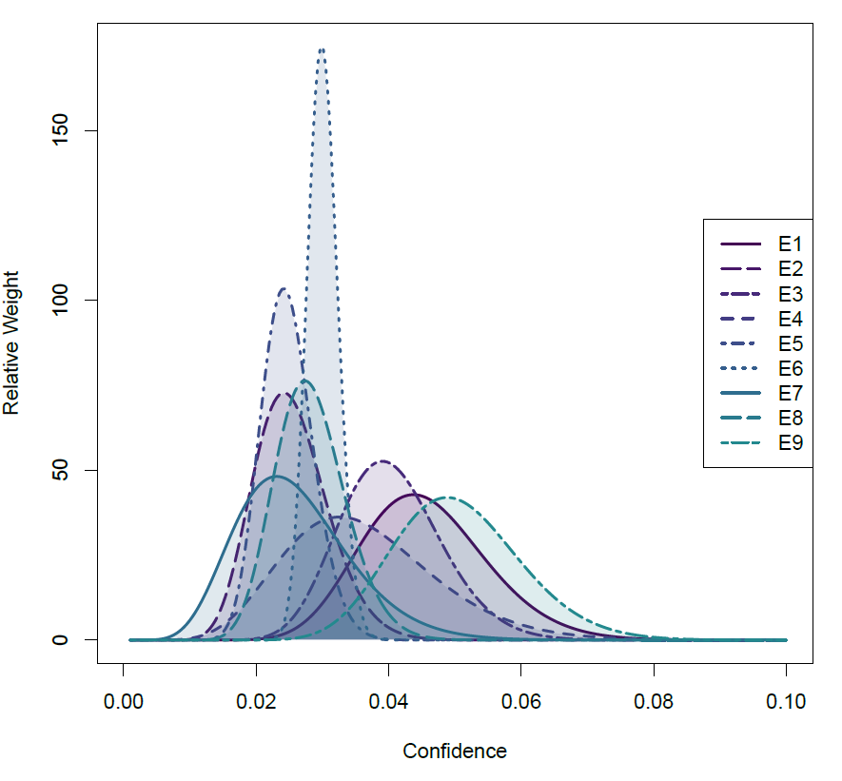

Supplementary File: Expert Elicitation Survey #1: Estimation of Disease Severity Using EE

Please complete the table below by filling in your estimated Lowest Possible, Most Likely, and Greatest Possible (%) rates of Plaque Psoriasis. Note that your estimates should reflect the untreated PsO population in the community as a whole (not just patients in your practice). Please ensure that your estimates only include the Plaque Psoriasis population, not patients with Erythrodermic or Pustular Psoriasis.
The table below provides example BSA thresholds for estimation. Feel free to modify these thresholds to values that you feel more confident estimating (note: if you modify the BSA thresholds, you may also change the direction of the greater-than or less-than qualifier). Please provide at least 3 estimation values (and the Lowest Possible and Greatest Possible estimates for each) to allow for statistical analyses.

 | BSA Thresholds
Estimation: | < 3% | < 10% | < 30% | < 75% | ≥ 75%
Lowest Possible (%) | 35 | 50 | 75 | 90 | 2
Most Likely (%) | 40 | 60 | 80 | 95 | 5
Greatest Possible (%) | 45 | 70 | 85 | 98 | 10

 | BSA Thresholds
Estimation: | < 3% | < 10% | < 30% | < 75% | ≥ 75%
Lowest Possible (%) | 50 | 5 | <1 | <1 | <1
Most Likely (%) | 75 | 15 | 5 | 3 | <1
Greatest Possible (%) | 90 | 20 | 10 | 5 | 2

 | BSA Thresholds
Estimation: | < 3% | < 10% | < 30% | < 75% | ≥ 75%
Lowest Possible (%) | 20 | 20 | 5 | 3 | 0.5
Most Likely (%) | 50 | 25 | 15 | 5 | 3
Greatest Possible (%) | 70 | 30 | 25 | 10 | 5

 | BSA Thresholds
Estimation: | < 3% | < 10% | < 30% | < 75% | ≥ 75%
Lowest Possible (%) | 10 | 30 | 80 | 85 | 1
Most Likely (%) | 20 | 60 | 85 | 88 | 2
Greatest Possible (%) | 30 | 70 | 96 | 98 | 4

 | BSA Thresholds
Estimation: | < 3% | < 10% | < 30% | < 75% | ≥ 75%
Lowest Possible (%) | 50 | 5 | 1 | .1% | .1%
Most Likely (%) | 75 | 18 | 4 | 2 | 1%
Greatest Possible (%) | 90 | 30 | 10 | 5 | 2%

 | BSA Thresholds
Estimation: | < 3% | < 10% | < 30% | < 75% | ≥ 75%
Lowest Possible (%) | 5 | 15 | 20 | 50 | 1
Most Likely (%) | 15 | 30 | 35 | 50 | 7
Greatest Possible (%) | 30 | 70 | 80 | 90 | 20

 | BSA Thresholds
Estimation: | < 3% | < 10% | < 30% | < 75% | ≥ 75%
Lowest Possible (%) | 5 | 10 | 95 | 98 | 0.1
Most Likely (%) | 10 | 20 | 96 | 99.5 | 0.5
Greatest Possible (%) | 15 | 30 | 99 | 99.9 | 0.7

 | BSA Thresholds
Estimation: | < 3% | < 10% | < 30% | < 75% | ≥ 75%
Lowest Possible (%) | 30% | 70% | 80% | 85% | 1%
Most Likely (%) | 35% | 75% | 85% | 90% | 2%
Greatest Possible (%) | 50% | 80% | 90% | 95% | 4%

 | BSA Thresholds
Estimation: | < 3% | < 10% | >30
Lowest Possible (%) | 33 | 25 | 15
Most Likely (%) | 50 | 33 | 27
Greatest Possible (%) | 75 | 50 | 33

Supplementary File: Raw Data from Expert Elicitation
Raw Data, n=9
Prevalence |  | Low | Mode | Highest |  | Beta | a | b
 |  | 2 | 4.5 | 7 |  |  | 22.139 | 463.146
 |  | 1 | 2.5 | 4 |  |  | 20.135 | 772.654
 |  | 1.99 | 4 | 6 |  |  | 26.605 | 630.919
 |  | 1.5 | 3.5 | 8.5 |  |  | 9.605 | 256.009
 |  | 1.5 | 2.5 | 3.5 |  |  | 39.359 | 1522.486
 |  | 2.5 | 3 | 4 |  |  | 168.03 | 5422.514
 |  | 1 | 2.5 | 5 |  |  | 8.717 | 327.407
 |  | 1.51 | 2.5 | 5 |  |  | 27.738 | 952.141
 |  | 2.5 | 5 | 7.5 |  |  | 26.166 | 491.194
 | get.beta.par((.01, .5, .99),p(l,m,h))
 |  |  |  |  |  | Bayes | 348.494 | 10838.5
 |  |  |  |  |  | Mean | 38.7216 | 1204.27
Severity
 | < 3% | 3% to 10% | 10% to 30% | 30% to 75% | 75% to 85% | > 85%
 | 3 | 10 | 30 | 75 | 85 | 100
 | 40 | 20 | 10 | 5 | 2 | 0.4 | 77.4
 | 40 | 20 | 10 | 5 | 2.5 | 1 | 78.5
 | 40 | 26 | 12 | 5.5 | 1.5 | 0.1 | 85.1
 | 50 | 27 | 13 | 7 | 2 | 1 | 100
 | 50 | 30 | 8 | 5 | 2 | 1 | 96
 | 49 | 30 | 14 | 4.5 | 2 | 0.5 | 100
 | 50 | 30 | 13 | 4.5 | 2 | 0.5 | 100
 | 40 | 24 | 14 | 7 | 1.6 | 0.1 | 86.7
 | 40 | 20 | 9 | 4.5 | 2 | 0.3 | 75.8

Severity Normalized
 | 3 | 10 | 30 | 75 | 85 | 100
 | 51.6796 | 25.8398 | 12.9199 | 6.45995 | 2.58398 | 0.5168
 | 50.9554 | 25.4777 | 12.7389 | 6.36943 | 3.18471 | 1.27389
 | 47.0035 | 30.5523 | 14.1011 | 6.46298 | 1.76263 | 0.11751
 | 50 | 27 | 13 | 7 | 2 | 1
 | 52.0833 | 31.25 | 8.33333 | 5.20833 | 2.08333 | 1.04167
 | 49 | 30 | 14 | 4.5 | 2 | 0.5
 | 50 | 30 | 13 | 4.5 | 2 | 0.5
 | 46.1361 | 27.6817 | 16.1476 | 8.07382 | 1.84544 | 0.11534
 | 52.7704 | 26.3852 | 11.8734 | 5.93668 | 2.63852 | 0.39578
 | 3 | 10 | 30 | 75 | 85 | 100
Mean | 49.9587 | 28.243 | 12.9016 | 6.0568 | 2.23318 | 0.60678
SD | 2.25396 | 2.21593 | 2.09626 | 1.17073 | 0.46772 | 0.41005
95% CI 1.96 | 4.41776 | 4.34322 | 4.10867 | 2.29463 | 0.91673 | 0.80369
NN UCI | 54.3765 | 32.5862 | 17.0102 | 8.35142 | 3.14991 | 1.41046
NN LCI | 45.5409 | 23.8997 | 8.7929 | 3.76217 | 1.31645 | -0.1969
 | 3 | 10 | 30 | 75 | 85 | 100
CPD | 49.9587 | 78.2017 | 91.1032 | 97.16 | 99.3932 | 100
SD | 2.25396 | 2.21593 | 2.09626 | 1.17073 | 0.46772 | 0.41005
95% CI 1.96 | 4.41776 | 4.34322 | 4.10867 | 2.29463 | 0.91673 | 0.80369
NN UCI | 45.5409 | 73.8585 | 86.9946 | 94.8654 | 98.4765 | 99.1963
NN LCI | 54.3765 | 82.5449 | 95.2119 | 99.4547 | 100.31 | 100.804

Best Fitted Cumulative Distribution Function
(-32449670 - 108.4973)/(1+(x/5.84E-11)^0.5363096) + 100.001+ 8.91075
 | -32449670 | 108.4973 | 5.84E-11 | 0.5363096 | 108.912
BSA | 2 | 3 | 5 | 10 | 20 | 50 | 75 | 90 | 100
% Cummulative Distribution | 36.235175 | 50.438772 | 64.451102 | 78.254677 | 87.7727 | 95.9797 | 98.5071 | 99.4763 | 99.9947

Supplementary File: Broad Dermatology Survey: Prevalence and Severity Estimates, Survey Results
Prevalence
What is the prevalence of plaque psoriasis in the adult population? | Combined  N=99 |  | Canadian  N=80 |  | International  N=19
 | Mean | Variance | Mean | Variance | Mean | Variance
Lowest Possible (%): | 1.73 | 1.04 | 1.81 | 1.11 | 1.37 | 0.58
Most Likely (%): | 3.73 | 1.71 | 3.56 | 1.81 | 2.58 | 0.82
Greatest Possible (%): | 5.44 | 2.58 | 5.70 | 2.61 | 4.37 | 2.13

Disease Severity
What proportion of the adult plaque psoriasis population is most appropriately treated with topical therapies? | Combined  N=99 |  | Canadian  N=80 |  | International  N=19
 | Mean | Variance | Mean | Variance | Mean | Variance
Lowest Possible (%): | 37.12 | 23.97 | 36.64 | 24.02 | 39.16 | 23.66
Most Likely (%): | 50.19 | 24.10 | 50.13 | 23.90 | 50.47 | 24.90
Greatest Possible (%): | 62.04 | 25.50 | 62.33 | 25.50 | 60.84 | 25.47

Disease Severity
What proportion of the adult plaque psoriasis population has 10% or more BSA of involvement? | Combined  N=99 |  | Canadian  N=80 |  | International  N=19
 | Mean | Variance | Mean | Variance | Mean | Variance
Lowest Possible (%): | 16.20 | 13.46 | 15.93 | 13.49 | 17.37 | 13.27
Most Likely (%): | 24.71 | 16.13 | 24.54 | 16.37 | 25.42 | 15.06
Greatest Possible (%): | 33.24 | 19.12 | 33.48 | 19.60 | 32.26 | 16.90

Disease Severity
What proportion of the adult plaque psoriasis population has 30% or more BSA of involvement? | Combined  N=99 |  | Canadian  N=80 |  | International  N=19
 | Mean | Variance | Mean | Variance | Mean | Variance
Lowest Possible (%): | 6.62 | 7.87 | 6.64 | 7.58 | 6.53 | 9.00
Most Likely (%): | 11.11 | 10.59 | 11.31 | 10.81 | 10.26 | 9.52
Greatest Possible (%): | 16.63 | 13.15 | 16.68 | 12.43 | 16.42 | 15.83

Disease Severity
What proportion of the adult plaque psoriasis population has a PASI score of 12 or greater? | Combined  N=99 |  | Canadian  N=80 |  | International  N=19
 | Mean | Variance | Mean | Variance | Mean | Variance
Lowest Possible (%): | 10.83 | 10.92 | 10.06 | 9.47 | 14.05 | 15.19
Most Likely (%): | 16.65 | 12.73 | 15.75 | 11.51 | 20.42 | 16.41
Greatest Possible (%): | 23.04 | 15.45 | 22.49 | 14.86 | 25.37 | 17.55

Specific Locations - Please indicate the proportion (%) of adult patients, at any given time, who have plaque psoriasis in the following locations:
Face | Combined  N=99 |  | Canadian  N=80 |  | International  N=19
Face | Mean | Variance | Mean | Variance | Mean | Variance
Lowest Possible (%): | 7.71 | 9.58 | 7.95 | 10.41 | 6.68 | 4.61
Most Likely (%): | 13.61 | 12.12 | 13.64 | 12.64 | 13.47 | 4.98
Greatest Possible (%): | 19.81 | 15.28 | 19.45 | 15.11 | 21.32 | 7.15

Specific Locations - Please indicate the proportion (%) of adult patients, at any given time, who have plaque psoriasis in the following locations:
Scalp | Combined  N=99 |  | Canadian  N=80 |  | International  N=19
Scalp | Mean | Variance | Mean | Variance | Mean | Variance
Lowest Possible (%): | 33.56 | 22.63 | 33.71 | 22.00 | 48.47 | 20.98
Most Likely (%): | 47.81 | 23.13 | 47.65 | 23.05 | 60.68 | 23.45
Greatest Possible (%): | 59.40 | 24.46 | 59.09 | 23.44 | 25.16 | 28.32

Specific Locations - Please indicate the proportion (%) of adult patients, at any given time, who have plaque psoriasis in the following locations:
Nails | Combined  N=99 |  | Canadian  N=80 |  | International  N=19
Nails | Mean | Variance | Mean | Variance | Mean | Variance
Lowest Possible (%): | 16.37 | 14.29 | 14.23 | 12.54 | 37.79 | 17.36
Most Likely (%): | 38.36 | 16.73 | 24.85 | 14.64 | 47.37 | 20.44
Greatest Possible (%): | 38.95 | 21.32 | 36.90 | 20.26 | 7.53 | 23.42

Specific Locations - Please indicate the proportion (%) of adult patients, at any given time, who have plaque psoriasis in the following locations:
Palms of hands | Combined  N=99 |  | Canadian  N=80 |  | International  N=19
Palms of hands | Mean | Variance | Mean | Variance | Mean | Variance
Lowest Possible (%): | 9.54 | 8.21 | 10.03 | 8.74 | 6.68 | 4.98
Most Likely (%): | 16.52 | 10.26 | 17.22 | 10.76 | 7.53 | 7.15
Greatest Possible (%): | 24.70 | 14.61 | 25.70 | 15.13 | 13.63 | 11.31

Specific Locations - Please indicate the proportion (%) of adult patients, at any given time, who have plaque psoriasis in the following locations:
Soles of feet | Combined  N=99 |  | Canadian  N=80 |  | International  N=19
Soles of feet | Mean | Variance | Mean | Variance | Mean | Variance
Lowest Possible (%): | 9.36 | 7.73 | 9.70 | 8.31 | 7.95 | 4.32
Most Likely (%): | 16.48 | 10.15 | 17.00 | 10.52 | 14.32 | 8.10
Greatest Possible (%): | 24.58 | 14.20 | 25.43 | 14.70 | 21.05 | 11.20

Specific Locations - Please indicate the proportion (%) of adult patients, at any given time, who have plaque psoriasis in the following locations:
Genitals | Combined  N=99 |  | Canadian  N=80 |  | International  N=19
Genitals | Mean | Variance | Mean | Variance | Mean | Variance
Lowest Possible (%): | 9.09 | 8.59 | 9.20 | 9.17 | 8.63 | 5.58
Most Likely (%): | 15.53 | 10.69 | 15.63 | 10.94 | 15.10 | 9.55
Greatest Possible (%): | 22.93 | 12.90 | 23.00 | 12.28 | 22.63 | 15.18

Specific Locations - Please indicate the proportion (%) of adult patients, at any given time, who have plaque psoriasis in the following locations:
Inverse Psoriasis | Combined  N=99 |  | Canadian  N=80 |  | International  N=19
Inverse Psoriasis | Mean | Variance | Mean | Variance | Mean | Variance
Lowest Possible (%): | 8.03 | 7.28 | 7.87 | 7.43 | 8.68 | 6.58
Most Likely (%): | 13.74 | 8.69 | 13.43 | 8.58 | 15.05 | 9.02
Greatest Possible (%): | 20.88 | 11.69 | 20.32 | 10.87 | 23.21 | 14.40

