Short-term Efficacy of Biologic Therapies in Moderate-to-severe Plaque Psoriasis: A Systematic Literature Review and an Enhanced Multinomial Network Meta-analysis

Authors:
Kyle Fahrbach,1
Grammati Sarri,2
David M. Phillippo,3
Binod Neupane,1
Samantha E. Martel,1
Sandeep Kiri,4
Kristian Reich,5
Affiliations:
1Evidera (Evidence Synthesis) 500 Totten Pond Rd, Fifth Floor, Waltham, MA, 02451 USA
2Evidera (Evidence Synthesis) The Ark, 201 Talgarth Rd. Hammersmith, London, W6 8BJ, UK
3Bristol Medical School (Population Health Sciences), University of Bristol, Bristol, UK
4UCB Pharma Ltd, Slough UK
5Translational Research in Inflammatory Skin Diseases, Institute for Health Services Research in Dermatology and Nursing, University Medical Center Hamburg-Eppendorf, and Skinflammation® Center, Hamburg, Germany

Corresponding Author: Kyle Fahrbach
Evidera, 500 Totten Pond Road, Fifth Floor, Waltham, MA 02451
Tel: +1 781.960.0245 Email: Kyle.fahrbach@evidera.com

Supporting Material

Table of Contents
Table S1. Search Strategy in Embase via Ovid 2
Table S2. Search Strategy in MEDLINE and MEDLINE In-Process via Ovid 5
Table S3. Search Strategy in Cochrane Database of Systematic Reviews and Cochrane Central Register of Clinical Trails via Ovid 7
Table S4. Search Strategy in PsycINFO 9
Table S5. Inclusion and Exclusion Criteria for the Systematic Literature Review 10
Table S6. Cochrane 2.0 Risk-of-bias Assessment of Trials Included in the NMA 12
Table S7. SUCRAs* and Ranks Based on Response Probabilities of Treatments Achieving Each PASI Response in Baseline Unadjusted REZ Fixed-Effect Multinomial Model 15
Table S8. Predicted Probabilities of Achieving PASI Responses at 10 to 16 Weeks in Baseline Unadjusted REZ Fixed-Effect Multinomial Model 17
Table S9. SUCRAs and Ranks Based on Response Probabilities of Treatments Achieving PASI Responses in Separate Baseline Risk Adjusted Random-Effects Binomial Models 19
Table S10. SUCRAs* and Ranks Based on Response Probabilities of Treatments Achieving Any PASI Threshold in Baseline Adjusted Standard** Random-Effects Multinomial Model 21
Table S11. Predicted Probabilities of Achieving each PASI Response at 10 to 16 Weeks in Baseline Adjusted Standard Random-Effects Multinomial Model 23
Figure S1. Network Diagram of Trials with ≥90% Biologic Treatment Naïve Patients 25
Figure S2. Network Diagram of Trials with 100% Biologic Treatment Naïve Patients 26
Figure S3. Adjusted Random-effects REZ Multinomial Network Meta-analysis; Probit Probabilities of Achieving PASI Outcomes at 10 to 16 Weeks in Populations ≥90% Naïve to Biologic Treatment* 27
Bayesian NMA Network Meta-analysis Model for Binomial Analysis 29
Bayesian NMA Models and Initials for Multinomial Analyses 30
Bayesian NMA Model for Multinomial Analysis with REZ and Random-effects Assumptions with Baseline Risk Adjustment 31

Table S1. Search Strategy in Embase via Ovid
# | Searches | Results
1 | exp psoriasis/ | 77,999
2 | (psoria$ or palmoplantar$ pustulosis or pustulosis palmaris et plantaris).ti,ab | 66,078
3 | or/1-2 | 84,847
4 | exp methotrexate/ | 165,354
5 | (methotrexate$ or amethopterin or mtx or mexate).ti,ab. | 66,406
6 | exp cyclosporine/ | 5,432
7 | (Ciclosporin or cyclosporine or cyclosporin).ti,ab. | 67,230
8 | exp etretin/ | 5,951
9 | (acitretin or soriatane or neotigason).ti,ab. | 2,073
10 | exp certolizumab pegol/ | 5,951
11 | (certolizumab pegol or cimzia or CDP870 or CDP 870).ti,ab. | 2,073
12 | exp adalimumab/ | 5,628
13 | (adalimumab$ or humira or d2e7).ti,ab. | 1,791
14 | exp etanercept/ | 29,115
15 | (etanercept$ or enbrel or embrel or benepali).ti,ab. | 15,599
16 | exp brodalumab/ | 735
17 | (brodalumab or siliq or kyntheum or KHK4827 or KHK 4827 or AMG 827 or AMG827).ti,ab. | 293
18 | exp ixekizumab/ | 1,107
19 | (ixekizumab or taltz or ly2439821 or ly 2439821).ti,ab. | 610
20 | exp secukinumab/ | 2,301
21 | (secukinumab or cosentyx or ain457 or ain 457).ti,ab. | 1,464
22 | exp guselkumab/ | 326
23 | (guselkumab or tremfya or cnto 1959 or cnto1959).ti,ab. | 153
24 | exp ustekinumab/ | 5,153
25 | (ustekinumab or stelara or cnto 1275 or cnto1275).ti,ab. | 2,912
26 | exp tildrakizumab/ | 201
27 | (tildrakizumab or Ilumya or Ilumetri or mk 3222 or mk3222 or sch 900222 or sch900222).ti,ab. | 106
38 | exp risankizumab/ | 132
29 | (risankizumab or bi 655066 or bi655066 or "abbv 066" or abbv066).ti,ab. | 65
30 | exp bimekizumab/ | 46
31 | (bimekizumab or UCB4940 or UCB 4940).ti,ab. | 16
32 | exp infliximab/ | 45,694
33 | (infliximab or remicade or renflexis or inflectra or ca2).ti,ab. | 235,043
34 | (apremilast or otezla or cc-10004 or cc 10004 or cc10004).ti,ab. | 902
35 | exp fumaric acid dimethyl ester/ | 3,002
36 | (dimethyl fumarate or dimethylfumarate or bg 0012 or bg00012 or bg-00012 or tecfidera or fag201 or fag 201 or fag-201 or fumaderm or bg12 or bg-12).ti,ab. | 2,254
37 | exp interleukin 23p19/ | 1,349
38 | (interleukin 23p19 or interleukin23p19 or interleukin-23p19 or IL-23p19 or IL-23 p19).ti,ab. | 864
39 | or/4-38 | 496,737
40^ | exp randomized controlled trial/ | 535,175
41 | exp RANDOMIZATION/ | 81,376
42^ | random*.ti,ab. | 1,377,321
43 | 'rct'.ti,ab. | 31,088
44 | 'controlled trial'.ti,ab. | 147,029
45^ | 'clinical trial'.ti,ab. | 177,340
46^ | 'trial'.ti,ab. | 754,435
47^ | exp Single Blind Procedure/ | 33,844
48^ | exp Double Blind Procedure/ | 157,574
49^ | exp Crossover Procedure/ | 58,135
50^ | 'cross over'.ti,ab. | 29,939
51^ | 'crossover'.ti,ab. | 67,868
52^ | exp PLACEBO/ | 329,594
53^ | 'placebo'.ti,ab. | 282,539
54 | (doubl* and blind*).ti,ab. | 198,083
55 | (singl* and blind*).ti,ab. | 62,675
56 | ('open' and label*).ti,ab. | 78,117
57^ | factorial*.ti,ab. | 34,509
58^ | assign*.ti,ab. | 356,514
59^ | allocate*.ti,ab. | 82,105
60^ | volunteer*.ti,ab. | 240,340
61 | 'controlled study'.ti,ab. | 56,106
62 | 'major clinical study'.ti,ab. | 13
63 | 'clinical article'.ti,ab. | 2,025
64 | or/40-63 | 2,548,534
65 | 3 and 39 and 64 | 6,057
66^ | animal/ not human/ | 1,029,111
67 | nonhuman/ | 5,692,892
68 | exp animal experiment/ | 2,332,870
69 | exp experimental animal/ | 606,438
70 | animal model/ | 1,185,002
71 | exp rodent/ | 3,347,637
72 | (rat or rats or mouse or mice).ti. | 1,399,049
73 | or/66-72 | 7,683,085
74 | 65 not 73 | 5,321
75 | limit 74 to english language | 5,116
76 | limit 75 to abstracts | 4,815
77 | 'conference abstract'.pt. | 3,290,928
78 | limit 77 to yr="1966 - 2016" | 2,602,526
79 | 76 not 78 | 3,308
*Search strategy adapted based on Cochrane Handbook for maximizing search sensitivity and precision for interventions.
Source: Lefebvre C, Manheimer E, Glanville J. Chapter 6: Searching for Studies. In: Higgins J, Green S, editors. Cochrane Handbook for Systematic Review of Interventions: The Cochrane Collaboration; 2011.

Table S2. Search Strategy in MEDLINE and MEDLINE In-Process via Ovid
# | Searches | Results
1 | exp Psoriasis/ | 37,062
2 | (psoria$ or palmoplantar$ pustulosis or pustulosis palmaris et plantaris).ti,ab. | 44,281
3 | or/1-2 | 49,986
4 | exp Methotrexate/ | 36,369
5 | (methotrexate$ or amethopterin or mtx or mexate).ti,ab. | 40,480
6 | exp Cyclosporine/ | 28,584
7 | (Ciclosporin or cyclosporine or cyclosporin).ti,ab. | 49,083
8 | exp Acitretin/ | 1,061
9 | (acitretin or soriatane or neotigason).ti,ab. | 1,262
10 | exp Certolizumab pegol/ | 502
11 | (certolizumab pegol or cimzia or CDP870 or CDP 870).ti,ab. | 658
12 | exp Adalimumab/ | 4,569
13 | (adalimumab$ or humira or d2e7).ti,ab. | 5,810
14 | exp Etanercept/ | 5,449
15 | (etanercept$ or enbrel or embrel or benepali).ti,ab. | 6,350
16 | (brodalumab or siliq or kyntheum or KHK4827 or KHK 4827 or AMG 827 or AMG827).ti,ab. | 174
17 | (ixekizumab or taltz or ly2439821 or ly 2439821).ti,ab. | 285
18 | (secukinumab or cosentyx or ain457 or ain 457).ti,ab. | 595
19 | (guselkumab or tremfya or cnto 1959 or cnto1959).ti,ab. | 88
20 | exp ustekinumab/ | 758
21 | (ustekinumab or stelara or cnto 1275 or cnto1275).ti,ab. | 1,311
22 | (tildrakizumab or Ilumya or Ilumetri or mk 3222 or mk3222 or sch 900222 or sch900222).ti,ab. | 57
23 | (risankizumab or bi 655066 or bi655066 or "abbv 066" or abbv066).ti,ab. | 38
24 | (bimekizumab or UCB4940 or UCB 4940).ti,ab. | 8
25 | exp infliximab/ | 9,354
26 | (infliximab or remicade or renflexis or inflectra or ca2).ti,ab. | 148,162
27 | (apremilast or otezla or cc-10004 or cc 10004 or cc10004).ti,ab. | 381
28 | exp dimethyl fumarate/ | 531
29 | (dimethyl fumarate or dimethylfumarate or bg 0012 or bg00012 or bg-00012 or tecfidera or fag201 or fag 201 or fag-201 or fumaderm or bg12 or bg-12).ti,ab. | 963
30 | exp Interleukin-23 Subunit p19/ | 457
31 | (interleukin 23p19 or interleukin23p19 or interleukin-23p19 or IL-23p19 or IL-23 p19).ti,ab. | 514
32 | or/4-31 | 261,727
33 | exp random allocation/ | 97,828
34^ | exp Randomized Controlled Trial/ | 477,528
35^ | random*.ti,ab. | 1,032,114
36 | 'rct'.ti,ab. | 17,808
37^ | 'controlled trial'.ti,ab. | 112,119
38^ | 'clinical trial'.ti,ab. | 124,294
39^ | 'trial'.ti,ab. | 534,027
40 | exp Single-Blind Method/ | 26,336
41 | exp Double-Blind Method/ | 149,789
42 | 'cross over'.ti,ab. | 21,817
43 | 'crossover'.ti,ab. | 58,323
44^ | exp PLACEBOS/ | 34,251
45 | exp placebo effect/ | 4,405
46^ | 'placebo'.ti,ab. | 201,154
47 | (doubl* and blind*).ti,ab. | 144,678
48 | (singl* and blind*).ti,ab. | 43,370
49 | ('open' and label*).ti,ab. | 44,832
50 | factorial*.ti,ab. | 27,123
51 | assign*.ti,ab. | 290,316
52 | allocate*.ti,ab. | 64,241
53 | volunteer*.ti,ab. | 182,104
54 | 'controlled study'.ti,ab. | 41,450
55 | 'major clinical study'.ti,ab. | 9
56 | 'clinical article'.ti,ab. | 354
57 | or/33-56 | 1,895,377
58 | 3 and 32 and 57 | 1,799
59^ | animals/ not humans/ | 4,520,408
60 | exp animals, laboratory/ | 833,612
61 | exp animal experimentation/ | 8,980
62 | exp models, animal/ | 529,454
63 | exp rodentia/ | 3,093,117
64 | (rat or rats or mouse or mice).ti. | 1,285,008
65 | or/59-64 | 5,390,601
66 | 58 not 65 | 1,775
67 | limit 66 to english language | 1,712
68 | limit 67 to abstracts | 1,643
69 | congress.pt. | 65,279
70 | clinical conference.pt. | 7,153
71 | or/69-70 | 72,429
72 | limit 71 to yr="1966 - 2016" | 70,942
73 | 68 not 72 | 1,642

Table S3. Search Strategy in Cochrane Database of Systematic Reviews and Cochrane Central Register of Clinical Trails via Ovid
# | Searches | Results
1 | MeSH descriptor: [Psoriasis] explode all trees | 2,867
2 | (psoriasis OR "palmoplantar pustulosis" OR "pustulosis palmaris et plantaris"):ab,ti | 5,154
3 | #1 OR #2 | 5,510
4 | MeSH descriptor: [Methotrexate] explode all trees | 3,714
5 | (methotrexate OR amethopterin OR mtx OR mexate):ab,ti | 6,903
6 | MeSH descriptor: [Cyclosporins] explode all trees | 3,021
7 | (Ciclosporin or cyclosporine or cyclosporin):ab,ti | 5,203
8 | MeSH descriptor: [Acitretin] explode all trees | 74
9 | (acitretin or soriatane or neotigason):ab,ti | 128
10 | MeSH descriptor: [Certolizumab Pegol] explode all trees | 122
11 | (certolizumab pegol or cimzia or CDP870 or "CDP 870"):ab,ti | 327
12 | MeSH descriptor: [Adalimumab] explode all trees | 549
13 | (adalimumab or humira or d2e7):ab,ti | 1,586
14 | MeSH descriptor: [Etanercept] explode all trees | 636
15 | (etanercept or enbrel or embrel or benepali):ab,ti | 1,282
16 | (brodalumab or siliq or kyntheum or KHK4827 or "KHK 4827" or "AMG 827" or AMG827):ab,ti | 79
17 | (ixekizumab or taltz or ly2439821 or "ly 2439821"):ab,ti | 218
18 | (secukinumab or cosentyx or ain457 or "ain 457"):ab,ti | 481
19 | (guselkumab or tremfya or "cnto 1959" or cnto1959):ab,ti | 70
20 | MeSH descriptor: [Ustekinumab] explode all trees | 116
21 | (ustekinumab or stelara or "cnto 1275" or cnto1275):ab,ti | 387
22 | (tildrakizumab or Ilumya or Ilumetri or "mk 3222" or mk3222 or "sch 900222" or sch900222):ab,ti | 30
23 | (risankizumab or bi 655066 or bi655066 or "abbv 066" or abbv066):ab,ti | 46
24 | (bimekizumab or UCB4940 or "UCB 4940"):ab,ti | 20
25 | MeSH descriptor: [infliximab] explode all trees | 646
26 | (infliximab or remicade or renflexis or inflectra or ca2):ab,ti | 1,862
27 | (apremilast or otezla or cc-10004 or cc 10004 or cc10004):ab,ti | 249
28 | MeSH descriptor: [dimethyl fumarate] explode all trees | 70
29 | (dimethyl fumarate or dimethylfumarate or bg 0012 or bg00012 or bg-00012 or tecfidera or fag201 or fag 201 or fag-201 or fumaderm or bg12 or bg-12):ab,ti | 324
30 | MeSH descriptor: [Interleukin-23 Subunit p19] explode all trees | 5
31 | (interleukin 23p19 or interleukin23p19 or interleukin-23p19 or IL-23p19 or IL-23 p19):ab,ti | 31
32 | #4 OR #5 OR #6 OR #7 OR #8 OR #9 OR #10 OR #11 OR #12 OR #13 OR #14 OR #15 OR #16 OR #17 OR #18 OR #19 OR #20 OR #21 OR #22 OR #23 OR #24 OR #25 OR #26 OR #27 OR #28 OR #29 OR #30 OR #31 | 17,983
33 | MeSH descriptor: [Random Allocation] explode all trees | 20,571
34 | MeSH descriptor: [Randomized Controlled Trial] explode all trees | 126
35 | random*:ab,ti | 654,671
36 | RCT:ab,ti | 14,218
37 | ("controlled trial" OR "clinical trial" OR trial OR "cross over" OR crossover OR placebo OR factorial* OR assign* OR allocate* OR volunteer* OR "controlled study" OR "major clinical study" OR "clinical article"):ab,ti | 659,191
38 | MeSH descriptor: [Single-Blind Method] explode all trees | 18,902
39 | MeSH descriptor: [Double-Blind Method] explode all trees | 130,079
40 | MeSH descriptor: [PLACEBOS] explode all trees | 23,462
41 | MeSH descriptor: [placebo effect] explode all trees | 1,413
42 | (doubl* and blind*):ti,ab | 186,219
43 | (singl* and blind*):ti,ab | 44,761
44 | (“open” and label*):ti,ab | 37,662
45 | #33 OR #34 OR #35 OR #36 OR #37 OR #38 OR #39 OR #40 OR #41 OR #42 OR #43 OR #44 | 850,181
46 | #3 AND #32 And #45 | 1,427
47 | Animals NOT humans | 1,204
48 | MeSH descriptor: [Animals, Laboratory] explode all trees | 443
49 | MeSH descriptor: [Animal Experimentation] explode all trees | 4
50 | MeSH descriptor: [Models, Animal] explode all trees | 454
51 | MeSH descriptor: [Rodentia] explode all trees | 2,102
52 | (rat or rats or mouse or mice):ti | 609
53 | #47 OR #48 OR #49 OR #50 OR #51 OR #52 | 3,806
54a | #46 NOT #53 in Cochrane Reviews | 13
54b | #46 NOT #53 in Trials | 1,411

Table S4. Search Strategy in PsycINFO
# | Search | Results (SB)
S1 | Psoriasis or ‘palmoplantar pustulosis’ or pustulosis palmaris et plantaris’ | 587
S2 | methotrexate or amethopterin or mtx or mexate | 377
S3 | cyclosporine or Ciclosporin | 331
S4 | etretin or acitretin or soriatane or neotigason | 3
S5 | ‘certolizumab pegol’ or cimzia or CDP870 | 2
S6 | adalimumab or humira or d2e7 | 30
S7 | etanercept or enbrel or embrel or benepali | 120
S8 | brodalumab or siliq or kyntheum or KHK4827 or 'KHK 4827' or 'AMG 827' or AMG827 | 1
S9 | ixekizumab or taltz or ly2439821 or 'ly 2439821' | 1
S10 | cosentyx or ain457 or 'ain 457' | 2
S11 | guselkumab or tremfya or 'cnto 1959' or cnto1959 | 0
S12 | ustekinumab or stelara or 'cnto 1275' or cnto1275 | 5
S13 | tildrakizumab or Ilumya or Ilumetri or 'mk 3222' or mk3222 or 'sch 900222' or sch900222 | 0
S14 | risankizumab or 'bi 655066' or bi655066 or 'abbv 066' or abbv066 | 0
S15 | bimekizumab or UCB4940 or 'UCB 4940' | 0
S16 | infliximab or remicade or renflexis or inflectra or ca2 | 9,036
S17 | apremilast or otezla or cc-10004 or ‘cc 10004’ or cc10004 | 3
S18 | dimethyl fumarate or dimethylfumarate or ‘bg 0012’ or bg00012 or bg-00012 or tecfidera or fag201 or ‘fag 201’ or fag-201 or fumaderm or bg12 or bg-12 | 72
S19 | interleukin 23p19 or interleukin23p19 or interleukin-23p19 or IL-23p19 or ‘IL-23 p19’ | 12
S20 | S2 OR S3 OR S4 OR S5 OR S6 OR S7 OR S8 OR S9 OR S10 OR S11 OR S12 OR S13 OR S14 OR S15 OR S16 OR S17 OR S18 OR S19 | 9,892
S21 | S1 AND S20 | 29

Table S5. Inclusion and Exclusion Criteria for the Systematic Literature Review
Category | Inclusion Criteria* | Exclusion Criteria
Population | Adult (≥18 years) patients with moderate-to-severe or very severe chronic PsO who are candidates for systemic PsO therapy | Studies on patients with forms of disease other than moderate-to-severe chronic PsO  Studies on pediatric patients
Interventions | Systemic biologics:  Certolizumab pegol 400 mg or 200 mg Q2W  Adalimumab 40 mg EOW  Etanercept 50 mg or 25 mg Q2W  Infliximab 5 mg/kg Q8W  Brodalumab 210 mg Q2W  Ixekizumab 80 mg Q4W  Secukinumab 150 mg or 300 mg Q4W  Ustekinumab 45 mg or 90 mg Q12W  Guselkumab 100 mg Q8W  Risankizumab 150 mg Q12W  Bimekizumab 320 mg Q4W  Tildrakizumab 100 mg or 200 mg Q12W  Any IL-23s19/IL-23 subunit 9 target  Systemic non-biologics:  Apremilast 30 mg BID  Methotrexate 7.5 mg–15 mg  Cyclosporine 2.5–5 mg/kg/day  Dimethyl fumarate 720 mg  Acitretin 0.4mg/kg | Studies that do not include a treatment arm with any of the selected comparators of interest
Comparisons | Placebo; any of the above therapies | Comparisons of different dosages of the same intervention
Outcomes* | PASI 50, 75, 90, 100  PsO symptoms on the face, scalp, nails and joints  DLQI  PGA, EQ-5D-3L  BSA affected  Mortality  Response rate, duration of response  Relapse rate  Adverse effects of treatment (including discontinuation due to adverse effects) | Publications that do not report data on relevant outcomes
Study designs | RCTs (phase II, III, IV) (including follow-up studies of RCTs) | Observational/real-world evidence studies; single-arm trials
Subgroups | Previous use of phototherapy and systemic non-biological therapy  Previous use of biological therapy  Severity of PsO | N/A
Duplicate | N/A | Publications that are duplicates of other publications in the search yield
Publication Types | N/A | Publications of the following types:  Narrative publications  Non-systematic reviews  Phase I studies  Case studies  Case reports  Editorials
Temporal Limits | Only English-language articles/conference abstracts will be included#  Abstracts and other materials from conferences limited to the past three years (2016–2018 inclusive) | Journal articles and conference abstracts not available in English
Temporal Limits | No limitation for peer-reviewed publications, during the last three years for conference abstracts | Studies published outside the time frame of interest
BSA, body surface area; DLQI, Dermatology Life Quality Index; EQ-5D-3L, EuroQol, Five Dimensions, Three Levels; IL, interleukin; mg, milligram; N/A, not applicable; PASI, Psoriasis Area and Severity Index; PGA, physician global assessment; PsO, psoriasis; Q2W, every two weeks; RCT, randomized controlled trial.
*All variations in outcome endpoints will be extracted as reported.

Table S6. Cochrane 2.0 Risk-of-bias Assessment of Trials Included in the NMA
Trial | Randomization Process | Deviations from Intended Interventions | Missing Outcome Data | Measurement of the Outcome | Selection of the Reported Result | Overall Bias
ACCEPT | Low | Low | Low | Some concerns | Low | Low
AMAGINE 1 | Low | Low | Low | Low | Low | Low
AMAGINE 2, AMAGINE 3 | Low | Low | Low | Low | Low | Low
Antiga, 2010 | Low | Low | Some concerns | Low | Low | Low
Asahina, 2010 | Low | Low | Low | Low | Low | Low
Bachelez, 2015 | Low | Low | Low | Low | Low | Low
Bagel, 2012 | Low | Low | Low | Low | Low | Low
BRIDGE | Low | Low | Low | Low | Low | Low
Cai, 2017 | Low | Low | Low | Low | Low | Low
Caproni, 2009 | Low | Low | Low | Low | Some concerns | Some concerns
CARIMA | Low | Low | High | Low | Low | Some concerns
CHAMPION | Low | Low | Low | Low | Low | Low
Chaudhari, 2001 | Low | Low | Low | Low | Low | Low
CIMPACT | Low | Low | Low | Low | Low | Low
CIMPASI-1, CIMPASI-2 | Low | Low | Low | Low | Low | Low
CLARITY | Low | Low | Low | Low | Low | Low
CLEAR | Low | Low | Low | Low | Low | Low
ECLIPSE | Some concerns | Low | High | Low | Some concerns | High
ERASURE, FIXTURE | Low | Low | Low | Low | Low | Low
ESTEEM 1 | Low | Low | Low | Low | Low | Low
ESTEEM 2 | Low | Low | Low | Low | Low | Low
EXPRESS | Low | Low | Low | Low | Low | Low
EXPRESS II | Low | Low | Some concerns | Low | Low | Some concerns
FEATURE | Low | Low | Low | Low | Low | Low
Flystrom, 2008 | Low | Low | Low | Low | Low | Low
Gisondi, 2008 | Low | Low | Low | Low | Low | Low
Goldminz, 2015 | Low | Low | Low | Low | Low | Low
Gottlieb, 2003a | Low | Low | Low | Low | Low | Low
Heydendael, 2003 | Low | Low | Low | Low | Low | Low
Igarashi, 2012 | Low | Low | Some concerns | Low | Low | Low
IXORA-S | Low | Low | Low | Low | Low | Low
JUNCTURE | Low | Low | Low | Low | Low | Low
Leonardi, 2003 | Low | Low | Low | Low | Low | Low
LIBERATE | Low | Low | Low | Low | Low | Low
M02-528 | Low | Low | Low | Low | Low | Low
M10-114 | Low | Low | Low | Low | Low | Low
Meffert, 1997 | Low | Low | Low | Low | Low | Low
Nakagawa, 2016 | Low | Low | Low | Low | Low | Low
Ohtsuki, 2017 | Low | Low | Low | Low | Low | Low
Ohtsuki, 2018 | Low | Low | Low | Low | Low | Low
Papp, 2005 | Low | Low | Low | Low | Low | Low
Papp, 2012a | Low | Low | Low | Low | Low | Low
Papp, 2015 (P0545) | Low | Low | Low | Low | Low | Low
Papp, 2012b | Low | Low | Low | Low | Low | Low
PHOENIX 1 | Low | Low | Low | Low | Low | Low
PHOENIX 2 | Low | Low | Low | Low | Low | Low
PIECE | Low | Low | Low | Low | Low | Low
Reich, 2012 | Low | Low | Low | Low | Low | Low
Reich, 2020 | Some concerns | Low | Low | Some concerns | Low | Some concerns
RESTORE1* | High | High | Low | Low | Low | High
RESURFACE 1, RESURFACE 2 | Low | Low | Low | Low | Low | Low
REVEAL | Low | Low | Low | Low | Low | Low
Rich, 2013 | Low | Low | Some concerns | Low | Low | Some concerns
SPIRIT | Low | Low | Some concerns | Low | Low | Low
Torii, 2010 | Low | Low | Low | Low | Low | Low
TRANSFIGURE | Low | Low | Low | Low | Low | Low
Tyring, 2006 | Low | Low | Low | Low | Low | Low
UltiMMA 2 | Low | Low | Low | Low | Low | Low
UltiMMA1 | Low | Low | Low | Low | Low | Low
UNCOVER 1 | Low | Low | Low | Low | Low | Low
UNCOVER 2, UNCOVER 3 | Low | Low | Low | Low | Low | Low
UNVEIL | Low | Low | Low | Low | Low | Low
Van de Kerkhof, 2008 | Low | Low | Low | Low | Low | Low
VIP | Some concerns | Low | High | Low | Some concerns | High
VOYAGE 1 | Low | Low | Low | Low | Low | Low
VOYAGE 2 | Low | Low | Some concerns | Low | Low | Some concerns
X-PLORE | Some concerns | Low | Some concerns | Low | Low | Some concerns
Yang, 2012 | Low | Low | Low | Low | Low | Low
*An open-label RCT comparing infliximab to methotrexate. The study was deemed to have a high risk of bias related to randomization due to the open-label design, as well as high risk of bias from deviation from intervention, as patients were allowed to increase their dose halfway through the intervention period based on response.
Source: Barker J, Hoffmann M, Wozel G, et al. Efficacy and safety of infliximab vs. methotrexate in patients with moderate-to-severe plaque psoriasis: results of an open-label, active-controlled, randomized trial (RESTORE1). Br J Dermatol 2011;165:1109-17.

Table S7. SUCRAs* and Ranks Based on Response Probabilities of Treatments Achieving Each PASI Response in Baseline Unadjusted REZ Fixed-Effect Multinomial Model
 | PASI50 |  | PASI75 |  | PASI90 |  | PASI100
Treatment** | SUCRA | Rank | SUCRA | Rank | SUCRA | Rank | SUCRA | Rank
Ixekizumab 80 mg | 97.37 | 1 | 98.11 | 1 | 96.93 | 2 | 94.93 | 2
Risankizumab 150 mg | 96.18 | 2 | 96.7 | 2 | 94.93 | 1 | 95.84 | 1
Secukinumab 300 mg | 89.03 | 3 | 89.04 | 3 | 94.93 | 4 | 85.84 | 4
Brodalumab 210 mg | 85.66 | 4 | 86.67 | 4 | 94.93 | 3 | 94.77 | 3
Guselkumab 100 mg | 83.76 | 5 | 81.47 | 5 | 94.93 | 5 | 80.18 | 5
Infliximab 5 mg/kg | 70.07 | 6 | 75.53 | 6 | 94.93 | 6 | 75.68 | 6
Secukinumab 150 mg | 69.63 | 7 | 69.13 | 7 | 94.93 | 7 | 67.97 | 7
Certolizumab pegol 400 mg | 66.64 | 8 | 66.34 | 8 | 94.93 | 9 | 56.65 | 10
Ustekinumab 45 or 90 mg | 63.94 | 9 | 61.1 | 9 | 94.93 | 8 | 66.46 | 8
Ustekinumab 90 mg | 57.86 | 10 | 58.15 | 10 | 94.93 | 10 | 57.99 | 9
Certolizumab pegol 200 mg | 49.47 | 11 | 50.88 | 11 | 94.93 | 13 | 44.76 | 14
Tildrakizumab 200 mg | 49.17 | 12 | 47.84 | 12 | 94.93 | 11 | 50.93 | 11
Adalimumab 40 mg | 42.67 | 14 | 43.89 | 13 | 94.93 | 12 | 45.89 | 13
Tildrakizumab 100 mg | 44.16 | 13 | 41.67 | 14 | 94.93 | 14 | 48.57 | 12
Etanercept 50 mg | 32.71 | 15 | 32.08 | 15 | 94.93 | 15 | 31.82 | 15
Cyclosporine 2.5 to 5 mg/kg | 29.26 | 16 | 29.33 | 16 | 94.93 | 16 | 28.3 | 16
Etanercept 25 mg | 24.51 | 17 | 22.16 | 17 | 94.93 | 18 | 19.8 | 18
Methotrexate 7.5 to 25 mg | 18.41 | 18 | 20.89 | 18 | 94.93 | 17 | 23.94 | 17
Apremilast 30 mg | 12.06 | 19 | 11.92 | 19 | 94.93 | 20 | 10.19 | 20
Acitretin 0.4 mg/kg/day | 11.78 | 20 | 10.28 | 20 | 94.93 | 19 | 10.74 | 19
Dimethyl fumarate up to 720 mg | 5.65 | 21 | 6.84 | 21 | 94.93 | 21 | 8.69 | 21
Placebo | 0 | 22 | 0 | 22 | 94.93 | 22 | 0.05 | 22
PASI, Psoriasis Area and Severity Index; SUCRA, surface under cumulative ranking curve
* SUCRAs were calculated ranking posterior samples of probabilities of reaching each PASI level, and ranks were based on these SUCRAs.
** Treatments are sorted by the highest to lowest estimates of probabilities of reaching PASI75.

Table S8. Predicted Probabilities of Achieving PASI Responses at 10 to 16 Weeks in Baseline Unadjusted REZ Fixed-Effect Multinomial Model
Treatment* | PASI50 | PASI75 | PASI90 | PASI100
Ixekizumab 80 mg | 0.975 [0.957, 0.986] | 0.915 [0.886, 0.938] | 0.754 [0.702, 0.801] | 0.436 [0.375, 0.498]
Risankizumab 150 mg | 0.973 [0.950, 0.986] | 0.910 [0.868, 0.941] | 0.757 [0.687, 0.819] | 0.443 [0.362, 0.528]
Secukinumab 300 mg | 0.960 [0.936, 0.977] | 0.879 [0.845, 0.907] | 0.694 [0.639, 0.743] | 0.371 [0.315, 0.427]
Brodalumab 210 mg | 0.954 [0.927, 0.972] | 0.872 [0.834, 0.903] | 0.722 [0.666, 0.773] | 0.436 [0.374, 0.498]
Guselkumab 100 mg | 0.950 [0.922, 0.970] | 0.853 [0.811, 0.887] | 0.649 [0.588, 0.705] | 0.303 [0.248, 0.361]
Infliximab 5 mg/kg | 0.913 [0.877, 0.941] | 0.816 [0.760, 0.863] | 0.574 [0.499, 0.649] | 0.261 [0.187, 0.347]
Secukinumab 150 mg | 0.912 [0.868, 0.945] | 0.779 [0.725, 0.826] | 0.522 [0.456, 0.588] | 0.211 [0.164, 0.267]
Certolizumab pegol 400 mg | 0.905 [0.857, 0.941] | 0.767 [0.695, 0.832] | 0.487 [0.401, 0.575] | 0.175 [0.120, 0.246]
Ustekinumab 45 or 90 mg | 0.899 [0.867, 0.925] | 0.748 [0.699, 0.791] | 0.493 [0.436, 0.550] | 0.205 [0.166, 0.249]
Ustekinumab 90 mg | 0.885 [0.826, 0.928] | 0.736 [0.659, 0.801] | 0.463 [0.377, 0.548] | 0.180 [0.117, 0.260]
Certolizumab pegol 200 mg | 0.863 [0.804, 0.910] | 0.707 [0.629, 0.778] | 0.418 [0.337, 0.504] | 0.143 [0.095, 0.205]
Tildrakizumab 200 mg | 0.861 [0.795, 0.911] | 0.691 [0.619, 0.758] | 0.423 [0.348, 0.501] | 0.160 [0.116, 0.216]
Adalimumab 40 mg | 0.840 [0.785, 0.885] | 0.676 [0.617, 0.730] | 0.424 [0.363, 0.486] | 0.148 [0.114, 0.187]
Tildrakizumab 100 mg | 0.845 [0.776, 0.899] | 0.666 [0.593, 0.734] | 0.411 [0.337, 0.487] | 0.155 [0.111, 0.210]
Etanercept 50 mg | 0.789 [0.744, 0.828] | 0.551 [0.495, 0.603] | 0.268 [0.224, 0.314] | 0.076 [0.056, 0.101]
Cyclosporine 2.5 to 5 mg/kg | 0.744 [0.612, 0.848] | 0.506 [0.367, 0.647] | 0.235 [0.138, 0.362] | 0.062 [0.026, 0.127]
Etanercept 25 mg | 0.685 [0.620, 0.744] | 0.406 [0.340, 0.476] | 0.158 [0.118, 0.207] | 0.034 [0.019, 0.058]
Methotrexate 7.5 to 25 mg | 0.603 [0.519, 0.679] | 0.395 [0.320, 0.475] | 0.176 [0.128, 0.235] | 0.046 [0.027, 0.077]
Apremilast 30 mg | 0.513 [0.441, 0.583] | 0.279 [0.224, 0.340] | 0.091 [0.063, 0.127] | 0.016 [0.008, 0.028]
Acitretin 0.4 mg/kg/day | 0.504 [0.329, 0.673] | 0.259 [0.134, 0.422] | 0.091 [0.034, 0.198] | 0.016 [0.004, 0.050]
Dimethyl fumarate up to 720 mg | 0.401 [0.298, 0.514] | 0.221 [0.147, 0.314] | 0.081 [0.046, 0.135] | 0.013 [0.006, 0.030]
Placebo | 0.164 [0.138, 0.192] | 0.060 [0.047, 0.076] | 0.018 [0.013, 0.025] | 0.003 [0.002, 0.005]
PASI, Psoriasis Area and Severity Index
* Treatments are sorted by the highest to lowest estimates of probabilities of reaching PASI75.
Top 10 treatments have the same ranks for PASI75, PASI90, PASI100 of based on the (median) estimates of response probabilities.

Table S9. SUCRAs and Ranks Based on Response Probabilities of Treatments Achieving PASI Responses in Separate Baseline Risk Adjusted Random-Effects Binomial Models
 | PASI50 |  | PASI75 |  | PASI90 |  | PASI100***
Treatment*,** | SUCRA | Ranks | SUCRA | Ranks | SUCRA | Ranks | SUCRA | Ranks
Ixekizumab 80 mg | - | - | 0.97 | 1 | 0.93 | 2 | 0.90 | 2
Risankizumab 150 mg | - | - | 0.97 | 2 | 0.97 | 1 | 0.93 | 1
Brodalumab 210 mg | 0.80 | 4 | 0.87 | 3 | 0.93 | 3 | 0.86 | 3
Guselkumab 100 mg | 0.96 | 1 | 0.87 | 4 | 0.85 | 4 | 0.64 | 5
Secukinumab 300 mg | - | - | 0.84 | 5 | 0.81 | 5 | 0.77 | 4
Infliximab 5 mg/kg | 0.86 | 2 | 0.76 | 6 | 0.74 | 6 | 0.63 | 6
Certolizumab pegol 400 mg | 0.82 | 3 | 0.71 | 7 | 0.67 | 7 | 0.40 | 11
Secukinumab 150 mg | - | - | 0.63 | 8 | 0.50 | 12 | 0.54 | 8
Certolizumab pegol 200 mg | 0.63 | 8 | 0.59 | 9 | 0.51 | 11 | 0.32 | 13
Ustekinumab 45 or 90 mg | 0.75 | 5 | 0.56 | 10 | 0.54 | 10 | 0.57 | 7
Adalimumab 40 mg | 0.64 | 6 | 0.52 | 11 | 0.62 | 8 | 0.35 | 12
Ustekinumab 90 mg | 0.63 | 7 | 0.52 | 12 | 0.56 | 9 | - | -
Tildrakizumab 200 mg | - | - | 0.46 | 13 | 0.43 | 13 | 0.46 | 10
Tildrakizumab 100 mg | - | - | 0.40 | 14 | 0.39 | 14 | 0.48 | 9
Etanercept 50 mg | 0.48 | 9 | 0.32 | 15 | 0.28 | 15 | 0.21 | 15
Cyclosporine 2 5 to 5 mg kg | 0.36 | 11 | 0.29 | 16 | 0.23 | 16 | - | -
Etanercept 25 mg | 0.36 | 10 | 0.23 | 17 | 0.12 | 19 | - | -
Methotrexate 7.5 to 25 mg | 0.22 | 12 | 0.18 | 18 | 0.17 | 18 | 0.15 | 16
Dimethyl fumarate up to 720 mg | 0.17 | 14 | 0.14 | 19 | 0.19 | 17 | - | -
Apremilast 30 mg | 0.18 | 13 | 0.12 | 20 | 0.07 | 20 | 0.30 | 14
Acitretin 0.4 mg/kg/day | 0.14 | 15 | 0.06 | 21 | - | - | - | -
Placebo | 0 | 16 | 0 | 22 | 0 | 21 | 0.01 | 17
PASI = Psoriasis Area and Severity Index; SUCRA, surface under the cumulative ranking curve.
* Treatments are sorted by the highest to lowest estimates of SUCRA for PASI75.
** A treatment with no data for a PASI response (i.e., not included in a binomial analysis) has missing SUCRA and rank for the PASI response.
*** Due to the low response rates in the placebo arms, results of the fixed effects unadjusted model were presented for PASI100

Table S10. SUCRAs* and Ranks Based on Response Probabilities of Treatments Achieving Any PASI Threshold in Baseline Adjusted Standard** Random-Effects Multinomial Model
Treatment*** | SUCRA | Rank
Risankizumab 150 mg | 96.6 | 1
Brodalumab 210 mg | 95.0 | 2
Ixekizumab 80 mg | 93.8 | 3
Secukinumab 300 mg | 83.9 | 4
Guselkumab 100 mg | 83.1 | 5
Infliximab 5 mg/kg | 75.8 | 6
Certolizumab pegol 400 mg | 69.1 | 7
Ustekinumab 45 or 90 mg | 61.6 | 8
Secukinumab 150 mg | 59.6 | 9
Ustekinumab 90 mg | 56.0 | 10
Adalimumab 40 mg | 53.1 | 11
Certolizumab pegol 200 mg | 52.7 | 12
Tildrakizumab 200 mg | 45.8 | 13
Tildrakizumab 100 mg | 40.6 | 14
Etanercept 50 mg | 32.9 | 15
Cyclosporine 2.5 to 5 mg/kg | 26.3 | 16
Etanercept 25 mg | 24.0 | 17
Methotrexate 7.5 to 25 mg | 18.8 | 18
Dimethyl fumarate up to 720 mg | 13.6 | 19
Apremilast 30 mg | 10.7 | 20
Acitretin 0.4 mg/kg/day | 7.1 | 21
Placebo | 0.0 | 22
PASI, Psoriasis Area and Severity Index; SUCRA, surface under cumulative ranking curve
* SUCRAs were calculated ranking posterior samples of predicted response probabilities of achieving a PASI threshold, and ranks were based on these SUCRAs.
** Note that under standard model, SUCRAs (and ranks) for all PASI levels is the same.
*** Treatment are sorted by the highest to lowest SUCRAs

Table S11. Predicted Probabilities of Achieving each PASI Response at 10 to 16 Weeks in Baseline Adjusted Standard Random-Effects Multinomial Model
Treatment* | PASI50 | PASI75 | PASI90 | PASI100
Risankizumab 150 mg | 0.971 [0.956, 0.981] | 0.902 [0.866, 0.929] | 0.730 [0.667, 0.786] | 0.418 [0.348, 0.490]
Brodalumab 210 mg | 0.969 [0.958, 0.977] | 0.895 [0.870, 0.918] | 0.719 [0.674, 0.762] | 0.404 [0.356, 0.458]
Ixekizumab 80 mg | 0.967 [0.956, 0.976] | 0.892 [0.866, 0.914] | 0.712 [0.666, 0.754] | 0.398 [0.348, 0.447]
Secukinumab 300 mg | 0.952 [0.939, 0.962] | 0.855 [0.827, 0.879] | 0.648 [0.604, 0.689] | 0.329 [0.290, 0.372]
Guselkumab 100 mg | 0.950 [0.935, 0.962] | 0.851 [0.818, 0.879] | 0.642 [0.592, 0.689] | 0.324 [0.278, 0.371]
Infliximab 5 mg/kg | 0.923 [0.901, 0.940] | 0.793 [0.754, 0.830] | 0.556 [0.503, 0.608] | 0.248 [0.208, 0.293]
Certolizumab pegol 400 mg | 0.897 [0.865, 0.924] | 0.746 [0.691, 0.796] | 0.494 [0.429, 0.559] | 0.202 [0.159, 0.252]
Ustekinumab 45 or 90 mg | 0.879 [0.858, 0.898] | 0.715 [0.680, 0.747] | 0.456 [0.417, 0.495] | 0.176 [0.151, 0.203]
Secukinumab 150 mg | 0.877 [0.845, 0.904] | 0.710 [0.659, 0.757] | 0.451 [0.395, 0.508] | 0.173 [0.138, 0.212]
Ustekinumab 90 mg | 0.869 [0.814, 0.912] | 0.698 [0.614, 0.773] | 0.437 [0.349, 0.529] | 0.164 [0.113, 0.228]
Adalimumab 40 mg | 0.865 [0.839, 0.887] | 0.690 [0.650, 0.727] | 0.428 [0.385, 0.470] | 0.159 [0.133, 0.186]
Certolizumab pegol 200 mg | 0.863 [0.824, 0.896] | 0.689 [0.629, 0.743] | 0.426 [0.364, 0.491] | 0.157 [0.121, 0.200]
Tildrakizumab 200 mg | 0.847 [0.805, 0.882] | 0.662 [0.602, 0.719] | 0.397 [0.337, 0.461] | 0.140 [0.107, 0.180]
Tildrakizumab 100 mg | 0.829 [0.786, 0.867] | 0.636 [0.575, 0.695] | 0.371 [0.313, 0.433] | 0.125 [0.095, 0.161]
Etanercept 50 mg | 0.735 [0.706, 0.763] | 0.510 [0.476, 0.544] | 0.257 [0.230, 0.286] | 0.070 [0.059, 0.083]
Cyclosporine 2.5 to 5 mg/kg | 0.661 [0.543, 0.765] | 0.425 [0.309, 0.546] | 0.193 [0.120, 0.288] | 0.046 [0.023, 0.084]
Etanercept 25 mg | 0.633 [0.581, 0.683] | 0.395 [0.344, 0.449] | 0.173 [0.140, 0.211] | 0.039 [0.029, 0.052]
Methotrexate 7.5 to 25 mg | 0.594 [0.521, 0.663] | 0.357 [0.291, 0.427] | 0.148 [0.110, 0.195] | 0.031 [0.020, 0.047]
Dimethyl fumarate up to 720 mg | 0.547 [0.438, 0.653] | 0.313 [0.223, 0.417] | 0.122 [0.075, 0.188] | 0.024 [0.012, 0.044]
Apremilast 30 mg | 0.527 [0.476, 0.577] | 0.296 [0.253, 0.341] | 0.112 [0.090, 0.138] | 0.021 [0.015, 0.028]
Acitretin 0.4 mg/kg/day | 0.447 [0.283, 0.624] | 0.231 [0.119, 0.386] | 0.079 [0.032, 0.167] | 0.013 [0.004, 0.037]
Placebo | 0.164 [0.139, 0.193] | 0.057 [0.045, 0.071] | 0.012 [0.009, 0.016] | 0.001 [0.001, 0.002]
PASI, Psoriasis Area and Severity Index
* Treatments are sorted by the highest to lowest estimates of probabilities of reaching PASI75

Figure S1. Network Diagram of Trials with 100% Biologic Treatment Naïve Patients
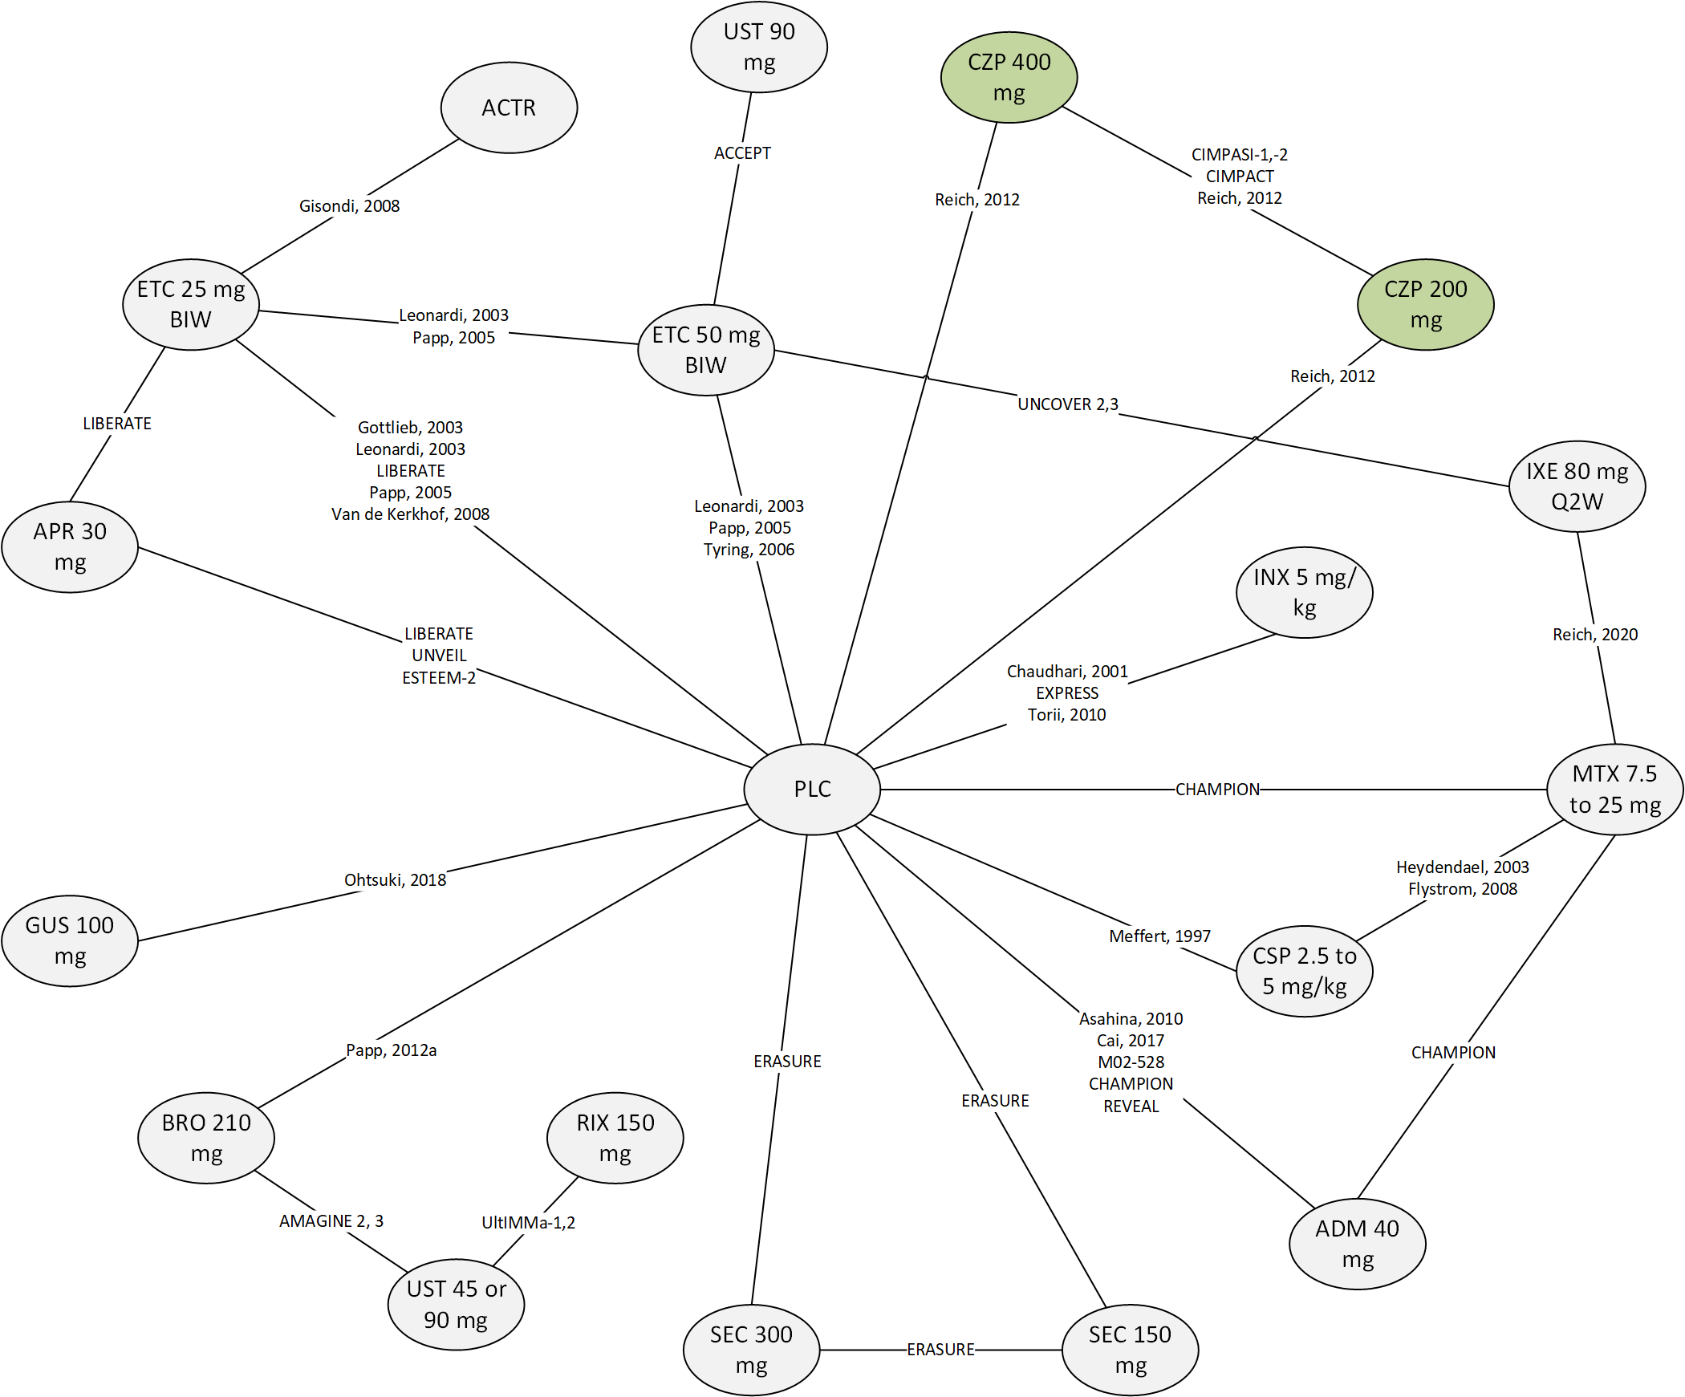
BID, twice daily; BIW, twice weekly; EOW, every other week; Q2W, every two weeks; Q4W, every four weeks; Q8W, every eight weeks; Q12W, every 12 weeks.
Note: data from biologic-naïve subgroups were included when the overall population included biologic exposed patients.

Figure S2. Network Diagram of Trials with ≥90% Biologic Treatment Naïve Patients
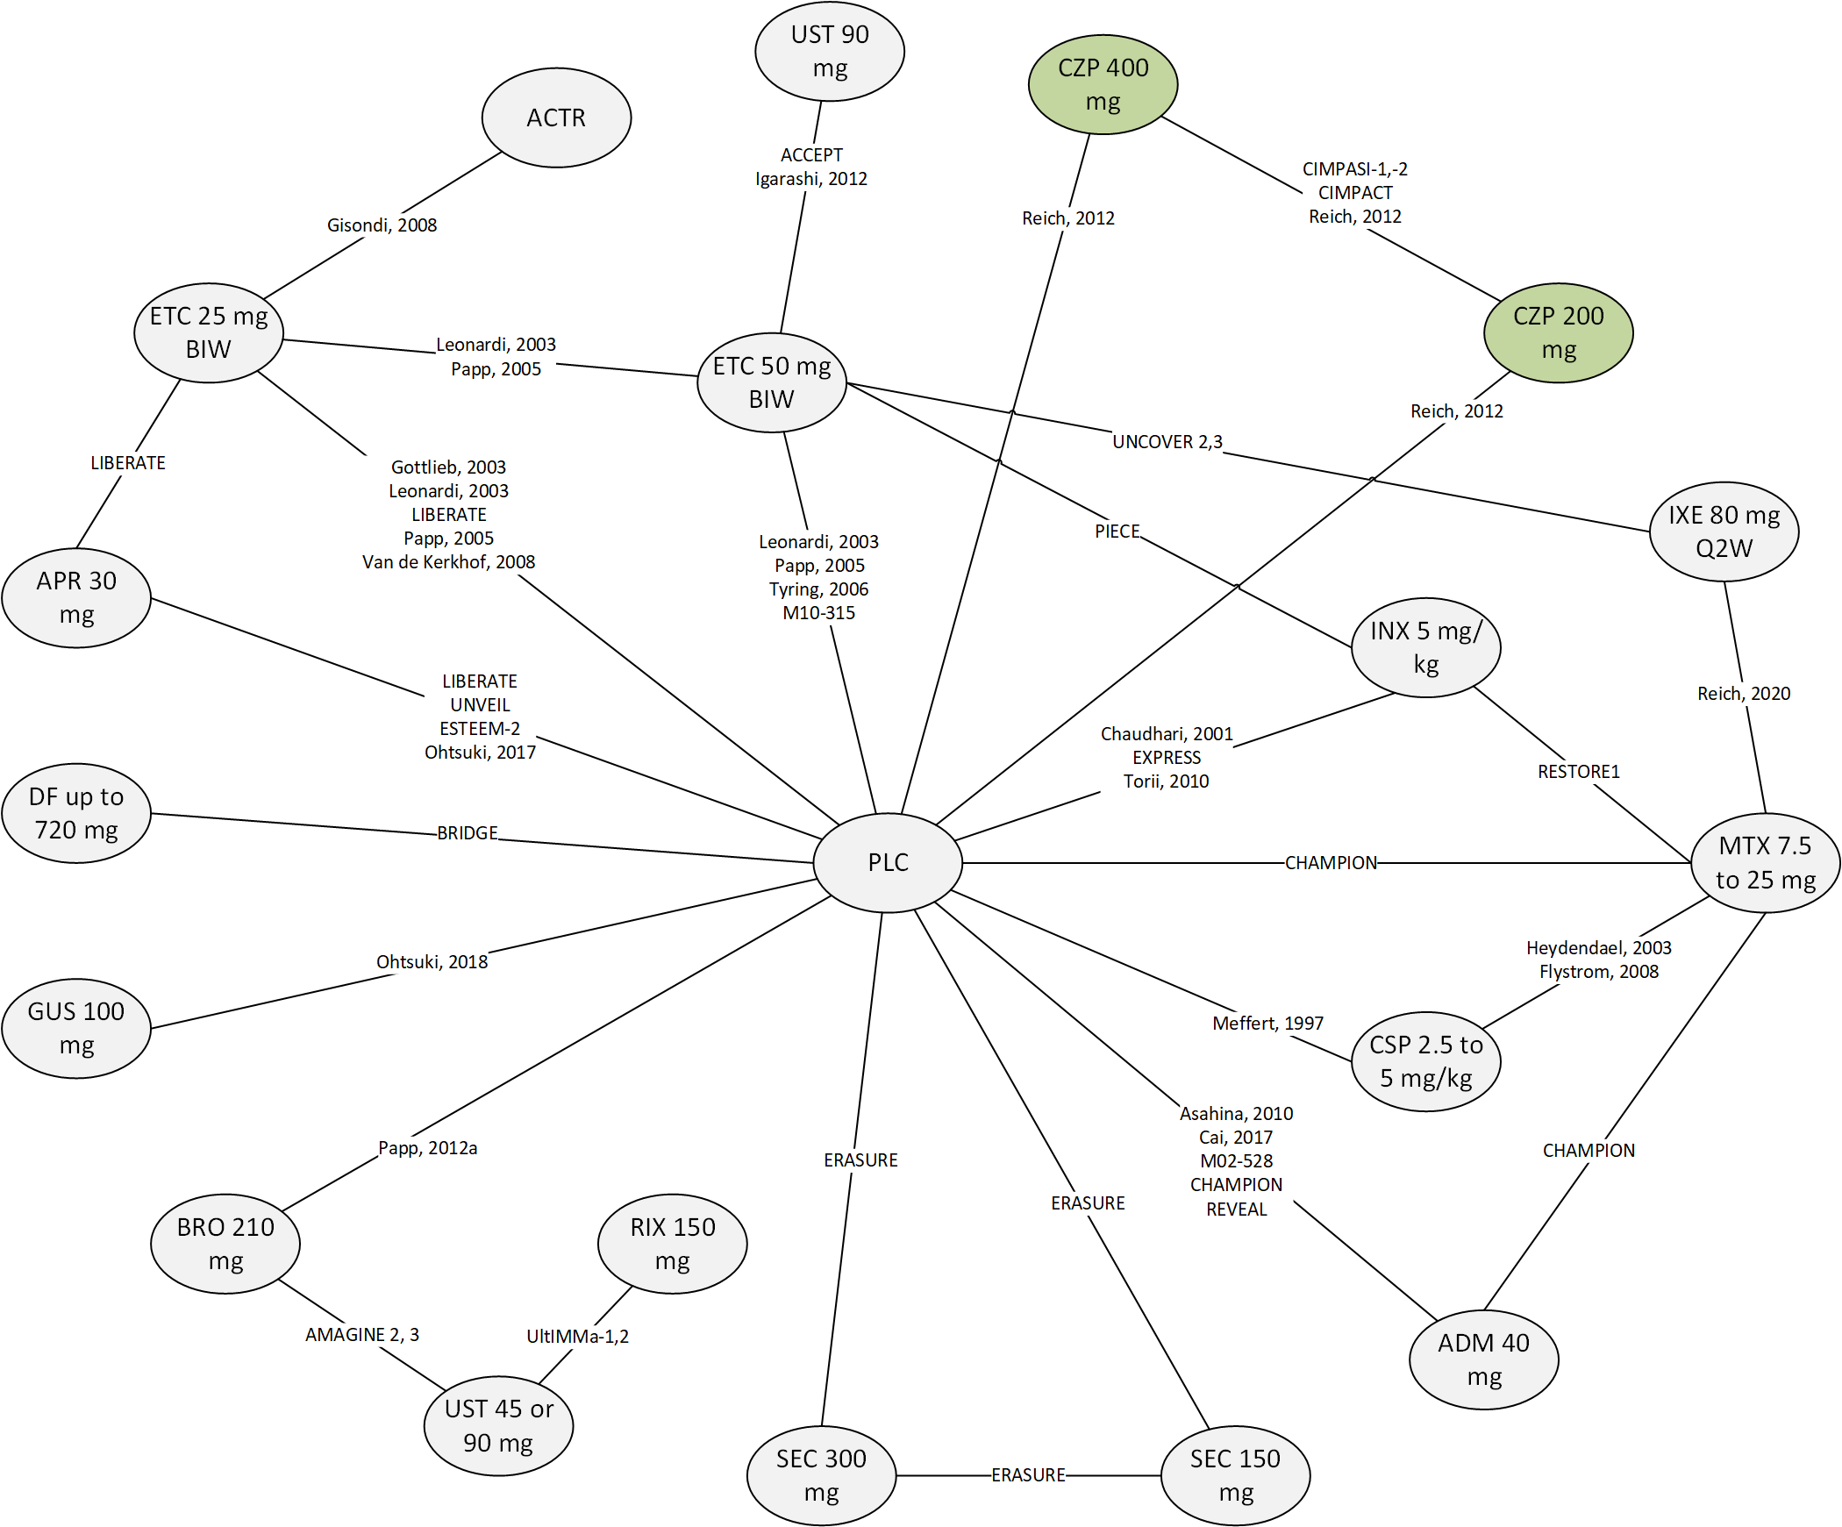
BIW, twice weekly; EOW, every other week; Q2W, every two weeks; Q4W, every four weeks; Q8W, every eight weeks; Q12W, every 12 weeks.
Note: data from biologic-naïve subgroups were included when the overall population included >10% biologic exposed patients.

Figure S3. Adjusted Random-effects REZ Multinomial Network Meta-analysis; Probit Probabilities of Achieving PASI Outcomes at 10 to 16 Weeks in Populations ≥90% Naïve to Biologic Treatment*
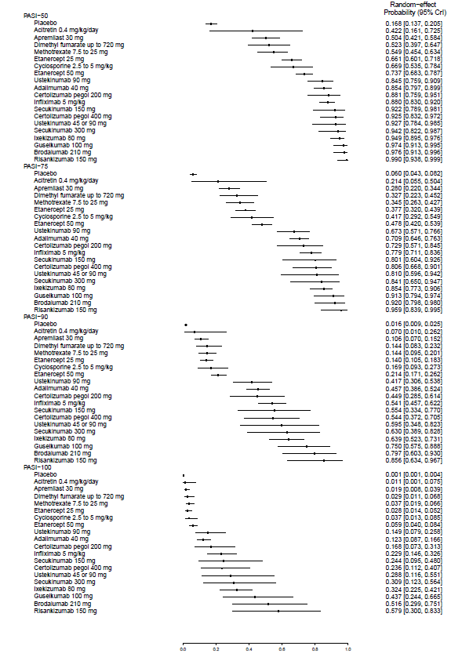
CrI, credible interval; PASI, Psoriasis Area and Severity Index.
*Treatments are sorted by the estimates of the PASI75 response probabilities.

Figure S4. Adjusted Random-effects REZ Multinomial Network Meta-analysis; Probit Probabilities of Achieving PASI Outcomes at 10 to 16 Weeks in Populations 100% Naïve to Biologic Treatment*
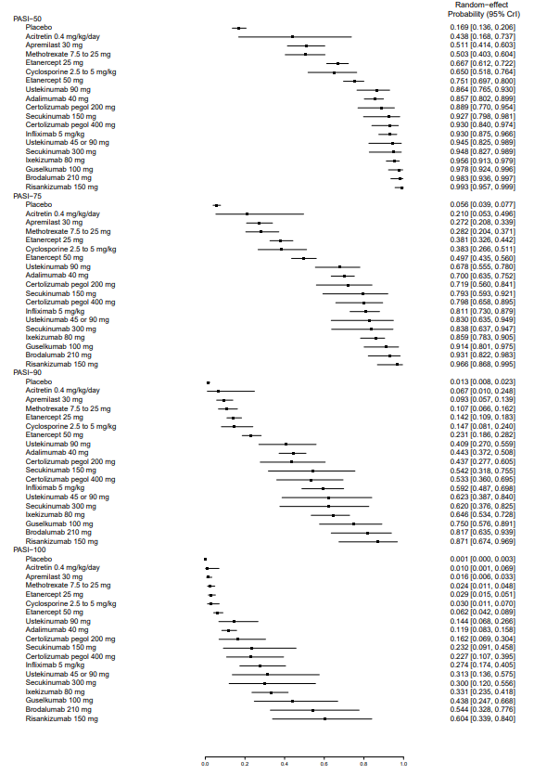

CrI, credible interval; PASI, Psoriasis Area and Severity Index.
*Treatments are sorted by the estimates of the PASI75 response probabilities.

Bayesian NMA Network Meta-analysis Model for Binomial Analysis
A simple example of a binomial model fitting is described below. In the absence of direct head-to-head evidence comparing treatments A and B (e.g., a log-odds ratio [LOR] between treatments; call this comparison d_{AB}), an unbiased estimate from randomized controlled trials (RCT) comparing treatments A and C and from RCTs comparing B and C can be derived:
d_{AB} = d_{AC} - d_{BC} (Equation 1)
The assumption being made is that the same d_{AB} that is estimated by the AB trials would also be estimated in the BC and AC trials, only if all three treatments had been included in them. If this assumption is correct, indirect evidence can be used instead of direct evidence, as well as to supplement it.
Consider a hypothetical situation with four treatments (A, B, C, and D) investigated in several pairwise trials. Functional parameters d_{BC}, d_{BD}, and d_{CD} can then be expressed in terms of the basic parameters d_{AB}, d_{AC}, and d_{AD}:
d_{BC} = d_{AC} - d_{AB}
d_{BD} = d_{AD} - d_{AB} (Equation 2)
d_{CD} = d_{AD} - d_{AC}
For illustrative purposes, consider the binary outcome of 75% response on PASI. The data consist of the numerators r_{jk} (number of patients with 75% response) and denominators n_{jk} (total number of patients with and without 75% responses) for trial j (j=1,2…) in treatment k (k is one of A, B, C, D). If we take p_{jk} as the probability of the event in treatment k in trial j, then the numerator r_{jk} is assumed to be generated from a binomial distribution with n_{jk} subjects and p_{jk} probability. The likelihood contribution of each arm is thus:
r_{jk} ~ B_{in} (p_{jk}, n_{jk}) (Equation 3)
The role of the model is to relate the probabilities p_{jk} to the basic parameters, if necessary, via the functional parameters. We can express the random-effects model in the form of a logistic regression (Equation 4):
Logit (p_{jk}) = μ_{jb} if k=b, b=A, B, C
= μ_{jb} + δ_{jbk} if k alphabetically “after” b (Equation 4)
δ_{jbk} ~ N(d_{bk,} τ²) (Equation 5)
Where μ_{jb} is the log-odds of response for treatment b in study j, δ_{jbk} is the LOR of treatment k vs. treatment b in trial j, and d_{bk} is the average LOR for treatment k compared to treatment b, the parameter of interest; and τ² is the common between-study variance for all treatment comparisons. Under the fixed-effects model, τ² in equation 5 is assumed to be 0 (i.e., δ_{jbk} =d_{bk} is assumed in Equation 4).

Bayesian NMA Models and Initials for Multinomial Analyses
The PASI50, PASI75, PASI90 and PASI100 responses are not mutually exclusive, but dependent on each other. For example, PASI75 responders are a subset of PASI50 responders. For a multinomial analysis with probit link, these data are transformed into independent ordinal categories of patients. For instance, if PASI50, PASI75 and PASI90 data are available in a treatment arm in a study, four independent categories (nc=4) are formed where PASI50 non-responders form the first non-response category of PASI 0 to 50, and PASI50 responders are grouped into three response categories of PASI 50% to 75% responders, 75% to 90% responders and 90% to 100% responders. In a multinomial model, it is assumed that there is an underlying continuous variable (which is percentage change in PASI score from baseline in this context) categorised by specifying different cut-offs, z_{ij} (j=1,2,…(maximum number of categories - 1)) where, this threshold is the point at which an individual is assigned to jth response category instead of (j-1)the response category in study i.¹
As in a binomial analysis, the number of responses in the jth response category for the kth treatment arm in the ith trial follows binomial distribution as:
r_{ikj} ~ Binomial(q_{ikj}, n_{ikj})
where q_{ikj} is the conditional probability of response in category j given the response in category j-1 among n_{ikj} responders (effective sample size) in category j. For example, the effective sample size for the category of PASI 50% to 75% is the number of PASI50 responders.
Probit differences are modelled in a multinomial model unlike LORs in a binomial model. The linear model for baseline risk adjusted REZ random-effects (RE) model in the jth category in the kth treatment arm in the ith study is presented as:
Φ⁻¹(p_{jkj}) = θ_{ikj} = μ_{jb} + z_{ij} + β(μ_{jb -} $\overline{μ}$) if k=b, b=A, B, C
= μ_{jb} + δ_{jbk} + z_{ij} + β(μ_{jb -} $\overline{μ}$), if k alphabetically “after” b
where, θ_{ikj} is the probit (standard normal) score corresponding to the probability p_{jkj}, μ_{jb} is the baseline risk in probit scale for treatment ‘b’, δ_{jbk} is the probit difference of treatment in arm k vs. b, z_{ij} is an underlying PASI threshold (probit difference of response in category j vs. response in category j to 1 for all treatments in trial i), β is the effect of baseline risk on probit difference, and $\overline{μ}$ is the mean value of baseline risk used for centring purpose. In the above model, we assume:
RE model: δ_{jbk} ~ Normal(d_{bk},τ²) for all trials i comparing k with b
REZ model: z_{jj} ~ Normal(${\overline{z}}_{j}$, $σ_{z}^{2}$) for all j = 1,2,3,4
However, in a fixed-effects model, a fixed value of δ_{jbk} = d_{bk} is assumed. Also, in a ‘standard’ probit model, a fixed value of z_{ij} = z_{j} is assumed.

Bayesian NMA Model for Multinomial Analysis with REZ and Random-effects Assumptions with Baseline Risk Adjustment
# Binomial likelihood with probit link for ordinal categories data
# Random-effects for treatment effects in individual studies
# Random-effects for underlying thresholds
# BetaPlac is the baseline risk parameter (on probit scale), and sd is the between-study standard deviation of probit differences and sdz is the standard deviation of Z’s.
# number of (unique) studies = 72 and number of treatments = 22 included in the analysis
model{
dummyvar<-nclass[1]+posttreat[1]+poststudy[1]
for(i in 1:72){ #! LOOP THROUGH STUDIES
w[i,1] <- 0 #! adjustment for multi-arm trials for control arm
delta[i,1] <- 0 #! treatment effect is zero for control arm
mu[i] ~ dnorm(0,0.001) #! vague priors for all trial baselines
for (k in 1:na[i]) { #! LOOP THROUGH ARMS
p[i,k,1] <- 1 #! Pr(PASI >0)
for (j in 1:(nc[i]-1)) { #! LOOP THROUGH CATEGORIES
r[i,k,j] ~ dbin(q[i,k,j],n[i,k,j]) #! binomial likelihood
q[i,k,j] <- 1-(p[i,k,C[i,j+1]]/p[i,k,C[i,j]]) #! conditional probabilities
theta[i,k,j] <- mu[i] + delta[i,k] + z[ntreat[i,k],C[i,j+1]-1] + (BetaP[ntreat[i,k]]-BetaP[ntreat[i,1]]) * (mu[i]-Mmu)
rhattreat[i,k,j] <- q[i,k,j] * n[i,k,j]
dv[i,k,j] <- 2 * (r[i,k,j]*(log(r[i,k,j])-log(rhattreat[i,k,j]))
+(n[i,k,j]-r[i,k,j])*(log(n[i,k,j]-r[i,k,j])-log(n[i,k,j]-rhattreat[i,k,j])))
}
dev[i,k] <- sum(dv[i,k,1:(nc[i]-1)])
for (j in 2:nc[i]) {
p[i,k,C[i,j]] <- 1 - phi.adj[i,k,j]
phi.adj[i,k,j] <- step(8+theta[i,k,j-1]) * (step(theta[i,k,j-1]-8) + step(8-theta[i,k,j-1])*phi(theta[i,k,j-1]) ) # Adjustment for extreme phi
}
}
for (k in 2:na[i]) {
delta[i,k] ~ dnorm(md[i,k],taud[i,k])
md[i,k] <- dd[ntreat[i,k]] - dd[ntreat[i,1]] + sw[i,k]
taud[i,k] <- prec*2*(k-1)/k
w[i,k] <- (delta[i,k] - dd[ntreat[i,k]] + dd[ntreat[i,1]])
sw[i,k] <- sum(w[i,1:(k-1)])/(k-1)
}
resdev[i] <- sum(dev[i,1:na[i]])
}
totresdev <- sum(resdev[]) #! Total Residual Deviance

for (i in 1:22) { #! LOOP THROUGH TREATMENTS
z[i,1] <- 0
for (j in 2:(Cmax-1)) {
z[i,j] <- z[i,j-1] + z.aux[i,j]
z.aux[i,j] ~ dnorm(MeanZ[j],precz)
}
}

for (j in 2:(Cmax-1)) {
MeanZ[j] ~ dunif(0,5) #! Prior for mean z_j (j=1,2,..)
}
precz <-1/(sdz*sdz)
sdz ~ dunif(0.001,0.5) # Prior for sdz = SD of z_ij

###calculate prob of achieving threshold- on treat k
A ~ dnorm(0.919, 268.7)
for (k in 1:22) {
for (j in 1: (Cmax-1)) { TThresh[j,k] <- 1 - phi(A + dd[k] + z[k,j] + (BetaP[k])*(A-Mmu)) }
}

dd[1] <- 0 BetaP[1]<- 0
BetaPlac ~ dnorm(0,0.01) #! vague prior for baseline effect
for (k in 2:22){
dd[k] ~ dnorm(0,0.001) #! vague priors for basic treatment effects
BetaP[k]<-BetaPlac
}

sd ~ dunif(0.001,1) #! vague prior for between-trial SD
tau<-sd
prec<- pow(tau,-2)
tau2<-1/prec

for (index in 1:22){ # Response probability for each treatment at each threshold
for (i in 1:(Cmax-1)) {
Thresh[i,pretreat[index]]<-TThresh[i,index]
}
}

for (index in 1:72){ # estimates of mu’s corresponding to 72 studies
study[prestudy[index]]<-mu[index] # prestudy = original study number
}

###! All pairwise treatment comparisons of differences in probit
for (c in 1:(22-1)){
for (k in (c+1):22){ # pretreat = original treatment number
Pbitdiff[pretreat[c],pretreat[k]] <- dd[c] - dd[k]
Pbitdiffprob[pretreat[c],pretreat[k]] <- step(Pbitdiff[pretreat[c],pretreat[k]])
}
}
}

Initials values for the third chain are provided (as a list in R object format) below:
Inits3 = structure(list(
mu=c(1, 1, 1, 1, 1, 1, 1, 1, 1, 1, 1, 1, 1, 1, 1, 1, 1, 1, 1, 1, 1, 1, 1, 1, 1, 1, 1, 1, 1, 1, 1, 1, 1, 1, 1, 1, 1, 1, 1, 1, 1, 1, 1, 1, 1, 1, 1, 1, 1, 1, 1, 1, 1, 1, 1, 1, 1, 1, 1, 1, 1, 1, 1, 1, 1, 1, 1, 1, 1, 1, 1, 1),
dd=c(NA, 0.5, 0.5, 0.5, 0.5, 0.5, 0.5, 0.5, 0.5, 0.5, 0.5, 0.5, 0.5, 0.5, 0.5, 0.5, 0.5, 0.5, 0.5, 0.5, 0.5, 0.5),
sd=0.2,
sdz=0.4,
BetaPlac=-0.5,
z.aux=structure(c(NA,
NA, NA, NA, NA, NA, NA, NA, NA, NA, NA, NA, NA, NA, NA, NA, NA,
NA, NA, NA, NA, NA, 0.3, 0.3, 0.3, 0.3, 0.3, 0.3, 0.3, 0.3, 0.3,
0.3, 0.3, 0.3, 0.3, 0.3, 0.3, 0.3, 0.3, 0.3, 0.3, 0.3, 0.3, 0.3,
0.5, 0.5, 0.5, 0.5, 0.5, 0.5, 0.5, 0.5, 0.5, 0.5, 0.5, 0.5, 0.5,
0.5, 0.5, 0.5, 0.5, 0.5, 0.5, 0.5, 0.5, 0.5, 0.7, 0.7, 0.7, 0.7,
0.7, 0.7, 0.7, 0.7, 0.7, 0.7, 0.7, 0.7, 0.7, 0.7, 0.7, 0.7, 0.7,
0.7, 0.7, 0.7, 0.7, 0.7), .Dim = c(22, 4)),
delta=structure(c(NA,
NA, NA, NA, NA, NA, NA, NA, NA, NA, NA, NA, NA, NA, NA, NA, NA,
NA, NA, NA, NA, NA, NA, NA, NA, NA, NA, NA, NA, NA, NA, NA, NA,
NA, NA, NA, NA, NA, NA, NA, NA, NA, NA, NA, NA, NA, NA, NA, NA,
NA, NA, NA, NA, NA, NA, NA, NA, NA, NA, NA, NA, NA, NA, NA, NA,
NA, NA, NA, NA, NA, NA, NA, 0.5, 0.5, 0.5, 0.5, 0.5, 0.5, 0.5,
0.5, 0.5, 0.5, 0.5, 0.5, 0.5, 0.5, 0.5, 0.5, 0.5, 0.5, 0.5, 0.5,
0.5, 0.5, 0.5, 0.5, 0.5, 0.5, 0.5, 0.5, 0.5, 0.5, 0.5, 0.5, 0.5,
0.5, 0.5, 0.5, 0.5, 0.5, 0.5, 0.5, 0.5, 0.5, 0.5, 0.5, 0.5, 0.5,
0.5, 0.5, 0.5, 0.5, 0.5, 0.5, 0.5, 0.5, 0.5, 0.5, 0.5, 0.5, 0.5,
0.5, 0.5, 0.5, 0.5, 0.5, 0.5, 0.5, 0.5, 0.5, 0.5, 0.5, 0.5, 0.5,
NA, NA, NA, NA, NA, 0.5, 0.5, NA, NA, NA, NA, NA, NA, NA, 0.5,
NA, NA, NA, NA, NA, NA, NA, 0.5, NA, 0.5, NA, NA, NA, NA, NA,
NA, NA, NA, NA, 0.5, NA, NA, NA, 0.5, NA, 0.5, 0.5, 0.5, NA,
NA, 0.5, NA, 0.5, NA, 0.5, NA, NA, NA, NA, NA, NA, NA, 0.5, 0.5,
0.5, 0.5, 0.5, 0.5, 0.5, 0.5, 0.5, 0.5, 0.5, 0.5, NA, NA, NA,
NA, NA, NA, NA, NA, NA, NA, NA, NA, NA, NA, NA, NA, NA, NA, NA,
NA, NA, NA, NA, NA, NA, 0.5, NA, NA, NA, NA, NA, NA, NA, NA,
NA, NA, NA, NA, NA, NA, NA, NA, NA, NA, NA, NA, NA, NA, NA, NA,
NA, NA, NA, NA, NA, NA, NA, NA, NA, NA, NA, NA, NA, NA, NA, NA,
NA, 0.5, NA, NA, NA, 0.5, NA, NA, NA), .Dim = c(72, 4)))
)

Initials values for Chain 1 and Chain 2 were sufficiently different. For example, in Chain 1 and Chain 2, all the initials were 0 and -0.5 for ‘dd’ parameters for 21 treatments vs. placebo, -0.2 and -0.8 for ‘BetaPlac’, 0.2 and 0.05 for ‘sdz’, 0.1 and 0.05 for ‘sd’, respectively.

Sources:
1. Dias S, Welton N, Sutton A, Ades AE. NICE DSU Technical Support Document 2: A Generalised Linear Modelling Framework for Pairwise and Network Meta-Analysis of Randomised Controlled Trials. 2011 [Last updated September 2016; last accessed November 2, 2017]; Available from: http://nicedsu.org.uk/wp-content/uploads/2016/03/A-general-linear-modelling-framework-for-pair-wise-and-network-meta-analysis-of-randomised-controlled-trials..pdf
2. National Institute for Health and Care Excellence (NICE). TA537: Ixekizumab for treating active psoriatic arthritis after inadequate response to DMARDs. August 8, 2018 [last accessed January 2020; Available from: https://www.nice.org.uk/guidance/ta537

Phototherapy with or without psoralen was included in final NICE scope for CZP but was not searched in the previous SLR.

