Supplementary information
Supplementary Figure 1 AMAGINE -2 and -3 study designs. Q2W, every 2 weeks; Q4W, every 4 weeks; Q8W, every 8 weeks; R, randomized.
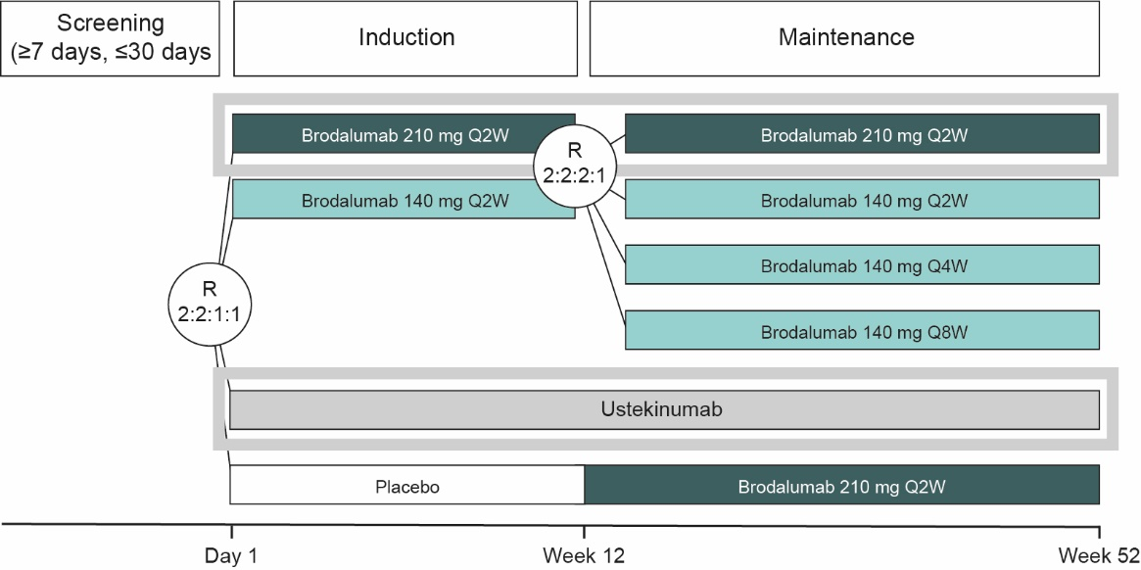
Supplementary Table 1 Grading of tobacco and alcohol use, by treatment
Lifestyle factor, n (%) | Brodalumab  (n = 339) | Ustekinumab  (n = 590)
Tobacco use
Non-smoker | 228 (67.3) | 381 (64.6)
Smoker (>0 cigarettes per day) | 111 (32.7) | 209 (35.4)
Light smoker (<11 cigarettes per day) | 63 (18.6) | 135 (22.9)
Moderate smoker (11–19 cigarettes per day) | 14 (4.1) | 25 (4.2)
Heavy smoker (≥20 cigarettes per day) | 34 (10.0) | 47 (8.0)
Smoker (amount not specified) | 0 | 2 (0.3)
Alcohol use
Non-drinker | 138 (40.7) | 207 (35.1)
Alcohol drinker | 201 (59.3) | 383 (64.9)
Light drinker (<7 alcoholic drinks per week) | 160 (47.2) | 305 (51.7)
Moderate drinker (8–11 alcoholic drinks per week) | 25 (7.4) | 56 (9.5)
Heavy drinker (>11 alcoholic drinks per week) | 16 (4.7) | 22 (3.7)
n, number of patients.

