Supplementary Material

Matching-adjusted indirect comparison of the efficacy at week 32 of tralokinumab and dupilumab in the treatment of moderate-to-severe atopic dermatitis
Tiago Torres¹; Anne Sohrt Petersen²; Ulla Ivens²; Albert Bosch Vilaro²; John Stinson²; José Manuel Carrascosa³
¹ Centro Hospitalar Universitário de Santo António, University of Porto, Porto, Portugal
² LEO Pharma A/S, Ballerup, Denmark
³ Hospital Universitari Germans Trias i Pujol, UAB, IGTP. Badalona, Spain
Corresponding author: Anne Sohrt Petersen
Full postal address: LEO Pharma A/S. Industriparken 55. DK-2750 Ballerup, Denmark
Email: oypdk@leo-pharma.com

Figure S1 Comparisons of additional continuous endpoints for tralokinumab vs dupilumab at week 32
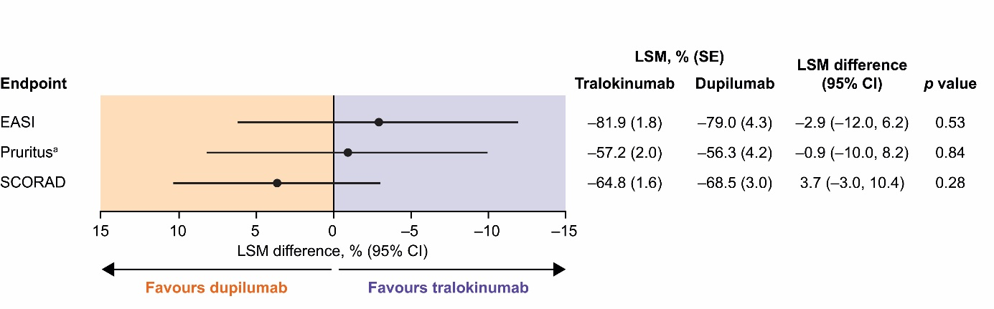
p value is for 2-sided test for zero difference between LSM changes from baseline with tralokinumab and dupilumab.
ª Change in worst daily pruritus NRS.
Data shown in forest plot are LSM differences in changes in outcome measures; negative LSM differences indicate larger mean improvements with tralokinumab than with dupilumab.
CI, confidence interval; EASI, Eczema Area and Severity Index; LSM, least squares mean; NRS, numeric rating scale; SCORAD, SCORing Atopic Dermatitis index; SE, standard error.

