SUPPLEMENTARY APPENDIX

Hidradenitis Suppurativa Symptom Daily Diary (HSSDD) and Questionnaire (HSSQ): Psychometric Validation and Interpretation Threshold Derivation Using Phase 3 Study Data
John R. Ingram,^{1,2} Jérémy Lambert,³ Valerie Ciaravino,³ Robert Rolleri,⁴ Ingrid Pansar,⁵ Luke Peterson,⁴ Christopher G. Pelligra,⁶ Linnea Thorlacius^{7,8}
¹Department of Dermatology & Academic Wound Healing, Division of Infection and Immunity, Cardiff University, Cardiff, UK; ²European Hidradenitis Suppurativa Foundation (EHSF), Dessau, Germany; ³UCB, Colombes, France; ⁴UCB, Morrisville, NC, USA; ⁵UCB, Brussels, Belgium; ⁶Evidera, Atlanta, GA, USA; ⁷Department of Dermatology, Zealand University Hospital, Roskilde, Denmark; ⁸Health Sciences Faculty, University of Copenhagen, Copenhagen, Denmark
Correspondence to:
Dr John R. Ingram
Department of Dermatology & Academic Wound Healing, Division of Infection and Immunity, Cardiff University, Cardiff, UK.
UK Email: ingramjr@cardiff.ac.uk

 | 0 days missing | 1 day missing | 2 days missing | 3 days missing | 4 days missing | 5 days missing | 6 days missing
HSSDD symptom item score
(mean [SD])^{b}
Worst skin pain | 4.34 (2.38) | 4.34 (2.38) | 4.34 (2.39) | 4.34 (2.39) | 4.34 (2.40) | 4.34 (2.41) | 4.34 (2.45)
Average skin pain | 3.66 (2.30) | 3.66 (2.30) | 3.66 (2.31) | 3.66 (2.31) | 3.65 (2.32) | 3.65 (2.33) | 3.66 (2.36)
Smell or odour | 3.57 (2.66) | 3.57 (2.66) | 3.57 (2.66) | 3.57 (2.66) | 3.57 (2.67) | 3.57 (2.68) | 3.57 (2.71)
Itch at its worst | 3.91 (2.43) | 3.91 (2.43) | 3.91 (2.44) | 3.91 (2.44) | 3.91 (2.45) | 3.92 (2.46) | 3.91 (2.50)
Drainage or oozing | 3.60 (2.49) | 3.60 (2.49) | 3.60 (2.50) | 3.60 (2.50) | 3.60 (2.51) | 3.60 (2.52) | 3.60 (2.56)
Supplementary Table 1. Variation of HSSDD symptom item scores across missing-day scenarios/rules based on data pooled from all selected weeks (HSSDD analysis set, n=934ª)

ªn=724 study participants with 0 days missing at each prespecified weekly assessment (and overall). ^{b}Mean and SD provided for the 0 days missing scenario (not simulated) and summary statistics are provided for the mean and SD across 100 replications. Abbreviations: HSSDD: Hidradenitis Suppurativa Symptom Daily Diary; HSSQ: Hidradenitis Suppurativa Symptom Questionnaire; SD: standard deviation.

Supplementary Figure 1. HSSDD and HSSQ symptom item scores in HS subgroups as defined by PGI-S-HS (A–B) and HS PGA (C–D) at Week 16 (known-groups validity)
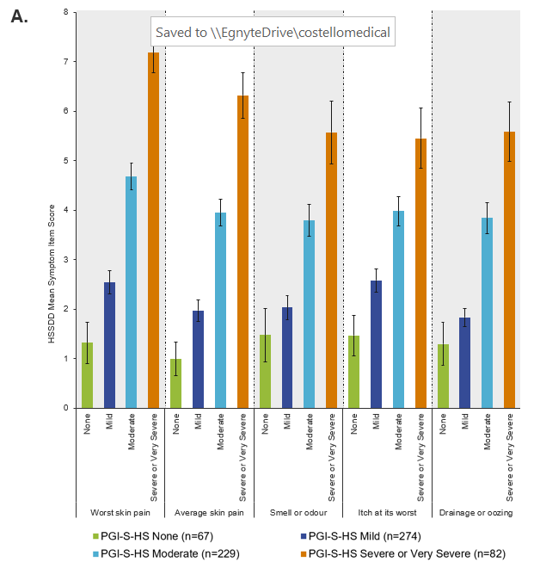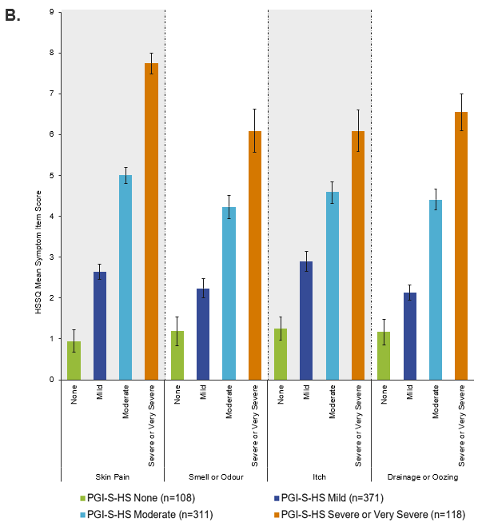
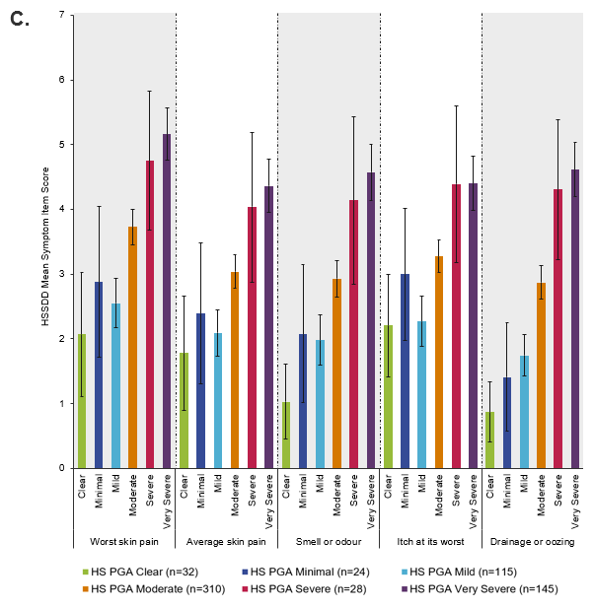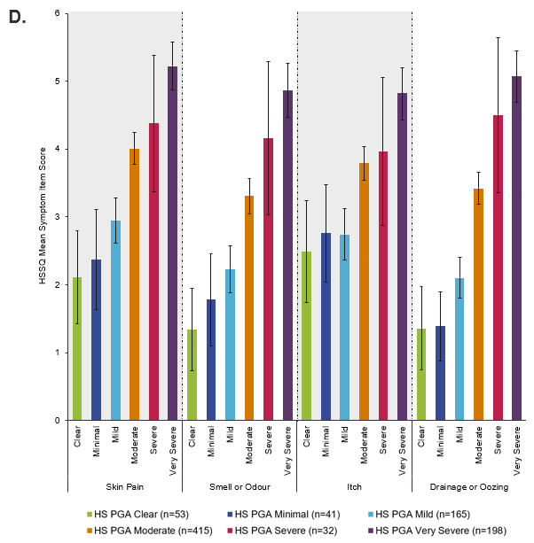
Error bars show 95% confidence limits. Overall p values estimated using the Kruskal-Wallis test were all p<0.001 at Week 16. Abbreviations: HS: hidradenitis suppurativa; HS PGA: HS Physician’s Global Assessment; HSSDD: Hidradenitis Suppurativa Symptom Daily Diary; HSSQ: Hidradenitis Suppurativa Symptom Questionnaire; PGI-S-HS: Patient Global Impression of HS Severity.

