Supplementary Material

Network Meta-Analysis of 1.5% Ruxolitinib Cream Versus Systemic Agents in the Treatment of Moderate Atopic Dermatitis

Melinda J. Gooderham,^{1,}* H. Chih-ho Hong,² Di Wang,³ Becky Hooper,³ Avery Hughes-Martin,³ Heather Cameron,³ Laura Pastor,³ Alicia Pepper,⁴ Ping Wu,⁴ Ali Mojebi,⁴ Grace Wong,⁵ Rafael Marino,⁶ Marie-Lise Dion,⁵ Mehdi Larbi⁵

¹SKiN Centre for Dermatology, Peterborough, ON, Canada
²Department of Dermatology and Skin Science, University of British Columbia, Vancouver, BC, Canada
³EVERSANA, Burlington, ON, Canada
⁴Precision AQ, Vancouver, BC, Canada
⁵Incyte Biosciences Canada Corporation, Pointe-Claire, QC, Canada
⁶Incyte Corporation, Wilmington, DE, USA

*Correspondence:
Melinda J. Gooderham
775 Monaghan Road, Peterborough, ON K9J 5K2
Telephone number: 705-874-1533
E-mail: mgooderham@centrefordermatology.com

Search Strategies
Embase: 1974 to 2023 February 09; Search executed: February 10, 2023
Search Strategy for Embase:
No. | Strings | Hits
1 | atopic dermatitis/ | 54,326
2 | exp eczema/ | 35,227
3 | (atopic* or dermatiti* or neurodermatitis or eczema*).mp. | 199,105
4 | or/1-3 | 199,105
5 | (Janus kinase inhibitor or jak inhibitor).mp. or exp Janus kinase inhibitor/ | 27,899
6 | exp ruxolitinib/ | 8,653
7 | (Ruxolitinib or opzelura or inc 424 or inc424).mp. | 8,924
8 | exp upadacitinib/ | 1,703
9 | (Upadacitinib or Rinvoq or ABT 494 or ABT-494 or ABT494 or 4RA0KN46E0 or 1310726-60-3 or 1607431-21-9).mp. | 1,760
10 | exp abrocitinib/ | 339
11 | (Abrocitinib or cibinqo or pf4965842 or pf04965842 or pf 4965842 or "pf 04965842").mp. | 380
12 | biologics.mp. or biological products/ | 75,666
13 | exp dupilumab/ | 5,199
14 | (Dupilumab or dupixent or regn 668 or REGN-668 or regn668 or sar 231893 or sar-231893 or sar231893 or 420K487FSG or 1190264-60-8).mp. | 5,431
15 | exp tralokinumab/ | 713
16 | (Tralokinumab or tralokinumab-ldrm or adtralza or adbry or cat 354 or cat354 or "lp 0162" or lp0162).mp. | 789
17 | (topical* adj3 PDE-4).mp. | 6
18 | exp crisaborole/ | 497
19 | (Crisaborole or eucrisa or staquis or an 2728 or an2728).mp. | 608
20 | exp Roflumilast/ | 2,315
21 | (zoryve or arq-151 or arq 151).mp. | 11
22 | (systemic adj immunosuppress*).mp. | 3,628
23 | exp methotrexate/ | 201,950
24 | (Methotrexate or MTX or amethopterin or Trexall or Rheumatrex or Otrexup).mp. | 211,758
25 | exp cyclosporine/ | 26,673
26 | (c?closporin* or CyA or Cy-A or CsA or Cs-A or csaneoral or neoral or sandimmun*).mp. | 197,023
27 | exp azathioprine/ | 104,068
28 | (az?thioprine or im?uran or Azasan).mp. | 107,094
29 | exp mycophenolate mofetil/ | 29,762
30 | (mycophen?lat* or mycophenol* or mycofen?lat* or mycofenol* or mofetil* or MMF or erl-080* or erl080* or melbex or myfortic or nsc-129185 or nsc129185 or CellCept).mp. | 92,272
31 | or/5-30 | 553,370
32 | exp clinical trial/ | 1,801,173
33 | exp randomized controlled trial/ | 762,753
34 | exp controlled clinical trial/ | 954,183
35 | exp multicenter study/ | 361,203
36 | exp Phase 3 clinical trial/ | 67,016
37 | exp Phase 4 clinical trial/ | 5,232
38 | exp randomization/ | 98,113
39 | exp single blind procedure/ | 49,932
40 | exp double blind procedure/ | 205,105
41 | exp crossover procedure/ | 73,312
42 | exp placebo/ | 396,110
43 | randomi?ed controlled trial$.tw. | 311,469
44 | rct.tw. | 51,358
45 | (random$ adj2 allocat$).tw. | 53,032
46 | single blind$.tw. | 30,724
47 | double blind$.tw. | 240,267
48 | ((treble or triple) adj blind$).tw. | 1,764
49 | placebo$.tw. | 359,687
50 | exp prospective study/ | 837,430
51 | or/32-50 | 2,912,715
52 | exp Case study/ | 95,662
53 | Case report.tw. | 516,538
54 | exp Abstract report/ or exp letter/ | 1,293,161
55 | Conference proceeding.pt. | -
56 | Conference abstract.pt. | 4,673,291
57 | Editorial.pt. | 754,755
58 | Letter.pt. | 1,278,363
59 | Note.pt. | 916,548
60 | or/52-59 | 8,159,006
61 | 51 not 60 | 2,087,654
62 | exp retrospective studies/ | 1,381,891
63 | exp cohort studies/ | 964,304
64 | exp cohort analysis/ | 964,304
65 | (observational adj3 (study or studies or design or analysis or analyses)).ti,ab. | 328,611
66 | (retrospective adj7 (study or studies or design or analysis or analyses or cohort or data or review)).ti,ab. | 1,109,807
67 | ((comment or editorial or practice-guideline or review or letter or journal correspondence or posters or News or Newspaper article or meeting abstracts or lectures or interview or historical article or handbooks or guidelines or guidebooks or essays or editorial or database or comment or clinical conference or catalogs) not "randomized controlled trial").pt. | 5,044,838
68 | or/62-67 | 7,463,020
69 | 61 not 68 | 1,526,906
70 | 4 and 31 and 69 | 1,172

Ovid MEDLINE(R) and Epub Ahead of Print, In-Process, In-Data-Review & Other Non-Indexed Citations and Daily: 1946 to February 9, 2023; Search executed: February 10, 2023
Search strategy for MEDLINE
No | Strings | Hits
1 | atopic dermatitis/ | 23,934
2 | exp eczema/ | 12,546
3 | (atopic* or dermatiti* or neurodermatitis or eczema*).mp. | 131,559
4 | or/1-3 | 131,559
5 | (Janus kinase inhibitor or jak inhibitor).mp. or exp Janus kinase inhibitor/ | 3,131
6 | ruxolitinib.tw. | 2,201
7 | (Ruxolitinib or opzelura or inc 424 or inc424).mp. | 2,522
8 | upadacitinib.tw. | 404
9 | (Upadacitinib or Rinvoq or ABT 494 or ABT-494 or ABT494 or 4RA0KN46E0 or 1310726-60-3 or 1607431-21-9).mp. | 468
10 | abrocitinib.tw. | 117
11 | (Abrocitinib or cibinqo or pf4965842 or pf04965842 or pf 4965842 or "pf 04965842").mp. | 128
12 | biologics.mp. or biological products/ | 45,452
13 | dupilumab.tw. | 1,933
14 | (Dupilumab or dupixent or regn 668 or REGN-668 or regn668 or sar 231893 or sar-231893 or sar231893 or 420K487FSG or 1190264-60-8).mp. | 2,129
15 | tralokinumab.tw. | 135
16 | (Tralokinumab or tralokinumab-ldrm or adtralza or adbry or cat 354 or cat354 or "lp 0162" or lp0162).mp. | 168
17 | (topical* adj3 PDE-4).mp. | 5
18 | crisaborole.tw. | 147
19 | (Crisaborole or eucrisa or staquis or an 2728 or an2728).mp. | 187
20 | Roflumilast.tw. | 705
21 | (zoryve or arq-151 or arq 151).mp. | 6
22 | (systemic adj immunosuppress*).mp. | 2,288
23 | exp methotrexate/ | 40,917
24 | (Methotrexate or MTX or amethopterin or Trexall or Rheumatrex or Otrexup).mp. | 61,454
25 | exp cyclosporine/ | 30,482
26 | (c?closporin* or CyA or Cy-A or CsA or Cs-A or csaneoral or neoral or sandimmun*).mp. | 77,565
27 | exp azathioprine/ | 15,249
28 | (az?thioprine or im?uran or Azasan).mp. | 24,552
29 | exp Mycophenolic Acid/ | 8,885
30 | (mycophen?lat* or mycophenol* or mycofen?lat* or mycofenol* or mofetil* or MMF or erl-080* or erl080* or melbex or myfortic or nsc-129185 or nsc129185 or CellCept).mp. | 18,249
31 | or/5-30 | 214,047
32 | Randomized Controlled Trials as Topic/ | 160,319
33 | randomized controlled trial/ | 586,408
34 | Random Allocation/ | 106,907
35 | Double Blind Method/ | 174,254
36 | Single Blind Method/ | 32,481
37 | clinical trial/ | 537,045
38 | clinical trial, phase i.pt. | 24,604
39 | clinical trial, phase ii.pt. | 39,260
40 | clinical trial, phase iii.pt. | 21,385
41 | clinical trial, phase iv.pt. | 2,381
42 | controlled clinical trial.pt. | 95,184
43 | randomized controlled trial.pt. | 586,408
44 | multicenter study.pt. | 330,499
45 | clinical trial.pt. | 537,045
46 | exp Clinical Trials as topic/ | 380,321
47 | or/32-46 | 1,549,887
48 | (clinical adj trial$).tw. | 463,181
49 | ((singl$ or doubl$ or treb$ or tripl$) adj (blind$3 or mask$3)).tw. | 194,522
50 | PLACEBOS/ | 35,925
51 | placebo$.tw. | 243,076
52 | randomly allocated.tw. | 35,417
53 | (allocated adj2 random$).tw. | 39,121
54 | or/48-53 | 762,969
55 | 47 or 54 | 1,883,144
56 | Case Study/ | 2,317,802
57 | case report.tw. | 384,660
58 | letter/ | 1,207,065
59 | historical article/ | 369,038
60 | or/56-59 | 3,716,540
61 | 55 not 60 | 1,829,479
62 | 4 and 31 and 61 | 901
63 | limit 62 to english language | 861

EBM Reviews - Cochrane Central Register of Controlled Trials January 2023; Search executed: February 10, 2023
Search strategy for CENTRAL
No. | Strings | Hits
1 | atopic dermatitis/ | 2,267
2 | exp eczema/ | 1,281
3 | (atopic* or dermatiti* or neurodermatitis or eczema*).mp. | 13,509
4 | or/1-3 | 13,509
5 | (Janus kinase inhibitor or jak inhibitor).mp. or exp Janus kinase inhibitor/ | 1,144
6 | ruxolitinib.tw. | 684
7 | (Ruxolitinib or opzelura or inc 424 or inc424).mp. | 692
8 | upadacitinib.tw. | 561
9 | (Upadacitinib or Rinvoq or ABT 494 or ABT-494 or ABT494 or 4RA0KN46E0 or 1310726-60-3 or 1607431-21-9).mp. | 598
10 | abrocitinib.tw. | 100
11 | (Abrocitinib or cibinqo or pf4965842 or pf04965842 or pf 4965842 or "pf 04965842").mp. | 139
12 | biologics.mp. or Biological Products/ | 2,078
13 | dupilumab.tw. | 833
14 | (Dupilumab or dupixent or regn 668 or REGN-668 or regn668 or sar 231893 or sar-231893 or sar231893 or 420K487FSG or 1190264-60-8).mp. | 851
15 | tralokinumab.tw. | 142
16 | (Tralokinumab or tralokinumab-ldrm or adtralza or adbry or cat 354 or cat354 or "lp 0162" or lp0162).mp. | 154
17 | (topical* adj3 PDE-4).mp. | 2
18 | crisaborole.tw. | 92
19 | (Crisaborole or eucrisa or staquis or an 2728 or an2728).mp. | 115
20 | Roflumilast.tw. | 415
21 | (zoryve or arq-151 or arq 151).mp. | 19
22 | (systemic adj immunosuppress*).mp. | 183
23 | exp methotrexate/ | 4,685
24 | (Methotrexate or MTX or amethopterin or Trexall or Rheumatrex or Otrexup).mp. | 13,530
25 | exp cyclosporine/ | 2,983
26 | (c?closporin* or CyA or Cy-A or CsA or Cs-A or csaneoral or neoral or sandimmun*).mp. | 9,490
27 | exp azathioprine/ | 1,296
28 | (az?thioprine or im?uran or Azasan).mp. | 3,374
29 | exp Mycophenolic Acid/ | 1,545
30 | (mycophen?lat* or mycophenol* or mycofen?lat* or mycofenol* or mofetil* or MMF or erl-080* or erl080* or melbex or myfortic or nsc-129185 or nsc129185 or CellCept).mp. | 5,295
31 | or/5-30 | 31,738
32 | 4 and 31 | 1,249

Risk of Bias
Most trials were double-blinded and conducted in multiple countries; exceptions were Zhao 2022, Katoh 2022 (Rising Up), and Goujon 2018, which were conducted in a single country (limited external validity), with Goujon 2018 also being open-label (leading to higher risk of performance bias) with a smaller sample size [1-3].
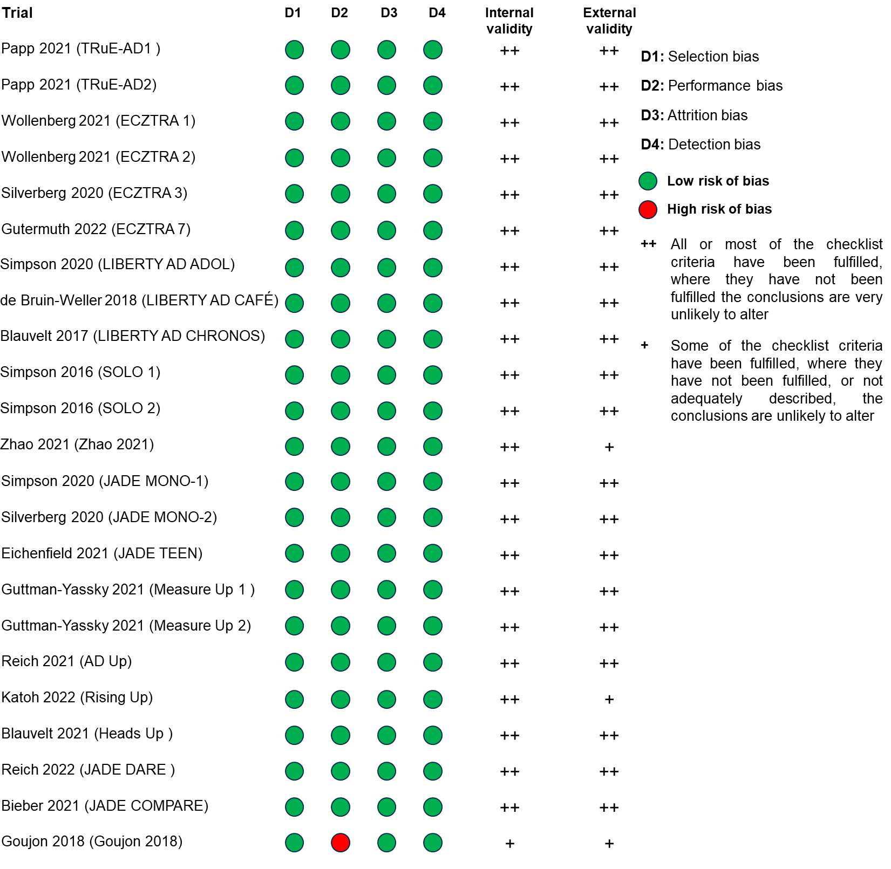
Supplementary Material Figure 1 Risk of bias assessment of the included trials, full trial population.

Feasibility Assessment for the Full Trial Population
An assessment was conducted considering the full intent-to-treat (ITT) populations for all trials. The interventions were compared against placebo, placebo + TCS, and placebo + topicals (including TCS, TCI, or PDE-4). The main network included 4 separate satellites depending on the type of placebo arm, which included an independent satellite for the oral immunosuppressants (Supplementary Material Fig. 2).
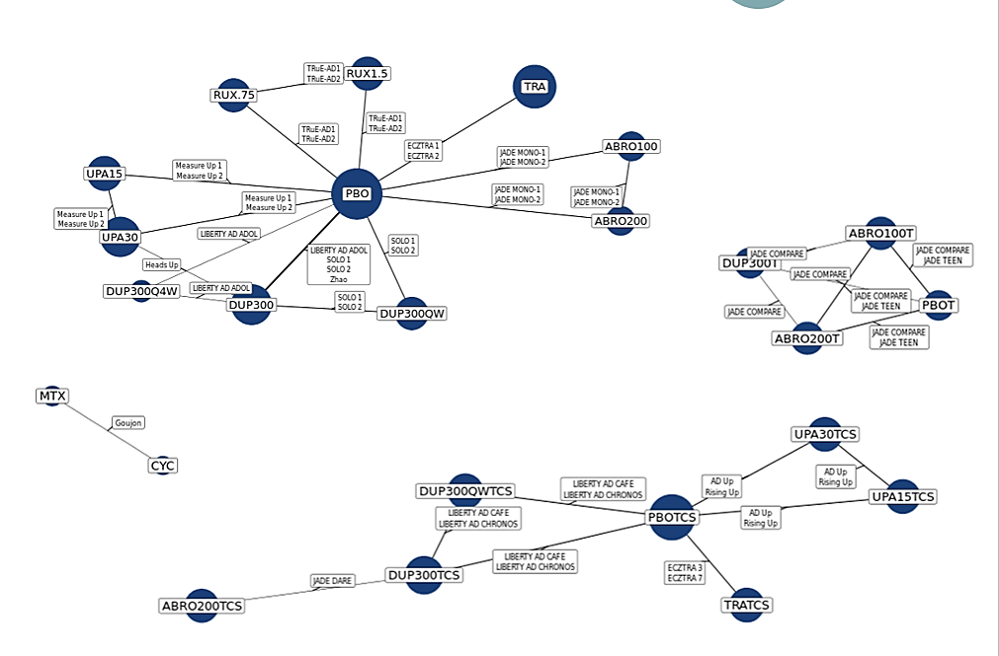
Supplementary Material Fig. 2 Main network connectivity, full trial population.ª
ª 0.75% ruxolitinib cream was not included in the analysis as it is not commercially available.
ABRO100, abrocitinib 100 mg; ABRO100T, abrocitinib 100 mg + topical treatment; ABRO200, abrocitinib 200 mg; ABRO200T, abrocitinib 200 mg + topical treatment; ABRRO200TCS, abrocitinib 200 mg + TCS; CYC, cyclosporin; DUP300, dupilumab every 2 weeks; DUP300T, dupilumab every 2 weeks + topical treatment; DUP300TCS, dupilumab every 2 weeks + TCS; DUP300Q4W, dupilumab every 4 weeks; DUP300QW, dupilumab every week; DUP300QWTCS, dupilumab every week + TCS; mg, milligrams; MTX, methotrexate; PBO, placebo; PBOT, placebo + topical treatment; PBOTCS, placebo + TCS; RUX.75, 0.75% ruxolitinib cream; RUX1.5, 1.5% ruxolitinib cream; TCS, topical corticosteroid; TRA, tralokinumab; TRATCS, tralokinumab + TCS; UPA15, upadacitinib 15 mg; UPA30, upadacitinib 30 mg; UPA15TCS, upadacitinib 15 mg + TCS; UPA30TCS, upadacitinib 30 mg + TCS.

Supplementary Material Table 1 Summary of inclusion and exclusion criteria for the SLR
Criteria | Include | Exclude
Population | Adult and adolescent patients (≥12 years) with AD  Potential subgroups of interest:  AD severity: mild; moderate; severe; mild to moderate; moderate to severe  Prior treatment experience | Pediatric patients (<12 years)  Mixed-age populations with <80% patients over 12 years of age if outcomes are not reported separately for the ≥12 years subgroup  Mixed-indication populations if outcomes are not reported separately for the AD subgroup
Intervention | Regimens approved (or anticipating approval in near future) by Health Canada or recommended by CDA, as monotherapy, in combination with each other, or with concomitant background topical treatment:  JAK inhibitors  Ruxolitinib (topical)  Upadacitinib (oral)  Abrocitinib (oral)  Monoclonal Antibodies  Dupilumab (SC)  Tralokinumab (SC)  PDE-4 Inhibitors  Crisaborole (topical)  Roflumilast (topical)  Immunosuppressants  Methotrexate (oral or IV)  Cyclosporine (oral or IV)  Azathioprine (oral)  Mycophenolate mofetil (oral or IV) | Different topical interventions administered to different lesions on the same patients (e.g., Treatment A on the left side of body and Treatment B on the right side of body)  Interventions not listed
Comparators | Placebo (e.g., involving topical use of vehicles with emollient properties)  Any intervention of interest as monotherapy or in combination  Any intervention of interest + concomitant background topical treatment
Outcomes | Efficacy outcomes:  IGA score (or variant such as ISGA score, v-IGA-AD score, % IGA-TS)ª  EASI scoreª  SCORAD score  BSA %  Flare  Patient-reported outcomes:  Itch NRS scoreª  Skin Pain NRS score  PROMIS Sleep-Related Impairment score  Safety outcomes  Treatment-emergent and treatment-related AEsª  Serious AEs  Treatment-related serious AEs  Treatment discontinuation due to AEs  Study withdrawal due to AEs | No outcomes of interest
Study Design | Phase III or IV RCTs | Phase 0 or I trials  Phase II trials  Dose-finding/dose-escalation trials  Non-RCTs  Single-arm trials  Observational studies  Pooled analyses of RCTs  Systematic literature reviews, meta-analyses  Case reports, case series  Letters, editorials, press releases, narrative reviews, opinion pieces
Language | Only studies published in English | Non-English papers (even if abstract is available in English)
Time | No time restriction | None
AD, atopic dermatitis; AE, adverse event; BSA, body surface area; CDA, Canada’s Drug Agency; EASI, Eczema Area and Severity Index; IGA, Investigator’s Global Assessment; IGA-TS, Investigator’s Global Assessment treatment success; ISGA, Investigator’s Static Global Assessment; IV, intravenous, JAK, Janus kinase; NRS, Numerical Rating Scale; PDE-4, phosphodiesterase-4; PROMIS, Patient-Reported Outcomes Measurement Information System; RCT, randomized controlled trial; SC, subcutaneous; SCORAD, scoring atopic dermatitis index; SLR, systematic literature review; v-IGA-AD, validated Investigator Global Assessment for atopic dermatitis.
ª Outcome assessed in the feasibility assessment and ITC where feasible.

Supplementary Material Table 2 Summary of RCTs included in the full trial population feasibility assessment
Study Name | Phase | Trial Duration (Weeks) | Interventions | Region(s) | Age | Severity Criteria | Population | Efficacy Outcomes of Interest
 |  |  |  |  |  |  |  | IGA 0/1 | EASI-75 | Itch NRS4
TRuE-AD1  (NCT03745638) | III | 12 | 0.75% ruxolitinib; 1.5% ruxolitinib; vehicle | Canada, France, Germany, Hungary, Italy, Poland, US | ≥12 | BSA 3-20%, IGA 2-3 at screening and baseline | Mild-moderate | ✓  IGA score 0 or 1, with an improvement of ≥2 grades from baseline | ✓ | ✓  Worst Pruritus NRS measured as proportion of patients with a ≥ 4-point reduction from baseline
TRuE-AD2  (NCT03745651) | III | 12 | 0.75% ruxolitinib; 1.5% ruxolitinib; vehicle | Bulgaria, Canada, Czech Republic, Germany, Poland, Spain, US | ≥12 | BSA 3-20%, IGA 2-3 at screening and baseline | Mild-moderate | ✓  IGA score 0 or 1, with an improvement of ≥2 grades from baseline | ✓ | ✓  Worst Pruritus NRS measured as proportion of patients with a ≥ 4-point reduction from baseline
ECZTRA 1  (NCT03131648) | III | 52 | Tralokinumab 300 mg Q2W; placebo | France, Germany, Japan, Spain, US | ≥18 | EASI ≥12 at screening and EASI ≥16 baseline, IGA ≥3, NRS ≥4, BSA ≥10% | Moderate-severe | ✓  IGA score of 0 or 1 | ✓ | ✓  Worst Pruritus NRS measured as % of patients with pruritus NRS of ≥4 points
ECZTRA 2  (NCT03160885) | III | 52 | Tralokinumab 300 mg Q2W; placebo | Australia, Canada, Denmark, Italy, Korea, Poland, Russia, UK, US | ≥18 | EASI ≥12 at screening and EASI ≥16 baseline, IGA ≥3, NRS ≥4, BSA ≥10% | Moderate-severe | ✓  IGA score of 0 or 1 | ✓ | ✓  Worst Pruritus NRS measured as % of patients with pruritus NRS of ≥4 points
ECZTRA 3  (NCT03363854) | III | 32 | Tralokinumab 300 mg Q2W; placebo | Belgium, Canada, Germany, Netherland, Poland, Spain, UK, US | ≥18 | EASI ≥12 at screening and EASI ≥16 baseline, IGA ≥3, NRS ≥4, BSA ≥10% | Moderate-severe | ✓  IGA score of 0 or 1 | ✓ | ✓  Worst Pruritus NRS measured as % of patients with pruritus NRS of ≥4 points
ECZTRA 7  (NCT03761537) | III | 26 | Tralokinumab 300 mg Q2W; placebo | Belgium, Czech Republic, France, Germany, Poland, Spain, UK | ≥18 | EASI ≥20, IGA ≥3, NRS ≥4, BSA ≥10% | Severe | ✓  IGA score of 0 or 1 | ✓ | ✓  Worst Pruritus NRS measured as % of patients with pruritus NRS of ≥4 points
LIBERTY AD ADOL  (NCT03054428) | III | 16 | Dupilumab 300 mg Q4W; dupilumab 200 mg or 300 mg Q2W; placebo | Canada, US | 12-18 | IGA ≥3, BSA ≥10, EASI ≥16, Pruritus NRS ≥4 | Moderate-severe | ✓  IGA score 0 or 1, with an improvement of ≥2 grades from baseline | ✓ | ✓  Peak Pruritus NRS measured as % of patients with peak pruritus NRS of ≥4 points
LIBERTY AD CAFÉ  (NCT02755649) | III | 16 | Dupilumab 300 mg QW or Q2W; placebo | Austria, Belgium, Germany, Ireland, Netherlands, Poland, Russia, Slovakia, Spain, UK | ≥18 | IGA ≥3, BSA ≥10, EASI ≥20 | Moderate-severe | ✓  IGA score 0 or 1, with an improvement of ≥2 grades from baseline | ✓ | ✓  Peak Pruritus NRS measured as % of patients with peak pruritus NRS of ≥4 points
LIBERTY AD CHRONOS  (NCT02260986) | III | 52 | Dupilumab 300 mg QW or Q2W; placebo | Australia, Canada, Czech Republic, Hungary, Italy, Japan, Korea, Netherlands, New Zealand, Poland, Romania, Spain, UK, US, | ≥18 | IGA ≥3, BSA ≥10, EASI ≥16, Pruritus NRS ≥3 | Moderate-severe | ✓  IGA score 0 or 1, with an improvement of ≥2 grades from baseline | ✓ | ✓  Peak Pruritus NRS measured as % of patients with peak pruritus NRS of ≥4 points
SOLO 1  (NCT02277743) | III | 16 | Dupilumab 300 mg QW or Q2W; placebo | Bulgaria, Canada, Denmark, Estonia, Finland, Germany, Japan, Singapore, Spain, US | ≥18 | IGA ≥3, BSA ≥10, EASI ≥16, Pruritus NRS ≥3 | Moderate-severe | ✓  IGA score 0 or 1, with an improvement of ≥2 grades from baseline | ✓ | ✓  Peak Pruritus NRS measured as % of patients with peak pruritus NRS of ≥3 or 4 points
SOLO 2  (NCT02277769) | III | 16 | Dupilumab 300 mg QW or Q2W; placebo | Canada, France, Germany, Hong Kong, Italy, Korea, Lithuania, Poland, Sweden, UK, US | ≥18 | IGA ≥3, BSA ≥10, EASI ≥16, Pruritus NRS ≥3 | Moderate-severe | ✓  IGA score 0 or 1, with an improvement of ≥2 grades from baseline | ✓ | ✓  Peak Pruritus NRS measured as % of patients with peak pruritus NRS of ≥3 or 4 points
Zhao 2022  (NCT03912259) | III | 33 | Dupilumab 300 mg Q2W; placebo | China | ≥18 | IGA ≥3, BSA ≥10, EASI ≥16, Pruritus NRS ≥4 | Moderate-severe | ✓  IGA score 0 or 1, with an improvement of ≥2 grades from baseline | ✓ | ✓  Peak Pruritus NRS measured as % of patients with peak pruritus NRS of ≥3 or 4 points
JADE MONO-1  (NCT03349060) | III | 12 | Abrocitinib 100 mg or 200 mg QD; placebo | Australia, Canada, Czech Republic, Germany, Hungary, Poland, UK, US | ≥12 | EASI ≥16, IGA ≥3, NRS ≥4, BSA ≥10% | Moderate-severe | ✓  IGA score 0 or 1, with an improvement of ≥2 grades from baseline | ✓ | ✓  Peak Pruritus NRS measured as % of patients with peak pruritus NRS of ≥4 points
JADE MONO-2  (NCT03575871) | III | 12 | Abrocitinib 100 mg or 200 mg QD; placebo | Australia, Bulgaria, Canada, China, Czech Republic, Germany, Hungary, Japan, Korea, Latvia, Poland, UK, US | ≥12 | EASI ≥16, IGA ≥3, NRS ≥4, BSA ≥10% | Moderate-severe | ✓  IGA score 0 or 1, with an improvement of ≥2 grades from baseline | ✓ | ✓  Peak Pruritus NRS measured as % of patients with peak pruritus NRS of ≥4 points
JADE TEEN  (NCT03796676) | III | 16 | Abrocitinib 100 mg or 200 mg QD; placebo | Australia, China, Czech Republic, Germany, Hungary, Italy, Japan, Latvia, Mexico, Poland, Spain, Taiwan, UK, US | 12-17 | EASI ≥16, IGA ≥3, NRS ≥4, BSA ≥10% | Moderate-severe | ✓  IGA score 0 or 1, with an improvement of ≥2 grades from baseline | ✓ | ✓  Peak Pruritus NRS measured as % of patients with peak pruritus NRS of ≥4 points
Measure Up 1  (NCT03569293) | III | 16 | Upadacitinib 15 mg or 30 mg QD; placebo | Argentina, Australia, Bosnia and Herzegovina, Bulgaria, Canada, China, Colombia, Croatia, Denmark, Estonia, Finland, France, Germany, Italy, Japan, Malaysia, New Zealand, Puerto Rico, Romania, Russia, Switzerland, Turkey, Ukraine, UK, US | ≥12 | v-IGA ≥3, BSA ≥10, EASI ≥16, Pruritus NRS ≥4 | Moderate-severe | ✓  v-IGA-AD score of 0 or 1, with ≥2 grades of improvement from baseline | ✓ | ✓  Worst Pruritus NRS measured as % of patients with pruritus NRS of ≥4 points
Measure Up 2  (NCT03607422) | III | 16 | Upadacitinib 15 mg or 30 mg QD; placebo | Australia, Austria, Belgium, Bulgaria, Canada, Croatia, Czech Republic, Denmark, France, Germany, Greece, Hungary, Ireland, Italy, Korea, Netherlands, New Zealand, Portugal, Singapore, Spain, Taiwan, UK, US | ≥12 | v-IGA ≥3, BSA ≥10, EASI ≥16, Pruritus NRS ≥4 | Moderate-severe | ✓  v-IGA-AD score of 0 or 1, with ≥2 grades of improvement from baseline | ✓ | ✓  Worst Pruritus NRS measured as % of patients with pruritus NRS of ≥4 points
AD Up  (NCT03568318) | III | 16 | Upadacitinib 15 mg or 30 mg QD; placebo | Australia, Austria, Belgium, Canada, China, Czech Republic, France, Germany, Greece, Hong Kong, Hungary, Ireland, Israel, Italy, Japan, Netherlands, New Zealand, Norway, Puerto Rico, Slovakia, Spain, Sweden, UK, US | ≥12 | v-IGA ≥3, BSA ≥10, EASI ≥16, WP-NRS ≥4 | Moderate-severe | ✓  v-IGA-AD score of 0 or 1, with ≥2 grades of improvement from baseline | ✓ | ✓  Worst Pruritus NRS measured as % of patients with pruritus NRS of ≥4 points
Rising Up  (NCT03661138) | III | 141 | Upadacitinib 15 mg or 30 mg QD; placebo | Japan | ≥12 | v-IGA ≥3, BSA ≥10, EASI ≥16, Pruritus NRS ≥4 | Moderate-severe | ✓  v-IGA-AD score of 0 or 1, with ≥2 grades of improvement from baseline | ✓ | ✓  Worst Pruritus NRS measured as % of patients with pruritus NRS of ≥4 points
Heads Up  (NCT03738397) | IIIb | 41 | Upadacitinib 30 mg QD; dupilumab 300 mg Q2W | Australia, Canada, Croatia, Czech Republic, Finland, France, Germany, Hungary, Ireland, Israel, Italy, Malaysia, Netherlands, New Zealand, Norway, Poland, Singapore, Spain, Sweden, Taiwan, Ukraine, UK, US | 18-75 | EASI ≥16, v-IGA ≥3, NRS ≥4, BSA ≥10% | Moderate-severe | N/A | ✓ | ✓  Worst Pruritus NRS measured as % of patients with pruritus NRS of ≥4 points
JADE DARE  (NCT04345367) | III | 30 | Abrocitinib 200 mg QD; dupilumab 300 mg Q2W | Australia, Bulgaria, Canada, Chile, Finland, Germany, Hungary, Italy, Korea, Latvia, Poland, Slovakia, Spain, Taiwan, US | ≥18 | EASI ≥16, IGA ≥3, NRS ≥4, BSA ≥10% | Moderate-severe | ✓  IGA score 0 or 1, with an improvement of ≥2 grades from baseline | ✓ | ✓  Peak Pruritus NRS measured as % of patients with peak pruritus NRS of ≥4 points
JADE COMPARE  (NCT03720470) | III | 20 | Abrocitinib 100 mg or 200 mg QD; dupilumab 300 mg Q2W; placebo | Australia, Bulgaria, Canada, Chile, Czech Republic, Germany, Hungary, Italy, Japan, Korea, Latvia, Mexico, Poland, Slovakia, Spain, Taiwan, UK, US | ≥18 | EASI ≥16, IGA ≥3, NRS ≥4, BSA ≥10% | Moderate-severe | ✓  IGA score 0 or 1, with an improvement of ≥2 grades from baseline | ✓ | ✓  Peak Pruritus NRS measured as % of patients with peak pruritus NRS of ≥4 points
Goujon 2018  (NCT00809172) | III | 156 | Cyclosporine 2.5 mg/kg/day; methotrexate 15mg/week | France | >18 | SCORAD > 15 | Moderate-severe | N/A | N/A | N/A
Note that 25 studies were identified in the formal SLR but 2 phase III studies (AD-301 and AD-302) that evaluated crisaborole (a PDE-4 inhibitor of interest) were excluded from the analysis as the baseline characteristics were not reported for patients ≥ 12 years old [4].
BSA, body surface area; EASI, Eczema Area and Severity Index; IGA, Investigator’s Global Assessment; N/A, not applicable; NRS, numeric rating scale; QD, every day; QW, once per week; Q2W, once every 2 weeks; Q4W, once every 4 weeks; RCT, randomized controlled trial; SCORAD, SCORing Atopic Dermatitis; SLR, systematic literature review; UK, United Kingdom; US, United States; v-IGA-AD, validated Investigator’s Global Assessment for atopic dermatitis; WP-NRS, worst pruritus numeric rating scale.
For trials connected to 1.5% ruxolitinib cream through a common placebo comparator, outcome definitions were generally aligned across trials and the baseline risk was comparable when considered by type of placebo arm. Most trials were phase III, double-blind, RCTs conducted across multiple regions, except for 3 trials that were conducted within individual countries. Key differences were observed in eligibility criteria and baseline characteristics given that eligibility criteria varied with regards to age, severity, and prior treatment. Prior treatment was required in the comparator trials; while prior treatments were allowed and the majority were pre-treated in TRuE-AD, it was not a requirement. Baseline characteristics demonstrated notable differences in the patient populations with regards to AD duration and severity given the eligibility criteria (Supplementary Material Table 3). Due to significantly different trial eligibility criteria and baseline characteristics, an NMA comparing 1.5% ruxolitinib cream with systemic therapies for the treatment of AD based on the full trial populations was deemed not feasible. Additionally, as immunosuppressants formed an independent satellite, the feasibility of conducting a matching-adjusted indirect treatment comparison (MAIC) of 1.5% ruxolitinib cream versus immunosuppressants was explored [1]. It was deemed that an MAIC would not be feasible as Goujon 2018 1) was an open-label trial, 2) was conducted only in one country, 3) lacked key outcomes such as IGA 0/1 and EASI-75, and 4) included patients who had longer AD duration and more severe disease per the BSA and EASI scores compared with the full TRuE-AD population [1].

Supplementary Material Table 3 Disease severity of patients at trial entry, full trial population
Trial | Intervention | N | IGA, n (%) |  |  | BSA%ª | EASIª | SCORADª | Worst Itch |  | Disease Durationª
Trial | Intervention | N | 2 | 3 | 4 | BSA%ª | EASIª | SCORADª | NRS Scoreª | NRS ≥ 4,  n (%) | Disease Durationª
TRuE-AD1 | 1.5% ruxolitinib cream | 253 | 60  (23.7) | 193  (76.3) | 0  (0.0) | 9.3  (5.2) | 7.9  (4.6) | -- | 5.2  (2.5) | 161  (63.6) | 16.0  (0.0-69.2) ^{b}
TRuE-AD1 | Vehicle | 126 | 31  (24.6) | 95  (75.4) | 0  (0.0) | 9.2  (5.1) | 7.4  (4.3) | -- | 5.1  (2.5) | 78  (61.9) | 17.9  (1.9-79.1) ^{b}
TRuE-AD2 | 1.5% ruxolitinib cream | 246 | 63  (25.6) | 183  (74.4) | 0  (0.0) | 9.9  (5.4) | 7.8  (4.9) | -- | 4.9  (2.5) | 154  (62.6) | 16.6  (0.0-68.8) ^{b}
TRuE-AD2 | Vehicle | 124 | 33  (26.6) | 91  (73.4) | 0  (0.0) | 10.1  (5.8) | 8.2  (5.2) | -- | 5.1  (2.4) | 81  (65.3) | 15.9  (0.8-70.7) ^{b}
ECZTRA 1 | Tralokinumab | 603 | -- | 298  (49.4) | 305  (50.6) | 50.0  (33.0-70.0) | 28.2  (21.3-40.0) | 69.2  (61.5-79.1) | 7.9  (6.7-8.9) | 603  (100) | 27.0  (19.0-38.0)
ECZTRA 1 | Placebo | 199 | -- | 97  (48.7) | 102  (51.3) | 52.5  (31.0-77.0) | 30.3  (22.0-41.5) | 70.8  (63.8-81.0) | 7.9  (6.9-8.7) | 199  (100) | 28.0  (18.0-41.0)
ECZTRA 2 | Tralokinumab | 593 | -- | 307  (51.8) | 286  (48.2) | 50.0  (31.0-74.0) | 28.2  (19.8-40.8) | 69.5  (60.5-79.1) | 8.0  (7.0-7.9) | 593  (100) | 25.5  (17.0-39.0)
ECZTRA 2 | Placebo | 201 | -- | 100  (49.8) | 101  (50.2) | 50.0  (31.0-74.0) | 29.6  (20.6-41.4) | 69.9  (61.9-79.1) | 8.1  (7.1-9.0) | 201  (100) | 25.0  (18.0-36.0)
ECZTRA 3 | Tralokinumab + TCS | 253 | -- | 136  (53.8) | 116  (45.8) | 41.0  (30.0-63.0) | 24.7  (18.4-35.9) | 66.2  (57.6-76.3) | 8.0  (6.6-8.7) | 253  (100) | 27.0  (17.0-39.0)
ECZTRA 3 | Placebo + TCS | 127 | -- | 66  (52.0) | 60  (47.2) | 40.0  (26.0-74.0) | 26.5  (19.9-39.3) | 67.9  (59.4-79.0) | 8.0  (7.0-9.0) | 127  (100) | 26.0  (18.0-39.0)
ECZTRA 7 | Tralokinumab + TCS | 140 | -- | 68  (49.3) | 70  (50.7) | 52.0  (36.5-70.0) | 28.6  (22.4-38.0) | 69.2  (61.5-76.5) | 7.4  (6.4-8.3) | 140  (100) | 26.0  (18.0-35.0)
ECZTRA 7 | Placebo + TCS | 137 | -- | 70  (51.1) | 67  (48.9) | 52.0  (35.0-60.0) | 29.1  (22.8-40.2) | 68.9  (61.2-81.0) | 7.5  (6.6-8.4) | 137  (100) | 25.0  (17.0-34.0)
LIBERTY AD ADOL | Dupilumab Q4W | 84 | -- | 38  (45.2) | 46  (54.8) | 56.9  (23.5) | 35.8  (14.8) | 69.8  (14.1) | 7.5  (1.8) | 84  (100) | 11.9  (3.2)
LIBERTY AD ADOL | Dupilumab Q2W | 82 | -- | 39  (47.6) | 43  (52.4) | 56.0  (21.4) | 39.0  (13.8) | 70.6  (13.9) | 7.5  (1.5) | 82  (100) | 12.5  (3.0)
LIBERTY AD ADOL | Placebo | 85 | -- | 39  (45.9) | 46  (54.1) | 56.4  (24.1) | 39.0  (14.0) | 70.4  (13.3) | 7.7  (1.6) | 85  (100) | 12.3  (3.4)
LIBERTY AD CAFÉ | Dupilumab QW + TCS | 110 | -- | 58  (52.7) | 52  (47.3) | 55.8  (41.5-68.0) | 31.1  (24.5-39.0) | 66.1  (55.4-75.4) | 6.4  (5.2-7.7) | -- | 32.0  (21.0-42.0)
LIBERTY AD CAFÉ | Dupilumab Q2W + TCS | 107 | -- | 57  (53.3) | 50  (46.7) | 55.0  (44.0-66.0) | 31.6  (25.2-39.2) | 66.7  (61.1-76.2) | 7.0  (5.4-8.0) | -- | 29.0  (19.0-43.0)
LIBERTY AD CAFÉ | Placebo + TCS | 108 | -- | 56  (51.9) | 52  (48.1) | 53.0  (38.3-69.3) | 31.7  (24.2-40.7) | 67.5  (58.5-76.6) | 6.9  (4.9-8.1) | -- | 28.5  (19.5-40.0)
LIBERTY AD CHRONOS | Dupilumab QW + TCS | 319 | -- | 172  (54.0) | 147  (46.0) | 52.0  (36.0-71.5) | 29.0  (21.6-40.7) | 65.3  (55.2-76.3) | 7.4  (6.0-8.6) | -- | 26.0  (18.0-39.0)
LIBERTY AD CHRONOS | Dupilumab Q2W + TCS | 106 | -- | 53  (50.0) | 53  (50.0) | 58.8  (43.5-78.5) | 30.9  (22.3-41.6) | 69.7  (60.4-79.8) | 7.7  (6.6-8.5) | -- | 28.0  (20.0-44.0)
LIBERTY AD CHRONOS | Placebo + TCS | 105 | -- | 168  (53.0) | 147  (47.0) | 55.0  (40.0-75.0) | 29.6  (22.2-40.8) | 64.1  (55.9-76.1) | 7.6  (6.3-8.6) | -- | 26.0  (17.0-38.0)
SOLO 1 | Dupilumab QW | 223 | -- | 117  (52.5) | 106  (48.0) | 54.5  (39.0-73.0) | 29.8  (22.0-41.2) | 65.9  (57.2-75.8) | 7.7  (6.0-8.7) | -- | 26.0  (16.0-42.0)
SOLO 1 | Dupilumab Q2W | 224 | -- | 116  (51.8) | 108  (48.0) | 53.4  (37.4-72.5) | 30.4  (21.5-40.8) | 65.1  (56.5-77.4) | 7.6  (5.9-8.7) | -- | 26.0  (17.0-40.0)
SOLO 1 | Placebo | 224 | -- | 114  (50.9) | 110  (49.0) | 57.0  (37.4-77.0) | 31.8  (22.2-43.8) | 67.0  (58.0-77.6) | 7.7  (6.2-8.6) | -- | 28.0  (19.0-40.0)
SOLO 2 | Dupilumab QW | 239 | -- | 127  (53.1) | 112  (47.0) | 50.0  (34.0-69.0) | 29.0  (21.2-41.8) | 67.4  (58.4-77.9) | 7.8  (6.3-8.9) | -- | 24.0  (17.0-37.0)
SOLO 2 | Dupilumab Q2W | 233 | -- | 118  (50.6) | 115  (49.0) | 50.0  (36.0-68.0) | 28.6  (21.0-40.1) | 67.8  (57.3-75.7) | 7.8  (6.7-8.9) | -- | 24.5  (18.0-36.0)
SOLO 2 | Placebo | 236 | -- | 121  (51.3) | 115  (49.0) | 53.3  (34.0-72.8) | 30.5  (22.1-41.7) | 68.9  (58.6-78.5) | 7.7  (6.5-9.0) | -- | 26.0  (18.0-39.0)
Zhao 2022 | Dupilumab Q2W | 82 | -- | 35  (42.7) | 47  (57.0) | 55.0  (35.0-73.5) | 30.3  (22.8-42.9) | -- | 8.0  (6.8-8.9) | 82  (100) | 13.0  (10.0-22.0)
Zhao 2022 | Placebo | 83 | -- | 37  (44.6) | 46  (55.0) | 55.0  (40.1-71.0) | 31.0  (24.5-39.8) | -- | 8.0  (6.8-9.0) | 83  (100) | 12.0  (7.0-20.0)
JADE MONO-1 | Abrocitinib 100 mg | 156 | -- | 92  (59.0) | 64  (41.0) | 50.8  (23.4) | 31.3  (13.6) | 67.1  (13.1) | 6.9  (2.0) | 156  (100) | 24.9  (16.1)
JADE MONO-1 | Abrocitinib 200 mg | 154 | -- | 91  (59.0) | 63  (41.0) | 49.9  (24.4) | 30.6  (14.1) | 64.3  (13.1) | 7.1  (1.9) | 154  (100) | 22.7  (14.5)
JADE MONO-1 | Placebo | 77 | -- | 46  (60.0) | 31  (40.0) | 47.4  (22.7) | 28.7  (12.5) | 64.5  (13.2) | 7.0  (1.8) | 77  (100) | 22.5  (14.4)
JADE MONO-2 | Abrocitinib 100 mg | 158 | -- | 107  (67.7) | 51  (32.3) | 48.7  (21.4) | 28.4  (11.2) | 64.1  (13.1) | 7.1  (1.6) | 158  (100) | 21.1  (14.8)
JADE MONO-2 | Abrocitinib 200 mg | 155 | -- | 106  (68.4) | 49  (31.6) | 47.7  (22.3) | 29.0  (12.4) | 63.8  (11.4) | 7.0  (1.6) | 155  (100) | 20.5  (14.8)
JADE MONO-2 | Placebo | 78 | -- | 52  (66.7) | 26  (33.3) | 48.2  (20.8) | 28.0  (10.2) | 64.3  (12.4) | 6.7  (1.9) | 78  (100) | 21.7  (14.3)
JADE TEEN | Abrocitinib 100 + Topical tx | 95 | -- | 57  (60.0) | 38  (40.0) | 51.2  (21.7) | 31.0  (12.8) | 67.6  (13.5) | 7.0  (1.8) | 95  (100) | 9.8  (5.4)
JADE TEEN | Abrocitinib 200 + Topical tx | 94 | -- | 61  (64.9) | 33  (35.1) | 48.7  (21.7) | 29.5  (12.2) | 66.2  (13.3) | 6.8  (2.0) | 94  (100) | 9.7  (5.3)
JADE TEEN | Placebo + Topical tx | 96 | -- | 57  (59.4) | 39  (40.6) | 45.8  (22.4) | 29.2  (12.7) | 68.5  (13.4) | 7.2  (1.7) | 96  (100) | 10.5  (4.8)
Measure Up 1 | Upadacitinib 15 mg | 281 | -- | 154  (54.8) | 127  (45.2) | 48.5  (22.2) | 30.6  (12.8) | 68.2  (12.6) | 7.2  (1.6) | 281  (100) | 20.5  (15.9)
Measure Up 1 | Upadacitinib 30 mg | 285 | -- | 154  (54.0) | 131  (46.0) | 47.0  (22.0) | 29.0  (11.1) | 67.3  (12.5) | 7.3  (1.5) | 285  (100) | 20.4  (14.3)
Measure Up 1 | Placebo | 281 | -- | 156  (55.5) | 125  (44.5) | 45.7  (21.6) | 28.8  (12.6) | 66.1  (12.9) | 7.3  (1.7) | 281  (100) | 21.3  (15.3)
Measure Up 2 | Upadacitinib 15 mg | 276 | -- | 126  (45.7) | 150  (54.3) | 45.1  (22.4) | 28.6  (11.7) | 66.6  (12.5) | 7.2  (1.6) | 276  (100) | 18.8  (13.3)
Measure Up 2 | Upadacitinib 30 mg | 282 | -- | 126  (44.7) | 156  (55.3) | 47.0  (23.2) | 29.7  (12.2) | 66.7  (13.0) | 7.3  (1.6) | 282  (100) | 20.8  (14.3)
Measure Up 2 | Placebo | 278 | -- | 125  (45.0) | 153  (55.0) | 47.6  (22.7) | 29.1  (12.1) | 67.9  (12.1) | 7.3  (1.6) | 278  (100) | 21.1  (13.6)
AD Up | Upadacitinib 15 mg + TCS | 300 | -- | 143  (48.0) | 157  (52.0) | 46.7  (21.6) | 29.2  (11.8) | -- | 7.1  (1.8) | 300  (100) | 22.9  (13.9)
AD Up | Upadacitinib 30 mg + TCS | 297 | -- | 140  (47.0) | 157  (53.0) | 48.5  (23.1) | 29.7  (11.8) | -- | 7.4  (1.6) | 297  (100) | 23.1  (16.1)
AD Up | Placebo + TCS | 304 | -- | 141  (46.0) | 163  (54.0) | 48.6  (23.1) | 30.3  (13.0) | -- | 7.1  (1.6) | 304  (100) | 24.3  (15.2)
Rising Up | Upadacitinib 15 mg + TCS | 91 | -- | 47  (51.6) | 44  (48.4) | 61.7  (23.7) | 34.2  (14.1) | -- | 6.7  (1.4) | 91  (100) | 23.0  (14.3)
Rising Up | Upadacitinib 30 mg + TCS | 91 | -- | 48  (52.7) | 43  (47.3) | 66.7  (21.2) | 36.1  (14.5) | -- | 7.0  (1.4) | 91  (100) | 20.7  (14.1)
Rising Up | Placebo + TCS | 90 | -- | 47  (52.2) | 43  (47.8) | 62.0  (20.5) | 34.4  (13.0) | -- | 6.8  (1.3) | 90  (100) | 24.7  (14.4)
Heads Up | Dupilumab | 344 | -- | 171  (49.7) | 173  (50.3) | 44.4  (22.8) | 28.8  (11.5) | -- | 7.5  (1.7) | 344  (100) | 25.0  (14.8)
Heads Up | Upadacitinib | 348 | -- | 174  (50.0) | 174  (50.0) | 48.2  (24.0) | 30.8  (12.5) | -- | 7.4  (1.6) | 348  (100) | 23.5  (14.7)
JADE DARE | Abrocitinib + TCS | 362 | -- | 216  (60.0) | 146  (40.0) | 42.5  (19.9) | 28.1  (11.5) | -- | 7.4  (1.6) | 362  (100) | --
JADE DARE | Dupilumab + TCS | 365 | -- | 220  (60.0) | 145  (40.0) | 42.6  (21.3) | 28.1  (11.9) | -- | 7.4  (1.6) | 365  (100) | --
JADE COMPARE | Abrocitinib 100 + Topical tx | 238 | -- | 153  (64.3) | 85  (35.7) | 48.1  (23.1) | 30.3  (13.5) | 66.8  (13.8) | 7.1  (1.7) | 238  (100) | 22.7  (16.3)
JADE COMPARE | Abrocitinib 200 + Topical tx | 226 | -- | 138  (61.1) | 88  (38.9) | 50.8  (23.0) | 32.1  (13.1) | 69.3  (12.7) | 7.6  (1.5) | 226  (100) | 23.4  (15.6)
JADE COMPARE | Dupilumab + Topical tx | 242 | -- | 162  (66.9) | 80  (33.1) | 46.5  (22.1) | 30.4  (12.0) | 67.9  (11.4) | 7.3  (1.7) | 242  (100) | 22.8  (14.8)
JADE COMPARE | Placebo + Topical tx | 131 | -- | 88  (67.2) | 43  (32.8) | 48.9  (24.9) | 31.0  (12.6) | 67.9  (12.0) | 7.1  (1.8) | 131  (100) | 21.4  (14.4)
Goujon 2018 | Methotrexate | 50 | -- | -- | -- | 38  (25.0) | 18.0  (0.0) | 53.0  (14.2) | 6.4  (3.0) | -- | 24.0  (14.0-29.0)
Goujon 2018 | Cyclosporine | 47 | -- | -- | -- | 43  (28.0) | 19.0  (12.0) | 58.0  (15.0) | 6.7  (2.0) | -- | 23.0  (19.0-29.0)
Note that 25 studies were identified in the formal SLR but 2 phase III studies (AD-301 and AD-302) that evaluated crisaborole (a PDE-4 inhibitor of interest) were excluded from the analysis as the baseline characteristics were not reported for patients ≥ 12 years old [4].
ª Median interquartile range (IQR) and mean standard deviation (SD) were reported unless otherwise specified.
^{b} Median (range) was reported.
BSA, body surface area; EASI, Eczema Area and Severity Index; IGA, Investigator’s Global Assessment; IQR, interquartile range; NRS, numeric rating scale; PDE-4, phosphodiesterase-4; QW, once per week; Q2W, once every 2 weeks; Q4W, once every 4 weeks; SCORAD; scoring atopic dermatitis; SD, standard deviation; SLR, systematic literature review; TCS, topical corticosteroids; TCI, topical calcineurin inhibitors; Topical tx, TCS or TCI or PDE-4 inhibitors.

Supplementary Material Table 4 Main analysis model fit statistics – Frequentist
Diagnostic | IGA 0/1 | EASI-75 | Itch NRS4
Akaike Information Criterion (AIC) | 55.785 | 67.0732 | 48.332
Residual Deviance | 1.0037 | 0.18115 | 0.032207
AIC, Akaike information criterion; EASI, Eczema Area and Severity Index; IGA, Investigator Global Assessment; NRS, Numerical Rating Scale.
Supplementary Material Table 5 Main analysis model fit statistics – Bayesianª
Diagnostic | EASI-75 | Itch NRS4
Deviance Information Criterion (DIC) | 67.39 | 48.49
Total Residual Deviance^{b} | 10.21 | 7.12
ª It was not feasible to assess IGA with Bayesian NMA.
^{b} EASI-75 versus 10 data points and Itch NRS4 versus 7 data points.
DIC, Deviance Information Criterion; EASI, Eczema Area and Severity Index; IGA, Investigator Global Assessment; NMA, network meta-analysis; NRS, Numerical Rating Scale.
Supplementary Material Table 6 Main analysis Bayesian NMA results for EASI-75, systemic-eligible moderate AD subgroup
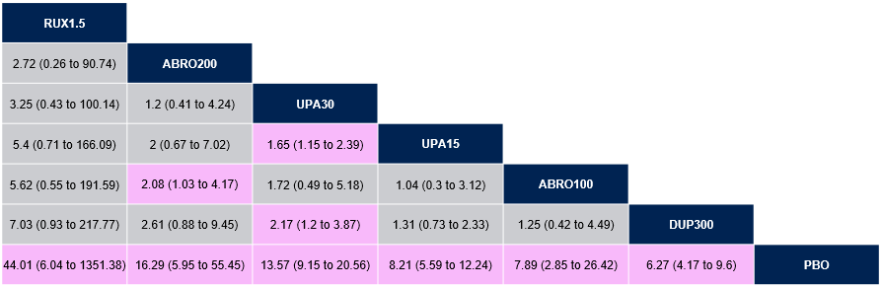
Results are presented as OR and associated 95% CrI. Pink cells indicate results where one treatment is statistically significantly favored over the other.
ABRO, abrocitinib; AD, atopic dermatitis; CrI, credible interval; DUP, dupilumab; EASI, Eczema Area and Severity Index; NMA, network meta-analysis; OR, odds ratio; PBO, placebo; RUX, ruxolitinib cream; UPA, upadacitinib.

Supplementary Material Table 7 Main analysis Bayesian NMA results for Itch NRS4, systemic-eligible moderate AD subgroup
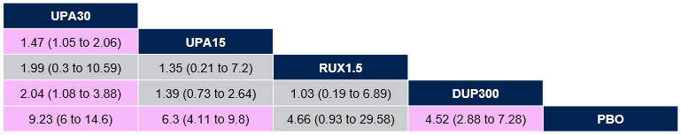
Results are presented as OR and associated 95% CrI. Pink cells indicate results where one treatment is statistically significantly favored over the other.
AD, atopic dermatitis; CrI, credible interval; DUP, dupilumab; NMA, network meta-analysis; NRS, Numerical Rating Scale; OR, odds ratio; PBO, placebo; RUX, ruxolitinib cream; UPA, upadacitinib.

Sensitivity Analyses
Sensitivity Analysis 1 included LIBERTY AD ADOL, a trial which only included adolescent patients. Sensitivity Analysis 2 assessed the main analysis with pooled doses for upadacitinib (pooled 15 mg and 30 mg) and abrocitinib (pooled 100 mg and 200 mg). The results of the sensitivity analyses were consistent with the main analysis, in that 1.5% ruxolitinib cream was similar or better compared with all other treatments for all outcomes in the systemic-eligible moderate AD subgroup.
Supplementary Material Table 8 Sensitivity analysis 1 - frequentist NMA results – IGA 0/1
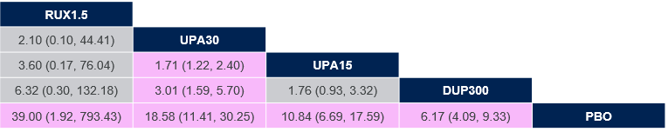
Results are presented as OR and associated 95% CI. Pink cells indicate results where one treatment is statistically significantly favored over the other.
CI, confidence interval; DUP, dupilumab; IGA, Investigator Global Assessment; NMA, network meta-analysis; OR, odds ratio; PBO, placebo; RUX, ruxolitinib cream; UPA, upadacitinib.
Supplementary Material Table 9 Sensitivity analysis 1 - frequentist NMA results – EASI-75
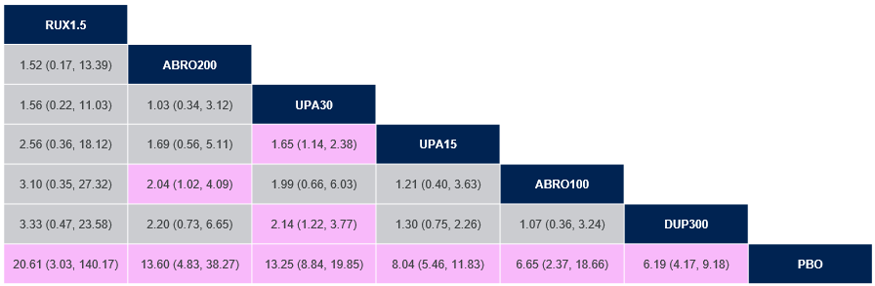
Results are presented as OR and associated 95% CI. Pink cells indicate results where one treatment is statistically significantly favored over the other.
ABRO, abrocitinib; CI, confidence interval; DUP, dupilumab; EASI, Eczema Area and Severity Index; NMA, network meta-analysis; PBO, placebo; OR, odds ratio; RUX, ruxolitinib cream; UPA, upadacitinib.
Supplementary Material Table 10 Sensitivity analysis 1 - frequentist NMA results – Itch NRS4
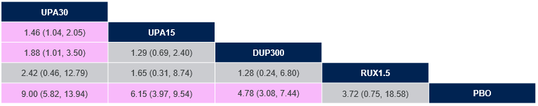
Results are presented as OR and associated 95% CI. Pink cells indicate results where one treatment is statistically significantly favored over the other.
CI, confidence interval; DUP, dupilumab; NMA, network meta-analysis; NRS, Numerical Rating Scale; OR, odds ratio; PBO, placebo; RUX, ruxolitinib cream; UPA, upadacitinib.
Supplementary Material Table 11 Sensitivity analysis 1 - Bayesian NMA results – EASI-75
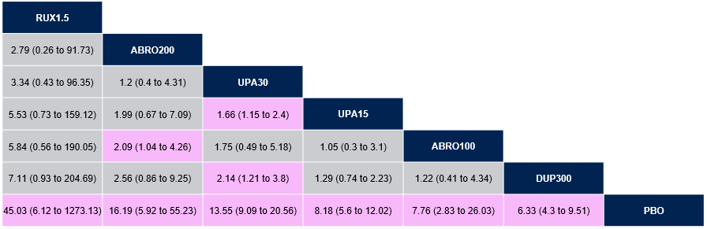
Results are presented as OR and associated 95% CrI. Pink cells indicate results where one treatment is statistically significantly favored over the other.
ABRO, abrocitinib; CrI, credible interval; DUP, dupilumab; EASI, Eczema Area and Severity Index; NMA, network meta-analysis; OR, odds ratio; PBO, placebo; RUX, ruxolitinib cream; UPA, upadacitinib.
Supplementary Material Table 12 Sensitivity analysis 1 - Bayesian NMA results – Itch NRS4
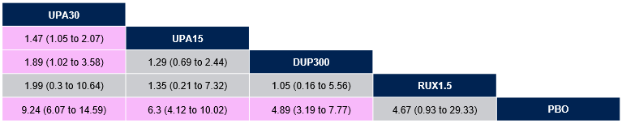
Results are presented as OR and associated 95% CrI. Pink cells indicate results where one treatment is statistically significantly favored over the other.
CrI, credible interval; DUP, dupilumab; NMA, network meta-analysis; NRS, Numerical Rating Scale; OR, odds ratio; PBO, placebo; RUX, ruxolitinib cream; UPA, upadacitinib.
Supplementary Material Table 13 Sensitivity analysis 2 - frequentist NMA results – IGA 0/1

Results are presented as OR and associated 95% CI. Pink cells indicate results where one treatment is statistically significantly favored over the other.
CI, confidence interval; DUP, dupilumab; IGA, Investigator Global Assessment; NMA, network meta-analysis; OR, odds ratio; PBO, placebo; RUX, ruxolitinib cream; UPA, upadacitinib.
Supplementary Material Table 14 Sensitivity analysis 2 - frequentist NMA results – EASI-75
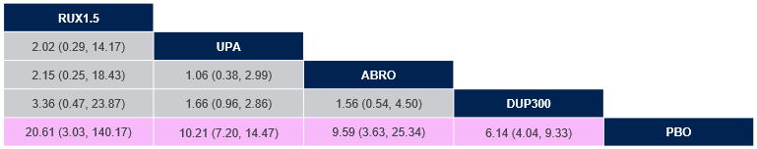
Results are presented as OR and associated 95% CI. Pink cells indicate results where one treatment is statistically significantly favored over the other.
ABRO, abrocitinib; CI, confidence interval; DUP, dupilumab; EASI, Eczema Area and Severity Index; NMA, network meta-analysis; PBO, placebo; OR, odds ratio; RUX, ruxolitinib cream; UPA, upadacitinib.
Supplementary Material Table 15 Sensitivity analysis 2 - frequentist NMA results – Itch NRS4
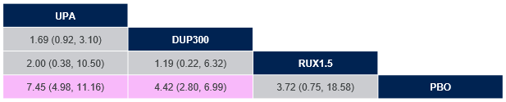
Results are presented as OR and associated 95% CI. Pink cells indicate results where one treatment is statistically significantly favored over the other.
CI, confidence interval; DUP, dupilumab; NMA, network meta-analysis; NRS, Numerical Rating Scale; OR, odds ratio; PBO, placebo; RUX, ruxolitinib cream; UPA, upadacitinib.
Supplementary Material Table 16 Sensitivity analysis 2 - Bayesian NMA results – EASI-75
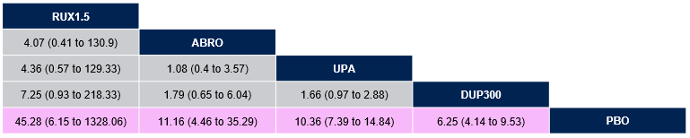
Results are presented as OR and associated 95% CrI. Pink cells indicate results where one treatment is statistically significantly favored over the other.
ABRO, abrocitinib; CrI, credible interval; DUP, dupilumab; EASI, Eczema Area and Severity Index; NMA, network meta-analysis; OR, odds ratio; PBO, placebo; RUX, ruxolitinib cream; UPA, upadacitinib.
Supplementary Material Table 17 Sensitivity analysis 2 - Bayesian NMA results – Itch NRS4
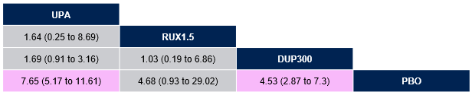
Results are presented as OR and associated 95% CrI. Pink cells indicate results where one treatment is statistically significantly favored over the other.
CrI, credible interval; DUP, dupilumab; NMA, network meta-analysis; NRS, Numerical Rating Scale; OR, odds ratio; PBO, placebo; RUX, ruxolitinib cream; UPA, upadacitinib.

Supplementary Material Table 18 Patient numbers and outcomes assessed, systemic-eligible moderate AD subgroup
Study Name | Treatment Arm | Timepoint | EASI-75 |  | IGA 0/1 |  | Itch NRS4
Study Name | Treatment Arm | Timepoint | N | n (%) | N | n (%) | N | n (%)
TRuE-AD  Pooled  Subgroup: IGA 3, BSA ≥ 10% and EASI ≥ 16 at baseline | 1.5% RUX | Week 8 | 32 | 23 (71.9) | 32 | 19 (59.4) | 18 | 11 (61.1)
 | Vehicle | Week 8 | 13 | 1 (7.7) | 13 | 0 (0) | 11 | 3 (27.3)
LIBERTY AD ADOL  Subgroup: IGA 3 | DUP | Week 16 | 39 | 17 (43.6) | 39 | 12 (30.8) | 39 | 11 (28.2)
LIBERTY AD ADOL  Subgroup: IGA 3 | Placebo | Week 16 | 39 | 4 (10.3) | 39 | 1 (2.6) | 39 | 1 (2.6)
SOLO 1/2  Subgroup: IGA 3 | DUP | Week 16 | 234 | (59) | 234 | 116 (49.6) | 234 | 95 (40.6)
SOLO 1/2  Subgroup: IGA 3 | Placebo | Week 16 | 234 | (18.8) | 234 | 33 (14.1) | 234 | 31 (13.2)
JADE MONO-1  Subgroup: EASI 16-25 | ABRO 100 | Week 12 | 65 | 33 (50.8) | NA | NA | NA | NA
JADE MONO-1  Subgroup: EASI 16-25 | ABRO 200 | Week 12 | 72 | 49 (68.1) | NA | NA | NA | NA
JADE MONO-1  Subgroup: EASI 16-25 | Placebo | Week 12 | 40 | 5 (12.5) | NA | NA | NA | NA
Zhao  Subgroup: IGA 3 | DUP | Week 16 | NA | NA | 35 | 11 (31.4) | NA | NA
Zhao  Subgroup: IGA 3 | Placebo | Week 16 | NA | NA | 37 | 3 (8.1) | NA | NA
Measure Up 1 & Measure Up 2  Subgroup: v-IGA = 3 | UPA 15 | Week 16 | 280 | 183/280 (65.4) | 280 | 139/280 (49.6) | 271 | 123/271 (45.4)
Measure Up 1 & Measure Up 2  Subgroup: v-IGA = 3 | UPA 30 | Week 16 | 280 | 212/280 (75.9) | 280 | 176/280 (62.7) | 275 | 151/275 (54.9)
Measure Up 1 & Measure Up 2  Subgroup: v-IGA = 3 | Placebo | Week 16 | 281 | 53/281 (19.0) | 281 | 23/281 (8.1) | 272 | 32/272 (11.8)
ABRO, abrocitinib; AD, atopic dermatitis; BSA, body surface area; DUP, dupilumab; EASI, Eczema Area and Severity Index; IGA, Investigator Global Assessment; NA, not applicable, RUX, ruxolitinib cream; UPA, upadacitinib; v-IGA, validated Investigator’s Global Assessment.

References

1. Goujon C, Viguier M, Staumont-Salle D, et al. Methotrexate versus cyclosporine in adults with moderate-to-severe atopic dermatitis: a phase III randomized noninferiority trial. J Allergy Clin Immunol Pract. 2018; 6(2):562-9.
2. Katoh N, Ohya Y, Murota H, et al. A phase 3 randomized, multicenter, double-blind study to evaluate the safety of upadacitinib in combination with topical corticosteroids in adolescent and adult patients with moderate-to-severe atopic dermatitis in Japan (Rising Up): an interim 24-week analysis. JAAD Int. 2022; 6:27-36.
3. Zhao Y, Wu L, Lu Q, et al. The efficacy and safety of dupilumab in Chinese patients with moderate-to-severe atopic dermatitis: a randomized, double-blind, placebo-controlled study. Br J Dermatol. 2022; 186(4):633-41.
4. Luger TA, Hebert AA, Zaenglein AL, et al. Subgroup analysis of crisaborole for mild-to-moderate atopic dermatitis in children aged 2 to < 18 years. Paediatr Drugs. 2022; 24(2):175-83.

