Long-term safety and efficacy of up to 6 years tralokinumab in patients with moderate-to-severe atopic dermatitis: Final results from ECZTEND
Andrew Blauvelt, MD, MBA¹, H. Chih-ho Hong, MD², Norito Katoh, MD, PhD³, Richard G Langley, MD⁴, Vivian Laquer, MD⁵, Aleksandra Lesiak, MD, PhD⁶, Ketty Peris, MD⁷, Julien Seneschal, MD, PhD⁸, Juan-Francisco Silvestre, MD⁹, Richard B Warren, MBChB, PhD¹⁰, Andreas Wollenberg, MD¹¹, Matthew Zirwas, MD¹², Niels Højsager Bennike, MD, PhD¹³, Farzaneh Safavimanesh, MSc, PhD¹³, Ann-Marie Tindberg, MSc¹³, Kristian Reich, MD¹⁴
¹Blauvelt Consulting, LLC, Annapolis, MD, US. ²Department of Dermatology and Skin Science, University of British Columbia, Vancouver, BC, Canada and Dr. Chih-ho Hong Medical Inc., Surrey, BC, CA. ³North Campus, Kyoto Prefectural University of Medicine Graduate School of Medical Science, Kyoto, Japan. ⁴Dalhousie University, Halifax, NS, CA. ⁵ First OC Dermatology Research, Fountain Valley, CA, US. ⁶ Department of Dermatology, Pediatric Dermatology and Oncology, Laboratory of Autoinflammatory, Genetic and Rare Skin Disorders, Medical University of Lodz, Lodz, Poland. ⁷Dermatologia, Università Cattolica del Sacro Cuore, Rome, Italy. ⁸Department of Dermatology, Hôpital Saint-André, CHU de Bordeaux, Bordeaux, France and Bordeaux University, CNRS, ImmunoConcept, UMR 5164, 33000 Bordeaux, France. ⁹Dermatology Department, Hospital General Universitario Dr Balmis, ISABIAL, Alicante, Spain. ¹⁰Dermatology Centre, Northern Care Alliance NHS Foundation Trust & Division of Musculoskeletal and Dermatological Sciences Manchester Academic Health Science Centre, University of Manchester, Manchester, United Kingdom. ¹¹Department of Dermatology and Allergy, University Hospital Augsburg, Augsburg, Germany; Department of Dermatology and Allergy, Ludwig-Maximilian University, Munich, Germany; and Comprehensive Center for Inflammation Medicine, University of Luebeck, Luebeck, Germany. ¹²Dermatology of the Central States, Bexley, OH, USA; Probity Medical Research, Bexley, OH, USA; and Ohio University, Bexley, OH, USA. ¹³LEO Pharma A/S, Ballerup, DK. ¹⁴Translational Research in Inflammatory Skin Diseases, University Medical Center Hamburg-Eppendorf, Hamburg, DE.

Corresponding Author:
Andrew Blauvelt, M.D., M.B.A.
Blauvelt Consulting, LLC, Annapolis, MD, USA
Email: blauveltconsults@gmail.com

Supplementary material
Key eligibility criteria
Key inclusion criteria:
- Completed the treatment period(s) in ECZTRA 1-8 or TraSki to the satisfaction of the investigator
- Complied with the clinical trial protocol (CTP) in the parent trial to the satisfaction of the investigator
- Able and willing to self-administer tralokinumab treatment at home (or have it administered by a caregiver)
- Stable dose of emollient twice daily (or more, as needed) for at least 14 days before baseline
Key exclusion criteria:
- Any condition requiring permanent discontinuation of investigational medicinal product (IMP) in parent trial
- More than 26 weeksª between last treatment in parent trial and ECZTEND baseline
- Reported any adverse event or serious adverse event related to IMP that in the investigator’s opinion contraindicated continued tralokinumab treatment
ªChanged from 20 weeks to 26 weeks in Amendment 6 (17-Feb-2020)
Sensitivity analysis
To mitigate potential survival bias, missing data due to other reasons than AEs or lack of efficacy were imputed using a 2-step multiple imputation (MI) strategy, where, in step 1, missing data up to the 1st year (week 56 visit) were imputed using a full conditional gaussian regression-based approach adjusting for existed previous visit, existed next visit, parent trial and region. In step 2, missing data after the first year were imputed using a within-subject non-parametric approach, leveraging the proportion of response each subject had achieved. This involved linear interpolation and data transformation into a binary endpoint to estimate the response over time.

Supplementary Tables
Table S1: Overview of AEs in the AESI Eye disorders
 | ECZTEND (up to Week 268)
Tralokinumab
N=1672; PYE=4466.2
 | E | n (%) | IR
All AEs | 260 | 189 (11.3) | 4.59
Severity
Mild | 157 | 120 (7.2) | 2.83
Moderate | 96 | 80 (4.8) | 1.85
Severe | 7 | 7 (0.4) | 0.16
SAEs | 2 | 2 (0.1) | 0.04
Outcome
Recovered/resolved | 198 | 152 (9.1) | 3.63
Not recovered/resolved | 41 | 38 (2.3) | 0.86
AEs leading to permanent discontinuation of trial drug | 8 | 7(0.4) | 0.16

AE = adverse event; AESI = AEs of special interest; E = number of AEs; IR = Incidence rate (n/100PYE), for IR calculations, patient exposure was censored at the time of first event; n = number of patients with ≥1 event; N = number of patients in indicated treatment set; PYE = patient years of exposure; SAE = serious AE.
Table S2: AESI Eye disorder by system organ class and preferred term
 | ECZTEND (up to Week 268)
System organ class  Preferred term | Tralokinumab  N=1672; PYE=4466.2
 | E | n (%) | IR
Infections and infestations | 158 | 120 (7.2) | 2.83
Conjunctivitis | 130 | 102 (6.1) | 2.38
Conjunctivitis bacterial | 15 | 13 (0.8) | 0.29
Conjunctivitis viral | 6 | 6 (0.4) | 0.13
Keratitis viral | 5 | 5 (0.3) | 0.11
Keratitis bacterial | 23 | 1 (0.1) | 0.02
Eye disorders | 102 | 82 (4.9) | 1.90
Conjunctivitis allergic | 78 | 61 (3.6) | 2.40
Atopic keratoconjunctivitis | 13 | 12 (0.7) | 0.27
Keratitis | 5 | 5 (0.3) | 0.11
Noninfective conjunctivitis | 2 | 2 (0.1) | 0.40
Punctate keratitis | 2 | 2 (0.1) | 0.40
Ulcerative keratitis | 2 | 2 (0.1) | 0.40

AE = adverse event; AESI = AEs of special interest; E = number of AEs; IR = Incidence rate (n/100PYE), for IR calculations, patient exposure was censored at the time of first event; n = number of patients with ≥1 event; N = number of patients in indicated treatment set; PYE = patient years of exposure.

Supplementary Figures
Figure S1: Trial design
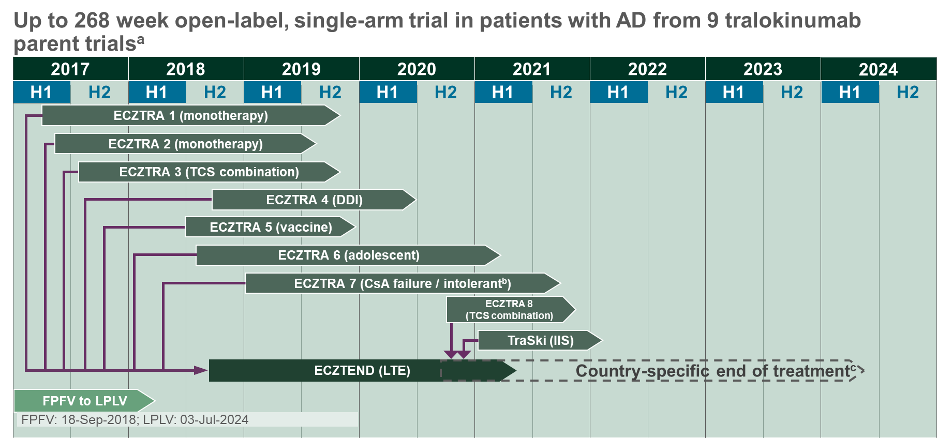
a
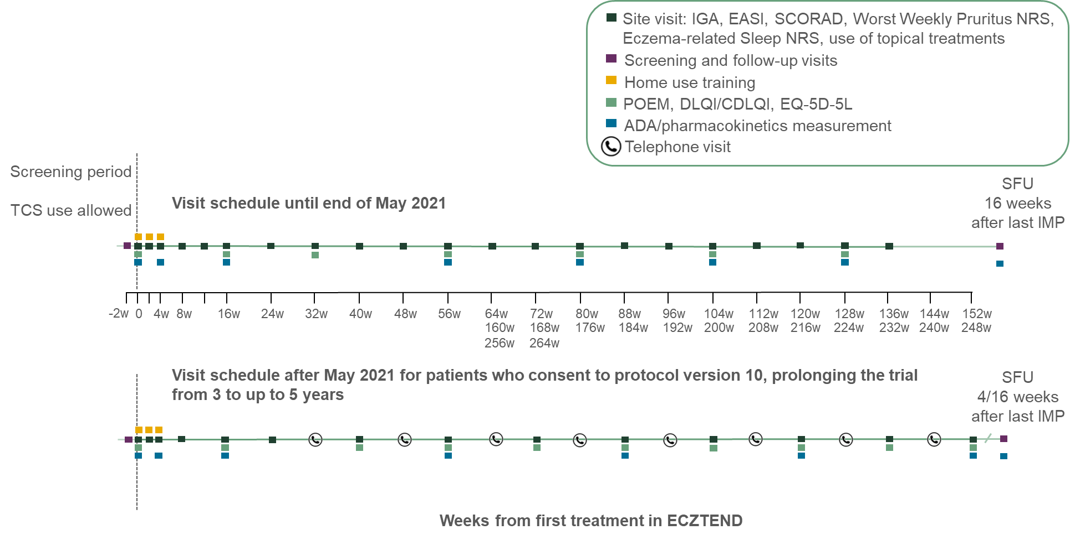
b

ªPrevious treatment regimens in parent trials included tralokinumab Q2W, Q4W, or placebo +/- TCS; ^{b}Study in patients with AD who are not adequately controlled with or have contraindications to oral CsA; ^{c}Protocol amendment in May 2021 prolonged the trial from up to 3 to up to 5 years.
AD, atopic dermatitis; ADA, anti-drug antibodies; CDLQI, Children’s Dermatology Life Quality Index; CsA, cyclosporine; DDI, drug–drug interaction; DLQI, Dermatology Life Quality Index; EASI, Eczema Area and Severity Index; EQ-5D-5L, EuroQol 5 Dimension Health Questionnaire 5-Level; FPFV, first patient first visit; IGA, Investigator Global Assessment; IIS, investigator-initiated study; IMP, investigational medicinal product; LPLV, last patient last visit; LTE, long-term extension; NRS, numeric rating scale; POEM, Patient Oriented Eczema Measure; Q2W, every 2 weeks; Q4W, every 4 weeks; SCORAD, SCOring Atopic Dermatitis; SFU, safety follow-up; TCS, topical corticosteroid; w, weeks.
Figure S2: Time to permanent discontinuation of IMP
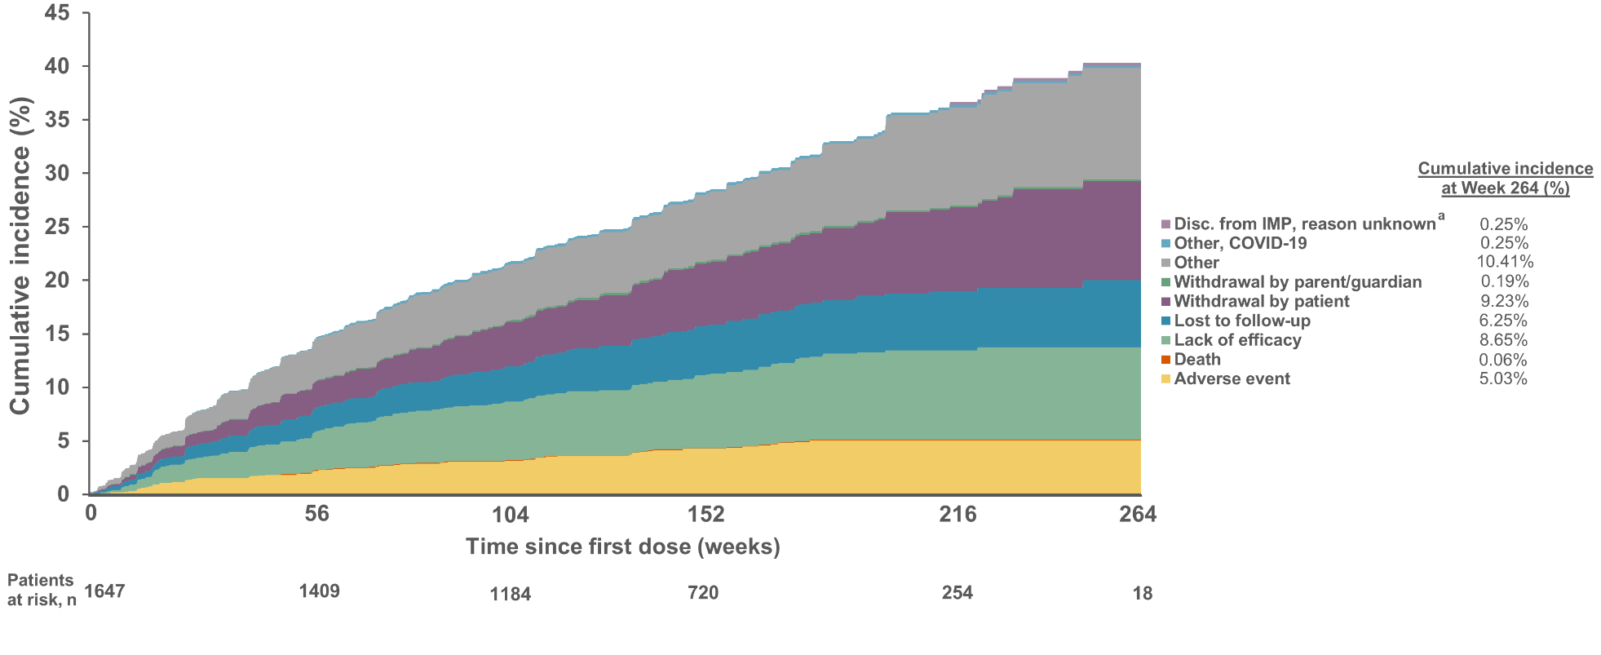
ª25 patients were excluded from the efficacy analysis set. These patients were enrolled at one investigational site that was prematurely closed due to GCP non-compliance. These patients are included in the ‘Discontinuation of IMP, reason unknown’ category.
IMP, investigational medicinal product; n, number of patients with the indicated metric.
Figure S3: EASI ≤7 and ≤3 by visit
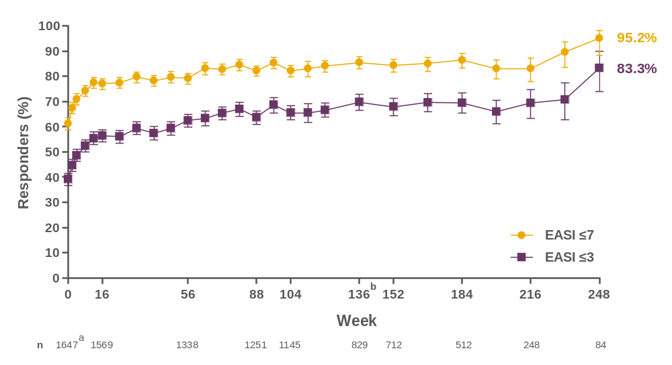
Error bars represent 95% CI; ª25 patients were excluded from the efficacy analysis set. These patients were enrolled at one investigational site that was prematurely closed due to GCP non-compliance. ^{b}Study duration varied based on patients’ consent to the amendment to prolong the study from 3 to 5 years and the country of enrollment.
%, percentage of patients with observation; CI, confidence interval; EASI, Eczema Area and Severity Index; n, number of patients with the indicated metric.
Figure S4: SCORAD score by visit
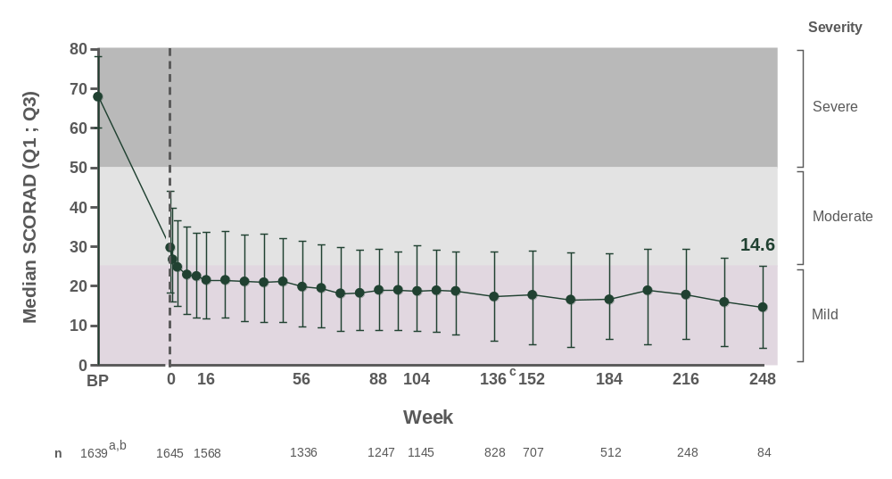
ª25 patients were excluded from the efficacy analysis set. These patients were enrolled at one investigational site that was prematurely closed due to GCP non-compliance. ^{b}Baseline data for the 8 patients included from the investigator-initiated study TRASKI were not transferred to LEO Pharma A/S. ^{c}Study duration varied based on patients’ consent to the amendment to prolong the study from 3 to 5 years and the country of enrollment.
BP, parent trial baseline; n, number of patients with the indicated metric; Q1, 1st quartile (25th percentile); Q3, 3rd quartile (75th percentile); SCORAD, SCORing Atopic Dermatitis.
Figure S5: POEM score by visit
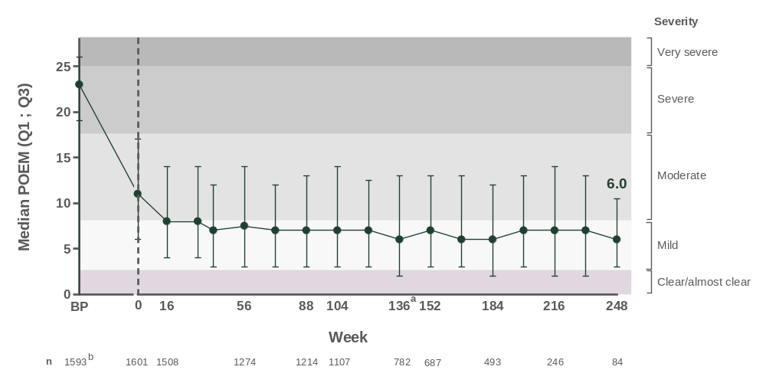
ªStudy duration varied based on patients’ consent to the amendment to prolong the study from 3 to 5 years and the country of enrollment. ^{b}Patients with available data capture in parent trial.
BP, parent trial baseline; n, number of patients with the indicated metric; POEM, Patient Oriented Eczema Measure; Q1, 1st quartile (25th percentile); Q3, 3rd quartile (75th percentile).
Figure S6: Worst weekly pruritus NRS by visit
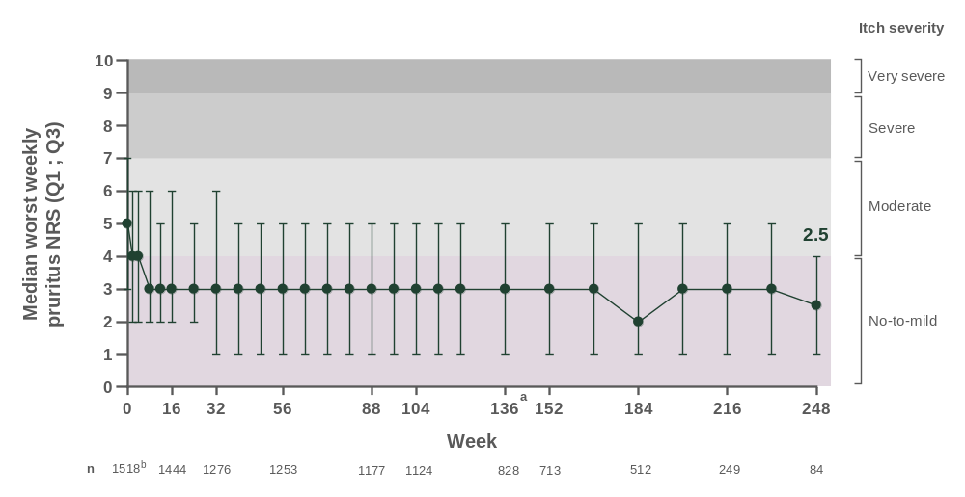
ªStudy duration varied based on patients’ consent to the amendment to prolong the study from 3 to 5 years and the country of enrollment. ^{b}Adult patients only.
CI, confidence interval; n, number of patients with the indicated metric; NRS, numeric rating scale; Q1, 1st quartile (25th percentile); Q3, 3rd quartile (75th percentile).
Figure S7: Eczema-related weekly sleep NRS by visit
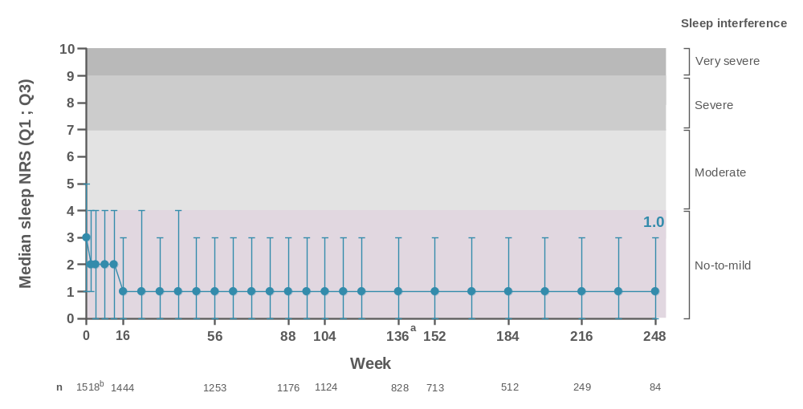
ªStudy duration varied based on patients’ consent to the amendment to prolong the study from 3 to 5 years and the country of enrollment. ^{b}Adult patients only.
CI, confidence interval; n, number of patients with the indicated metric; NRS, numeric rating scale; Q1, 1st quartile (25th percentile); Q3, 3rd quartile (75th percentile).
Figure S8: DLQI by visit
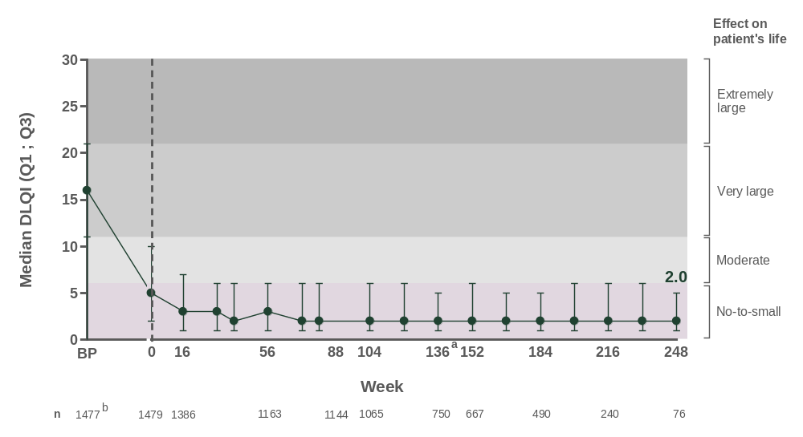
ªStudy duration varied based on patients’ consent to the amendment to prolong the study from 3 to 5 years and the country of enrollment. ^{b}Adult patients only.
BP, parent trial baseline; DLQI, Dermatology Life Quality Index; n, number of patients with the indicated metric; Q1, 1st quartile (25th percentile); Q3, 3rd quartile (75th percentile).
Figure S9: Worst weekly pruritus NRS ≤4 and sleep NRS ≤4 by visit
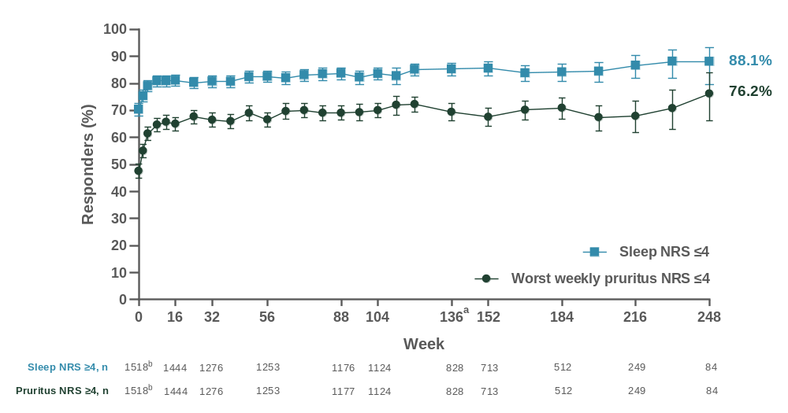
Error bars represent 95% CI.
ªStudy duration varied based on patients’ consent to the amendment to prolong the study from 3 to 5 years and the country of enrollment. ^{b}Adult patients only.
%, percentage of patients with observation; CI, confidence interval; n, number of patients with the indicated metric; NRS, numeric rating scale.
Figure S10: DLQI ≤5 by visit
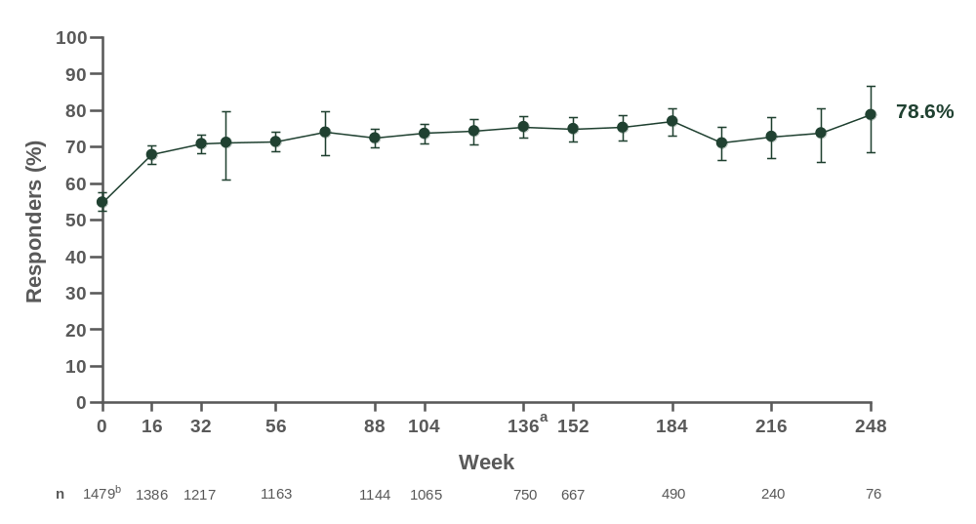
Error bars represent 95% CI.
ªStudy duration varied based on patients’ consent to the amendment to prolong the study from 3 to 5 years and the country of enrollment. ^{b}Adult patients only.
%, percentage of patients with observation; CI, confidence interval; DLQI, Dermatology Life Quality Index; n, number of patients with the indicated metric.

Appendix: ECZTEND independent ethics committee (IEC) / institutional review board (IRB) committee and trial investigators
IEC/IRB Committee Chair and Name of Committee | Investigator / Site
Belgium
Ethics Committee  Vice Chairman: Prof. Dr. D.  Michielsen  Clinical Trial Centre – Commissie Medische Ethiek  Universitair Ziekenhuis Brussel  Grote Prefab, Niv 1  Laarbeeklaan 101  1090 Brussel | Dr. Arjen Nikkels (850-1013)  Centre Hospitalier Universitaire de Liège  Domaine du Sart Tilman B35  Avenue de l'Hôpital, 1  4000 Liege
Dr. Pierre-Dominique Ghislain (852-1014)
Cliniques Universitaires St-Luc
Avenue Hippocrate, 10, Route 413
1200 Brussels
Dr. Jan Gutermuth (853-1025)
UZ Brussel
Laarbeeklaan 101
1090 Brussels
Dr. Pierre-Paul Roquet-Gravy (854-1149)
Grand Hopital de Charleroi
Rue de Villers 1
6280 Loverval
Dr. Julien Lambert (855-1037)
University Hospital Antwerp
Wilrijkstraat 10
2650 Edegem
Dr. Hilde Lapeere (856-1208)
UZ Gent
Corneel Heymanslaan, 10
Vijverpark - ground floor, entrance 52
9000 Gent
Dr. Valérie Failla (857-1209)
Clinique André Renard
Rue André Renard, 1
Red line - Level +4
4040 Herstal

IEC/IRB Committee Chair and Name of Committee | Investigator / Site
Dr. Sven Lanssens (858-1377)
Dermatologie Maldegem
Brugse Steenweg 181A
9990 Maldegem
Dr. Bernard Kint (859-1388)
AZ Sint Lucas
Groenebriel 1
9000 Gent
Dr. Tom Hillary (860-1389)
UZ Leuven
Campus Gasthuisberg
Herestraat 49
3000 Leuven
Dr. Erwin Suys (861-1407)
Dermatologie Handelskaai
Handelskaai 1g
8500 Kortrijk
Canada
Neil Malhotra, Chair  Research Review Board, Inc.  55 Northfield Drive East  Suite 303  Waterloo, Ontario  Canada N2K 3T6 | Darryl Toth, 300-0377  XLR8 Medical Research  2425 Tecumseh Road East  Suite 210  Windsor, Ontario, N8W 1E6
Same IRB as Site 300-0377 | Chih-ho Hong, 301-0505  Dr. Chih-ho Hong Medical Inc.  15300 105th Avenue  Suite 20  Surrey, British Columbia, V3R 6A7
Same IRB as Site 300-0377 | Mark Lomaga, 302-0555  DermEdge Research  755 Queensway East  Suite 107  Mississauga, Ontario. L4Y 4C5

IEC/IRB Committee Chair and Name of Committee | Investigator / Site
Same IRB as Site 300-0377 | Julien Ringuet, 303-0072  Yves Poulin (end-date 10May2021)  Centre de Recherche Dermatologique du Quebec Metropolitain  2880 Chemin Quatre-Bourgeois  Suite 105  Quebec, Quebec, G1V 4X7
Same IRB as Site 300-0377 | David Gratton, 304-0820  Dr. David Gratton Dermatologue Inc.  3550 Cote des Neiges  Suite 740  Montreal, Quebec, H3H 1V4
Same IRB as Site 300-0377 | Kim Papp, 305-0162  K. Papp Cinical Research  135 Union Street East  Waterloo, Ontario, N2J 1C4
Same IRB as Site 300-0377 | Melinda Gooderham, 306-0006  Skin Centre for Dermatology  775 Monaghan Road  Peterborough, Ontario, K9J 5K2
Same IRB as Site 300-0377 | Les Rosoph, 307-0606  North Bay Dermatology Centre  500 Cassells Street  North Bay, Ontario, P1B3Z7
Same IRB as Site 300-0377 | Jill Keddy-Grant, 308-0005  Winnipeg Clinic Dermatology Research  425 St. Mary Avenue  2nd floor, Reception Desk  Winnipeg, Manitoba, R3C 0N2
Same IRB as Site 300-0377 | Irina Turchin, 309-0554  Dr. Irina Turchin PC Inc.  204 Brunswick Street  Fredericton, New Brunswick, E3B 1G9
Same IRB as Site 300-0377 | Charles Lynde, 310-0007  Lynderm Research Inc.  25 Main Street Markham North  Markham, Ontario, L3P 1X3

IEC/IRB Committee Chair and Name of Committee | Investigator / Site
Chris MacKnight, Executive Chair  Nova Scotia Health Research Ethics Board  Center for Clinical Research  Room 121  5790 University Avenue  Halifax, Nova Scotia  Canada B3H 1V7 | Richard Langley, 311-0286  Dalhousie University & Nova Scotia Health  Authority  6054 Coburg Road  Halifax, Nova Scotia, B3H 1Z2
Same IRB as Site 300-0377 | Jason Rivers, 312-0937  Pacific Dermaesthetics  200 - 2425 Hemlock Street  Vancouver, British Columbia, V6H 4E1
Same IRB as Site 300-0377 | Lyn Guenther, 313-0013  The Guenther Dermatology Research Centre  835 Richmond Street  London, Ontario, N6A 3H7
Same IRB as Site 300-0377 | Elena Poulos, 314-0823  Kingsway Clinical Research  1243 Islington Avenue  Suite 1000  Etobicoke, Ontario, M8X 1Y9
Same IRB as Site 300-0377 | Michael Robern, 315-1072  Dermatology Clinic of Dr. Michael Robern  885 Meadowlands Drive East  Suite 402  Ottawa, Ontario, K2C 3N2
Lindsay Nicolle, MD, FRCPC, Chair  University of Manitoba  Bannatyne Campus Research Ethics Boards  Biomedical Research Ethics Board (BREB)  P126-770 Bannatyne Avenue  Winnipeg, Manitoba  Canada R3E 0W3 | Marni Wiseman, 316-0788  Wiseman Dermatology Research Inc.  6-1170 Taylor Avenue  Winnipeg, Manitoba, R3M 3Z4
Same IRB as Site 300-0377 | Lorne Albrecht, 317-0161  Dr. Lorne E. Albrecht Inc.  13737 96th Avenue  Suite 603  Surrey, British Columbia, V3V 0C6

IEC/IRB Committee Chair and Name of Committee | Investigator / Site
Same IRB as Site 300-0377 | Mani Raman, 318-0011  The Centre for Dermatology and Cosmetic Surgery  312 Highway #7 East  Richmond Hill, Ontario, L4B 1A5
Same IRB as Site 300-0377 | David Adam, 319-0283  CCA Medical Research  95 Bayly Street West  Suite G-02  Ajax, Ontario, L1S 7K8
Same IRB as Site 300-0377 | France Lepage, 320-0159  Maritime Medical Research Centre  950 Picot Ave.  Bathurst, New Brunswick, E2A 4Z9
Same IRB as Site 300-0377 | Afsaneh Alavi, 321-0818  York Dermatology Center  250 Harding Blvd. West  Suite 401  Richmond Hill, Ontario, L4C 9M7
Same IRB as Site 300-0377 | Sameh Hanna, 322-0757  Research Toronto  34 Park Road  Toronto, Ontario, M4W 2N2
Lindsay Nicolle, MD, FRCPC, Chair  University of Manitoba  Bannatyne Campus Research Ethics Boards  Biomedical Research Ethics Board (BREB)  P126-770 Bannatyne Avenue  Winnipeg, Manitoba  Canada R3E 0W3 | Sunil Kalia, 324-0076  Skin Care Centre  113-835 West 10th Avenue  Vancouver, British Columbia, V5Z 4E8
Jacqueline Senych, HREBA Director  Peter Venner, HREBA-CTC  Health Research Ethics Board of Alberta  Clinical Trials Committee  1500, 10104 - 103 Avenue NW  Edmonton, Alberta  Canada T5J 0H8 | Andrei Metelitsa, 325-0292  Beacon Dermatology  3110-17 Avenue SW  Suite 201  Calgary, Alberta, T3E 0B2

IEC/IRB Committee Chair and Name of Committee | Investigator / Site
Same IRB as Site 300-0377 | Gordon Sussman, 326-1107  Gordon Sussman Clinical Research Inc.  240 Duncan Mill Rd  Suite 703  Toronto, Ontario, M3B 3S6
Same IRB as Site 300-0377 | Jason Ohayon, 327-1142  Hamilton Allergy Clinic  201-1685 Main Street West  Hamilton, Ontario, L8S 1G5
Same IRB as Site 300-0377 | Wei Jing Loo, 328-1085  DermEffects  1560 Hyde Park Road  London, Ontario, N6H 5L5
Same IRB as Site 300-0377 | Joel Liem, 329-1147  Joel Liem Medicine Professional Corporaton  1407 Ottawa Street  Windsor, Ontario, N8X 2G1
Same IRB as Site 300-0377 | Sheetal Sapra, 330-0278  The Centre for Clinical Trials Inc.  1344 Cornwall Rd.  Suite 100  Oakville, Ontario, L6J 7W5
Same IRB as Site 300-0377 | Simon Nigen, 331-1088  Recherche Sima  55 rue de l’Eglise  Bureau 47  Verdun, Quebec, H4G 3E7
Same IRB as Site 325-0292 | Jaggi Rao, 332-1086  Alberta DermaSurgery Centre  United Health Centres - 3rd Floor  7609-109 Street NW, Unit 300  Edmonton, Alberta, T6G 1C3

IEC/IRB Committee Chair and Name of Committee | Investigator / Site
Craig Pochini, Co-Chair, Clinical Trials  Newfoundland and Labrador Health  Research Ethics Board  Suite 200, Eastern Trust Building  95 Bonaventure Avenue  St. John’s, Newfoundland  Canada A1B 2X5 | Kamal Ohson, 333-1089  Karma Clinical Trials Inc.  63 Airport Road  St-John's, Newfoundland and Labrador, A1A 4Y3
Same IRB as Site 325-0292 | Parbeer Grewal, 334-0077  Stratica Medical Inc.  10140-117 Street  Suite 200  Edmonton, Alberta, T5K 1X3
Donald W. Morrish, MD, PhD, FRCPC  Associate Chair  Health Research Ethics Board –  Biomedical Panel  University of Alberta North Campus  2-01 North Power Plant  11312 - 89 Avenue NW  Edmonton, Alberta  Canada T6G 2N2 | Loretta Fiorillo, 336-1093  Stollery Children's Hospital  8440 112 Street  Edmonton, Alberta, T6G 2B7
Same IRB as Site 325-0292 | Vimal Prajapati, 337-0292  Dermatology Research Institute Inc.  8500 Blackfoot Trail SE  Suite 310  Calgary, Alberta, T2J 7E1
Same IRB as Site 300-0377 | Davindra Singh, 338-1094  AvantDerm  45 Mill Street  Toronto, Ontario, M5A 3R6
Same IRB as Site 300-0377 | Kirsten Walker, 339-1096  Angela Law (end-date 04Jan2021)  Skinsense Medical Research  411 2nd Ave North  Suite 2  Saskatoon, Saskatchewan, S7K 2C1

IEC/IRB Committee Chair and Name of Committee | Investigator / Site
Czech Republic
Ethics Committee  Chairman: Prof. MUDr. Jan Pachl, CSc.  FN Královské Vinohrady  Šrobárova 1150/50  Budova Q - 1. patro  Praha 10, 100 34 | Dr. Petr Arenberger (600-1378)  Sanatorium profesora Arenbergera  Bolzanova 7  110 00 Prague 1
Ethics Committee  Chairman: Prof. MUDr. Jan Pachl, CSc.  FN Královské Vinohrady  Šrobárova 1150/50  Budova Q - 1. patro  Praha 10, 100 34 | Dr. Jaroslava Vaneckova (601-1384)  CCR Czech a.s.  Trida miru, 2800x  530 02 Pardubice
Ethics Committee  Chairman: MUDr. Jaroslav Žák  Karlovarské krajské nemocnice a.s.  Bezručova 1190/19  360 01 Karlovy Vary | Dr. Tomas Pospisil (602-1382)  Karlovarska krajska nemocnice a.s.  Karlovy Vary Hospital,Bezručova 1190/19  Kozni oddeleni  360 01 Karlovy Vary
Ethics Committee  Chairman: doc. MUDr. Karol Zeleník, Ph.D., MBA  Etická komise (EK) Fakultní nemocnice (FN) Ostrava  17. listopadu 1790/5  708 52 Ostrava-Poruba | Dr. Yvetta Vantuchova (603-1380)  Fakultni nemocnice Ostrava  17.listopadu 1790/5  Kozni oddeleni  708 52 Ostrava-Poruba
Ethics Committee  Chairman: JUDr. Jaroslav Hofman  Etická komise NZZ CLINTRIAL, s.r.o.  CLINTRIAL s.r.o.  Počernická 1427/16,  100 00 Praha 10 | Dr. Otakar Komarek (604-1412)  Clintrial s.r.o.  Počernická 16  100 00 Prague 10
Ethics Committee  Chairman: MUDr. Jiří Vortel  Etická komise  FN Hradec Králové  Sokolská 581  500 05 Hradec Králové - Nový Hradec Králové | Dr. Lucie Petru (605-1413)  Kozni ambulance Kutna Hora s.r.o.  Kpt. Vosky 781  284 01 Kutna Hora
IEC/IRB Committee Chair and Name of Committee | Investigator / Site
France
Ethics Committee  Chairman: Sabine De la Porte  Comité de Protection des Personnes Ile de France XI  UVSQ-UFR Simone Veil  2 Av de la Source de la Bièvre  78180 Montigny-le-Bretonneux  France  Previous address:  Pavillon Jacques Courtois – 2ème étage, 20, rue Armagis  78105 Saint Germain en Laye Cedex | Dr. Med. Mireille Ruer Mulard (670-0029)  Cabinet médical du Dr RUER  Le Bateau Blanc-Immeuble A, 1er étage  26 Chemin de Paradis  13500 Martigues  Bouches-du-Rhône
Dr. Med. Jean-Luc Perrot (671-0028)
Hôpital Nord
Service de Dermatologie
42000 Saint-Etienne
Loire
Dr. Med. Philippe Modiano (672-0299)
Hôpital Saint Vincent de Paul
Boulevard de Belfort BP 387
59020 Lille Nord
Dr. Med. Thomas Hubiche (673-0025)
Dr. Med. Jean Philippe Lacour
(end-date 03Sep2021)
CHU de Nice
Hôpital de l'Archet II
Service de Dermatologie-Vénérologie
151, Route Saint Antoine de Ginestière
06202 Nice, Alpes-Maritimes
Dr. Med. Julien Seneschal (674-0080)
Hopital Saint-André
Service de Dermatologie, Unité 16 – 1e Etage1, rue Jean Burguet
33 075 Bordeaux Gironde 5
Dr. Med. Carle Paul (676-0382)
CHU de Toulouse - Hopital Larrey
Service de Dermatologie
24 Chemin de Pouvourville - TSA 30030
31059 Toulouse Haute-Garonne

IEC/IRB Committee Chair and Name of Committee | Investigator / Site
Dr. Med. Joann Le Borgne (677-0620)
Dr. Anne-Laure Liegeon
(end-date 23Oct2020)
Dr. François Skowron (end-date 15May2020)
Centre Hospitalier de Valence
Service de Dermatologie
179 Boulevard Maréchal Juin
26000 Valence Drôme
Dr. Med. Evelyne Collet (678-0730)
CHU de Dijon
14 Rue Paul Gaffarel
21079 Dijon Côte-d'Or
Dr. Med. Gatherine Michel (681-0836)
Groupe Hospitalier Région Mulhouse et Sud Alsace
20 Avenue du Dr René Laennec
68100 Mulhouse Haut-Rhin
Dr. med. Anne-Benedicte Duval-Modeste
(682-0837)
Hopital Charles Nicolle
1 rue de Germont
76031 Rouen Seine-Maritime 10
Dr. Med. Delphine Staumont-Sallé (683-0052)
Hôpital Claude Huriez
Clinique de Dermatologie
1 rue Michel Polonovski
59000 Lille Nord
Dr. Med. Audrey Nosbaum (684-0449)
Centre Hopitalier Lyon Sud
165 Chemin Grand Revoyet
Pavillon 1K-Bâtiment 5 F
69495 Pierre-Bénite Rhône

IEC/IRB Committee Chair and Name of Committee | Investigator / Site
Dr. med. Julie Charles (685-0051)
CHU Michallon
Entrée Côté Belledonne-11ème étage
Boulevard de la Chantourne
38000 Grenoble Isère
Dr. Med. Jean David Bouaziz (686-1237)
Hopital Saint Louis
Accueil principal, RDC
1, Avenue Claude Vellefaux
75010 Paris
Dr. Med. Nathalie Quiles-Tsimaratos
(687-0453)
Hôpital Saint-Joseph
Service de Dermatologie
26 Boulevard de Louvain
13285 Marseille Bouches-du-Rhône
Germany
Ethics Committee  Chairman: Prof. Dr. med. Kurt Racké  Ethikkommission an der Medizinischen Fakultät der Rheinischen Friedrich-Wilhelms-Universität Bonn  Venusberg Campus 1  Geb. 02 (Auenbruggerhaus)  53127 Bonn | Dr. med. Laura Maintz (900-0166)  Dr. Galina Balakirski (end-date 28May2021)  Dr. Hans-Jürgen Kammler (end-date 15Jul2019)  Universitätsklinikum Bonn  Studienzentrum Dermatologie  Venusberg-Campus 1  53127 Bonn
Ethics Committee  Chairman: Herr PD Dr. med. H. Theilen  Ethikkommission  Technische Universität Dresden  Fetscherstraße 74  01307 Dresden | Prof. Dr. med. Stefan Beissert (901-0033)  Universitätsklinikum  Carl Gustav Carus  Klinik und Poliklinik für Dermatologie  Fetscherstraße 74  01307 Dresden

IEC/IRB Committee Chair and Name of Committee | Investigator / Site
Ethics Committee  Chairman: Univ.-Prof. Dr. med.  Wolfgang E. Berdel  Ethikkommission der Ärztekammer Westfalen-Lippe und der Westfälischen Wilhelms-Universität Münster  Gartenstr. 210 - 214  48147 Münster | Dr. med. Rolf Dominicus (902-0837)  Hautzentrum Dülmen  Vollenstraße 8  48249 Dülmen
Ethics Committee  Chairman: Univ.-Prof. Dr. med.  Wolfgang E. Berdel  Ethikkommission der Ärztekammer Westfalen-Lippe und der Westfälischen Wilhelms-Universität Münster  Gartenstr. 210 - 214  48147 Münster | Prof. Dr. med. Isaak Effendy (903-0686)  Klinikum Bielefeld Rosenhöhe, Hautklinik  An der Rosenhöhe 27  33647 Bielefeld
Ethics Committee  Chairman: Prof. Dr. med. Rolf Stahl  Ärztekammer Hamburg  Ethikkommission  Weidestraße 122 b  22083 Hamburg | Dr. med. Swarna Ekanayake-Bohlig (904-0225)  MENSINGDERMA  Heegbarg 4  22391 Hamburg
Ethics Committee  Chairman: Prof. Dr. rer. nat.  Hans-Joachim Trampisch  Ethikkommission der medizinischen Fakultät der Ruhr-Universität-Bochum  Gesundheitscampus 33  44801 Bochum | Prof. Dr. med. Thilo Gambichler (905-0041)  Ruhr-University of Bochum  Department of Dermatology  Gudrunstr. 56  44791 Bochum
Ethics Committee  Chairman: Prof. Dr. med. Andreas Creutzig  Ethikkommission bei der Ärztekammer Niedersachsen  Karl-Wiechert-Allee 18-22  30625 Hannover | Dr. med. Markus Kaspari (906-0046)  Hautärzte Zentrum Hannover  Osterstrasse 24  30159 Hannover

IEC/IRB Committee Chair and Name of Committee | Investigator / Site
Ethics Committee  Chairman: Univ.-Prof. Dr. med.  Wolfgang E. Berdel  Ethikkommission der Ärztekammer Westfalen-Lippe und der Westfälischen Wilhelms-Universität Münster  Gartenstr. 210 - 214  48147 Münster | Dr. med. Nina Magnolo (907-0228)  Universitätsklinikum Münster  Klinik und Poliklinik für Hautkrankheiten  Zentrale Studienkoordination für innovative  Dermatologie  Von-Esmarch-Strasse 58  48149 Münster
Ethics Committee  Chairman: Univ.-Prof. Dr. med.  Wolfgang E. Berdel  Ethikkommission der Ärztekammer Westfalen-Lippe und der Westfälischen Wilhelms-Universität Münster  Gartenstr. 210 - 214  48147 Münster | Dr. med. Johannes Niesmann (908-2760)  DR. NIESMANN & DR. OTHLINGHAUS Ihre Hautärzte im Jahrhunderthaus  Alleestr. 80  44793 Bochum
Ethics Committee  Chairman: Prof. Dr. med. Andreas Creutzig  Ethikkommission bei der Ärztekammer Niedersachsen  Karl-Wiechert-Allee 18-22  30625 Hannover | Dr. med. Sylvia Pauser (909-0486)  KLIFOs Klinische Forschung Osnabrück  Hakenstr. 1  49074 Osnabrück
Ethics Committee  Chairman: Prof. Dr. med. Sebastian Harder  Ethikkommission des Fachbereichs Medizin der Johann-Wolfgang-Goethe-Universität – Haus 1  Theodor-Stern-Kai 7  60590 Frankfurt am Main | Dr. med. A. Pinter (910-0014)  Universitätsklinikum Frankfurt  Klinik für Dermatologie, Venerologie  und Allergologie  Klinische Forschung  Theodor-Stern-Kai 7  60590 Frankfurt am Main
Ethics Committee  Chairman: Prof. Dr. med. Gerlinde Egerer  Ethikkommission bei der  Landesärztekammer  Baden-Württemberg  Liebknechtstrasse 33  70565 Stuttgart | Dr. med. Peter Radny (912-0751)  Derma-Study-Center  Friedrichshafen GmbH  Charlottenstr. 12/1  88045 Friedrichshafen
IEC/IRB Committee Chair and Name of Committee | Investigator / Site
Ethics Committee  Chairman: Prof. Dr. med. Ekkehard Schleußner  Ethikkommission der Friedrich-Schiller-Universität Jena  Bachstr. 18  07740 Jena | PD Dr. med. Maria Sibylle Schliemann  (913-0677)  Universitätsklinikum Jena  Klinik für Hautkrankheiten  Erfurter Str. 35  07743 Jena
Ethics Committee  Chairman: PD Dr. Friedrich Meier  Ethikkommission der  Landesärztekammer Thüringen  Im Semmicht 33  07751 Jena | Mrs. Sabine Sell (915-0163)  SRH Wald-Klinikum Gera GmbH  Zentrum für klinische Studien  Straße des Friedens 122  07548 Gera
Ethics Committee  Chairman: Prof. Dr. Dr. Ortrun Riha  Geschäftsstelle der Ethik-Kommission  an der Medizinischen Fakultät  der Universität Leipzig  c/o zentrale Poststelle  Liebigstr. 18  04109 Leipzig | Prof. Dr. Jan Simon (916-0827)  Universitätsklinikum Leipzig, Klinik und Poliklinik für Dermatologie, Venerologie und Allergologie  Philipp-Rosenthal-Straße 23  Haus 10  04103 Leipzig
Ethics Committee  Chairman: Prof. Dr. med. K.  Thomas Moesta  Landesamt für Gesundheit und Soziales Berlin (LAGeSo)  Geschäftsstelle der Ethik-Kommission des Landes Berlin  Turmstr. 21  10559 Berlin | Dr. med. Margrit Simon (917-0229)  ISA GmbH  Rankestr. 34  10789 Berlin
Ethics Committee  Chairman: Prof. Dr. med. Kerstin Amann  Ethikkommission der  Friedrich-Alexander-Universität  Erlangen-Nürnberg  Krankenhausstraße 12  91054 Erlangen | Prof. Dr. Michael Sticherling (919-0680)  Universitätsklinikum Erlangen – Hautklinik  Ulmenweg 18  91054 Erlangen

IEC/IRB Committee Chair and Name of Committee | Investigator / Site
Ethics Committee  Chairman: Prof. Dr. med. Maximilian Mehdorn  Medizinische Fakultät der Christian-  Albrecht-Universität zu Kiel  Ethikkommission  Schwanenweg 20  24105 Kiel | PD Dr. med. Sascha Gerdes (920-0996)  Dr. Stephan Weidinger (end-date 26Nov2020)  Universitätsklinikum Schleswig-Holstein, Campus Kiel, Klinik für Dermatologie, Venerologie und Allergologie  Arnold-Heller-Str. 3  24105 Kiel
Ethics Committee  Chairman: Prof. Dr. Wolfgang  Eisenmenger  Ethikkommission der Ludwig-  Maximillian-Universität München  Pettenkoferstr. 8 IV,  Zi. I 4.07 — I 4.10,  80336 München | Prof. Dr. Julia Welzel 922-0799)  Universitätsklinikum Augsburg A.d.ö.R, Klinik für Dermatologie und Allergologie  Sauerbruchstraße 6  86179 Augsburg
Ethics Committee  Chairman: Prof. Dr. med. Hermann M. Behre  Ethik-Kommission der Medizinischen Fakultät der Martin-Luther-Universität Halle Wittenberg  Magdeburger Str. 12  06112 Halle/Saale | Prof. Dr. Johannes Wohlrab (924-0496)  Universitätsklinikum Halle (Saale), Universitätsklinik und Poliklinik für Dermatologie und Venerologie  Ernst-Grube-Str. 40  06120 Halle (Saale)
Ethics Committee  Chairman: Prof. Dr. Wolfgang  Eisenmenger  Ethikkommission der Ludwig-  Maximillian-Universität München  Pettenkoferstr. 8 IV,  Zi. I 4.07 — I 4.10,  80336 München | Prof. Dr. Andreas Wollenberg (925-0863)  LMU München, Klinik und Poliklinik für Dermatologie und Allergologie  Frauenlobstraße 9–11  80337 München

IEC/IRB Committee Chair and Name of Committee | Investigator / Site
Ethics Committee  Chairman: Prof. Dr. med. K.  Thomas Moesta  Landesamt für Gesundheit und Soziales Berlin (LAGeSo)  Geschäftsstelle der Ethik-Kommission des Landes Berlin  Turmstr. 21  10559 Berlin | Prof. Dr. Margitta Worm (926-0003)  Charité - Universitätsmedizin Berlin, Klinik für Dermatologie, Allergologie und Venerologie  Charitéplatz 1  10117 Berlin
Ethics Committee  Chairman: Professor Dr. med. Karl Jaschonek  Ethikkommission an der Medizinischen Fakultät der Eberhard-Karls-Universität und am Universitätsklinikum Tübingen  Gartenstraße 47  72074 Tübingen | Dr. med. Sebastian Volc (927-0035)  Dr. med. Jörg Fischer (end-date 21Jul2021)  Universitäts-Hautklinik Tübingen  Liebermeisterstr. 25  72076 Tübingen
Ethics Committee  Chairman: Prof. Dr. med. Andreas Creutzig  Ethikkommission bei der Ärztekammer Niedersachsen  Karl-Wiechert-Allee 18-22  30625 Hannover | PD Dr. Athanasios Tsianakas (928-1001)  Fachklinik Bad Bentheim  Dermatologische Studienambulanz  Am Bade 1  48455 Bad Bentheim
Ethics Committee  Chairman: Univ.-Prof. Dr. med. Dipl. Ing. Stephan Letzel  Ethik-Kommission der Landesärzte-  kammer Rheinland-Pfalz  Deutschhaus­platz 3  55116 Mainz | Prof. Dr. Dr. Sven Quist (929-1273)  BAG Dres Quist  Hautzentrum am MDZ  Haifa-Allee 20  55128 Mainz

IEC/IRB Committee Chair and Name of Committee | Investigator / Site
Ethics Committee  Chairman: Herr. Günther Schmalzing  Ethik-Kommission an der medizinischen Fakultät der Rheinisch-Westfälischen Technischen Hochschule Aachen (RWTH Aachen)  Pauwelsstr. 30  52074 Aachen | Prof. Dr. Amir Yazdi (932-1181)  Universitätsklinikum RWTH Aachen – Abteilung für Dermatologie und Allergologie  Anstalt des öffentlichen Rechts (AöR)  Pauwelsstr. 30  52074 Aachen
Ethics Committee  Chairman: Univ.-Prof. Dr. med. Dipl. Ing. Stephan Letzel  Ethik-Kommission der Landesärztekammer Rheinland-Pfalz  Deutschhaus­platz 3  55116 Mainz | Dr. med. Ralph von Kiedrowski (933-0793)  CMS 3 – Company for Medical Study  & Service Selters  Kirchstr. 1  56242 Selters
Italy
Ethics Committee  Chairman: Prof Andrea Bacigalupo  Previously Prof. Antonio G. SPAGNOLO  Comitato etico dell’Università Cattolica del Sacro Cuore e annesso policlinico "A.Gemelli"  L.go Francesco Vito 1  00168 Roma | Dr. med. Kerry Peris (800-0253)  Policlinico Universitario "Agostino Gemelli" - U.O.C Dermatologia  9° Piano Ala E  Largo Agostino Gemelli 8  00168 Roma
Ethics Committee  Chairman: Dr. Goffredo Del Rosso  Comitato etico per le province di L'Aquila e Teramo  Via Vetoio  67100 Coppito (L'Aquila) | Dr. med. Maria Fargnoli (801-0748)  UOSD Dermatologia Generale ed Oncologica  Ospedale San Salvatore  UOSD Dermatologia - Building L2, Groundfloor  via Lorenzo Natali 1  67100 L'Aquila

IEC/IRB Committee Chair and Name of Committee | Investigator / Site
Ethics Committee  Chairman: Lawyer Agostino Migone De Amicis  Comitato Etico indipendente Istituto Clinico Humanitas  Lawyer Agostino Migone De Amicis  Via A. Manzoni, 56  20089 Rozzano (MI) | Dr. Med. Antonio Constanzo (802-0831)  Istituto Clinico Humanitas  Building 4, 1° piano  U.O. Dermatologia Via Manzoni 56  20089 Rozzano
Ethics Committee  Chairman: Mrs. Sandra Sigala  Previously: Mrs. Nicola Latronico  Comitato Etico Provinciale della Provincia di Brescia  Piazzale Spedali Civili 1  25123 Brescia | Dr. Med. Maria Teresa Rossi (803-0257)  ASST degli Spedali Civili di Brescia - U.O. Dermatologia  U.O. Dermatologia - Stair 11- Floor 5  Piazzale Spedali Civili 1  25123 Brescia
Ethics Committee  Chairman: Prof Renato Bernardini  Previously: Mr. Filippo Drago  Comitato Etico Catania 1  AOU Policlinico Vittorio Emanuele  Catania  Via S. Sofia  78 95124 Catania | Dr. Med. Giuseppe Micali (804-0259)  A.O.U. Policlinico Vittorio Emanuele  P.O. G.Rodolico  U.O.C. Dermatologia  Via S. Sofia 78 Edificio 4 piano (0) Ingresso A  95123 Catania
Ethics Committee  Chairman: Prof. Francesco D’Agostino  Comitato Etico Centrale Istituti di Ricovero e Cura a Carattere Scientifico Regione Lazio  Via Elio Chianesi, 53  00144 Roma | Dr. Med. Antonio Cristaudo (805-0258)  IRCCS Istituti Fisioterapici Ospitalieri (IFO)  Dermatologia Clinica  Via Elio Chianesi, 53  00144 Roma
Japan
Ethics Committee  Chairman: Yuki Suyama  Toshiko Wakabayashi  (end-date 31Jan2019)  Dr. Mano Medical Clinic Institutional Review  1-8-1, Ebisu Shibuya-ku 150-0013 Tokyo | Dr. Hiroyuki Sakai (400-0959)  Asahikawa City Hospital  1-1-65 Kinseicho  Asahikawa-shi 070-8610 Hokkaido

IEC/IRB Committee Chair and Name of Committee | Investigator / Site
Ethics Committee  Chairman: Akira Ohkawara  Medical Corporation Kojinkai Sapporo Skin Clinic Institutional Review Board  2-1-1, Minami3jo-nishi Chuo-ku  Sapporo-shi  060-0063 Hokkaido | Dr. Masatoshi Abe (401-0960)  Medical Corporation Kojinkai Sapporo Skin Clinic  2-1-1 Minami3jo Nishi  Chuo-ku Sapporo-shi  060-0063 Hokkaido
Ethics Committee  Chairman: Hideaki Yoshida  Noriharu Shijubo  (end-date 31May2020)  JR Sapporo Hospital Institutional Review Board  1-chome, Kitasanjo-higashi Chuo-ku Sapporo-shi  060-0033 Hokkaido | Dr. Kazuhiro Kikuchi (402-0961)  Dr. Kei Ito (end-date 21Feb2020)  JR Sapporo Hospital  1-chome, Kita 3-jo Higashi  Chuo-ku Sapporo-shi  060-0033 Hokkaido
Ethics Committee  Chairman: Akira Ohkawara  Medical Corporation Kojinkai Sapporo Skin Clinic Institutional Review Board  2-1-1, Minami3jo-nishi Chuo-ku Sapporo-shi  060-0063 Hokkaido | Dr. Hidetoshi Takahashi (403-0962)  Takagi Dermatological Clinic  16, Minami 4chome, Nishi 3jo  Obihiro-shi  080-0013 Hokkaido
Ethics Committee  Chairman: Takumi Kudo  Hideyuki Kikuchi (end-date 31Mar2020)  Iwate Prefectural Hospital Joint Institutional Review Board  1-4-1, Ueda Morioka-shi  020-0066 Iwate | Dr. Yasuki Mori (404-0963)  Iwate Prefectural Central Hospital  1-4-1 Ueda, Morioka-shi  020-0066 Iwate
Ethics Committee  Chairman: Samon Koyanagi  Motonori Saku (end-date 31Oct2019)  Haradoi Hospital Institutional Review Board  6-40-8, Aoba Higashi-ku Fukuoka-shi 813-8588 Fukuoka | Dr. Toshiyuki Yamamoto (405-0964)  Fukushima Medical University Hospital  1 Hikarigaoka  Fukushima-shi  960-1295 Fukushima

IEC/IRB Committee Chair and Name of Committee | Investigator / Site
Ethics Committee  Chairman: Seiji Hori  Institutional Review Board of The Jikei University Hospital  3-19-18, Nishishimbashi  Minatu-ku  105-8471 Tokyo | Dr. Akihiko Asahina (406-0966)  Dr. Takaoki Ishiji (end-date 25Mar2021)  The Jikei University Hospital  3-19-18, Nishishimbashi  Minatu-ku  105-8471 Tokyo
Ethics Committee  Chairman: Akihiko Tsuchida  Haruo Hanyu (end-date 31Mar2020)  Tokyo Medical University Hospital  Institutional Review Board  6-7-1, Nishishinjuku Shinjuku-ku  160-0023 Tokyo | Dr. Tomonobu Ito (407-0967)  Tokyo Medical University Hospital  6-7-1, Nishishinjuku  Shinjuku-ku  160-0023 Tokyo
Ethics Committee  Chairman: Yasuhiro Ishii  Ogikubo Hospital Institutional Review Board  3-1-24, Imagawa  Suginami-ku  167-0035 Tokyo | Dr. Yuko Futei (408-0968)  Ogikubo Hospital  3-1-24 Imagawa  Suginami-ku  167-0035 Tokyo
Ethics Committee  Chairman: Yoshinobu Saito  Nippon Medical School Hospital Institutional Review Board  1-1-5, Sendagi  Bunkyo-ku  113-8603 Tokyo | Dr. Hidehisa Saeki (409-0971)  Nippon Medical School Hospital  1-1-5, Sendagi  Bunkyo-ku  113-8603 Tokyo
Ethics Committee  Chairman: Akihiko Yura  Nihonbashi Sakura Clinic Institutional Review Board  1-9-2, Nihombashikayabacho Chuo-ku Tokyo 103-0025 | Dr. Fumiaki Shirasaki (410-0973)  Shirasaki Dermatology Clinic  3-5-33, Ekinan  Takaoka-shi  933-0871 Toyama

IEC/IRB Committee Chair and Name of Committee | Investigator / Site
Ethics Committee  Chairman: Kiyoshi Doi  Hiroyuki Morita (end-date 31Mar2019)  Gifu University Hospital Institutional  Review Board  1-1, Yanagito Gifu-shi  501-1194 Gifu | Dr. Yoko Mizutani (411-0974)  Dr. Yuki Mizutani (end-date 25Feb2022)  Dr. Mariko Seishima (end-date 31Mar2021)  Gifu University Hospital  1-1, Yanagito Gifu-shi  501-1194 Gifu
Ethics Committee  Chairman: Kunio Kitamura  Toshihiro Yamanaka (end-date 30Apr2019)  Ichinomiya Municipal Hospital Institutional Review Board  2-2-22, Bunkyo  Ichinomiya-shi  491-8558 Aichi | Dr. Teruyuki Mitsuma (412-0975)  Ichinomiya Municipal Hospital  2-2-22 Bunkyo  Ichinomiya-shi  491-8558 Aichi
Ethics Committee  Chairman: Mikito Tsuyuki  Japan Community Health care Organization Chukyo Hospital IRB  1-1-10, Sanjo Minami-ku Nagoya-shi 457-8510 Aichi | Dr. Masanari Kodera (413-0976)  Japan Community Health care Organization Chukyo Hospital  1-1-10 Sanjo  Minami-ku Nagoya-shi  457-8510 Aichi
Ethics Committee  Chairman: Koichi Takayama  Norito Katoh (end-date 31Mar2019)  University Hospital Kyoto Prefectural University of Medicine Institutional  Review Board  465, Kajii-cho Hirokoji agaru  Kawaramachi-dori Kamigyo-ku  Kyoto-shi 602-8566 Kyoto | Dr. Norito Katoh (414-0977)  University Hospital Kyoto Prefectural University of Medicine  465 Kajiicho, Hirokoji agaru  Kawaramachi-dori  Kamigyo-ku Kyoto-shi  602-8566 Kyoto
Ethics Committee  Chairman: Toshifumi Ito  Nobutaka Hatanaka (end-date 30Sep2020)  Japan Community Health care  Organization Osaka Hospital Institutional Review Board  4-2-78, Fukushima Fukushima-Ku Osaka-shi  553-0003 Osaka | Dr. Yuki Takehara (415-0980)  Japan Community Health care Organization Osaka Hospital  4-2-78, Fukushima, Fukushima-Ku  Osaka-shi  553-0003 Osaka
IEC/IRB Committee Chair and Name of Committee | Investigator / Site
Ethics Committee  Chairman: Mitsutaka Taniguchi  Hirohisa Tanimura (end-date 31Mar2020)  Gokeikai Osaka Kaisei Hospital Institutional Review Board  1-6-10, Miyahara Yodogawa-ku  Osaka-shi  532-0003 Osaka | Dr. Atsuko Kato (416-0981)  Gokeikai Osaka Kaisei Hospital  1-6-10, Miyahara  Yodogawa-ku, Osaka-shi  532-0003 Osaka
Ethics Committee  Chairman: Akira Ohkawara  Medical Corporation Kojinkai Sapporo Skin Clinic Institutional Review Board  2-1-1, Minami3jo-nishi Chuo-ku Sapporo-shi  060-0063 Hokkaido | Dr. Ichiro Kurokawa (417-0982)  Meiwa Hospital  4-31 Agenaruo-cho,  Nishinomiya-shi  663-8186 Hyogo
Ethics Committee  Chairman: Takahiro Kuragano  Masahura Ishihara (end-date 19Sep2019)  Hisashi Shinohara (end-date 19Sep2020)  Institutional Review Board of Hospital of Hyogo College of Medicine  1-1, Mukogawa-cho Nishinomiya-shi 663-8501 Hyogo | Dr. Nobuo Kanazawa (418-0983)  Dr. Yasutomo Imai (end-date 31Jul2021)  Hyogo College of Medicine College  Hospital  1-1, Mukogawa-cho  Nishinomiya-shi  663-8501 Hyogo
Ethics Committee  Chairman: Hiroaki Kawasaki  Toshihiko Yanase (end-date 31Mar2019)  Institutional Review Board of Fukuoka University Hospital  7-45-1, Nanakuma, Jonan-ku  Fukuoka-shi 814-0180 Fukuoka | Dr. Shinichi Imafuku (420-0985)  Fukuoka University Hospital  7-45-1, Nanakuma, Jonan-ku  Fukuoka-shi  814-0180 Fukuoka
Ethics Committee  Chairman: Yasuo Takeda  Kagoshima University Hospital Clinical trial review committee  8-35-1, Sakuragaoka  Kagoshima-shi  890-8520 Kagoshima | Dr. Takuro Kanekura (421-0986)  Kagoshima University Hospital  8-35-1 Sakuragaoka  Kagoshima-shi  890-8520 Kagoshima

IEC/IRB Committee Chair and Name of Committee | Investigator / Site
Ethics Committee  Chairman: Kazuo Umemura  Hamamatsu University Hospital Institutional Review Board  1-20-1, Handayama  Higashi-ku Hamamatsu-shi  431-3192 Shizuoka | Dr. Toshiharu Fujiyama (422-0461)  Dr. Yoshiki Tokura (end-date 31Mar2020)  Hamamatsu University School of  Medicine  1-20-1 Handayama  Higashi-ku Hamamatsu-shi  431-3192 Shizuoka
Ethics Committee  Chairman: Akira Ohkawara  Medical Corporation Kojinkai Sapporo Skin Clinic Institutional Review Board  2-1-1, Minami3jo-nishi Chuo-ku  Sapporo-shi  060-0063 Hokkaido | Dr. Akihiro Kume (423-1039)  KUME CLINIC  1-65-2 Otorihigashimachi, Nishi-Ku  Sakai-shi  593-8324 Osaka
Ethics Committee  Chairman: Tsukasa Ohmori  Jichi Medical University Hospital Institutional Review Board  3311-1, Yakushiji Shimotsuke-shi  329-0498 Tochigi  Japan | Dr. Mayumi Komine (424-0965)  Jichi Medical University Hospital  3311-1 Yakushiji,  Shimotsuke-shi  329-0498 Tochigi  Japan
Ethics Committee  Chairman: Tashiro Tanaka  Osaka Habikino Medical Center  Institutional Review Board  3-7-1, Habikino Habikino-shi  583-8588 Osaka | Dr. Yoko Kataoka (425-0978)  Osaka Habikono Medical Center  3-7-1, Habikino  Habikino-shi  583-8588 Osaka
Ethics Committee  Chairman: Masahisa Nakamoto  Shinwa-kai Medical Corporation Adachi Kyosai Hospital Institutional Review Board  1-36-8, Yanagihara Adachi Ku  120-0022 Tokyo | Dr. Hitoshi Kobayashi (426-1220)  Medical Corporation Association Kobayashi Skin Clinic  Nishi 4-chome, Kita 7-jyo, Kita-ku  Sapporo-shi  060-0807 Hokkaido

IEC/IRB Committee Chair and Name of Committee | Investigator / Site
Ethics Committee  Chairman: Akira Ohkawara  Medical Corporation Kojinkai Sapporo Skin Clinic  Institutional Review Board  2-1-1, Minami3jo-nishi Chuo-ku  Sapporo-shi  060-0063 Hokkaido | Dr. Akira Itami (427-1636)  KOTONI-TOWER Skin and Cosmetic Surgery Clinic  1-1-20, Kotoni-2jyo Nishi-ku Sapporo-shi  063-0812 Hokkaido
Ethics Committee  Chairman: Akira Ohkawara  Medical Corporation Kojinkai Sapporo Skin Clinic  Institutional Review Board  2-1-1, Minami3jo-nishi Chuo-ku  Sapporo-shi  060-0063 Hokkaido | Dr. Yasuaki Yanagihara (428-1637)  Yanagihara Dermatology Clinic  4-15-3, Ainokawa Ichikawa-shi  272-0143 Chiba
Ethics Committee  Chairman: Akira Ohkawara  Medical Corporation Kojinkai Sapporo Skin Clinic  Institutional Review Board  2-1-1, Minami3jo-nishi Chuo-ku  Sapporo-shi  060-0063 Hokkaido | Dr. Junko Kawashima (429-1639)  Kawashima Dermatology  1-10-1-214, Ichikawaminami Ichikawa-shi  272-0033 Chiba
Ethics Committee  Chairman: Akira Ohkawara  Medical Corporation Kojinkai Sapporo Skin Clinic, Institutional Review Board  2-1-1, Minami3jo-nishi Chuo-ku  Sapporo-shi  060-0063 Hokkaido | Dr. Naoko Hattori (430-1224)  Naoko Dermatology Clinic  4-9-27, Yoga Setagaya-ku  158-0097 Tokyo
Ethics Committee  Chairman: Masahisa Nakamoto  Shinwa-kai Medical Corporation Adachi Kyosai Hospital Institutional Review Board  1-36-8, Yanagihara Adachi Ku  120-0022 Tokyo | Dr. Ryuji Maruyama (431-1214)  Maruyama Dermatology Clinic  7-9-13-301, Higashisuna Koto-ku  136-0074 Tokyo

IEC/IRB Committee Chair and Name of Committee | Investigator / Site
Ethics Committee  Chairman: Masahisa Nakamoto  Shinwa-kai Medical Corporation Adachi Kyosai Hospital Institutional Review Board  1-36-8, Yanagihara Adachi Ku  120-0022 Tokyo | Dr. Kazutomo Toyofuku (432-1233)  Yamate Dermatological Clinic  3-2-5, Takadanobaba Shinjuku-ku  169-0075 Tokyo
Ethics Committee  Chairman: Akira Ohkawara  Medical Corporation Kojinkai Sapporo Skin Clinic  Institutional Review Board  2-1-1, Minami3jo-nishi Chuo-ku  Sapporo-shi  060-0063 Hokkaido | Dr. Aisaku Yamamoto (433-1640)  Medical Corporation Kojunkai Kosugi Dermatology Clinic  3-441-1 Kosugi-machi, Nakahara-ku  Kawasaki-shi  211-0063 Kanagawa
Ethics Committee  Chairman: Akira Ohkawara  Medical Corporation Kojinkai Sapporo Skin Clinic  Institutional Review Board  2-1-1, Minami3jo-nishi Chuo-ku  Sapporo-shi  060-0063 Hokkaido | Dr. Yuko Nomura (434-1641)  Nomura Dermatology Clinic  4-27-14, Tanmachi  Kanagawa-ku  Yokohama-shi  221-0825 Kanagawa
Ethics Committee  Chairman: Masahisa Nakamoto  Shinwa-kai Medical Corporation Adachi Kyosai Hospital Institutional Review Board  1-36-8, Yanagihara Adachi Ku  120-0022 Tokyo | Dr. Tokuya Omi (435-1219)  Queen's Square Medical Facilities  2-3-5, Minatomirai Nishi-ku Yokohama-shi  220-6208 Kanagawa
Ethics Committee  Chairman: Masahisa Nakamoto  Shinwa-kai Medical Corporation Adachi Kyosai Hospital Institutional Review Board  1-36-8, Yanagihara Adachi Ku  120-0022 Tokyo | Dr. Kenzo Kaji (436-1217)  KAJI Dermatology Clinic  1-465, Okyozuka Nonoichi-shi  921-8801 Ishikawa

IEC/IRB Committee Chair and Name of Committee | Investigator / Site
Ethics Committee  Chairman: Akira Ohkawara  Medical Corporation Kojinkai Sapporo Skin Clinic  Institutional Review Board  2-1-1, Minami3jo-nishi Chuo-ku  Sapporo-shi  060-0063 Hokkaido | Dr. Takaaki Hanafusa (437-1215)  Senri-Chuo Hanafusa Dermatology Clinic  2-24-50-1, Kamishinden Toyonaka-shi  560-0085 Osaka
Ethics Committee  Chairman: Akira Ohkawara  Medical Corporation Kojinkai Sapporo Skin Clinic  Institutional Review Board  2-1-1, Minami3jo-nishi Chuo-ku  Sapporo-shi  060-0063 Hokkaido | Dr. Juichiro Nakayama (438-1642)  Hoshikuma Hifuka Allergy Clinic  2-1-1, Noke Sawaraku  Fukuokashi  814-0171 Fukuoka
Ethics Committee  Chairman: Masahisa Nakamoto  Shinwa-kai Medical Corporation Adachi Kyosai Hospital Institutional Review Board  1-36-8, Yanagihara Adachi Ku  120-0022 Tokyo | Dr. Shinichiro Yasumoto (439-1643)  Yasumoto Dermatology Clinic  2-4-1, Harisurichuo Chikushino-shi  818-0083 Fukuoka
Ethics Committee  Chairman: Akira Ohkawara  Medical Corporation Kojinkai Sapporo Skin Clinic  Institutional Review Board  2-1-1, Minami3jo-nishi Chuo-ku  Sapporo-shi  060-0063 Hokkaido | Dr. Yoshihiko Katahira (440-1648)  Medical Corporation Ojinkai Katahira Dermato Urology Clinic  1-10-7, Kamoike Kagoshima-shi  890-0063 Kagoshima
Ethics Committee  Chairman: Akira Ohkawara  Medical Corporation Kojinkai Sapporo Skin Clinic  Institutional Review Board  2-1-1, Minami3jo-nishi Chuo-ku  Sapporo-shi  060-0063 Hokkaido | Dr. Hiroki Kanda (441-1226)  Mita Dermatology Clinic  4-5-8, Shiba Minato-ku  108-0014 Tokyo
IEC/IRB Committee Chair and Name of Committee | Investigator / Site
Poland
Ethics Committee  Chairman: Prof. Eugeniusz Małafiej  Komisja Bioetyczna przy  Okręgowej Izbie Lekarskiej w Łodzi  ul. Czerwona 3  93-005 Łódź | Dr. Aleksandra Lesiak (950-0771)  DERMOKLINIKA CENTRUM MEDYCZNE  ul. Kosciuszki 93  90-436 Lodz
Dr. Santa Vanaga-Besser (951-0870)
Synexus Polska Sp. z o.o. oddział w Katowicach
ul. Konckiego 1
40-040 Katowice
Dr. Adam Reich (952-0920)
Kliniczny Szpital Wojewódzki
Klinika Dermatologii
ul. Szopena 2
35-055 Rzeszow
Dr. Andrzej Kaszuba (953-0922)
"DERMED" Centrum Medyczne Sp.
ul. Piotrkowska 48
90-265 Lodz
Dr. Monika Dudra-Jastrzebska (954-0665)
NZOZ MED. LASER BORZECKI SPOLKA JAWNA
Ul. Mlynska 14 a
20-406 Lublin
Dr. Jolanta Weglowska (955-0664)
DermMedica Sp. z.o.o.
ul. Krzysztofa Kolumba 6
51-503 Wroclaw
Dr. Dorota Szybinska Wielowieyska (956-0763)
KRAKOWSKIE CENTRUM MEDYCZNE
Sp. z.o.o.
ul. Kopernika 32
31-501 Krakow
Dr. Dorota Kolodziejczyk (957-0874)
Pratia MCM Kraków
ul. Pana Tadeusza 2
30-727 Kraków
IEC/IRB Committee Chair and Name of Committee | Investigator / Site
Dr. Wojciech Baran (958-1019)
Wromedica s.c.
ul. Mickiewicza 91
51-685 Wroclaw
Dr. Adam Szarmach (959-0876)
Centrum Medyczne PRATIA Gdynia
ul. B. Chrzanowskiego 3/5
81-338 Gdynia
Dr. Karolina Antkowiak-Piatyszek (960-0868)
Dr. Pawel Pietkiewicz (end-date 03Dec2019)
Synexus Polska Sp. z o.o. Oddział w Poznaniu
ul. Głogowska 31/33
60-702 Poznan
Dr. Rafal Slugocki (961-0869)
Synexus Polska Sp. z o.o. Oddział w Gdyni
ul. Łużycka 3C
81-537 Gdynia
Dr. Witold Owczarek (962-0919)
Wojskowy Instytut Medyczny-Panstwowy Instytut Badawczy, Klinika Dermatologiczna
ul. Szaserów 128
01-141 Warszawa
Dr. Elzbieta Kowalska- Oledzka (963-1134)
Centrum Medyczne Evimed
ul. Woronicza 16
02-625 Warszawa
Dr. Teresa Kusiba- Wodniak (964-0872)
Dr. Agnieszka Miasik-Pogodzinska
(end-date 22Mar2021)
Małopolskie Centrum Kliniczne
ul. Balicka 12a/5b
30-149 Krakow

IEC/IRB Committee Chair and Name of Committee | Investigator / Site
Dr. Dorota Bystrzanowska (965-0762)
High-Med Przychodnia Specjalistycza
ul. Kasprowicza 27/2
01-817 Warszawa
Dr. Bartlomiej Kwiek (966-1435)
Klinika AMBROZIAK Sp. z o.o.
ul. Kosiarzy 9A
02-953 Warszawa
Dr. Dorota Jenerowicz (967-1360)
Dr. Magdalena Czarnecka-Operacz
(end-date 12May2023)
NSZOZ Termedica – Centrum Badan Klinicznych
Osiedle Bolesława Chrobrego 101
60-681 Poznan
Dr. Aleksandra Okuniewska (968-1351)
Centrum Badan Klinicznych PI-House Sp. z.o.o.
ul. Na Zaspe 3
80-546 Gdansk
Dr. Maria Poznanska (969-1358)
Specderm Poznanska sp.j.
ul. Kaczorowskiego 7/50 U
15-375 Bialystok
Dr. Dorota Krasowska (970-0768)
Samodzielny Publiczny Szpital Kliniczny nr 1
ul. Staszica 11 H
20-081 Lublin
Dr. Luiza Marek – Józefowicz (971-1342)
Szpital Uniwersytecki nr 1 im. A.
Jurasza Klinika Dermatologii
Chorób Przenoszonych Drogą Płciową i
Immunodermatologii
ul. Marii Skłodowskiej-Curie 9
85-094 Bydgoszcz

IEC/IRB Committee Chair and Name of Committee | Investigator / Site
Dr. Barbara Rewerska (972-1350)
Diamond Clinic
ul. Stefana Rogozińskiego 6/U3
31-559 Krakow
Dr. Elzbieta Krolikowska (973-1361)
Centrum Terapii Wspolczesnej
ul. Przedzalniana 66
90-338 Lodz
Dr. Pawel Brzewski (974-1362)
Specjalistyczny Gabinet Dermatologiczny
Aplikacyjno-Badawczy s.c.
Ul.Zbozowa 2/25
30-002 Krakow
Dr. Marta Rachel (975-1393)
Podkarpacki Ośrodek Pulmonologii i Alergologii
ul. Warnenczyka 111
35-612 Rzeszow
Dr. Małgorzata Kalicka- Dudzik (976-1406)
Centrum Usług Medycznych MaxMed Maciaszek
ul. Krakowska 27 a
32-700 Bochnia
Dr. Joanna Sieniawska (977-1408)
IP Clinic Sp. z o.o.
ul. Żeligowskiego 3/5
90-752 Lodz
Dr. Joanna Maj (978-1136)
Centrum Medyczne Oporów
ul. Ludwika Solskiego 4a/1
52-416 Wroclaw
Dr. Grażyna Pulka (980-1390)
Centrum Medyczne ALL-MED Badania Kliniczne
ul. Sienkiewicza 23
30-033 Krakow

IEC/IRB Committee Chair and Name of Committee | Investigator / Site
Dr. Malgorzata Dyczek (981-1403)
Centrum Nowoczesnych Terapii
"Dobry Lekarz" Sp. z.o.o.
Pl. Szczepański 3
31-011 Krakow
Spain
Ethics Committee  Chairman: Jefe de Sección del Servicio Cardiología (Head of Section of the Cardiology Service)  Almudena Castro Conde  CEIm Hospital Universitario la Paz,  Hospital General, 8ª Planta  Paseo De La Castellana 261  ES-28046 Madrid | Dr. Pedro Herranz (700-0740)  Hospital Universitario La Paz  UCICEC Consultas externas traumatologia  Planta semisotano  Paseo Castellana, 261  28046 Madrid
Dr. Pablo de la Cueva Dobao (701-0530)
Hospital Univ. Infanta Leonor
Servicio Dermatologia
Gran Vía del este 80
28031 Madrid
Dr. Javier Sánchez Pérez (702-0531)
Hospital Universitario de La Princesa
Hospital La Princesa. C/Diego de León 62
Unidad de Ensayos Clínicos. PLANTA 7
28006 Madrid
Dr. Anastasia Garrido (703-0744)
Hospital de Fuenlabrada
Servicio de Dermatología
Camino del Molino 2
Consultas Externas, 1ª planta
28942 Fuenlabrada (Madrid)
Dr. Agustín España (704-0236)
Clinica Universitaria de Navarra
Unidad de Ensayos Clínicos, Fase II, Planta 7
Avenida Pio XII, 36
31008 Pamplona, Navarra

IEC/IRB Committee Chair and Name of Committee | Investigator / Site
Dr. Mercedes Rodríguez Serna (705-0239)
Hospital Universitario y Politecnico de La Fe
Avinguda de Fernando Abril Martorell, nº 106
Torre C, 7ª planta - Departamento de
Dermatología
46026 Valencia
Dr. José Manuel Carrascosa (706-0241)
Dr. Carlos Ferrandiz Foraster
(end-date 07Jul2020)
Hospital Germans Trias i Pujol
Servicio de Dermatología
Consultas Externas, Planta 0
Carretera de Canyet s/n
08915 Badalona, Barcelona
Dr. Ramon Pujol (707-0237)
Hospital del Mar
Paseo Maritimo 25-29
Barcelona 08003
Dr. Susana Puig Sarda (708-0235)
Hospital Clinic de Barcelona
C/ Villarroel, 170
Escala 3 Planta 4
Barcelona 08036
Dr. Esther Serra Baldrich (709-0814)
Hospital Sant Pau i Santa Creu
Servicio de Dermatologia
Carrer de Sant Quintí, 89
Barcelona 08041
Dr. Rosa Izu (710-0897)
Hospital Universitario Basurto
Avda. Montevideo s/n
Bilbao, Vizcaya 48013
Dr. Jesus Gardeazabal Garcia (711-0899)
Hospital Universitario Cruces
Plaza de Cruces s/n
Barakaldo, Vizcaya 48903

IEC/IRB Committee Chair and Name of Committee | Investigator / Site
Dr. Almudena Fernández Orland (712-0240)
Hospital Virgen de La Macarena
Edificio policlínico 2ª planta
Avda. Dr. Fedria
Sevilla 41009
Dr. Juan Ruano (713-0238)
Hospital Universitario Reina Sofía
Avda Menéndez Pidal s/n
Edificio de Investigación Clínica (espalda anatomía patológica)
Acceso 1, primera planta
Cordoba 14004
Dr. Angeles Florez Menendez (714-0533)
Complexo Hospitalario Universitario de
Pontevedra
Casa do Mar C.E. Mollabao
Servicio de Dermatología
Rua Simón Bolívar s/n
Area Xestión Integrada Pontevedra Salnés
Pontevedra 36001
Dr. Violeta Zaragoza Ninet (715-1018)
Hospital General de Valencia
Avenida Tres Cruces S/N
Pabellón B, 4ª planta, sector 4
Valencia 46014
Dr. José Estebaranz (716-1016)
Fundación Hospital Alcorcón
C/ Budapest, 1 Alcorcon
Madrid 28922
Dr. Juan Francisco Silvestre (717-1017)
Hospital General de Alicante
Avenida Pintor Baeza 12
Edif Consultas Externas
6ª Planta, EECC Dermatología
Alicante 03010

IEC/IRB Committee Chair and Name of Committee | Investigator / Site
Dr. Ignasi Figueras (718-0535)
Hospital Universitari de Bellvitge
Consultas externas, planta 2 - Módulo 25
c/ Feixa Llarga s/n L' Hospitalet de Llobregat
Barcelona 08907
Dr. Jesus Tercedor Sanchez (719-1338)
Hospital Universitario Virgen de las Nieves
Av. de Madrid nº15
Edificio Hospital Dr. Oloriz
Servicio de Dermatología, Planta Baja.
Granada 18012
United Kingdom
Ethics Committee  Chairman: Mrs Jeanne-Anna Charly  Mr John Aldridge (end-date  31Dec2020)  Leicester South Research Ethics  Committee  Equinox House, City Link  Nottingham NG2 4LA  United Kingdom  Previously: The Old Chapel  Royal Standard Place  Nottingham NG1 6FS | Prof. Michael Cork (500-0816)  Royal Hallamshire Hospital  K Floor The Medical Tower - RHH Tower  Beech Hill Road  Sheffield, South Yorkshire S10 2RX
Dr. Andrew Pink (501-0817)
Guys & St Thomas’ Trust
Skin Therapy Research Unit
St.John's Inst Derm,1st Floor, Counting House
Great Maze Pond, London SE1 9RT
Dr. Evmorfia Ladoyanni (502-0478)
Russells Hall Hospital
Dermatology, 1st floor, North Wing
Pensnett Road
Dudley, Westmidlands, DY1 2HQ
Dr. Sandeep Cliff (503-0045)
East Surry Hospital
Dermatology Department
Canada Avenue
Redhill, Surry RH1 5RH
Dr. James Halpern (504-0575)
Walsall Manor Hospital
Moat Road
Walsall, West Midlands WS2 9PS

IEC/IRB Committee Chair and Name of Committee | Investigator / Site
Dr. John Foerster (505-0048)
Ninewells Hospital
Clinical Research Centre
James Arrott Drive, Level 6
Dundee, Angus DD1 9SY
Dr. Anthony Bewley (507-0020)
Whipss Cross Hospital
Clinical Research Facility, Dermatology
Whips Cross Road
Leytonstone, London E11 1NR
Prof. Richard Warren (508-0022)
Salford Royal Hospital
Dermatopharmacology Department
1st Floor Barnes Building
Salford Royal NHS Foundation Trust
Stott Lane
Salford, Greater Manchester M6 8HD
Dr. Ben Esdaile (509-0518)
The Whittington Hospital NHS Trust
Magdala Avenue
London N19 5NF
Dr. Agustin Martin-Clavijo (510-0739)
Queen Elizabeth Hospital Birmingham
First Floor, Wellcome Building
Mindelsohn Way Edgbaston
Birmingham, West Midlands B15 2TH
Dr. Alison Layton (511-0023)
Harrogate District Hospital
Department of Dermatology
Lancaster Park Road
Harrogate, North Yorkshire HG2 7SX
Dr. Mahreen Ameen (512-1042)
The Royal Free Hospital
Royal Free NHS Foundation Trust
Pond Street
London NW3 2QG

IEC/IRB Committee Chair and Name of Committee | Investigator / Site
Dr. Roberto Verdolini (514-1024)
The Princess Alexandra Hospital
Hamstel Road
Harlow, Essex CM20 1QX
Dr. Justyn Thomas (515-1022)
Addenbooke's Hospital
Cambridge University Hospitals NHS Foundation Trust
Hills Road
Cambridge, Cambridgeshire CB2 0QQ
Prof. Michael Ardern-Jones (516-1210)
Southampton General Hospital
Clinical Trials, Pharmacy Receipts
Loading Bay, level B, Tremona Road
Southampton, Hampshire SO16 6YD
Dr. Rebecca Rose (518-1284)
Pinderfields Hospital
Unit 10, Clarke Hall Farm
Aberford Road
Wakefield, West Yorkshire WF1 4AL
Dr. Rubeena Zaman (519-0314)
Castle Hill Hospital
Hull University Teaching Hospitals NHS Trust
Castle Road
Cottingham, East Yorkshire HU16 5JQ
United States
Susan Ebert, MS, CIP, Senior Chair Director  Advarra  6100 Merriweather Dr., Suite 600  Columbia, Maryland 21044 | Dr. Kenneth Beer (103-0370)  Beer Dermatology  1500 N. Dixie Highway, Suite 305  West Palm Beach, Florida 33401
Same as Site 103-0370 | Dr. Andrew Blauvelt (104-0106)  Oregon Medical Research Center, PC  9495 SW Locust Street, Suite G  Portland, Oregon 97223

IEC/IRB Committee Chair and Name of Committee | Investigator / Site
Same as Site 103-0370 | Dr. Tracy Bridges (105-0892)  Georgia Pollens Clinical Research Centers, Inc.  105 Spanish Ct.  Albany, Georgia 31707
Same as Site 103-0370 | Dr. Robert Chrzanowski (108-0884)  Allergy Center at Brookstone Research  1220 Brookstone Center Parkway  Columbus, Georgia 31904
Same as Site 103-0370 | Dr. David Cohen (109-0195)  Dermatologic Surgery Specialists  308 Coliseum Drive, Suite 200  Macon, Georgia 31217
Same as Site 103-0370 | Dr. Laura Ferris (116-0326)  University of Pittsburgh Medical Center  3601 Fifth Avenue, 5th Floor,  Falk Medical Building  Pittsburgh, Pennsylvania 15213
Melissa Epstein, PhD, MBE, CIP  Weill Cornell Medicine IRB  1300 York Ave., Box 89  New York, New York 10065 | Dr. Richard Granstein (117-0923)  Weill Cornell - Department of Dermatology  1305 York Avenue – 9th Floor  New York, New York 10021
Same as Site 103-0370 | Dr. Rola Gharib (118-0844)  West Virginia Research Institute  600 Suncrest Towne Centre, Suite 115  Morgantown, West Virginia 26505
Same as Site 103-0370 | Dr. Corinne Howington (119-0945)  Meridian Clinical Research  6510 Waters Avenue  Savannah, Georgia 31406
Same as Site 103-0370 | Dr. Bruce Katz (120-0846)  Juva Foundation Research Center  60 East 56th Street, Suite 2  New York, New York 10022-3204
Same as Site 103-0370 | Dr. Barry Kuttner (122-0807)  Integrated Clinical Research  1840 Forest Hill Blvd, Suite 102  West Palm Beach, Florida 33406
IEC/IRB Committee Chair and Name of Committee | Investigator / Site
Same as Site 103-0370 | Dr. Wendy McFalda (123-0586)  Clarkston Skin Research  5701 Bow Pointe Drive, Suite 215  Clarkston, Michigan 48346
Same as Site 103-0370 | Dr. Walter Nahm (124-0108)  University Clinical Trials, Inc.  7695 Cardinal Court, Suite 210  San Diego, California 92123
Same as Site 103-0370 | Dr. Vivian Laquer (125-0901)  Tien Q. Nguyen, MD, Inc.  17271 Brookhurst Street  Fountain Valley, California 92708
Same as Site 103-0370 | Dr. Maureen Olivier (126-0851)  Clinical Trials of SWLA, LLC  600 Bayou Pines East Dr. STE B  Lake Charles, Louisiana 70601
Same as Site 103-0370 | Dr. Lawrence Osman (127-0852)  Quest Dermatology Research  18546 Roscoe Blvd – Suite 306  Northridge, California 91324
Same as Site 103-0370 | Dr. David Pariser (128-0110)  Virginia Clinical Research, Inc.  6160 Kempsville Circle, Suite 200A  Norfolk, Virginia 23502
Same as Site 103-0370 | Dr. George Schmieder (131-0590)  Park Avenue Dermatology  906 Park Avenue  Orange Park, Florida 32073
Same as Site 103-0370 | Dr. Leon Kircik (132-0196)  Derm Research, PLLC  1169 Eastern Parkway, Suite 2310  Louisville, Kentucky 40217

IEC/IRB Committee Chair and Name of Committee | Investigator / Site
Matthew Bonner, PhD, Michael Cimino, MS. RPh  University at Buffalo Institutional Review Board  Office of Research Compliance  1021 Main St.  Buffalo, New York 14203 | Dr. Animesh Sinha (133-0888)  University at Buffalo: Clinical and Translational Research  875 Ellicott Street  Buffalo, New York 14203
Same as Site 103-0370 | Dr. Howard Sofen (134-0183)  Dermatology Research Associates  8930 S. Sepulveda Blvd., Suite 114  Los Angeles, California 90045
Same as Site 103-0370 | Dr. Weily Soong (135-0881)  Clinical Research Center of Alabama  504 Brookwood Blvd – Suite 250  Birmingham, Alabama 35209
Same as Site 103-0370 | Dr. Melody Stone (136-0889)  Medisearch Clinical Trials LLC  1427 Village Drive  St. Joseph, Missouri 64506
Same as Site 103-0370 | Dr. Patricia Lee (138-0118)  Center for Clinical Studies  451 N. Texas Avenue  Webster, Texas 77598
Same as Site 103-0370 | Dr. Matthew Zirwas (140-0855)  Bexley Dermatology Research  2356 East Main Street  Bexley, Ohio 43209
Same as Site 103-0370 | Dr. Stephen Tyring (144-0118)  Houston Skin Associates  1401 Binz St. #200  Houston, Texas 77004
Same as Site 103-0370 | Dr. George Murakawa (145-0179)  Derm Center  255 Kirts Blvd  Troy, Michigan 48084

IEC/IRB Committee Chair and Name of Committee | Investigator / Site
Same as Site 103-0370 | Dr. John Ramey (150-1036)  National Allergy and Asthma Research, LLC  7555 Northside Drive  North Charleston, South Charleston 29420
Same as Site 103-0370 | Dr. Jamie Weisman (151-1035)  Medical Dermatology Specialists  5730 Glenridge Drive, Suite T-100  Atlanta, Georgia 30328
Same as Site 103-0370 | Dr. Paul Yamauchi (152-0189)  Clinical Science Institute  2001 Santa Monica Blvd.,Suite 1160W and 1185W  Santa Monica, California 90404
Sharad Adekar, MD, PhD  Chair, Signature Authority  WCG IRB  1019 39th Avenue SE  Suite 120  Puyallup, Washington 98374 | Dr. Boni Elewski (153-1032)  University of Alabama at Birmingham  500 22 Street South, Suite 3400  Birmingham, Alabama 35233
Same as Site 103-0370 | Dr. Eduardo Weiss (154-0177)  Dr. Javier Alonso-Llamazares (end-date 01Nov2019)  International Dermatology Research, Inc.  8370 W. Flagler Street, Suite 200  Miami, Florida 33144
Same as Site 103-0370 | Dr. Sunil Dhawan (155-0096)  Center for Dermatology Clinical Research  2557 Mowry Ave – Suite 25  Fremont, California 94538
Same as Site 103-0370 | Dr. Adnan Nasir (156-1030)  Wake Research  3100 Duraleigh Road, Suite 304  Raleigh, North Carolina 27612
Same as Site 103-0370 | Dr. Scott Guenthner (157-0100)  The Indiana Clinical Trials Center, PC  824 Edwards Drive, Suite 172  Plainfield, Indiana 46168

IEC/IRB Committee Chair and Name of Committee | Investigator / Site
Same as Site 103-0370 | Dr. Enrique Hanabergh (160-1139)  L & C Professional Medical Research Institute  5975 SW 8 Street, Suite B  Miami, Florida 33144
Same as Site 103-0370 | Dr. Paul Shapero (161-1205)  Paul A. Shapero, MD, PA  700 Mt. Hope Avenue, Suite 430  Bangor, Maine 04401
Same as Site 103-0370 | Dr. David Bernstein (162-1231)  Bernstein Clinical Research Center, LLC  8444 Winton Road  Cincinnati, Ohio 45231
Same as Site 103-0370 | Dr. Christopher Smith (163-1186)  Certified Research Associates  3767 Luker Rd.  Cortland, New York 13045
Same as Site 103-0370 | Dr. Barbara Baxter (164-1251)  DCT-Baxter Research, LLC dba Discovery Clinical Trials  6114 Sherry Lane  Dallas, Texas 75225
Same as Site 103-0370 | Dr. Tonny Tanus (165-1302)  Kern Research, Inc  1921 18th Street  Bakersfield, California 93301
Same as Site 103-0370 | Dr. Mark Amster (167-1267)  Metro Boston Clinical Partners  280 Washington St., #204  Brighton, Massachusetts 02135
Same as Site 103-0370 | Dr. Lawrence Pasik (168-1265)  Revival Research Institute, LLC  5775 West Maple Rd.  West Bloomfield, Michigan 48322
Same as Site 103-0370 | Dr. Syed Rehman (169-1303)  Toledo Institute of Clinical Research, Inc.  7247 West Central Avenue, Suite A  Toledo, Ohio 43617
IEC/IRB Committee Chair and Name of Committee | Investigator / Site
Same as Site 103-0370 | Dr. Matthew Zook (200-0359)  Olympian Clinical Research  1201 S. Myrtle Ave.  Clearwater, Florida 33756
Same as Site 103-0370 | Dr. Mark Ling (201-0105)  MedaPhase  710 Newnan Crossing Bypass  Newnan, Georgia 30263
Same as Site 103-0370 | Dr. Jerry Bagel (203-0169)  Psoriasis Treatment Center of Central NJ  59 One Mile Road, Extension Suite G  East Windsor, New Jersey 08520
Same as Site 103-0370 | Dr. Kenneth Dawes (207-0171)  Dawes Fretzin Clinical Research Group, LLC  7910 N Shadeland Avenue  Indianapolis, Indiana 46250
Same as Site 103-0370 | Dr. Jess DeMaria (208-0729)  Aventiv Research Inc.  7293 Sawmill Rd, Suite 150  Dublin, Ohio 43016
Same as Site 103-0370 | Dr. Michael Heffernan (213-0909)  San Luis Dermatology and Laser Clinic  15 Santa Rosa Street  San Luis Obispo, California 93405
Same as Site 103-0370 | Dr. Victoria Kuohung (216-0734)  Beacon Clinical Research, LLC  1250 Hancock Street, Suite 503S  Quincy, Massachusetts 02169
Same as Site 103-0370 | Dr. Edward Lain (217-0364)  Pflugerville Dermatology Research  1601 E. Pflugerville Parkway Building 1, Suite 1101  Pflugerville, Texas 78660
Same as Site 103-0370 | Dr. Mark Lee (218-0176)  Progressive Clinical Research  1973 N.W. Loop 410 Suite 106  San Antonio, Texas 78213

IEC/IRB Committee Chair and Name of Committee | Investigator / Site
Same as Site 103-0370 | Dr. Jeffrey Leflein (219-0847)  Respiratory Medicine Research Institute of Michigan, PLC  2000 N. Huron River Drive, Suite 200  Ypsilanti, Michigan 48197
Same as Site 103-0370 | Dr. Keith Loven (220-0791)  Rivergate Dermatology and Skin Care Center  201 Bluebird Drive  Goodlettsville, Tennessee 37072
Same as Site 103-0370 | Dr. Mark McCune (221-0850)  Epiphany Dermatology of Kansas, LLC  8505 College Blvd  Overland Park, Kansas 66210
Same as Site 103-0370 | Dr. Navid Nami (222-0887)  Island Dermatology  360 San Miguel Drive #507  Newport Beach, California 92660
Same as Site 103-0370 | Dr. Phoebe Rich (224-0372)  Oregon Dermatology and Research Center  2565 NW Lovejoy Street, Suite 200  Portland, Oregon 97210
Same as Site 103-0370 | Dr. Neil Sadick (225-0792)  Sadick Dermatology  911 Park Ave  New York, New York 10075
Same as Site 103-0370 | Dr. Jennifer Soung (226-0589)  Southern California Dermatology, Inc.  1125 E. 17th Street, Suite W-248-244  Santa Ana, California 92701
Maureen Moran, MPH  Northwestern University Institutional Review Board  750 N. Lake Shore Drive  Rubloff Building 7th floor  Chicago, Illinois 60611 | Dr. Walter Liszewski (227-0903)  Dr. Joaquin Brieva (end-date 23May22)  Dr. Jonathan Silverberg (end-date 07Oct2019)  Northwestern University  676 N. Saint Clair Street, Suite 1600  Chicago, Illinois 60611

IEC/IRB Committee Chair and Name of Committee | Investigator / Site
Same as Site 103-0370 | Dr. Kristen Aguirre (228-0737)  Advanced Skincare Surgery & MedCenter  301 W. Bastanchury Road, Suite 210  Fullerton, California 92835
Same as Site 103-0370 | Dr. Christopher Smith (229-0864)  Corning Center for Clinical Research  2977 Westinghouse Rd.  Horseheads, New York 14845
Jonathan Ehrman, Ph.D., Chair  Henry Ford Health System IRB  One Ford Place, 2nd Floor  Detroit, Michigan 48202 | Dr. Linda Stein-Gold (230-0114)  Henry Ford Medical Centre  New Center One, Department of Dermatology  3031 W. Grand Blvd., Suite 800  Detroit, Michigan 48202
Same as Site 103-0370 | Dr. Tory Sullivan (232-0882)  Private Practice - Dr. Tory P. Sullivan  16100 NE 16th Ave, Suite A  North Miami Beach, Florida 33162
Same as Site 103-0370 | Dr. Jeffrey Travers (234-0917)  Wright State Physicians  725 University Blvd.  Fairborn, Ohio 45324
Same as Site 103-0370 | Dr. Johnnie Woodson (235-0593)  Clinical Studies Group  229 N. Pecos Road, Suite 100  Henderson, Nevada 89074
Same as Site 103-0370 | Dr. Todd Schlesinger (237-0611)  Dermatology and Laser Center of Charleston, PA  2180 Henry Tecklenburg Drive  Charleston, South Carolina 29407
Same as Site 103-0370 | Dr. Craig Teller (238-0905)  Bellaire Dermatology Associates  6565 West Loop South – Suite 800  Bellaire, Texas 7740

IEC/IRB Committee Chair and Name of Committee | Investigator / Site
Same as Site 103-0370 | Dr. Stacy Smith (240-0925)  California Dermatology & Clinical Research Institute  561 Saxony Place – Suite 102  Encinitas, California 92024
Julie Slayton, JD, PhD, Director, OPRS  University of Southern California IRB  1640 Marengo Street, Suite 700  Los Angeles, California 90033-9269 | Dr. Maria Ochoa (241-0918)  Dr. April Armstrong (end-date 11Nov2019)  USC Department of Dermatology  1441 Eastlake Ave, Room G419  Los Angeles, California 90033
Same as Site 103-0370 | Dr. Debra Breneman (252-0363)  University of Cincinnati  222 Piedmont Ave., Suite 5300  Cincinnati, Ohio 45219
Same as Site 103-0370 | Dr. Megan Landis (253-1031)  DS Research  1005 E. Lewis & Clark Parkway  Clarksville, Indiana 47129
Same as Site 103-0370 | Dr. Manuel Sanchez (255-1078)  Direct Helpers Research Center  425 W. 51st Place  Hialeah, Florida 33012
Same as Site 103-0370 | Dr. Jeffrey Weinberg (256-0379)  Forest Hills Dermatology Group  80-02 Kew Gardens Rd., Concourse Suite 107  Kew Gardens, New York 11415
Same as Site 103-0370 | Dr. Ivette Espinosa-Fernandez (257-1052)  Dr. Delilah Alonso (end-date 27Oct2021)  Revival Research  8200 NW 27th Street, Suite #116  Doral, Florida 33122
Same as Site 103-0370 | Dr. Ricardo Tan (258-1104)  California Allergy & Asthma Medical  1950 Sawtelle Blvd., Suite 138  Los Angeles, California 90025

IEC/IRB Committee Chair and Name of Committee | Investigator / Site
Same as Site 103-0370 | Dr. Joseph Merola (259-1036)  Brigham and Women's Hospital Harvard Medical School  221 Longwood Ave  Boston, Massachusetts 02115
Same as Site 103-0370 | Dr. Janet DuBois (260-1041)  DermResearch, Inc.  8140 North Mopac, Building 3, Suite 120  Austin, Texas 78759
Same as Site 103-0370 | Dr. David Fivenson (261-0172)  David Fivenson, MD, PLC  3200 W. Liberty Rd., Suite C5  Ann Arbor, Michigan 48103
Same as Site 103-0370 | Dr. Sandra Johnson (262-1108)  Johnson Dermatology Clinic  5921 Riley Park Drive  Fort Smith, Arkansas 72916
Same as Site 103-0370 | Dr. Timothy Rodgers (263-1148)  Rodgers Dermatology  3880 Parkwood Blvd. Suite 102  Frisco, Texas 75034
Same as Site 103-0370 | Dr. David Stoll (265-1173)  Zenith Research, Inc  9735 Wilshire Blvd., Suite 418  Beverly Hills, California 90212
Same as Site 103-0370 | Dr. Edward Kent Jr. (267-1171)  Timber Lane Allergy & Asthma Research, LLC  54 Timber Lane  South Burlington, Vermont 05403
Same as Site 103-0370 | Dr. Carl Thornblade (268-1174)  Montana Medical Research, Inc.  2673 Palmer Street, Suite 102  Missoula, Montana 59808
Same as Site 103-0370 | Dr. John Niven (269-1176)  Lenus Research & Medical Group, LLC  1414 NW 107 Ave. Suite 214  Sweetwater, Florida 33172
IEC/IRB Committee Chair and Name of Committee | Investigator / Site
Same as Site 103-0370 | Dr. Gisela Torres-Bonilla (270-0359)  Olympian Clinical Research  4700 N. Habana Ave., Suite 303  Tampa, Florida 33614
Same as Site 103-0370 | Dr. Saakshi Khattri (271-0754)  Dr. Andrew Alexis (end-date 26Feb2021)  Mount Sinai Doctors Dermatology  234 East 85th Street – 1st Floor  New York, New York 10028
Same as Site 103-0370 | Dr. Joyce Teng (272-1140)  L. PACKARD CHILDREN'S HOSPITAL of Stanford  50 Broadway Street Pavilion C, 2nd Floor  Redwood City, California 94063
Same as Site 103-0370 | Dr. Amie Shannon (273-1081)  Meridian Clinical Research  5326 O’Donovan Drive  Baton Rouge, Louisiana 70808
Same as Site 103-0370 | Dr. Robert Billingsley (285-1164)  Dr. Fayz Hudefi (end-date 28Mar2019)  Woodland Research Northwest  609 W. Dyke Rd.  Rogers, Arkansas 72758
Same as Site 103-0370 | Dr. Carlos Cohen (288-1292)  Leon Medical Research  5931 NW 173rd Drive, Suite 7  Miami, Florida 33015
Same as Site 103-0370 | Dr. Mirwais Saifi (289-1268)  Dr. Roy Springer (end-date 01Jan2021)  MD Strategies Research Centers  6280 Jackson Dr., Suite 4  San Diego, California 92119
Same as Site 103-0370 | Dr. Richard Antaya (291-1082)  Yale Center for Clinical Investigation  2 Church Street South  New Haven, Connecticut 06519

IEC/IRB Committee Chair and Name of Committee | Investigator / Site
Same as Site 103-0370 | Dr. Thomas Bender (293-1368)  Horizon Research Partners, LLC  580 Providence Park Drive East  Moblie, Alabama 36695
Same as Site 103-0370 | Dr. John Browning (294-1080)  Texas Dermatology and Laser Specialists  3320 Oakwell Court  San Antonio, Texas 78218
Same as Site 103-0370 | Dr. Lawrence Cheung (295-1092)  Synergy Dermatology  595 Buckingham Way, Suite 220  San Francisco, California 94132
Same as Site 103-0370 | Dr. Iftikhar Hussain (297-1160)  Vital Prospects Clinical Research Institute, P.C.  7307 S. Yale Avenue  Tulsa, Oklahoma 74136
Same as Site 103-0370 | Dr. James Sublett (299-1084)  Family Allergy and Asthma Research Institutue  1700 Bluegrass Avenue, Suite 400  Louisville, Kentucky 40215

