Efficacy and Safety of the PD-1 Agonist JNJ-67484703 in Participants With Atopic Dermatitis: Phase 2a, Randomized, Double-Blind, Placebo-Controlled Trial Results
Michael Cecchini, MD^{1,2,3}; Bartlomiej Kwiek, MD, PhD^{4,5}; Fang Liu-Walsh, MD, PhD⁶; Michael Scully, BSc⁶; Jessica Harakal, PhD⁶; Erika H. Noss, MD, PhD⁶; Ashley Orillion, PhD⁶; He Li, PhD⁶; Bin Gao, PhD⁷; Ilia Tikhonov, MD, PhD⁸

¹University of Toronto, ON, Canada; ²Womens College Hospital, ON, Canada; ³York Dermatology Clinic & Research Centre, ON, Canada; ⁴Klinika Ambroziak Dermatologia, Warsaw, Poland; ⁵Medical Faculty, Lazarski University, Warsaw, Poland; ⁶Department of Immunology, Johnson & Johnson, Spring House, PA, USA; ⁷Department of Manufacturing and Early Development Statistics, Johnson & Johnson, Spring House, PA, USA; ⁸Department of Immunology, Johnson & Johnson, Raritan, NJ, USA

Corresponding author: Michael Scully
Address: 1400 McKean Road, Spring House, PA 19477; Email: mscully@its.jnj.com
Target journal: Dermatology and Therapy
Word count: 3237 (limit: 4000 words)
Tables/figures: 3/3 (no limit)

Supplementary Information
Efficacy and Safety of the PD-1 Agonist JNJ-67484703 in Participants With Atopic Dermatitis: Phase 2a, Randomized, Double-Blind, Placebo-Controlled Trial Results
Michael Cecchini, MD^{1,2,3}; Bartlomiej Kwiek, MD, PhD^{4,5}; Fang Liu-Walsh, MD, PhD⁶; Michael Scully, BSc⁶; Jessica Harakal, PhD⁶; Erika H. Noss, MD, PhD⁶; Ashley Orillion, PhD⁶; He Li, PhD⁶; Bin Gao, PhD⁷; Ilia Tikhonov, MD, PhD⁸

¹University of Toronto, ON, Canada; ²Womens College Hospital, ON, Canada; ³York Dermatology Clinic & Research Centre, ON, Canada; ⁴Klinika Ambroziak Dermatologia, Warsaw, Poland; ⁵Medical Faculty, Lazarski University, Warsaw, Poland; ⁶⁶Department of Immunology, Johnson & Johnson, Spring House, PA, USA; ⁷Department of Manufacturing and Early Development Statistics, Johnson & Johnson, Spring House, PA, USA; ⁸Department of Immunology, Johnson & Johnson, Raritan, NJ, USA

Corresponding author: Michael Scully
Address: 1400 McKean Road, Spring House, PA 19477; Email: mscully@its.jnj.com

Table S1. List of institutional review boards at each study site
Name | Country
Veritas IRB Inc. | Canada
Health Research Ethics Board of Alberta Clinical Trials Committee | Canada
Ethikkommission Technische Universität Dresden | Germany
Ethik-Kommission des Fachbereichs Medizin der Johann Wolfgang Goethe-Universität | Germany
Ethik-Kommission der Ärztekammer Hamburg | Germany
Ethik-Kommission der Ärztekammer Westfalen-Lippe und der Medizinischen Fakultät der Westfälischen Wilhelms-Universität Münster | Germany
Ethikkommission bei der Landesärztekammer Baden-Württemberg | Germany
Landesamt für Gesundheit und Soziales Berlin Geschäftsstelle der Ethik-Kommission des Landes Berlin | Germany
Ethikkommission der Medizinischen Fakultat der Christian-Albrechts-Universitat zu kiel | Germany
Ethikkommission der Medizinischen Fakultät der Universität Heidelberg | Germany
Komisja Bioetyczna przy Dolnośląskiej Izbie Lekarskiej | Poland

Figure S1. Study design
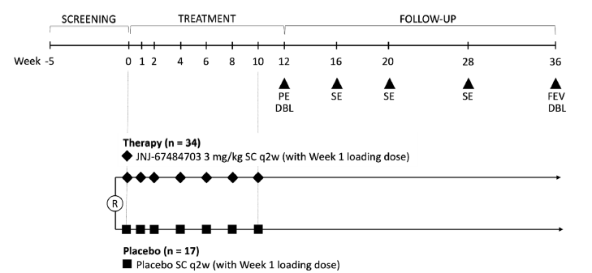
DBL, database lock; FEV, final efficacy/safety visit; PE, primary endpoint; q2w, once every 2 weeks; SC, subcutaneous; SE, safety/efficacy follow-up.

Figure S2. Exploratory analysis of EASI-75 response at Week 12 by demographics, disease duration, baseline disease activity, or previous treatment history
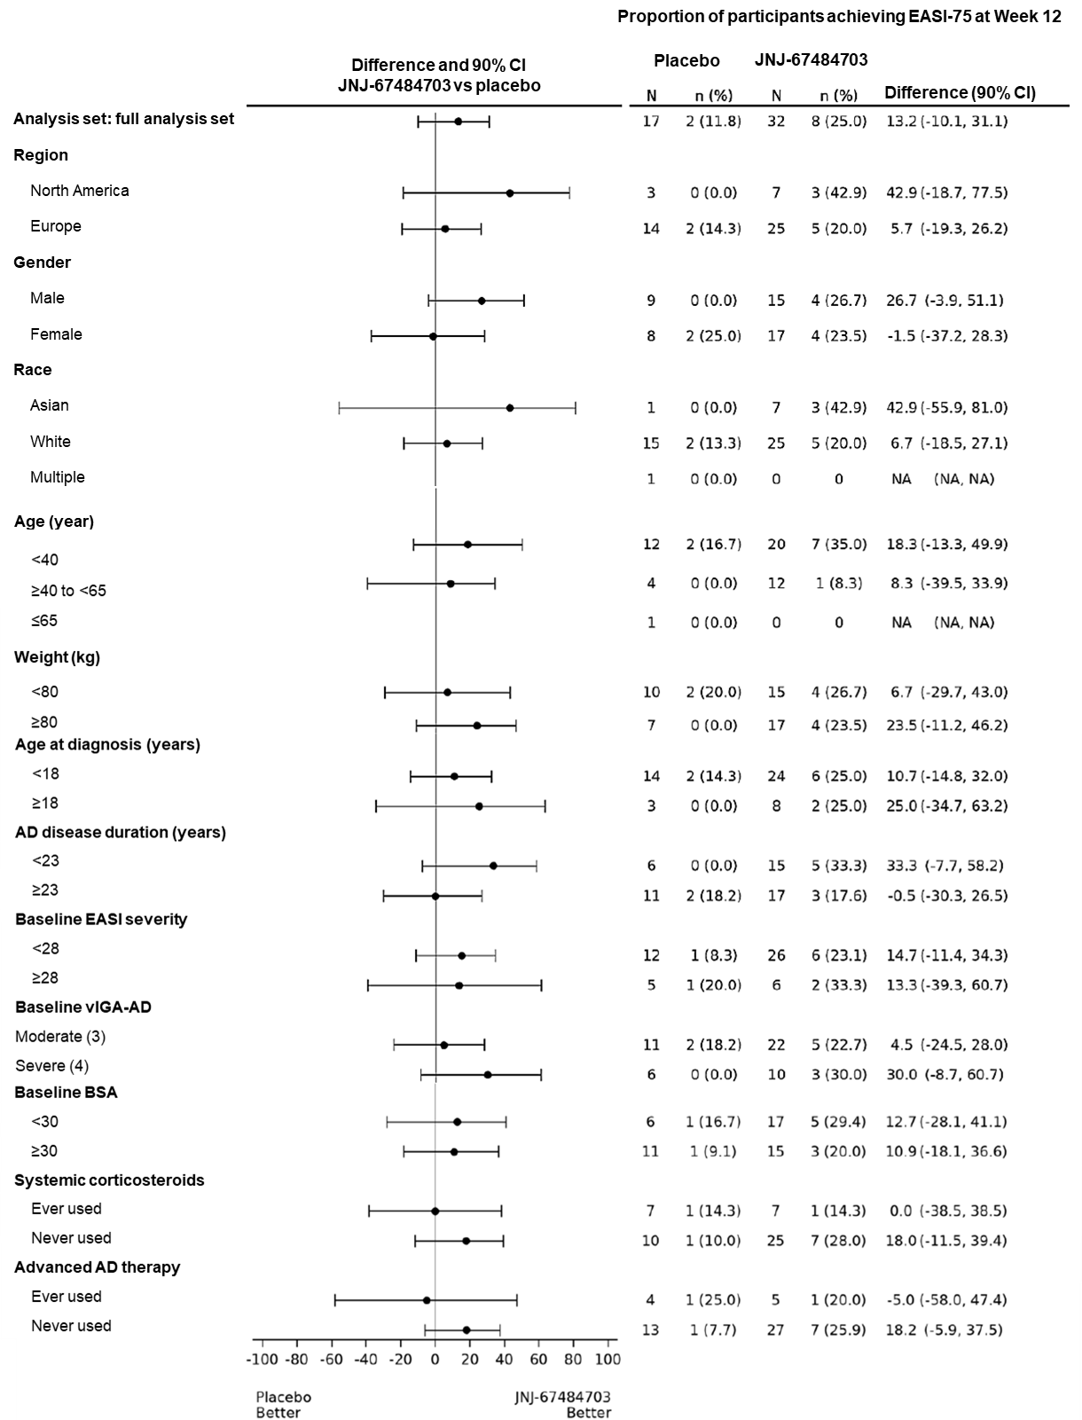
AD, atopic dermatitis; BSA, body surface area; CI, confidence interval; EASI, Eczema Area and Severity Index; NA, not available; vIGA-AD, validated Investigator Global Assessment scale for Atopic Dermatitis.

