Sup data

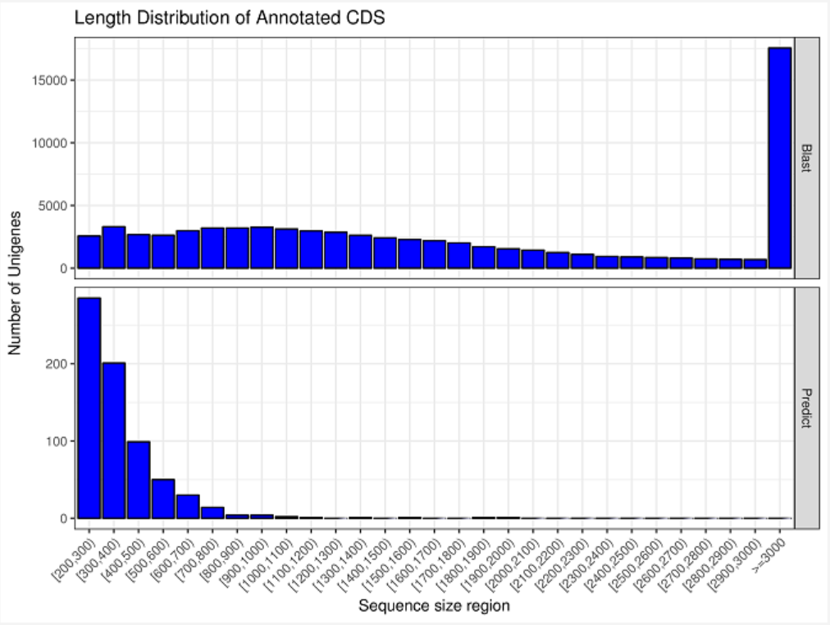

A

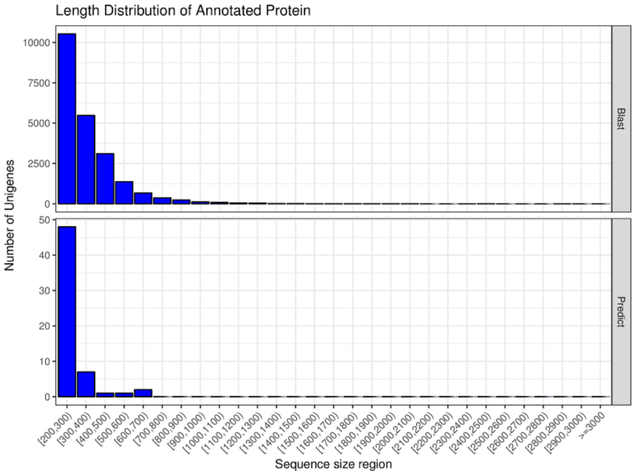
B

S1

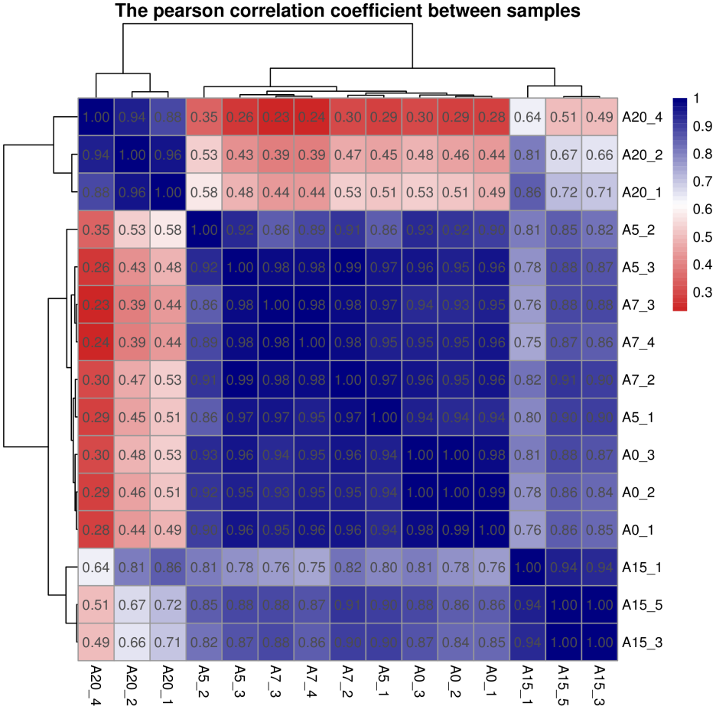

S2

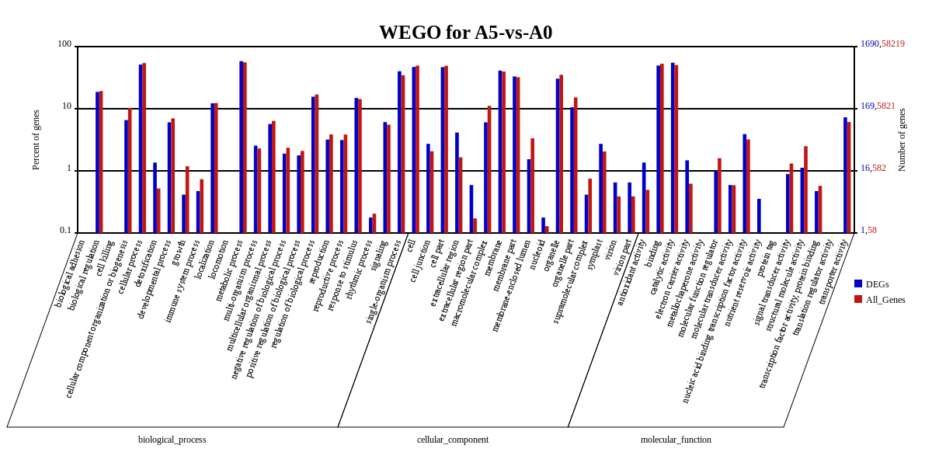

S3
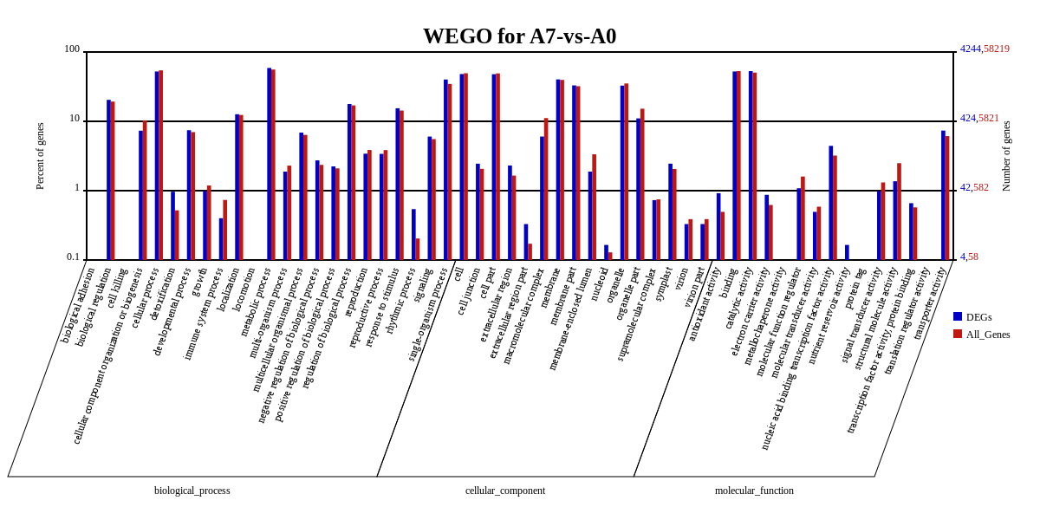S4

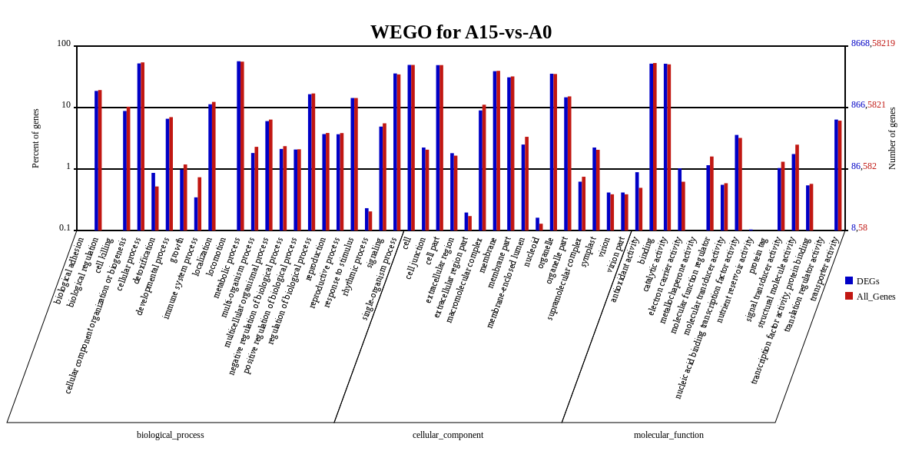
S5

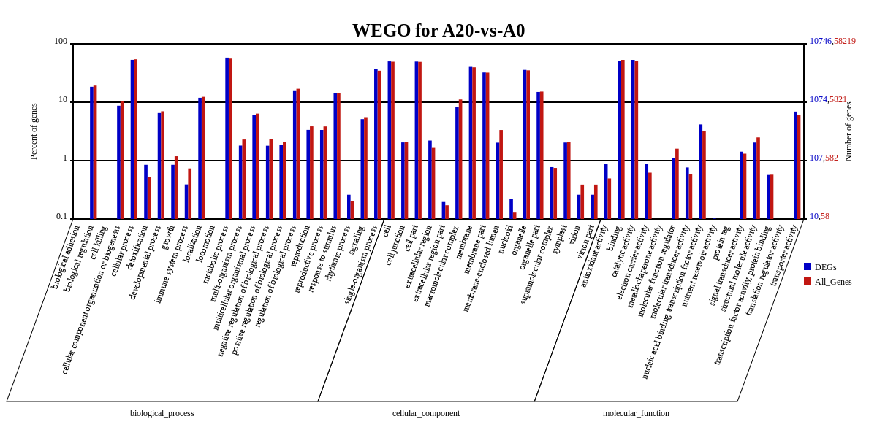
S6

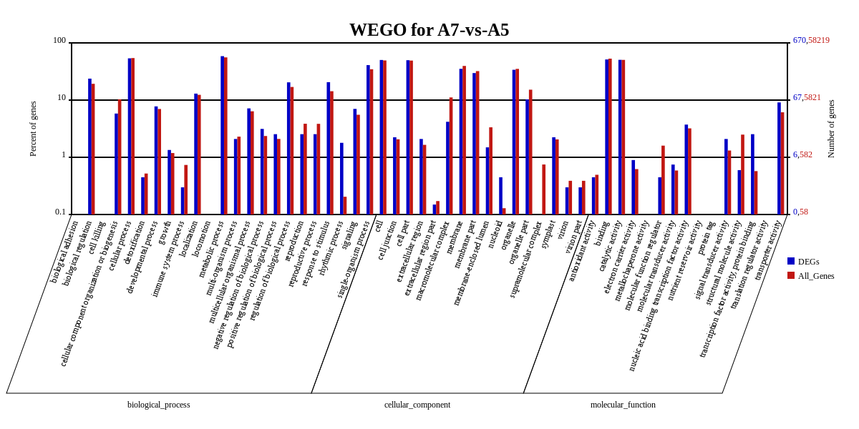
S7

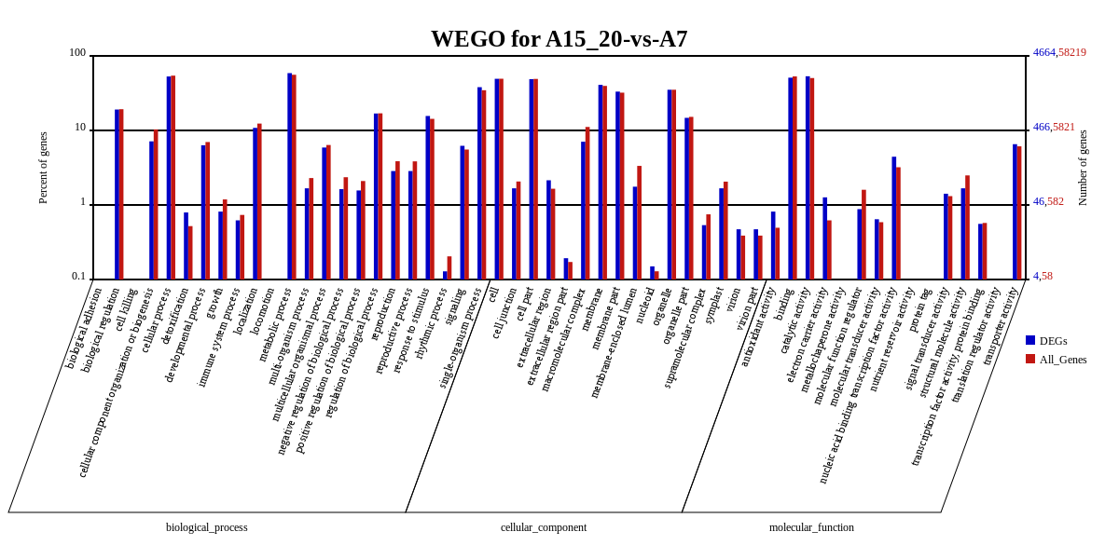

S8

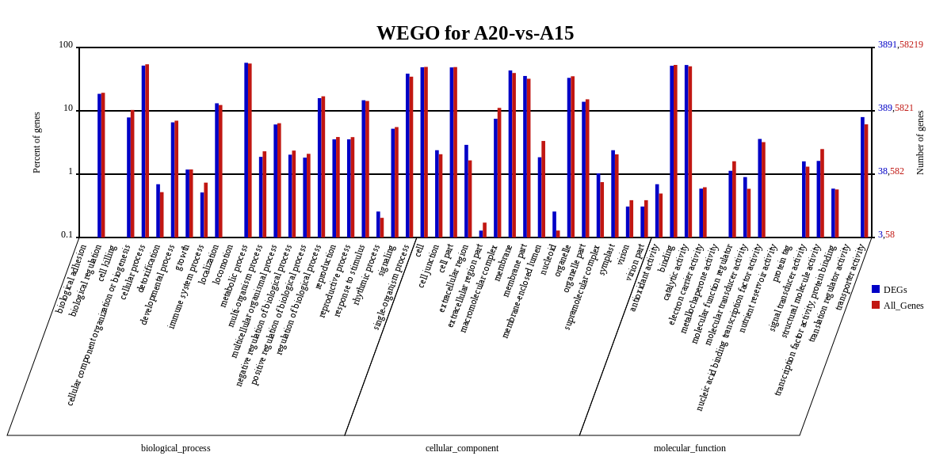

S9

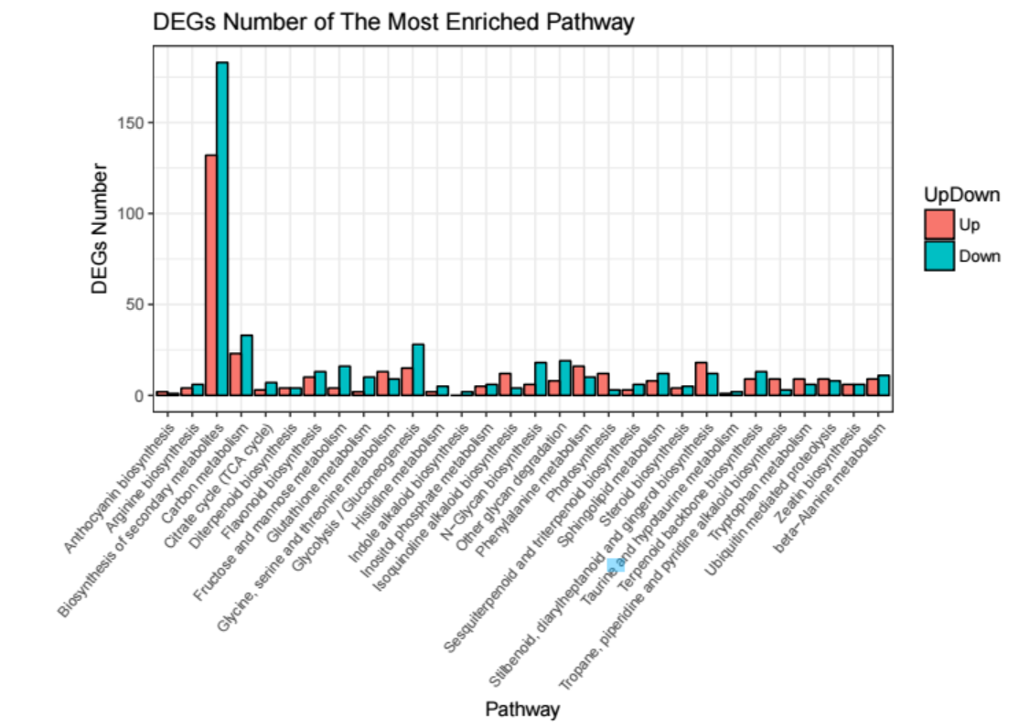
S10

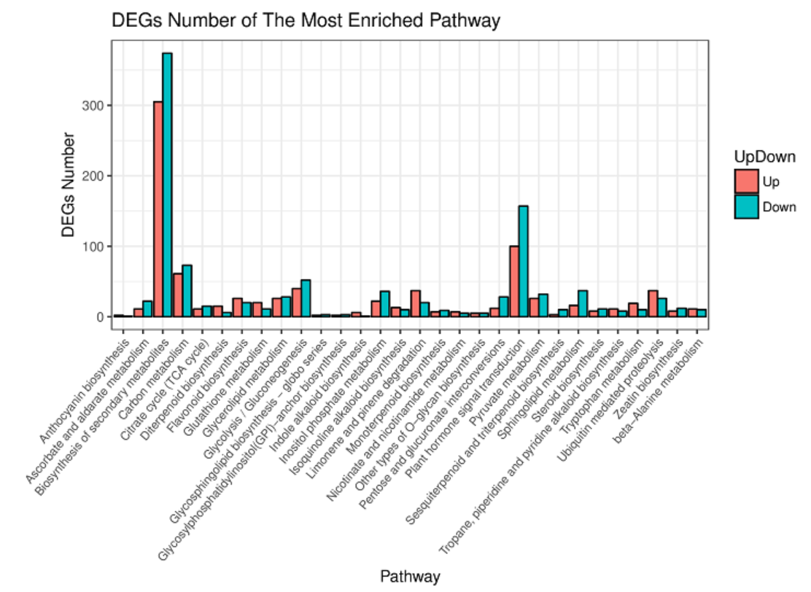
S11

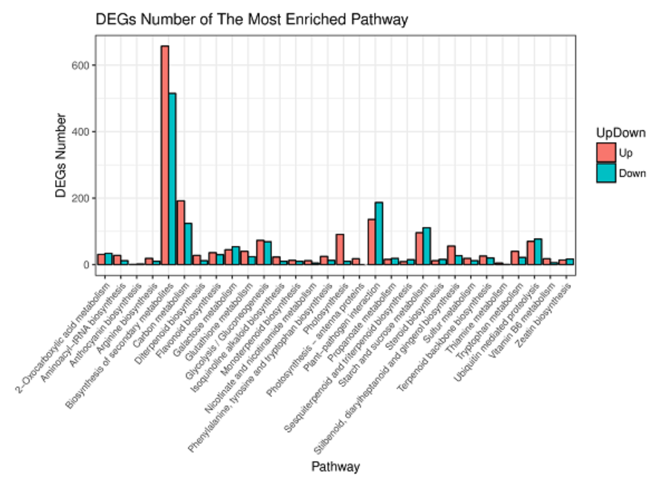
S12

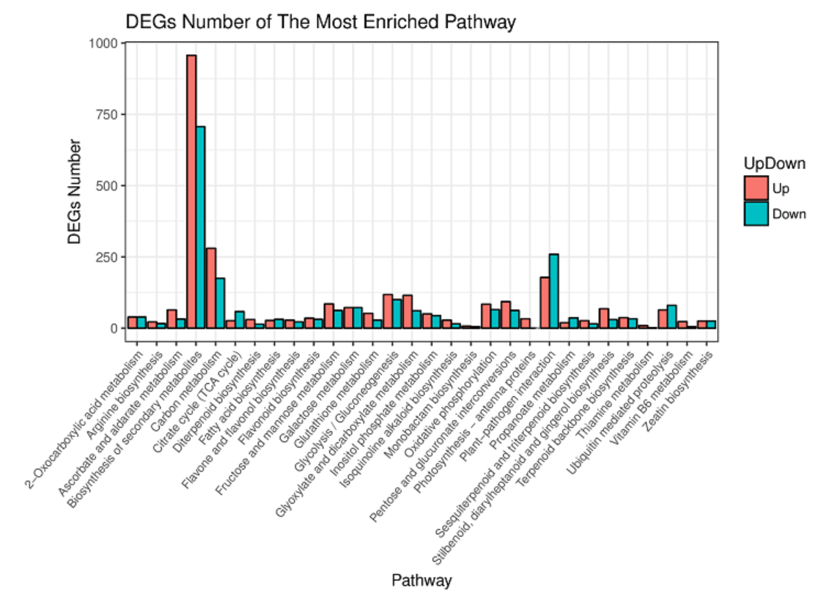
S13

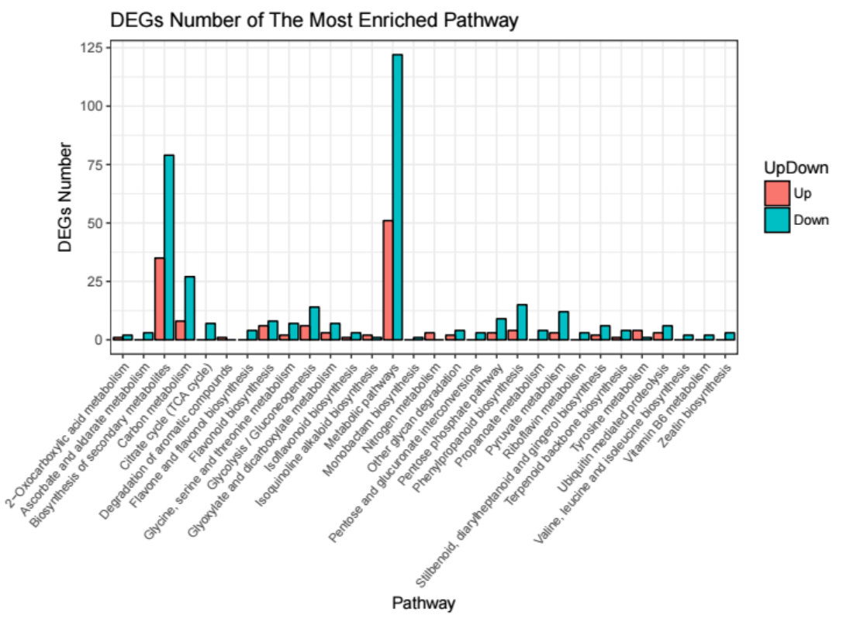
S14

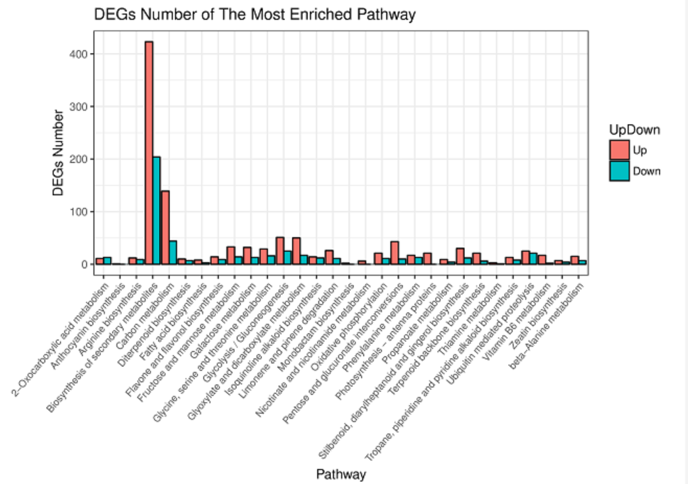
S15

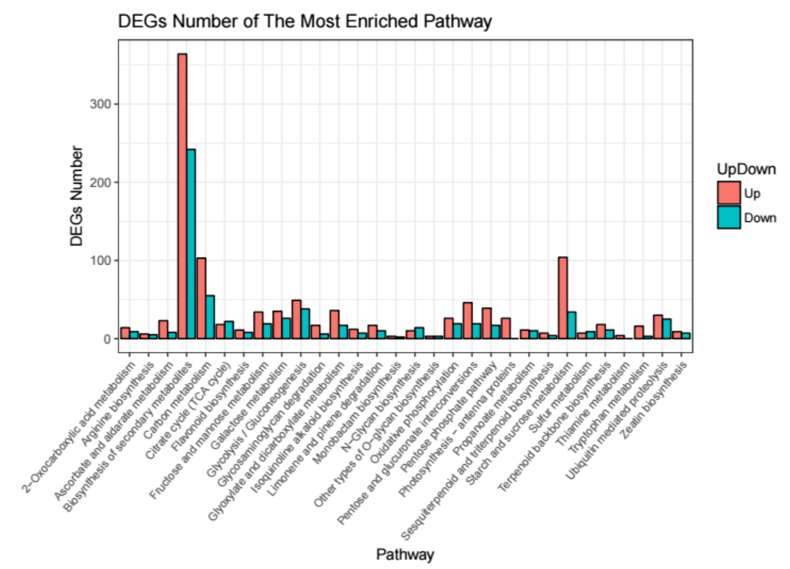

S16

Table S1. Primer of qRT-PCR

Gene name | Primer sequence | Product size (bp)
CL9.Contig2951_All | F5' GGGGATAGGAGAAACGATAAG 3' | 177
CL9.Contig2951_All | R5' GGGGCAACAAAGATGATAGA 3' | 177
CL1.Contig2575_All | F5'ATCATCAGTGTTTCCAGGTCC 3' | 168
CL1.Contig2575_All | R5'ATCATCAGTGTTTCCAGGTCC 3' | 168
CL9.Contig2824_All | F5' TAGCGGCTGCTGGAAAAT 3' | 243
CL9.Contig2824_All | R5' TGCAAGACTTAGTCCCTGGTT 3' | 243
CL24.Contig1294_All | F5' GGATGAATACAGACCGTTGACCT 3' | 221
CL24.Contig1294_All | R5' GATGAATACAGACCGTTGACCT 3' | 221
CL1.Contig10130_All | F5' TTCCCTTGGCTACCTTCG 3' | 234
CL1.Contig10130_All | R5' GGGAATAGTGCTGATGTGATG 3' | 234
CL6.Contig5041_All | F5' CCAGTTTTGCCCTTTCTCA 3' | 90
CL6.Contig5041_All | R5' CGGAATGTCTCGGCTTAGTA 3' | 90
CL6.Contig2778_All | F5' CGTTCATCAACCACGGCTA 3' | 105
CL6.Contig2778_All | R5' CGAAGGCAAAGGCTGTCATA 3' | 105
CL24.Contig2155_All | F5' GGCGAGAACAATGGCACC 3' | 198
CL24.Contig2155_All | R5' CAATGGCGGGAGAAAAGTC 3' | 198
CL23.Contig257_All | F5' TTGGCCGGACTCGATGTA 3' | 189
CL23.Contig257_All | R5' TCCCGTGGGTCTGGTTCA 3' | 189
CL1.Contig12862_All | F5' TCATACGACGAAAGCAAACG 3' | 255
CL1.Contig12862_All | R5' CCCGAAGACGAGGCAAAT 3' | 255
β-Actin | F5'CACCACTGCTGAACGGGAA 3'
β-Actin | R5' AGAGGACTTCTGGACAACGGA 3'

Table S2 Assembly information of Unigenes
Categories | Sequences(all samples)
Unigene Number | 94769
Mean Length (bp) | 1921
N50 (bp) | 3470
N90 (bp) | 918
Percent GC (%) | 40.67
Total_mapped_reads (%) | 68.47 to 74.75
Unique_mapped_reads | 19.38 to 21.54

Table S3. The results of SSR search
Searching items | Data
Total number of sequences examined: | 94769
Total size of examined sequences (bp): | 182133171
Total number of identified SSRs: | 17456
Number of SSR containing sequences: | 13967
Number of sequences containing more than 1 SSR: | 2716
Number of SSRs present in compound formation: | 560

