Fig. S1 Representative (A) 2D COSY spectrum and (B) 2D HSQC-DEPT spectrum
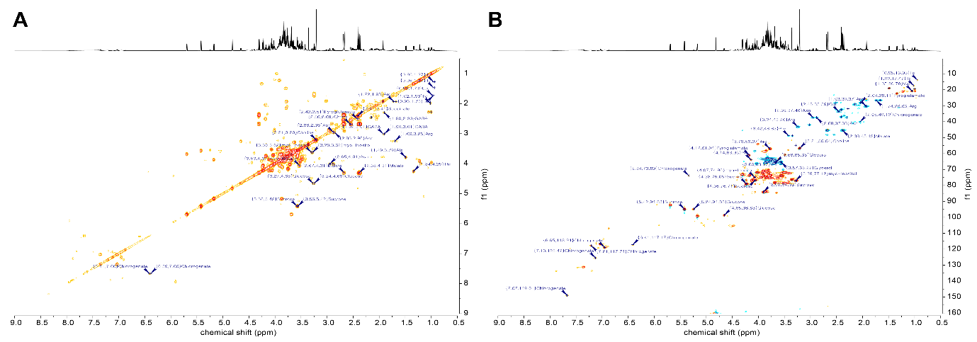
Fig. S2 Representative UPLC–QTOF/MS chromatograms of (A) fennel and (B) dill
