Exploring Mass and Economic Potentials of Rare Earth Elements Recycling from Electric Vehicles at End-of-Life
Gianluca Torta¹, Luca Ciacci¹, Ivano Vassura¹, Fabrizio Passarini¹
¹Department of Industrial Chemistry "Toso Montanari", University of Bologna - Alma Mater Studiorum, Viale
Risorgimento 4, 40136 - Bologna, Italy.

GT – gianluca.torta2@unibo.it; LC – luca.ciacci5@unibo.it; IV– Ivano.vassura@unibo.it;
FP – fabrizio.passarini@unibo.it

Supplementary Information (SI)

Table S1 – MP-AES multi-element standards: concentrations of multi-element standard used for MP-AES analysis
Element | ppm | ppm | ppm | ppm | ppm
Nd | 50 | 100 | 130 | 180 | 200
Pr | 1 | 10 | 20 | 30 | 40
Dy | 1 | 10 | 20 | 30 | 40
Gd | 1 | 10 | 20 | 30 | 40
Ce | 10 | 20 | 40 | 60 | 80

Table S2 – MP-AES analysis of magnets composition: mass REEs over mass magnet per every component and related standard deviation.
Vehicle | Component | % w/w mass REEs /mass magnet |  |  |  |  | Standard deviation (σ)
Vehicle | Component | Nd | Pr | Dy | Gd | Ce | Nd | Pr | Dy | Gd | Ce
Vehicle | Component | (%) | (%) | (%) | (%) | (%) | (%) | (%) | (%) | (%) | (%)
FIAT Ducato electric | electric drive motor | 20.4₀ | 6.80₀ | 4.5₄ | 0 | 0 | 0.1₅ | 0.08₅ | 0.07₄ | 0 | 0
 | electric power steering motor | 22.9₁ | 4.8₁ | 0 | 0 | 0 | 0.3₈ | 0.1₁ | 0 | 0 | 0
 | Air conditioning | 22.3₉ | 5.35₉ | 1.197₂ | 0 | 0 | 0.2₆ | 0.08₄ | 0.009₃ | 0 | 0
 | compressor
FIAT 500 elettric | Electric drive motor | 28.4₀ | 0 | 4.36₃ | 0 | 0 | 0.4₁ | 0 | 0.05₃ | 0 | 0
 | electric power steering motor | 19.9₀ | 5.0₃ | 1.73₃ | 0 | 0 | 0.6₂ | 0.1₉ | 0.05₂ | 0 | 0
 | Air conditioning | 22.3₉ | 5.35₉ | 1.197₂ | 0 | 0 | 0.2₆ | 0.08₄ | 0.009₃ | 0 | 0
 | compressor
Jeep Compass Plug-in Hybrid | Electric power steering motor | 20.22₆ | 5.198₃ | 0 | 0 | 0 | 0.07₅ | 0.009₆ | 0 | 0 | 0
Jeep Compass Plug-in Hybrid | Air conditioning | 22.3₉ | 5.35₉ | 1.197₂ | 0 | 0 | 0.2₆ | 0.08₄ | 0.009₃ | 0 | 0
Jeep Compass Plug-in Hybrid | compressor
Jeep Compass Plug-in Hybrid | Big Electric gear motor | 20.8₂ | 4.5₀ | 2.15₅ | 0 | 0 | 0.8₄ | 0.1₉ | 0.08₃ | 0 | 0
Jeep Compass Plug-in Hybrid | Small Electric gear | 19.4₅ | 4.2₃ | 0 | 0 | 0 | 1.8₁ | 0.4₁ | 0 | 0 | 0
Jeep Compass Plug-in Hybrid | motors
Jeep Compass Plug-in Hybrid | Alternator | 18.4₁ | 5.0₆ | 0 | 0 | 0 | 0.3₉ | 0.1₅ | 0 | 0 | 0

Fig.S1 Dismantling diagram of the studied components from Fiat 500 electric
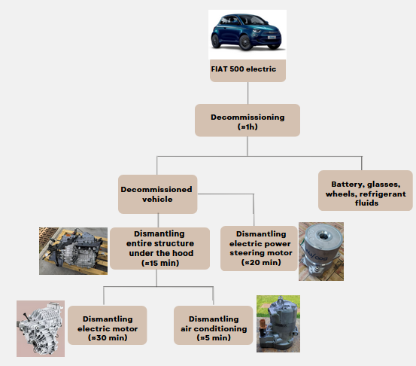
Fig.S2 Dismantling diagram of the studied components from Jeep Compass Plug-in Hybrid
