Supplementary Material_1. Identification of pLVX-GSK3B plasmid
- Vector map of pLVX-GSK3B:
- Agarose gel electrophoresis of pLVX-GSK3B:
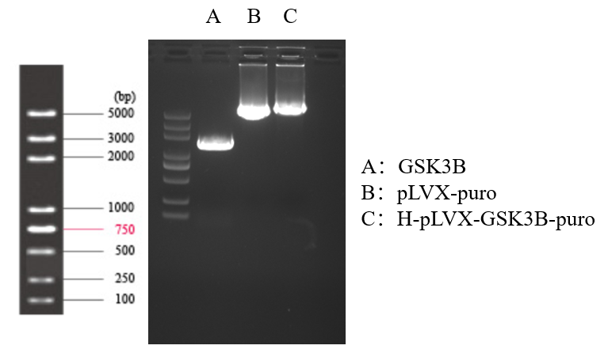
- Sequencing of pLVX-GSK3B：
hGSK3B-L1302-Forward：
ATGATGACGATAAAGGATCCATGTCAGGGCGGCCCAGA
