SUPPLEMENTARY MATERIALS

Title:
Expression of PD-1 ligands in the immune microenvironment was altered in TTF-1-negative lung adenocarcinoma

Journal:
Human Cell

Authors:
Hiroyuki Yamada, Hiromu Yano, Eri Matsubara, Shukang Zhao, Yusuke Shinchi, Cheng Pan, Takamasa Koga, Kosuke Fujino, Yukio Fujiwara, Koei Ikeda, Yoshihiro Komohara*, Makoto Suzuki

*Corresponding author at: Department of Cell Pathology, Graduate School of Medical Sciences, Kumamoto University, 1-1-1, Honjo, Chuo-ku, Kumamoto 860-8556, Japan
E-mail address: ycomo@kumamoto-u.ac.jp (Y. Komohara)

Supplementary Table 1. Univariate and multivariate Cox regression analyses for recurrence-free survival
 | Univariate |  |  | Multivariate
 | HR | 95% CI | p-value | Adjusted HR | 95% CI | p-value
Age
≥65 vs. <65 | 1.325 | 0.754–2.331 | 0.33
Gender
Female vs. Male | 2.311 | 1.389–3.845 | 0.001 | 1.473 | 0.798–2.720 | 0.22
Smoking
BI ≥600 vs. <600 | 2.481 | 1.522–4.045 | <0.001 | 1.825 | 0.993–3.352 | 0.053
Pathological stage
II–IV vs. 0–I | 7.311 | 4.440–12.039 | <0.001 | 6.673 | 3.950–11.273 | <0.001
EGFR gene status
Mutant vs. Wild type | 0.628 | 0.383–1.028 | 0.064 | 1.461 | 0.802–2.662 | 0.22
TTF-1 expression
Positive vs. Negative | 0.357 | 0.200–0.637 | <0.001 | 0.615 | 0.321–1.177 | 0.14
Note: Underline indicates statistically significant.
Abbreviations: HR, hazard ratio; CI, confidence interval; BI, Brinkman index; EGFR, epidermal growth factor; TTF-1, thyroid transcription factor-1.

Supplementary Table 2. Logistic regression analyses for predictors of high PD-L1 MPS (≥50%)
 | Univariate |  |  | Multivariate
 | OR | 95% CI | p-value | Adjusted OR | 95% CI | p-value
Age
≥65 vs. <65 | 1.265 | 0.700–2.291 | 0.44
Gender
female vs. male | 0.604 | 0.351–1.035 | 0.067 | 0.732 | 0.344–1.555 | 0.41
Smoking
BI ≥600 vs. <600 | 0.642 | 0.367–1.116 | 0.12 | 1.120 | 0.507–2.505 | 0.78
Pathological stage
II–IV vs. 0–I | 0.541 | 0.280–1.028 | 0.063 | 0.693 | 0.348–1.372 | 0.29
EGFR gene status
mutant vs. wild type | 1.935 | 1.128–3.345 | 0.017 | 1.392 | 0.745–2.605 | 0.30
TTF-1 expression
positive vs. negative | 3.926 | 1.662–10.378 | 0.003 | 2.969 | 1.178–8.239 | 0.026
Note: Underline indicates statistically significant.
Abbreviations: PD-L1, programmed cell death-1 ligand 1; MPS, macrophage proportion score; OR, odds ratio.

Supplementary Table 3. Logistic regression analyses for predictors of high PD-L2 MPS (≥50%)
 | Univariate |  |  | Multivariate
 | OR | 95% CI | p-value | Adjusted OR | 95% CI | p-value
Age
≥65 vs. <65 | 0.681 | 0.368–1.240 | 0.21
Gender
female vs. male | 0.517 | 0.298–0.889 | 0.018 | 0.800 | 0.363–1.790 | 0.58
Smoking
BI ≥600 vs. <600 | 0.501 | 0.285–0.874 | 0.015 | 0.906 | 0.392–2.097 | 0.82
Pathological stage
II–IV vs. 0–I | 0.221 | 0.107–0.434 | <0.001 | 0.269 | 0.128–0.545 | <0.001
EGFR gene status
mutant vs. wild type | 2.477 | 1.431–4.340 | 0.001 | 1.681 | 0.878–3.231 | 0.12
TTF-1 expression
positive vs. negative | 3.818 | 1.652–9.631 | 0.003 | 2.179 | 0.849–5.938 | 0.11
Note: Underline indicates statistically significant.
Abbreviations: PD-L2, programmed cell death-1 ligand 2

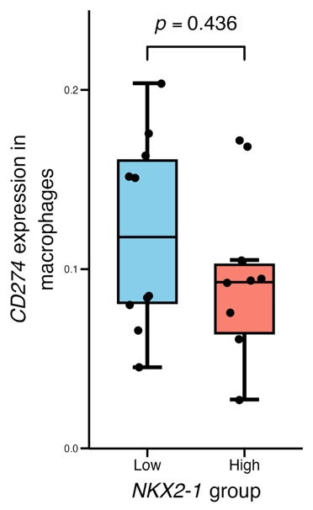
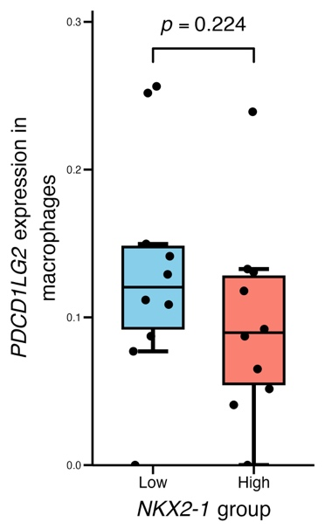

NKX2-1
NKX2-1

Supplementary Figure 1.
Comparison of CD274 and PDCD1LG2 expressions in macrophages between NKX2-1-high and -low groups. Patients were stratified by median NKX2-1 expression in tumor cells. Comparisons were performed using the Mann-Whitney U test.

