Supplementary Materials

Establishment of immortalized ovarian stromal cell lines using Sendai virus vectors: a platform for studying tumor–stroma interactions and carcinogenesis

Journal name: Human Cell

Masayo Okawa¹, Hiroaki Komatsu¹, Yasuhiro Kazuki^{2,3}, Kanako Kazuki³, Genki Hichiwa², Kohei Hikino1, Yuki Iida1, Mayumi Sawada1, Hiroyuki Kugoh⁴, Shinya Sato¹, Mitsuo Oshimura³, Tasuku Harada⁵, Fuminori Taniguchi¹

1 Department of Obstetrics and Gynecology, Tottori University School of Medicine, Tottori, Japan
2 Department of Chromosome Biomedical Engineering, Integrated Medical Sciences, Graduate School of Medical Sciences, Tottori University
3 Chromosome Engineering Research Center, Tottori University
4 Division of Genome and Cellular Function, Department of Molecular and Cellular Biology,
5 Tottori University Hospital, Tottori, Japan

Corresponding Author
Hiroaki Komatsu, MD, PhD
Department of Obstetrics and Gynecology
Tottori University School of Medicine,
36-1 Nishicho, Yonago, Tottori 683-8504, Japan
Email: komatsu.h.med@tottori-u.ac.jp
Phone: +81-859-38-6647

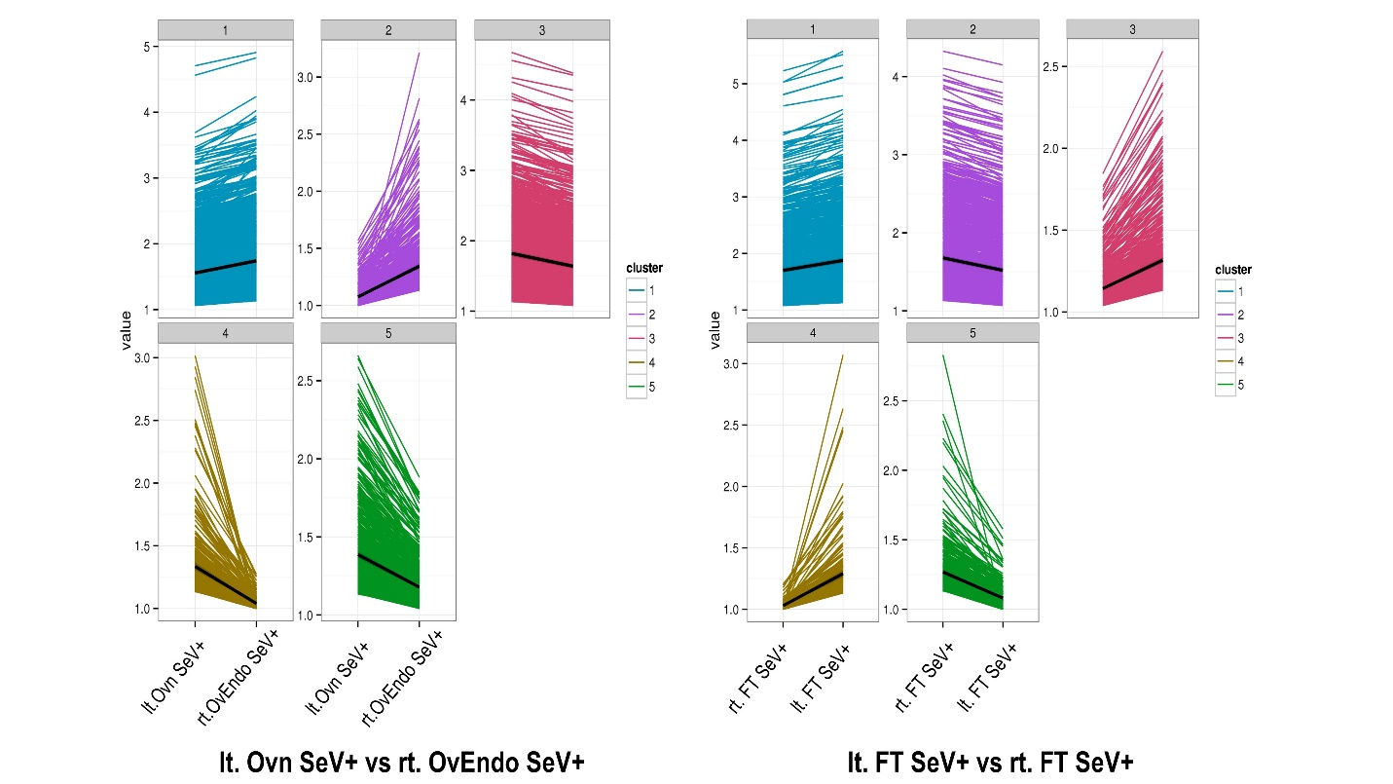

Supplementary Figure 1 Clustering Analysis in Human Transcriptome Sequencing Analysis. The results of clustering analysis between the left ovary and right ovarian endometrial cyst and between the left and right fimbrae are shown. Each analysis classifies the samples into five clusters. FT, fimbrae; SeV, Sendai virus; Ovn, ovary; OvEndo, ovarian endometrial cysts.

Supplementary Table 1: Read Length and Number of Assembled Transcripts in Human Transcriptome Sequencing Analysis for Each Cell Line
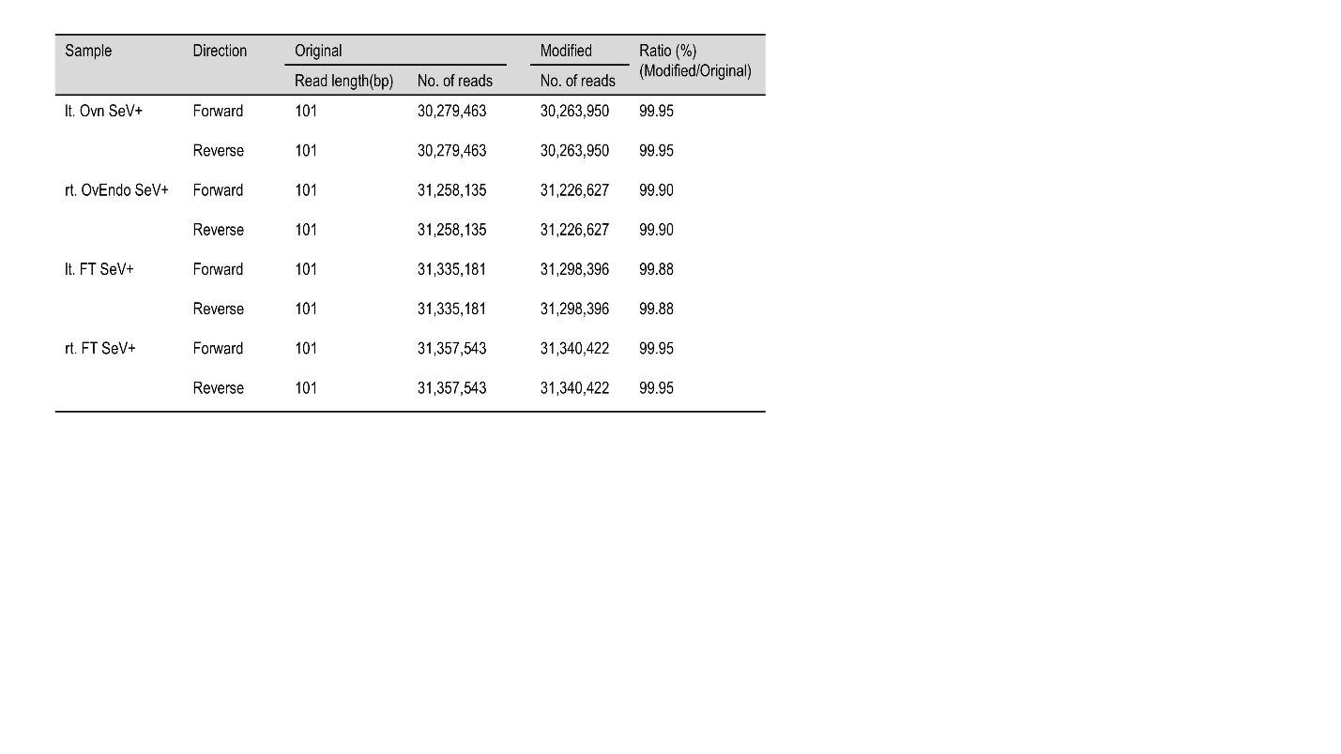

Supplementary Table 2: Human Transcriptome Sequencing Analysis
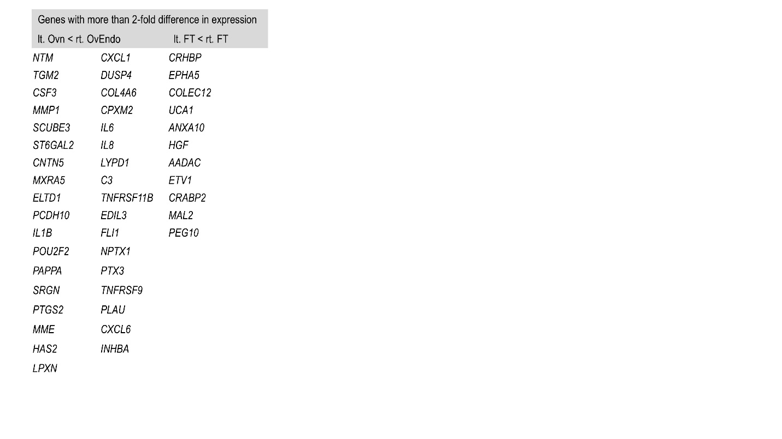
The genes MMP1, PAPPA, and CXCL1 in the rt. OvEndo was expressed at levels more than twice as high as those of lt. Ovn

