Generation and characterization of Early-stage Oral Cancer cell line of Buccal mucosa of Indian Origin
Akhila George^{1,2}, Sudhir Nair ^{2,3,4}, Kumar Prabhash^{2,4,5,6}, Sayujata Thakur¹, Poonam Gera⁷, Arjun Singh^{2,3,4}, Pankaj Chaturvedi^{2,3,4}, Swapnil Rane^{2,4,8}, Trupti Pradhan¹, Subrata Sen⁹, Madan Barkume⁹, Dhanlaxmi Shetty²,¹⁰, Kruti Chaubal¹⁰, Arpita Ghosh¹¹, Sanjeev Kamte¹¹, Jyoti Kode^{1,2,9*}
Supplementary figures:

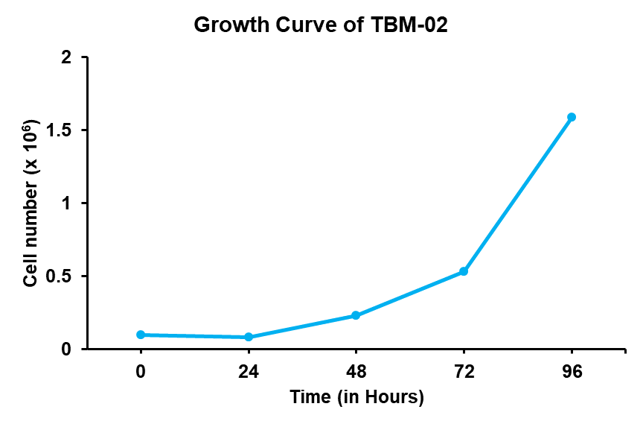

Figure S1: Growth curve of Cell line TBM-02; Doubling time of the cell line was found to be 26.39 hours.

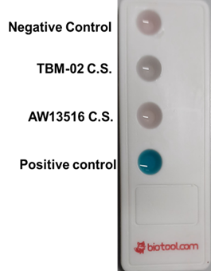

Figure S2: Mycoplasma detection in cell culture supernatant; the cell culture supernatant of TBM-02 shows absence of any mycoplasma contamination

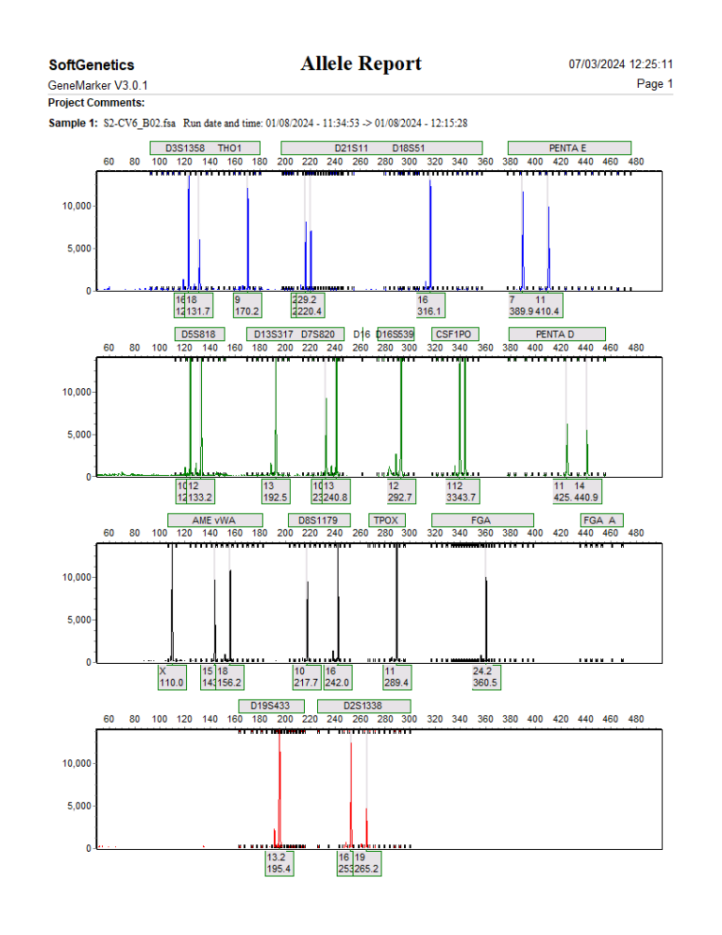
Figure S3: STR profile of TBM-02 at passage 50.

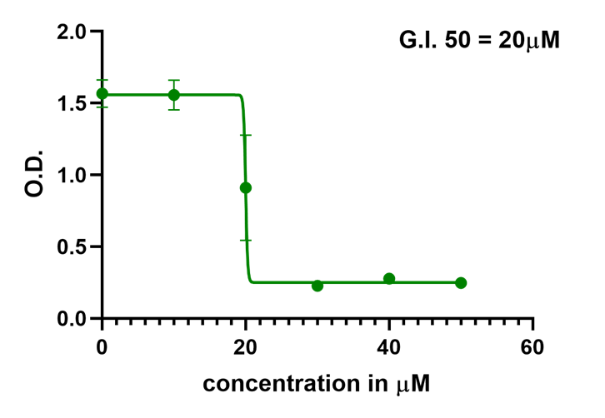
Figure S4: Inhibitory concentration (IC₅₀) of phytochemical 6-Shogaol was found to be 20 μM

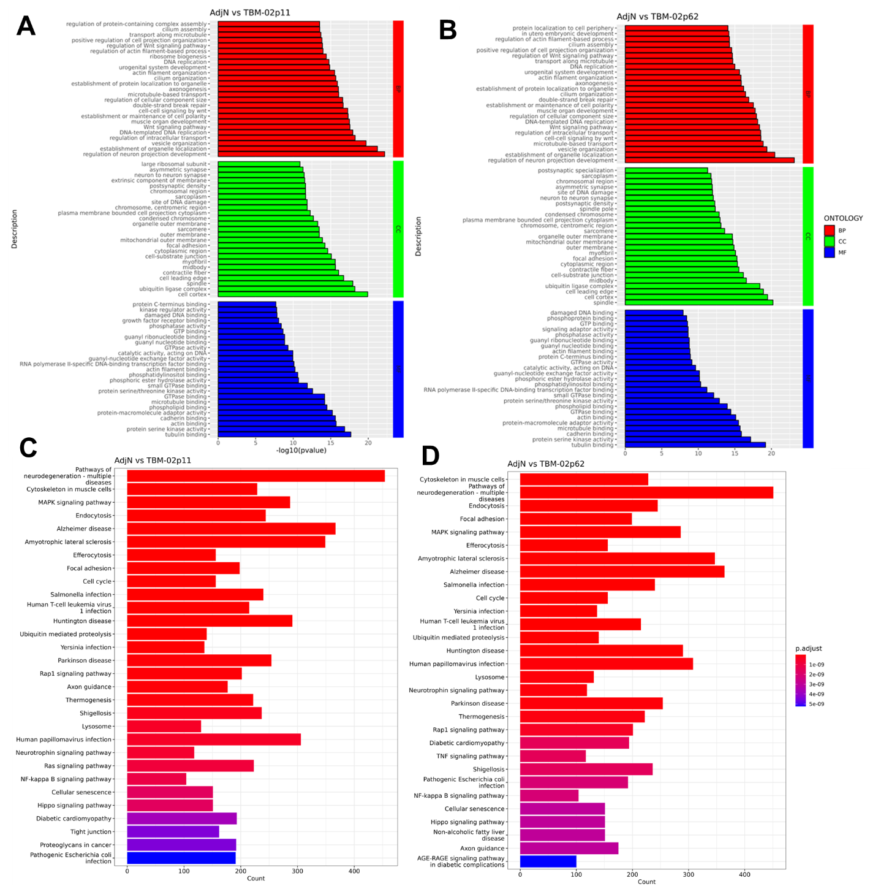
Figure S4: Transcriptome analysis of TBM-02 cell line. The graphs show gene ontology to decipher the genes associated with the dysregulated pathways of TBM-02 at early passage p11(A) and late passage p62 (B). KEGG pathways analysis in TBM-02 p11 (C) and p62 (D) in comparison to normal buccal mucosa (SRA database SRX19125628 and SRX19125629).

