Article

Advanced assessment of nutrient deficiencies in greenhouse

with electrophysiological signals
Daniel Tran^{1,*}, ORCID: 0000-0002-5669-8618
Elena Najdenovska^{2,*}, ORCID: 0000-0002-5799-9316
Fabien Dutoit^{2,*}, ORCID: 0000-0003-4136-2799
Carrol Plummer³, ORCID: 0000-0001-7069-5109
Nigel Wallbridge³, ORCID: 0000-0002-7732-3807
Marco Mazza⁴, ORCID: N/A
Cédric Camps¹, ORCID: 0000-0003-1086-5668
Laura Elena Raileanu², ORCID: 0000-0001-9045-5620

1. Agroscope, Institute for Plant Production Systems, Conthey, Switzerland
2. School of Engineering and Management Vaud (HEIG-VD), HES-SO University of Applied Sciences and Arts Western Switzerland, Yverdon-les-Bains, Switzerland
3. Vivent SA, Gland, Switzerland
4. School of Engineering and Architecture Fribourg (HEIA-Fr), HES-SO University of Applied Sciences and Arts of Western Switzerland, Fribourg, Switzerland
* Equally contributing authors

SUPPLEMENTARY DATA

Table S1. Correlation-based selection of features used for modelling the deficit of Mn
15 s | 30 s | 1 min | 2 min | 5 min | 10 min | 30 min
Minimum | Variance | Variance | Variance | Variance | Variance | Minimum
Maximum | Skewness | Skewness | Skewness | Skewness | Skewness | Maximum
Variance | Kurtosis | Kurtosis | Kurtosis | Kurtosis | Kurtosis | Variance
Skewness | Hjorth mobility | Hjorth mobility | Hjorth mobility | Hjorth mobility | Hjorth complexity | Skewness
Kurtosis | Hjorth complexity | Hjorth complexity | Hjorth complexity | Hjorth complexity | RMS | Kurtosis
Hjorth mobility | GHE | GHE | GHE | GHE | Crest factor | Hjorth mobility
Hjorth complexity | Crest factor | Maximum of WD1* | Crest factor | Crest factor | Minimum of WD1* | Hjorth complexity
GHE | Minimum of WD1* | Minimum of WD4* | Minimum of WD1* | Shape factor | Minimum of WD4* | GHE
Logarithmic wentropy | Minimum of WD4* | Maximum of WD4* | Maximum of WD1* | Margin factor | White noise | Logarithmic wentropy
Shannon wentropy | Maximum of WD4* | White noise | Min of WD4* | Minimum of WD1* | Brown noise | Crest factor
Crest factor | White noise | Brown noise | Maximum of WD4* | Maximum of WD1* |  | Shape factor
Shape factor | Brown noise |  | White noise | Minimum of WD4* |  | Margin factor
Margin factor |  |  | Brown noise | Frequency center |  | Minimum of WD1*
Minimum of WD1* |  |  |  | Root Variance of the Frequency |  | Maximum of WD1*
Minimum of WD4* |  |  |  | White noise |  | Minimum of WD4*
Maximum of WD4* |  |  |  | Brown noise |  | Frequency center
Frequency center |  |  |  | Blue noise |  | Frequency RMS
Frequency RMS |  |  |  |  |  | White noise
White noise |  |  |  |  |  | Pink noise
Brown noise |  |  |  |  |  | Blue noise
*WDn: decomposed signal at level n resulting from the performed wavelet decomposition of order 8

Table S2. Correlation-based selection of features used for modelling the deficit of Fe
15 s | 30 s | 1 min | 2 min | 5 min | 10 min | 30 min
Minimum | Variance | Skewness | Minimum | Variance | Minimum | Minimum
Maximum | Skewness | Kurtosis | Maximum | Skewness | Maximum | Maximum
Mean | Kurtosis | IQR | Variance | Kurtosis | Variance | Variance
Variance | IQR | Hjorth mobility | Skewness | IQR | Skewness | Skewness
Skewness | Hjorth mobility | Hjorth complexity | Kurtosis | Hjorth mobility | Kurtosis | Kurtosis
Kurtosis | GHE | GHE | IQR | Hjorth complexity | IQR | IQR
IQR | Crest factor | Crest factor | Hjorth mobility | GHE | Hjorth mobility | Hjorth mobility
Hjorth mobility | Minimum of WD1* | Shape factor | Hjorth complexity | Logarithmic wentropy | Hjorth complexity | Hjorth complexity
Hjorth complexity | Minimum of WD4* | Margin factor | GHE | Crest factor | Crest factor | Logarithmic wentropy
GHE | Frequency center | Minimum of WD1* | Crest factor | Shape factor | Shape factor | Shannon wentropy
Logarithmic wentropy | White noise | Maximum of WD1* | Shape factor | Margin factor | Margin factor | Crest factor
Shannon wentropy | Brown noise | Minimum of WD4* | Minimum of WD1* | Minimum of WD1* | Minimum of WD1* | Shape factor
Crest factor |  | Frequency center | Minimum of WD4* | Minimum of WD4* | Minimum of WD4* | Margin factor
Margin factor |  | White noise | Maximum of WD4* | Maximum of WD4* | Maximum of WD4* | Minimum of WD1*
Minimum of WD1* |  | Brown noise | Frequency center | Frequency center | Frequency RMS | Mean of WD1*
Minimum of WD4* |  |  | Frequency RMS | Frequency RMS | White noise | Minimum of WD4*
Frequency center |  |  | White noise | White noise | Brown noise | Minimum of WD8*
Frequency RMS |  |  | Brown noise | Brown noise |  | Frequency center
White noise |  |  |  |  |  | Frequency RMS
Pink noise |  |  |  |  |  | White noise
Brown noise |  |  |  |  |  | Pink noise
Purple noise |  |  |  |  |  | Purple noise
*WDn: decomposed signal at level n resulting from the performed wavelet decomposition of order 8

Table S3. Correlation-based selection of features used for modelling the deficit of N

15 s | 30 s | 1 min | 2 min | 5 min | 10 min | 30 min
Minimum | Variance | Variance | Variance | Variance | Var_10min | Minimum
Maximum | Skewness | Skewness | Skewness | Kurtosis | Kurtosis_10min | Maximum
Variance | Kurtosis | Kurtosis | Kurtosis | IQR | IQR | Variance
Skewness | IQR | IQR | IQR | Hjorth complexity | Hjorth mobility | Skewness
Kurtosis | Hjorth mobility | Hjorth mobility | Hjorth mobility | Crest factor | Hjorth complexity | Kurtosis
IQR | Hjorth complexity | Hjorth complexity | Hjorth complexity | Shape factor | GHE | IQR
Hjorth mobility | Crest factor | RMS | GHE | Margin factor | Crest Factor | Hjorth mobility
Hjorth complexity | Shape factor | Crest factor | Crest factor | Minimum of WD1* | Shape Factor | Hjorth complexity
GHE | Minimum of WD1* | Shape factor | Shape factor | Minimum of WD4* | Minimum of WD1* | GHE
Logarithmic wentropy | Minimum of WD4* | Margin factor | Margin factor | Frequency center | Minimum of WD4* | Logarithmic wentropy
Shannon wentropy | Maximum of WD4* | Minimum of WD1* | Minimum of WD1* | White noise | Frequency center | Crest factor
Crest factor | Frequency center | Minimum of WD4* | Minimum of WD4* | Brown noise | Brown noise | Shape factor
Shape factor | Frequency RMS | Maximum of WD4* | Frequency center |  |  | Margin factor
Margin factor | White noise | Frequency center | Root variance frequency |  |  | Minimum of WD1*
Minimum of WD1* | Brown noise | Frequency RMS | White noise |  |  | Minimum of WD4*
Minimum of WD4* |  | Brown noise | Brown noise |  |  | Frequency center
Maximum of WD4*
Frequency center
Frequency RMS
White noise
Pink noise
Brown noise
*WDn: decomposed signal at level n resulting from the performed wavelet decomposition of order 8

Table S4. Correlation-based selection of features used for modelling the deficit of Ca
15 s | 30 s | 1 min | 2 min | 5 min | 10 min | 30 min
Minimum | Variance | Variance | Variance | Variance | Maximum | Minimum
Variance | Skewness | Skewness | Skewness | Skewness | Variance | Variance
Skewness | Kurtosis | Kurtosis | Kurtosis | Kurtosis | Skewness | Skewness
Kurtosis | IQR | IQR | IQR | IQR | Kurtosis | Kurtosis
IQR | Hjorth mobility | Hjorth mobility | Hjorth mobility | Hjorth mobility | IQR | IQR
Hjorth mobility | Hjorth complexity | Hjorth complexity | Hjorth complexity | Hjorth complexity | Hjorth mobility | Hjorth mobility
Hjorth complexity | GHE | GHE | GHE | GHE | Hjorth complexity | Hjorth complexity
GHE | Crest factor | Crest factor | Crest factor | Crest factor | GHE | GHE
Logarithmic wentropy | Shape factor | Shape factor | Shape factor | Shape factor | Crest factor | Logarithmic wentropy
Shannon wentropy | Minimum of WD1* | Minimum of WD1* | Margin factor | Margin factor | Shape factor | Crest factor
Crest factor | Frequency center | Minimum of WD4* | Minimum of WD4* | Minimum of WD1* | Minimum of WD1* | Shape factor
Shape factor | Frequency RMS | Maximum of WD4* | Frequency center | Maximum of WD1* | Maximum of WD1* | Margin factor
Margin factor | White noise | Frequency center | Root variance frequency | Maximum of WD4* | Minimum of WD4* | Minimum of WD1*
Minimum of WD1* | Brown noise | White noise | White noise | White noise | Frequency RMS | Maximum of WD1*
Frequency center |  | Brown noise | Brown noise | Brown noise | White noise | Mean of WD1*
Frequency RMS |  |  |  |  | Brown noise | Minimum of WD4*
White noise |  |  |  |  |  | Maximum of WD8*
Brown noise |  |  |  |  |  | Frequency center
 |  |  |  |  |  | White noise
 |  |  |  |  |  | Brown noise

*WDn: decomposed signal at level n resulting from the performed wavelet decomposition of order 8

Table S5. Performance summary of the models built upon the found most discriminative features for identifying nutrient deficiency
Stressor | Tuned parameters** | Number of features  (selection based on correlation) | Training accuracy  (folds average) | Accuracy | Precision* | Recall* | Specificity*
Deficit of Mn | [100, 4, 0.05] | 8 | 81.34% | 78.53% | 72.01% | 93.34% | 63.72%
Deficit of Fe | [100, 4, 0.05] | 5 | 74.00% | 78.12% | 74.50% | 85.53% | 70.72%
Deficit of  N | [100, 9, 0.05] | 7 | 85.81% | 89.64% | 89.60% | 89.70% | 89.58%
Deficit of Ca | [200, 9, 0.05] | 6 | 77.05% | 78.10% | 73.51% | 87.85% | 68.34%
*positive class: deficit
** values correspond to: number of trees, max depth, and learning rate, respectively

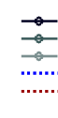
Initial set of features
Set with 10 most discriminative features
Set with minimum number of features
Application of stressor
Appearance of visual symptoms
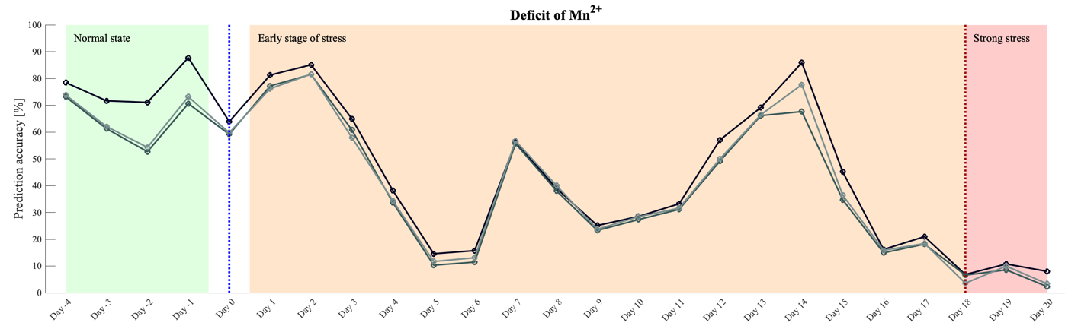
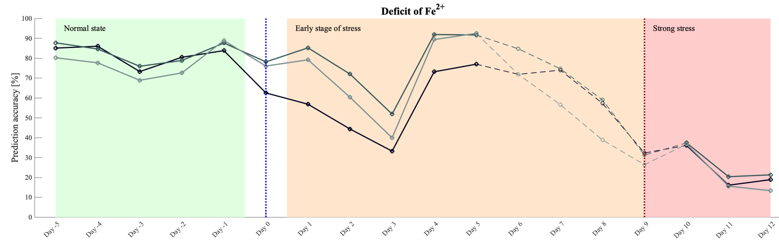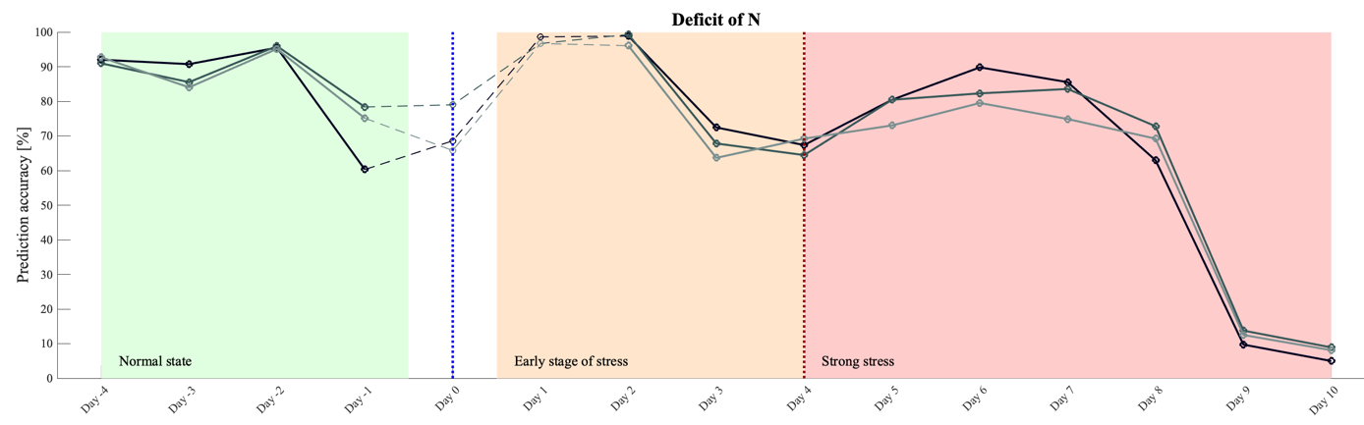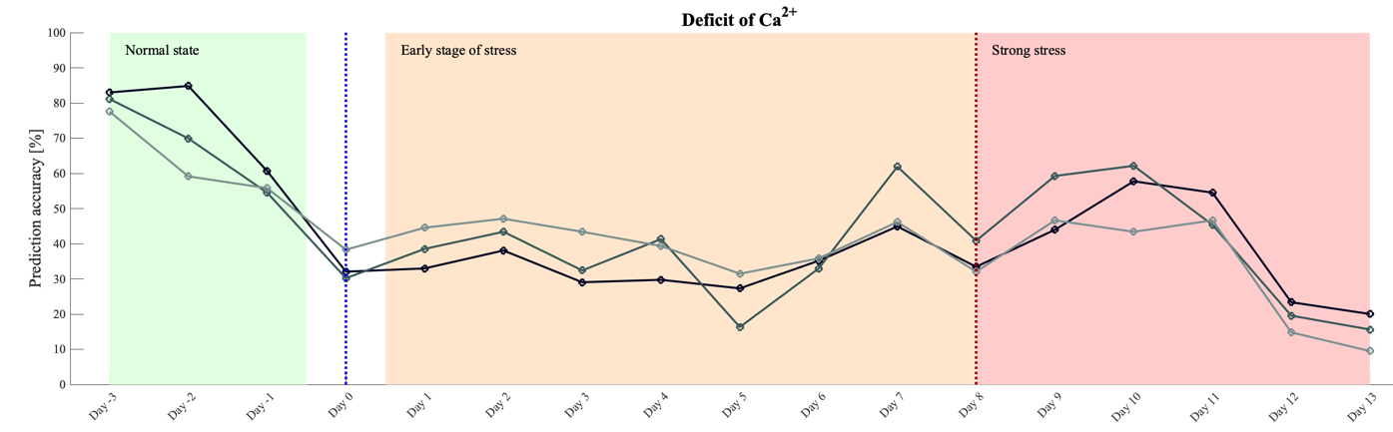
Figure S1. Prediction of the normal state throughout the duration of the recordings starting from the beginning of the experiment until the end of the deprivation of the specific. The prediction is done on the data recorded from the test-set plants for each nutrient deprivation respectively employing three models using: i) the initial set of features, ii) the 10 most discriminative features, and iii) the set enclosing the minimum number of features allowing a good prediction in the original selected interval of the recordings forming the test set. The dashed lines correspond to the days when part of the recorded data was missing due to technical issues.

