Supplementary Information

Supplementary Table S1. The list of Chinese cabbage cultivars used in this study.
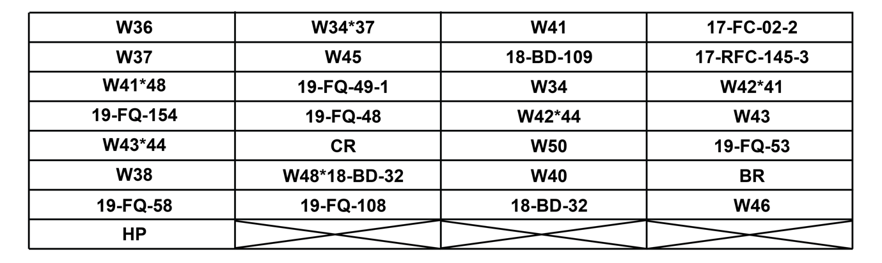
Supplementary Table S2. LC-MS parameters used to analyze glucosinolate concentration.
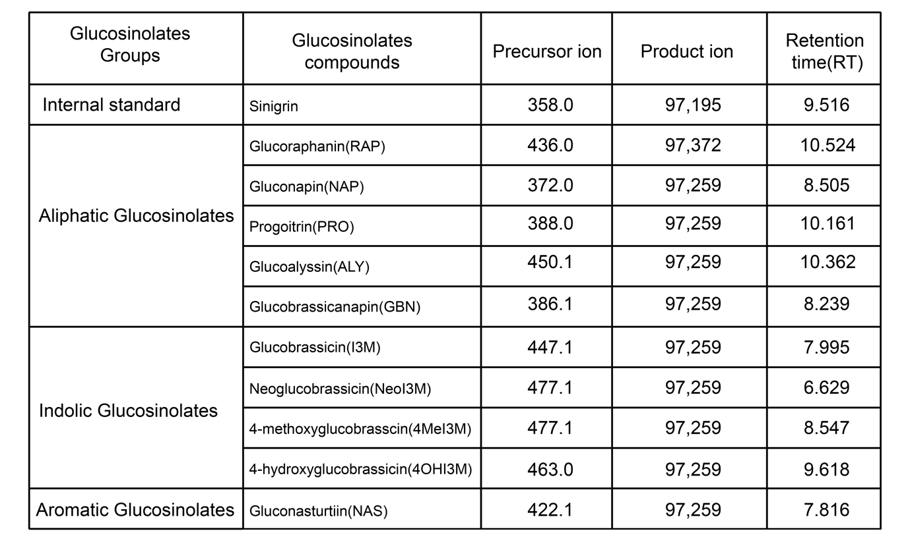

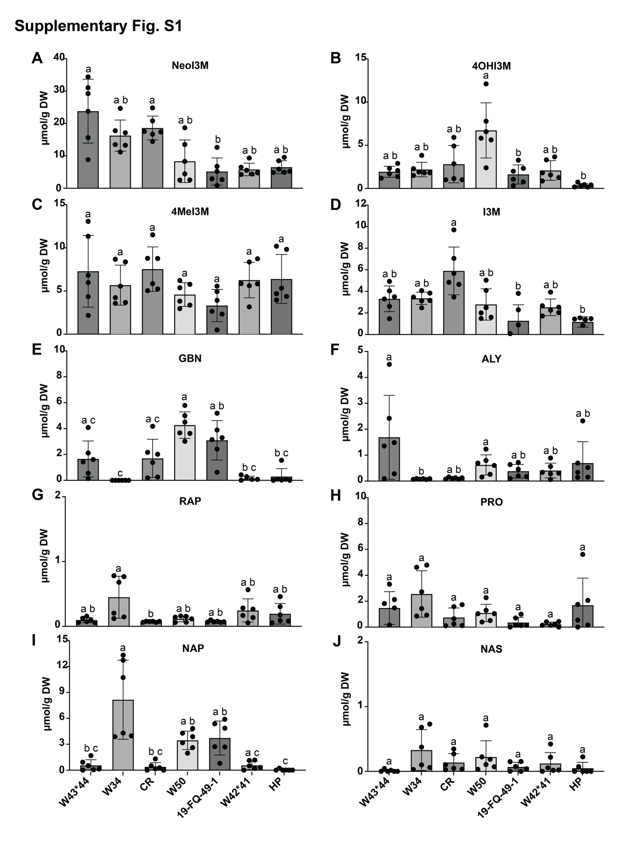
Supplementary Figure 1. Concentrations of glucosinolates in seven Chinese cabbage Cultivars.
Letters indicate significant differences (Friedman test followed by Dunn’s test, P < 0.05).

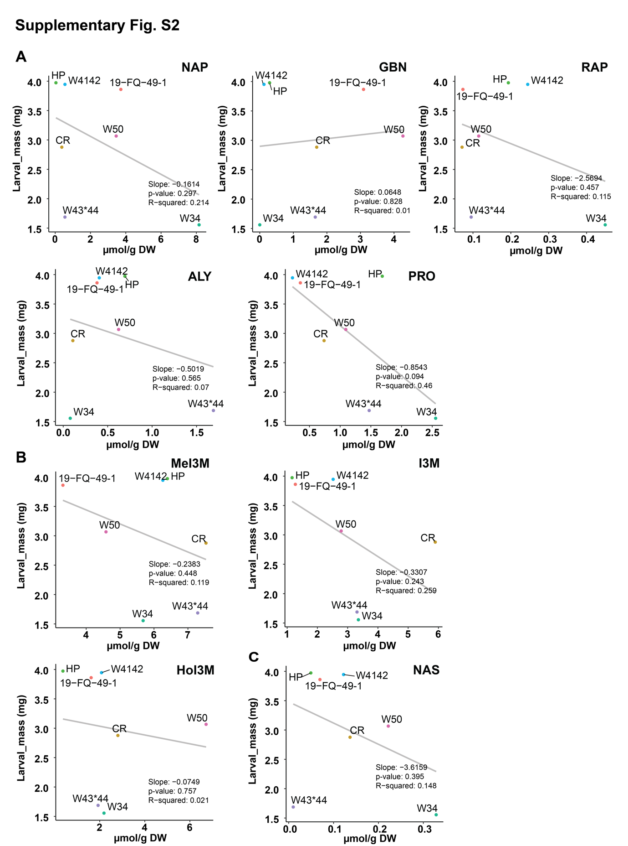
Supplementary Figure 2. Linear regression analysis of each glucosinolate and larval mass.

