Appendix A. Supporting information

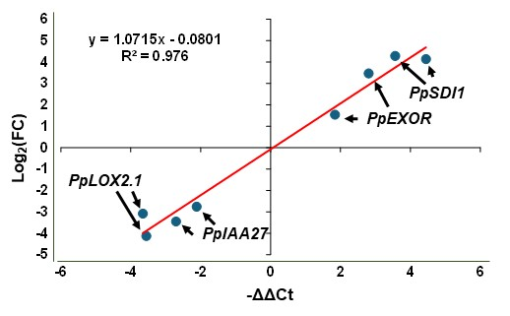
Supplementary Figure 1. Scatter plot between RNAseq (Log₂(FC)) and qRT-PCR (-ΔΔCt) of genes of interest.
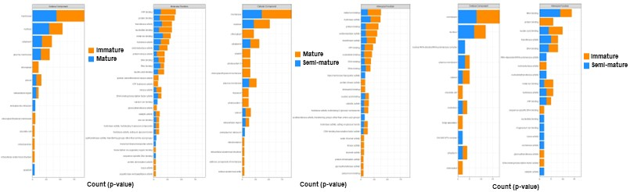
Supplementary Figure 2. GO enrichment analysis of cellular component and molecular function of DEGs under the various comparisons.

