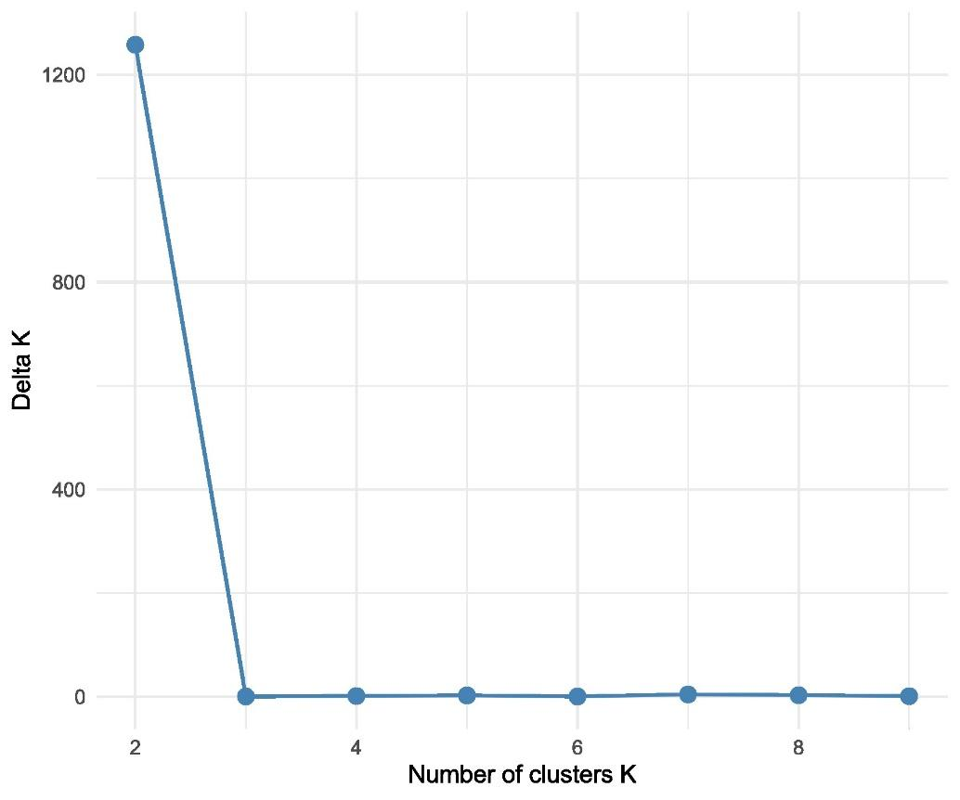
Supplementary Fig. S1 The most likely number of genetic clusters (K) within the VA-VC group, which was identified during the second round of the STRUCTURE analysis, was based on the method described by Evanno et al. (2005). K values ranging from 110 were derived from ten independent runs. The delta K graph indicates the maximum value at K = 2.
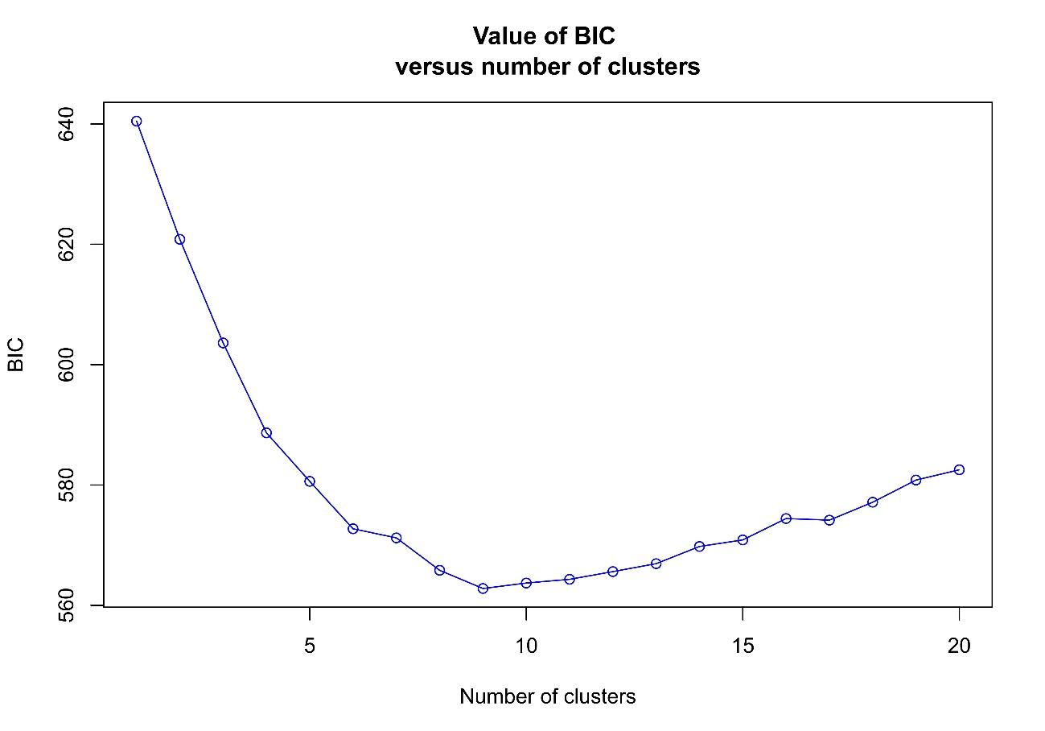
Supplementary Fig. S2 Bayesian information criterion (BIC) values for different numbers of clusters. The accepted true number of clusters was nine.

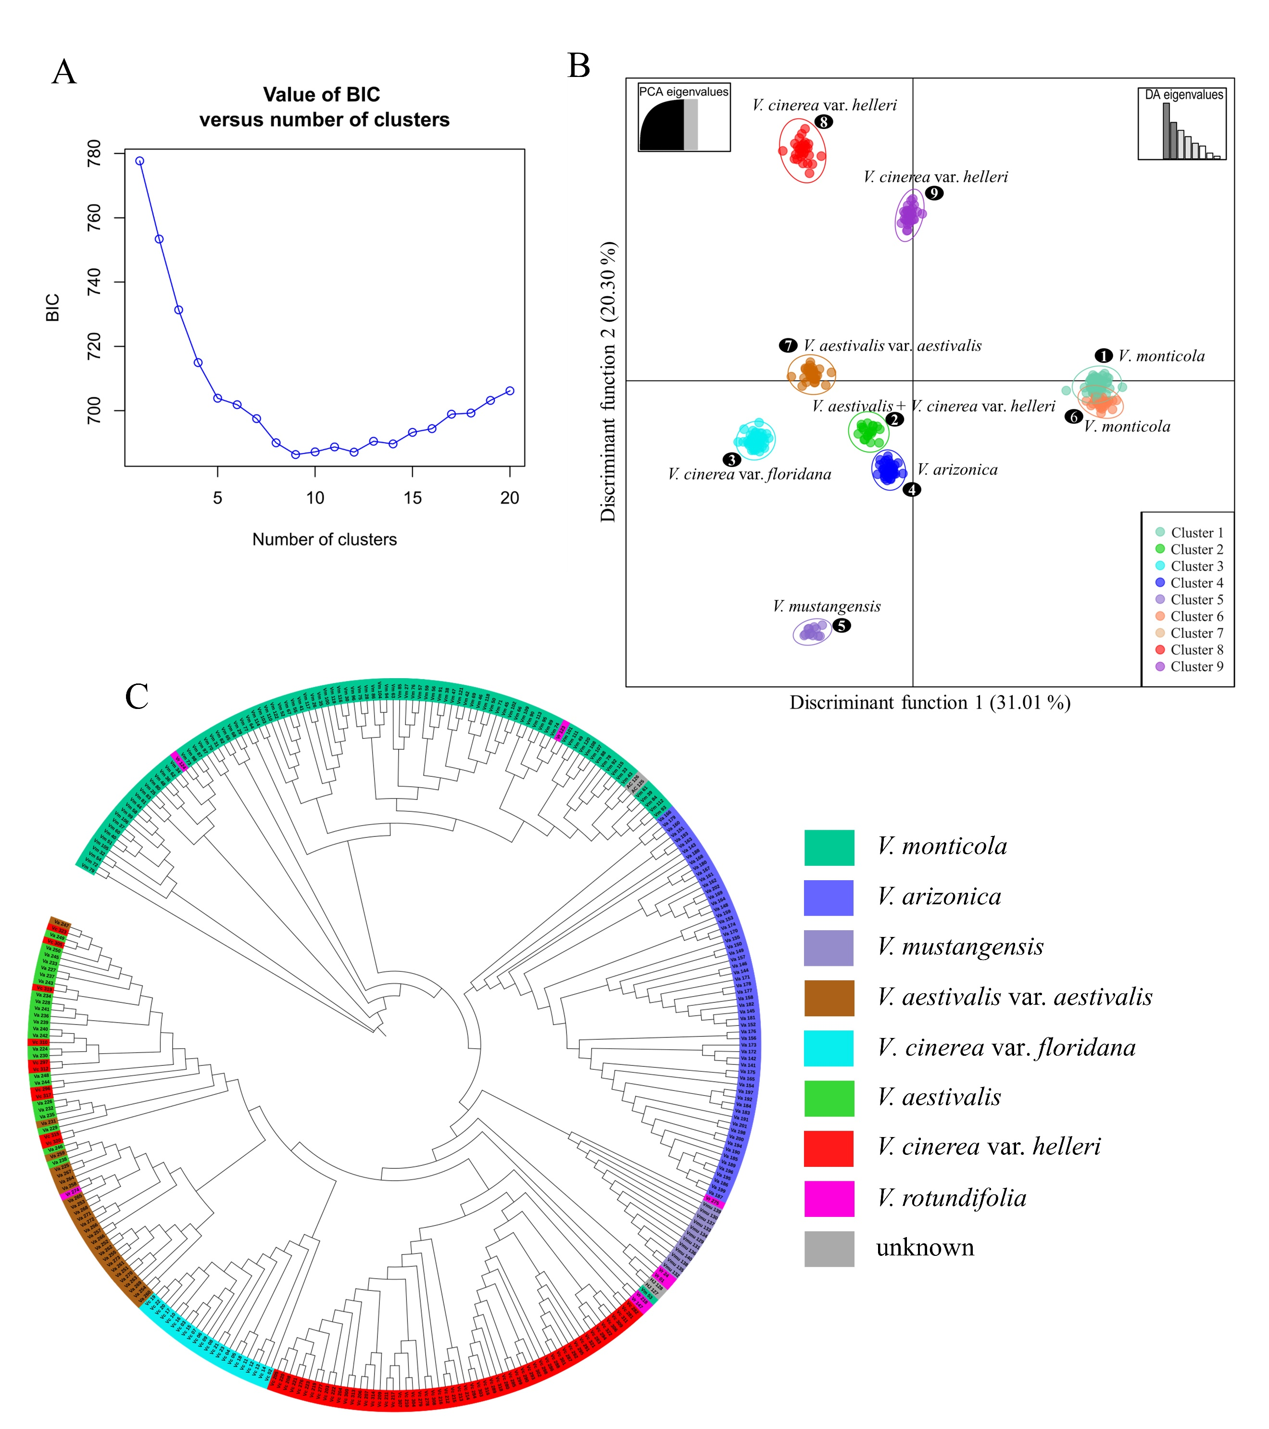

Supplementary Fig. S3 Genetic structure analysis of the Vitis spp. germplasm collection based on 25 SSR markers, after excluding the four loci with high null allele frequencies (VVMD32, GF05-13, CenGen6, and SC34-8). (A) Bayesian Information Criterion (BIC) values for different numbers of clusters, which indicate a value of nine as the optimal number of clusters (K = 9). (B) Scatterplot from Discriminant Analysis of Principal Components (DAPC) based on the K-means algorithm, which demonstrates the genetic differentiation among the 323 Vitis accessions. Each dot represents a single accession, with distinct colors indicating cluster membership. (C) Neighbor-Joining dendrogram illustrating the genetic relationships among the accessions. Cluster colors and labels match those used in the main figures to facilitate direct comparison.

Supplementary Table S4 Preliminary evaluation of downy mildew resistance in eight accessions from the FEM wild germplasm collection, based on OIV descriptor 452. Accessions were vegetatively propagated and grown in pots under greenhouse conditions. Five-month-old plants were inoculated by spraying a fresh suspension of P. viticola sporangia (1.2 × 10⁵ sporangia/mL) onto the leaf surface. The inoculum was obtained from susceptible V. vinifera varieties maintained in an untreated field, following the protocol described by Vezzulli et al. (2018). After inoculation, the plants were placed in a growth chamber at 24°C with 80% relative humidity. Downy mildew symptoms were assessed eight days after inoculation, and resistance levels were visually scored according to OIV descriptor 452, as recommended by the International Organisation of Vine and Wine (OIV 2022).
ID | Accession name | OIV 452 | Rpv-loci detected
42 | Vitis monticola_042 | 3/5 | Rpv3-1
104 | Vitis monticola_104 | 7 | Rpv3-1
137 | Vitis mustangensis_134 | 7 | Not detected
162 | Vitis arizonica_162 | 7 | Not detected
207 | Vitis cinerea var. helleri_207 | 5 | Rpv3-2
237 | Vitis aestivalis_237 | 5 | Rpv14, Rpv3-2
261 | Vitis aestivalis var. aestivalis_261 | 5 | Rpv14, Rpv3-3
264 | Vitis aestivalis var. aestivalis_264 | 7 | Rpv27

