Supplementary Materials

Horticulture, Environment, and Biotechnology

Photosynthetic performance and nutrient uptake of Lilium under salinity and drought stress

Ynna Park¹,Won Jun Jo¹, Hyun Hwan Jung², Yun-Im Kang², Hyo Beom Lee^{1, 3*}

¹Department of Agriculture Forestry and Bioresources, Seoul National University, Seoul 08826, Korea
²Floriculture Research Division, National Institute of Horticultural and Herbal Science, Wanju 55365, Korea
³Research Institute of Agriculture and Life Sciences Seoul National University, Seoul 08826, Korea

*Corresponding author: hyobumi1003@snu.ac.kr

The supporting information includes Table S1-2; Figures S1-4

S1.1. Automated irrigation system
The automated irrigation system was equipped with 12 soil moisture sensors (10HS; METER Group, Inc., USA) calibrated using linear regression to ensure precision (Fig. S1B). To automatically record VWC data at 10-s intervals, the sensors were connected to an AM16/32B multiplexer (Campbell Scientific Inc., Logan, UT, USA), which interfaced with a CR1000 datalogger. A relay driver (SDM-CD16AC; Campbell Scientific Inc., Logan, UT, USA) controlled solenoid valves based on preset VWC thresholds (±0.2%). Irrigation was triggered whenever VWC dropped below the threshold, and uniform water distribution was achieved using two shrubblers per box, each with a flow rate of 20 mL/min. The daily irrigation amount was calculated as the cumulative water supplied after reaching the VWC threshold. The system was programmed and monitored using the Loggernet 4.7 software (Campbell Scientific Inc., Logan, UT, USA).
Supplementary Tables
Table S1. Growth characteristics of Lilium LA Hybrid ‘Serrada’ under different substrate volumetric water contents (VWCs) (0.25, 0.35, 0.45, and 0.55 m³·m⁻³) and NaCl concentrations (0, 200, and 400 mM).
VWC^{z} | NaCl concentration | Bulb size | Root length | Number of | Leaf area | Mortality rate
(m^{3.}m⁻³) | (mM) | (cm) | (cm) | leaves | (cm²) | (%)
0.25 | 0 | 14.9 b–e^{y} | 15.7 ab | 52.3 a | 583.8 ab | 33.3 ab
 | 200 | 12.7 cde | 9.0 ab | 42.0 a | 342.9 bc | 46.7 bc
 | 400 | 10.0 e | 6.3 b | 0.0 b | 0.0 c | 66.7 a
0.35 | 0 | 16.0 b–e | 19.4 ab | 53.3 a | 593.1 ab | 0.0 c
 | 200 | 14.0 cde | 16.5 ab | 48.7 a | 455.9 abc | 20.0 bc
 | 400 | 11.7 de | 12.1 ab | 40.3 a | 401.5 abc | 26.7 b
0.45 | 0 | 21.7 ab | 32.6 a | 54.3 a | 772.5 ab | 0.0 c
 | 200 | 18.3 a–d | 22.6 ab | 49.3 a | 640.6 ab | 0.0 c
 | 400 | 16.8 a–d | 20.9 ab | 46.0 a | 593.3 ab | 0.0 c
0.55 | 0 | 23.3 a | 33.4 a | 55.3 a | 836.5 a | 0.0 c
 | 200 | 19.0 abc | 28.3 ab | 49.3 a | 598.7 ab | 0.0 c
 | 400 | 17.8 a–d | 25.8 ab | 48.0 a | 580.2 ab | 0.0 c
Significance^{x} | Water (W) | ∗∗∗ | ∗∗∗ | ∗∗∗ | ∗∗∗ | ∗∗∗
 | Salinity (S) | ∗∗∗ | ∗∗ | ∗∗∗ | ∗∗∗ | ∗∗
 | Water × Salinity (WS) | NS | NS | ∗∗∗ | ∗∗∗ | NS
^{z}VWC: volumetric water content
^{y}Different letters in the same row denote significant difference according to Tukey’s HSD test (α = 0.05).
^{x}NS, **, ***: nonsignificant or significant at P < 0.01 or 0.001, respectively.
Table S2. Flowering characteristics of Lilium LA Hybrid ‘Serrada’ under different substrate volumetric water contents (VWCs) (0.25, 0.35, 0.45, and 0.55 m³⋅m⁻³) and NaCl concentrations (0, 200, and 400 mM).
VWC^{z}  (m^{3.}m⁻³) | NaCl concentration  (mM) | Days to  flowering | Number of  buds | Flower width  (cm)
0.25 | 0 | 71.0 b^{y} | 2.0 | 14.9 cde
0.25 | 200 | 71.0 b | 2.4 | 14.5 de
0.25 | 400 | 74.0 a | 1.8 | 14.0 e
0.35 | 0 | 70.0 bc | 3.0 | 16.0 bcd
0.35 | 200 | 71.0 b | 2.1 | 16.5 abc
0.35 | 400 | 72.0 b | 1.9 | 15.3 cde
0.45 | 0 | 70.0 bc | 3.0 | 17.4 ab
0.45 | 200 | 71.0 b | 2.7 | 16.6 abc
0.45 | 400 | 72.0 b | 2.1 | 15.2 cde
0.55 | 0 | 68.0 c | 3.0 | 18.0 a
0.55 | 200 | 71.0 b | 2.7 | 17.5 ab
0.55 | 400 | 71.0 b | 2.5 | 17.3 ab
Significance^{x} | Water (W) | *** | * | ***
 | Salinity (S) | *** | *** | ***
 | Water × Salinity (WS) | *** | NS | ***
^{z}VWC: volumetric water content
^{y}Different letters in the same row denote significant difference according to Tukey’s HSD test (α = 0.05).
^{x}NS, *, ***: nonsignificant or significant at P < 0.05 or 0.001, respectively.

Supplementary Figures
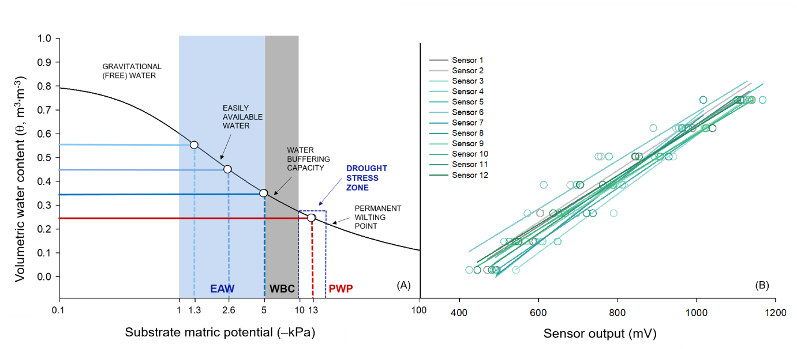
Fig. S1. The water retention curve of the substrate used in this study (A). The irrigation thresholds for volumetric water content (θ, m³·m⁻³) were set at 1.3, 2.6, 5.0, and 13.0 −kPa, corresponding to 0.55, 0.45, 0.35, and 0.25 m³·m⁻³, respectively. Each data point represents the association between irrigation set points and substrate matric potential (B). Calibration of 10HS sensors for precise measurement of volumetric water content (θ, m³·m⁻³).

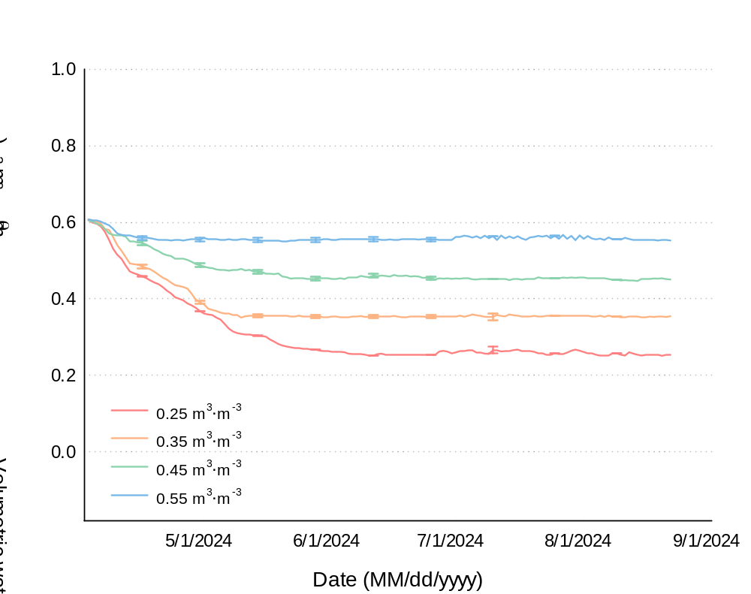

Fig. S2. Changes in volumetric water content (θ) for Lilium LA Hybrid ‘Serrada’ monitored over 161 days after planting using a soil moisture sensor–based automatic irrigation system. A datalogger monitored θ using soil moisture sensors, maintaining θ in four treatments (θ = 0.55, 0.45, 0.35, and 0.25 m³·m⁻³). The treatments reached their respective threshold θ values of 0.55, 0.45, 0.35, and 0.25 m³·m⁻³ after 8, 27, 31, and 68 days, respectively. The error bars indicate the standard error (n = 3).

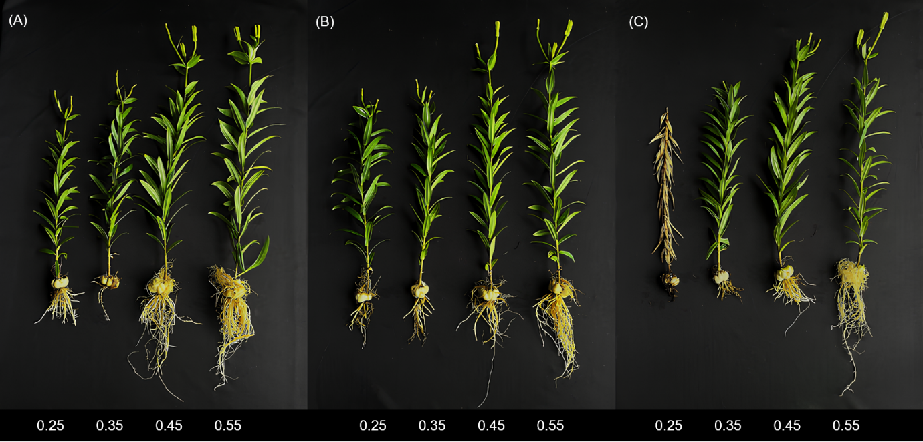

Fig. S3. Growth of Lilium LA Hybrid ‘Serrada’ at 161 days (A, B, C) under different volumetric water contents (0.25, 0.35, 0.45, and 0.55 m³·m⁻³) subjected to three treatments: 0, 200, and 400 mM NaCl.

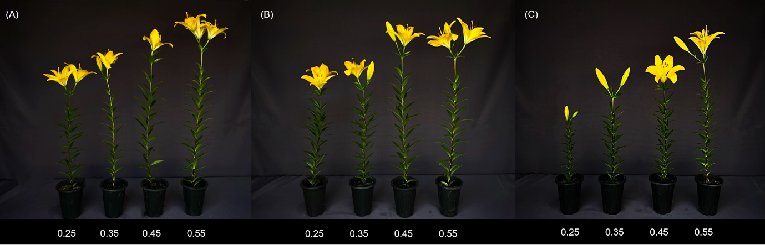

Fig. S4. Growth of Lilium LA Hybrid ‘Serrada’ at flowering (A, B, C) under different volumetric water contents (0.25, 0.35, 0.45, and 0.55 m³·m⁻³) subjected to three treatments: 0, 200, and 400 mM NaCl.

