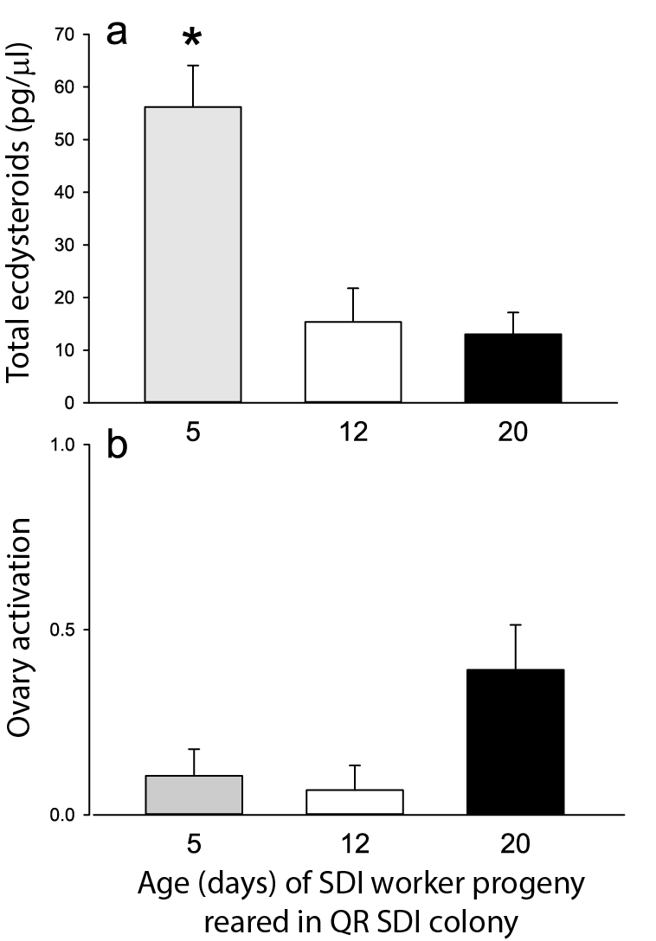

Hemolymph ecdysteroids and ovary activation in daughters of an SDI queen reared without manipulation in their SDI natal colony and collected at 5, 12, or 20 days of age. (Experiment 4). a. Ecdysteroid titers (mean ± standard error, pg/µL). b. Ovary activation by treatment (mean ± standard error). * denotes significant difference in Tukey-Kramer post hoc pairwise comparisons of 5, 12, and 20-day old workers, p < 0.0001. Sample sizes: 5 days (n = 19); 12 days (n = 15); 20 days (n = 23).

