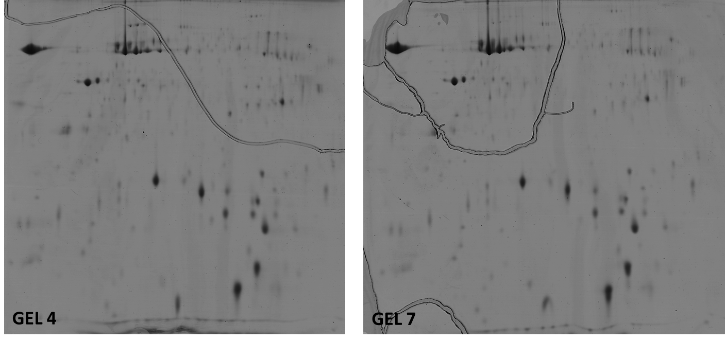
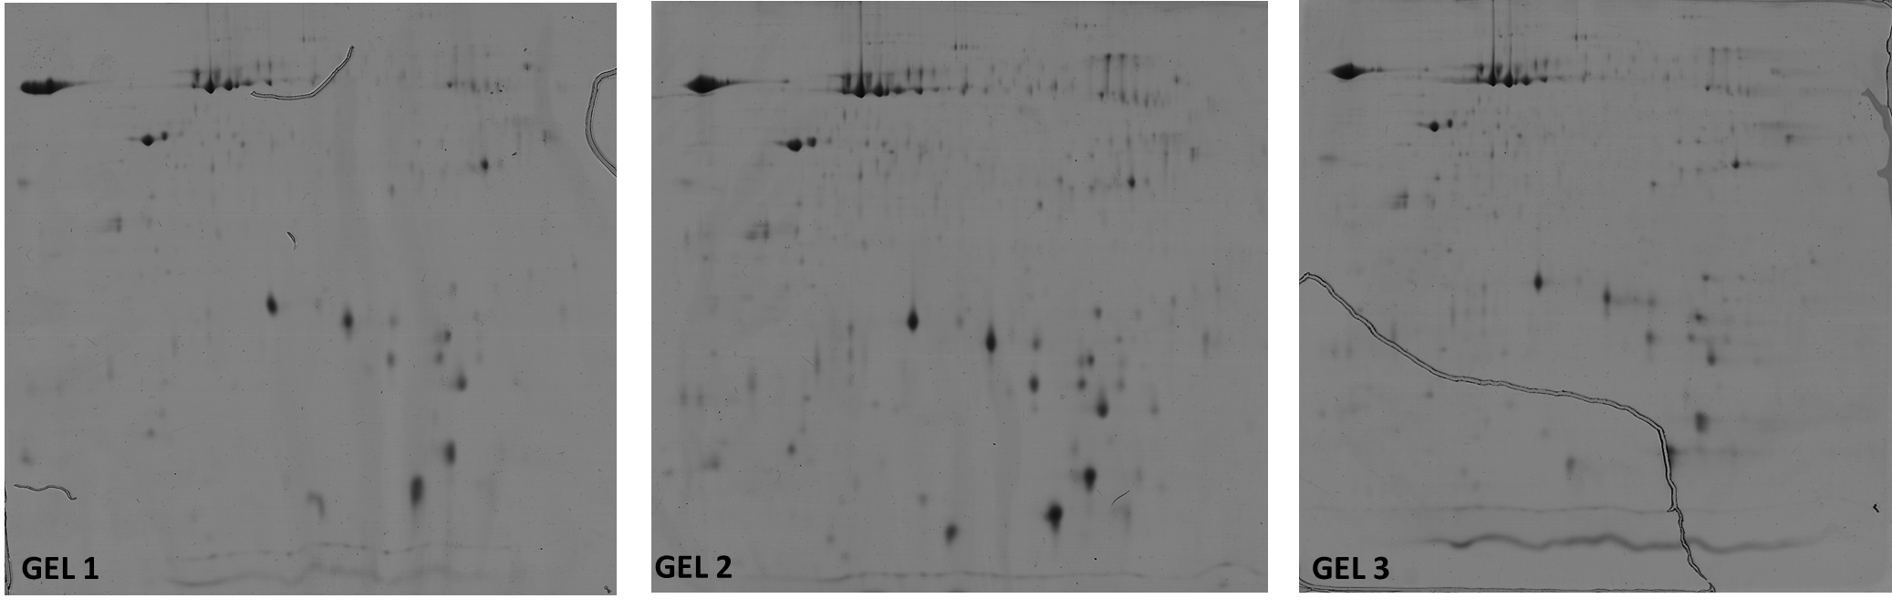

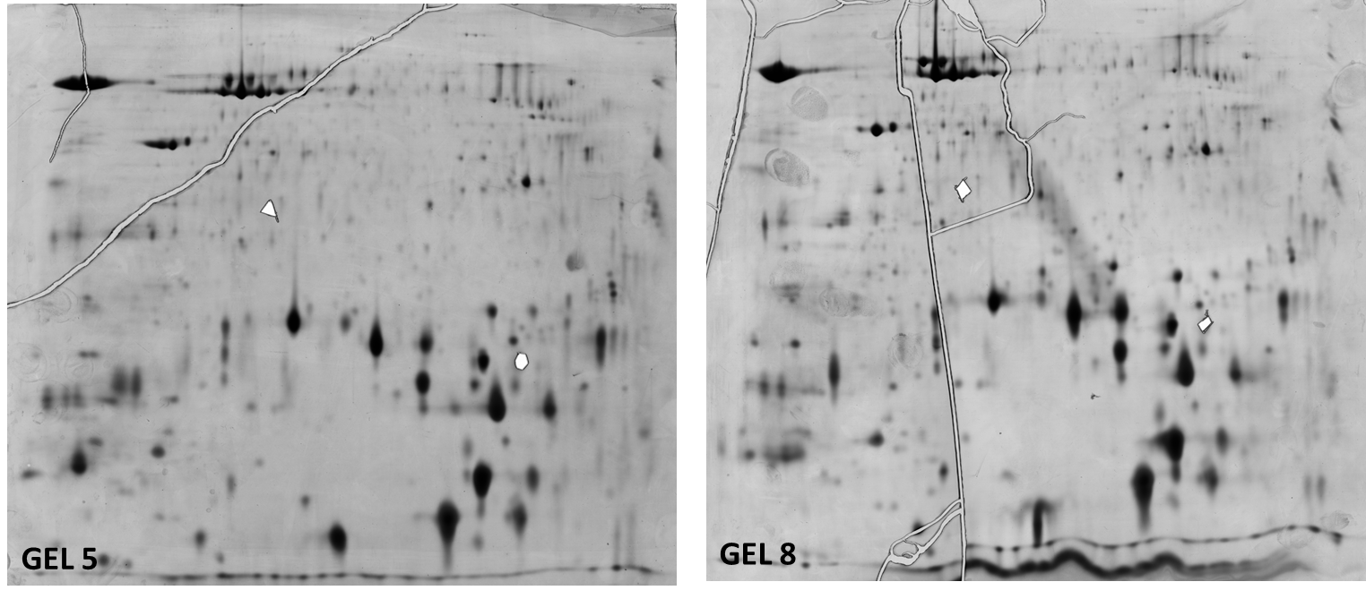

Figure S2. The 2D-DIGE gels stained with Coomassie Brilliant Blue R-250 (Gel 1-4 and 7) or silver-stained (Gel 5 and 8). Gels are referred to number (Gel 1 – Gel 9) presented in Supplementary Table S1. Such gels were used for manual protein spot picking.

