Supplementary material
Insights into Ethiopian honey bee diversity based on wing geomorphometric and mitochondrial DNA analyses
Teweldemedhn Gebretinsae Hailu*¹ ⁶, Paul D'Alvise¹, Adam Tofilski³, Stefan Fuchs⁵, Juergen Greiling⁴, Peter Rosenkranz², Martin Hasselmann¹
¹University of Hohenheim, Faculty of Agricultural Sciences, Institute of Animal Science, Department of Livestock Population Genomics, Garbenstraße 17, 70599 Stuttgart, Germany; ²University of Hohenheim, State Institute of Bee Research, August-von-Hartmann-Str. 13, 70599 Stuttgart, Germany; ³University of Agriculture in Krakow, Department of Zoology and Animal Welfare, Poland; ⁴Ethiopian Apicultural Board, Legehar, Churchill Avenue, Tekilu Desta Bldg, P.O.Box 2307 Addis Ababa, Ethiopia; ⁵Goethe University Frankfurt am Main, Oberursel Bee Research Institute, Karl-von-Frisch-Weg 2, 61440 Oberursel, Germany; ⁶Aksum University, Faculty of Agriculture, Department of Animal Sciences; P.O.Box 314 Shire, Ethiopia
*teweldemedhng.hailu@uni-hohenheim.de
Supplementary tables
Table S1: References sequences included in phylogenetic analysis; accessed from NCBI

Subspecies | Haplotype | Accession
A.m.jemenitica | KSA4c | KC149981
 | O5a | EU785974
 | O5' | EU785977
A.m.jemenitica | KSA4d | KC149982
 | O5d | FJ743632
 | O5 | FJ743633
A.m.jemenitica | KSA5 | KC149985
 | M3 | FJ743636
 | M4 | FJ743637
 | M2 | FJ743635
 | C2g | FJ357807
 | C2f | FJ357806
A.m.monticola | voucher 1626 | MF678581
A.m.scutellata | voucher 1982 | KY614238
A.m.scutellata | voucher KR | MG552699
 | A1 | EF033649
A.m.jemenitica | Y1b | FJ477999
A.m.jemenitica | Y1a | FJ477998
A.m.jemenitica | Y2b | FJ478001
A.m.jemenitica | Y2a | FJ478000
A.m.jemenitica | Y2d | FJ478003

Table S2. Lineage classification (presented in diverging order) and squared Mahalanobis distance between this study sample colonies and the reference lineages A, C, M, O and Y. Most of the samples were classified as lineage Y, which was also the closest in terms of squared Mahalanobis distance.

colony | classified as (in diverging order) |  |  |  |  | Squared Mahalanobis distance
colony | 1 | 2 | 3 | 4 | 5 | Y | A | O | C | M
111 | Y | A | C | O | M | 39.71 | 77.8 | 130.01 | 129.26 | 167.09
112 | Y | A | O | C | M | 78.89 | 104.13 | 138.1 | 161.91 | 184.36
113 | Y | A | C | O | M | 56.35 | 79.07 | 122.79 | 105.37 | 137.17
114 | Y | A | O | C | M | 35.67 | 66.16 | 112.51 | 137.56 | 174.3
115 | Y | A | M | O | C | 47.14 | 84.29 | 156.66 | 160.81 | 139.22
116 | Y | A | O | C | M | 48.97 | 80.47 | 141.67 | 149.41 | 183.54
121 | Y | A | O | C | M | 44.17 | 63.19 | 90.74 | 95.36 | 165.29
122 | A | Y | O | C | M | 62.5 | 50.61 | 78.39 | 119.54 | 148.76
123 | Y | A | O | C | M | 42.53 | 75.15 | 109.07 | 129.03 | 206.75
124 | Y | A | O | C | M | 35.1 | 78.46 | 137.68 | 148.17 | 224.15
125 | Y | A | O | C | M | 37.97 | 75.47 | 124.68 | 152.59 | 217.87
126 | Y | A | O | C | M | 40.57 | 65.62 | 110.14 | 122.33 | 168.77
131 | Y | A | O | C | M | 30.52 | 59.95 | 110.14 | 114.38 | 145.71
132 | Y | A | O | M | C | 70.09 | 81.87 | 138.18 | 183.36 | 173.76
133 | Y | A | C | O | M | 32.17 | 51.77 | 112.61 | 105.73 | 149.93
134 | Y | A | C | O | M | 29.02 | 41.89 | 105.45 | 93.38 | 153.55
135 | Y | A | O | C | M | 43.04 | 54.86 | 109.81 | 118.28 | 143.18
136 | Y | A | O | C | M | 53.15 | 74.33 | 102.82 | 128.41 | 187.92
211 | Y | A | C | O | M | 55.98 | 84.57 | 111.66 | 104.07 | 211.95
212 | Y | A | O | C | M | 40.12 | 82.44 | 134.86 | 146.38 | 202.82
213 | Y | A | O | C | M | 48.39 | 74.54 | 103.73 | 136.95 | 191.5
214 | Y | A | O | C | M | 38.45 | 45.64 | 86.09 | 90.16 | 173.5
215 | Y | A | O | C | M | 53.09 | 55.8 | 87.38 | 91.87 | 182.76
216 | Y | A | O | C | M | 50.07 | 69.73 | 109.1 | 111.23 | 189.71
221 | Y | A | O | C | M | 87.51 | 121.53 | 141.72 | 170.96 | 267.13
222 | Y | A | O | C | M | 52.41 | 80.63 | 129.5 | 149.6 | 250.03
223 | Y | A | O | C | M | 39.86 | 58.19 | 87.56 | 132.66 | 191.16
224 | Y | A | O | C | M | 52.73 | 73.29 | 112.43 | 123.51 | 198.05
225 | Y | A | C | O | M | 38.62 | 76.27 | 139.59 | 121.09 | 215.67
226 | Y | A | O | C | M | 39.55 | 46.28 | 80.16 | 105.68 | 183.27
231 | Y | A | C | O | M | 43.96 | 46.55 | 90.77 | 65.45 | 135.83
232 | Y | A | O | C | M | 36.33 | 50.84 | 97.39 | 102.43 | 145.88
233 | A | O | Y | C | M | 77.19 | 60.45 | 73.61 | 94.15 | 165.18
234 | Y | A | C | O | M | 57.53 | 88.19 | 122.54 | 120.49 | 206.57
235 | Y | A | O | C | M | 64.63 | 89.75 | 127.17 | 128.21 | 214.57
236 | A | Y | C | O | M | 56.08 | 46.81 | 84.8 | 73.1 | 167.16
311 | Y | A | O | C | M | 68.46 | 80.4 | 106.36 | 129.37 | 212.29
312 | Y | A | O | C | M | 55.08 | 62.35 | 94.13 | 96.14 | 180.48
313 | Y | A | O | C | M | 46.41 | 53.75 | 101.82 | 120.15 | 160.68
314 | Y | A | C | O | M | 57.52 | 83.28 | 150.48 | 139.73 | 206.79
315 | Y | A | O | C | M | 46.99 | 77.37 | 112.31 | 137.61 | 227.77
316 | Y | A | O | C | M | 31.53 | 47.2 | 106.1 | 112.29 | 151.01
321 | Y | A | C | O | M | 44.94 | 57.11 | 100.39 | 99.54 | 157.53
322 | Y | A | O | C | M | 37.5 | 51.47 | 102.9 | 116.77 | 197.41
323 | Y | A | O | C | M | 29.59 | 47.47 | 107.45 | 114.15 | 166.68
324 | Y | A | C | O | M | 36.32 | 73.52 | 143.78 | 136.8 | 222.62
325 | Y | A | C | O | M | 26.91 | 59.07 | 132.33 | 123.79 | 202.49
326 | Y | A | O | C | M | 69.93 | 92.17 | 137.14 | 150.62 | 217.17
331 | A | Y | C | O | M | 48.16 | 47.33 | 103.38 | 96.98 | 119.72
332 | Y | A | O | C | M | 36.4 | 56.15 | 88.2 | 101.39 | 150.05
333 | Y | A | C | O | M | 39.33 | 64.75 | 112.58 | 101.82 | 173.56
334 | Y | A | C | O | M | 24.15 | 62 | 120.83 | 107.08 | 165.44
335 | A | Y | O | C | M | 44.86 | 39.33 | 71.76 | 96.16 | 130.59
336 | Y | A | O | C | M | 50.64 | 68.78 | 123.49 | 143.48 | 201.69
411 | Y | A | O | C | M | 51.88 | 75.03 | 110.87 | 126.17 | 179.71
412 | Y | A | C | O | M | 57.98 | 74.74 | 108.92 | 104.45 | 187.06
413 | Y | A | O | C | M | 62.29 | 89.76 | 136.14 | 148.94 | 237.28
414 | Y | A | C | O | M | 48.7 | 76.51 | 115.63 | 102.76 | 208.82
415 | Y | A | O | C | M | 52.65 | 76.57 | 110.38 | 113.47 | 160.76
416 | Y | A | O | C | M | 32.41 | 65.04 | 111.89 | 126.83 | 185.52
421 | Y | A | O | C | M | 37.01 | 58 | 118.95 | 120.77 | 147.91
422 | A | Y | O | C | M | 52.99 | 50.08 | 99.42 | 115.42 | 165.93
423 | Y | A | O | C | M | 43.96 | 67.09 | 108.74 | 127.79 | 158.09
424 | Y | A | C | O | M | 32.25 | 66.87 | 120.08 | 96.64 | 184.95
425 | Y | A | C | O | M | 29.76 | 63.43 | 118.06 | 108.86 | 186.18
426 | Y | A | C | O | M | 48.43 | 86.28 | 149.42 | 123.07 | 158.2

Table S3. Classification of this study sample colonies into their respective honey bee subspecies. Most of them were classified as A.m.simensis. Sample colonies are represented by 3 digit identification numbers.
Colony | Classified to subspecies as (in diverging order)
Colony | 1 | 2 | 3 | 4 | 5 | 6 | 7 | 8 | 9 | 10 | 11 | 12
111 | sim⁷¹ | scu¹¹⁷ | mon¹²¹ | yem¹²⁵ | lit¹⁴¹ | ada¹⁴⁴ | Cap¹⁵⁴ | uni¹⁸⁴ | lam¹⁸⁸ | rut¹⁹⁸ | int¹⁹⁹ | sah²¹⁹
112 | uni¹¹² | sim¹³⁵ | mon¹⁴⁷ | scu¹⁵⁷ | ada¹⁹⁰ | lit¹⁹⁴ | cap¹⁹⁵ | yem²⁰³ | sah²²⁴ | lam²²⁸ | int²³¹ | rut³¹¹
113 | sim⁷¹ | ada¹²⁷ | scu¹³⁵ | mon¹⁴¹ | yem¹⁵⁵ | lit¹⁷⁰ | cap²⁰² | int²⁰⁵ | uni²¹⁶ | sah²¹⁹ | lam²⁴⁵ | rut²⁷⁸
114 | sim⁶¹ | scu⁸⁴ | mon⁹³ | ada⁹⁶ | lit¹²³ | sah¹³⁹ | uni¹⁴⁴ | yem¹⁵² | int¹⁵⁶ | cap¹⁶² | lam¹⁷⁷ | rut²⁷⁷
115 | sim⁵⁰ | mon⁹² | scu¹¹⁷ | ada¹²⁹ | yem¹³⁵ | lit¹⁴³ | cap¹⁴⁸ | uni¹⁴⁹ | lam¹⁶² | int¹⁷⁰ | sah¹⁸⁴ | rut²⁴⁰
116 | sim¹⁰⁴ | mon¹⁰⁴ | scu¹¹⁹ | lam¹⁴³ | cap¹⁴⁸ | ada¹⁴⁹ | yem¹⁵³ | lit¹⁵⁵ | uni¹⁸¹ | sah¹⁹¹ | int²¹⁰ | rut²⁴¹
121 | sim⁶⁰ | scu⁸⁶ | mon⁹⁶ | yem¹⁰⁹ | ada¹¹⁴ | lit¹²² | cap¹²³ | uni¹⁵⁰ | sah¹⁷⁰ | int¹⁷³ | lam¹⁷⁹ | rut²⁰⁷
122 | sim⁷¹ | ada⁹⁶ | scu⁹⁸ | mon¹⁰⁴ | yem¹⁰⁶ | cap¹²² | lit¹²³ | sah¹²⁷ | int¹⁴⁷ | uni¹⁵⁵ | lam¹⁹² | rut¹⁹⁵
123 | sim¹⁰³ | yem¹³⁵ | mon¹⁴² | scu¹⁴⁵ | ada¹⁵⁶ | lit¹⁶⁶ | cap¹⁶⁷ | uni¹⁹¹ | lam²⁰⁶ | sah²¹⁸ | rut²²⁸ | int²⁴⁵
124 | sim⁷⁵ | mon⁹⁶ | scu¹³² | yem¹³⁵ | ada¹³⁶ | lit¹⁵² | cap¹⁶⁰ | lam¹⁷⁵ | sah¹⁸⁸ | uni¹⁹¹ | rut²²³ | int²³³
125 | sim⁵⁵ | scu⁸² | ada⁸⁹ | mon⁹² | yem¹⁰⁷ | lit¹¹⁴ | cap¹³³ | sah¹⁴⁶ | lam¹⁶⁶ | uni¹⁶⁶ | int¹⁷⁵ | rut¹⁸⁴
126 | sim⁷⁰ | scu⁹³ | mon⁹⁴ | ada¹¹⁵ | yem¹²³ | cap¹³² | lit¹³⁴ | uni¹⁴³ | lam¹⁶⁵ | sah¹⁷⁰ | int¹⁹¹ | rut²⁰⁵
131 | sim⁴⁹ | scu⁸³ | mon⁹¹ | ada¹⁰⁷ | lit¹¹⁴ | yem¹¹⁶ | cap¹²⁶ | uni¹²⁷ | int¹⁴⁴ | sah¹⁴⁷ | lam¹⁷⁰ | rut²³⁵
132 | sim⁶⁹ | mon¹⁰¹ | scu¹²⁴ | ada¹²⁵ | uni¹²⁷ | lit¹³⁵ | yem¹³⁹ | cap¹⁴⁵ | sah¹⁵³ | int¹⁶⁹ | lam¹⁸⁶ | rut²³⁸
133 | sim⁵³ | scu⁸² | ada⁸³ | mon¹⁰⁴ | yem¹¹³ | sah¹¹⁵ | lit¹²³ | int¹²⁴ | cap¹³³ | lam¹⁷⁰ | uni¹⁷⁹ | rut¹⁹⁴
134 | sim⁴⁹ | scu⁶⁴ | ada⁷⁷ | mon⁸⁸ | yem⁹⁴ | lit¹⁰² | cap¹⁰⁷ | sah¹¹⁷ | int¹¹⁹ | uni¹⁴⁶ | lam¹⁶⁶ | rut¹⁷¹
135 | sim⁴⁷ | mon⁶⁵ | scu⁷⁷ | ada⁸⁹ | lit¹¹⁸ | yem¹²⁰ | uni¹²⁸ | cap¹⁴⁴ | sah¹⁵⁴ | lam¹⁵⁸ | int¹⁷¹ | rut²⁶⁵
136 | sim⁹² | scu⁹⁸ | mon¹¹⁷ | cap¹¹⁹ | ada¹²⁸ | yem¹³⁰ | lit¹⁴⁹ | uni¹⁶⁷ | int¹⁶⁹ | lam¹⁸⁰ | sah¹⁸⁸ | rut²¹⁹
211 | scu¹⁰² | sim^{135.7} | mon^{135.8} | ada¹⁴³ | lit¹⁵⁸ | yem¹⁶⁸ | uni¹⁷⁹ | cap¹⁸⁴ | lam¹⁸⁸ | sah²²⁶ | int²⁶⁴ | rut³⁰⁹
212 | sim⁶⁹ | scu¹⁰⁷ | mon¹¹⁶ | ada¹²⁷ | lit^{166.5} | yem^{167.3} | cap^{168.9} | sah^{169.2} | uni¹⁷⁰ | int¹⁸⁶ | lam²⁰⁰ | rut²²⁵
213 | sim⁸¹ | scu⁸³ | mon⁹⁰ | ada¹⁰⁹ | yem¹²⁶ | lit¹³⁰ | cap¹⁴⁵ | uni¹⁶⁹ | lam¹⁷⁵ | sah¹⁹⁴ | int²²⁵ | rut²⁵⁸
214 | scu⁶⁹ | mon⁷⁵ | sim⁸¹ | ada⁹⁵ | uni¹⁰³ | lit¹¹¹ | yem¹²⁴ | cap¹⁴⁷ | sah¹⁴⁸ | lam¹⁸² | int²¹² | rut²⁶⁷
215 | sim⁹⁸ | scu⁹⁵ | mon⁹⁷ | ada¹⁰² | yem¹⁰² | lit¹²³ | uni¹³³ | cap¹³⁹ | sah¹⁴⁹ | int¹⁹⁰ | lam¹⁹⁶ | rut²²⁰
216 | Sim¹⁰⁸ | scu¹²³ | mon¹²⁶ | uni¹⁵² | ada¹⁵³ | yem¹⁶⁰ | sah^{176.1} | cap^{176.3} | lit¹⁷⁹ | lam²¹⁸ | int²⁴² | rut²⁹⁵
221 | sim¹²⁸ | scu¹⁶⁸ | mon¹⁷⁹ | ada¹⁹⁰ | yem¹⁹² | cap²²³ | lit²²⁴ | lam²⁵⁰ | uni²⁵⁷ | sah²⁶¹ | int²⁷⁸ | rut³³⁵
222 | sim⁶⁷ | scu⁸¹ | mon⁹² | ada⁹³ | lit⁹⁹ | yem¹⁰⁴ | cap¹²³ | lam¹⁴² | int¹⁴⁸ | sah¹⁵³ | rut¹⁶⁶ | uni¹⁷³
223 | sim⁷⁹ | mon⁸⁹ | scu⁸⁹ | yem⁹³ | ada⁹⁸ | cap¹¹⁴ | lit¹¹⁴ | lam¹¹⁷ | uni¹⁴³ | int¹⁵⁵ | sah¹⁶⁴ | rut²¹²
224 | sim⁸¹ | ada⁸⁸ | scu⁹⁵ | yem¹⁰⁵ | lit¹⁰⁹ | mon¹¹⁵ | cap¹³⁵ | lam¹⁸⁰ | int¹⁹⁷ | sah²⁰¹ | rut²⁰¹ | uni²⁰³
225 | sim⁶⁶ | scu¹⁰⁹ | mon¹²⁰ | ada¹²⁵ | lit¹⁶⁶ | yem¹⁷³ | uni¹⁸¹ | cap¹⁸⁷ | sah1⁸⁷ | int²⁰⁷ | lam²²³ | rut²⁶⁰
226 | scu⁴⁷ | sim⁵² | mon⁶⁴ | ada⁶⁸ | yem⁸¹ | lit⁸⁴ | cap⁹¹ | sah¹¹⁸ | uni¹¹⁹ | lam¹⁴⁰ | int¹⁴² | rut¹⁸⁸
231 | sim⁵⁸ | scu⁹⁸ | ada⁷² | mon⁹² | yem⁹⁶ | lit¹⁰² | int¹¹⁸ | cap¹²⁰ | lam¹⁴⁶ | sah¹⁶⁶ | uni¹⁶⁹ | rut¹⁷⁷
232 | sim⁵¹ | ada⁷⁷ | mon⁷⁸ | scu78 | yem¹²¹ | lit¹²² | cap¹⁴⁰ | int¹⁵⁸ | lam¹⁶⁴ | uni¹⁷² | sah¹⁷² | rut²⁵²
233 | scu⁷⁸ | yem⁸⁵ | sim⁹¹ | ada⁹⁴ | mon¹⁰⁴ | lit¹⁰⁷ | cap¹¹³ | int¹⁴⁸ | uni¹⁵² | lam¹⁵⁷ | sah¹⁷⁹ | rut²⁰¹
234 | sim⁹¹ | ada¹⁴⁴ | scu¹⁴⁵ | mon¹⁵⁰ | yem¹⁸¹ | lit¹⁹³ | int²¹⁰ | lam²¹³ | cap²¹⁶ | rut²⁹⁰ | uni²⁴⁶ | sah²⁶²
235 | sim⁹⁰ | ada¹³⁰ | scu¹³¹ | mon¹⁵² | yem¹⁶⁸ | lit¹⁸⁶ | cap¹⁹⁰ | sah²⁰⁸ | int²¹³ | uni²³¹ | lam²³⁵ | rut³³⁴
236 | scu53 | mon⁷⁷ | sim⁸² | ada⁹⁰ | cap¹⁰⁰ | lit¹⁰⁴ | yem¹⁰⁹ | uni¹⁴⁶ | int¹⁵³ | lam¹⁵⁷ | sah¹⁶³ | rut¹⁷⁹
311 | scu¹²⁶ | mon¹³⁹ | sim¹⁵⁰ | cap¹⁶³ | ada¹⁶⁸ | lit¹⁷¹ | yem¹⁷⁹ | lam²⁰¹ | uni²⁰³ | rut²⁰⁶ | int²⁵⁰ | sah²⁹⁶
312 | sim⁷⁴ | yem¹¹⁰ | mon¹¹² | ada¹¹³ | scu¹¹⁸ | lit¹³⁸ | cap¹⁵¹ | uni¹⁷² | sah¹⁷⁸ | lam¹⁸² | int²⁰⁵ | rut²³⁰
313 | mon⁷⁹ | sim⁸⁰ | scu¹⁰⁶ | ada¹¹⁹ | lit¹³¹ | yem¹⁴³ | uni¹⁴⁴ | cap¹⁴⁴ | lam¹⁷⁴ | sah¹⁸⁵ | int²¹¹ | rut²⁴⁷
314 | sim⁷⁴ | ada¹²⁰ | scu¹²⁵ | mon¹³⁷ | yem¹⁴⁵ | lit¹⁵⁶ | cap¹⁸² | int²¹⁴ | uni²¹⁵ | sah²¹⁹ | lam²²¹ | rut²²⁵
315 | sim⁴⁹ | ada⁸⁹ | scu⁹⁴ | mon⁹⁴ | lit¹¹⁰ | yem¹¹¹ | cap¹⁴¹ | uni¹⁴² | int¹⁴⁷ | sah¹⁴⁸ | lam¹⁹⁵ | rut¹⁹⁸
316 | sim⁵² | mon⁷¹ | scu⁸⁷ | ada¹⁰⁵ | lit¹⁰⁷ | yem¹¹¹ | cap¹¹⁶ | uni¹⁵⁸ | int¹⁷¹ | lam¹⁷⁵ | sah¹⁸¹ | rut¹⁸⁷
321 | sim⁶³ | scu⁸⁶ | mon⁹³ | ada¹⁰⁴ | yem¹¹⁷ | cap¹²¹ | lit¹²⁹ | int¹⁴⁸ | uni¹⁵⁶ | lam¹⁷⁷ | sah¹⁸⁴ | rut¹⁸⁸
322 | sim⁶¹ | scu⁶⁶ | mon⁶⁸ | ada⁸⁴ | lit¹⁰⁴ | yem¹⁰⁵ | cap¹²⁵ | sah¹⁴⁷ | lam¹⁵¹ | int¹⁶⁷ | uni¹⁷³ | rut¹⁸⁵
323 | sim⁴³ | mon⁹² | scu⁹⁵ | ada¹⁰⁸ | yem¹¹² | lit¹¹⁷ | uni¹²⁰ | cap¹²² | int¹³⁹ | sah¹⁵¹ | rut¹⁶⁸ | lam¹⁷¹
324 | sim⁶³ | mon¹²⁶ | scu¹³⁰ | yem¹⁵² | cap¹⁵³ | ada¹⁵⁵ | lit¹⁷³ | int¹⁸⁷ | uni¹⁹⁴ | sah²⁰² | rut^{207.6} | lam^{208.4}
325 | sim⁴² | mon⁹⁴ | scu⁹⁵ | yem⁹⁸ | ada¹⁰⁷ | lit¹¹⁹ | cap¹²¹ | sah¹⁵¹ | int¹⁵³ | uni¹⁵⁵ | lam¹⁵⁶ | rut¹⁸³
326 | sim¹¹⁰ | mon¹²³ | scu¹²⁶ | ada¹⁵⁰ | yem¹⁷⁶ | uni¹⁷⁸ | lit¹⁸² | cap¹⁸² | lam¹⁸⁶ | int²²⁹ | sah²⁵⁶ | rut²⁷⁰
331 | sim⁶⁹ | scu⁸² | ada⁸³ | mon¹⁰⁶ | lit¹²⁶ | yem¹³² | cap¹³⁵ | uni¹⁵⁴ | int¹⁵⁶ | sah¹⁷¹ | lam¹⁸⁵ | rut²²⁸
332 | sim⁵⁵ | ada⁷⁷ | scu⁸³ | mon⁹⁷ | yem¹¹³ | lit¹¹⁶ | cap¹⁵⁰ | sah¹⁶⁴ | lam¹⁶⁵ | int¹⁷³ | uni¹⁸⁹ | rut²³¹
333 | sim⁸⁵ | ada¹⁴³ | scu¹⁴⁵ | mon¹⁶⁷ | yem¹⁷³ | lit¹⁹⁵ | cap²⁰⁶ | int²¹⁵ | sah²²⁶ | uni²⁶⁰ | lam²⁶⁵ | rut²⁸⁴
334 | sim⁴³ | scu¹¹⁹ | ada¹²⁹ | mon¹³² | yem¹⁴⁰ | lit¹⁵⁷ | cap¹⁶⁰ | int¹⁸³ | uni¹⁸⁶ | sah²¹⁴ | lam²³⁵ | rut²³⁷
335 | sim⁷⁴ | ada⁸⁵ | scu⁹⁶ | yem¹⁰⁹ | lit¹¹⁴ | mon¹²⁰ | cap¹⁵² | sah¹⁵⁶ | int¹⁶⁴ | uni¹⁹³ | lam²²⁵ | rut²²⁶
336 | sim⁸⁷ | scu⁸⁸ | yem¹⁰⁶ | ada¹¹³ | mon¹¹⁸ | cap¹²¹ | lit¹²⁹ | lam¹⁴⁷ | rut¹⁶¹ | int¹⁶¹ | uni¹⁷⁷ | sah¹⁸⁹
411 | scu⁸² | sim¹⁰⁸ | mon¹⁰⁹ | ada¹³⁷ | cap¹⁵⁹ | lit¹⁶² | lam¹⁷⁸ | uni¹⁷⁹ | yem¹⁸⁰ | sah²⁰⁸ | int²¹⁴ | rut²⁷²
412 | sim⁹⁸ | scu¹¹⁷ | yem¹³⁷ | ada¹³⁷ | lit¹⁵³ | mon¹⁵⁶ | cap¹⁵⁸ | int¹⁹⁹ | rut²¹¹ | lam²²³ | uni²³⁵ | sah²⁵⁵
413 | sim⁹⁶ | mon¹¹⁰ | scu¹¹² | uni¹⁴⁴ | ada¹⁵⁵ | lit¹⁷¹ | yem¹⁸⁰ | cap¹⁸⁷ | sah¹⁹⁴ | lam²⁰⁸ | int²³³ | rut²⁹¹
414 | sim⁶⁵ | scu¹¹² | yem¹¹³ | mon¹²⁶ | ada¹²⁷ | cap¹²⁹ | lit¹⁴¹ | int¹⁸¹ | sah²⁰⁸ | uni²¹⁰ | lam²¹¹ | rut²¹⁸
415 | sim⁸⁶ | scu¹²⁶ | ada¹⁴⁵ | mon¹⁵² | yem¹⁶⁸ | lit¹⁶⁹ | cap¹⁸⁶ | int²⁰⁷ | uni²⁰⁷ | lam²⁴³ | rut²⁷¹ | sah²⁴⁵
416 | sim⁶¹ | scu⁷⁶ | mon⁹³ | ada¹⁰⁷ | lit¹³⁵ | yem¹⁴⁶ | cap¹⁴⁶ | uni¹⁵³ | int¹⁵⁸ | sah¹⁶² | lam¹⁶⁸ | rut²⁰⁵
421 | sim⁴⁹ | mon⁷⁹ | ada⁹⁴ | scu¹⁰¹ | yem¹¹⁶ | lit¹²³ | sah¹³¹ | cap¹⁵³ | lam¹⁶⁵ | uni¹⁷⁴ | int¹⁹³ | rut²⁸⁴
422 | scu⁷⁷ | yem⁹² | sim⁹² | ada⁹⁹ | mon¹⁰⁶ | lit¹⁰⁶ | cap¹¹² | int¹⁶⁴ | uni¹⁶⁴ | lam¹⁶⁷ | sah¹⁶⁷ | rut¹⁸¹
423 | sim⁶⁹ | mon⁹¹ | scu¹¹⁵ | yem¹²⁷ | cap¹³¹ | lit¹³³ | ada¹³⁵ | uni¹⁴⁹ | lam¹⁷⁰ | sah¹⁸⁴ | int¹⁹⁶ | rut²⁴⁵
424 | sim⁶¹ | scu⁹⁵ | ada¹¹³ | mon¹¹⁸ | yem¹⁴⁵ | cap¹⁴⁷ | lit¹⁵² | int¹⁷⁵ | sah¹⁸⁰ | rut¹⁹⁶ | lam¹⁹⁸ | uni²¹²
425 | sim⁵¹ | mon¹¹³ | scu¹¹⁵ | ada¹⁴³ | uni¹⁵⁶ | yem¹⁵⁸ | cap¹⁵⁹ | lit¹⁶⁸ | sah¹⁷³ | int²⁰³ | lam²²⁴ | rut²⁴⁵
426 | sim⁷⁰ | scu¹²² | mon¹³⁹ | ada¹⁴⁶ | uni¹⁶⁴ | cap¹⁷³ | yem¹⁷⁵ | lit¹⁷⁸ | int²⁰⁰ | lam²³⁰ | rut²⁶⁴ | sah²²⁷
Note: Y: sim: A.m.simensis; A: scu: A.m.scutellata; mon: A.m.monticola; yem: A.m.jementica; lit: A.m.litorea; ada: A.m.adansonii; uni: A.m.unicolor; lam: A.m.lamarckii; lit: A.m.litorea; int: A.m.intermisa; rut: A.m.rutnerii; sah: A.m.saharensis
Superscripted values are Squared Mahalanobis distances between individual colonies of this study and the reference subspecies

Supplementary figures
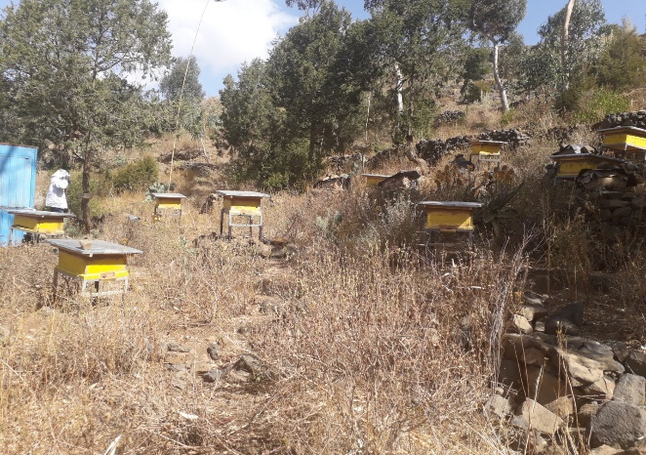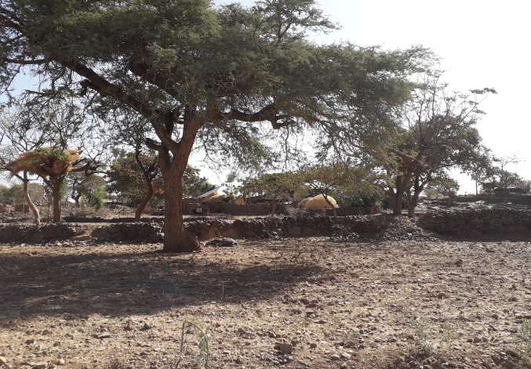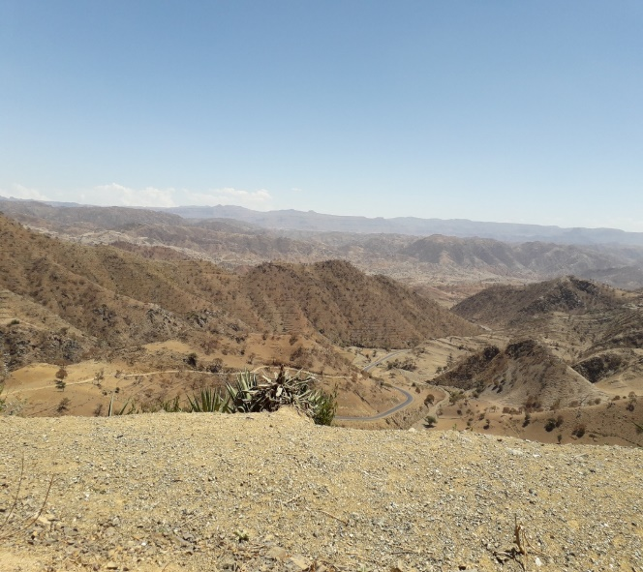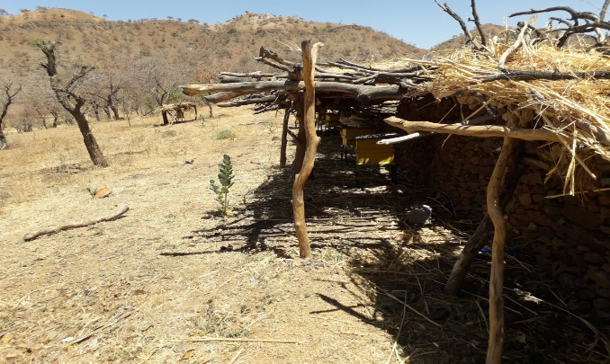
A
B
C
D
Fig S1. Features of the highland (A), midland (B) and lowland (C and D) agro-ecological zones in Tigray region; namely Mugulat (A), Zongui (B) and Werie (C and D) local areas, Tigray, Ethiopia. The highland study areas are mainly mountains covered with dry montane vegetation including Juniperus procera, Olia Africana and Becium grandiflorum (A); whereas the midlands are covered mainly with Acacia itbica, Otostegia integrifolia, Cordia Africana and Acacia albida (B). The lowlands have small hills mainly covered with deciduous thorny shrubs and trees of acacia species, evergreen large riparian fig tree species and Ziziphus abyssinica (C).

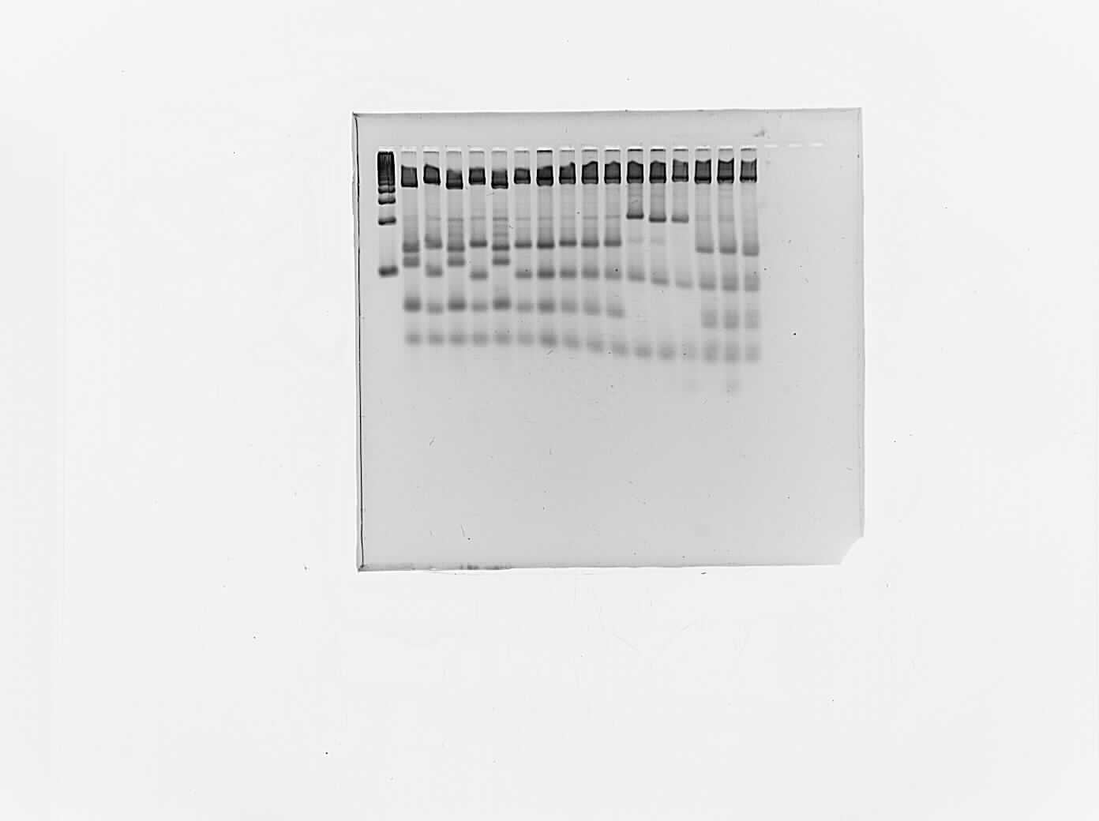
100 bp DNA ladder
100
200
400

Fig S2. Agarose gel (4%) electrophoresis image displaying COI-COII restriction (DraI) fragments length polymorphism separated on a 100bp DNA ladder (left) for 16 samples; represented by four digit identification numbers. For the honey bees from Tigray, the first digit (right) stands for individual bee sample (one of 10 bees), the second digit represents colony numbers 1 to 6 in every site, the third digit stands for the AEZ of the specific site (1 refers to highland, 2 to midland, 3 to lowland), and the fourth digit stands for local area: 1 for Mugulat, 2 for Werie, 3 for Shire, and 4 for Wendogenet. For example, identification number 1234 means bee number 4 out of the third colony from the midland AEZ (Adikebero) of Mugulat local area. Whereas in samples from the Wendogenet, 1 represents midland and 2 represents lowland AZEs.
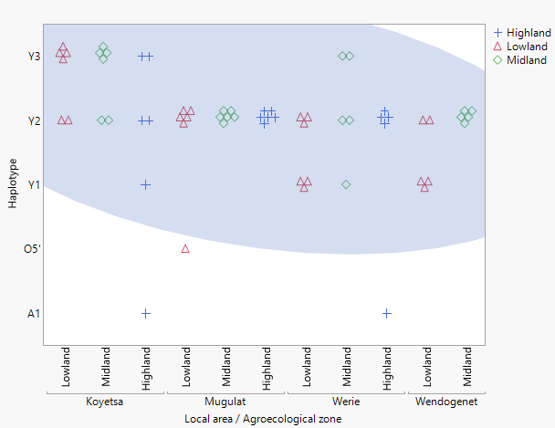
Fig S3. Plot of haplotype distribution by agroecological zones (lowland, midland, highland) in four local areas. Samples that belong to haplotypes Y1, Y2 and Y3 are within a 95% ellipse

