Supplementary materials
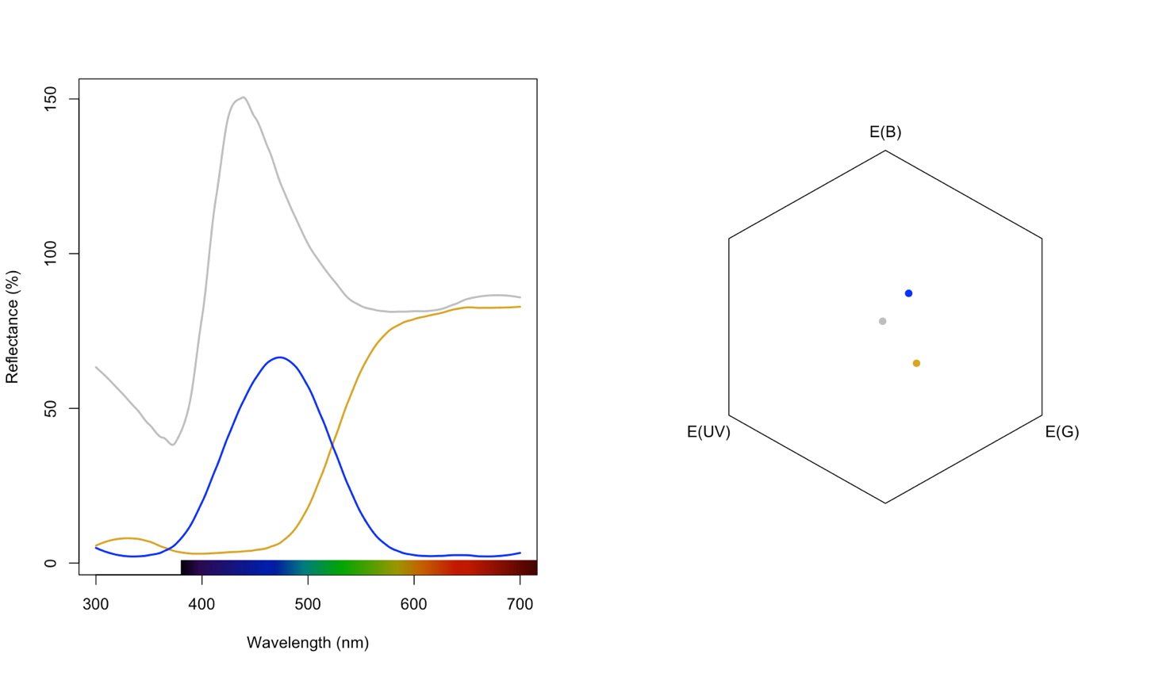
Figure S1: Reflectance spectra (left) of the yellow, blue, and white cardboard used to construct artificial flowers in our behavioural assays, and their location in the hexagon model of hymenopteran colour vision (right). As points are separated by Euclidean distances well above empirically validated absolute discrimination thresholds, they should be readily discriminated by bees under our experimental conditions.

