Supplementary materials
Examination of a subset of data gained during the first sampling (10 days after caging). At this time, queens of all treatment groups were restricted for the same duration. Thus, treatment groups were compared jointly with the unrestricted control group.

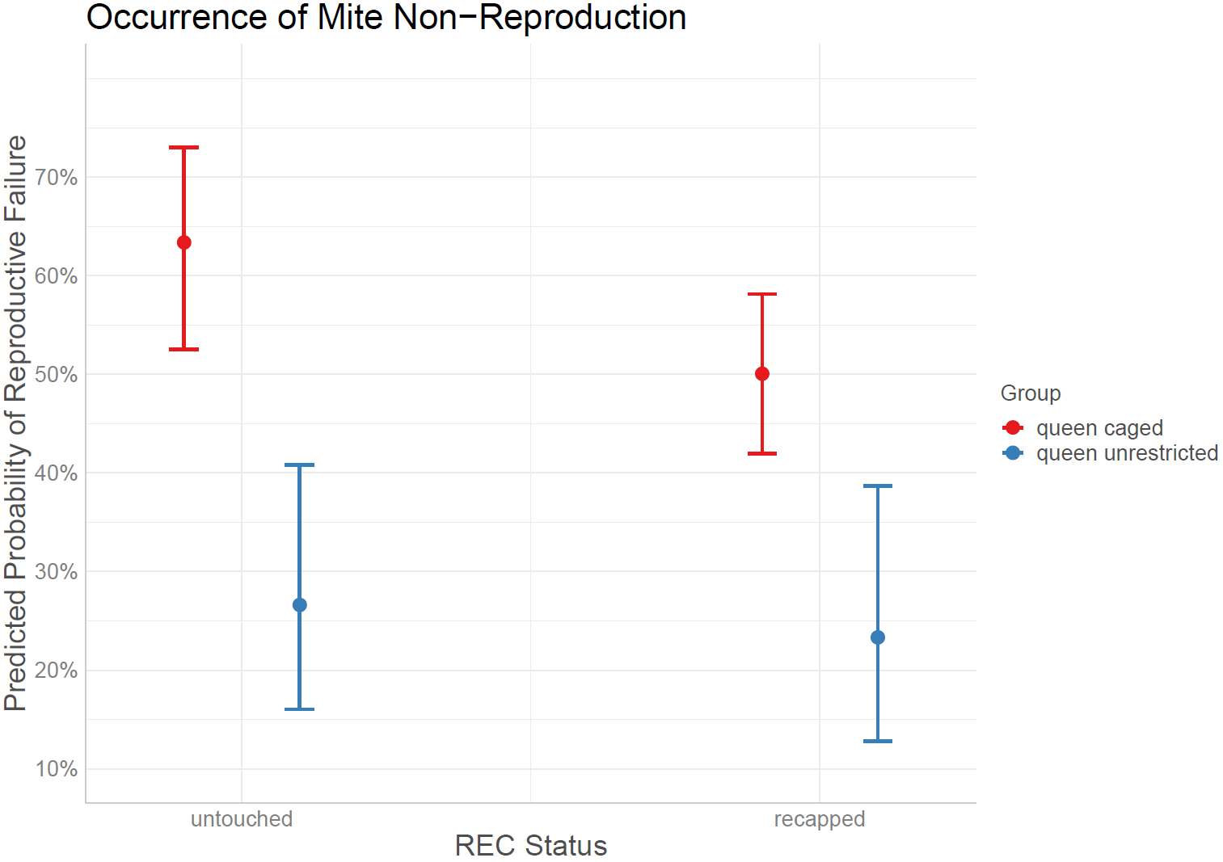
Figure I: Predicted probabilities of reproductive failure (MNR) of mother mites in brood combs sampled at day 10 after caging (displayed with 95% CI). Test statistics are given in the text.
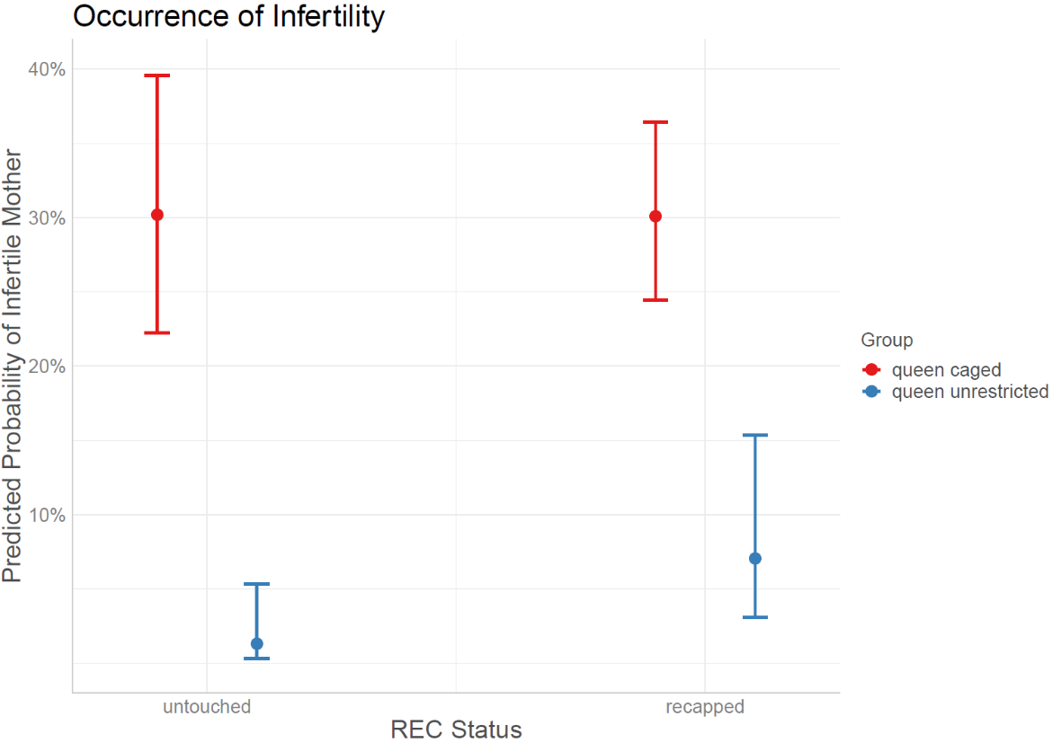
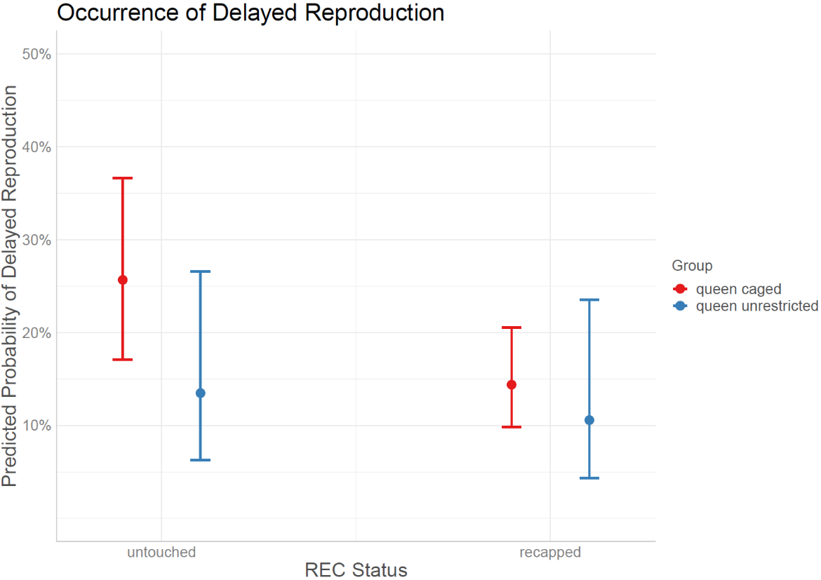
Figure II: Predicted probabilities of infertile mother mites in brood combs sampled at day 10 after caging (displayed with 95% CI). Test statistics are given in the text.
Figure III: Predicted probabilities of delayed reproduction in brood combs sampled at day 10 after caging (displayed with 95% CI). Test statistics are given in the text.
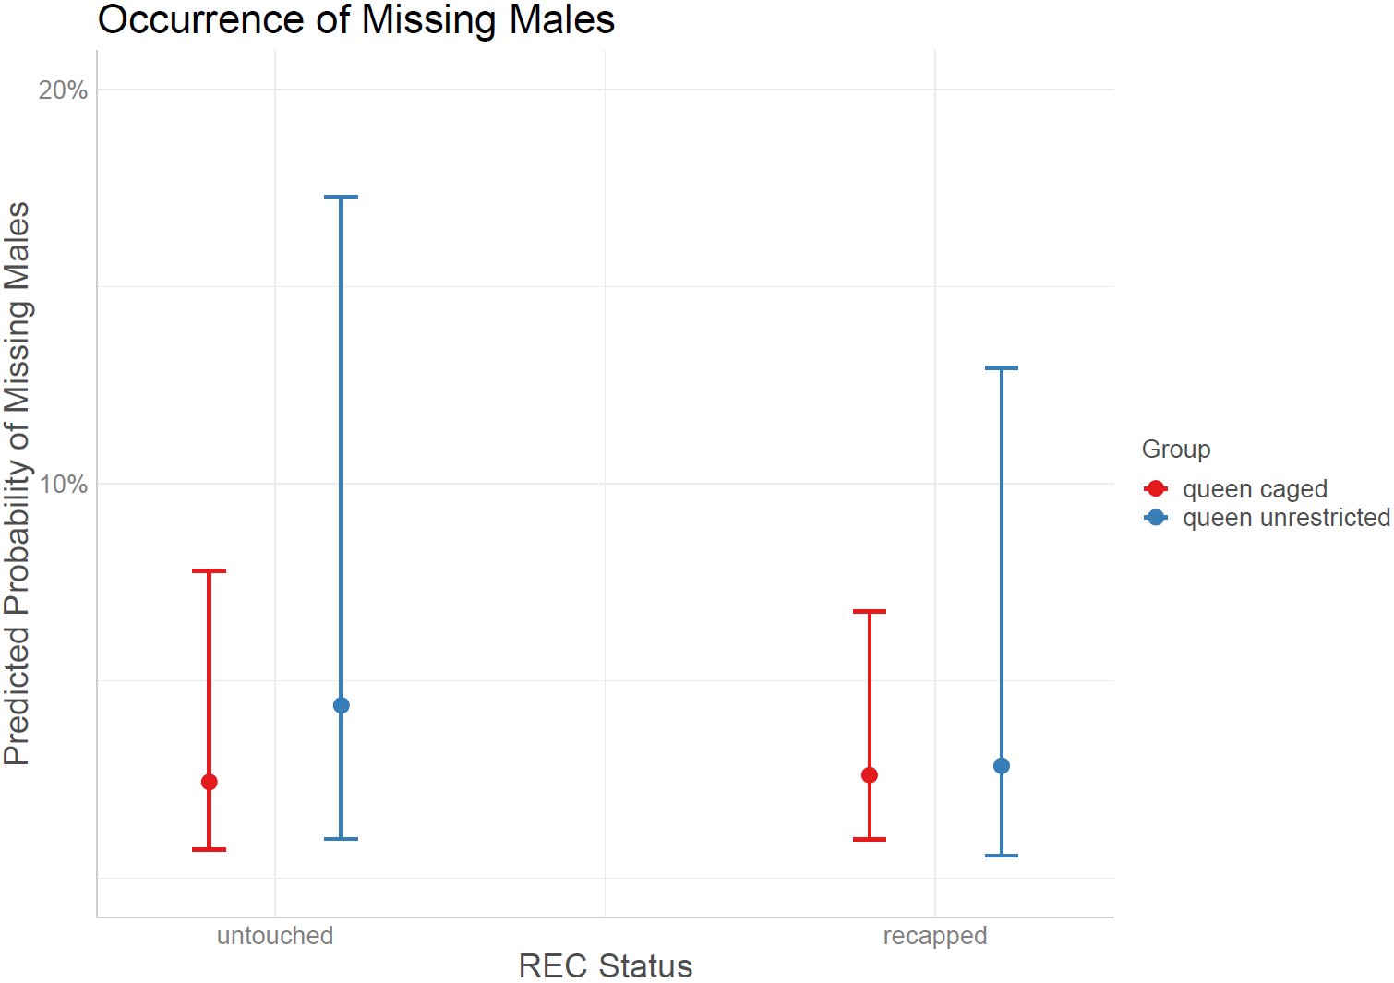
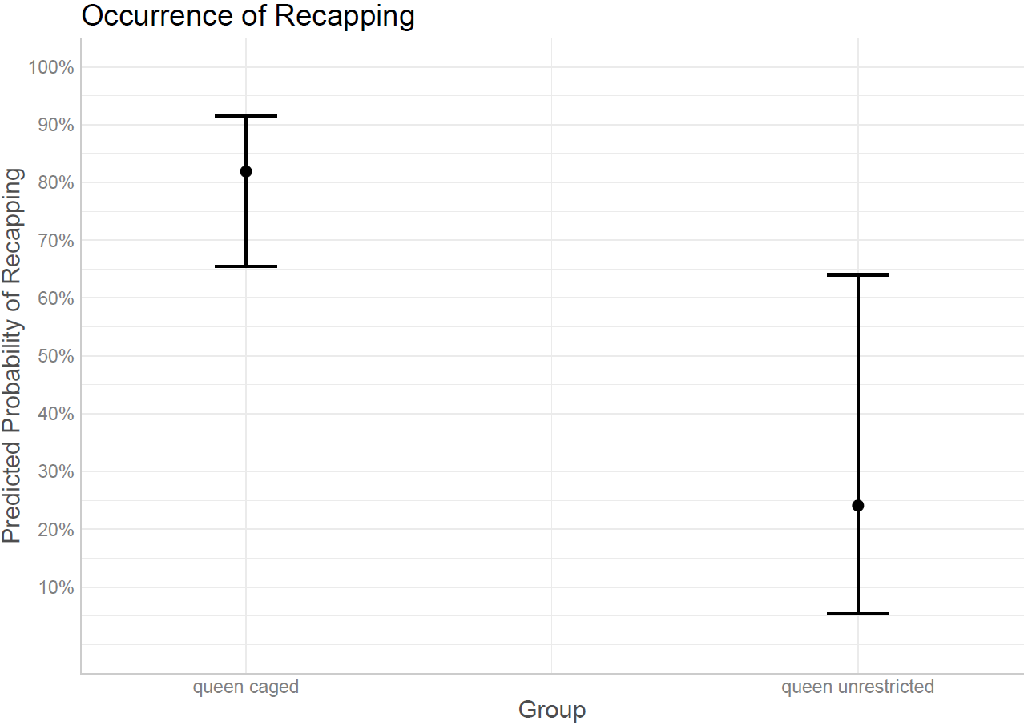
Figure IV: Predicted probabilities of missing males in brood combs sampled at day 10 after caging (displayed with 95% CI). Test statistics are given in the text.

Figure V: Predicted probabilities of Recapping in brood combs sampled at day 10 after caging (displayed with 95% CI). Test statistics are given in the text.

