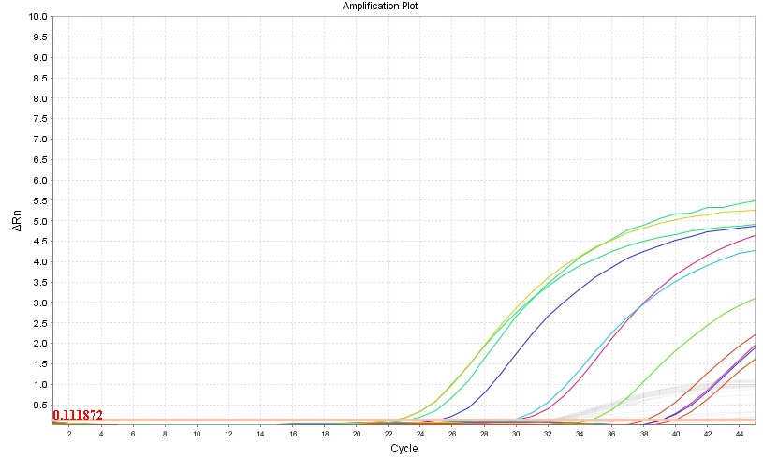

Image of the Real-Time PCR assay for the detection (presence / absence) of the Melissococcus plutonius DNA. The threshold 0.111872 and the amplification curves of positive samples with Ct values from 22.34 to 39.99 are shown.

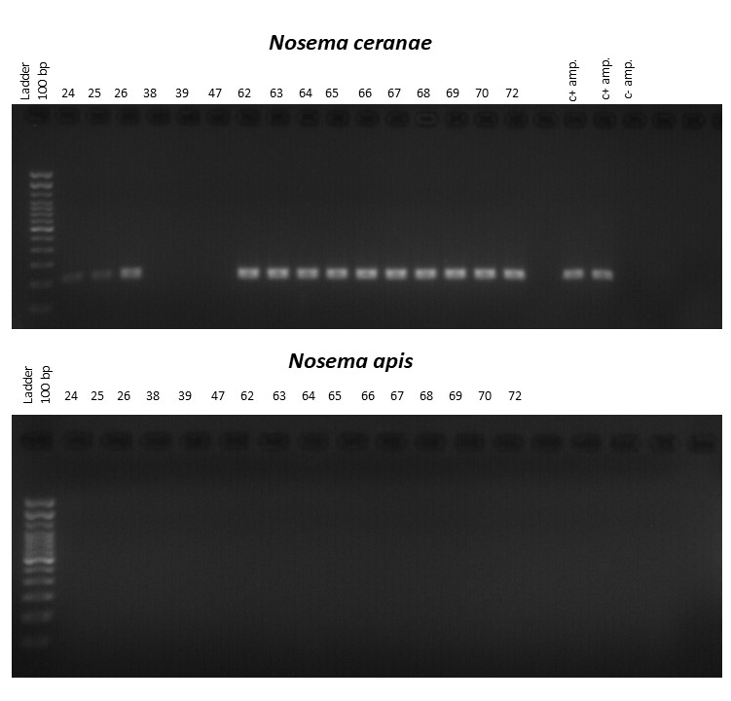

Image of the PCR products for the detection (presence / absence) of N. ceranae and N. apis DNA.

