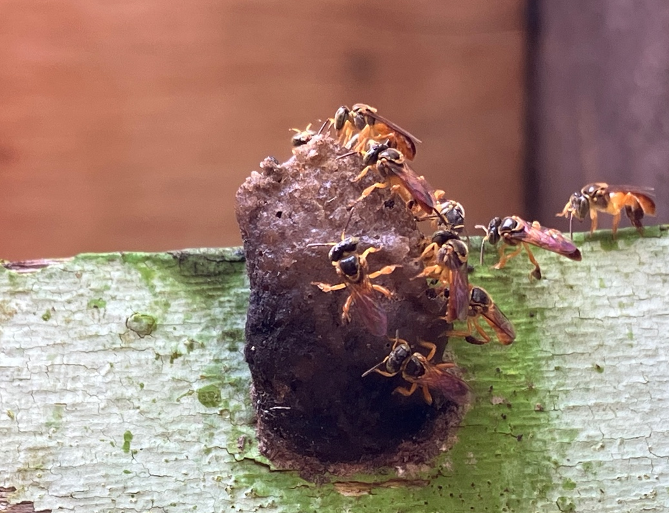
Figure S1. Entrance of observed nest of T. angustula. Guard bees are sitting in the cerumen tunnel from where foragers leave and return to the nest (Photo: SB).

