Appendices

Heritability and correlations for honey yield, handling ease, brood quantity, and traits related to resilience in a French honeybee population

Apidologie
Tristan Kistler^{1,2,3}, Coline Kouchner^{4,2}, Evert W. Brascamp³, Charlène Dumas^{5,2}, Fanny Mondet^{5,2}, Alain Vignal^{6,2}, Benjamin Basso^{5,2}, Piter Bijma³, and Florence Phocas^{1,2*}
¹Université Paris-Saclay, INRAE, AgroParisTech, GABI, 78350 Jouy-en-Josas, France
²UMT PrADE, 84914 Avignon, France
³Wageningen University & Research, Animal Breeding and Genomics, P.O. Box 338, 6700 AH Wageningen, the Netherlands
⁴ADAPI, 13626 Aix-en-Provence, France
⁵ INRAE, UR 406 Abeilles et Environnement, 84914 Avignon, France
⁶GenPhySE, Université de Toulouse, INRAE, ENVT, 31326 Castanet Tolosan, France
ORCID numbers
Tristan Kistler: 0000-0002-0798-0473
Evert W. Brascamp: 0000-0003-2284-0513
Fanny Mondet: 0000-0002-7737-0101
Alain Vignal: 0000-0002-6797-2125
Benjamin Basso: 0000-0003-4289-2898
Piter Bijma: 0000-0002-9005-9131
Florence Phocas: 0000-0003-1161-3665
Corresponding author: Tristan Kistler
mailto: tristan.kistler@inrae.fr
Supplementary Figure S1 Pedigree scheme
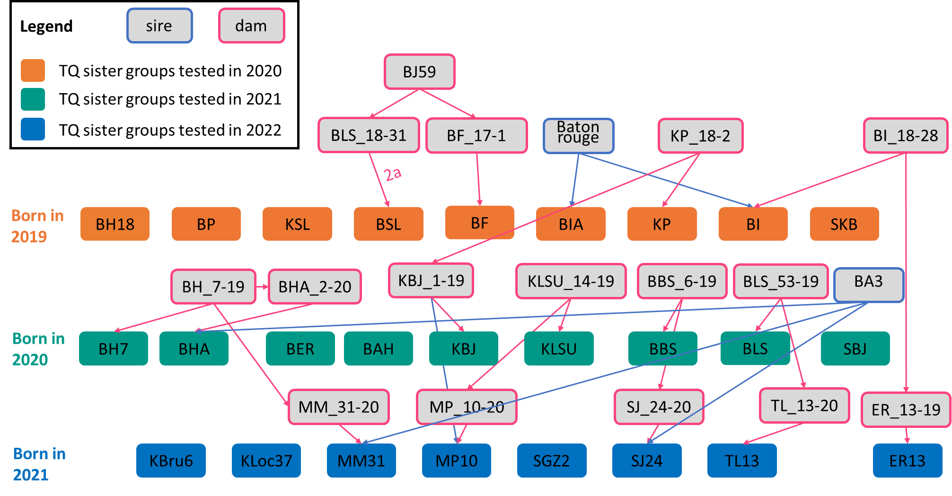
Supplementary Figure S2 Distribution of raw honey yield records

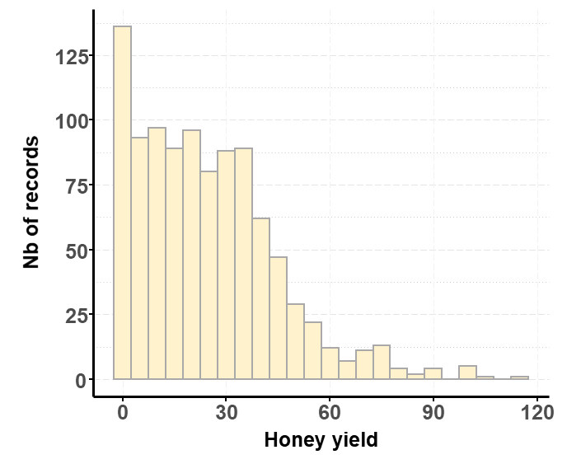

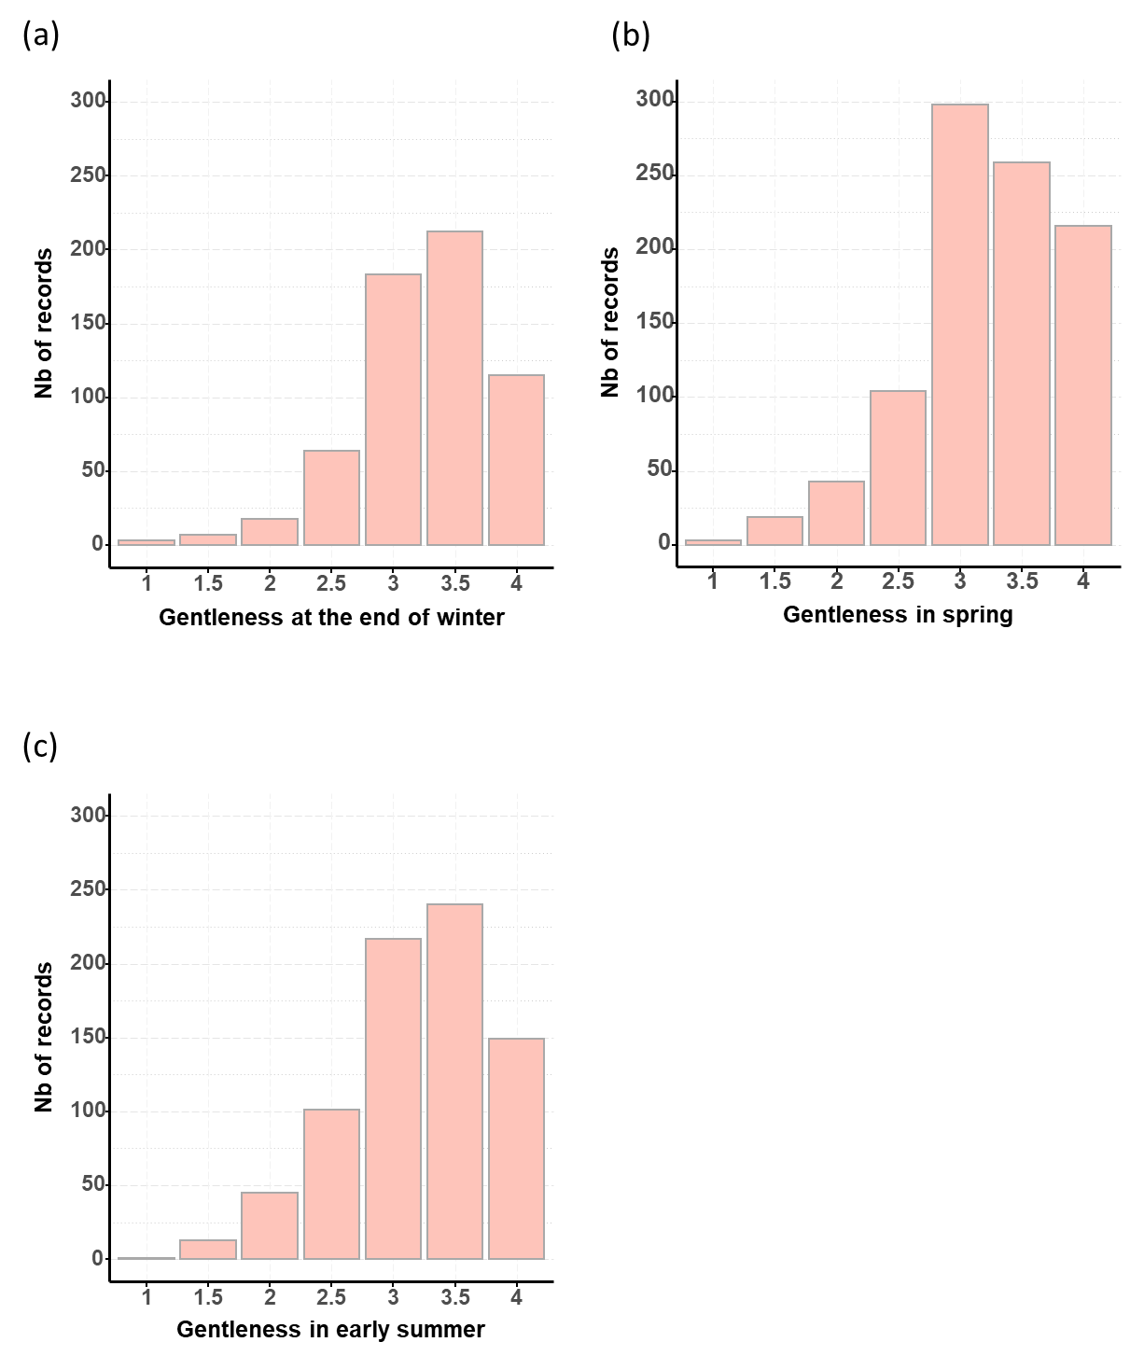
Supplementary Figure S3 Distribution of raw gentleness records measured at the end of winter (a), spring (b), and early summer (c)
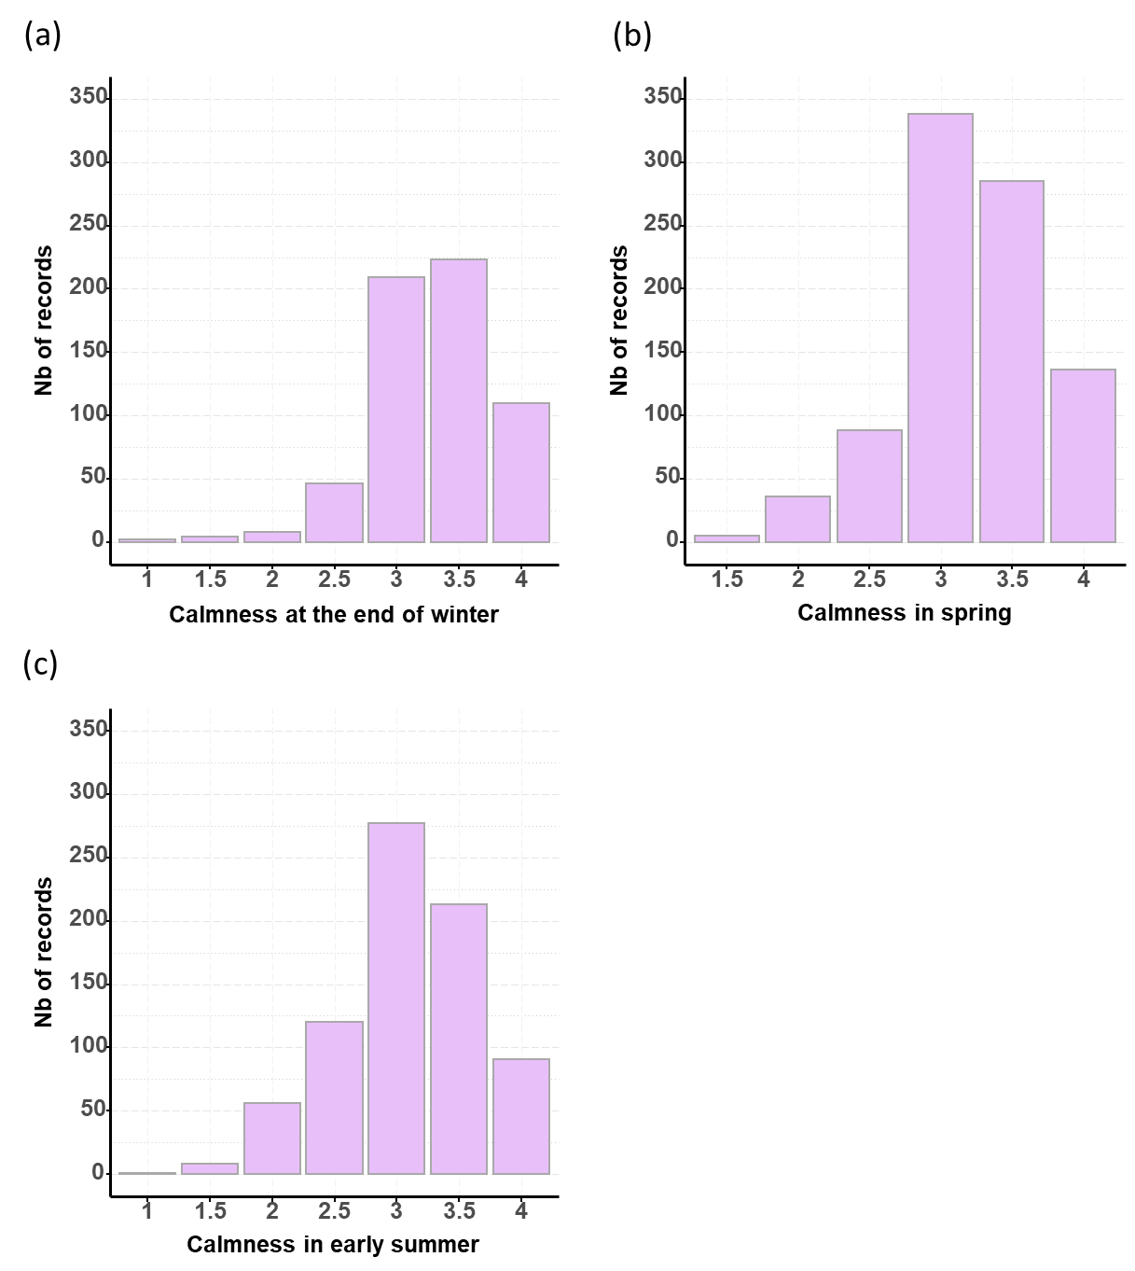
Supplementary Figure S4 Distribution of raw calmness records measured at the end of winter (a), spring (b), and early summer (c)

Supplementary Figure S5 Distribution of raw capped worker brood surface records measured in spring (a), and early summer (b)
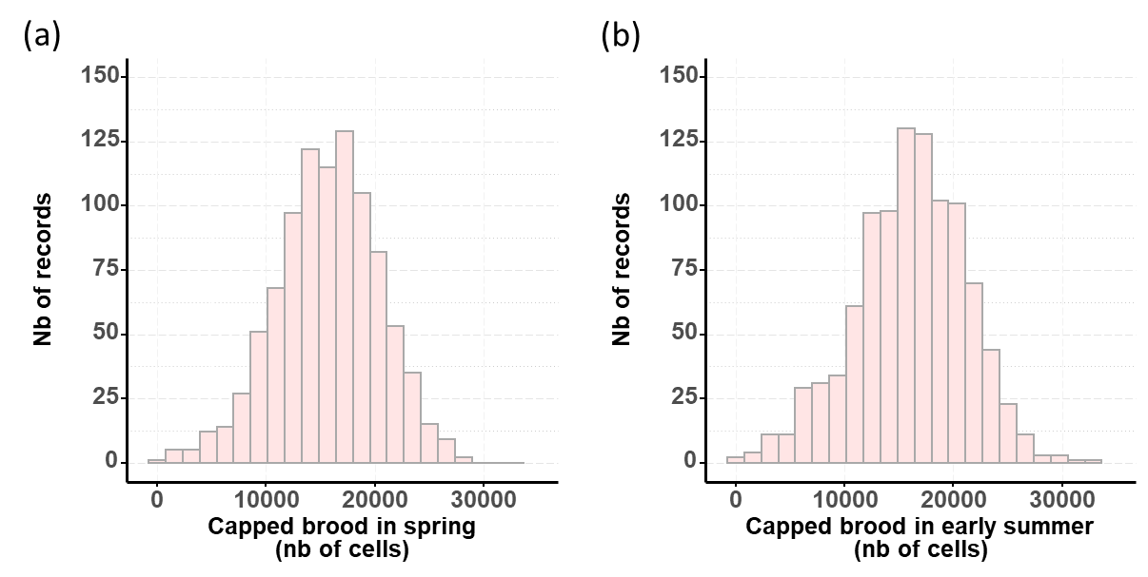
Supplementary Figure S6 Distribution of raw phoretic V. destructor load records measured in spring (a), and early summer (b)
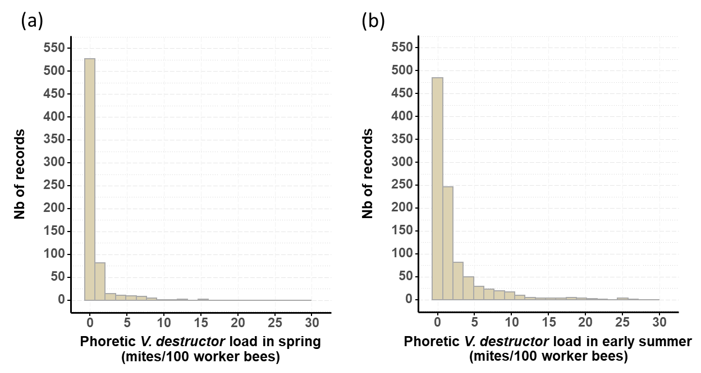
Supplementary Figure S7 Distribution of raw hygienic behavior (pin-test) records measured at the end of winter (a), and spring (b)
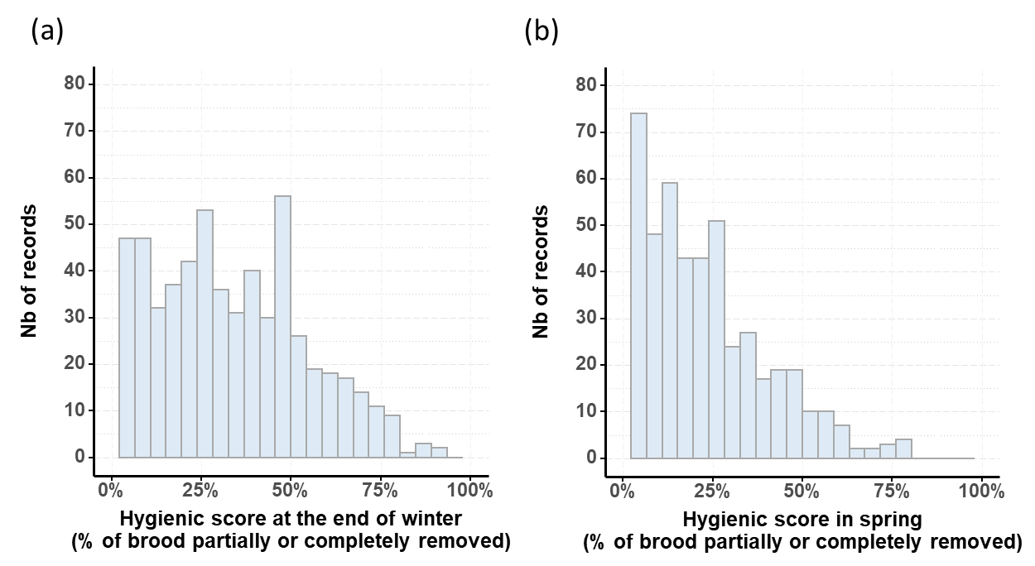

Supplementary Figure S8 Distribution of raw honey reserves in the brood chamber records measured at the end of winter (a), spring (b), and early summer (c)
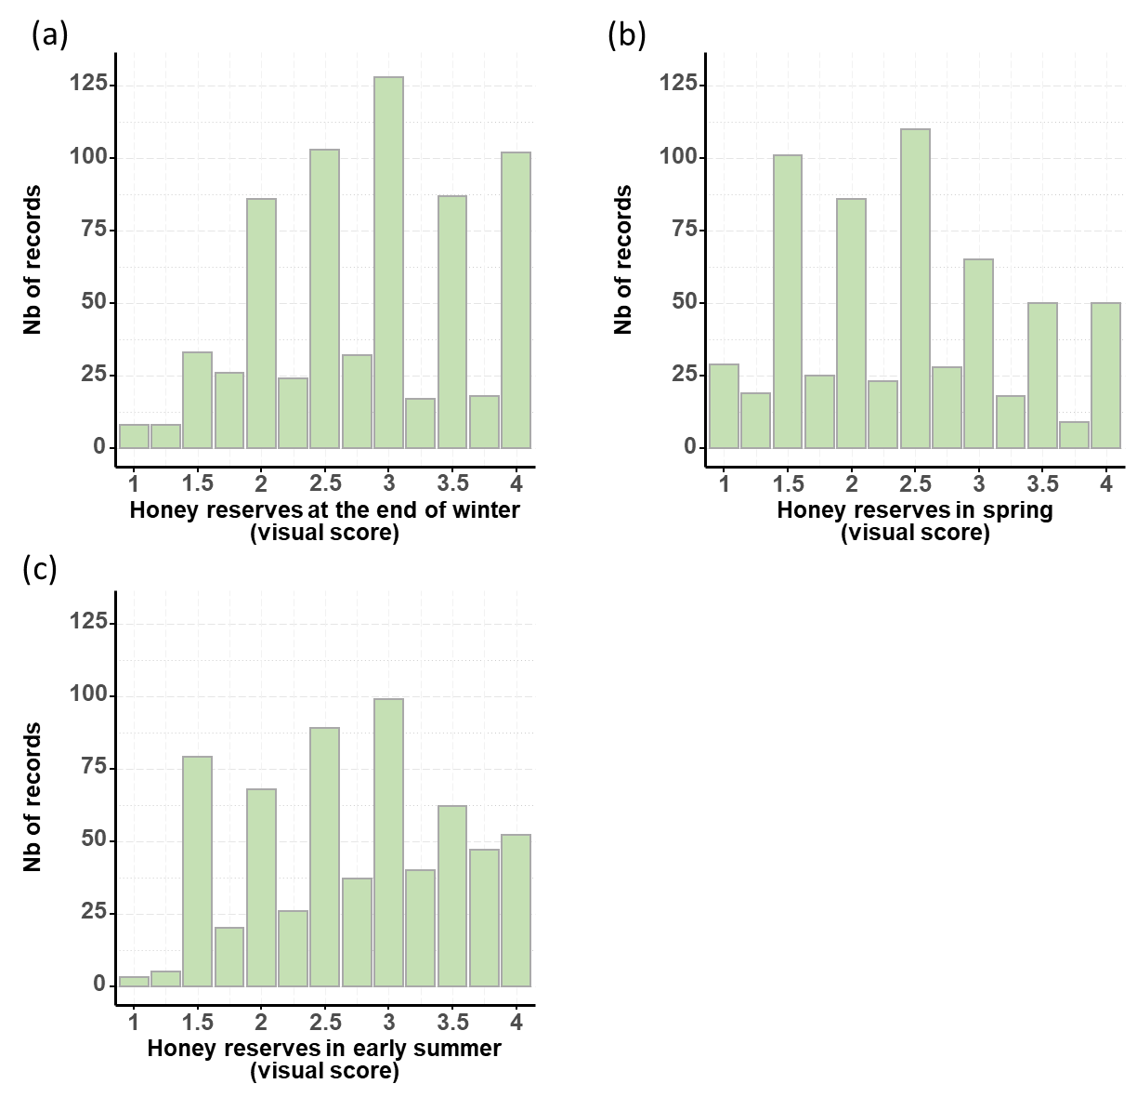

Supplementary Table S1: Phenotypic Pearson’s correlation coefficients between raw phenotypes (upper triangle) and corrected for fixed effects as estimated in BLUP analysis (lower triangle) for production and a subset of traits recorded in spring or early summer
Trait | HONEY | CALM EarlySummer | BROOD EarlySummer | VARROA EarlySummer | HYG  Spring | RESERVES EarlySummer
HONEY |  | -0.02 | 0.38 | -0.06 | -0.14 | -0.30
CALM EarlySummer | -0.07 |  | 0.02 | -0.03 | -0.13 | 0.03
BROOD EarlySummer | 0.34 | -0.06 |  | -0.08 | -0.07 | -0.42
VARROA EarlySummer | -0.06 | 0.01 | 0.01 |  | -0.11 | 0.06
HYG Spring | 0.01 | -0.07 | 0.06 | -0.10 |  | 0.09
RESERVES EarlySummer | -0.25 | 0.11 | -0.33 | -0.01 | -0.08
HONEY: total seasonal honey yield; CALM EarlySummer: calmness during inspection measured in early summer; BROOD EarlySummer: Number of capped brood cells estimated in early summer; VARROA EarlySummer: varroa infestation rate (soapy water method) estimated in early summer (Nb mites per 100 workers); HYG Spring: hygienic behavior measured by the pin-killed brood method in spring (rate of partially or totally removed brood); RESERVES EarlySummer: amount of honey reserves in the brood chamber, scored visually from 1 to 4.
Supplementary Table S2: Genetic correlation estimates from bivariate BLUP analyses (upper triangle) and residual correlations (lower triangle) for production and a subset of traits recorded in spring or early summer
Trait | HONEY | CALM EarlySummer | BROOD EarlySummer | VARROA EarlySummer | HYG  Spring | RESERVES EarlySummer
HONEY |  | -0.76 (2.15) | 0.32 (1.97) | 0.19 (1.29) | -0.48 (1.24) | -0.43 (1.79)
CALM EarlySummer | 0.08 (0.12) |  | -0.51 (1.58) | 0.36 (1.06) | 0.54 (1.88) | -0.29 (1.67)
BROOD EarlySummer | 0.37 (0.12) | 0.01 (0.08) |  | 0.47 (1.54) | -0.45 (1.42) | -0.83 (1.09)
VARROA EarlySummer | -0.12 (0.14) | -0.05 (0.10) | -0.14 (0.11) |  | -0.51 (0.81) | -0.42 (1.13)
HYG Spring | 0.23 (0.24) | -0.19 (0.15) | 0.22 (0.15) | 0.07 (0.19) |  | -0.17 (1.54)
RESERVES EarlySummer | -0.10 (0.14) | 0.15 (0.11) | -0.20 (0.09) | 0.18 (0.13) | -0.04 (0.16)
HONEY: total seasonal honey yield; CALM EarlySummer: calmness during inspection measured in early summer; BROOD EarlySummer: Number of capped brood cells estimated in early summer; VARROA EarlySummer: varroa infestation rate (soapy water method) estimated in early summer (Nb mites per 100 workers); HYG Spring: hygienic behavior measured by the pin-killed brood method in spring (rate of partially or totally removed brood); RESERVES EarlySummer: amount of honey reserves in the brood chamber, scored visually from 1 to 4.
Appendix A: Protocol for the scoring of the trait ‘reserves in the brood chamber’
All frames of each hive were inspected to rate the amount of honey reserves present on frames (RESERVES). The scoring scale, from 1 to 4, is detailed in the table below and was used to rate the trait by choosing the score best representing the overall quantities of reserves in side frames (without brood) and brood frames. Half score points were used to accommodate for colonies in an intermediary situation compared to the description in the grading scale. The scale is also depicted in representative brood frames (from 1 to the left, to 4 on the right) in the figure below.
Side frames | Score | Brood frames
No reserves | 1 | No reserves
½ a frame filled with reserves | 2 | Angles filled with reserves (from 5 to 7% of the frame surface)
1 full frame filled with reserves | 3 | Upper frame band with reserves (from 10 to 15% of the frame surface)
2 full frame filled with reserves or more | 4 | Large band of reserves around the brood (> 20% of the frame surface)
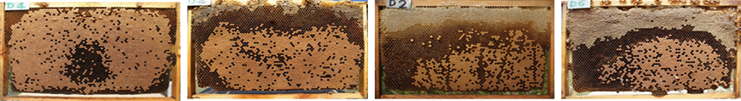

Appendix B: Simplified models (WM, QM) in datasets containing only records from colonies with open-mated queens used as potential drone-producing queens
The genetic analysis in our dataset builds on 2 pieces of information:
- The phenotypic records of colonies, with only open-mated queens (TQs)
- The relationship between the different queens or worker groups (Ws) in these colonies, used to interpret the phenotypic covariances between the colonies’ records.
As a consequence of the tested queens being open-mated, the sire of any worker group is always unknown. Therefore, different worker groups can only be related when they are descending from queens that are related (since no relationship can be known on the sire path).
We will show that with such a data structure, we are in a peculiar situation in which the queen model (QM) and the worker model (WM) are equivalent (or isomorphic), because we cannot disentangle queen effects and worker effects in the analysis. In this special case, a general result can be given to directly relate estimates of QM breeding values and variance components with estimates of the WM, which is otherwise not possible.
Colony 2
Colony 1
$$r_{W1, W2} \\ =\frac{1}{4}r_{TQ_{1},TQ_{2} }$$

BQ
$$TQ_{1}$$
PS_{OM}
NS=$+∞$,
ND=12
$$W_{1}$$

$$W_{2}$$
$$TQ_{2}$$

PS
NS=3
ND=8
$$r_{TQ_{1},TQ_{2} }$$

$$r_{TQ_{1},W_{1} }=\frac{1}{2}$$

Legend
NS: nb of drone-producing queens constituing a pseudo sire; ND: nb of drones fecundating a queen; r: relationship coefficient.
The figure above illustrates the situation for two sister test queens (TQ1 and TQ2), descending from a breeding queen (BQ) unrelated to the pseudo sire (PS) that mated her.
First demonstration: expressing WM and QM estimates to what they correspond if the data was generated using the colony model (CM)
If the records were generated according to the colony model, we would have:
$a_{Colony 1}=m_{TQ1}+\frac{1}{2}d_{TQ1}$, and $a_{Colony 2}=m_{TQ2}+\frac{1}{2}d_{TQ2}$
where ‘a’ is the additive genetic effect of a colony as projected onto the queen, ‘m’ is the additive genetic effect for queen effects (i.e. maternal effects), and ‘d’ for worker effects (i.e direct effects). The coefficient $\frac{1}{2}$ arises from the fact that $W_{1}$ is a non-inbred offspring from $TQ_{1}$. Therefore, half its worker effect is inherited from its dam, as when randomly picking one allele at a certain locus for $W_{1}$ and one for $TQ_{1}$, there is a probability of ½ to pick up the same allele.
The phenotypic covariance between two colonies’ records is:
$\begin{matrix}Cov(a_{Colony_{1}},a_{Colony_{2}}) & = & Cov(m_{TQ1}+\frac{1}{2}d_{TQ1}, m_{TQ2}+\frac{1}{2}d_{TQ2}) \\ & = & Cov\left(m_{TQ1}, m_{TQ2}\right)+ Cov\left({\frac{1}{2}d}_{TQ1},{\frac{1}{2}d}_{TQ2}\right)+Cov\left({{\frac{1}{2}d}_{TQ1},m}_{TQ2}\right)+Cov\left({{\frac{1}{2}d}_{TQ2},m}_{TQ1}\right) \\ & = & {r_{TQ_{1},TQ_{2} }∙σ}_{m}^{2}+2∙\frac{1}{2}∙r_{TQ_{1},TQ_{2} }∙σ_{m,d}+\frac{1}{4}∙r_{TQ_{1},TQ_{2} }{∙σ}_{d}^{2} \\ & = & r_{TQ_{1},TQ_{2} }∙σ_{m}^{2}+r_{TQ_{1},TQ_{2} }∙σ_{m,d}+\frac{1}{4}∙r_{TQ_{1},TQ_{2} }σ_{d}^{2} \left(1\right)\end{matrix}$with $σ_{M}^{2}$ and $σ_{D}^{2}$ the additive genetic variance in the base population for queen and worker effects respectively, and $σ_{M,D}$ the genetic covariance between both effects.
In the QM:
$\begin{matrix}Cov(a_{Colony_{1}},a_{Colony_{2}}) & = & r_{TQ_{1},TQ_{2} }∙σ_{a^{(QM)} }^{2}\end{matrix}$ (2)
Using (1) and (2):
$\begin{matrix}r_{TQ_{1},TQ_{2} }∙σ_{a^{(QM)} }^{2} & = & r_{TQ_{1},TQ_{2} }∙σ_{m}^{2}+r_{TQ_{1},TQ_{2} }∙σ_{m,d}+\frac{1}{4}∙r_{TQ_{1},TQ_{2} }σ_{d}^{2} \\ σ_{a^{(QM)} }^{2} & = & σ_{m}^{2}+σ_{m,d}+\frac{1}{4}σ_{d}^{2} (3)\end{matrix}$
While in the WM:
$\begin{matrix}Cov(a_{Colony_{1}},a_{Colony_{2}}) & = & \frac{1}{4}∙r_{TQ_{1},TQ_{2} }σ_{a^{(WM)} }^{2}\end{matrix}$ (4)
Using (1) and (4):
$\begin{matrix}\frac{1}{4}∙r_{TQ_{1},TQ_{2} }σ_{a^{\left(WM\right)} }^{2} & = & r_{TQ_{1},TQ_{2} }∙σ_{m}^{2}+r_{TQ_{1},TQ_{2} }∙σ_{m,d}+\frac{1}{4}∙r_{TQ_{1},TQ_{2} }σ_{d}^{2} \\ \frac{1}{4}σ_{a^{(WM)} }^{2} & = & σ_{m}^{2}+σ_{m,d}+\frac{1}{4}σ_{d}^{2} (5)\end{matrix}$
Using (3) and (5) leads to:
$$σ_{a^{(QM)} }^{2}=\frac{1}{4}σ_{a^{(WM)} }^{2}$$
Because
$σ_{P^{(QM)} }^{2}=σ_{a^{(QM)} }^{2}+σ_{e^{(QM)} }^{2}$, with $σ_{P^{(QM)} }^{2}$and $σ_{e^{(QM)} }^{2}$the phenotypic and residual variances in the QM, respectively,
And
${{σ_{P^{(WM)} }^{2}=r}_{TQ_{1},TQ_{2} }∙σ}_{a^{(WM)} }^{2}+σ_{e^{(WM)} }^{2}$, with $σ_{P^{(WM)} }^{2}$and $σ_{e^{(WM)} }^{2}$the phenotypic and residual variances in the WM, respectively,
We have:
$$\begin{matrix}σ_{a^{(QM)} }^{2}+σ_{e^{(QM)} }^{2} & = & {r_{TQ_{1},TQ_{2} }∙σ}_{a^{(WM)} }^{2}+σ_{e^{(WM)} }^{2} \\ σ_{e^{(QM)} }^{2} & = & {r_{TQ_{1},TQ_{2} }∙σ}_{a^{(WM)} }^{2}-σ_{a^{(QM)} }^{2}+σ_{e^{(WM)} }^{2} \\ σ_{e^{(QM)} }^{2} & = & \left(r_{TQ_{1},TQ_{2} }-\frac{1}{4}\right){∙σ}_{a^{(WM)} }^{2}+σ_{e^{(WM)} }^{2}\end{matrix}$$

Second demonstration: expressing WM and QM estimates without assumptions on the underlying true model
Manuel Du (manuel.du@hu-berlin.de) communicated us another demonstration, independently derived from ours.
If $A$ is the relationship matrix containing all relationship coefficients of queens, worker groups and pseudo sires as described by Brascamp and Bijma (2014), then the relation between the submatrix of relationship coefficients for all worker groups ($A_{w}$) and the submatrix of relationship coefficients for all queens ($A_{q}$) is:
$A_{w}={\frac{1}{4}A}_{q}+\left(a_{SS}-\frac{1}{4}\right)I$ (1)
The factor ¼ in (1) arising from the following (see figure above): if TQ₁ and TQ₂ are related with relationship coefficient $r_{TQ_{1},TQ_{2} }$ , then their offspring are related by $r_{W1, W2}=\frac{1}{4}r_{TQ_{1},TQ_{2} }$as follows: by definition, if we consider a random locus and pick one allele from TQ₁ and one allele from TQ₂, there is a probability of $r_{TQ_{1},TQ_{2} }$to have picked the same allele. Furthermore, W₁ and W₂ are supposed only related by their dams (and not by their sires, considered unknown). Therefore, by picking randomly one allele at any locus for W₁ and one for W₂ to obtain the same two allele, we have to independently pick two times two maternally inherited alleles. Each time, for W₁ and for W₂, the chance to pick a maternally inherited allele is of ½, as true for any diploid non-inbred offspring of a diploid dam, leading to $\frac{1}{2}∙\frac{1}{2}=\frac{1}{4}$.
The factor $\left(a_{SS}-\frac{1}{4}\right)$ can be explained as follows:
On the diagonal of $A$, for any non-inbred queen $q_{i}$ we have $A_{q_{i}, q_{i}}=1$ (the relationship coefficient of a queen with herself), but for any worker group $w_{i}$ we have $A_{w_{i}, w_{i}}=a_{SS}$, with $a_{SS}$ being the average relationship coefficient between two diploid offspring of a queen and therefore of the worker group with itself (Brascamp and Bijma, 2014). Therefore, the difference between both diagonal submatrices is $a_{SS}-\frac{1}{4}$.
Assuming that the total variance V, sum of ${\hat{σ}}_{A }^{2}$ and ${\hat{σ}}_{e}^{2}$, the estimated genetic and residual variances, in the queen (QM) and in the worker (WM) models can be expressed as:
${V\left({\hat{σ}}_{A^{(QM)} }^{2}+ {\hat{σ}}_{e^{(QM)} }^{2}\right)={\hat{σ}}_{A^{(QM)} }^{2}A}_{q}+{\hat{σ}}_{e^{(QM)}}^{2}I$ (2),
${V\left({\hat{σ}}_{A^{(WM)} }^{2}+ {\hat{σ}}_{e^{(WM)} }^{2}\right)={\hat{σ}}_{A^{(WM)} }^{2}A}_{w}+{\hat{σ}}_{e^{(WM)}}^{2}I$ (3),
by injecting (1) in (3), we have:
$$\begin{matrix}V\left({\hat{σ}}_{A^{(WM)} }^{2}+ {\hat{σ}}_{e^{(WM)} }^{2}\right) & = & {\hat{σ}}_{A^{(WM)} }^{2}\left[{\frac{1}{4}A}_{q}+\left(a_{SS}-\frac{1}{4}\right)I\right]+{\hat{σ}}_{e^{(WM)}}^{2}I\end{matrix}$$$\begin{matrix}V\left({\hat{σ}}_{A^{(WM)} }^{2}+ {\hat{σ}}_{e^{(WM)} }^{2}\right) & = & \frac{1}{4}{\hat{σ}}_{A^{(WM)} }^{2}A_{q}+\left[{\hat{σ}}_{A^{(WM)} }^{2}\left(a_{SS}-\frac{1}{4}\right)+{\hat{σ}}_{e^{(WM)}}^{2}\right]I\end{matrix}$ (4)
The desired result:
$V\left({\hat{σ}}_{A^{(QM)} }^{2}, {\hat{σ}}_{e^{(QM)} }^{2}\right)=V\left({\hat{σ}}_{A^{(WM)} }^{2}, {\hat{σ}}_{e^{(WM)} }^{2}\right)$
Is true if (using (3) and (4)):
$$\frac{1}{4}{\hat{σ}}_{A^{(WM)} }^{2}{=\hat{σ}}_{A^{(QM)} }^{2}$$
And
${\hat{σ}}_{A^{(WM)} }^{2}\left(a_{SS}-\frac{1}{4}\right)+{\hat{σ}}_{e^{(WM)}}^{2}={\hat{σ}}_{e^{(QM)} }^{2}$

