Supplementary Information for:
The Importance of Vegetation on Mayan Meliponiculture: A Case Study on the Pollen Foraging Preferences of Melipona beecheii
Alejandro Pérez-Morfi,¹ Elia Ramírez Arriaga,^{2*} Azucena Canto¹
¹Centro de Investigación Científica de Yucatán, A.C. (CICY), Mérida, Yucatán, México
²Instituto de Geología, Universidad Nacional Autónoma de México (UNAM), Ciudad Universitaria, CDMX, México

Alejandro Pérez-Morfi: https://orcid.org/0000-0002-0786-7710
Elia Ramírez Arriaga: https://orcid.org/0000-0002-9082-3398
Azucena Canto: https://orcid.org/0000-0002-0712-2241

*Corresponding Author: elia@unam.mx

This PDF file includes:
- Supplementary Figures (1 to 3)
- Supplementary Tables (1 to 5)

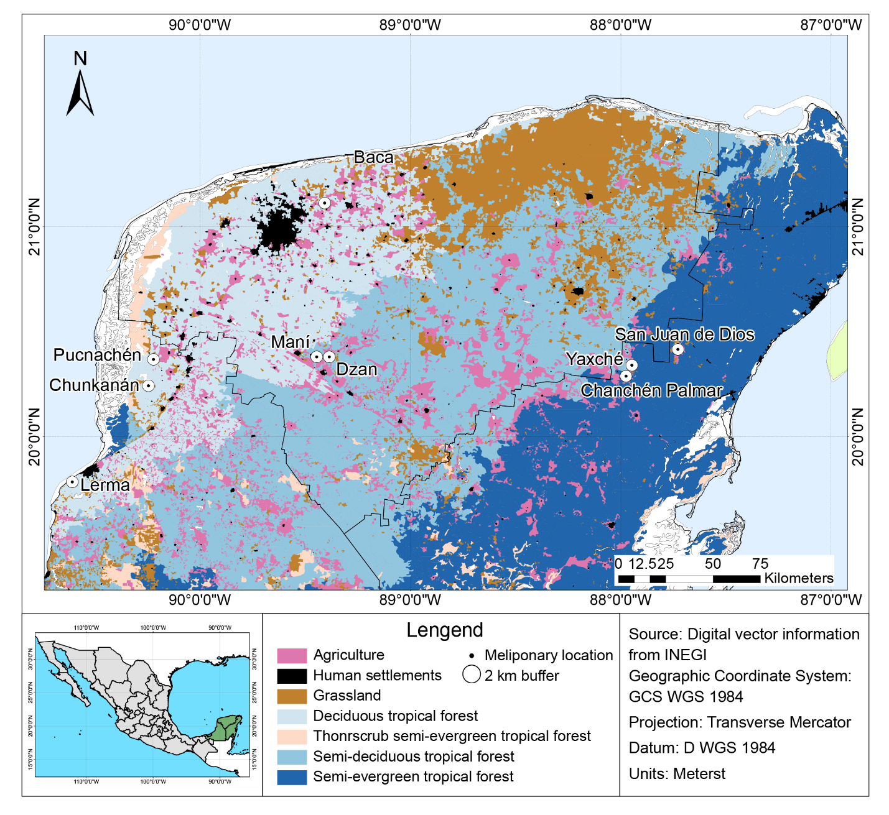
Fig. 1. Location of the nine meliponaries sampled on the Yucatan Peninsula. Modified from (Pérez-Morfi et al. 2024)
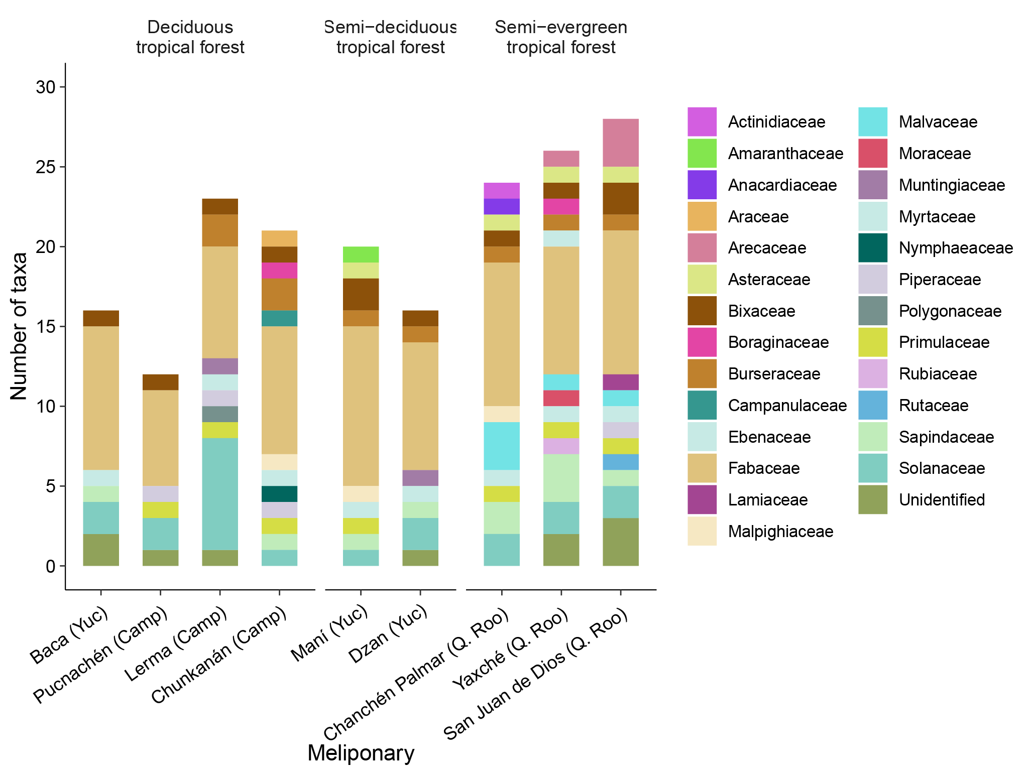
Fig. 2. Number of morphotypes/species of pollen grains per botanical family in Melipona beecheii pot-pollen from nine meliponaries on the Yucatan Peninsula.

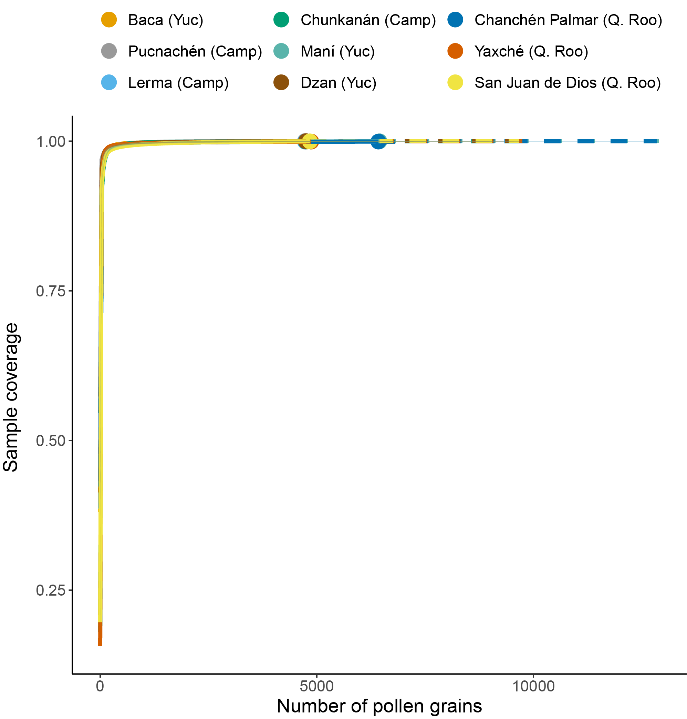
Fig. 3. Sample coverage of pollen morphotypes in Melipona beecheii pot-pollen from nine meliponaries on the Yucatan Peninsula.

Table 1. Weight of each of the pot-pollen samples taken from nine Melipona beecheii meliponaries from the Yucatán Peninsula.
Vegetation type | State | Meliponary | Sampling date | Colony code | Pot-pollen sample weight
Deciduous tropical forest | Campeche | Chunkanán | 10/05/2021 | M12C1 | 5.871
 |  |  |  | M12C2 | 9.073
 |  |  |  | M12C3 | 4.916
Deciduous tropical forest | Campeche | Lerma | 06/05/2021 | M11C1 | 5.834
 |  |  |  | M11C2 | 5.231
 |  |  |  | M11C3 | 6.85
Deciduous tropical forest | Campeche | Pucnachén | 19/03/2021 | M10C1 | 6.036
 |  |  |  | M10C2 | 4.446
 |  |  |  | M10C3 | 8.519
Deciduous tropical forest | Yucatán | Baca | 23/02/2021 | M3C1 | 7.413
 |  |  |  | M3C2 | 9.812
 |  |  |  | M3C3 | 9.144
Semi-deciduous tropical forest | Yucatán | Dzan | 01/03/2021 | M4C1 | 12.221
 |  |  |  | M4C6 | 12.957
 |  |  |  | M4C13 | 10.03
Semi-deciduous tropical forest | Yucatán | Maní | 22/02/2021 | 1.1 Col. 017 | 1.339
 |  |  |  | 1.1 Col. 034 | 4.239
 |  |  |  | 2 Jobon 1 | 7.995
 |  |  |  | 2 Jobon 2 | 7.334
Semi-evergreen tropical forest | Quintara Roo | Chachén Palmar | 03/03/2021 | M5C1 | 13.417
 |  |  |  | M5C2 | 10.007
 |  |  |  | M5C3 | 7.197
Semi-evergreen tropical forest | Quintara Roo | San Juan de Dios | 03/03/2021 | M7C1 | 5.395
 |  |  |  | M7C2 | 9.306
 |  |  |  | M7C3 | 6.483
Semi-evergreen tropical forest | Quintara Roo | Yaxché | 03/03/2021 | M6C1 | 2.362
 |  |  |  | M6C2 | 8.485
 |  |  |  | M6C3 | 6.824
 |  |  |  | M6C4 | 9.107

Table 2. Blooming periods of plant species identified from pollen morphotypes in Melipona beecheii pot-pollen from the Yucatán Peninsula.
Family | Species | Life forms | January | February | March | April | May | June | July | August | September | October | November | December
Amaranthaceae | Alternanthera ramosissima | Grass |  |  |  |  |  |  |  |  |  | x
Anacardiaceae | Astronium graveolens | Tree |  |  |  | x | x
Arecaceae | Thrinax radiata | Palm tree | x | x | x | x | x | x | x | x | x | x | x | x
Asteraceae | Melanthera nivea | Grass | x | x | x | x | x | x | x | x | x | x | x | x
Asteraceae | Sphagneticola trilobata | Grass | x | x | x | x | x | x | x | x | x | x | x | x
Bixaceae | Cochlospermun vitifolium | Tree | x | x | x | x |  |  |  |  |  | x |  | x
Bixaceae | Bixa orellana | Tree | x | x |  |  |  |  | x |  | x | x | x
Burseraceae | Bursera simaruba | Tree |  |  |  | x | x
Burseraceae | Bursera schlechtendalii | Shrub |  |  | x
Fabaceae | Leucaena leucocephala | Tree | x | x | x | x | x | x | x | x | x | x | x | x
Fabaceae | Cenostigma gaumeri | Tree | x | x | x | x | x |  | x | x | x | x | x | x
Fabaceae | Senna racemosa | Tree | x | x | x | x |  | x |  |  |  | x | x | x
Fabaceae | Mimosa bahamensis | Tree | x |  |  | x | x | x | x | x | x | x | x
Fabaceae | Desmodium triflorum | Grass |  |  |  |  |  |  |  |  |  |  | x
Fabaceae | Desmanthus virgatus | Grass | x | x | x | x | x | x | x | x | x | x | x | x
Fabaceae | Desmodium aff scorpiorus | Grass | x | x | x |  |  | x | x | x | x | x | x | x
Fabaceae | Senna pallida | Shrub | x | x | x | x | x |  |  |  |  |  |  | x
Fabaceae | Pithecellobium aff. cognatum | Tree |  |  |  |  |  |  | x
Fabaceae | Senna occidentalis | Grass | x |  |  |  |  |  |  | x | x | x | x | x
Fabaceae | Harpalyce arborescens | Shrub |  | x
Lamiaceae | Leonotis nepetifolia | Grass | x | x |  |  |  |  | x | x | x | x | x | x
Malpighiaceae | Byrsonima bucidifolia | Tree |  |  | x | x | x | x | x | x | x | x
Malvaceae | Heliocarpus mexicanus | Tree | x | x | x | x | x |  |  |  | x | x | x | x
Malvaceae | Waltheria indica | Grass | x | x | x | x | x | x | x | x | x | x | x | x
Malvaceae | Heliocarpus donnellsmithii | Tree | x | x |  |  |  |  |  |  |  | x | x | x
Malvaceae | Corchorus siliquosus | Shrub | x | x |  |  |  | x |  | x | x | x | x | x
Moraceae | Brosimum alicastrum | Tree |  | x |  |  | x | x | x |  | x | x | x
Muntingiaceae | Muntingia calabura | Tree | x | x | x | x | x | x | x | x | x | x | x | x
Myrtaceae | Psidium guajava | Tree |  | x | x | x | x | x | x | x |  |  | x | x
Piperaceae | Piper auritum | Shrub | x | x | x | x | x | x | x | x | x | x | x | x
Primulaceae | Myrsine cubana | Tree | x
Rutaceae | Amyris elemifera | Tree | x | x | x |  |  |  |  |  |  |  |  | x
Sapindaceae | Serjania racemosa | Climbing plant | x
Sapindaceae | Thouinia paucidentata | Tree |  |  | x |  |  |  | x | x | x | x | x | x
Solanaceae | Solanum erianthum | Tree | x | x | x | x | x |  |  | x | x | x | x | x
Solanaceae | Solanum verbacifolium | Shrub | x | x |  |  |  | x | x | x | x | x | x | x
Solanaceae | Solanum nudum | Tree |  |  |  |  | x | x | x | x | x | x | x
Solanaceae | Physalis philadelphica | Grass |  | x
Solanaceae | Solanum torvum | Shrub |  | x | x | x | x |  | x
Solanaceae | Physalis pubescens | Grass | x | x | x | x | x | x | x | x | x | x | x | x
Total number of species blooming per month |  |  | 26 | 27 | 22 | 21 | 21 | 18 | 22 | 21 | 23 | 27 | 26 | 24

Table 3. Eigenvectors of species on the ordination axes for the species abundance of vegetation surrounding nine meliponaries on the Yucatan Peninsula.
Species | PC1 | PC2 | Species | PC1 | PC2
Abutilon permolle | -0.0063598 | 0.0902285 | Impatiens walleriana | -0.0020111 | 0.0285328
Abutilon trisulcatum | -0.3484499 | -0.0504149 | Ipomoea crinicalyx | 0.0266904 | 0.0162254
Acalypha leptopoda | 0.0049754 | 0.0691262 | Ipomoea hederifolia | 0.0153058 | -0.0307600
Acalypha sp. | -0.0503978 | 0.0306300 | Ipomoea heterodoxa | -0.0028442 | 0.0403514
Acanthaceae | -0.0179448 | -0.0113338 | Ipomoea indica | 0.0119626 | 0.0278685
Acanthocereus tetragonus | -0.1009240 | -0.0175522 | Ipomoea nil | 0.0072242 | -0.0001196
Adonidia merrillii | 0.0315113 | 0.1401096 | Ipomoea triloba | 0.0102166 | -0.0001692
Aeschynomene fascicularis | -0.0253778 | -0.0160284 | Ixora coccinea | 0.0084588 | 0.0197060
Agave fourcroydes | 0.0151787 | -0.0188593 | Jacquemontia pentantha | 0.0556138 | -0.0439616
Ageratum gaumeri | 0.0084588 | 0.0197060 | Justicia cardinalis | 0.0485197 | -0.0355323
Allophylus cominia | 0.0147278 | -0.0116431 | Kalanchoe pinnata | -0.0028442 | 0.0403514
Aloe vera | 0.0408291 | 0.0401669 | Kalanchoe sp. | 0.0147278 | -0.0116431
Aloysia virgata | 0.0288919 | 0.0056020 | Karwinskia humboltiana | 0.0147278 | -0.0116431
Alpinia sp. | 0.0147278 | -0.0116431 | Lagascea mollis | 0.0214659 | -0.0266711
Althernanthera flavescens | 0.0294557 | -0.0232862 | Lantana camara | 0.0578505 | 0.0176476
Alvaradoa amorphoides | -0.0190463 | 0.0499119 | Lasiacis divaricata | -0.0179448 | -0.0113338
Amaranthus sp. | 0.0084588 | 0.0197060 | Lasiacis sp. | -0.0304356 | 0.0375067
Annona muricata | 0.0219520 | -0.0117627 | Lepidium virginicum | 0.0158847 | 0.0519791
Annona sp. | -0.0179448 | -0.0113338 | Leucaena leucocephala | -0.1330610 | -0.0326892
Annona squamosa | 0.0423448 | 0.0748514 | Lippia graveolens | 0.0567935 | -0.0705651
Anoda cristata | -0.0358896 | -0.0226676 | Lonchocarpus rugosus | 0.0084588 | 0.0197060
Anthurium schlechtendallii | 0.0128621 | 0.0558987 | Lonchocarpus sp. | 0.0352674 | -0.1199514
Aphelandra scabra | -0.0273889 | 0.0125044 | Lysiloma latisiliquum | 0.0783725 | -0.0467757
Apocynaceae | 0.0084588 | 0.0197060 | Machaonia lindeniana | 0.0151787 | -0.0188593
Apoplanesia paniculata | 0.0144484 | -0.0002392 | Maclura tinctoria | -0.0665189 | -0.0239441
Ardisia escallonioides | 0.0606780 | -0.0672833 | Macroptilium sp. | -0.0253778 | -0.0160284
Asclepias curassavica | 0.0161946 | 0.0351540 | Malachra sp. | -0.0179448 | -0.0113338
Asteraceae | 0.0158847 | 0.0519791 | Malvastrum coromandelianum | 0.0127657 | 0.0769193
Astraea lobata | 0.0208283 | -0.0164658 | Malvaviscus arboreus | -0.0776014 | -0.0346490
Astrocasia tremula | -0.0179448 | -0.0113338 | Mangifera indica | 0.0177260 | 0.0455215
Ayenia abutilifolia | 0.0102166 | -0.0001692 | Manilkara zapota | 0.0177260 | 0.0455215
Azadirachta indica | -0.0483653 | -0.0077961 | Melampodium divaricatum | 0.0401567 | -0.0261543
Barleria cristata | 0.0074259 | 0.0322731 | Melanthera nivea | 0.0188522 | -0.0023372
Bauhinia divaricata | 0.0234365 | 0.0824248 | Melia azedarach | 0.0074259 | 0.0322731
Bauhinia monandra | 0.0084588 | 0.0197060 | Melicoccus bijugatus | 0.0116042 | 0.0401122
Beaucarnea pliabilis | 0.0266904 | 0.0162254 | Melicoccus oliviformis | 0.0248103 | 0.1005285
Begonia nelumbiifolia | 0.0147278 | -0.0116431 | Melochia tomentosa | 0.0298298 | 0.0152725
Begonia sp. | 0.0147278 | -0.0116431 | Merremia dissecta | 0.0360757 | -0.0285196
Bidens alba | 0.0119626 | 0.0278685 | Mesosphaerum pectinatum | 0.0384842 | -0.0528505
Bignoniaceae | -0.0253778 | -0.0160284 | Metopium brownei | 0.0356360 | 0.1465285
Bixa orellana | 0.0169495 | 0.0938798 | Mimosa bahamensis | 0.1127085 | -0.1490331
Boerhavia coccinea | 0.0105018 | 0.0456411 | Mimosa sp. | -0.0253778 | -0.0160284
Boerhavia erecta | 0.0108509 | 0.0844314 | Mirabilis jalapa | 0.0125127 | -0.0002072
Bougainvillea sp. | 0.0285451 | 0.0754851 | Momordica charantia | 0.0120077 | 0.1048977
Bourreria pulchra | 0.0626638 | -0.0878095 | Momordica sp. | -0.0179448 | -0.0113338
Bromelia karatas | -0.0467533 | -0.0545265 | Morinda citrifolia | 0.0158847 | 0.0519791
Brosimum alicastrum | -0.0454459 | 0.1140600 | Morinda royoc | 0.1589305 | 0.0155492
Bunchosia swartziana | 0.0708766 | -0.0234159 | Moringa oleifera | 0.0074259 | 0.0322731
Bursera simaruba | 0.0890933 | -0.0486349 | Murraya paniculata | 0.0254139 | 0.0789331
Byrsonima bucidifolia | 0.0074259 | 0.0322731 | Musa paradisiaca | 0.0189606 | 0.0653471
Byrsonima crassifolia | 0.0105018 | 0.0456411 | Neea sp. | -0.0107206 | -0.0114534
Byttneria aculeata | -0.0358896 | -0.0226676 | Neomillspaughia emarginata | 0.1925918 | -0.2447342
Caesalpinia pulcherrima | -0.0326504 | 0.0662581 | Ocimum micranthum | 0.0371801 | -0.0461957
Caesalpinia vesicaria | -0.0179448 | -0.0113338 | Opuntia inaperta | -0.0683989 | -0.0110254
Caesalpinia yucatanensis | -0.0179448 | -0.0113338 | Oxalis frutescens | 0.0151787 | -0.0188593
Calea sp. | 0.0074259 | 0.0322731 | Parmentiera millspaughiana | 0.0335145 | -0.0327849
Calea urticifolia | 0.0144174 | 0.1078651 | Parthenium hysterophorus | 0.1846201 | 0.2312968
Callicarpa acuminata | 0.0243435 | 0.0716851 | Paspalum fimbriatum | 0.0216456 | -0.0435012
Calyptocarpus vialis | 0.0054148 | 0.0608059 | Passiflora ciliata | 0.0147278 | -0.0116431
Camonea umbellatus | -0.0179448 | -0.0113338 | Paullinia fuscescens | 0.0072242 | -0.0001196
Canna indica | 0.0146501 | 0.0321535 | Petiveria alliacea | -0.4152447 | -0.0380772
Capraria biflora | 0.0712877 | 0.1723859 | Phaseolus sp. | 0.0074259 | 0.0322731
Capraria frutescens | 0.0181315 | 0.0776956 | Phyllanthaceae | -0.0179448 | -0.0113338
Capsicum annuum | 0.0173773 | 0.0886744 | Phyllanthus acidus | 0.0146501 | 0.0321535
Carica papaya | 0.0493182 | 0.0596377 | Pilocarpus racemosus | 0.0084588 | 0.0197060
Cascabela gaumeri | 0.0153058 | -0.0307600 | Piper auritum | 0.0158847 | 0.0519791
Cascabela thevetia | 0.0074259 | 0.0322731 | Piscidia piscipula | 0.1094186 | -0.1438401
Cassia fistula | 0.0189606 | 0.0653471 | Pisonia aculeata | -0.0273889 | 0.0125044
Cecropia peltata | 0.0243435 | 0.0716851 | Plagiolophus millspaughii | 0.0242792 | -0.0041325
Cedrela odorata | 0.0168676 | 0.1767513 | Pluchea carolinensis | -0.0179448 | -0.0113338
Ceiba pentandra | 0.0064477 | 0.0482388 | Plumbago zeylanica | -0.0034834 | 0.0494202
Celtis iguanaea | 0.0147278 | -0.0116431 | Plumbago zeylanica | -0.0683989 | -0.0110254
Cenostigma gaumeri | 0.0626945 | 0.0438441 | Plumeria rubra | 0.0208283 | -0.0164658
Centratherum punctatum | 0.0119626 | 0.0278685 | Poaceae | -0.0643533 | -0.0130621
Centrosema virginianum | 0.0153058 | -0.0307600 | Porophyllum punctatum | 0.0042090 | 0.0092962
Chamaecrista glandulosa var. flavicoma | 0.0432082 | 0.0356713 | Priva lappulacea | 0.0232416 | 0.0950294
Chamaedorea seifizii | 0.0119626 | 0.0278685 | Pseudophoenix sargentii | 0.0074259 | 0.0322731
Chiococca alba | 0.0237646 | -0.0110540 | Psidium guajava | 0.0156830 | 0.0195864
Chloris sp. | 0.0265104 | -0.0532778 | Psidium sartorianum | 0.0265104 | -0.0532778
Chloroleucon mangense | -0.0028442 | 0.0403514 | Psychotria sp. | 0.0084588 | 0.0197060
Chromolaena odorata | 0.0191079 | 0.0285887 | Punica granatum | 0.0231089 | 0.0518595
Chrysophyllum cainito | -0.0020111 | 0.0285328 | Randia longiloba | -0.0503765 | 0.0207367
Chrysophyllum mexicanum | 0.0156830 | 0.0195864 | Randia obcordata | 0.0224029 | -0.0189789
Cissampelos pareira | 0.0336904 | 0.0394329 | Rauvolfia tetraphylla | 0.0356690 | 0.0726536
Cissus verticillata | 0.0231089 | 0.0518595 | Rhynchosia minima | -0.0179448 | -0.0113338
Citrus aurantium | 0.0551789 | 0.1170986 | Rhynchosia sp. | 0.0153058 | -0.0307600
Citrus latifolia | 0.0793923 | -0.0746450 | Ricinus communis | 0.0074259 | 0.0322731
Citrus reticulata | 0.0851907 | -0.0683836 | Rivina humilis | -0.3861500 | 0.0141040
Citrus sinensis | 0.1979642 | -0.2111215 | Rosa sp. | 0.0158847 | 0.0519791
Cnidoscolus aconitifolius | 0.0347927 | 0.0813163 | Ruellia blechum | -0.0531600 | -0.0631962
Cnidoscolus souzae | 0.0415961 | -0.0634253 | Ruellia inundata | -0.0595162 | -0.0375899
Coccoloba spicata | 0.0252297 | 0.0339980 | Ruellia nudiflora | 0.0381673 | 0.0129119
Cocos nucifera | 0.0287686 | 0.0684682 | Sabal sp. | 0.0429263 | 0.0356781
Colubrina arborescens | 0.0119626 | 0.0278685 | Saccharum officinarum | 0.0084588 | 0.0197060
Colubrina elliptica | 0.0214659 | -0.0266711 | Salvia serotina | 0.0162199 | 0.1069033
Colubrina yucatanensis | 0.0144484 | -0.0002392 | Salvia sp. | -0.0179448 | -0.0113338
Commelina erecta | 0.0513060 | -0.0591531 | Sapindaceae | 0.0151787 | -0.0188593
Convolvulus nodiflorus | 0.0151787 | -0.0188593 | Sapindus saponaria | 0.0119626 | 0.0278685
Corchorus siliquosus | 0.0437236 | 0.0785947 | Schwenkia americana | 0.0072242 | -0.0001196
Cordia dodecandra | -0.0020111 | 0.0285328 | Selenicereus grandiflorus | 0.0074259 | 0.0322731
Cordia gerascanthus | 0.0066678 | 0.0081047 | Semialarium mexicanum | 0.0734954 | -0.0311534
Cordyline fruticosa | 0.0166049 | 0.0721649 | Senegalia gaumeri | -0.2173602 | -0.0434779
Coulteria mollis | 0.0695804 | 0.0454165 | Senna atomaria | -0.1604096 | -0.0258567
Coursetia caribaea | 0.0102166 | -0.0001692 | Senna pendula | 0.0074259 | 0.0322731
Coursetia greenmanii | -0.0028442 | 0.0403514 | Senna racemosa | 0.0331614 | -0.0002903
Crateva tapia | -0.0483653 | -0.0077961 | Senna sp. | -0.0179448 | -0.0113338
Crescentia cujete | 0.0072242 | -0.0001196 | Sida sp. | 0.0136719 | 0.0481191
Crinum amabile | 0.0084588 | 0.0197060 | Sida spinosa | 0.0102166 | -0.0001692
Crossopetalum gaumeri | 0.0147278 | -0.0116431 | Solanum donianum | -0.0439556 | -0.0277620
Crotalaria sp. | 0.0084588 | 0.0197060 | Solanum erianthum | 0.0049796 | -0.0537470
Croton ameliae | 0.0084588 | 0.0197060 | Solanum hirtum | -0.0020111 | 0.0285328
Croton arboreus | 0.0682893 | -0.0687682 | Solanum lycopersicum | 0.0105018 | 0.0456411
Croton ciliatoglandulifer | 0.0151787 | -0.0188593 | Solanum sp. | -0.0028442 | 0.0403514
Croton humilis | 0.0471186 | -0.0491311 | Solanum tridynamum | 0.0151787 | -0.0188593
Croton sp. | -0.0295183 | -0.0234696 | Spermacoce sp. | 0.0216456 | -0.0435012
Cryptostegia grandifolia | 0.0084588 | 0.0197060 | Spermacoce tetraqueta | 0.0216456 | -0.0435012
Cryptostegia sp. | 0.0105018 | 0.0456411 | Spermacoce verticillata | 0.0024254 | 0.1053043
Cucumis melo | 0.0255094 | -0.0201664 | Spondias purpurea | 0.0291772 | 0.0651779
Cucurbita moschata | 0.0375728 | -0.0120213 | Stigmaphyllon lindenianum | 0.0084588 | 0.0197060
Cyanthillium cinereum | 0.0096685 | 0.0401443 | Swietenia macrophylla | -0.0020111 | 0.0285328
Cyperus sp. | 0.0147278 | -0.0116431 | Tabernaemontana divaricata | 0.0213209 | 0.0756047
Dactyloctenium aegyptium | 0.0153058 | -0.0307600 | Talinum paniculatum | 0.0083650 | 0.1196999
Dalechampia scandens | 0.0144484 | -0.0002392 | Tamarindus indica | 0.0236375 | 0.0008467
Delilia biflora | 0.0102166 | -0.0001692 | Tamonea curassavica | 0.0335145 | -0.0327849
Delonix regia | -0.0020111 | 0.0285328 | Tecoma stans | 0.0074259 | 0.0322731
Desmanthus virgatus | 0.0082054 | 0.0283636 | Tephrosia cinerea | -0.0179448 | -0.0113338
Desmodium incanum | 0.0074259 | 0.0322731 | Terminalia buceras | 0.0084588 | 0.0197060
Desmodium sp. | 0.0306116 | -0.0615199 | Terminalia catappa | 0.0064477 | 0.0482388
Dicliptera sexangularis | -0.0253778 | -0.0160284 | Tetramerium nervosum | 0.0281156 | -0.0421037
Dioscorea sp. | 0.0119626 | 0.0278685 | Thouinia paucidentata | -0.0179519 | 0.0162447
Diospyros anisandra | 0.0088227 | -0.0271384 | Thrinax radiata | 0.0406306 | 0.1797421
Diospyros salicifolia | 0.0363735 | -0.0551442 | Tithonia diversifolia | 0.0158847 | 0.0519791
Diospyros tetrasperma | -0.0020111 | 0.0285328 | Tournefortia sp. | 0.0074259 | 0.0322731
Diphysa yucatanensis | 0.0141515 | 0.0092189 | Tradescantia spathacea | 0.0119626 | 0.0278685
Distimake quinquefolius | -0.0179448 | -0.0113338 | Tragia yucatanensis | 0.0151787 | -0.0188593
Dolichandra unguis-cati | 0.0072242 | -0.0001196 | Tridax procumbens | 0.1197444 | -0.1471189
Ehretia tinifolia | 0.0010158 | 0.0540133 | Turnefortia sp. | 0.0153058 | -0.0307600
Enterolobium cyclocarpum | -0.0020111 | 0.0285328 | Turnera ulmifolia | 0.0072242 | -0.0001196
Erythrina standleyana | 0.0084588 | 0.0197060 | Urechites andreuxii | -0.0179448 | -0.0113338
Erythrostemon yucatanensis | 0.0099514 | 0.0564012 | Vachellia collinsii | -0.0179448 | -0.0113338
Eugenia sp. | 0.0265104 | -0.0532778 | Vachellia pennatula ssp. parvicephala | -0.0258353 | -0.0386757
Euphorbia heterophylla | -0.0179448 | -0.0113338 | Vachellia sp. | -0.0159026 | -0.0384900
Euphorbia sp. | -0.0253778 | -0.0160284 | Vanilla sp. | 0.0074259 | 0.0322731
Ficus cotinifolia | 0.0072242 | -0.0001196 | Varronia curassavica | 0.0653327 | -0.0057442
Gaya calyptrata | 0.0304109 | 0.0079433 | Verbenaceae | -0.0020111 | 0.0285328
Glandularia canadensis | 0.0147278 | -0.0116431 | Viguiera dentata | -0.0132932 | -0.0759134
Gliricidia maculata | 0.0146511 | 0.0341318 | Vitex gaumeri | 0.0074259 | 0.0322731
Gossypium hirsutum | 0.0198642 | 0.0625449 | Waltheria indica | 0.1465389 | -0.1803472
Guazuma ulmifolia | -0.1068797 | 0.0105482 | Waltheria rotundifolia | 0.0214659 | -0.0266711
Guettarda combsii | 0.0147278 | -0.0116431 | Washingtonia sp. | 0.0147278 | -0.0116431
Gymnopodium floribundum | 0.0536734 | -0.0368103 | Wedelia acapulcensis | -0.0253778 | -0.0160284
Hamelia patens | 0.0949107 | 0.2349421 | Wissadula amplissima | 0.0161538 | -0.0002675
Havardia albicans | 0.0053058 | -0.0493525 | Ximenia americana | 0.0262903 | -0.0326653
Heliotropium angiospermum | -0.0040365 | 0.1171589 | Zanthoxylum caribaeum | -0.0107206 | -0.0114534
Herissantia crispa | 0.0276914 | -0.0190665 | Zapoteca formosa | 0.0151787 | -0.0188593
Hibiscus poeppigii | 0.0084588 | 0.0197060 | Zinnia elegans | 0.0208283 | -0.0164658
Hibiscus rosa-sinensis | -0.0034834 | 0.0494202 | Zuelania guidonia | 0.0084588 | 0.0197060
Hylocereus undatus | 0.0084588 | 0.0197060

Table 4. Eigenvectors of species on the ordination axes for the species abundance of Melipona beecheii pot-pollen at nine meliponaries on the Yucatan Peninsula.
Species | PC1 | PC2 | Species | PC1 | PC2
Alternanthera brasiliana var. villosa | -0.00018 | 0.00078 | Mimosa bahamensis | -0.052 | 0.088661
Amyris elemifera | -0.02929 | 0.097514 | Mimosa sp. | -0.08606 | -0.04699
Anthurium sp. | 0.00568 | -0.00269 | Morfo_43 | -0.02085 | -0.04793
Arecaceae_1 | -0.02247 | 0.040934 | Morfo_53 | -0.00366 | -0.01063
Arecaceae_2 | -0.00547 | 0.018213 | Morfo_62 | -0.00221 | 0.002958
Asteraceae | -0.00013 | 0.000552 | Morfo_65 | -0.01126 | 0.027645
Astronium graveolens | -0.00115 | 0.006923 | Morfo_74 | -0.00632 | 0.02103
Bixa orellana | -0.01259 | 0.042286 | Morfo_81 | -0.00447 | 0.014871
Bourreria sp. | 0.001848 | 0.002435 | Morfo_85 | 0.003604 | 0.000949
Brosimum alicastrum | -0.00221 | 0.002958 | Morfo_86 | 0.012708 | -0.00352
Bursera schlechtendalii | 0.141921 | -0.05783 | Muntingia calabura | 0.018622 | -0.04188
Bursera simaruba | 0.279428 | -0.0853 | Myrsine cubana | 0.101318 | 0.012571
Byrsonima roigii | -4.9E-05 | 0.070606 | Nymphaea sp. | 0.009839 | -0.00466
Cenostigma gaumeri | -0.00018 | 0.00078 | Physalis philadelphica | 0.081769 | -0.02264
Cestrum sp. | 0.031643 | -0.00876 | Physalis viscosa | 0.147329 | -0.04079
Coccoloba sp. | 0.013921 | -0.00385 | Piper auritum | 0.02705 | 0.016607
Cochlospermum vitifolium | 0.606687 | 0.08172 | Psichotria sp. | -0.00221 | 0.002958
Corchorus siliquosus | -0.00316 | 0.010515 | Psidium guajava | 0.182432 | -0.09458
Crotalaria sp. | -0.15686 | 0.49188 | Saurauia sp. | -0.00115 | 0.006923
Desmanthus virgatus | -0.06564 | -0.20892 | Senna occidentalis | 0.011361 | -0.00538
Desmodium aff. scorpiurus | -0.00494 | -0.00315 | Senna pallida | -0.00447 | 0.014871
Desmodium sp. | 0.004219 | -0.00772 | Senna racemosa var. racemosa | -0.40975 | -0.05757
Diospyros sp. | -0.01014 | 0.013556 | Senna sp. | -0.04779 | 0.388261
Grona triflora | -0.01714 | -0.04075 | Serjania goniocarpa | -0.01648 | -0.01765
Harpalyce arborescens | 0.01884 | -0.00892 | Serjania sp. | -0.0099 | 0.024129
Heliocarpus donnellsmithii | -0.00115 | 0.006923 | Solanum donianum | -0.02337 | -0.07332
Heliocarpus mexicanus | -0.00512 | 0.016174 | Solanum erianthum | -0.24007 | 0.394879
Leonotis nepetifolia | -0.00447 | 0.014871 | Solanum nudum | -0.04734 | 0.178504
Leucaena leucocephala | -0.01218 | -0.00088 | Solanum torvum | 0.140598 | -0.03892
Leucaena sp. | 0.003844 | 0.036275 | Sphagneticola trilobata | -0.00443 | 0.005916
Lobelia sp. | 0.027242 | -0.01289 | Thouinia paucidentata | -0.00153 | 0.030446
Lonchocarpus sp. 1 | -0.40029 | -0.48445 | Thrinax radiata | -0.00774 | 0.025757
Lonchocarpus sp. 2 | -0.06543 | 0.242657 | Waltheria indica | -0.00162 | 0.00979
Lonchocarpus sp. 3 | 0.023433 | -0.00649 | Zygia aff cognata | 0.005683 | -0.00157
Melanthera nivea | -0.0121 | 0.044665

Table 5. P values and R² for linear regression models in order to analyze the effect of plant species’ absolute density and coverage on their pollen grain abundance in Melipona beecheii pot-pollen.
Models | P | R²
log (pollen abundance) ~ log (plant absolute density) | 0.694 | 0.015
log (pollen abundance) ~ log (plant absolute coverage) | 0.229 | -0.027

References
Pérez-Morfi. A.. Dorantes-Euan. A.. Rodríguez. R.. Ramírez-Arriaga. E.. Dupuy-Rada. J.M.. Canto. A.. 2024. Diversity. structure. and composition of melliferous and non-melliferous vegetation surrounding meliponaries of the Yucatan Peninsula. Mexico. Bot. Sci. 102. 1109–1128. https://doi.org/10.17129/botsci.3497

