Supplementary Information

The severe invasion of Sosnowsky’s hogweed Heracleum sosnowskyi favours European honeybees Apis mellifera over other pollinators

Emilia Grzędzicka
Institute of Systematics and Evolution of Animals, Polish Academy of Sciences
Sławkowska 17, 31-016 Kraków, Poland
grzedzicka@isez.pan.krakow.pl ORCID: 0000-0002-3954-4895

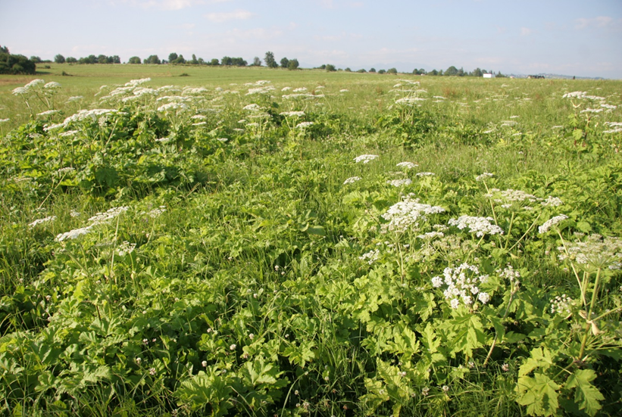
Fig. S1. An example of the marginal side of Heracleum sosnowskyi invaded patch, where it can be seen the border with the meadow and several smaller patches of invaders surrounded by a natural habitat (Szaflary, 16 VII 2019, second survey; photograph by E. Grzędzicka).

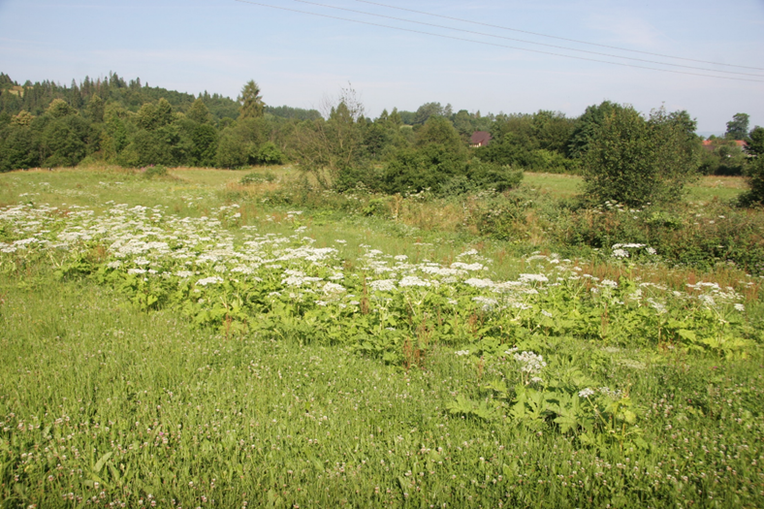
Fig. S2. An example of a large patch of Heracleum sosnowskyi composed of low aliens (about 1–1.5 m), but on the right side grows one about 2-meters specimen that stands out and can lure pollinators (Szaflary, 16 VII 2019, second survey; photograph by E. Grzędzicka).

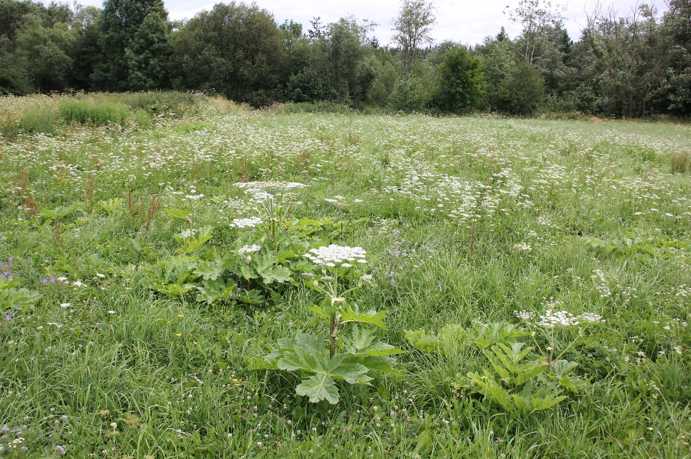
Fig. S3. The example of alien Heracleum sosnowskyi specimens with optimally developed inflorescences growing in open space without competition with other hogweeds and classified as a less invaded area (Szaflary, 2 VII 2019, second survey; photograph by E. Grzędzicka).

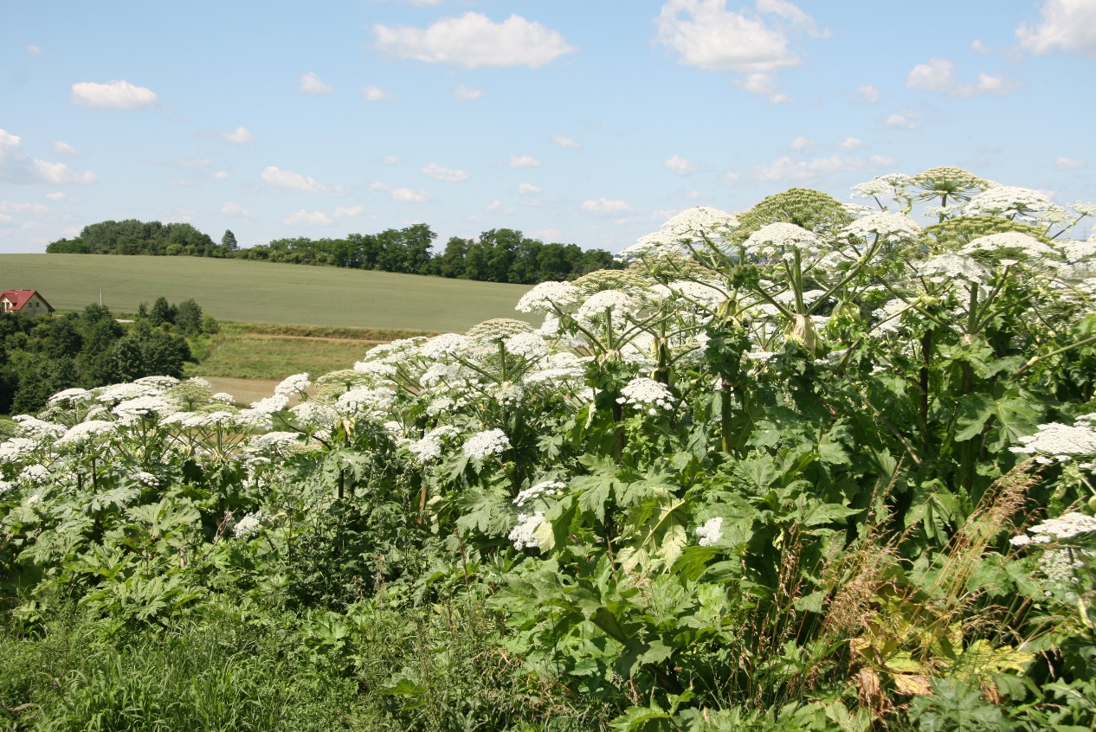
Fig. S4. The example of Heracleum sosnowskyi specimens growing in a dense thicket with space competition (Zastów, 10 km from Kraków, 30 VI 2020, photograph by E. Grzędzicka).

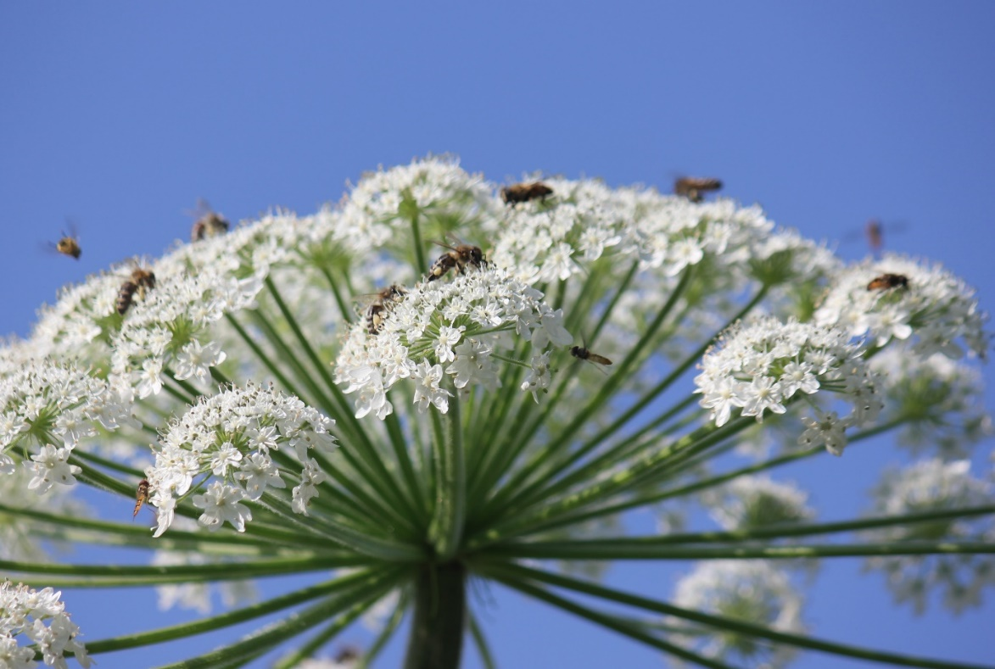
Fig. S5. The example of pollinators working on the central umbrella inflorescence of Heracleum sosnowskyi that contains numerous smaller florets; the photo was taken at a height of 1.5 meters (Baranówka, 25 VI 2019, first survey; photograph by E. Grzędzicka).

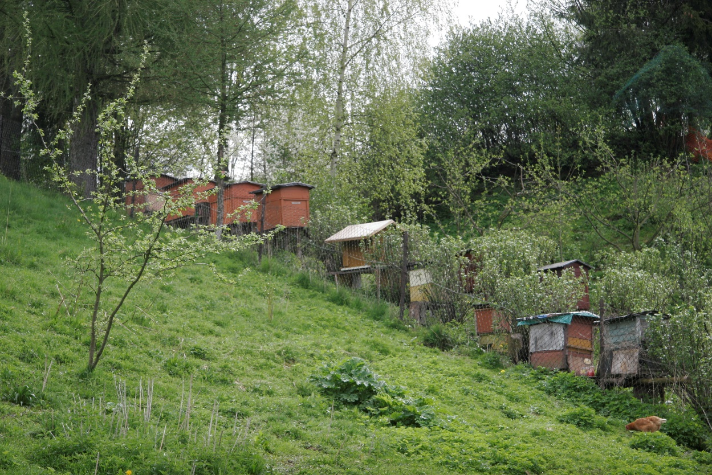 | (A)
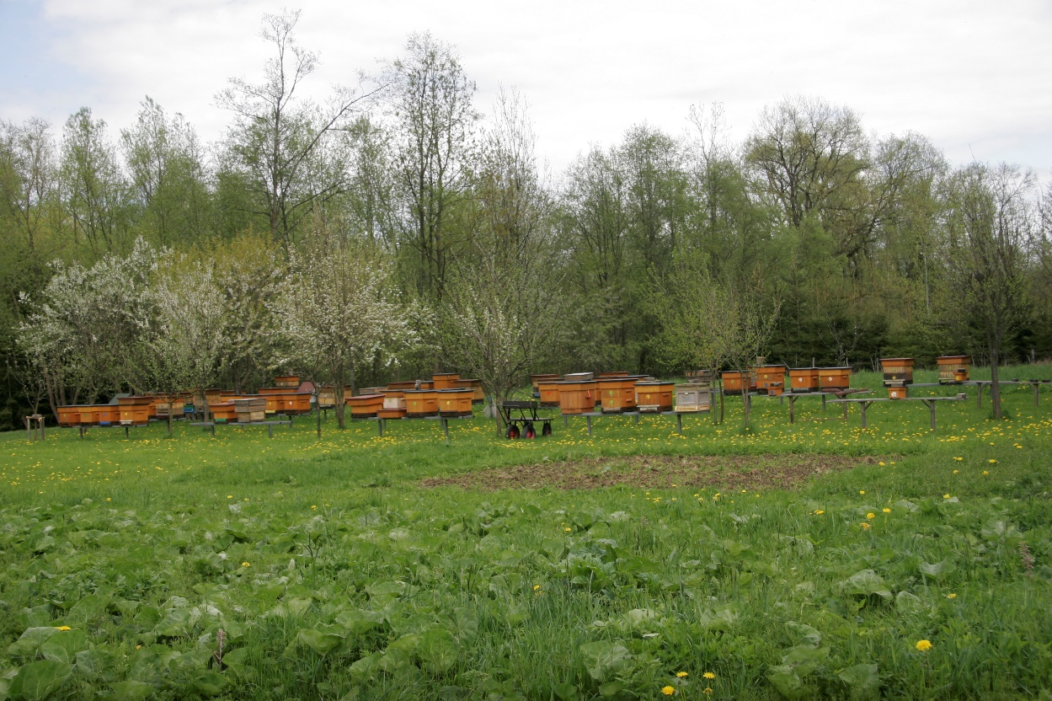 | (B)

Fig. S6. The examples of apiaries near the study sites: A) a small apiary, probably abandoned, with young Heracleum sosnowskyi in the front (Szaflary, 17 V 2021; photograph by E. Grzędzicka), B) the largest apiary in the research area containing sixty hives (Biały Dunajec, 19 V 2021; photograph by E. Grzędzicka).

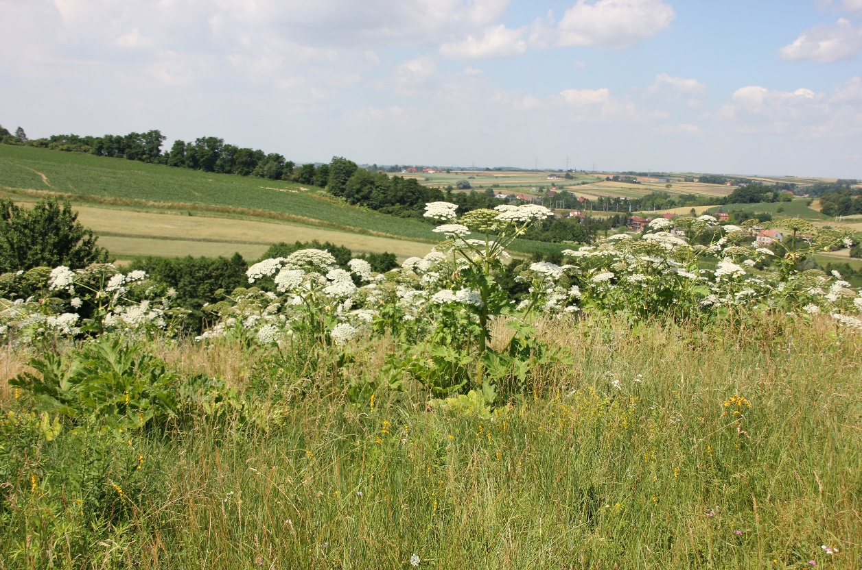
Fig. S7. The examples of Heracleum sosnowskyi after the formation of the first fruits (note the green inflorescences) growing in a moderate competition between invaders (Zastów, 10 km from Kraków, 20 VI 2019, first survey; photograph by E. Grzędzicka).

Table S1. A list of Sosnowsky’s hogweed Heracleum sosnowskyi characteristics used as the predictor variables in GLMM models and reasons for their choice.

Characteristics | Reason why the characteristic was included
Number of Sosnowsky’s hogweeds per plot | Informs if more hogweeds at 10 m × 10 m plots affected the abundance of pollinators; in this case, the number of hogweeds included flowering and non-flowering invaders at the plot.
Number of Sosnowsky’s hogweed flowering specimens per plot | Informs whether more flower resources of hogweeds at 10 m × 10 m plots affected the abundance of pollinators; the flowering specimen used as “one” meant single plant, not single umbrella inflorescence nor floret (inflorescence contains many florets – see: Figs. S5, S7). In the study plots, the height, development and light availability of individual hogweeds were comparable, which means the approximate amount of flower resources per flowering individual.
Cover of Sosnowsky’s hogweed per plot | Informs whether the patchiness of hogweeds and the presence of gaps between them with the availability of native flowering plants affected the abundance of pollinators. There were usually several smaller groups of hogweeds at the plot, the cover was first determined separately for each group by assessing the area it occupied at the plot, and then the covers of groups for the entire plot were summed up; a larger cover was usually associated with lower patchiness of hogweeds (Fig. S4) and the presence of gaps of native vegetation between them (Fig. S1).
Maximum height of Sosnowsky’s hogweed per patch | Informs whether the highest hogweeds that stood out from others in the patch attracted the attention of pollinators, no matter if, when lured, they pollinated the tallest hogweeds or lower aliens at the plot near the tallest hogweeds; the presence of the tallest hogweeds could distract insects from the plot with less attractive plants or lure insects from afar.

Table S2. The results of the GLMM model with the mean abundance of European honeybees Apis mellifera (calculated based on two surveys) as a dependent variable and hogweed characteristics as predictor variables, where “site ID” was the random effect; the groups of research areas: 2–less invaded, 3–severely invaded (number of surveying plots: n = 68). Significant results are in bold.

 | Estimate | SEM | df | z value | p value
(Intercept)  Heracleum cover in plot  Group (3)  Heracleum flowering number in plot  Heracleum maximum height in patch  Heracleum cover in plot x group (3)  Heracleum flowering number in plot x group (3) | 1.982  -0.012  -0.041  0.082  0.011  0.019  0.070 | 0.493  0.013  0.370  0.030  0.004  0.014  0.030 | 57  57  57  57  57  57  57 | 4.024  -0.871  -0.110  2.703  2.575  1.372  2.331 | <0.001  0.384  0.913  0.007  0.010  0.170  0.020

Table S3. The results of the GLMM model with the mean abundance of non-Apis pollinators (calculated based on two surveys) as a dependent variable and hogweed characteristics as predictor variables; “site ID” was the random effect; the groups of research areas: 2–less invaded, 3–severely invaded (number of surveying plots: n = 68). Significant results are in bold.

 | Estimate | SEM | df | z value | p value
(Intercept)  Heracleum cover in plot  Heracleum flowering number in plot  Group (3)  Heracleum maximum height in patch  Heracleum flowering number in plot x group (3)  Heracleum maximum height in patch x group (3) | 2.289  -0.0001  0.087  -2.244  -0.004  -0.111  0.022 | 1.095  0.011  0.047  1.225  0.010  0.047  0.012 | 57  57  57  57  57  57  57 | 2.090  -0.011  1.855  -1.833  -0.398  -2.342  1.885 | 0.037  0.991  0.064  0.067  0.691  0.019  0.059

Table S4. The results of the GLMM models with the abundance of European honeybees Apis mellifera or non-Apis pollinators from each survey as the dependent variables and the proportion of pollinated Heracleum flowers as a predictor variable, where “site ID” was the random effect; the groups of research areas: 2–less invaded plot, 3–severely invaded plot (the number of plots: n = 68). Significant results are in bold.

 | Estimate | SEM | df | z value | p value
The mean abundance of Apis mellifera
(Intercept)  Pollinated flowers  Group (3)  Pollinated flowers x group (3) | 3.691  -0.018  0.994  -0.009 | 0.298  0.001  0.137  0.001 | 60  60  60  60 | 12.392  -15.553  7.261  -6.791 | <0.001  <0.001  <0.001  <0.001
The mean abundance of non-Apis pollinators
(Intercept)  Pollinated flowers  Group (3)  Pollinated flowers x group (3) | 2.256  0.006  -0.586  0.008 | 0.517  0.001 0.316  0.002 | 60  60  60  60 | 4.359  4.124  -1.855  4.373 | <0.001  <0.001  0.064  <0.001

Table S5. The results of the GLMM models with the mean abundance of European honeybees Apis mellifera or non-Apis pollinators (calculated based on two surveys) as the dependent variables and distance to the nearest apiary as a predictor variable, where “site ID” was the random effect; the groups of research areas: 1–uninvaded plot, 2–less invaded plot, 3–severely invaded plot (the number of surveying plots: n = 99); apiary distance = distance to the nearest apiary. Significant results are in bold.

 | Estimate | SEM | df | z value | p value
The mean abundance of Apis mellifera
(Intercept)  Apiary distance  Group (2)  Group (3)  Apiary distance x group (2)  Apiary distance x group (3) | 3.704  -0.0003  0.243  1.049  -0.0001  -0.0001 | 0.365  0.0002  0.245  0.260  0.0002  0.0002 | 89  89  89  89  89  89 | 10.141  -1.446  0.991  4.029  -0.307  -0.296 | <0.001  0.148  0.321  <0.001  0.759  0.767
The mean abundance of non-Apis pollinators
(Intercept)  Apiary distance  Group (2)  Group (3)  Apiary distance x group (2)  Apiary distance x group (3) | 3.390  -0.0002  -1.123  -2.339  0.0003  0.001 | 0.503  0.0003 0.417  0.477  0.0003  0.0003 | 89  89  89  89  89  89 | 6.741  -0.802  -2.692  -4.906  0.855  2.758 | <0.001  0.423  0.007  <0.001  0.392  0.006

