SUPPLEMENTARY MATERIAL
Brennan, G., Law, G., Gloag, R. Pollen transport by male stingless bees

Table S1: Pollen Morphotype Glossary. The following glossary was compiled using images of pollen collected from the bodies of all bees sampled in this study. Where possible, a Family-level classification was ascribed, based on available literature regarding pollen morphological traits of major plant families. In some cases, a Genus-level identification was made, using the Pollen Library (S2). The size ascribed is based on the following guidelines provided by the PalDat Illustrated Pollen Glossary (2020): very small (<10 μm), small (10–25 μm), medium (26–50 μm), large (51–100 μm) and very large (>100 μm). All images were taken with a compound light microscope (Motic BA310) at x400 magnification. Several grains, marked with an asterisk (*), were seen during pilot testing of the pollen removal method but were not found on the bees from which data was collected.

Morphotype | Classification | Size | Images
1 | Myrtaceae,  Callistemon | Small
2 | Myrtaceae | Small | 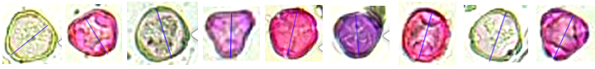
3 | Myrtaceae, Leptospermum | Small | 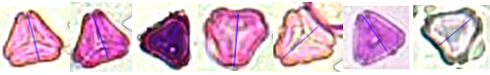
4 | Myrtaceae | Small | 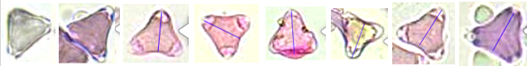
5 |  | Small | 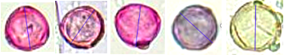
6 |  | Small | 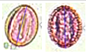
7 | Myrtaceae | Small | 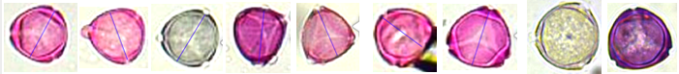
8 |  | Medium | 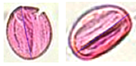
9 | Proteaceae, Theaceae | Medium | 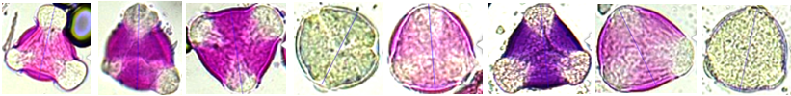
10 * | Lamiaceae | Medium | 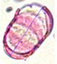
11 |  | Very small | 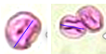
12 |  | Very small | 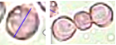
13 | Myrtaceae | Small | 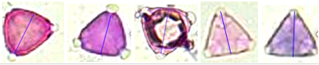
14 | Cunoniaceae | Small | 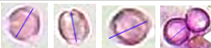
15 * | Myrtaceae | Small | 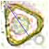
16 | Myrtaceae | Small | 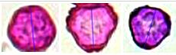
17 * | Proteaceae | Small | 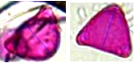
18 |  | Small | 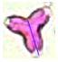
19 |  | Medium | 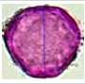
20 | Myrtaceae | Medium
21 | Myrtaceae | Medium | 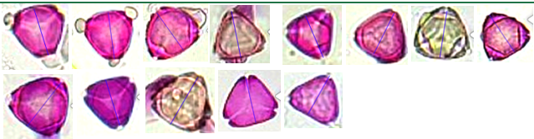
22 | Pittospracea, Hymenosporum | Medium | 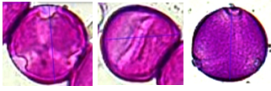
23 |  | Small | 
24 |  | Medium | 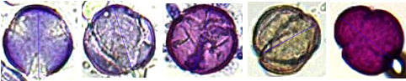
25 | Myrtaceae, Kunzea | Small | 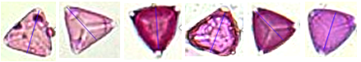
26 | Myrtaceae | Small | 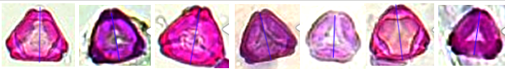
27 | Lamiaceae | Large | 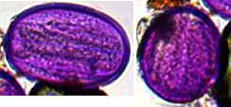
28 | Commelinaceae | Large | 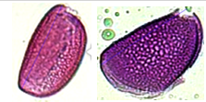
29 | Proteaceae | Medium | 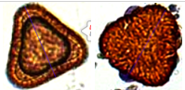
30 | Lythraceae | Medium | 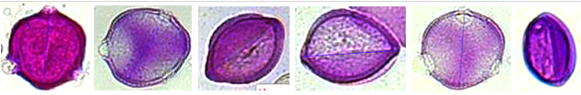
31 |  | Medium | 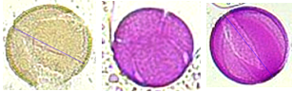
32 |  | Small | 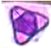
33 |  | Medium | 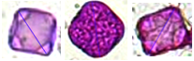
34 |  | Medium | 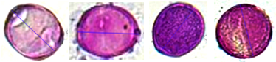
35 |  | Medium | 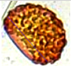
36 |  | Small | 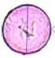
37 |  | Large | 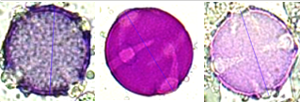
38 |  | Large | 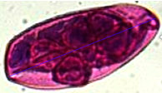
39 | Pontederiaceae | Medium | 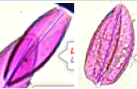
40 | Myrtaceae, Angophora | Small | 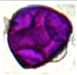
41 |  | Medium | 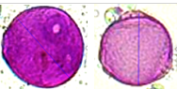
42 |  | Medium | 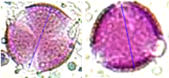
43 |  | Medium | 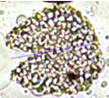
44 | Asteraceae | Small | 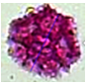
45 | Asteraceae | Medium | 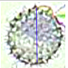
46 | Commelinaceae | Medium | 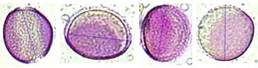
47 |  | Medium | 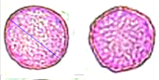
48 |  | Medium | 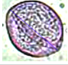
49 |  | Medium | 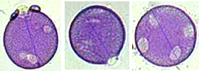
50 |  | Medium | 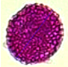
51 |  | Medium | 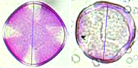
52 | Berberidaceae | Medium | 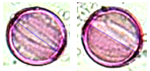
53 |  | Medium | 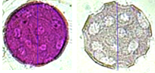
54 |  | Medium | 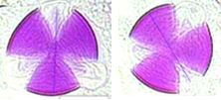

Table S2. Pollen Library. This library was compiled from images of pollen grains collected from most sites within the study. The size ascribed is based on the following guidelines provided by the PalDat Illustrated Pollen Glossary (2020): very small (<10 μm), small (10–25 μm), medium (26–50 μm), large (51–100 μm) and very large (>100 μm). All images taken with a light microscope at x40 magnification.

Name | Family | Site | Size | Images
Hibiscus rosa-sinensis | Malvaceae | Camperdown | very large | 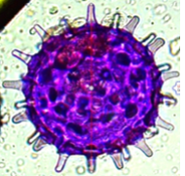
Clivia | Amaryllidaceae | Camperdown | large | 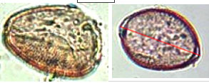
Camellia | Theaceae | Camperdown | large | 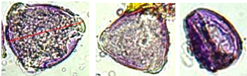
Cordyline stricta | Asparagaceae | Camperdown | medium | 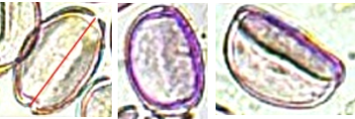
Echium candicans | Boraginaceae | Camperdown | small | 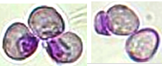
Russelia equisetiformis | Plantaginaceae | Camperdown | small | 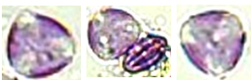
Protea cynaroides | Proteaceae | Camperdown | medium | 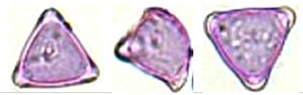
Callistemon | Myrtaceae | Camperdown | small | 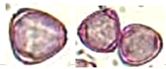
Dimorphotheca | Asteraceae | Camperdown | medium | 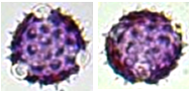
Callistemon | Myrtaceae | Camperdown | small | 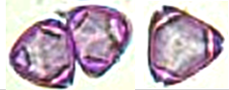
Plectranthus | Lamiaceae | Camperdown | medium | 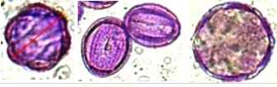
Grevillea | Proteaceae | Camperdown | small | 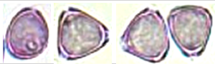
Tropaeolum majus | Tropaeolaceae | Camperdown | medium | 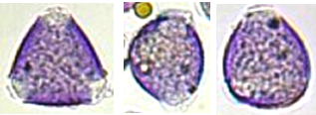
Hymenosporum flavum | Pittosporaceae | Camperdown | medium | 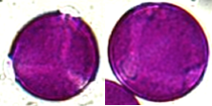
Salvia microphylla | Lamiaceae | Camperdown | medium | 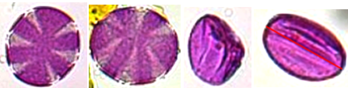
Backhousia citriodora | Myrtaceae | Camperdown | small | 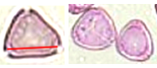
Eleaocarpus reticulatus | Elaeocarpaceae | Camperdown | very small | 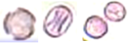
Ceratopetalum apetalum | Cunoniaceae | Camperdown | small | 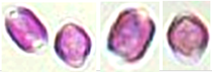
Lagerstroemia | Lythraceae | Camperdown | medium | 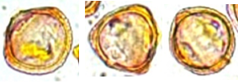
Callistemon | Myrtaceae | Camperdown | small | 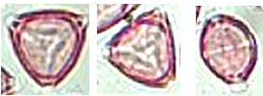
Dianella | Asphodelaceae | Camperdown | medium | 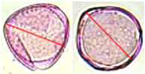
Callistemon | Myrtaceae | Camperdown | small | 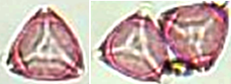
Callistemon | Myrtaceae | Camperdown | small | 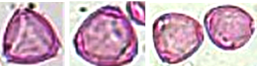
Azalea | Rhododendraceae | Camperdown | large | 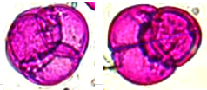
Tradescantia | Commelinaceae | Camperdown | large | 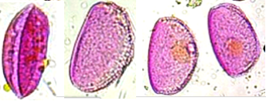
Ocimum | Lamiaceae | Camperdown | large | 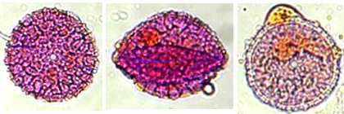
Ipomoea | Convolvulaceae | Camperdown | large | 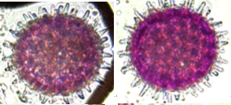
Salvia | Lamiaceae | Camperdown | small | 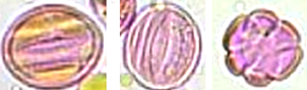
Salvia greggii | Lamiaceae | Camperdown | medium | 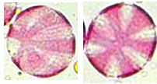
Meleuca thymifolia | Myrtaceae | Camperdown | small | 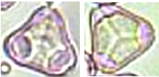
Xanthorrhoea | Asphodelaceae | Camperdown | medium | 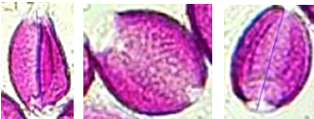
Chrysocephalum apiculatum | Asteraceae | Camperdown | medium | 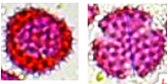
Anigozanthos | Haemodoraceae | Camperdown | medium | 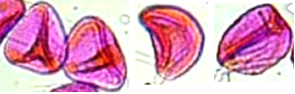
Kunzea | Myrtaceae | Camperdown | small | 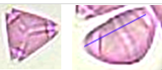
Hardenbergia | Fabaceae | Camperdown | medium | 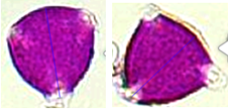
Hemerocallis | Asphodelaceae | Camperdown | large | 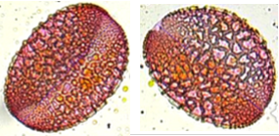
Gazania | Asteraceae | Camperdown | medium | 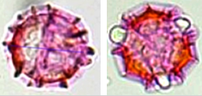
Carpobrotus | Aizoaceae | Camperdown | medium | 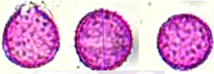
Tradescantia | Commelinaceae | Camperdown | medium | 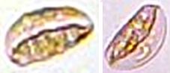
Nandina domestica | Berberidaceae | Camperdown | medium | 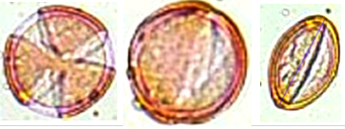
Grevillea | Proteaceae | Caringbah | large | 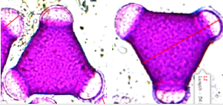
Erythrina | Fabaceae | Caringbah | medium | 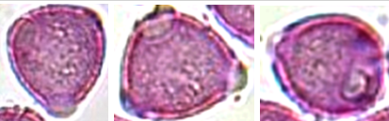
Ceratopetalum | Cunoniaceae | Caringbah | small | 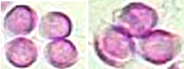
Kunzea | Myrtaceae | Caringbah | small | 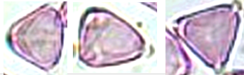
Isopogon anethifolius | Proteaceae | Caringbah | large | 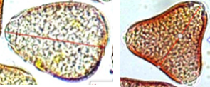
Cirsium | Asteraceae | Ku-ring-gai | large | 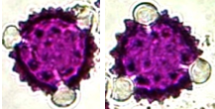
Meleleuca hypericifolia | Myrtaceae | Ku-ring-gai | small | 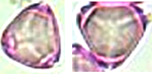
Dietes iridioides | Iridaceae | Ku-ring-gai | large | 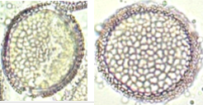
Angophora hispida | Myrtaceae | Ku-ring-gai | medium | 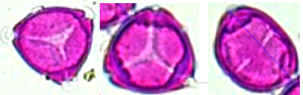
Actinotus minor | Apiaceae | Ku-ring-gai | small | 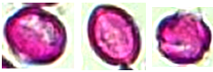
Acacia | Mimosaceae | Ku-ring-gai | medium | 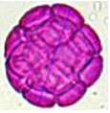
Crinum pedunculatum | Amaryllidaceae | Sydney Olympic Park | Large | 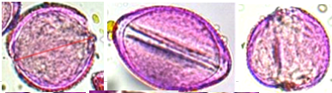
Brassica | Brassicaceae | Turramurra | Small | 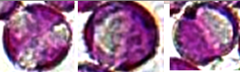
Tropaeolum majus | Tropaeolaceae | Turramurra | Small | 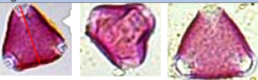
Salvia | Lamiaceae | Turramurra | Small | 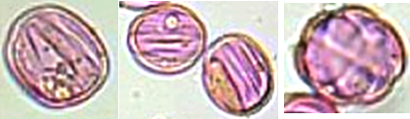
Lobularia maritima | Brassicaceae | Turramurra | Small | 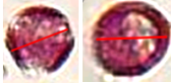
Aquilegia | Ranunculaceae | Turramurra | small | 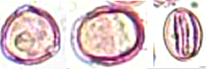
Citrus | Rutaceae | Wyoming | Medium | 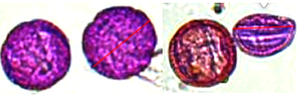
Hibiscus rosa-sinensis | Malvaceae | Wyoming | Very large | 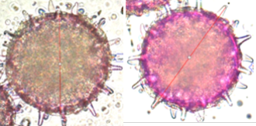
Commelina cyanea | Commelinaceae | Wyoming | Large | 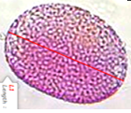

Table S3. Behavioural ethogram used to score videos of bees as they groomed. For analysis, behaviours were broadly categorised according to which body part they targeted.
Code | Description | Category
eat | Feeding on sugar water-soaked paper towel, tongue extended repeatedly. | physiology
walk | Walking around petri dish without stopping, grooming, or inspecting environment. | physiology
fly | Flying around petri dish or flying while remaining stationary, legs not contacting surface of petri dish. | physiology
flutter | Fluttering wings with legs still in contact with petri dish, remainder of body remains stationary. Can also be walking at the same time. | wings
wing | Scraping one or both hind tibiae against fore wing(s), holding them against the side(s) of the abdomen. | wings
eyes | Scraping one or both of the front eyes with one or both fore legs. | head
antennae | Scraping one or both antennae with one or both fore legs. | head
hind | Rubbing both hind legs together asynchronously, contact ranging from the inner tibiae to the tarsi and frequently also inolves one or both mid legs. | legs
fore | Rubbing both fore legs together asynchronously. | legs
mid | Rubbing fore leg(s) against mid leg(s). | legs
abdomen | Scraping one or both hind tibiae against side(s) of abdomen. | abdomen
thorax | Scraping dorsal thorax with fore leg(s). | thorax

Table S4. Behavioural ethogram used in BORIS to score videos of bees as they visited flowers. For analysis, videos were categorised according to whether or not contact with reproductive structures was observed.
Code | Description
Contact | Contacting the reproductive structures of the flower (stigma, anthers, or both) using any body part, excl. hind legs, for a minimum of 1s.
Nectar | Nectar foraging, indicated by tongue extended repeatedly in nectaries of flower (not always visible, but confirmed by eye prior to filming).
Walk | Walking between flowers of the same inflorescence.
Pollen | Foraging for pollen actively with legs or mouth and/or packing into pollen baskets (only applicable to females).
Groom | Autogrooming while on flower.
Walk/nectar | Walking and collecting nectar simultaneously.
Walk/contact | Walking and touching reproductive structures (ie. walking over anthers and/or stigma).
Flew away | Flew away before the video ended.

Table S5. Top five most prevalent pollen morphotypes (based on numbers assigned in Table S1) collected from male bee bodies at each site, ordered from most high (1st) to low (5th). Morphotypes in shaded cells are those that were also present on workers sampled at the same site, consistent with males commonly using floral resources that workers also use. Morphotypes in unshaded cells are those that were observed on males but not workers for that site. The site locations are as follows: Site 1 (Camperdown: 33.8870º S, 151.1766º E), Site 2 (Heathcote: 34.0818º S, 151.0041º E), Site 3 (Turramurra: 33.7335º S, 151.1280º E), Site 4 (Caringbah: 34.0410º S, 151.1225º E), Site 5 (Wyoming: 33.6671º S, 151.0175º E), and Site 6 (Marrickville: 33.9106º S, 151.1565ºE).
Pollen morphotype prevalence rank on males | Site 1 | Site 2 | Site 3 | Site 4 | Site 5 | Site 6
1st | 1 | 14 | 14 | 14 | 4 | 21
2nd | 21 | 23 | 7 | 4 | 26 | 9
3rd | 34 | 27 | 4 | 25 | 13 | 4
4th | 4 | 4 | 3 | 21 | 2 | 26
5th | 7 | 21 | 1 | 1 | 1 | 2

