Apidologie - Original Article

Urbanization reduces the number of visits and diversity of Euglossini bees in tropical urban green spaces

Jéssica L. S. Silva^{a*}, Victor G. M. N. Santana^{b*}, Thaís C. M. Andrade^{c}, Luanda A. P. S. Barbosa ^{c}; Daniele R. Parizotto^{d}; Ariadna V. Lopes^{a**}

ªDepartamento de Botânica, Universidade Federal de Pernambuco, Recife, Pernambuco, 50670-901, Brazil.
^{b}Universidade Federal de Pernambuco, Recife, Pernambuco, 50670-901, Brazil.
^{c}Programa de Pós-Graduação em Biologia Vegetal, Universidade Federal de Pernambuco, Recife, Pernambuco, 50670-901, Brazil.
^{d}Departamento de Agronomia, Universidade Federal Rural de Pernambuco, Recife, Pernambuco, 55810-700, Brazil.

*These authors contributed equally to this work.
**Corresponding author: Departamento de Botânica, Centro de Biociências, Universidade Federal de Pernambuco, Recife, Pernambuco, 50670-901, Brazil; + 55 81 2126-8352; ariadna.lopes@ufpe.br

SUPPLEMENTARY MATERIAL

FIGURE S1. Correlation matrix indicating Variance Inflation Factor values of all urban metrics [i.e., average building density (abd), average vegetation density (avd), number of cells with high building density (ncbd), number of cells with high vegetation density (ncvd), number of cells with paving/road (ncwr), distance to the nearest forest remnant area (dnga), number of cells with the presence of water bodies (ncwb), number of cells with the presence of a channel (ncpc)] in 14 urban green spaces distributed at Recife city, Pernambuco, Brazil.

FIGURE S2. Principal component analysis indicating the contribution of the variables used to obtain the urbanization ecological index of urban green spaces in Recife, Pernambuco, Brazil. The first and second components presented 52.7% and 27.8% of the explained variance, respectively.

FIGURE S3. Asymptote estimation curves of Hill numbers (q=0: species richness, q=1: Shannon diversity, q=2: Simpson diversity) based on the richness and abundance of Euglossini bee in 14 urban green spaces distributed in Recife city, Pernambuco, Brazil.
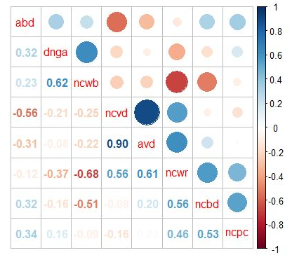
Fig. S1
Fig. S2

Fig. S3

