Supplementary File 1

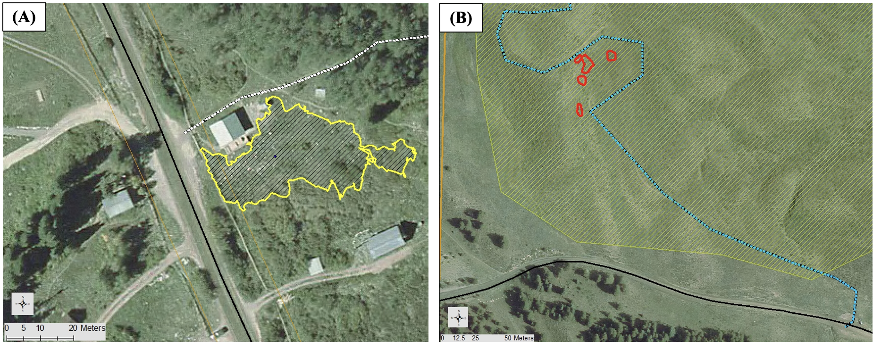
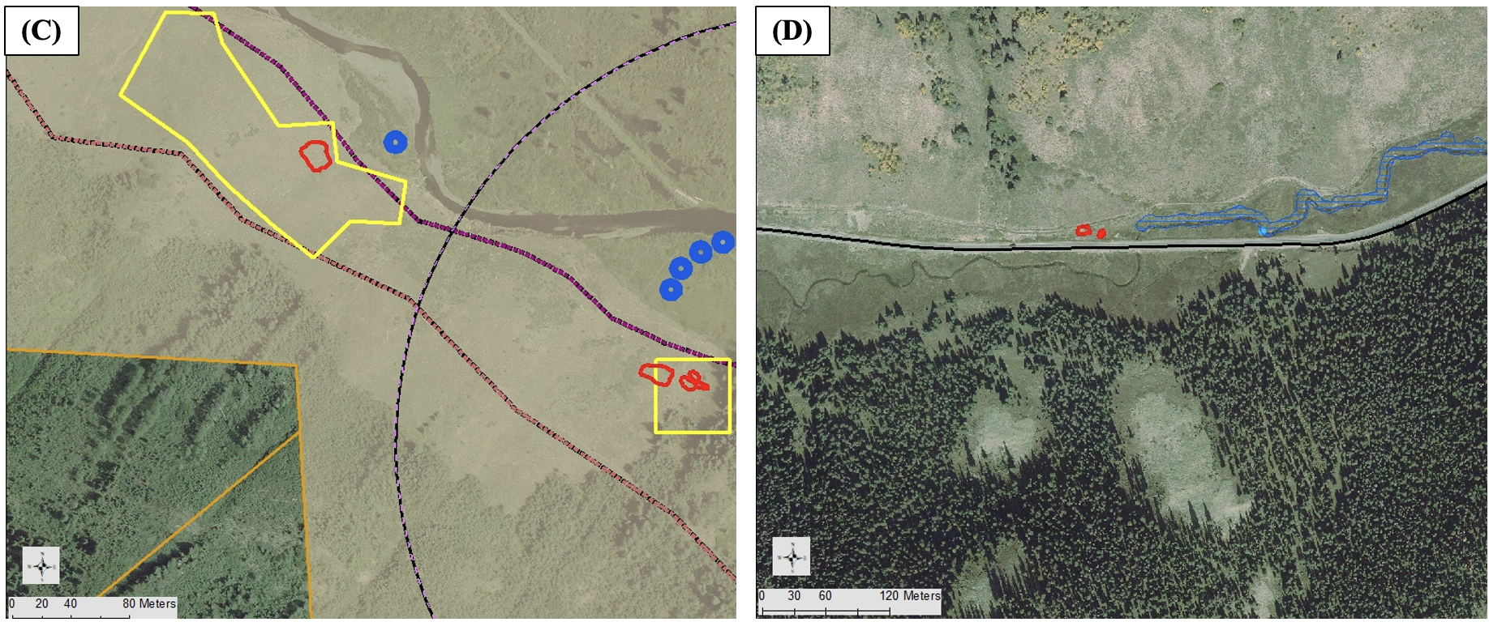
Figure S1: Maps of the four field sites used in the study. (A) The Rocky Mountain Biological Laboratory in Gothic, Colorado; (B) Lupine trail field site; (C) Lower Loop field site; (D) Kebler Pass field site. The yellow perimeters represent historic sites used by past researchers and used in this study. L. vulgaris grew in the entire area outlined in yellow. Red polygons represent some of the patches within the field sites that were observed in this study.

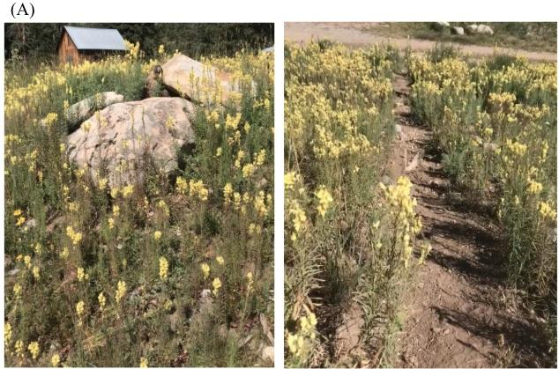
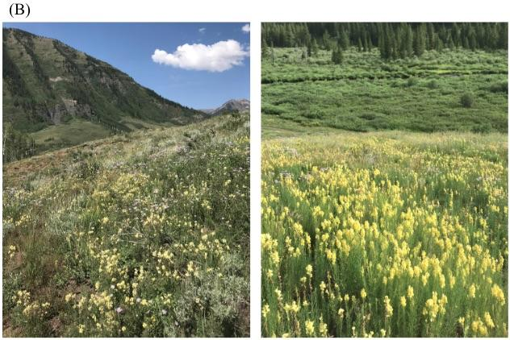

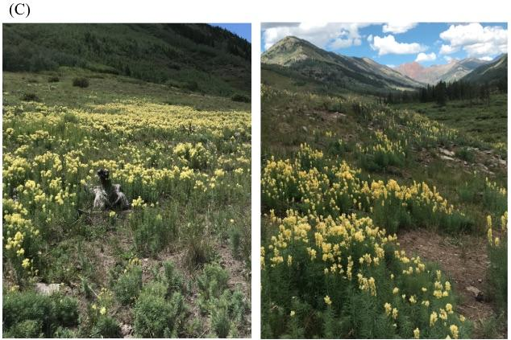
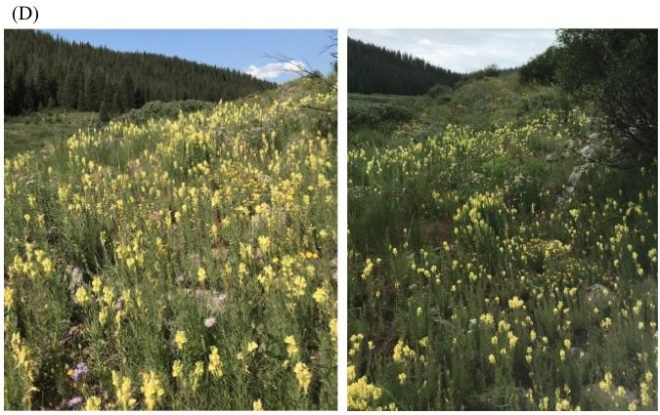
Figure S2: Field site images depicting patches of L. vulgaris used for the study (yellow flowers). (A) the Rocky Mountain Biological Laboratory; (B) Lupine trail field site; (C) Lower Loop trail site; (D) Kebler Pass site.

