Supplementary material to the manuscript
The socio-economic performance of agroecology. A review
Ioanna Mouratiadou^{a,b*⸸}, Alexander Wezel^{c⸸}, Kintan Kamilia^{c}, Angelica Marchetti^{d}, Maria Luisa Paracchini^{e}, Paolo Bàrberi^{d}

ªLaboratory of Rural Studies research unit, ISARA, Lyon, France
^{b}Land Use and Governance Research Area, Leibniz Centre for Agricultural Landscape Research (ZALF), Müncheberg, Germany
^{c}Agroecology and Environment research unit, ISARA, Lyon, France
^{d}Group of Agroecology, Center of Plant Sciences, Scuola Superiore Sant’Anna, Pisa, Italy
^{e}Joint Research Centre, European Commission, Ispra, Italy

*Corresponding author imouratiadou@isara.fr
⸸ Authors share equally first authorship.
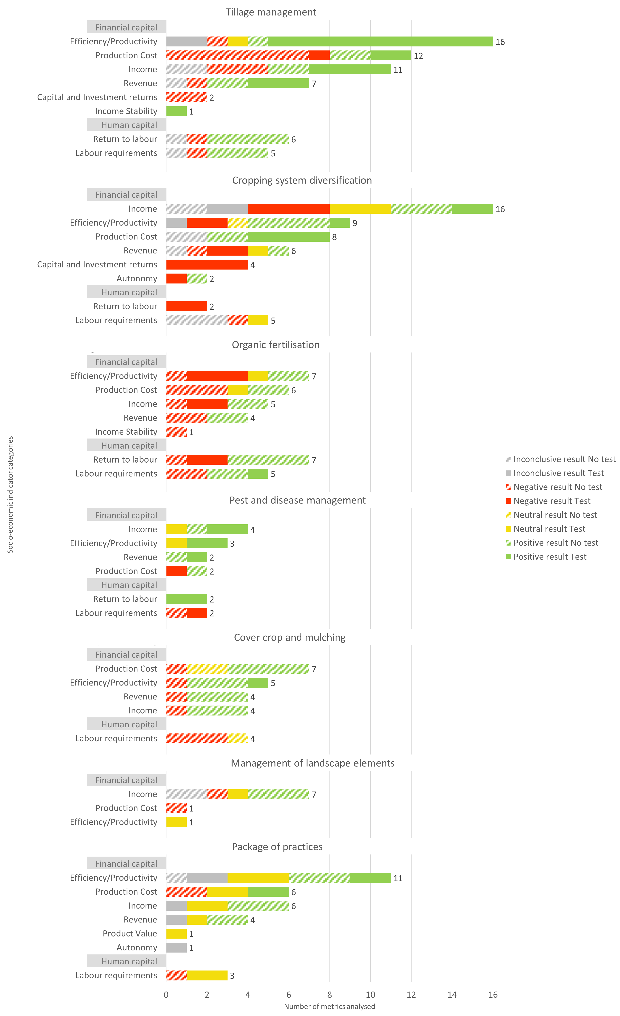
Figure S1. Type of outcomes retrieved from the articles on different agroecological practices structured according to socio-economic sub-themes. The numbers indicate the total number of evaluated metrics per sub-theme.

