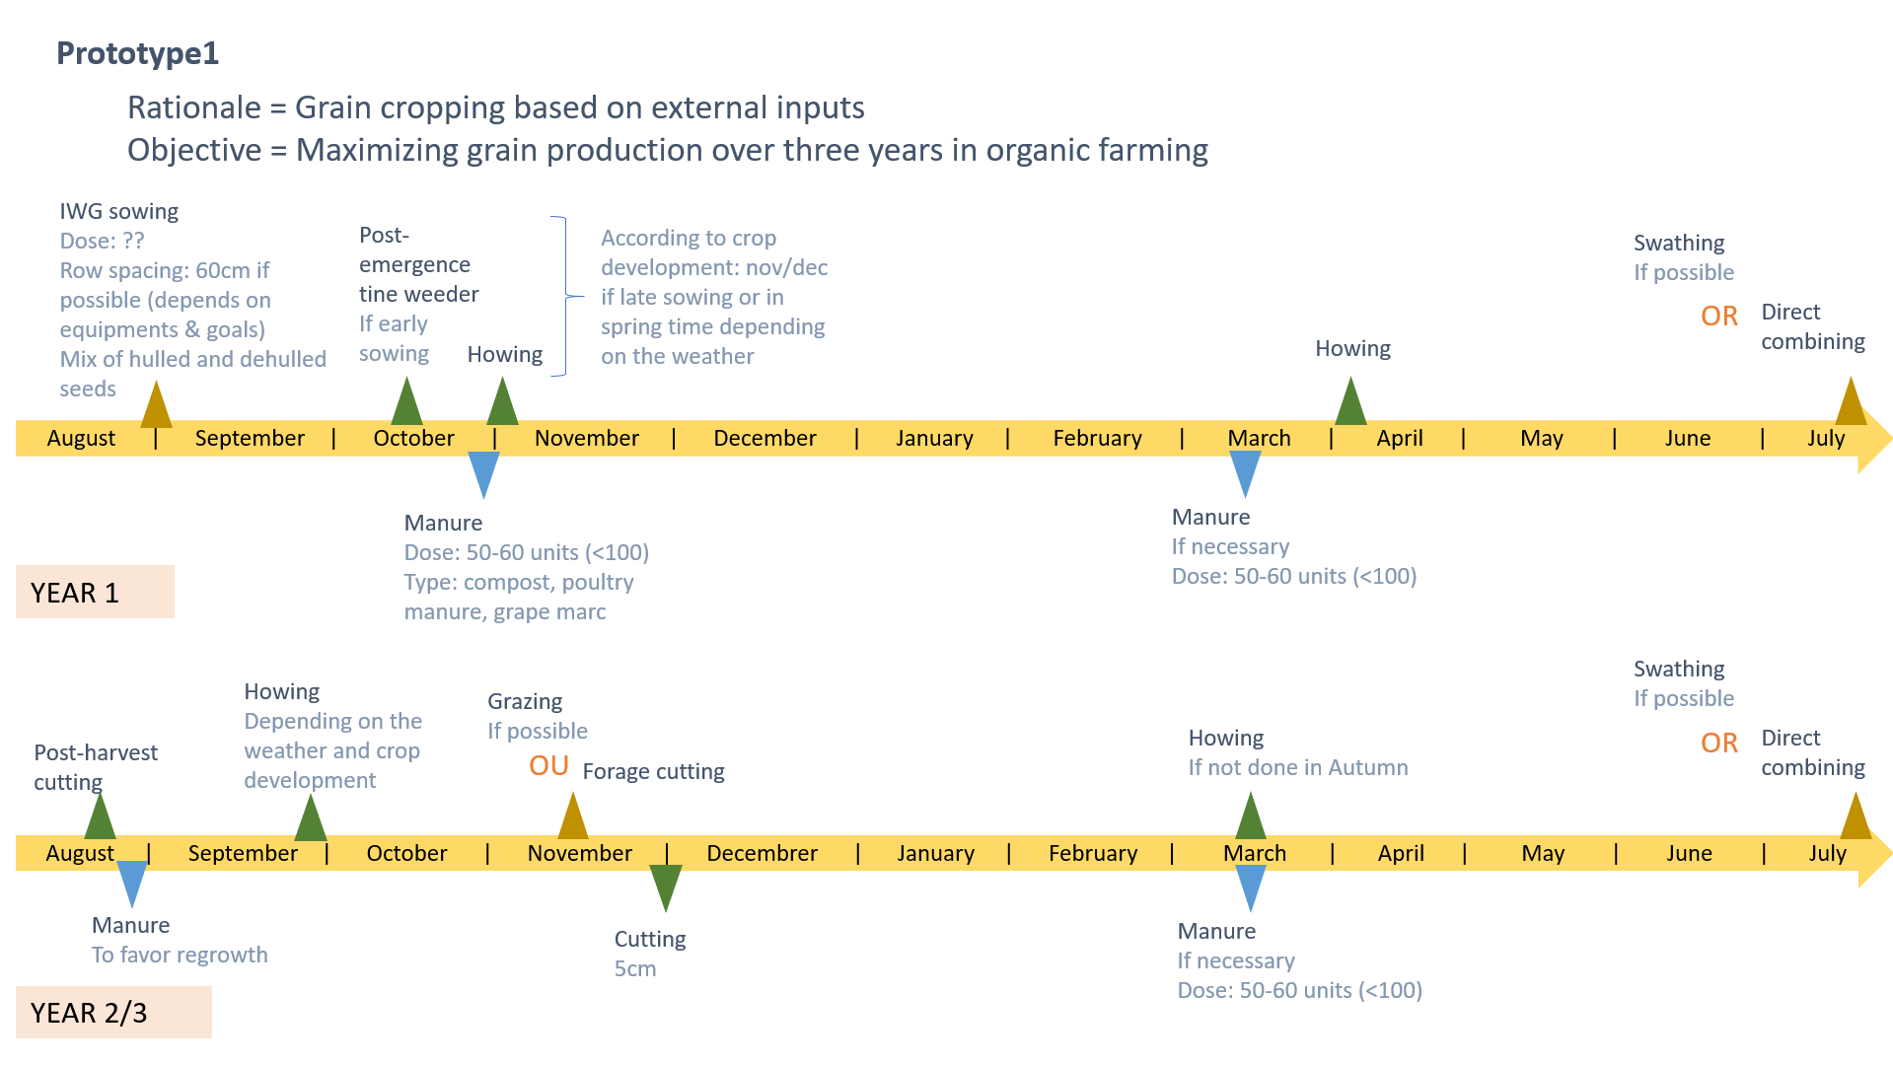
Supplementary material 2: Prototypes of IWG crop management. Among the 11 prototypes, we selected three to illustrate the three rationales of crop management. Objectives that were given for each prototype are specified.
