Supplementary Table S1 – Price values used for the marginal net revenue (MNR) calculation with respective units and sources.
MNR variables | Price | Units | Source
Rice PP (2018-2022) | 0.35 | € kg grain⁻¹ | (FAO, n.d.)
FNP (2018-2022) | 1.17 | € kg N⁻¹ | (Subsecretaría de Agricultura Pesca y Alimentación, 2024)
Costs CC
CC sowing | 100.32 | € ha⁻¹ | Associació de Propietaris de Maquinària Agrícola de les comarques del Baix-Ebre i Montsià
CC termination | 61.56 | € ha⁻¹ | Associació de Propietaris de Maquinària Agrícola de les comarques del Baix-Ebre i Montsià
CC incorporation | 34.20 | € ha⁻¹ | Associació de Propietaris de Maquinària Agrícola de les comarques del Baix-Ebre i Montsià
RG Seeds (40 kg ha⁻¹) | 88 | € ha⁻¹ | Local certified seed business
HV Seeds (63 kg ha ⁻¹) | 185.22 | € ha⁻¹ | Local certified seed business

Supplementary Table S2 – Significance levels of effects – cover crop species (CC) and rice N fertilisation levels (FER) - given by the p-values of the ANOVAS performed for the cover crop (CC) biomass and biomass N accumulation. The ANOVAs for the 2021 season excludes the FER effect.
 | CC Biomass |  |  | CC Biomass N
Seasons | 2021 | 2022 | 2023 | 2021 | 2022 | 2023
n | 16 | 16 | 16 | 16 | 16 | 16
Effects
CC | <0.001 | 0.028 | 0.0171 | 0.058 | 0.008 | <0.001
FER | - | 0.831 | 0.485 | - | 0.817 | 0.536
CC:FER | - | 0.955 | 0.012 | - | 0.772 | 0.126
Supplementary Table S3 - Significance levels of effects – season (S), cover crop treatment (CC), N fertilisation levels (FER), and respective interactions - given by the p-values of the RMANOVAS performed for the soil mineral N (SMN) at the start of the rice seasons (initial SMN), at rice panicle initiation (PI) and after rice harvest (residual SMN). The ANOVA for the soil total N at the end of the experiment excludes seasonal effect and respective interactions (i.e., two-way ANOVA).
 | At CC incorporation (0-60 cm) |  |  | At rice PI (0-30 cm) |  |  | After rice harvest (0-60 cm)
 | Nitrate-N | Ammonium-N | SMN | Nitrate-N | Ammonium-N | SMN |  | Nitrate-N | Ammonium-N | SMN | Total N
n | 144 | 144 | 144 | 129 | 129 | 129 |  | 137 | 137 | 137 | 48
Effects
S | < 0.001 | < 0.001 | < 0.001 | < 0.001 | < 0.001 | < 0.001 |  | < 0.001 | < 0.001 | < 0.001 | -
CC | < 0.001 | 0.178 | < 0.001 | 0.521 | 0.783 | 0.682 |  | 0.313 | 0.406 | 0.542 | 0.008
FER | - | - | - | 0.851 | 0.055 | 0.062 |  | 0.125 | 0.839 | 0.939 | 0.707
S:CC | 0.633 | 0.085 | 0.060 | 0.588 | 0.111 | 0.186 |  | < 0.001 | 0.040 | 0.002 | -
S:FER | - | - | - | 0.960 | 0.096 | 0.090 |  | 0.054 | 0.366 | 0.271 | -
CC:FER | - | - | - | 0.800 | 0.197 | 0.270 |  | 0.259 | 0.844 | 0.777 | 0.150
S:CC:FER | - | - | - | 0.746 | 0.452 | 0.769 |  | 0.222 | 0.626 | 0.678 | -

Supplementary Table S4 - Significance levels of effects – season (S), cover crop treatment (CC), N fertilisation levels (FER), and respective interactions - given by the p-values of the RMANOVAS performed for the rice: height at maturity; NDVI at panicle initiation (PI); panicle density (panicles m⁻²); panicle number per plant; grain number per panicle; and thousand kernel weight (TWK).
 | NDVI at IP | PD (pan. m²) | Panicles per plant | Grains per panicle | TKW (g)
n | 137 | 137 | 136 | 137 | 137
Effects
S | < 0.001 | < 0.001 | < 0.001 | < 0.001 | < 0.001
CC | < 0.001 | 0.002 | 0.263 | 0.522 | 0.443
FER | < 0.001 | < 0.001 | < 0.001 | < 0.001 | 0.088
S:CC | 0.015 | 0.055 | 0.484 | 0.696 | 0.205
S:FER | < 0.001 | 0.230 | 0.233 | < 0.001 | 0.723
CC:FER | 0.106 | 0.320 | 0.050 | 0.848 | 0.996
S:CC:FER | 0.943 | 0.695 | 0.084 | 0.807 | 0.696

Supplementary Table S5 - Significance levels of effects – season (S), cover crop treatment (CC), N fertilisation levels (FER), and respective interactions - given by the p-values of the RMANOVAS performed for the rice: straw production, grain yield, biomass N, N use efficiency (NUEy), N uptake efficiency (NUpE) and marginal net revenue (MNR).
 | Rice Straw  (t ha⁻¹) | Grain Yield  (t ha⁻¹) | Biomass N  (kg N ha⁻¹) | NUEy  (kg kg N⁻¹) | NUpE  (kg N kg N⁻¹) | MNR  (€ ha⁻¹)
n | 137 | 137 | 137 | 135 | 135 | 101
Effects
S | < 0.001 | 0.016 | < 0.001 | < 0.001 | < 0.001 | < 0.001
CC | < 0.001 | < 0.001 | < 0.001 | 0.002 | 0.022 | < 0.001
FER | < 0.001 | < 0.001 | < 0.001 | < 0.001 | < 0.001 | < 0.001
S:CC | 0.647 | 0.318 | 0.863 | 0.250 | 0.394 | 0.388
S:FER | < 0.001 | < 0.001 | 0.133 | < 0.001 | < 0.001 | 0.237
CC:FER | 0.899 | 0.703 | 0.529 | 0.574 | 0.864 | 0.845
S:CC:FER | 0.912 | 0.872 | 0.991 | 0.729 | 0.919 | 0.629

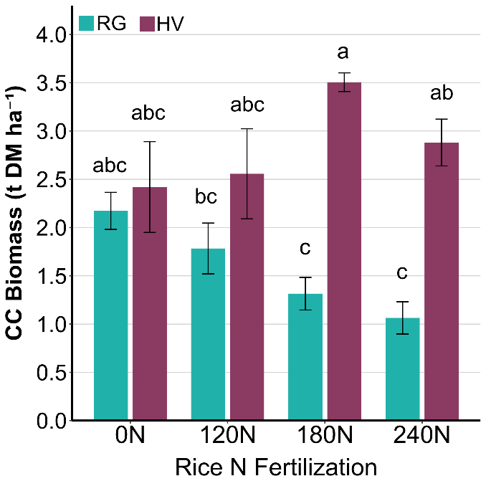
Supplementary Figure S1 - Aboveground biomass production (t DM ha⁻¹) means of each cover crop (CC) – ryegrass (RG) and hairy vetch (HV) – in 2023 according to each rice N fertilization treatment (FER). Significant differences (p < 0.05) are represented by different letters according to the Tukey’s HSD and standard errors by whisker bars

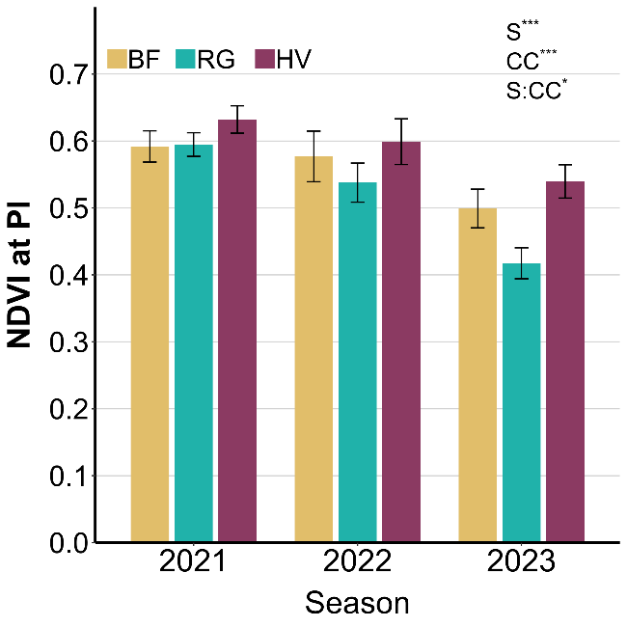
Supplementary Figure S2 - The rice NDVI at panicle initiation (PI) in each season (S) according to CC treatment - bare fallow (BF), ryegrass (RG) and hairy vetch (HV). Standard errors are represented by whisker bars. Significant effects and interactions on the from the RMANOVA on the SMN are represented by * at p < 0.05 and *** at p < 0.001.

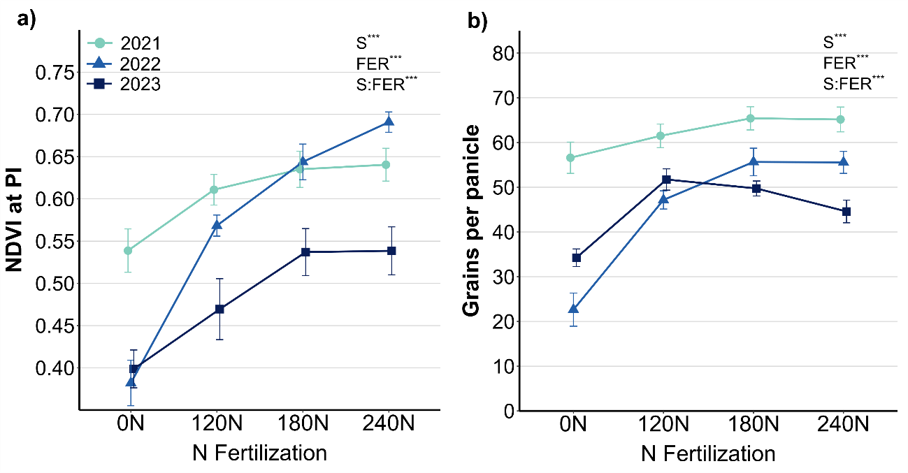
Supplementary Figure S3 - The rice NDVI at panicle initiation (PI; a) and grain production per panicle (b) according to the season (S) and fertilizer N level (FER). Standard errors are represented by whisker bars. Significant effects and interactions on the from the RMANOVA on the SMN are represented by *** at p < 0.001.

