SUPPLEMENTARY MATERIAL

Climate change-related lessons learned from a long-term field experiment with maize
Klára Pokovaiª, Hans-Peter Piepho^{b}, Jens Hartung^{b}, Tamás Árendás^{c,*}, Péter Bónis^{c}, Eszter Sugár^{c}, Roland Hollós^{c,d}, Nándor Fodor^{c}

ª Institute for Soil Sciences, Centre for Agricultural Research HUN-REN, Department of Soil Physics and Water Management Herman Ottó u. 15. 1022, Budapest, Hungary
^{b} Biostatistics Unit, Institute of Crop Science, University of Hohenheim, Fruwirthstrasse 23, 70599, Stuttgart, Germany
^{c} Agricultural Institute, Centre for Agricultural Research HUN-REN, Department of Crop Production, Brunszvik u. 2. 2462, Martonvásár, Hungary
^{d} Global Change Research Institute of the Czech Academy of Sciences, Bělidla 986/4a, Brno, 603 00, Czech Republic

Table SM1 Lack-of-fit for response surface regression in year-wise analyses. The lack-of-fit was tested via the fixed effect V.F.P. Only two lack of fit tests were significant at the 5% level. Overall, the results indicate good fit. Hence, we use the second-order model with N^{1/2} for analysis over years.
Year | Effect | Numerator Degree of Freedom | Denominator Degrees of Freedom | F value | F probability
1992 | V.F.P | 70 | 228 | 0.89 | 0.708
1993 | V.F.P | 70 | 228 | 0.78 | 0.8928
1994 | V.F.P | 70 | 228 | 0.94 | 0.6197
1995 | V.F.P | 70 | 228 | 1.38 | 0.0402
1996 | V.F.P | 70 | 228 | 1.13 | 0.2563
1997 | V.F.P | 70 | 228 | 0.92 | 0.6554
1998 | V.F.P | 70 | 228 | 0.98 | 0.5291
1999 | V.F.P | 70 | 228 | 0.93 | 0.6377
2000 | V.F.P | 70 | 228 | 0.75 | 0.9221
2001 | V.F.P | 70 | 228 | 0.74 | 0.9307
2002 | V.F.P | 70 | 228 | 0.63 | 0.9872
2003 | V.F.P | 70 | 228 | 0.92 | 0.6594
2004 | V.F.P | 70 | 228 | 0.93 | 0.633
2005 | V.F.P | 70 | 228 | 1.5 | 0.0134
2006 | V.F.P | 70 | 228 | 0.77 | 0.9052
2007 | V.F.P | 70 | 228 | 0.96 | 0.5659
2008 | V.F.P | 70 | 228 | 1.01 | 0.4704
2009 | V.F.P | 70 | 228 | 1.34 | 0.0557
2010 | V.F.P | 70 | 228 | 0.75 | 0.9246
2011 | V.F.P | 70 | 228 | 1.01 | 0.4599
2012 | V.F.P | 70 | 228 | 1.06 | 0.3645
2013 | V.F.P | 70 | 228 | 1.31 | 0.0716
2014 | V.F.P | 70 | 228 | 0.72 | 0.9439
2015 | V.F.P | 70 | 228 | 0.75 | 0.9181
2016 | V.F.P | 70 | 228 | 0.8 | 0.8616
2017 | V.F.P | 70 | 228 | 0.73 | 0.9404
2018 | V.F.P | 70 | 228 | 0.85 | 0.7878
2019 | V.F.P | 70 | 228 | 0.9 | 0.685
2020 | V.F.P | 70 | 209 | 0.82 | 0.833
2021 | V.F.P | 70 | 228 | 1.14 | 0.2394

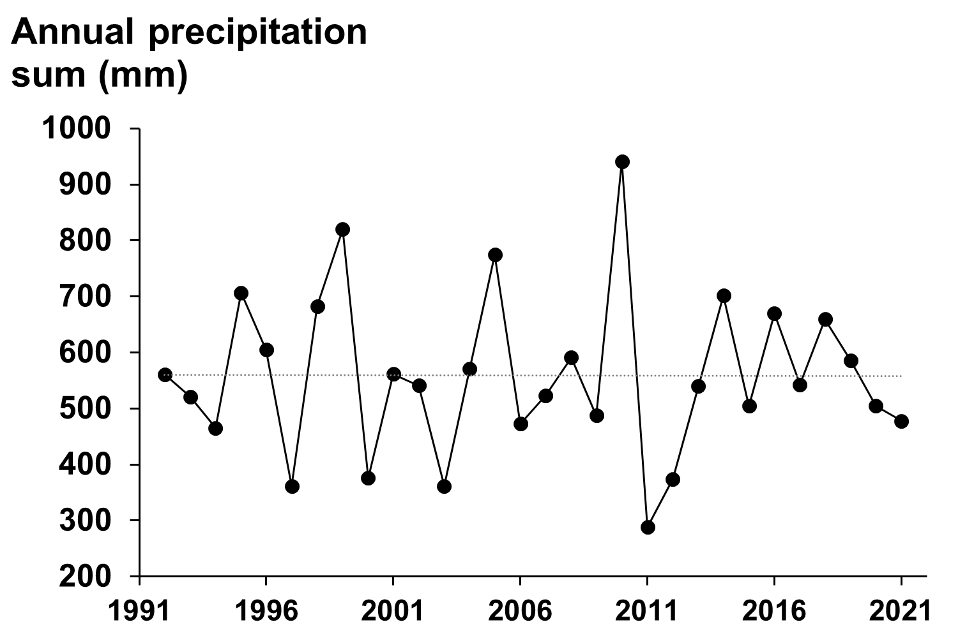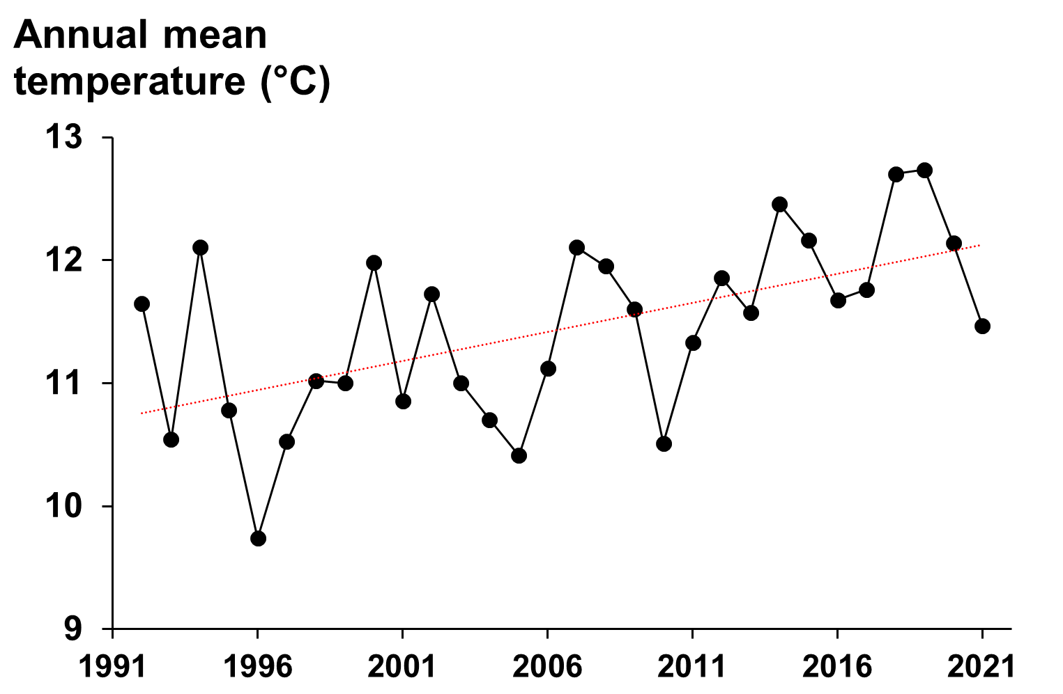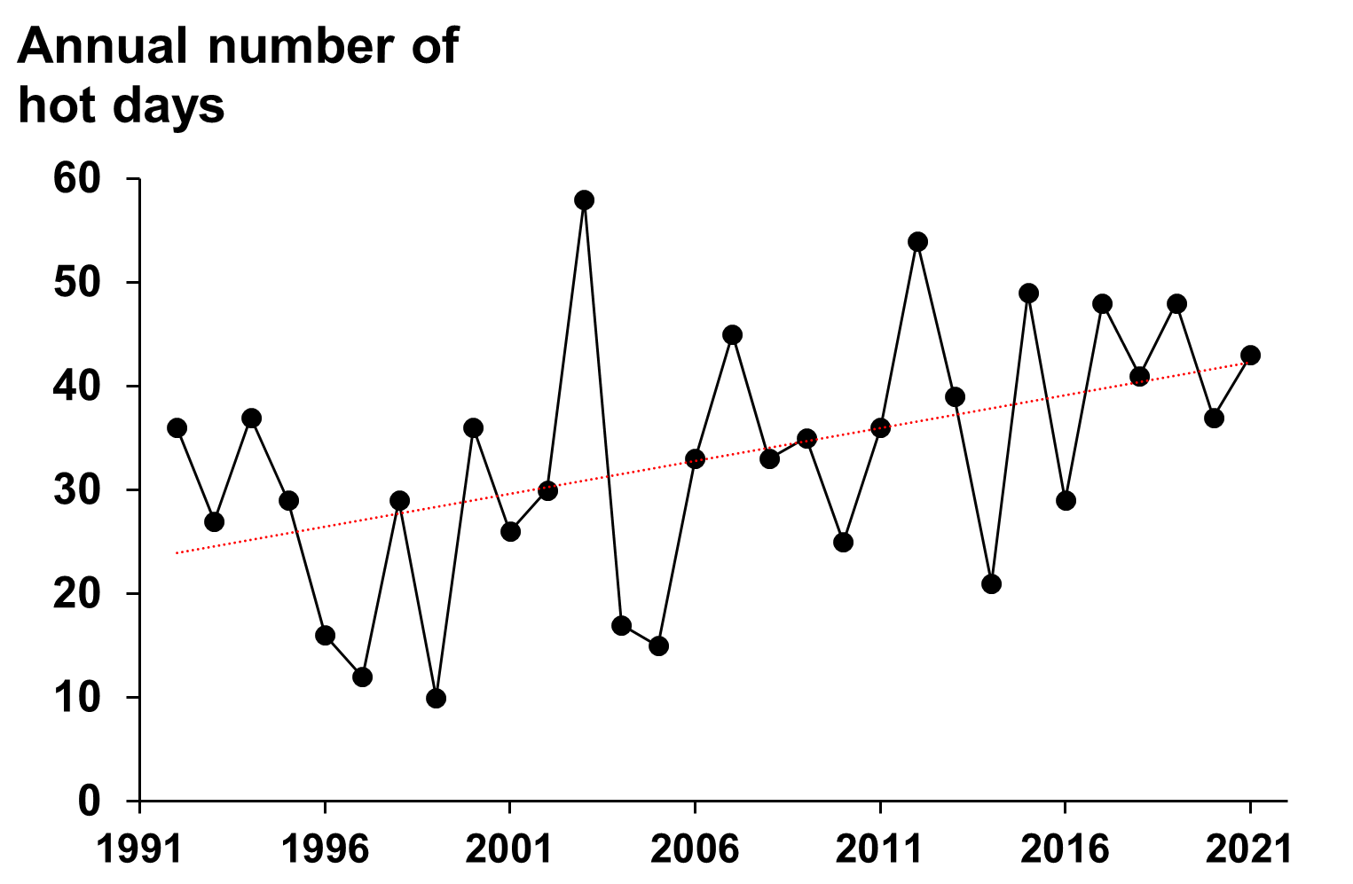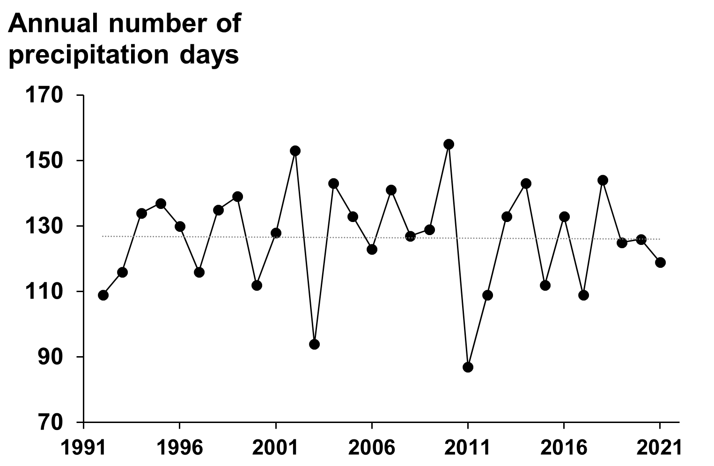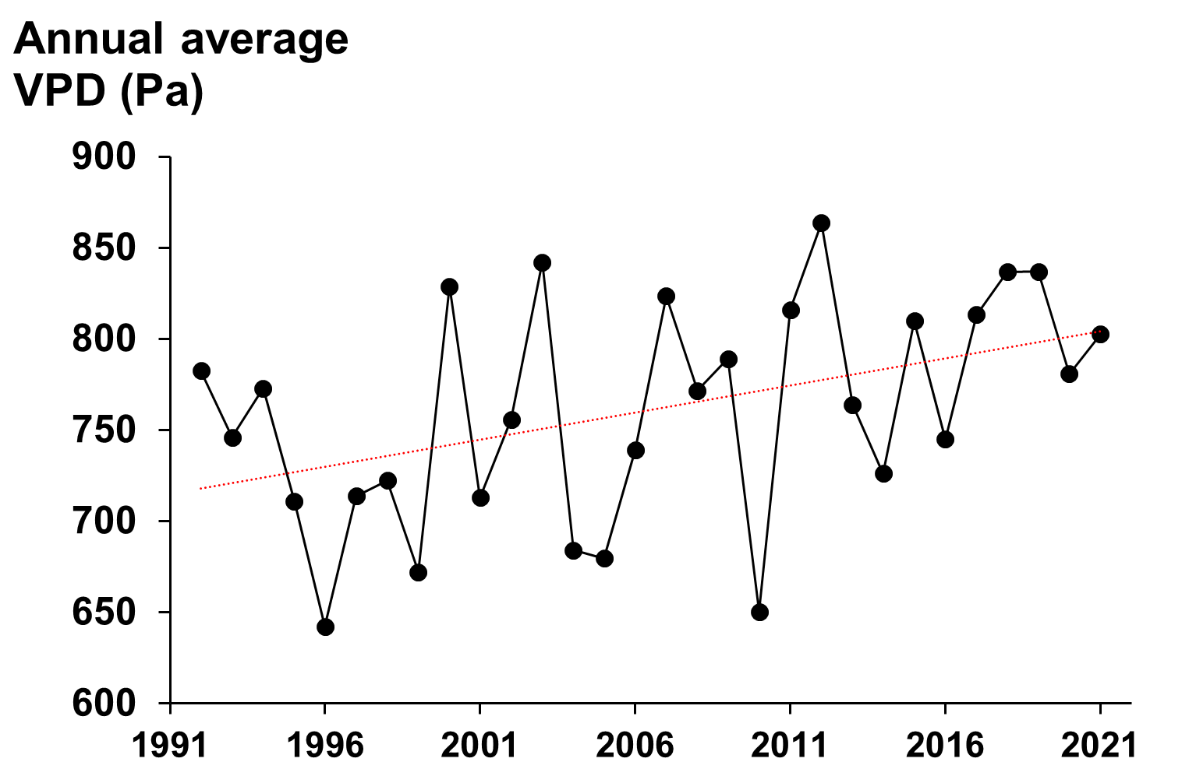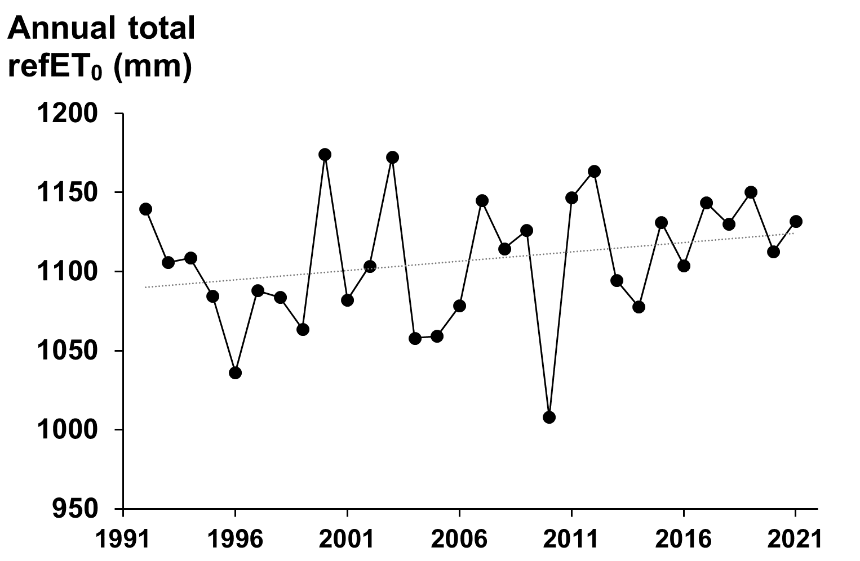

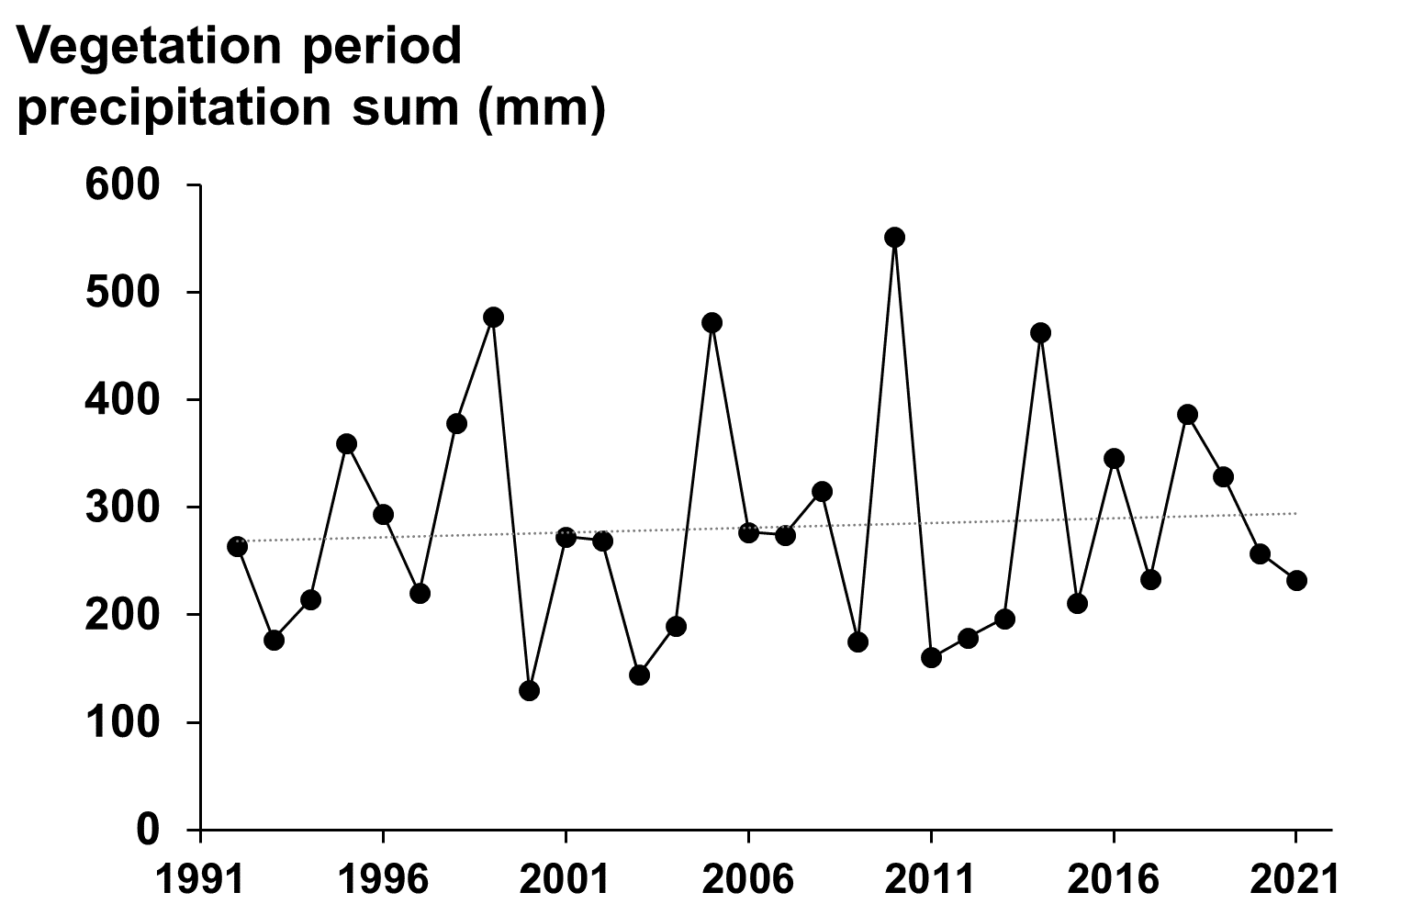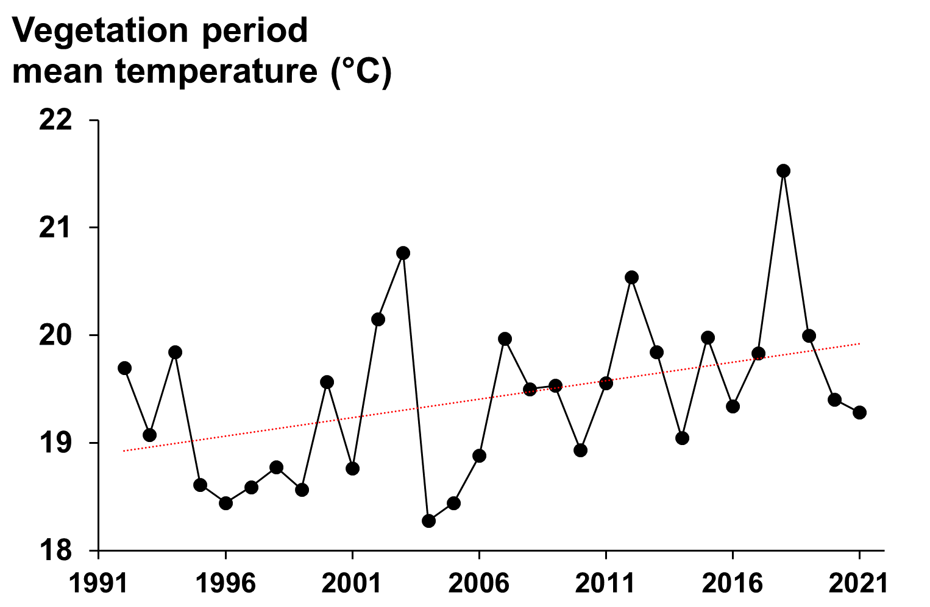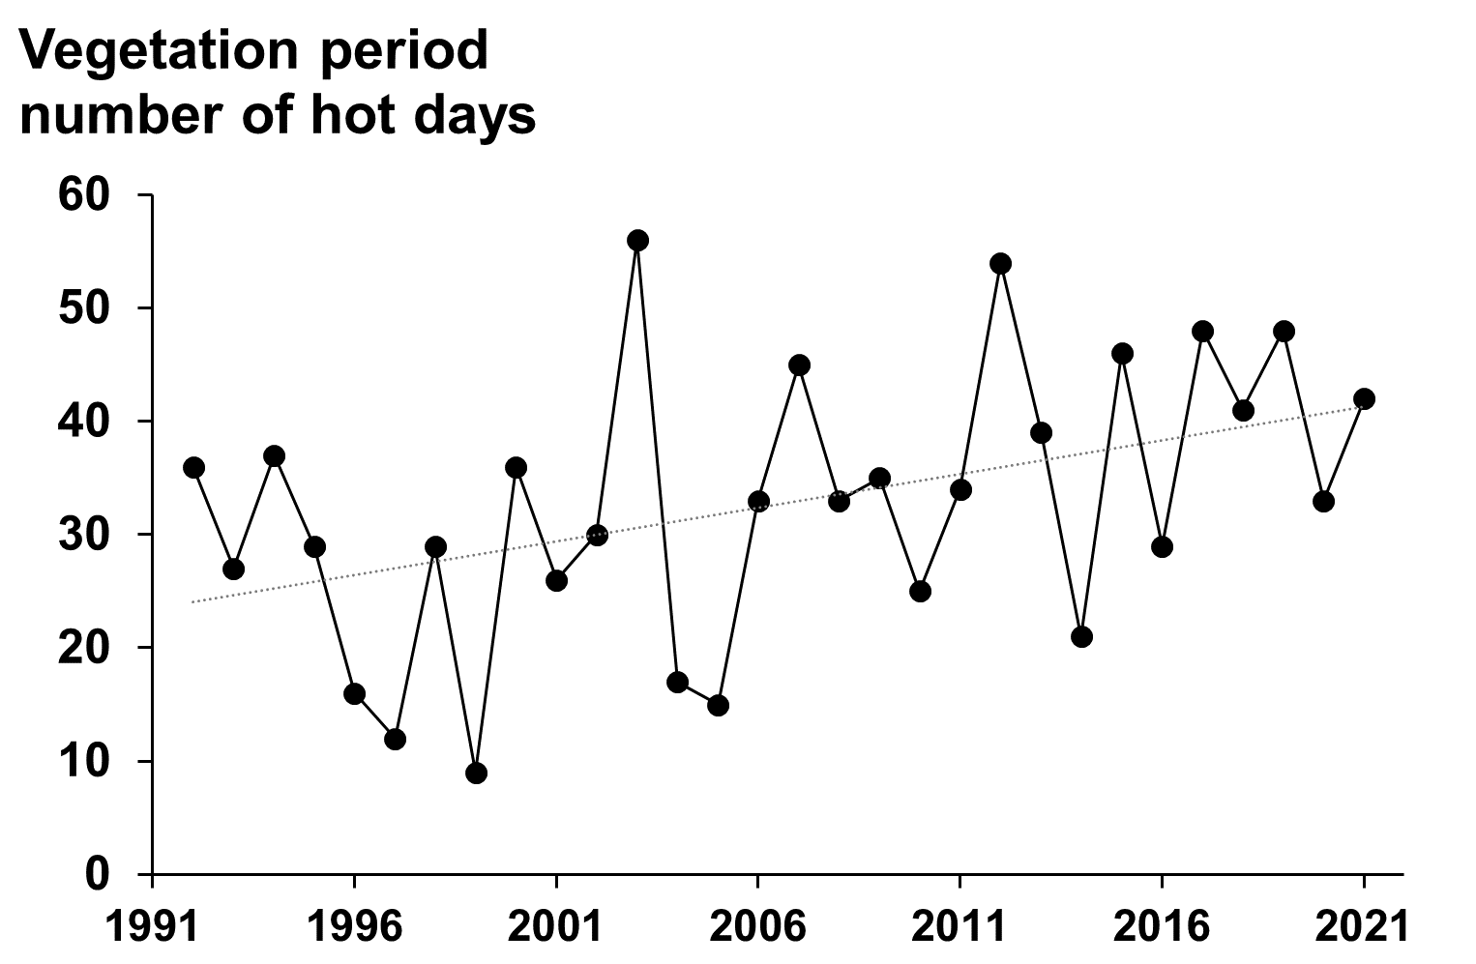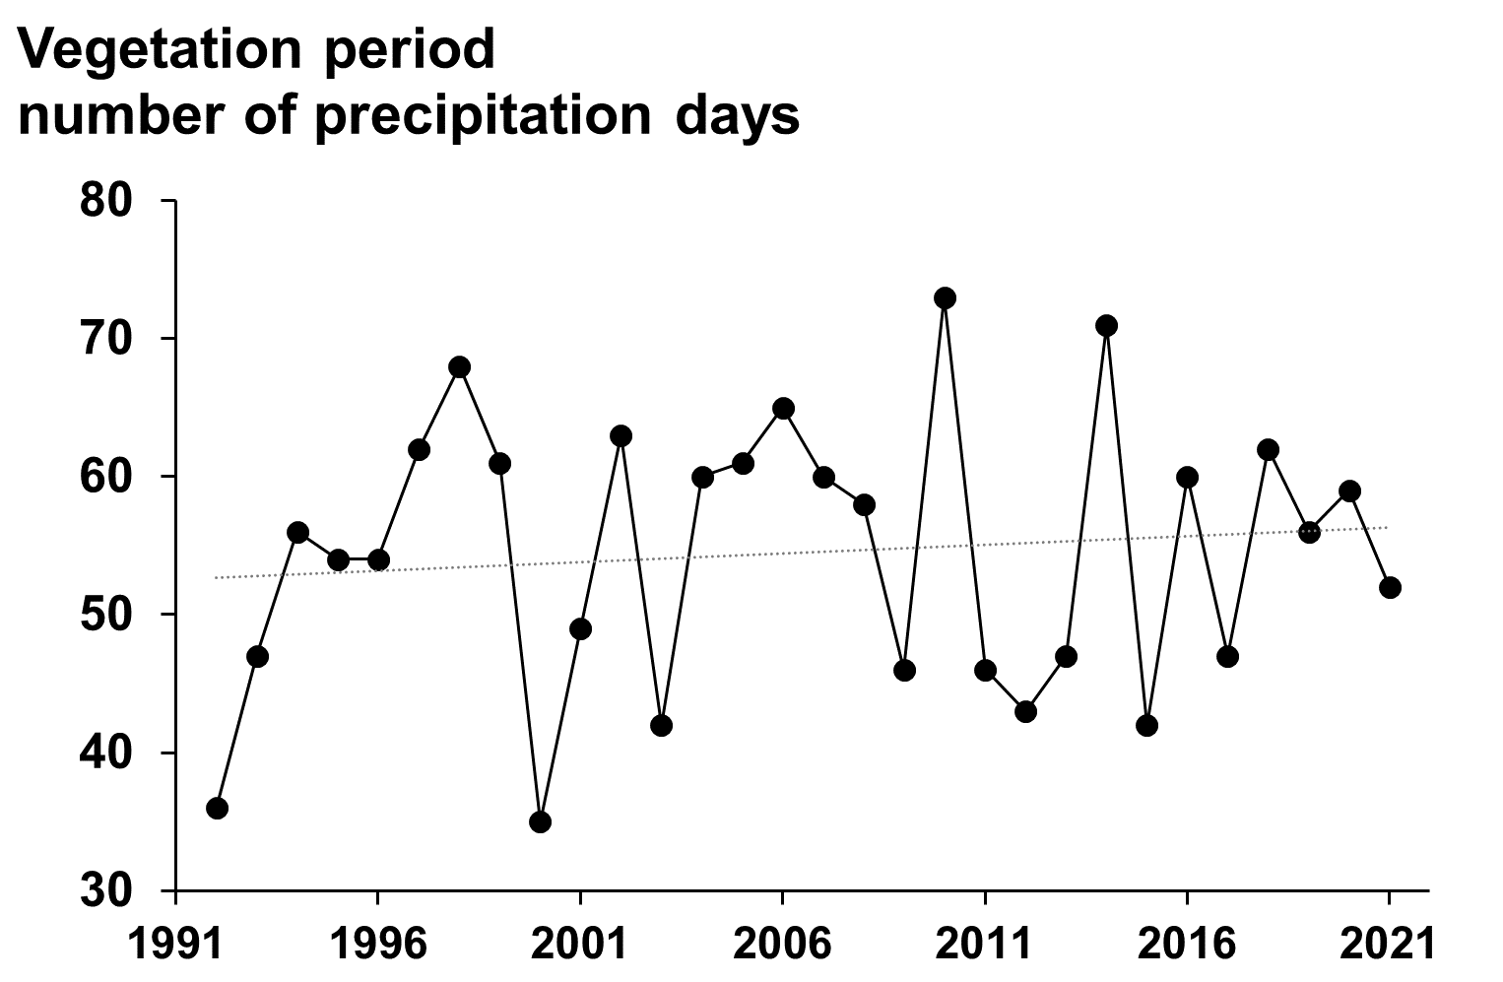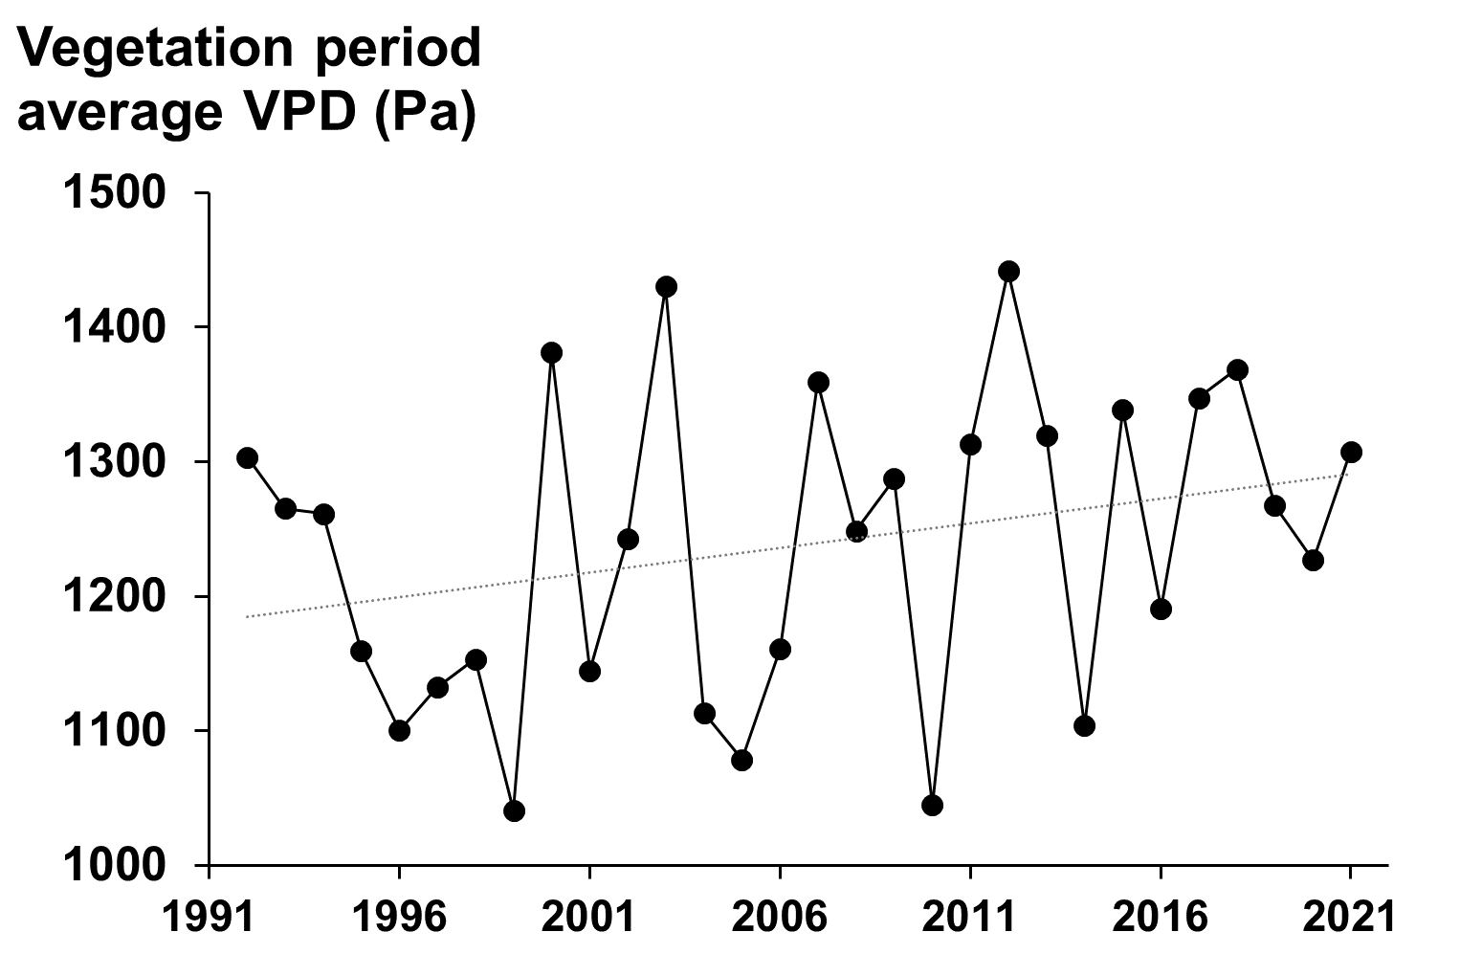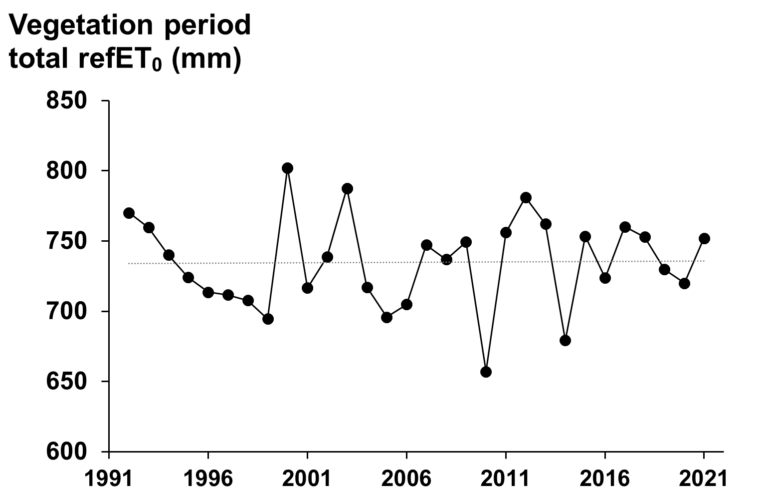

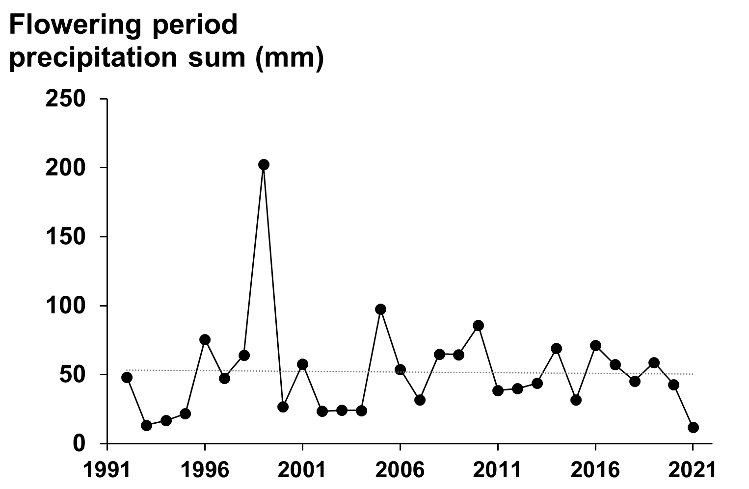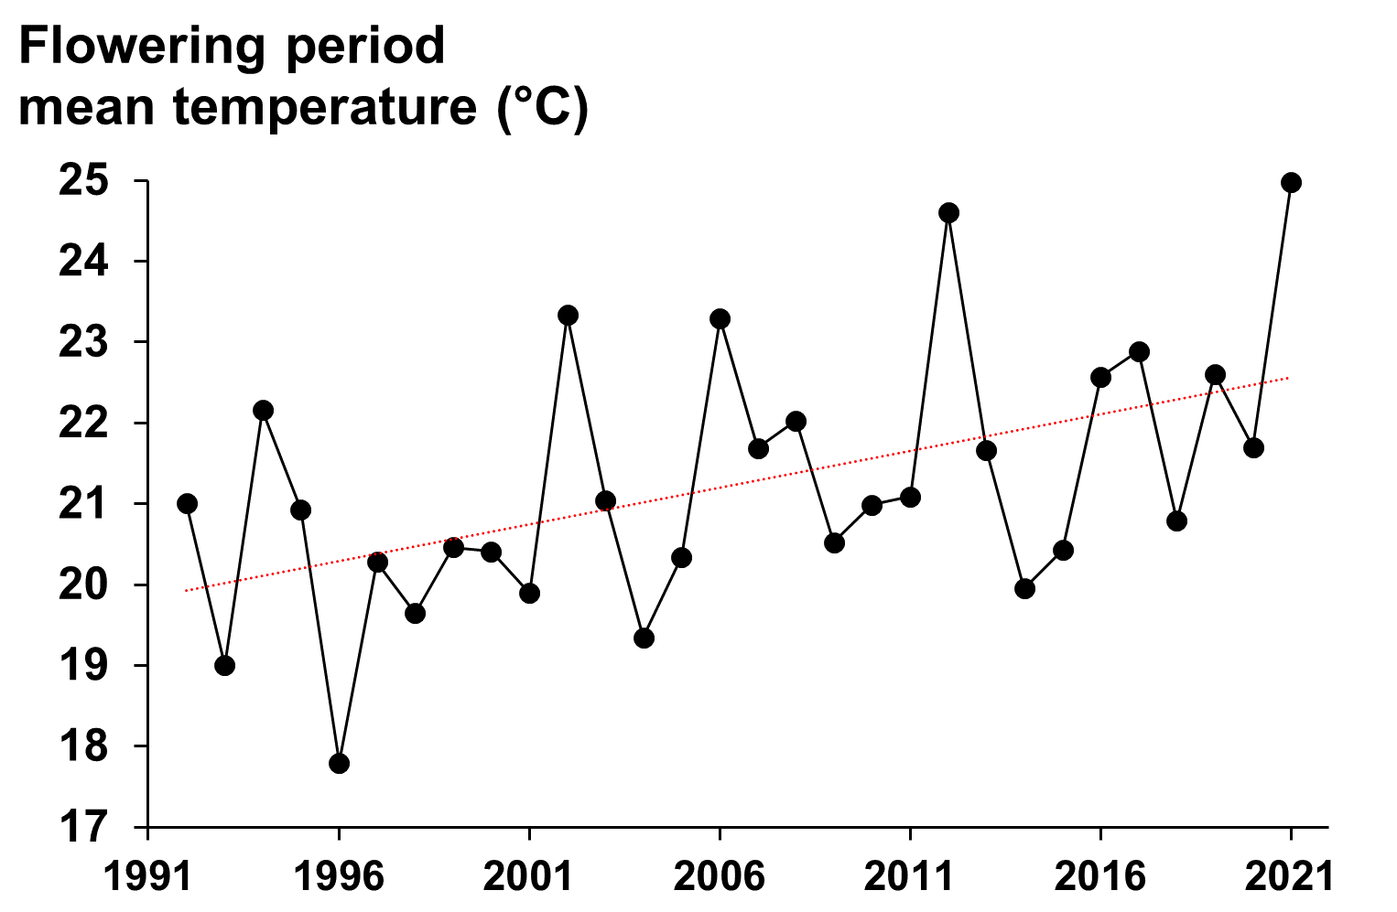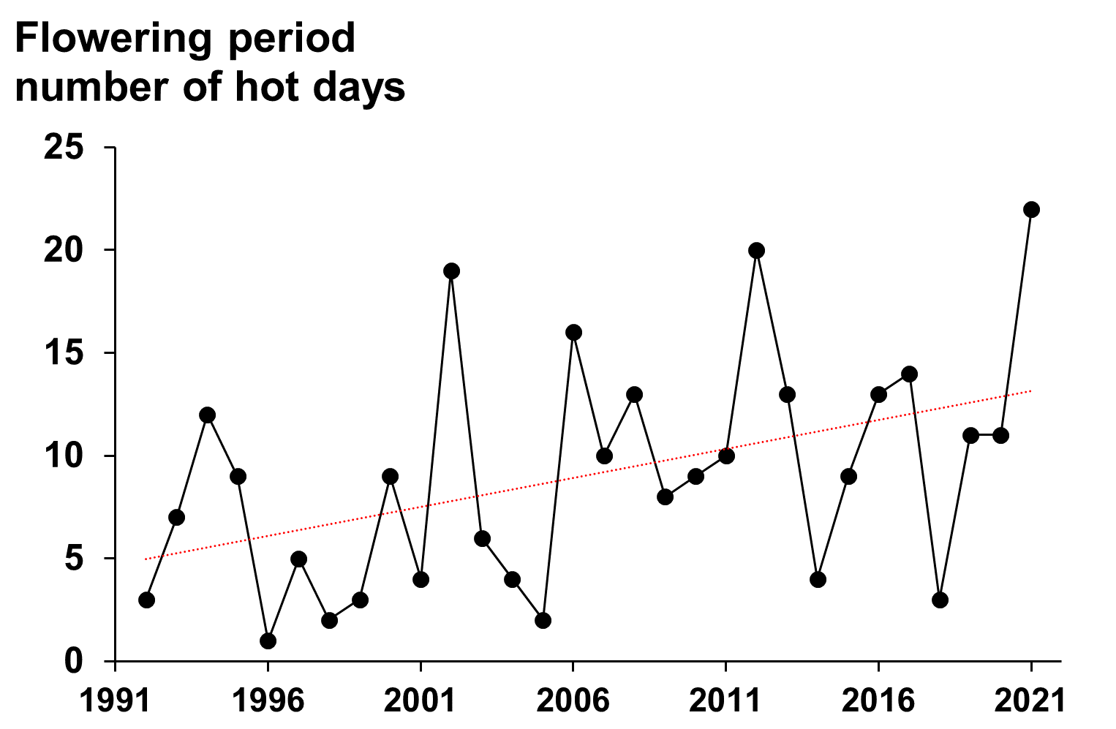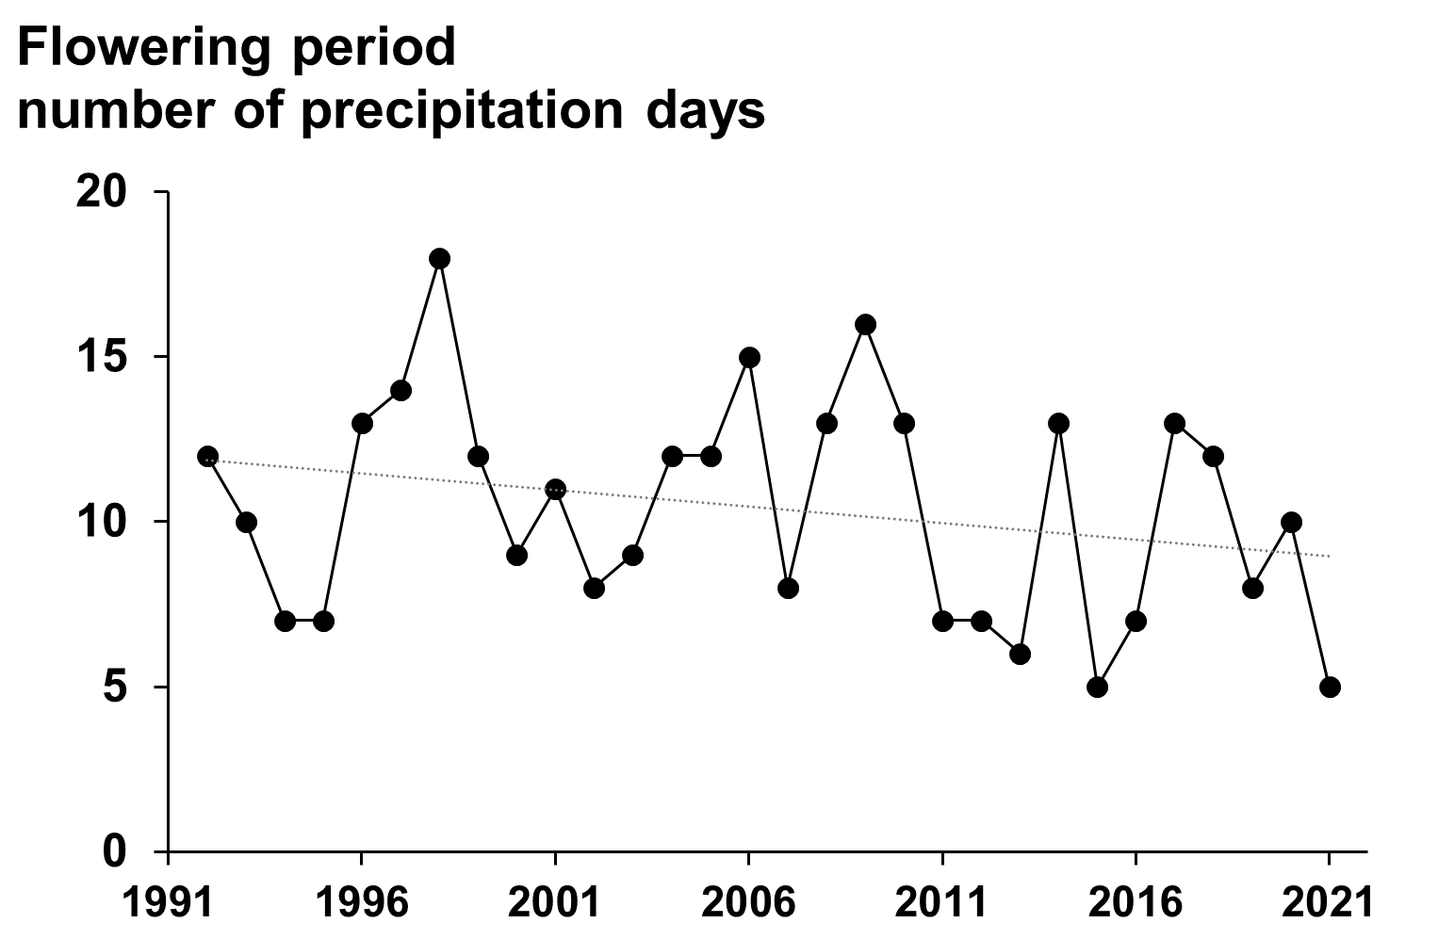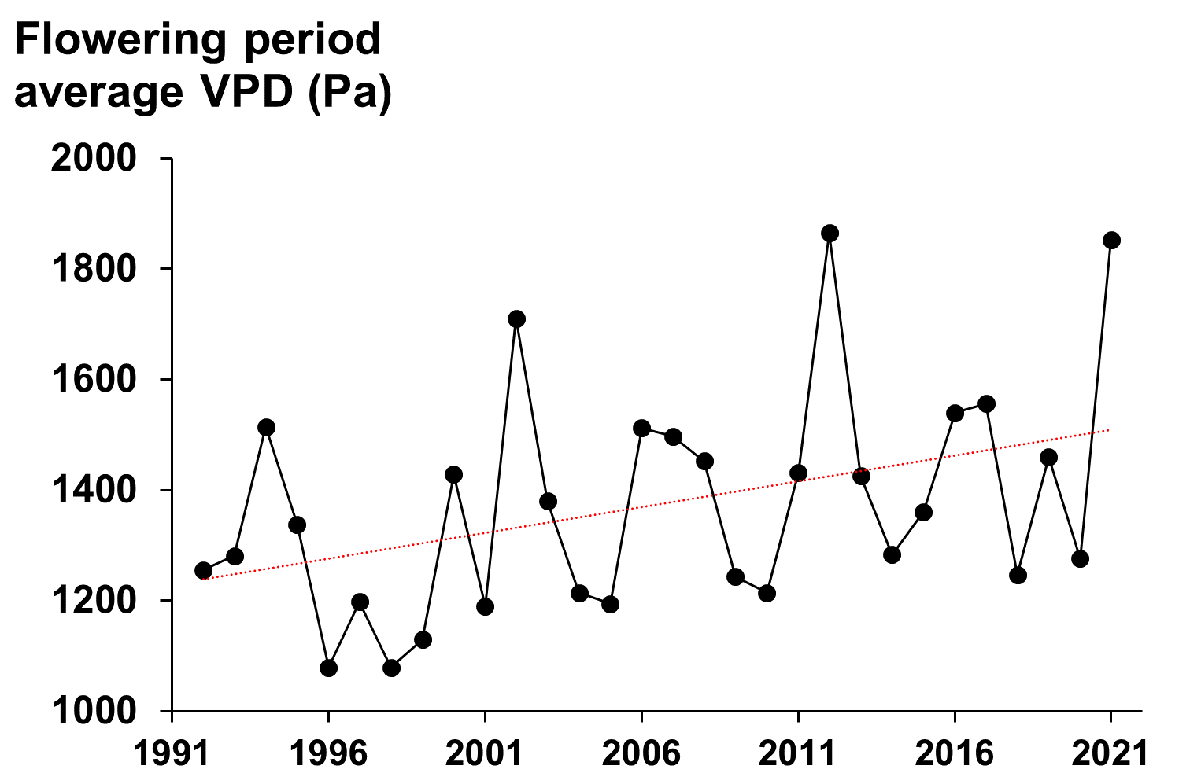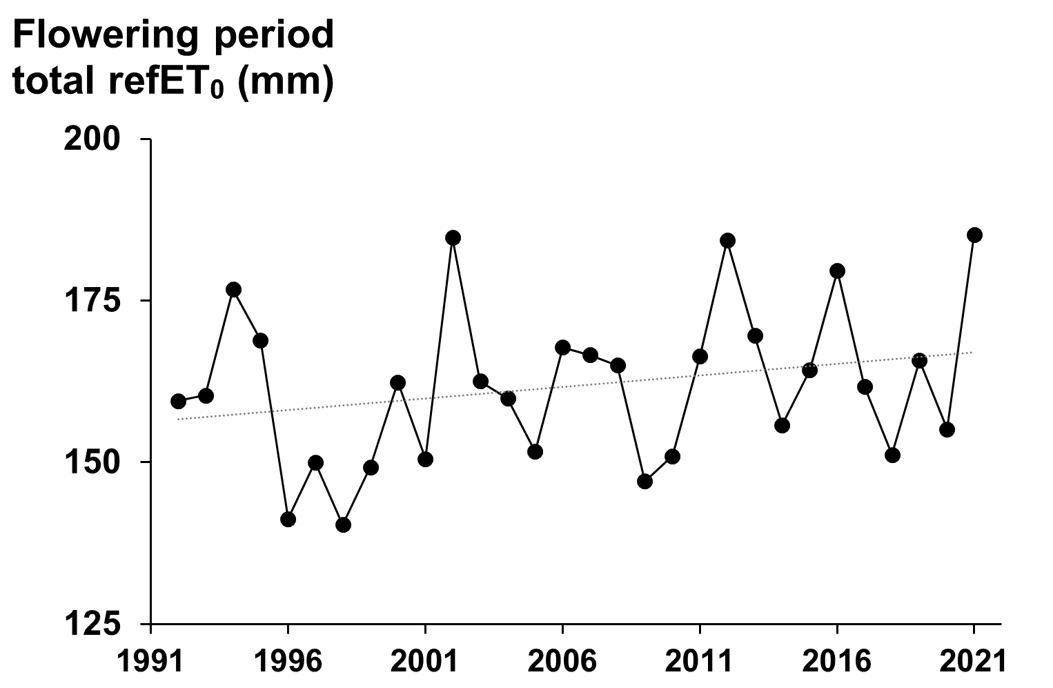

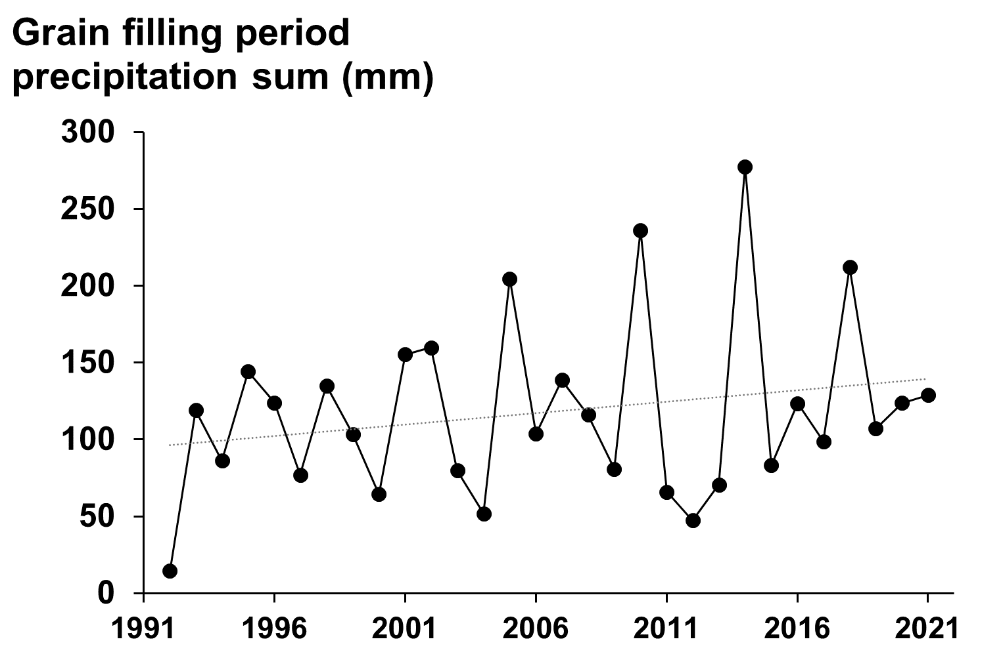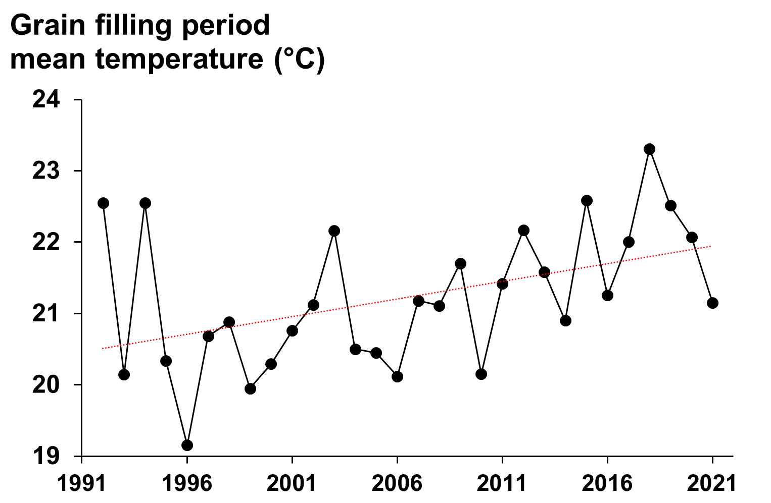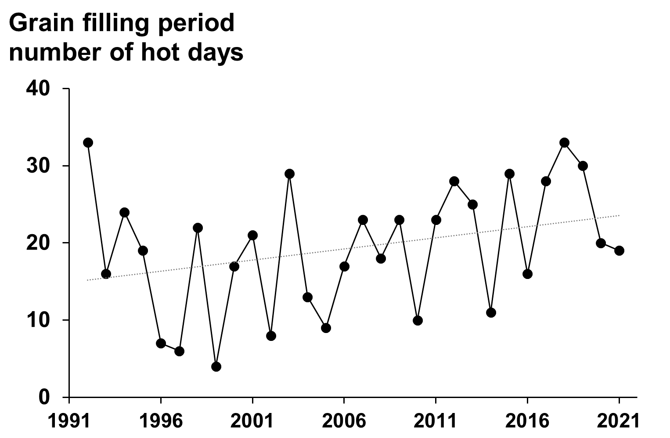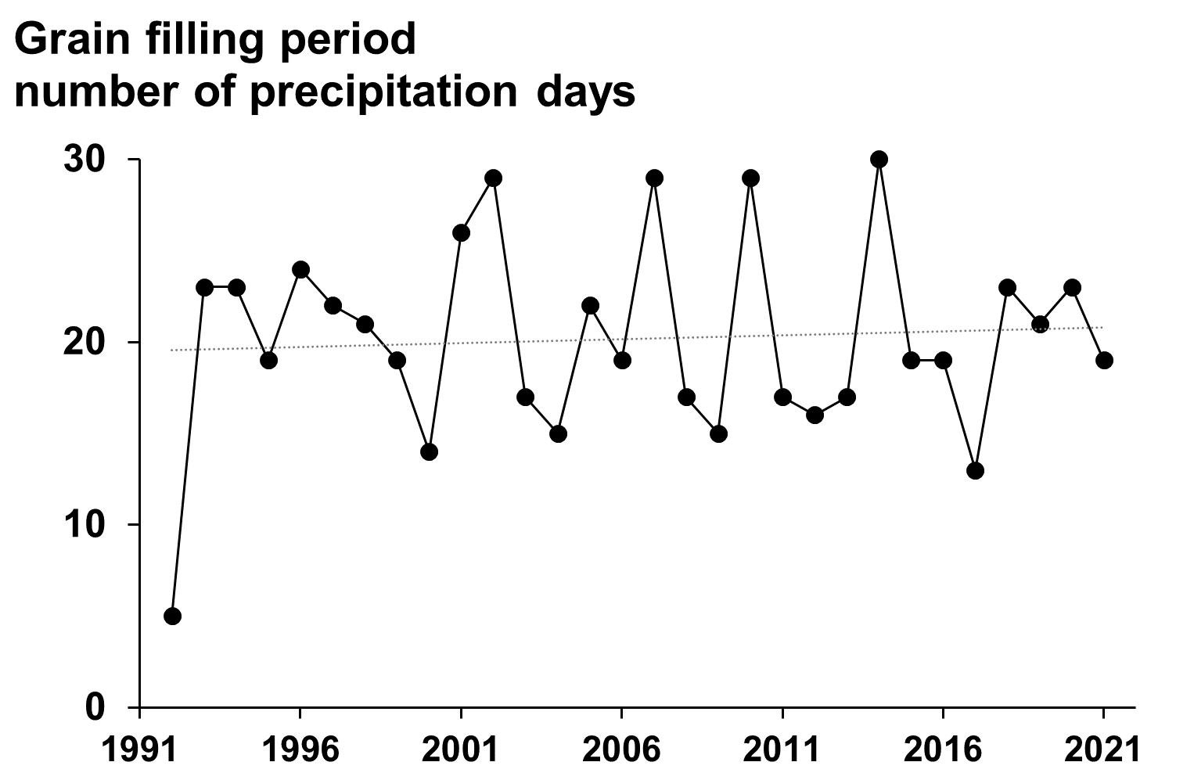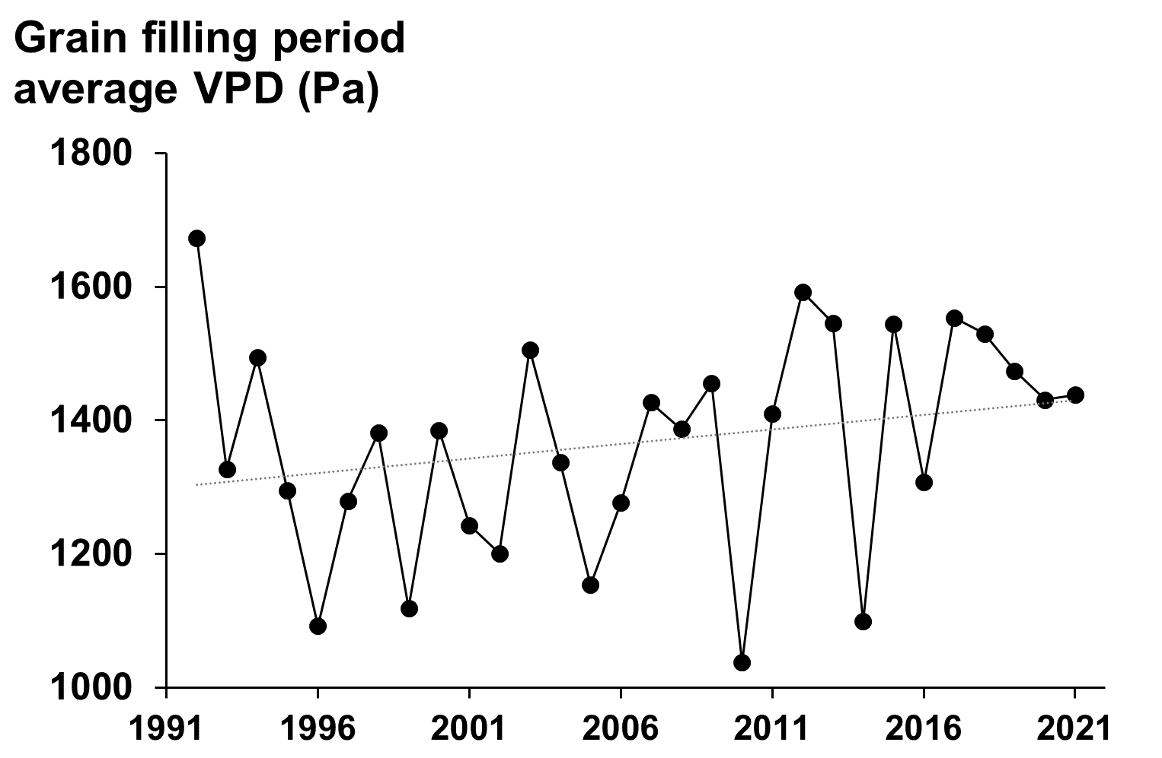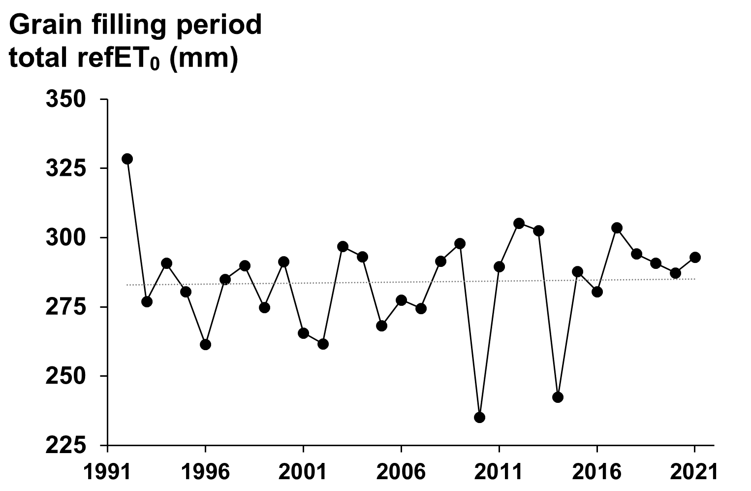
Fig. SM1 Annual and shorter period characteristics of the study area. Vegetation / Flowering / Grain filling periods are between 01.04. and 30.09. / 15.06. and 15.07. / 15.07. and 09.15., respectively. Hot days are days when the maximum temperature is over 30 °C. VPD and refET₀ denote the vapor pressure deficit and reference evapotranspiration during a given time period. Dotted (red) lines indicate (significant) linear trends.

Table SM2 Environmental covariates used as add-on in regression analyses

Time range | Covariate
Vegetation period  (March to October) | Number of precipitation days
Vegetation period  (March to October) | Sum of precipitation
Vegetation period  (March to October) | Average of air temperature
Vegetation period  (March to October) | Number of hot days (Tmax > 30 °C)
Vegetation period  (March to October) | Sum of growing degree days
Vegetation period  (March to October) | Average of aridity index
Annual | Number of precipitation days
Annual | Sum of precipitation
Annual | Average of air temperature
Annual | Number of hot days (Tmax > 30 °C)
Annual | Number of dry spells
Annual | Average length of dry spells
Annual | Maximal length of dry spells
Annual | Average of aridity index
Annual | Maximum of aridity index
Annual | Minimum of aridity index

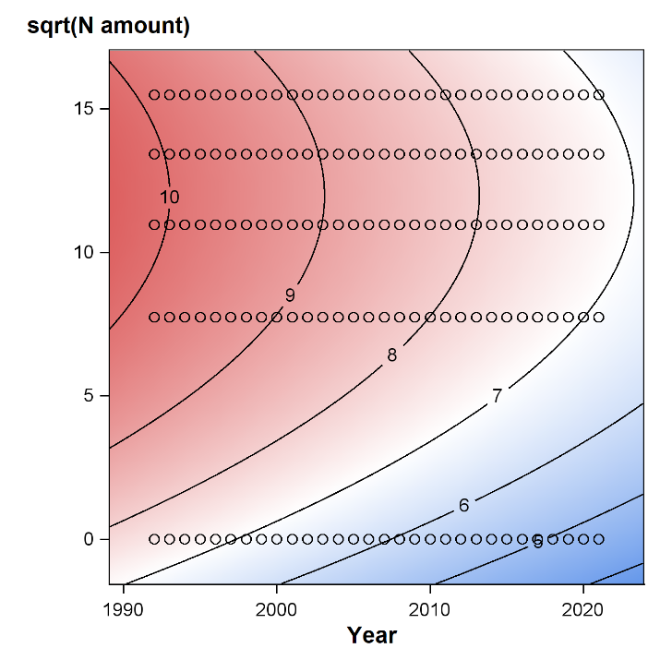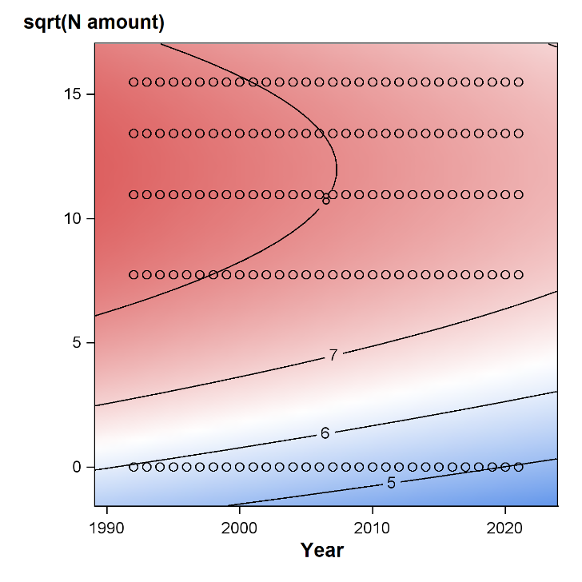
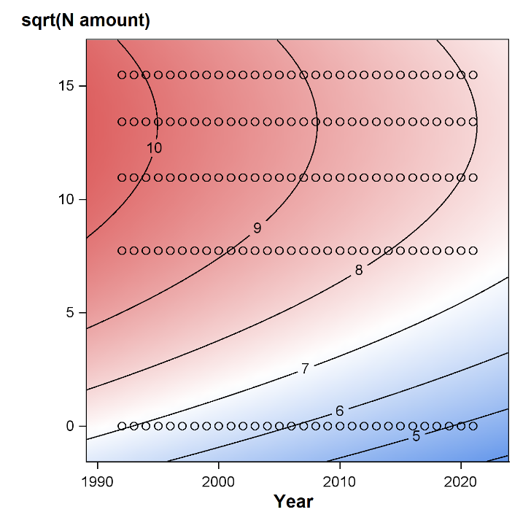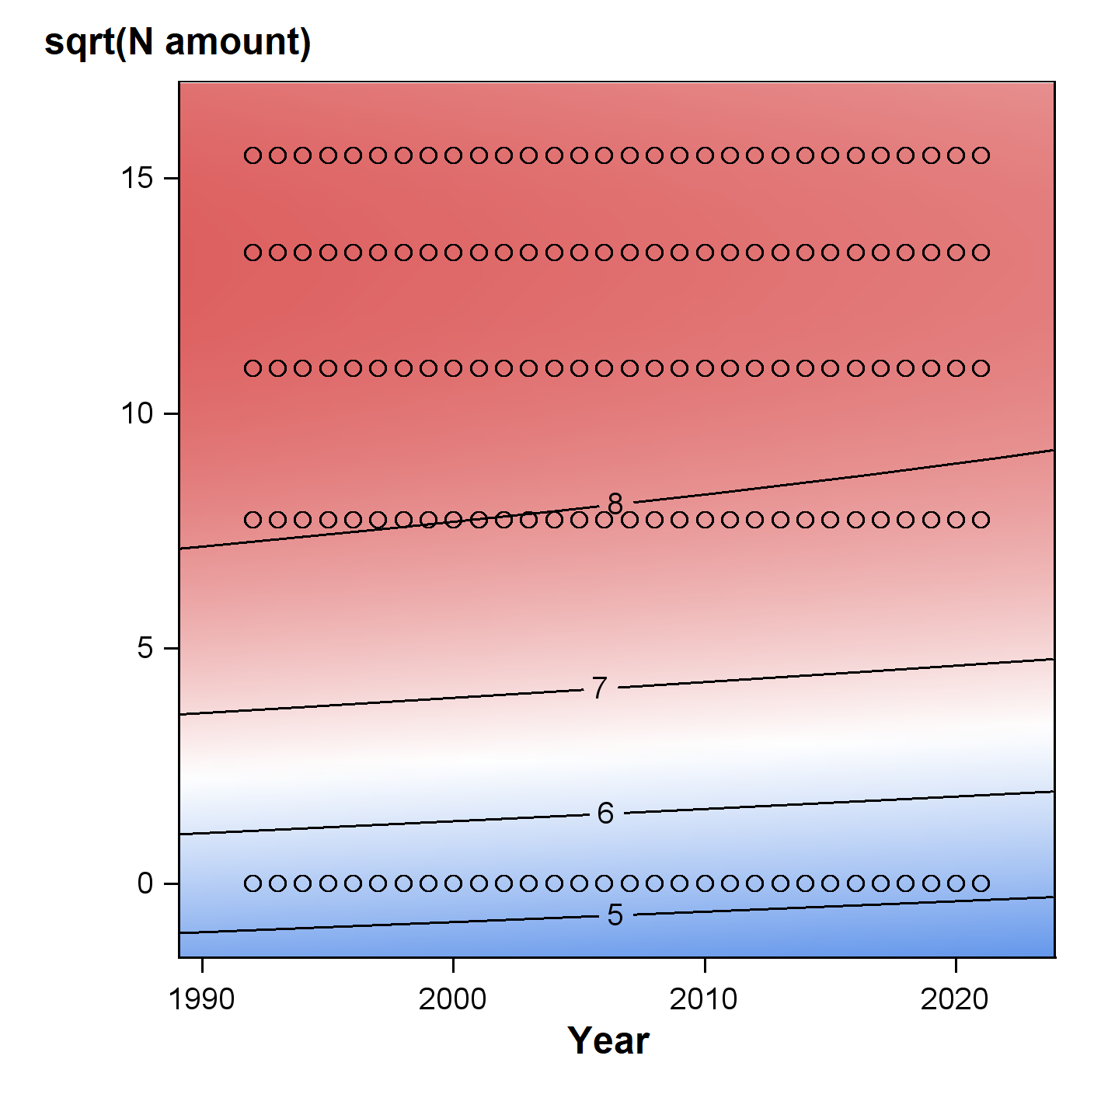
Fig. SM2 Contour plots of the model results describing temporal changes in the effect of the investigated factors. Left column: FAO number = 500, Right column: FAO number = 300; First row: Planting date = 123; Second row: Planting date = 102.

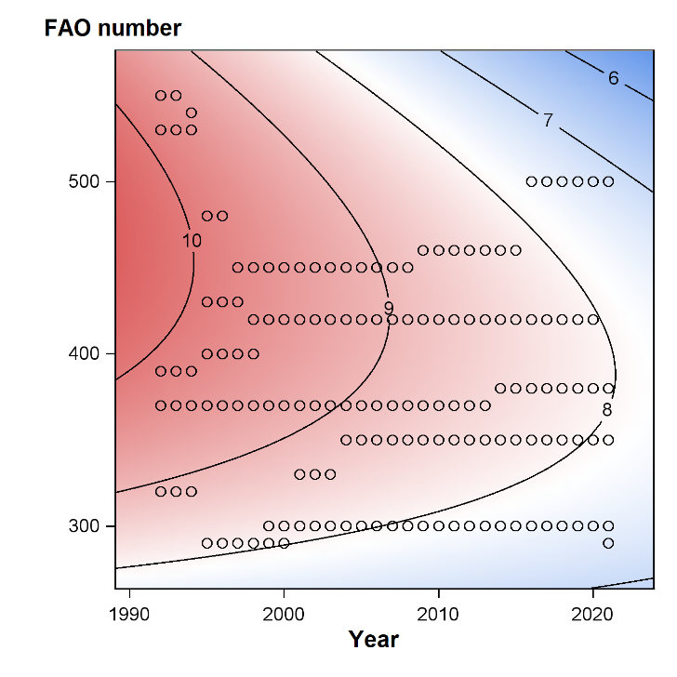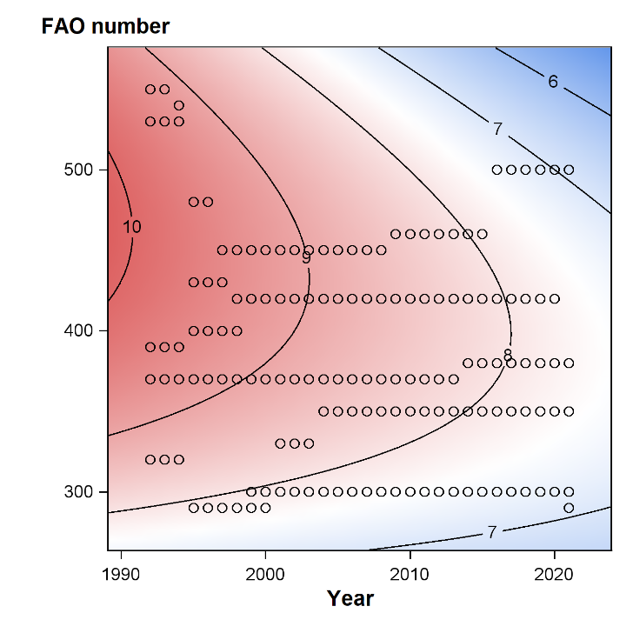
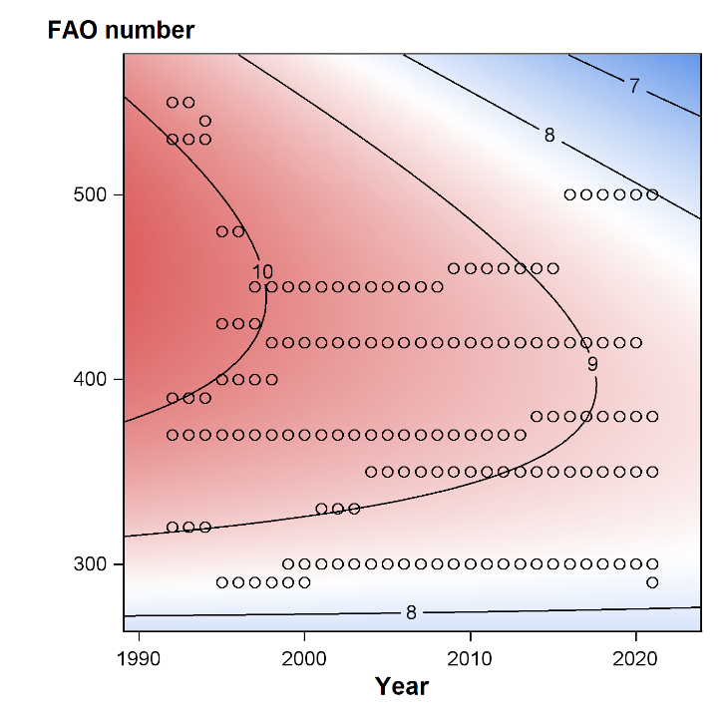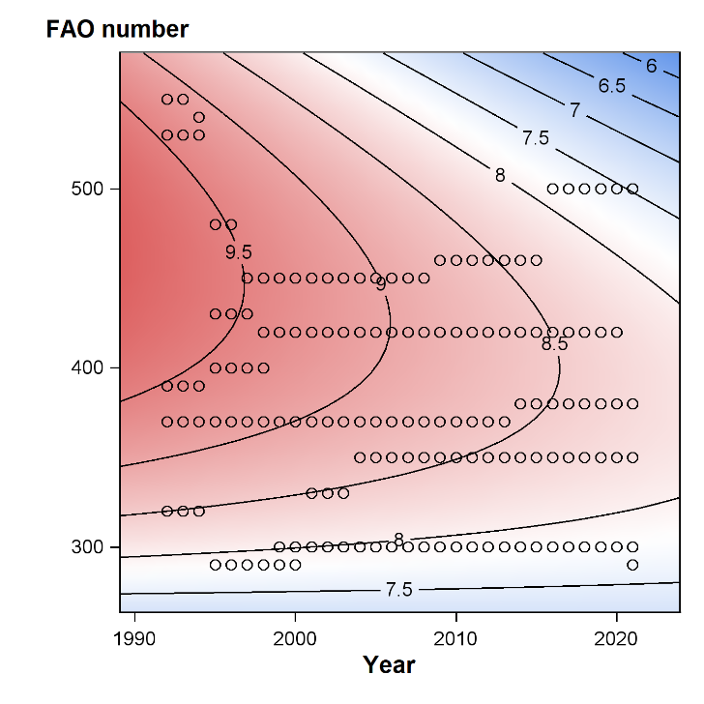Fig. SM3 Contour plots of the model results describing temporal changes in the effect of the investigated factors. Left column: N amount = 180 kg/ha/y, Right column: N amount = 60 kg/ha/y; First row: Planting date = 123; Second row: Planting date = 102.

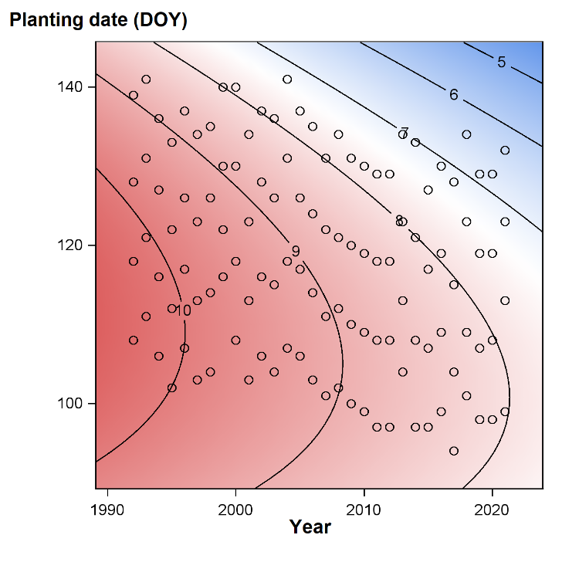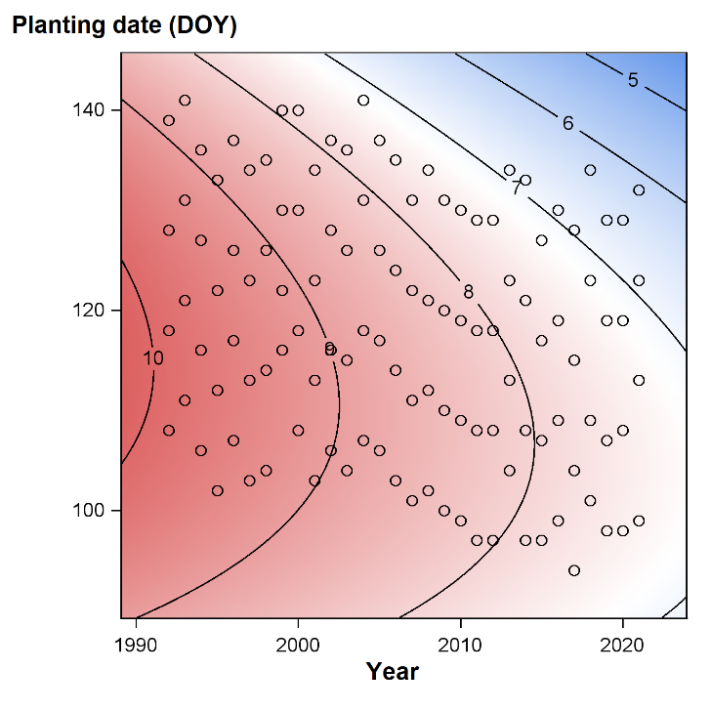
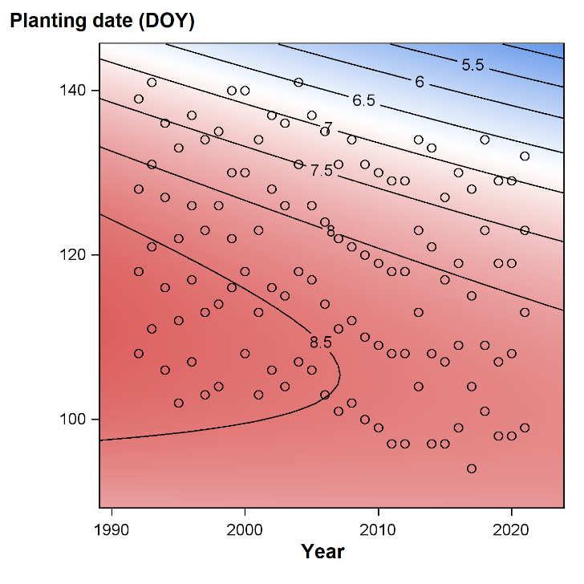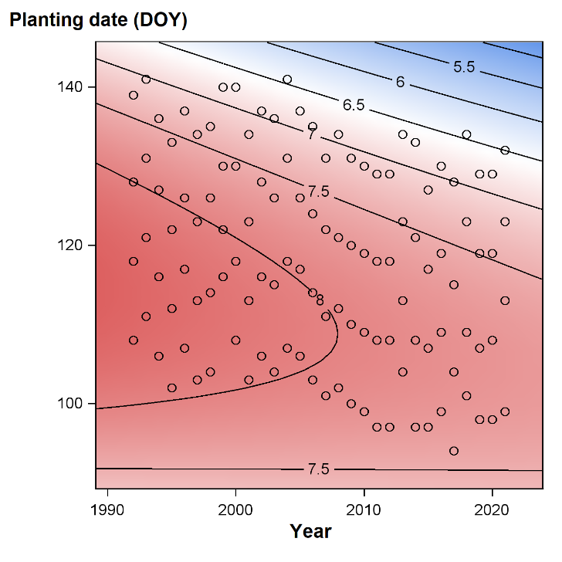Fig. SM4 Contour plots of the model results describing temporal changes in the effect of the investigated factors. Left column: N amount = 180 kg/ha/y, Right column: N amount = 60 kg/ha/y; First row: FAO number = 500; Second row: FAO number = 300.

Fig. SM5 Contour plots of the model results describing the inter-annual differences in the effect of the investigated factors. Left column: bad (suboptimal) years; Right column: good years; First row: N amount = 180 kg/ha/y; Second row: N amount = 60 kg/ha/y.

Fig. SM6 Contour plots of the model results describing the inter-annual differences in the effect of the investigated factors. Left column: bad (suboptimal) years; Right column: good years; First row: FAO number = 500; Second row: FAO number = 300.

