Supplementary material:
Organic minimum tillage systems based on intensification of legume cover cropping: agronomic and phytopathological aspects
Jörg Peter Baresel ¹, Adnan Šišić ^{1,*}, Anji Reddy Pittam², Alborz Saidi¹ and Maria Renate Finckh ¹
*Corresponding author: Adnan Šišić; postal address: Section of Ecological Plant Protection, University of Kassel, Nordbahnhofstr. 1a, 37213 Witzenhausen, Germany; email: adnan_sisic@uni-kassel.de; ORCID ID: https://orcid.org/0000-0001-7715-1817
¹ Section of Ecological Plant Protection, University of Kassel, Nordbahnhofstr. 1a, 37213 Witzenhausen, Germany
² Department of Geosciences, Eberhard Karls Universität Tübingen, Schnarrenbergstraße 94-96, 72076 Tübingen, Germany
Table S1. Mean root rot severity ratings and number of roots evaluated for clover and vetch used as cover crops prior to maize sowing, and pea plants following maize harvest.
 | Experiment 1 |  |  | Experiment 2 |  |  | Overall³ | Field Pea⁴
 | T1¹ | T2 | T3 | T1 | T2 | T3 | T1-T3 | Exp. 1 | Exp. 2
Clover | 1.2² | 1.1 | 1.0 | 1.3 | 1.0 | 1.1 | 1.1 a | 2.6 a | 5.2 b
(n) | 172 | 639 | 436 | 543 | 586 | 560 | 2936 | 475 | 461
Vetch | 2.0 | 2.9 | 2.8 | 1.3 | 1.8 | 2.3 | 2.2 b | 3.0 a | 5.0 b
(n) | 165 | 309 | 197 | 313 | 231 | 237 | 1452 | 473 | 571
¹Sampling dates: Experiment 1: T1=15.11.2019; T2=18.03.2020; T3=08.05.2020; Experiment 2: T1=26.11.2020; T2=08.4.2021; T3=10.05.2021.
²Mean root rot disease severity was evaluated using a 1-9 rating scale (1=healthy plants without symptoms; 9= dying plant (Šišić et al. 2022; Pflughöft et al. 2012).
³Different letters indicate significant differences in the overall mean severity ratings between the clover and vetch averaged over all sampling dates and the two sampling years (Kruskal post hoc test, P <0.05). Differences among the mean ratings for individual sampling dates were not statistically analyzed due to consistently healthy appearance of plant roots.
⁴Different letters indicate significant differences in pea root rot severity rating between experiment 1 and experiment 2 following clover and vetch cover crops - maize main cropping sequence.
n=Total number of plants assessed per crop and year.

Table S2. The Kruskal Wallis Test for the main factors effects root rot disease severity ratings of over-wintering legume cover crops (vetch and clover) grown prior to maize.
Factor | chi-squared | p-value
Leg. cover crop¹ | 123.17 | 0.01395
Year² | 94.89 | 0.3693
Sampling date³ | 108.61 | 0.1005
CC x Year x Sampling date | 119.32 | 0.02487
¹hairy vetch ad crimson clover
²Experiment 1:2019/20; Experiment 2:2020/21
³Sampling date: Experiment 1 (2019/20) T1=15.11.2019; T2=18.03.2020; T3=08.05.2020; Experiment 2 (2020/2021) - T1=26.11.2020; T2=08.4.2021; T3=10.05.2021.

Table S3. The Kruskal Wallis Test for the main factor effects on root rot disease severity of pea grown in overwintering legume cover crops - maize cropping sequences
Factor | chi-squared | p-value
Leg. cover crop (CC)¹ | 0.29 | 0.5928
Year² | 86.36 | < 2.2e-16
Tillage³ | 1.69 | 0.4293
CC termination date⁴ | 1.64 | 0.4394
Biomass use⁵ | 1.67 | 0.4333

Table S4. Summary of ANOVA results for the effects of legume cover crop, experimental year and sampling date on Didymella pinodella isolation frequencies. The generalized linear mixed model (GLM) analysis was performed on proportional data with a binomial distribution and logit link function.
Factor | Chisq | Df | Pr(>Chisq) | Signif. Code
Leg. cover crop (CC)¹ | 9.54 | 2 | 0.0085 | **
Year² | 20.90 | 2 | 0.0000 | ***
Sampling date³ | 21.14 | 3 | 0.0001 | ***
Year:Sampling date | 1.33 | 2 | 0.5147
Year:Leg. CC | 0 | 1 | 0.9995
Sampling data:Leg. CC | 0 | 2 | 1.0000
Year:Sampling date:Leg. CC | 0 | 2 | 1.0000
Signif. codes: 0 ‘***’ 0.001 ‘**’ 0.01 ‘*’ 0.05 ‘.’ 0.1 ‘ ’ 1
¹hairy vetch ad crimson clover
²Experiment 1:2019/20; Experiment 2:2020/21
³Sampling date: Experiment 1 (2019/20) T1=15.11.2019; T2=18.03.2020; T3=08.05.2020; Experiment 2 (2020/2021) - T1=26.11.2020; T2=08.4.2021; T3=10.05.2021.

Table S5. The total number and relative abundance of Fusarium isolates recovered from maize kernels, along with the percentage of infected maize kernels.
% maize kernels infected | FG | FA | FP | FC | FCr | FPo | FT
Experiment 1 | 0.20 | 0.00 | 0.10 | 0.10 | 0.10 | 0.00 | 0.00
Experiment 2 | 0.40 | 0.70 | 0.20 | 0.00 | 0.00 | 0.20 | 0.10
overall | 0.20 | 0.30 | 0.10 | 0.10 | 0.10 | 0.10 | 0.00
FG=F. graminearum; FA=F. avenaceum; FP=F. proliferatum, FC=F. culmorum; FCr=F. crookwallense; FPo=F. poae; FT=F. tricinctum

Table S6. Summary of ANOVA results for the effects of experimental year, legume cover crop species preceding maize, cover crop termination date and differential tillage prior to maize sowing and the interaction effects on pathogen Fusarium spp. isolation frequencies associated with maize stalks. The generalized linear mixed model (GLM) analysis was performed on proportional data with a binomial distribution and logit link function.
Factor | Chi square | Df | P value
Pathogen | 12.6639 | 4 | 0.01304 *
Legume cover crop (CC)¹ | 0.7228 | 1 | 0.39523
Experimental year² | 6.5545 | 1 | 0.01046 *
CC termination time³ | 0.2928 | 1 | 0.58843
Tillage⁴ | 2.5762 | 3 | 0.46168
Pathogen:Tillage | 10.3918 | 12 | 0.58163
Pathogen:Experimental year | 27.1412 | 4 | <0.0001 ***
Pathogen:Legume cover crop | 9.8315 | 4 | 0.04336 *
Pathogen:CC termination time | 2.5416 | 4 | 0.63721
Signif. codes: 0 ‘***’ 0.001 ‘**’ 0.01 ‘*’ 0.05 ‘.’ 0.1 ‘ ’ 1
¹hairy vetch ad crimson clover
²Experiment 1:2020; Experiment 2:2021
³early May (beginning of flowering) , late May (end of flowering)
⁴Leg. CC mulching + no-till maize sowing; Leg. CC mulching + rototiller;; Leg. CC harvesting + no-till; Leg. CC harvesting + rototiller
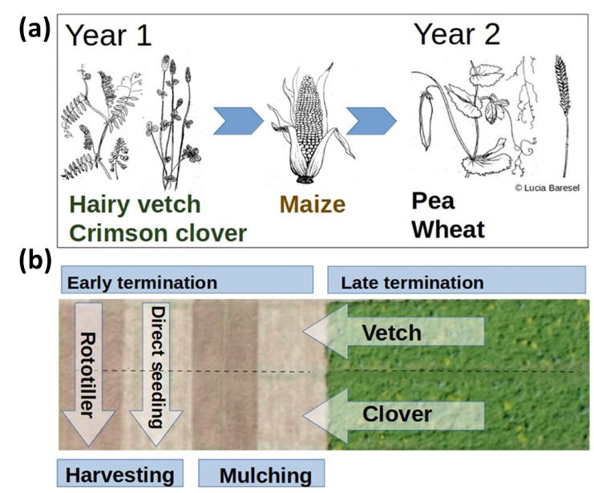
Fig. S1. Schematic representation of the crop rotation (a) and set-up of the field trial (b), one replication block. Aerial photo from 25.05.2020, after the first and before the second maize sowing date. Maize has already been sown on the left-hand subplot, the cover crops are still visible on the right-hand subplot. The size of each individual plot was 6 x 7 m. Pea, wheat and a pea-wheat mixtures were planted in the same direction as maize, subdividing each plot in three strips, respectively.

Fig. S2. Monthly precipitation and mean temperatures at Neu-Eichenberg experiment station, 2019 - 2022. Dashed lines and hatched areas indicate the long-term mean, 1991-2020.

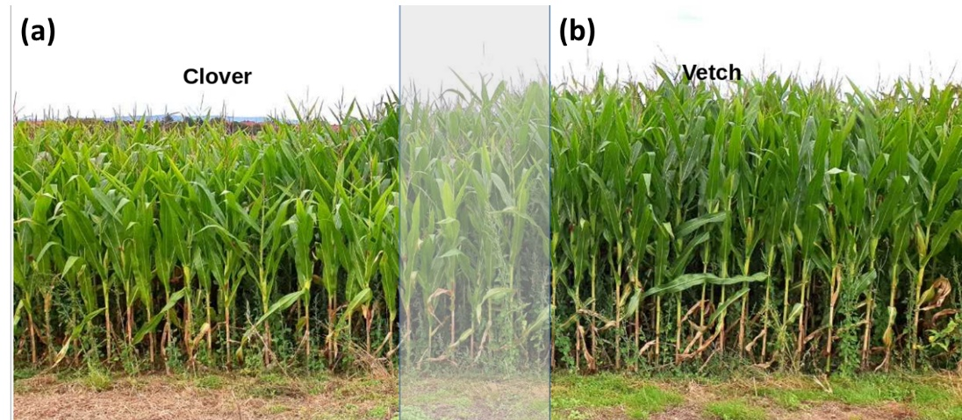
Fig. S3. Maize grown after crimson clover (a) and hairy vetch (b) in experiment 1: cover crops were shallow tilled at first termination date – before flowering.

Fig. S4. Variation in D. pinodella isolation frequencies (% colonized roots) depending on the sampling date. Sampling dates: Experiment 1 (2019/20) T1=15.11.2019 (n= number of plants used for fungal isolations; clover/vetch=74/71); T2=18.03.2020 (n=125/103); T3=08.05.2020 (n=102/67); Experiment 2 (2020/2021) - T1=26.11.2020 (n=118/75); T2=08.4.2021 (n=120/87); T3=10.05.2021 (n=116/81).

