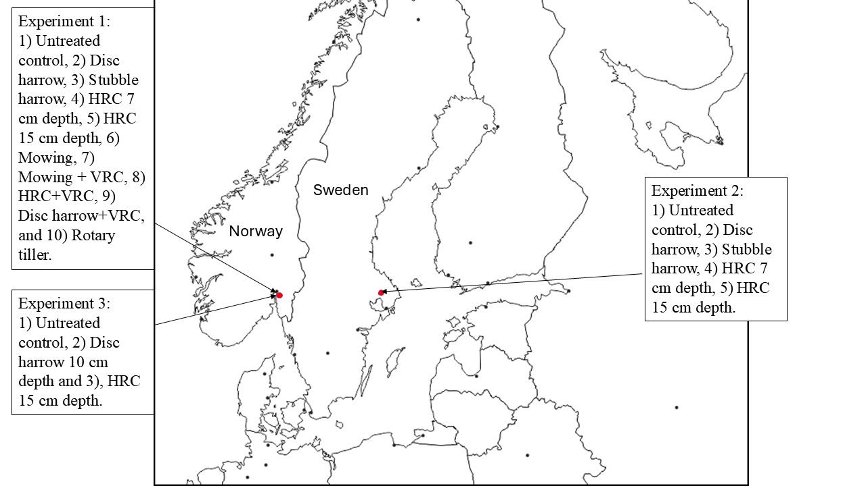
Supplementary Figure S1. Shows the locations of Experiment 1, 2 and 3 and their respective treatments. Experiment 1 and 2 studied the effect of the vertical and horizontal root cutters (VRC and HRC, respectively) on perennial weeds, while Experiment 3 studied the effect of the HRC on soil and nutrient losses.

