Competitive yields in organic and agroforestry cacao cropping systems: results from 15 years of a long-term systems comparison trial in Bolivia

Supplementary Materials

Agronomy for Sustainable Development
Johanna Rüegg^{1,5*}, Stéphane Saj¹, Ulf Schneidewind^{2,3}, Joachim Milz², Monika Schneider^{1,4}, Laura Armengot^{1,5}
¹ Research Institute of Organic Agriculture (FiBL), Department of International Cooperation, Frick, Switzerland
² Ecotop Foundation, La Paz, Bolivia
³ Thuenen Institute, Institute of Climate-Smart Agriculture, Braunschweig, Germany
⁴ retired
⁵ Universitat de Barcelona, Department of Evolutionary Biology, Ecology and Environmental Sciences and Biodiversity Research Institute (IRBio), Barcelona, Spain

* Corresponding author: johanna.rueegg@fibl.org; co-corresponding author: larmengot@ub.edu

Supplementary material 1: Precipitation [mm] and mean daily maximal (Max) and minimal (Min) temperatures [°C] as measured at Sara Ana research and training Centre meteorological station over the years of the study. In 2008 no data has been registered and precipitation measurement only started in 2010.
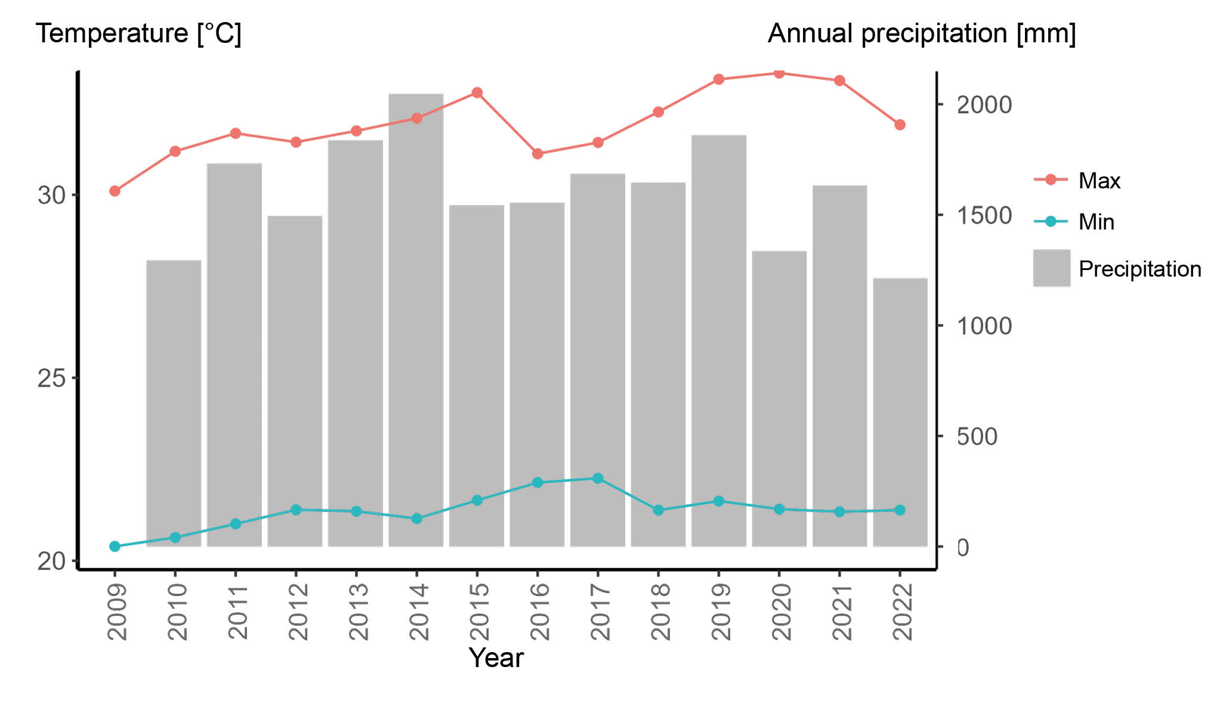

Supplementary material 2: Description of the main management practices of the 5 systems compared. MON-CON stands for conventional monoculture, MON-ORG for organic monoculture, AFS-CON for conventional agroforestry, AFS-ORG for organic agroforestry and AFS-SUC for successional agroforestry.
System | Management
MON-CON | Fertilizer: Chemical fertilizer: (Blaukorn BASF, Germany, 12-8-16-3 N-P2O5-K2O-MgO split in two doses applied in March and December. Dose: 144 g cacao tree⁻¹ (2010-2011), 288 g tree⁻¹, (2012), 384 g tree⁻¹, (2013), 480 g tree⁻¹ (2014-2022).  Weeding: with machetes (2008-2009) and herbicide applications, mainly Glyphosate 4-5 times per year, with brush cutters and machetes (around cacao trees) (2010-2022).  Annual cacao tree pruning: Formation prunings, fitosanitary prunings and structural prunings. 2 annual prunings (2009, 2017, 2018, 2019, 2022), 3 annual prunings (2010, 2012, 2013, 2015, 2016, 2020, 2021), 4 annual prunings (2011, 2014). Additionally, regular pruning of chupones. Pruning residues chopped and left below cacao canopy.  Cacao harvest: monthly and bi-weekly during peak harvest (2011-2013); bi-weekly all year round (2014-2022).  Pest and disease control: removal of diseased pods during harvest (2011-2014); biweekly removal of diseased pods, manual control of mealy bugs, manual control leaf cutter ants (2015-2022). Pesticide to control leaf cutter ant (2012, 2014). Witches broom removed during phytosanitary pruning.  *Fraction of transmitted light: 92 %
MON-ORG | Fertilizer: Locally made compost with crop and vegetation residues, hens’ slurry and sawdust applied to cacao trees; annual application. Dose: 17 l cacao tree⁻¹ (2010-2012); 21 l cacao tree⁻¹ (2013-2022).  Weeding: with machetes (2008-2013); with brush cutters and machetes (around cacao trees) (2014-2022)  Annual cacao tree pruning: Formation prunings, fitosanitary prunings and structural prunings. 2 annual prunings (2009, 2017, 2018, 2019, 2022), 3 annual prunings (2010, 2012, 2013, 2015, 2016, 2020, 2021), 4 annual prunings (2011, 2014). Additionally, regular pruning of chupones. Pruning residues chopped and left below cacao canopy.  Cacao harvest: monthly and bi-weekly during peak harvest (2011-2013); bi-weekly all year round (2014-2022).  Pest and disease control: removal of diseased pods during harvest (2011-2014); biweekly removal of diseased pods, manual control of mealy bugs, manual control leaf cutter ants (2015-2022). Witches broom removed during phytosanitary pruning.  Fraction of transmitted light: 92 %
AFS-CON | Fertilizer: Chemical fertilizer: (Blaukorn BASF, Germany, 12-8-16-3 N-P2O5-K2O-MgO split in two doses applied in March and December. Dose: 72 g cacao tree⁻¹ (2010-2011), 144 g tree⁻¹, (2012), 194 g tree⁻¹, (2013), 240 g g tree⁻¹ (2014-2022).  Weeding: with machetes (2008-2009) and herbicide applications, mainly Glyphosate 4-5 times per year, with brush cutters and machetes (around cacao trees) (2010-2022).  Annual cacao tree pruning: Formation prunings, fitosanitary prunings and structural prunings. 2 annual prunings (2009, 2017, 2018, 2019, 2022), 3 annual prunings (2010, 2012, 2013, 2015, 2016, 2020, 2021), 4 annual prunings (2011, 2014). Additionally, regular pruning of chupones. Pruning residues chopped and left below cacao canopy.  Cacao harvest: monthly and bi-weekly during peak harvest (2011-2013); bi-weekly all year round (2014-2022).  Pest and disease control: removal of diseased pods during harvest (2011-2014); biweekly removal of diseased pods, manual control of mealy bugs, manual control leaf cutter ants (2015-2022). Pesticide to control leaf cutter ant (2012). Witches broom removed during phytosanitary pruning.  Pruning shade trees: none (2008-2009), 1 annual pruning (2010-2014); 2 annual prunings (2015-2022).  Fraction of transmitted light: 39 %
AFS-ORG | Fertilizer: Locally made compost with crop and vegetation residues, hens’ slurry and sawdust applied to cacao trees; annual application. Dose: 8.5 l cacao tree⁻¹ (2010-2012); 10.5 l cacao tree⁻¹ (2013-2015). No further compost applied after 2015.  Weeding: with machetes (2008-2013); with machetes (around cacao trees) and brush cutters (2014-2022)  Annual cacao tree pruning: Formation prunings, fitosanitary prunings and structural prunings. 2 annual prunings (2009, 2017, 2018, 2019, 2022), 3 annual prunings (2010, 2012, 2013, 2015, 2016, 2020, 2021), 4 annual prunings (2011, 2014). Additionally, regular pruning of chupones. Pruning residues chopped and left below cacao canopy.  Cacao harvest: monthly and bi-weekly during peak harvest (2011-2013); bi-weekly all year round (2014-2022).  Pest and disease control: removal of diseased pods during harvest (2011-2014); biweekly removal of diseased pods, manual control of mealy bugs, manual control leaf cutter ants (2015-2022). Witches broom removed during phytosanitary pruning.  Pruning shade trees: none (2008-2009), 1 annual pruning (2010-2014); 2 annual prunings (2015-2022).  Fraction of transmitted light: 39 %
AFS-SUC | Fertilizer: No external inputs.  Weeding: machete, "selective weeding", including stratification pruning sometimes at the same time with shade tree management (2008-2017); machete, occasionally brush cutter (2018-2022).  Annual cacao tree pruning: Formation prunings, fitosanitary prunings and structural prunings. 2 annual prunings (2009, 2017, 2018, 2019, 2022), 3 annual prunings (2010, 2012, 2013, 2015, 2016, 2020, 2021), 4 annual prunings (2011, 2014). Additionally, regular pruning of chupones. Pruning residues chopped and left below cacao canopy.  Cacao harvest: monthly and bi-weekly during peak harvest (2011-2013); bi-weekly all year round (2014-2022).  Pest and disease control: removal of diseased pods during harvest (2011-2014); biweekly removal of diseased pods, manual control of mealy bugs, manual control leaf cutter ants (2015-2022). Witches broom removed during phytosanitary pruning.  Pruning shade trees: none (2008-2009), 1 annual pruning (2010); 2 annual prunings (2014-2022); 3 annual prunings together with selective weeding (2013, 2015), 4 annual prunings together with selective weeding (2011).  Fraction of transmitted light: 26 %

*The fraction of transmitted light was measured below the canopy. It was measured by taking four hemispherical photographs of each plot between the cacao tree lines using a Nikon CoolPix5400 equipped with an FC-E8 converter lens with a 180° angle of view. It can vary according to the pruning activities (Niether, W., Armengot, L., Andres, C. et al. Shade trees and tree pruning alter throughfall and microclimate in cocoa (Theobroma cacao L.) production systems. Annals of Forest Science 75, 38 (2018). https://doi.org/10.1007/s13595-018-0723-9)

Supplementary material 3: Associated tree density in the three agroforestry systems. Abbreviations stand for: Acai, Achachairu, Arazá, Avocado, Citrus, Copoazú, Peachpalm, Rambutan, Starfruit. The grey lines represent the border of the whole plots (48 m × 48 m) and the inner netplot (24 m × 24 m).

a) Original planting design of associated trees in AFS-ORG and AFS-CON plots. The design was fixed over time, however, some trees died over the years. Original planting density per associated tree group was: Timber and latex trees 16 m × 32 m, i.e. 20 ha⁻¹; fruit trees 16 m × 16 m, i.e. 39 ha⁻¹; leguminous biomass trees 8 m × 8 m, i.e. 156 ha⁻¹, palms (acai) irregular, i.e. 69 ha⁻¹. Assuming a regular continuation of the spacing, total original associated trees density was, therefore, 284 ha⁻¹. For extrapolating fruit tree yields per ha, it was assumed, that the design continues in a regular manner outside the netplot.
b) Example of shade tree density and diversity in AFS-SUC in the year 2021.
Originally, it was aimed for to have a similar design as the AFS-ORG and AFS-CON and complement it with trees by seed and from natural regeneration. Mayor thinning events over the years reduced the density step by step, shade tree density was approx. 600 ha⁻¹ in 2021 (without banana). This led to great differences in the design of the four SA plots in the trial, according to the concept of successional agroforestry.
Fruit trees were originally planted in lines at 8 m x 8 m, with one line per species, however some, like citrus, were not harvested due to missing markets and are therefore not included in this study. Copoazu, a well producing fruit tree was not considered in this study, as the line of copoazu trees was outside of the netplot. For extrapolating fruit tree yields per ha, it was assumed that the lines of fruit trees in the netplot are repeated in a regular manner, trees located on the border of the netplot were considered part of the netplot (i.e. peach palm) taking into account their spacing when extrapolating yields.

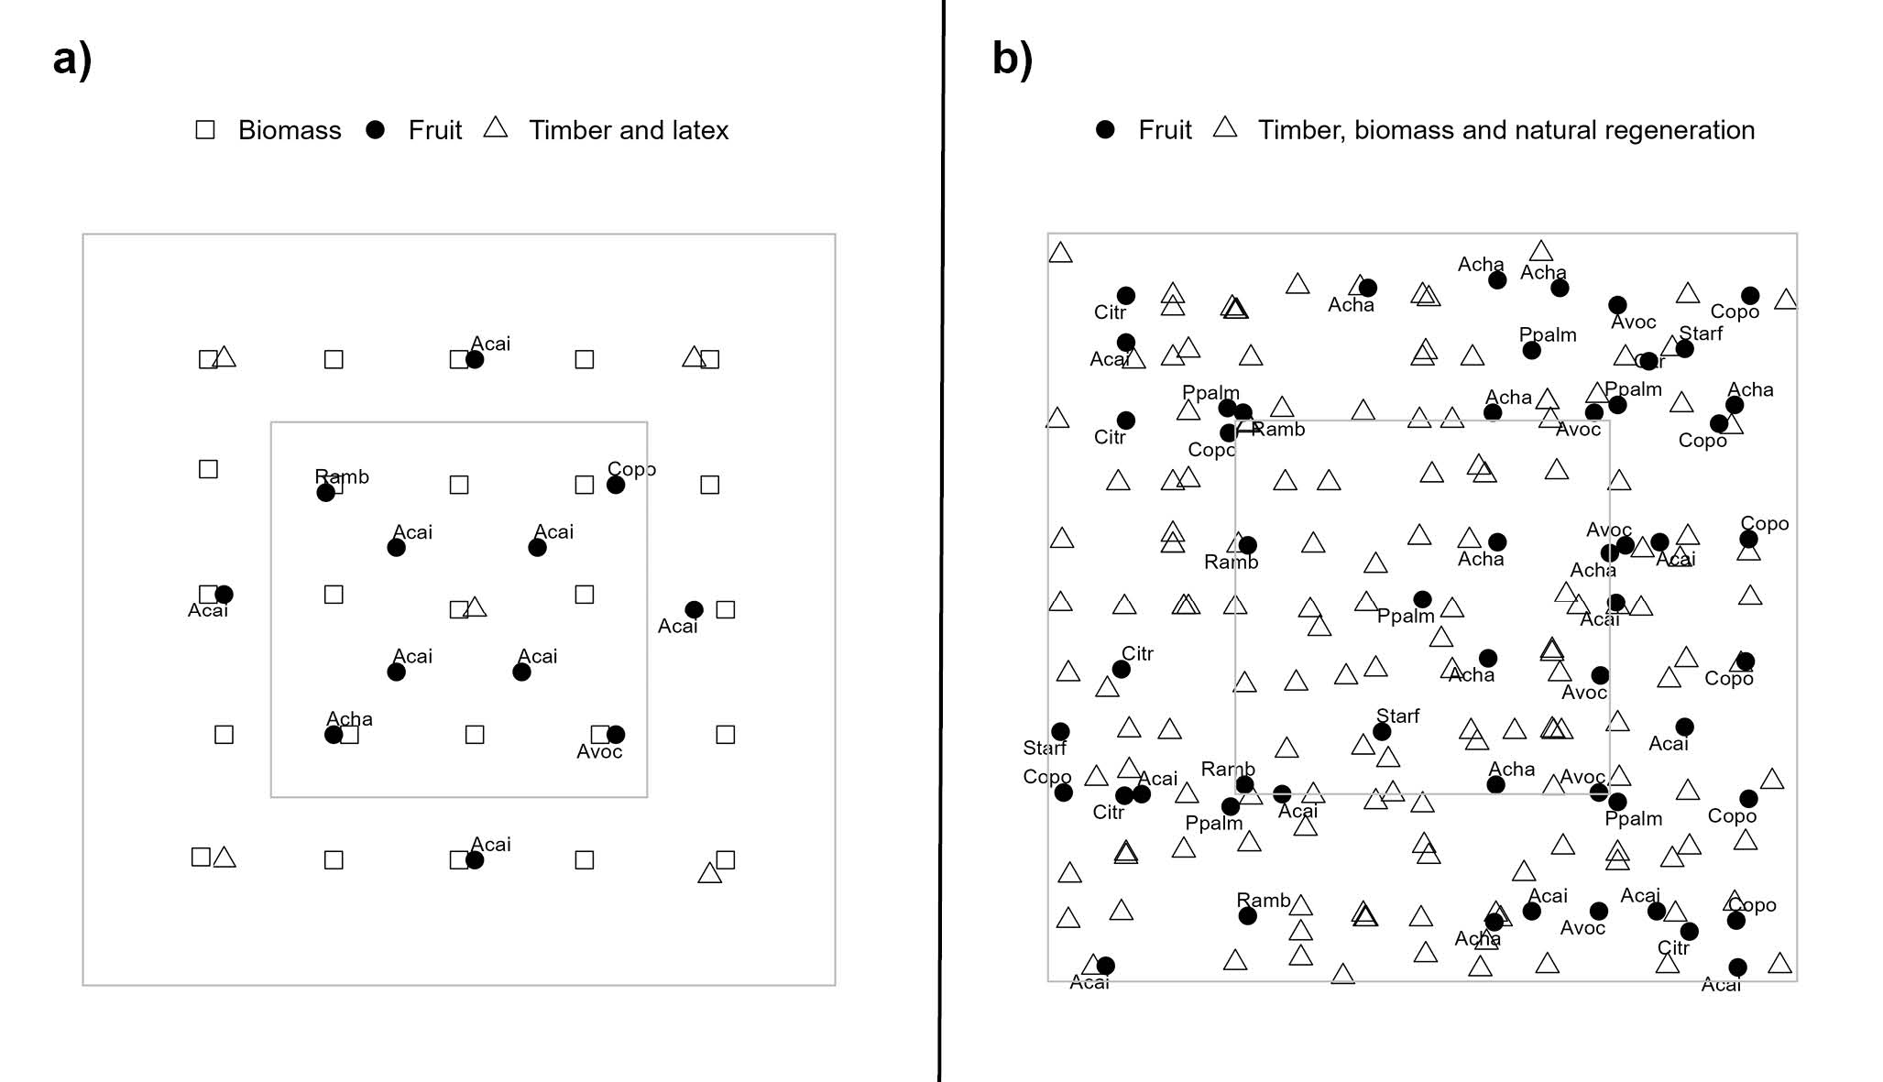

Supplementary material 4: Average cacao yields (mean and standard error) of the five cacao cropping systems for each year, as well as for the young phase (2011-2016), mature phase (2017-2022) and for the whole cacao production period. Different letters after the mean show significant differences between the production systems within the same year calculated with the lsmeans posthoc test.
.
year | Conventional  Monoculture |  |  | Organic  Monoculture |  |  | Conventional  Agroforestry |  |  | Organic  Agroforestry |  |  | Successional  Agroforestry
2011 | 111 | ± 36 | a | 62 | ± 6 | bc | 82 | ± 19 | ab | 74 | ± 10 | abc | 27 | ± 8 | c
2012 | 239 | ± 58 | a | 136 | ± 19 | b | 190 | ± 26 | ab | 154 | ± 41 | b | 47 | ± 10 | c
2013 | 569 | ± 42 | a | 313 | ± 17 | b | 262 | ± 14 | bc | 220 | ± 24 | c | 105 | ± 21 | d
2014 | 496 | ± 20 | a | 217 | ± 7 | b | 147 | ± 12 | c | 141 | ± 20 | c | 157 | ± 12 | c
2015 | 995 | ± 104 | a | 796 | ± 69 | b | 599 | ± 74 | bc | 622 | ± 66 | b | 432 | ± 64 | c
2016 | 632 | ± 113 | a | 509 | ± 45 | ab | 347 | ± 31 | c | 355 | ± 53 | bc | 252 | ± 52 | c
2017 | 1288 | ± 83 | a | 1011 | ± 100 | b | 701 | ± 48 | c | 625 | ± 14 | c | 562 | ± 29 | c
2018 | 1318 | ± 162 | a | 1169 | ± 140 | a | 794 | ± 72 | b | 776 | ± 30 | b | 627 | ± 37 | b
2019 | 1228 | ± 117 | a | 1313 | ± 86 | a | 709 | ± 58 | b | 671 | ± 34 | b | 594 | ± 18 | b
2020 | 1292 | ± 54 | a | 1057 | ± 75 | b | 874 | ± 65 | c | 913 | ± 23 | bc | 786 | ± 35 | c
2021 | 1476 | ± 37 | a | 1310 | ± 111 | a | 737 | ± 63 | b | 777 | ± 51 | b | 602 | ± 12 | b
2022 | 1707 | ± 139 | a | 1467 | ± 89 | a | 933 | ± 94 | b | 949 | ± 61 | b | 625 | ± 53 | c
Young phase | 507 | ± 46 | a | 339 | ± 22 | b | 271 | ± 23 | c | 261 | ± 34 | c | 170 | ± 24 | d
Mature phase | 1385 | ± 82 | a | 1221 | ± 89 | a | 791 | ± 59 | b | 785 | ± 24 | b | 632 | ± 12 | b
All years | 946 | ± 30 | a | 780 | ± 49 | b | 531 | ± 37 | c | 523 | ± 28 | c | 401 | ± 17 | d

Supplementary material 5: Temporal evolution of the plantain and banana yield across the across the 5 systems studied.
MON-CON stands for conventional monoculture, MON-ORG for organic monoculture, AFS-CON for conventional agroforestry, AFS-ORG for organic agroforestry and AFS-SUC for successional agroforestry. Plantain was removed end of 2011 in all systems. To replace it, in the AFS-ORG and AFS-CON banana was planted in October 2010 (4 m x 4m). In AFS-SUC, 4 different banana varieties (Guayaquil (Gros Michel), Manzano rojo, Manzano amarillo and Motacusillo) were planted at the same time (8 m × 8m). However, they did not develop well, and planting needed to be complemented in October 2012. Additionally, Cavendish banana was added to AFS-SUC at 4 m × 8 m at this time, the plants were taken out again in the end of 2015/beginning of 2016. This explains the peak in banana yields in AFS-SUC in 2014 and 2015. Plantain yields were significantly influenced by year (p < 0.001, F 21.47) and system (p < 0.05, F 4.06) as well as their interaction (p < 0.001, F 5.12). System had a significant effect in plantain yields in the year 2011 with both conventional systems higher than the three organic ones. Banana yields did not differ significantly between AFS-CON and AFS-ORG in any year and globally, year had a significant effect on banana yields in AFS-CON and AFS-ORG (p < 0.001, F 8.76).
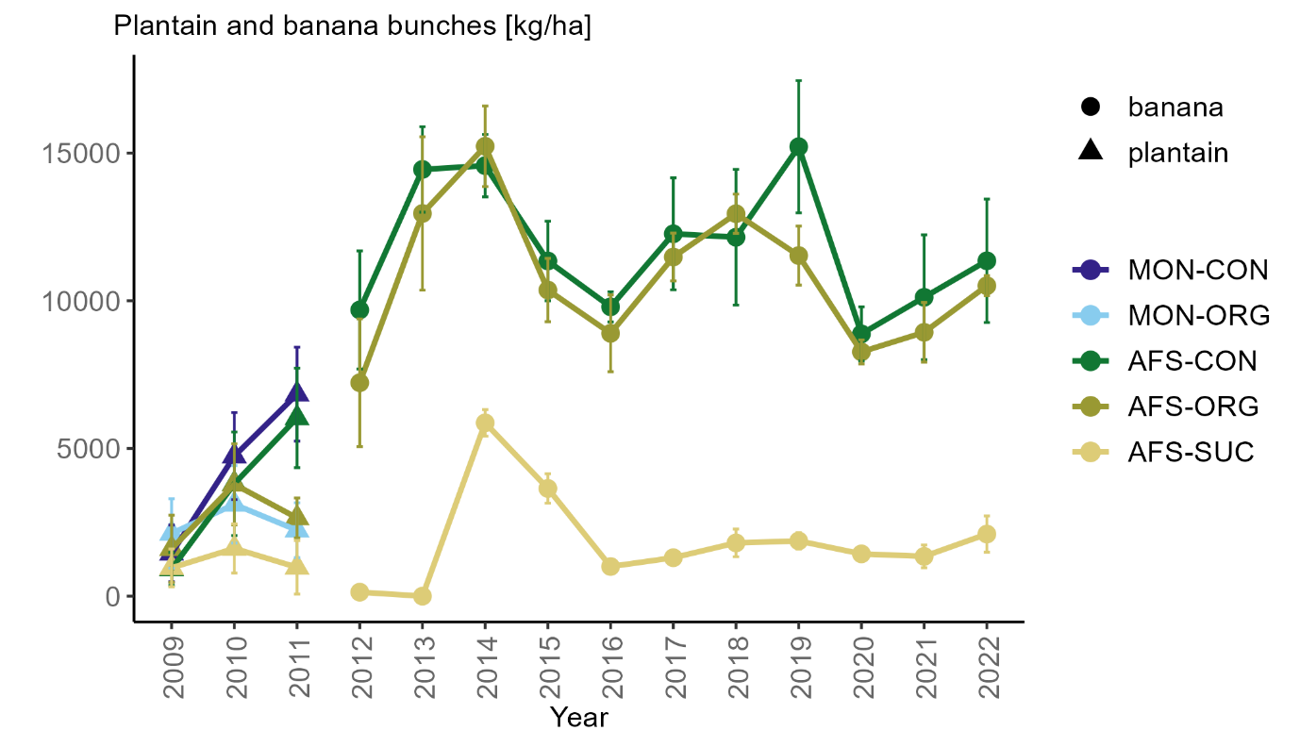

Supplementary material 6: Temporal evolution of the coffee yield across the across the three agroforestry systems studied. AFS-CON stands for conventional agroforestry, AFS-ORG for organic agroforestry and AFS-SUC for successional agroforestry. Coffee was planted in 2013 (AFS-SUC) and 2016 (AFS-CON and AFS-ORG), respectively. Treatment had a significant effect on yields (p< 0.05, F = 14.717), with significantly higher yields in AFS-CON and AFS-ORG compared to AFS-SUC. Treatment (p < 0.001, 35.7800) and year (p< 0.001, F =34.0101), as well as their interaction (p < 0.05, 2.9068) had a significant effect on yields. AFS-CON and AFS-ORG were significantly higher than AFS-SUC in all years, while there was no difference between AFS-CON and AFS-ORG.
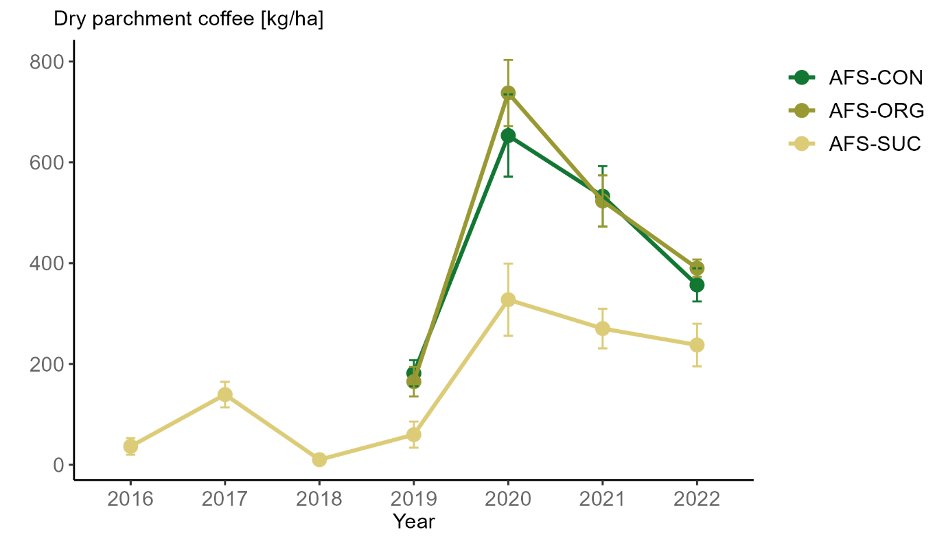
s
Supplementary material 7: Yield development of peach palm (a), ginger and curcuma (b) in successional agroforestry systems and fruit trees (c) across the three agroforestry systems studied. AFS-CON stands for conventional agroforestry, AFS-ORG for organic agroforestry and AFS-SUC for successional agroforestry.
Peach palm was one of the crops with a relatively constant production over the years. The surface of ginger and curcuma harvested inside the netplot varied considerably between years, which explains the variation in yields from one year to another. Fruit trees started to produce in the 8th year, in the case of Rambutan even only in the 13th year. Avocado trees in AFS-CON/AFS-ORG systems, especially in AFS-CON, showed high mortality, with only 1 tree per repetition present. Achachairu, acai and starfruit were not harvested regularly due to missing marketing opportunities.

