Supplementary information for:
A research agenda for UK agroforestry co-produced with stakeholders

Amelia S C Hood, Rosy E Scholes, Erika Degani, Tom Staton, Alexa Varah, Kate Beauchamp, Alice Broome, Paul Burgess, Helen Chesshire, Edward P Colbert, Emma Loder-symonds, James Ramskir-gardiner, Ann C Rayner, Colin Tosh, Alice L Mauchline, Rosemary Venn

Contents
- SI1. Online survey to gather questions
- SI2. Datasheets from the second workshop, including questions entered: attached as pdf
- SI3. Research priorities gathered from the survey and data-gathering workshop
- SI4. The demographics, roles, and experience working in agroforestry of survey respondents.

SI1. Online survey to gather questions

Co-producing research priorities for in-field agroforestry in the UK

Recently, there has been a lot of interest in agroforestry across the UK due to its potential to benefit biodiversity, the environment, and production. This survey is the first part of a larger project which aims to identity the most important topics for agroforestry research in the UK.

In this survey, we are asking you for your research ideas. This is open to anyone working in industries relevant to agroforestry (e.g. farmers, tree nurseries, policy makers, researchers, foresters, NGOs) – if you have research ideas that you think are important, we want to hear them!

The results of this survey will be presented to a group of experts (including farmers, researchers, and other businesses), who will create a list of “research priorities”. Our findings will be published in a scientific journal and made publicly available to direct researchers and funders to the most important agroforestry research questions.

[Followed by section on project funding, contact details, data handing and consent, and a tick box for acceptance]

You will now submit one to four research questions on in-field agroforestry in the UK. In-field agroforestry is defined as having single or multiple trees, shrubs, or woody perennials in arable, pastoral, poultry, or mixed systems. This:
- Includes productive (e.g. timber or food) and non-productive trees
- Includes regular (e.g. alley-cropping) and irregular (e.g. shelterbelts) planting arrangements
- Excludes hedgerows and riparian (riverside) strips that do not have crops/livestock in them

Questions can come from any research area – e.g. environment, policy, human livelihoods, knowledge exchange, markets – and will be assessed based on their:
- Impact – how important is this for the agricultural industry?
- Feasibility – is this a question that can be answered with research?
- Novelty – has this research question already been answered?

Specificity
Research questions must have a similar level of specificity (scope) to be comparable. Otherwise, broader questions get rated more important as they cover more topics. Please aim to suggest questions that could be addressed within a short (e.g. five-year) research project led by a small team (e.g. one-three people). We will adjust the specificity of questions after submission so please continue even if you are not sure about this! Please see examples below.

Example – too general | Example – too specific | Example - optimal
Does silvoarable farming benefit biodiversity compared to arable farming? | Does silvoarable farming benefit earthworms compared to arable farming? | Does silvoarable farming benefit soil health compared to arable farming?
How do trees benefit human health? | Can agroforestry lower farmer heart rate compared to arable or pastoral farming? | Can agroforestry promote farmer wellbeing compared to arable or pastoral farming?

- Please submit one to four research question(s):
X4 Open Text Spaces

- Which in-field agroforestry systems have you worked in or studied (you can select multiple)?
Silvoarable: trees with arable or horticulture fields // Silvopastoral: trees with livestock/grassland // Silvopoultry: trees with poultry // Agrisilvopastoral: trees with arable/horticulture and livestock // None of the above

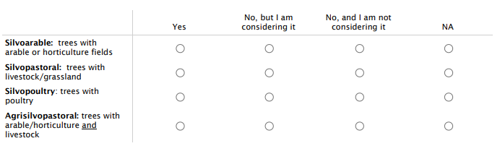
- Which in-field agroforestry systems have you established or managed (or helped to establish/manage)?

- What is your current role (you can select multiple)?
Agricultural supplier // Environmental NGO // Farmer // Farm advisor // Farmer association // Farmer school/educator // Policy maker or government advisory body // Researcher // Timber end-user (incl. designers, manufacturers) // Other (please specify) – open text

- Have you previously acted in another stakeholder role (you can select multiple)?
No // Yes, as an agricultural supplier // Yes, in an environmental NGO // Yes, as a farmer // Yes, as a farm advisor // Yes, in a farmer association // Yes, in a farmer school/educator // Yes, as a policy maker or government advisory body // Yes, as a researcher // Yes, as a timber end-user (incl. designers, manufacturers) // Yes, other (please specify) – open text

4-5(b). If participants answered “researcher” to Q4 or Q5, they were asked:
What is your area of research expertise (you can select multiple)?
List of 14 research fields with one open text.

- How long have you worked in these roles (current and previous)?
<1 Year // 1-5 Years // 6-10 Years // 11-20 Years // 21-30 Years // >30 Years

- What is your gender?
Woman // Man // Non-binary // In another way – open text // Prefer not to disclose

- How old are you?
<20 Years // 20-29 Years // 30-39 Years // 40-49 Years // 50-59 Years // 60-69 Years // 70-79 Years // >80 Years // Prefer not to disclose

SI2. Research priorities gathered from the survey and data-gathering workshop

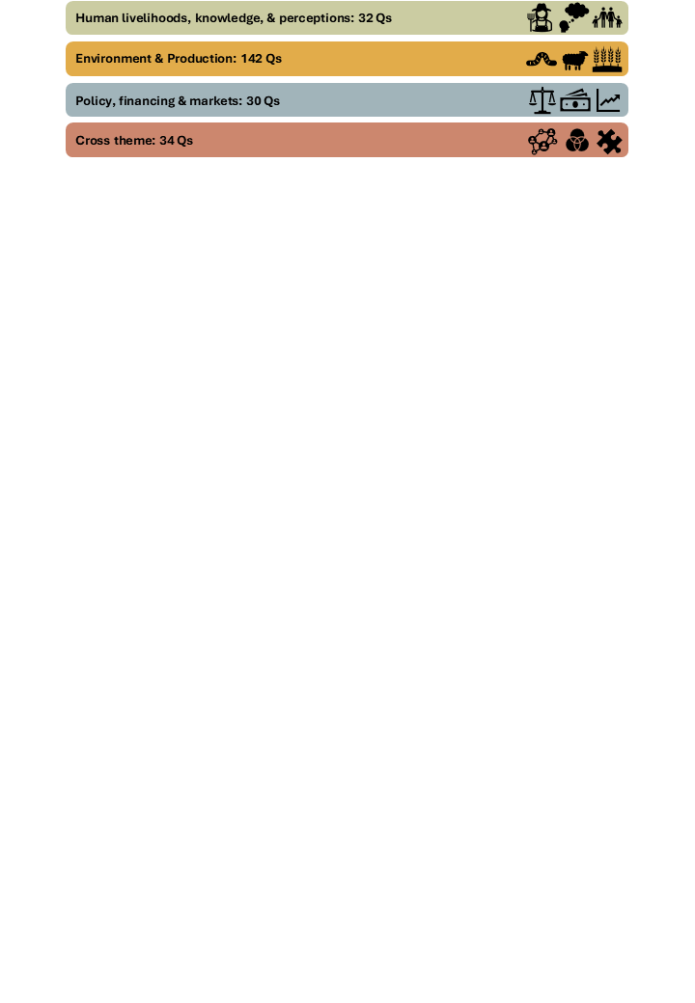
1. How can we address shortcomings in advice quality from government and NGOs in a manner that recognises issues of organisational culture?
2. What are the best and most efficient ways of supporting farmers in their transition to agroforestry?
3. What are the key challenges and barriers to the adoption of agroforestry systems in uk farming systems?
4. Is the advice and guidance about agroforestry being given to farmers by different kinds of knowledge intermediaries fit for purpose?
5. What are the key barriers to uptake of silvoarable farming systems amongst cropping farm businesses, and how can these be overcome?
6. How can we help farmers with little experience understand likely costs and returns associated with establishing agroforestry systems?
7. What are the main barriers and solutions to implementing agroforestry on tenanted land?
8. What specific data is needed to convince landowners to plant more trees?
9. Are tenants who have 'traditional' landlords less likely to be able to adopt AF than those with 'novel' or charity landlords.
10. Should hill and upland farmers be encouraged to plant AF.
11. What are the short/long-term ambitions of, and drivers of decision-making by, stakeholders implementing agroforestry projects in the UK?
12. Broadening the awareness of agroforestry in the farming community
13. How can agroforestry increase collaboration and innovation between the farming and forestry sectors?
14. Can agroforestry benefit the local community of a farm
15. Can agroforestry benefit human well-being compared to monoculture farming?
16. Do community harvesting events in silvopastoral/poultry orchards help with local food sovereignty and pride in local food?
17. Is agroforestry inherently more community centred?
18. Can agroforestry promote farmer wellbeing compared to arable or pastoral farming
19. Does agroforestry increase workload of a farmer
20. Does agroforestry provide an opening to more collaborative land stewardship?
21. Does agroforestry present opportunities to challenge historical land power dynamics
22. What is the public perception of planting trees in fields? Do people understand the benefits of trees in fields? Will this become an issues?
23. Is the general public ready for the change in the landscape as a result of large-scale alley cropping?
24. Do people prefer agroforestry landscapes or arable landscapes?
25. How do planting arrangements influence percived landscape quality?
26. Will the public approve of farmers being given financial support for undertaking AF rather than for producing food.
27. How is the landscape change associated with agroforestry regarded by the public?
28. How can we improve understanding of agroforestry amongst the general public
29. Can agroforestry disrupt perceptions of cultural ecosystem services?
30. More research on nutritional benefit of trees for livestock & making existing data more accessible to farmers
31. Does the milk and meat from ruminant animals fed on tree fodder have different nutritional quality, flavour and taste?
32. Do farmers understand the importance of tree health and management for resilience as part of their agroforestry practice?
33. What are the non-timber / food products that can also be included in an agroforestry system?
34. Should tree planting strips run north south or East west for best agricultural, biodiversity benefit?
35. What is the optimal height and distance between tree rows to optimise arable / crop production and /or biodiversity
36. Which arrangements of tree and crop species are best suited to productive, sustainable and resilient agroforestry systems?
37. How do different trees interact with different crops in silvoarable alley-cropping systems?
38. Which components of biodiversity win and lose from agroforestry
39. Does agroforestry benefit bird abundance and diversity
40. Does silvoarable benefit one species over another?
41. Which biodiversity groups are not present in agroforestry areas compared to nature woodlands in the UK?
42. Does silvoarable farming benefit biodiversity more than planting woodlands on farms?
43. What is the LIDAR-derived above-ground biomass (and thus carbon content) of agroforestry compared to arable or pasture farming?
44. What is the long-term impact of agroforestry on carbon stocks
45. Do agroforestry systems increase soil carbon storage (compared with grassland or arable) in mineral, organic mineral and organic soils?
46. What is the carbon sequestration potential of wood-pasture establishment in appropriate upland environments?
47. Does inclusion of trees in grazed pasture boost the soil carbon sink effect?
48. How large a contribution can agroforestry make to net-zero targets in the UK?
49. Do gains in carbon and biodiversity in agroforestry systems off-set losses in food production?
50. Does silvopasture farming promote greater climate change mitigation compared to pastoral farming?
51. Does silvoarable alley-cropping provide more crop resilience to climate extremes
52. Can in field agroforestry increase drought resilience of a field.
53. What are the potential heat stress mitigation benefits of silvoarable farming in the UK?
54. How can farmers ensure their tree-scapes are resilient to future climatic conditions or pest pressures? Should we stick to native only?
55. Will silvoarable farming provide resilience to climate change compared to arable farming?
56. Can agroforestry be designed to link up areas of seminatural habitat to create wildlife corridors?
57. To what extent could agroforestry increase habitat connectivity across a given region without reducing food production?
58. Does agroforestry on a larger scale have significantly greater benefits for biodiversity than isolated projects?
59. How can we preserve tree fodder (silage, hay) for feeding it indoors to ruminants (e.g. during winter)
60. How best to store tree fodder for later use?
61. Fruit tree agroforestry an harvest technology
62. Does silvoarable farming help to decrease inputs especially pesticides for the same yield?
63. What is the possible international leakage effect (LUC) from large scale conversion to agroforestry in the UK?
64. What is the implication for national-scale food production of various scenarios of agroforestry planting in the UK.
65. To maximise carbon capture, biodiversity and food production, is agroforestry better than a mix of dedicated land-uses?
66. How does leaf fall and canopy shade affect the nutritional quality of pasture below trees
67. How does different arrangements of trees impact light patterning to the below crops
68. How should forage hedgerow systems be optimised for utilisation by cattle and sheep?
69. Does silvopastural farming have a positive effect on livestock health and welfare
70. Does silvopasture farming benefit ruminant livestock health and performance compared to pastoral farming?
71. What are the optimal patterns of silvo-pastural tree planting in relation to animal welfare?
72. What are the effects of agroforestry on farm animal welfare?
73. Are there animal health/welfare gains under agroforestry?
74. What welfare benefits does agroforestry provide to livestock?
75. What are the animal health impacts of agroforestry compared to conventional livestock production?
76. What are the effects of agroforestry on farm animal welfare?
77. What benefits to animal health and production can be obtained from forage hedgerow systems
78. How does agroforestry impact animal welfare in silvopastoral systems
79. Do informal browse opportunities in silvopasture positively effect animal welfare and performance
80. Does browsing of tree and shrub leaves mitigate methane emissions from cattle?
81. What is the nutritional value of fresh tree fodder for grazing ruminants?
82. What is the feed/nutritional value of agroforestry for livestock?
83. What proportion of nutrinene intake in cattle can be derived from foliage and twigs in silvopasture?
84. Can we increase productivity and feed efficiency, and reduce methane emissions and nitrogen excretions, in ruminants by feeding tree fodder?
85. Are there meat productivity gains under agroforestry?
86. Does silvopasture improve daily liveweight gain of lambs?
87. Does silvopasture reduce lamb losses?
88. When is it inappropriate to introduce agroforestry for biodiversity e.g. in species-rich grasslands
89. Which income-producing trees are best suited to very marginal land un-suitable for arable crops?
90. How does agroforestry, affect the microbial community in soil, and how far does this affect move away from the trees into productive land?
91. How do trees in silvoarable systems affect the microclimate (e.g. temperatures) that crops and soils under crops are exposed to?
92. Can millable timber be produced from single or edge trees without pruning?
93. Do FRM tested provenances increase the quality/quantity of millable timber?
94. Do tested provenances obviate the need for pruning to produce millable timber?
95. How important are common mycorrhizal networks in agroforestry?
96. How does agroforestry's support for mycorrhizal communities impact the plant health of any crops grown on tillaged rows between tree strips.
97. How does the spatial configuration and density of tree planting impact vulnerability to loss from windfall, disease, etc.?
98. Do silvoarable systems promote pollination service compared to arable systems?
99. How does the presence of single or multiple trees and shrubs in UK agroforestry systems influence pollinator biodiversity?
100. Are there particular rootstocks that minimise competition between trees and crops for water?
101. How can farmers self-assess multiple benefits from agroforestry including production, soil health, carbon, biodiversity and reduced inputs?
102. How can farmers self-assess multiple benefits from agroforestry including production, soil health, carbon, biodiversity and reduced inputs?
103. What are the short term (within a couple of years) impacts of implementing agroforestry, in relation to biotic and abiotic conditions
104. Do shrubs work as well as trees in silvoarable farming?
105. Does silvoarable farming benefit crop health
106. Which biodiversity groups (e.g. functional groups, species) most benefit from agroforestry areas compared to pastoral farming in the UK?
107. What is the role of root exudates in carbon fixation and how this can improve soil life in deeper soil layers?
108. How does silvoarable farming benefit soil health compared to arable farming?
109. What is the mechanism by which in-field trees improve soil biology?
110. Subsoil below 1 metre nutrient transfer to annual crops
111. Does silvoarable farming have more of an impact on soil health than regenerative arable systems
112. How far do the ecological (dis)benefits of silvoarable farming spill over into adjacent crops (important for planting arrangement)?
113. In UK silvoarable systems how far do competitive effects extend, and to what extent is this influenced by tree species and management
114. How does the quantity and quality of timber produced through in-field agroforestry compare to traditional forestry?
115. Does agrofrestry reduce or increase the spread of tree diseases?
116. How can tree establishment be optimised in arable systems? Particularly in drought years etc
117. What are the best fencing systems for agroforestry design?
118. What are the best nurse species of trees within an agroforestry system?
119. In what situations can self-seeded trees create a viable and resilient agroforestry system?
120. Which current or less widely available rootstocks can allow productive top-fruit as part of an agroforestry system on marginal land?
121. How does presence of different trees boost levels of key ecosystem services, such as pollination, decomposition, soil processing, etc?
122. What species of trees have been proven to stay upright for 10-15 years plus whilst planted close to a post or two in a silvopasture system
123. Is it better to have hedgerows or tree shelter belts within an arable /crop production system to optimise food production?
124. What are the biodiversity trade-offs (beneficial insects & nesting birds) when using fast growing non-native-evergreen trees for shelter
125. What additional wildlife is present in agroforestry sites with varying tree numbers/species, compared to those that do not have these?
126. What is the impact of the choice of tree species on biodiversity - do some species jump start biodiversity more than others?
127. Is there an optimum mixture of trees to promote biodiversity?
128. Do fruit trees provide the same carbon sequestration and biodiversity benefits as other trees in agroforestry systems?
129. What are the crops that benefit the most from being integrated into a silvoarable system (and does it depend on the tree species)?
130. Are there any crops that consistently perform better in silvo-arable situations?
131. What are the nutritional qualities of different native tree and shrub species?
132. What edible woody species should be included in a UK forage hedgerow system?
133. Can leguminous trees have a positive yield effect on annual crops grown between rows
134. Do nitrogen fixing trees contribute worthwhile fertility to adjacent crops?
135. Which tree species produce the highest yield 5, 10, 20 and 30 years from planting, either from timber, fruit or another product?
136. What is the optimal combination of crops and trees to maximise yield gains for wheat production
137. What kinds of habitats can be introduced in the strips while the trees are establishing?
138. What understorey vegetation is optimal to support biodiversity?
139. What is the best understory to have under trees in an agroforestry system
140. How can vegetation management be carried out sustainably in agroforestry settings?
141. How feasible is it to grow understory cash crops within the tree rows?
142. What are best companion trees / shrubs to help establishment and early growth of fruit and nut trees in agroforestry row systems
143. What impact, if any, does silvoarable have on water quality
144. How does water usage efficiency in silvoarable systems (integrating crops and trees) in the UK compare to conventional arable farming?
145. How do agroforestry systems impact the micro climate (landscape / watershed), in particular focus on water – flooding and drought
146. How do trees impact the microclimate inc. water management and small water cycles?
147. What is the difference in yields between agroforestry and "conventional" farming in the production of key crops in the UK context?
148. What is the yield of alternative agroforestry farm types and how does this vary by food? 149. What does this mean for optimising land use?
150. How does agroforestry impact yield and productivity of arable crops or livestock?
151. What are the impacts of alley-cropping agroforestry on crop yields under climate change
152. Does silvoarable farming have a beneficial or detrimental effect on yields?
153. More information is needed on the relationship between detritivores and other parts of the ecosystem
154. Does silvoarable decrease nutrient loss from intensive (e.g. cereal) crop rotations?
155. Does agroforestry have greater benefits for soil health in non-organic systems than organic systems?
156. Can silvoarable systems provide more ecosystem services than agri-environment measures?
157. Develop the Ecological Site Classification tool to include tree crops e.g. nuts and stone fruit
158. Environmentally, how can silvoarable compliment traditional arable farming?
159. What is the best mulch/weed supressant method in agroforestry
160. How can farmland food webs be maximised in agroforestry settings?
161. Can we extend the riparian benefits of agroforestry?
162. Are there grassland disbenefits (management and productivity) under agroforestry?
163. How long does it take for agro-forestry approaches to deliver for specific outcomes (could be a question for each potential outcome)
164. What level of plant species diversity gives optimum environmental and animal health/nutrition benefits in silvopastoral systems?
165. Can wood-pasture establishment in upland environments mitigate flood and drought risk as climate change accelerates?
166. Can wood-pasture (re)establishment help conserve/enhance the biodiversity of upland biomes?
167. At what point does tree competition outweigh the potential benefits to crops?
168. What is the yield cf alternative farm types and how does this vary by food?
169. What is the optimum design for a sylvopastoral system based on woody forage hedgerows?
170. How does agroforestry support rotational grazing systems within dairy farms?
171. Can short rotation coppice planted in an alley system provide easy access to fodder for cows?
172. Does adding ramial woodchip to the cropped areas, from short rotation coppice rows of trees, improve soil health and crop yield
173. Can environmental benefits of agroforestry be quantified to add to overall output from agroforestry?
174. How can agroforestry contribute to renewable energy production on farm to produce a circular system?
175. Is agroforestry appropriate to all regions of the UK?
176. Does silvoarable farming improve the economic return of the arable crop grown alongside trees
177. Which systems can provide the largest economic return on grade 3 land in the Uk?
178. How can agroforestry systems be designed and managed to improve farm income?
179. Can silvoarable farming provide a greater economic return than arable farming in lowland UK?
180. Can silvopasture farming provide a greater economic return than pastoral farming in lowland or/and upland UK?
181. Is it financially viable to replace arable farming with silvorable?
182. Is agroforestry financially viable on a commercial scale for horticultural and livestock farms?
183. What are the economic outcomes for UK farmers who integrate woody perennials into pastoral systems?
184. Does planting trees in a field produce a greater total gross margin
185. What is the cost:benefit ratio of silvoarable woodlands?
186. How best to plant trees within an agricultural system to benefit from future carbon credits or biodiversity net gain income streams?
187. How can any form of agroforestry be monetised to provide an economic use of land?
188. More information on markets is needed – where are the gaps and how can they be filled?
189. Is green private sector green financing acceptable to farmers in relation to agroforestry?
190. What financial models can support new farmers to transition to agroforestry (e.g. green financing, ELMS subsidies)?
191. Supply chains for agroforestry
192. How can we ensure policy coherence across multiple governance objectives through agroforestry?
193. Should there be a UK wide policy towards AF rather than allowing the devolved administrations to develop more locally based policies.
194. What level of economic support (subsidy) is required to de-risk investing in agro-forestry
tree planting under grants brings restrictions (i.e grazing in woodland), what are the policy needs for this to change?
195. What key policy incentives would drive the widespread adoption of silvoarable systems in England?
196. What policies and practices are required for the landscape-scale establishment of wood-pasture in upland environments?
197. How can the RPA support farmers on their agroforestry projects?
198. Are schemes for farmers too complicated with too much red tape, would there be more uptake if they were straight forward simple?
199. Is uncertainty about AE schemes a disincentive to farmers adopting agroforestry?
200. How can rolling agroforestry be implemented in place of one-off planting systems?
201. If farmers were offered more choices in how they incorporate trees on their land to suit their farming system
202. How can we facilitate convenors for meetings between ethical producers and buyers of high-quality timber and non-timber products from high value agroforestry?
203. What is the legal status of agroforestry land in terms of valuation and tenancy? How can the Rural Payment Agency support and provide clarity for farmers as opposed to uncertainty?
204. How can pruning be incentivised to maximise the proportion of millable timber?
205. What are the incentives for agroforestry for biomass? How efficient is agroforestry for biomass and woodchip efficiency?
206. Potentially increasing economic benefits to landowners, can short rotation coppicing be sustainably incorporated into agroforestry systems?
207. How can community tree nurseries and farms work together to improve the genetic diversity of tree stocks available?
208. How best can farmers and community tree nurseries work together to find new seed stands (FRM) and self-sown saplings for local planting?
209. Is there benefit to farmers and community tree nurseries to making CTNs on farms, growing local provenance trees?
210. Can we monetise the agronomic benefits of silvoarable farming? How does this compare to the loss of output area?
211. What are the effects of agroforestry on disease risks?
212. What are the effects of agroforestry on disease risks? Agroforestry can have high levels of contact between wildlife, livestock and people
213. What types of agroforestry crops promote farmer wellbeing (including economic) compared to arable farming?
214. Can we bring together more case studies (10+year trial) of what works and what doesn’t?
215. How can we set up a sustainable database to record markets and contacts?
216. How can we set up sentinel landscapes and sustainable models of partnership monitor farms?
217. What are the major gaps between current agroforestry-related policy and implementation practices in the UK?
218. Can the UK food system absorb predicted increases in fruit and nut production from agroforestry systems? If not, what changes are needed?
219. Which tree and crop species combinations are likely to be the most productive and profitable under climate change over the next 10-30 years?
220. How can we stop agroforestry focusing on just a few timber or multipurpose trees?
221. To what extent could agroforestry support domestic timber production? (Species, quality, quantity...)
222. What are the quick wins (within 1-2 years) in agroforestry?
223. Where and what are the outcomes at scale and what are the business cases for various actors involved? I.e what happens to the climate in Hampshire following massive AF planting scheme?
224. How can we scale up and obtain better returns on social capital?
225. What delivers better for biodiversity, climate mitigation and economic return - tree grown in field vs trees grown off field?
226. Research Ecosystem services in silvo-horticulture
227. What are the social impacts of agroforestry and how can this system accelerate the transition to agroecology and or more mixed management land?
228. With so many digital trackers and tools, which one(s) should be using? Will there be an objective assessment of these tools?
229. Can agroforestry provide a transition pathway to greater perennial polycropping for key staple food crops in the UK?
230. Do farmers understand and plan for entry into the markets the tree component of new agroforestry schemes opens up to them?
231. Which tree species provide the greatest ecological and economic benefits in silvoarable farming?
232. Which tree species deliver the greatest benefits for biodiversity, climate change and economic returns in arable agro-forestry systems?
233. Potential benefits of expanded growth of elder (for berries/flowers) for biodiversity, environmental conditions, and farmers.
234. How can we ‘retrofit’ woodlands to agroforestry systems (policy and practice)?
235. Financial incentives and return on investments remain unclear – how can public / private money be leveraged in the support of farmers transitioning to agroforestry systems (but avoiding carbon credits!)?
236. What are the barriers to farmer empowerment given subsidy addiction problems?
237. How do above or belowground interactions in agroforestry impact on ecosystem service delivery?
238. Benefits to farmers of including yielding trees in farmland restoration projects, vs any potential biodiversity costs?

SI4. The demographics, roles, and experience working in agroforestry of survey respondents.
From the online survey gathering research questions, 53% of respondents identified as men and 44% as women (3% did not disclose), and 7% were 20-29 years old, 29.5% were 30-39, 19% were 40-49, 25% were 50-59, 12% were 60-69, and 4.5% were 70-79 (3% did not disclose). In terms of experience, 81% of respondents had studied or worked in agroforestry previously and 48.5% of respondents had direct experience of establishing or managing agroforestry systems. Therefore, we met our aim of including stakeholders with direct experience of agroforestry and people in related areas who may offer different perspectives. We also achieved a balance of experience across the different agroforestry systems in terms of the systems that respondents had studied, worked in, established, or managed; there was a bias towards silvopasture (40% of respondents) and silvoarable (38%) systems (Fig. SI4 (a and b)), but this reflects the greater land use area of pasture and arable systems compared to other agricultural systems (e.g. in 2022, 92% of agricultural land was under pasture and arable in the EU (DEFRA, 2024; Eurostat, 2024). Respondents had relevant experience across 12 current or previous roles (Fig. SI4 (c)), with many responses from researchers (40% of response occurrences), farmers (18%), farm advisors (13%), environmental NGO employees (13%), and policy makers or governmental advisory bodies (7%). Respondents with research roles also provided their research field, and we had broad coverage across 15 disciplines (Fig. SI4 (d)).
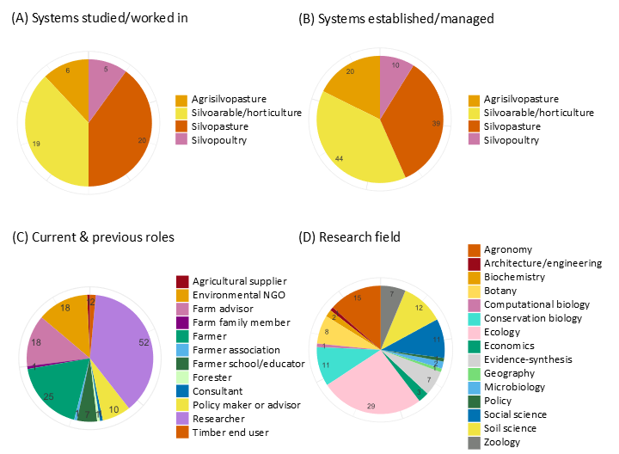Fig SI 4. Pie charts showing the proportion of survey respondents who had (a) studied or worked in or (b) established or managed (or helped to establish or manage) the different agroforestry systems. (c) Respondents’ current and previous roles and (d) researchers’ academic fields (this question was only asked if respondents answered ‘Researcher’ as a role). The numbers show the frequency of answers. Respondents could select multiple options so the total of these numbers may be more or less than the total number of respondents (68). See SI.1 for full questionnaire.

References
DEFRA. (2024). Farming Evidence Pack A high-level overview of the UK agricultural industry. https://assets.publishing.service.gov.uk/media/66e7e0b33f1299ce5d5c3ed9/Farming_evidence_pack_16sept24.pdf
Eurostat. (2024). Utilised Agricultural Area by Categories. https://ec.europa.eu/eurostat/databrowser/view/tag00025/default/table?lang=en

