Supplementary Material

Appendix I: Crop list & COROP Regions in experimental set up
As mentioned, the BRP data contain an indication for the main crops grown. The list of crops that is referenced was not composed on the basis of botanical criteria alone. Different potatoes are e.g. distinguished based on the purpose for which those potatoes are grown (consumption, starch or seed) and / or on the soil type (clay, sand etcetera). Besides a limited number of different landscape elements and different types of fallow governed by different rules are also included in the list. In total the list consists of 534 different items.
Table 7: Crop types distinguished in relation to the Crop Rotation Index
Letter | Description | Occurrence
O | Other crops | 125
T | Permanent crops | 94
G | Grass | 76
R | Root crops | 70
L | Leguminous crops | 51
K | Crops from the Brassicaceae family | 46
P | Potato | 24
F | Fallow | 23
C | Cereal crops | 17
M | C4 cereals | 8

In order to distinguish the areas in the Netherlands, the decision was made to divide the country in NUTS region 3 classes (EUROSTAT, 2024). These are the so-called COROP regions and are more detailed than the province boundaries (NUTS region 2). NUTS level 3 was chosen because this is a division of the Netherlands which is often used for statistical purposes. It is not an administrative or political division linked to governing bodies but it enables researchers, policymakers, and analysts to study and understand regional variations in economic, social, and demographic indicators (CBS, 2024). An advantage is also that within the COROP regions, the soil types are more or less uniform. Appendix II contains the names of the COROP regions.

No. | COROP area |  |  | No. | COROP area
01 | Oost-Groningen |  |  | 21 | Agglomeratie Haarlem
02 | Delfzijl en omgeving |  |  | 22 | Zaanstreek
03 | Overig Groningen |  |  | 23 | Groot-Amsterdam
04 | Noord-Friesland |  |  | 24 | Het Gooi en Vechtstreek
05 | Zuidwest-Friesland |  |  | 25 | Agglomeratie Leiden en Bollenstreek
06 | Zuidoost-Friesland |  |  | 26 | Agglomeratie 's-Gravenhage
07 | Noord-Drenthe |  |  | 27 | Delft en Westland
08 | Zuidoost-Drenthe |  |  | 28 | Oost-Zuid-Holland
09 | Zuidwest-Drenthe |  |  | 29 | Groot-Rijnmond
10 | Noord-Overijssel |  |  | 30 | Zuidoost-Zuid-Holland
11 | Zuidwest-Overijssel |  |  | 31 | Zeeuws-Vlaanderen
12 | Twente |  |  | 32 | Overig Zeeland
13 | Veluwe |  |  | 33 | West-Noord-Brabant
14 | Achterhoek |  |  | 34 | Midden-Noord-Brabant
15 | Arnhem/Nijmegen |  |  | 35 | Noordoost-Noord-Brabant
16 | Zuidwest-Gelderland |  |  | 36 | Zuidoost-Noord-Brabant
17 | Utrecht |  |  | 37 | Noord-Limburg
18 | Kop van Noord-Holland |  |  | 38 | Midden-Limburg
19 | Alkmaar en omgeving |  |  | 39 | Zuid-Limburg
20 | IJmond |  |  | 40 | Flevoland

Appendix II: Weighted CRI values over grassland and arable land in COROP regions
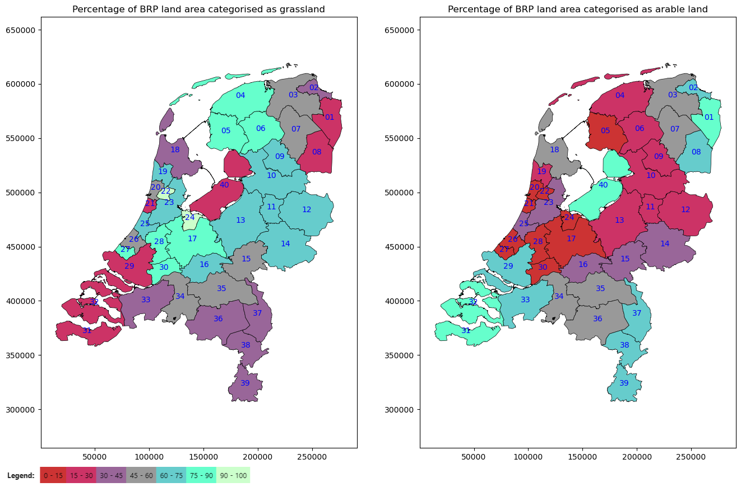
Figure 8: BRP land area divided in percentage grassland and arable lands

The mean crop rotation indices (CRI) are given below for all COROP regions, based on BRP data for 2022. A distinction was made between grassland and arable land. Besides, the standard deviation of the weighted mean is given as well as the number of parcels involved.
 | Grassland |  |  |  | Arable land
Code | CRI | StdDev | Number |  | CRI | StdDev | Number
CR01 | 0.806 | 0.0099 | 3448 |  | 0.250 | 0.0033 | 6709
CR02 | 0.902 | 0.0059 | 2728 |  | 0.361 | 0.0053 | 1770
CR03 | 0.932 | 0.0020 | 20499 |  | 0.289 | 0.0030 | 7782
CR04 | 0.946 | 0.0012 | 30908 |  | 0.305 | 0.0036 | 5977
CR05 | 0.960 | 0.0011 | 22040 |  | 0.366 | 0.0066 | 2035
CR06 | 0.936 | 0.0014 | 21863 |  | 0.323 | 0.0059 | 3464
CR07 | 0.872 | 0.0033 | 11371 |  | 0.267 | 0.0039 | 7141
CR08 | 0.794 | 0.0053 | 6369 |  | 0.216 | 0.0031 | 7796
CR09 | 0.895 | 0.0027 | 10751 |  | 0.297 | 0.0081 | 3805
CR10 | 0.922 | 0.0015 | 27847 |  | 0.298 | 0.0042 | 7461
CR11 | 0.929 | 0.0026 | 8732 |  | 0.328 | 0.0069 | 2687
CR12 | 0.900 | 0.0016 | 28994 |  | 0.288 | 0.0039 | 10202
CR13 | 0.944 | 0.0014 | 25323 |  | 0.305 | 0.0049 | 7441
CR14 | 0.893 | 0.0016 | 29710 |  | 0.374 | 0.0032 | 12292
CR15 | 0.928 | 0.0028 | 9390 |  | 0.480 | 0.0060 | 4977
CR16 | 0.946 | 0.0021 | 11450 |  | 0.608 | 0.0061 | 7070
CR17 | 0.961 | 0.0009 | 36370 |  | 0.458 | 0.0071 | 5529
CR18 | 0.811 | 0.0030 | 11599 |  | 0.357 | 0.0032 | 10477
CR19 | 0.939 | 0.0027 | 4284 |  | 0.393 | 0.0100 | 1084
CR20 | 0.967 | 0.0036 | 1545 |  | 0.269 | 0.0266 | 273
CR21 | 0.995 | 0.0064 | 341 |  | 0.154 | 0.0438 | 93
CR22 | 0.985 | 0.0018 | 2552 |  | 0.355 | 0.0294 | 62
CR23 | 0.947 | 0.0016 | 12053 |  | 0.410 | 0.0067 | 2493
CR24 | 0.979 | 0.0024 | 2652 |  | 0.317 | 0.0242 | 241
CR25 | 0.982 | 0.0016 | 4906 |  | 0.214 | 0.0096 | 1752
CR26 | 0.983 | 0.0022 | 2271 |  | 0.480 | 0.0526 | 94
CR27 | 0.974 | 0.0030 | 1605 |  | 0.417 | 0.0536 | 76
CR28 | 0.973 | 0.0010 | 16510 |  | 0.395 | 0.0142 | 2102
CR29 | 0.889 | 0.0040 | 7309 |  | 0.400 | 0.0037 | 8038
CR30 | 0.971 | 0.0013 | 10427 |  | 0.452 | 0.0126 | 779
CR31 | 0.814 | 0.0074 | 4021 |  | 0.490 | 0.0024 | 9050
CR32 | 0.821 | 0.0049 | 7540 |  | 0.504 | 0.0029 | 13097
CR33 | 0.834 | 0.0034 | 11857 |  | 0.466 | 0.0037 | 13218
CR34 | 0.859 | 0.0029 | 11333 |  | 0.480 | 0.0041 | 8306
CR35 | 0.857 | 0.0025 | 17766 |  | 0.430 | 0.0032 | 14168
CR36 | 0.822 | 0.0026 | 13898 |  | 0.429 | 0.0032 | 12842
CR37 | 0.854 | 0.0040 | 6669 |  | 0.485 | 0.0040 | 9487
CR38 | 0.863 | 0.0043 | 6492 |  | 0.482 | 0.0037 | 9297
CR39 | 0.922 | 0.0032 | 7060 |  | 0.467 | 0.0040 | 6898
CR40 | 0.669 | 0.0069 | 5184 |  | 0.329 | 0.0025 | 13456

Appendix III: distribution of CRI parcels over parcels on the arable and dairy farm
In Figure 9, the parcels of the arable and dairy farmer of both exchanging and non-exchanging scenarios are visualized. It is visible that when dairy farmers don’t exchange parcels, there is a number of parcels with the lowest value, which refer to the maize parcels. The arable farmer that exchanges parcels scores higher than without exchanging, where the CRI score does not exceed 0.4. At the same time the CRI value of the dairy farmer drops one class. The lowest value is in the class 0.6-0.8 instead of in the class 0.0-0.2.
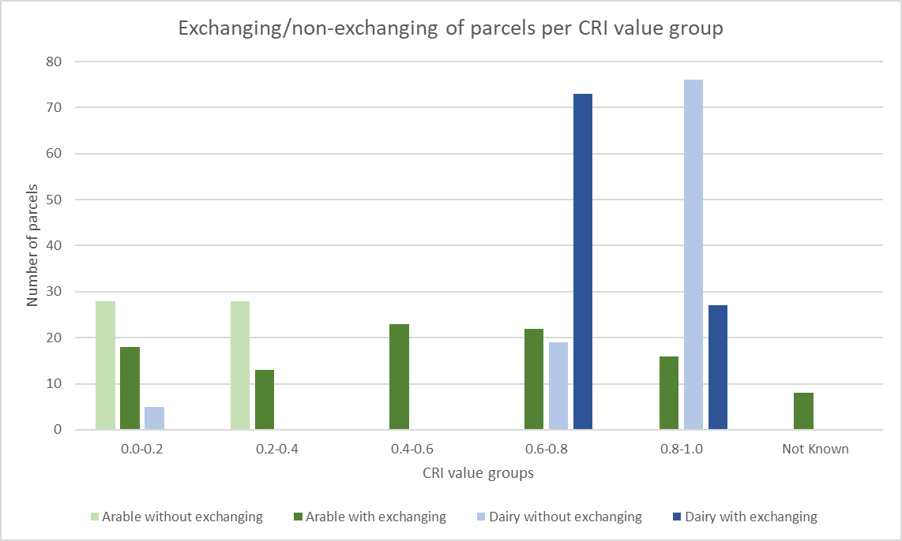
Figure 9 Distribution of parcels over the different classes of the CRI, representing the collaboration of sharing of parcels. Note: The size of the parcels is not accounted in this figure.

