Supplemental Material to the Article:
Drivers of arable flora diversity in productive Mediterranean pulse cropping systems
In: Agronomy for Sustainable Development

Vollheyde, Anna-Lena¹*, Schaarschmidt, Frank², von Haaren, Christina¹

¹Institute of Environmental Planning, Leibniz University Hannover
²Biostatistics Section, Institute of Cell Biology and Biophysics, Leibniz University Hannover
* Corresponding author: Anna-Lena Vollheyde, Institute of Environmental Planning, Leibniz University Hannover, Herrenhäuser Straße 2, 30419 Hannover, Germany, Mail: vollheyde@umwelt.uni-hannover.de

Supplement I – Primary data meta-analysis of the effects of management practices on biodiversity
Methods
As extreme weather events occurred in 2023, we tested for biodiversity differences between years. Due to non-normal distributions of all data, tests for differences were done using the Mann-Whitney U test via the stats package. Unpaired tests were applied for comparisons between years. All boxplots were visualized with the packages ggplot2 (Wickham 2016) and glue (Hester and Bryan 2022).
The field trials overall tested management practices aiming at reducing external inputs and utilizing crop diversity. Details on the treatments and their combinations, however, varied, as treatments were adapted to local agronomic and climatic contexts. An overview is presented in Table S1. All details on the field trials, including experimental layouts and management details, are reported in the data papers listed under the Data Availability Statement of the manuscript.
Table S1: Overview of the field trials (adapted from Vollheyde et al. 2024).
Country | Season | City | Legume |  | Treatments tested
Country | Season | City | Chickpea | Lentil | Treatments tested
Spain | 2022 | Carmona | x |  | Legume cultivar x pre-crop (x weeding)
Spain | 2022 | Carmona |  | x | Legume cultivar x intercropping x inoculation
Spain | 2023 | Carmona |  | x | Legume cultivar x intercropping x inoculation (+ unweeded edge plots)
Spain | 2023 | Carmona |  | x | Intercropping x weeding
Spain | 2023 | Cuenca |  | x | Legume cultivar x intercropping x inoculation (+ unweeded edge plots)
Spain | 2023 | Cuenca |  | x | Intercropping x weeding
Tunisia | 2023 | Korba | x |  | Weeding
Italy | 2022 | Pisa |  | x | Intercropping
Croatia | 2022 | Zagreb |  | x | Inoculation x intercropping
Croatia | 2022 | Zagreb | x |  | Inoculation x intercropping (+ unweeded edge plots)
Croatia | 2023 | Zagreb | x |  | Inoculation (and no weeding)

The effect of management practices on arable flora diversity was analysed with primary data meta-analysis in a two-stage approach (see Mengersen et al. 2013a; Nakagawa et al. 2023). Our two-stage approach followed this procedure: We first obtained individual effect estimates for each Location × Year × Treatment combination by fitting generalized linear models tailored to the data structure. Then we fitted random-effects and mixed-effects models to derive overall effect sizes (per subgroup and globally).
In the first stage, data on species richness of field trials were analyzed separately for each location and year. A generalized linear model with log-link and quasipoisson assumption was fitted to the observed count data. The model equation included the following categorical predictor variables: block, the treatment factor(s) of interest for meta-analysis, and (where necessary) additional treatment factors crossed with or nested in the treatment of interest. For initial model fits, the adequacy of quasipoisson assumption was checked using Q-Q-normal plots for count data (package hnp, Moral et al. 2017), and was found appropriate for all models.
The Shannon indices in the first stage were analyzed at the scale of effective species number (i.e., after applying the exp-transformation to the observed Shannon indices, following Pallmann et al. (2012) and Jost (2006)) in generalized linear models with normal family and log-link. Prior to detailed analysis, the adequacy of model assumptions (normality and homogeneous variance of model residuals) was analyzed using Q-Q-plots and residuals vs. fitted plots. Assumptions were fulfilled only for the model for exp-transformed Shannon indices. Conversely, when analyzing original Shannon indices, model residuals were found right skewed and with heterogeneous variances, such that assumptions were clearly violated for the following alternative model assumptions: assuming normal distribution without transformation, assuming normal distribution after log or square root transformation, or assuming Gamma or Inverse Gaussian distributions in generalized linear models. For each field trial, a generalized linear model was fitted separately.
For both datasets (species richness and Shannon index) then in the second stage, based on each fitted model, an analysis of deviance table was computed to test the overall significance of predictor variables, and estimates for the treatment means, treatment differences, and corresponding standard errors and confidence limits of interest were extracted using the package emmeans on the scale of natural logarithm (log_{e}). Then meta-analysis was conducted with the metafor package (Viechtbauer 2010). As an effect estimator, we used the response ratio which is typically transformed to a natural logarithmic scale (lnR) (see Equation 1) to result in a symmetric ratio, where 0 indicates no effect (Borenstein et al. 2009; Rosenberg et al. 2013; Higgins et al. 2019). Percentual changes of effect sizes were calculated as given in Equation 2 (Li et al. 2018).
$$\ln{R=}\ln\left({\overline{X_{I}}}/{\overline{X_{C}}}\right)=\ln\left(\overline{X_{I}}\right)-\ln\left(\overline{X_{C}}\right)$$
$whereby: \overline{X_{I}}=mean of intervention and \overline{X_{C}}= mean of comparator$ (1)
$change in \%=(exp{(lnR)}-1 )×100$ (2)
We calculated the overall summary effect across all trials and treatments, and conducted subgroup analysis using shared treatments as moderators and pooled effect sizes within the subgroups. We always fitted random-effects models for summary effects. This is commonly applied in ecology where homogenous groups can rarely be assumed (Mengersen et al. 2013b). The trials were weighted using the standard error via the sei function in the metafor package (Viechtbauer 2010), whereby a higher standard error leads to a lower weight. As a measure of between-study variance (τ²) in the random-effects models, we chose the Restricted Maximum Likelihood method. As within study variance, or in our case standard error respectively, is known, the Restricted Maximum Likelihood estimator is unbiased and evaluated to be more efficient than related estimates (Viechtbauer 2005; Veroniki et al. 2016). Moreover, two other heterogeneity parameters were calculated for each subgroup. We applied Q test to test for significant heterogeneity. As the Q test can be biased through sample sizes and excess of dispersion, we additionally computed the more robust I². I² expresses the proportion of real observed dispersion in % (Higgins and Thompson 2002; Borenstein et al. 2009; Harrer et al. 2022). Lastly, the summary effects of the subgroups were compared. As the treatments in the field trials were set beforehand, we used a mixed-effects model (or also called fixed-effects (plural) model) for this comparison. This model has the underlying assumption, that moderators were not selected randomly and only aims for a generalisation for the included set of studies (Borenstein and Higgins 2013). With these assumptions, an Omnibus test (Q_{M}) was conducted, checking for significant differences between the subgroups (Viechtbauer 2010; Harrer et al. 2022). Additionally, we calculated the amount of heterogeneity in the mixed-effects model that can be explained by including the treatment moderators (H) (Viechtbauer 2010) (see Equation 3).
$$H in \%=\left(\left(τ_{RE}^{2}- τ_{ME}^{2}\right)/ τ_{RE}^{2}\right)×100$$
$whereby: τ_{RE}^{2}= τ^{2} of the overall random-effects model, τ_{ME}^{2}=τ^{2} of the mixed-effects model$ (3)
The effects of trials conducted in Korba were presented in the results, but the data were not included in any summary statistics, as here the agricultural management of the plots differed in more practices than just the tested management treatment.
Results
Figure S1 illustrates the distribution of (a) arable flora species richness and (b) Shannon index across all sampled plots, with results shown for the total dataset (left) and differentiated by year (right).
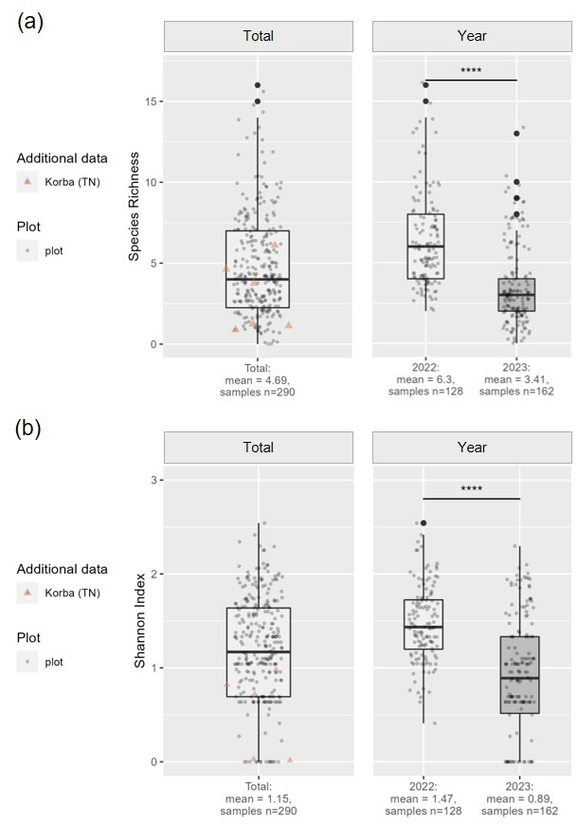
Figure S1: Distribution of (a) arable flora species richness and (b) arable flora Shannon index surveyed within the (repeated) sample-plots on the experimental trials, left: total dataset, right: differentiated by year. Grey dots represent the data included in further statistical calculation, orange triangles are the data sampled in Korba, Tunisia (TN), which are only displayed but not included in descriptive and summary statistics due to variations in agricultural management beyond the tested treatment

Supplement II - Redundancy Analysis
RDA triplots for the whole field, center, and edge for biodiversity and provisioning services are displayed in the following (see Figure S2- Figure S7). An overview of the significance of the marginal effects of all variables in the respective model can be found in Table S2.
Table S2: Results of the permutation test (n=999 permutations) assessing the significance of each explanatory variable in the biodiversity and yield models. If NA= not applicable, because the variables were not included as explanatory variables in the respective model. Variable abbreviations are: Size= field size, SNH= Shannon index of semi-natural habitats, Sand= sand content, clay= Clay content, OM= soil organic matter, Temp= average temperature, Precip= total precipitation, DAW= days after weeding, BBCHMax= maximum BBCH growing stage, Sow= sowing season, Grow= duration of growing period, Betw= sowing distance between rows, With= sowing distance within rows, Depth= sowing depth, Rot= number of crops in the rotation, CT = cropping type, Till= tillage regime, WeedApl= number of weeding operations, RotN= total nitrogen applied during crop rotation, Pass= number of field passings, LegCov= legume cover, FloraCov= arable flora cover, SpeciesRichness= arable flora species richness, ShannonIndex= arable flora Shannon index.
Group | Variable abbreviation | Biodiversity |  |  | Yield
Group | Variable abbreviation | Whole field | Edge | Center | Whole field | Edge | Center
Landscape Context | Size | 0.939 | 0.043 | 0.425 | 0.184 | 0.331 | 0.616
Landscape Context | SNH | 0.453 | 0.074 | 0.803 | 0.025 | 0.335 | 0.030
Environment (soil and weather) | Sand | 0.862 | 0.058 | 0.230 | 0.385 | 0.943 | 0.500
Environment (soil and weather) | Clay | 0.498 | 0.137 | 0.367 | 0.451 | 0.491 | 0.977
Environment (soil and weather) | OM | 0.763 | 0.133 | 0.748 | 0.854 | 0.365 | 0.866
Environment (soil and weather) | Temp | 0.609 | 0.156 | 0.720 | 0.017 | 0.344 | 0.046
Environment (soil and weather) | Precip | 0.780 | 0.375 | 0.353 | 0.017 | 0.315 | 0.037
Timing of sampling | DAW | 0.671 | 0.162 | 0.763 | NA | NA | NA
Timing of sampling | BBCHMax* | 0.789 | 0.059 | 0.963 | NA | NA | NA
Management | Sow | 0.847 | 0.353 | 0.644 | 0.071 | 0.643 | 0.128
Management | Grow | 0.406 | 0.242 | 0.400 | 0.020 | 0.226 | 0.040
Management | Betw | 0.763 | 0.061 | 0.954 | 0.092 | 0.948 | 0.154
Management | With | 0.937 | 0.128 | 0.628 | 0.151 | 0.180 | 0.205
Management | Depth | 0.791 | 0.102 | 0.628 | 0.023 | 0.253 | 0.026
Management | Rot | 0.945 | 0.212 | 0.178 | 0.251 | 0.801 | 0.234
Management | CT | 0.501 | 0.099 | 0.244 | 0.333 | 0.500 | 0.612
Management | Till | 0.996 | 0.063 | 0.396 | 0.071 | 0.407 | 0.058
Management | WeedApl | 0.888 | 0.331 | 0.561 | 0.013 | 0.920 | 0.055
Management | RotN | 0.662 | 0.623 | 0.300 | 0.134 | 0.126 | 0.150
Management | Pass | 0.683 | 0.093 | 0.556 | 0.736 | 0.390 | 0.960
Management | LegCov* | 0.779 | 0.513 | 0.219 | NA | NA | NA
Management | FloraCov* | NA | NA | NA | 0.839 | 0.817 | 0.941
Biodiversity | SpeciesRichness* | NA | NA | NA | 0.166 | 0.937 | 0.954
Biodiversity | ShannonIndex* | NA | NA | NA | 0.140 | 0.474 | 0.665

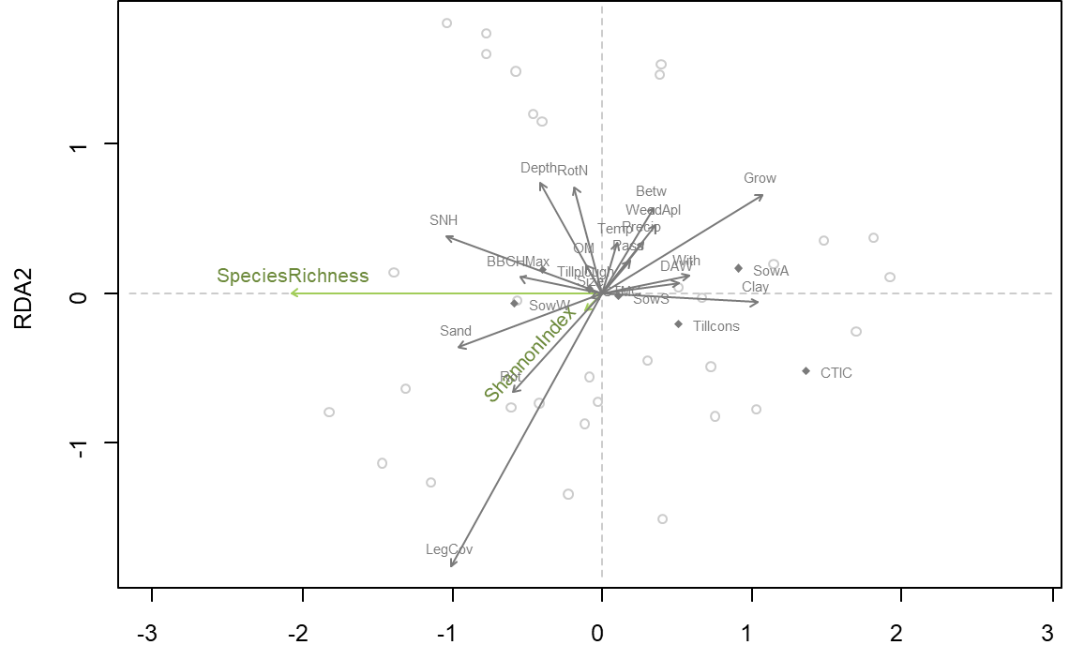
Figure S2: Ordination diagram (scaling 2) of the Redundancy Analysis (RDA) for biodiversity in the whole field. Variable abbreviations in the ordination diagramm are: BBCHMax= maximum BBCH growing stage, Betw= sowing distance between rows, Clay= clay content, CTIC= cropping type intercropping, DAW= days after weeding, Depth= sowing depth, Grow= duration of growing period, LegCov= legume cover, OM= soil organic matter, Pass= number of field passings, Precip= total precipitation, Rot= number of crops in the rotation, RotN= total nitrogen applied during crop rotation, Sand= sand content, ShannonIndex= arable flora Shannon index, Size= field size, SNH= Shannon index of semi-natural habitats, SowA= autumn sowing, SowS= spring sowing, SowW= winter sowing, SpeciesRichness= arable flora species richness, Temp= average temperature, Tillcons= conservation tillage, WeedApl= number of weeding operations, With= sowing distance within rows.
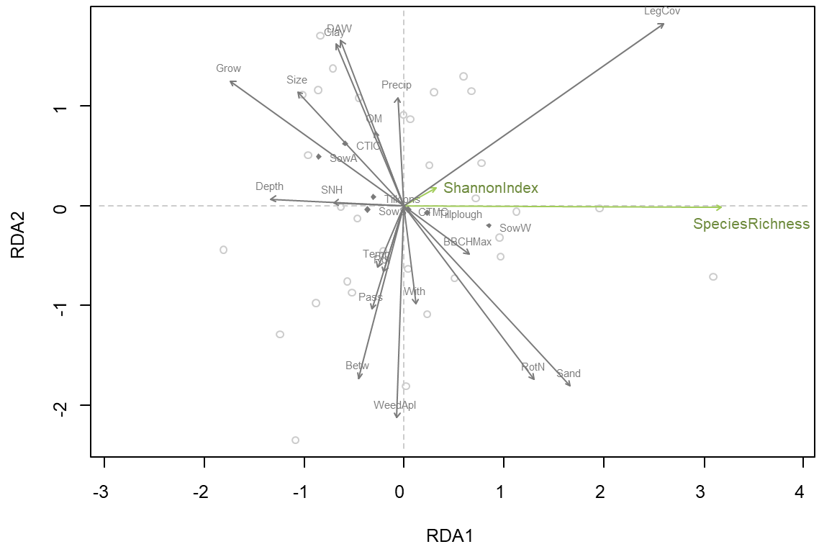
Figure S3: Ordination diagram (scaling 2) of the Redundancy Analysis (RDA) for biodiversity in the field center. Variable abbreviations in the ordination diagramm are: BBCHMax= maximum BBCH growing stage, Betw= sowing distance between rows, Clay= clay content, CTIC= cropping type intercropping, DAW= days after weeding, Depth= sowing depth, Grow= duration of growing period, LegCov= legume cover, OM= soil organic matter, Pass= number of field passings, Precip= total precipitation, Rot= number of crops in the rotation, RotN= total nitrogen applied during crop rotation, Sand= sand content, ShannonIndex= arable flora Shannon index, Size= field size, SNH= Shannon index of semi-natural habitats, SowA= autumn sowing, SowS= spring sowing, SowW= winter sowing, SpeciesRichness= arable flora species richness, Temp= average temperature, Tillcons= conservation tillage, WeedApl= number of weeding operations, With= sowing distance within rows.
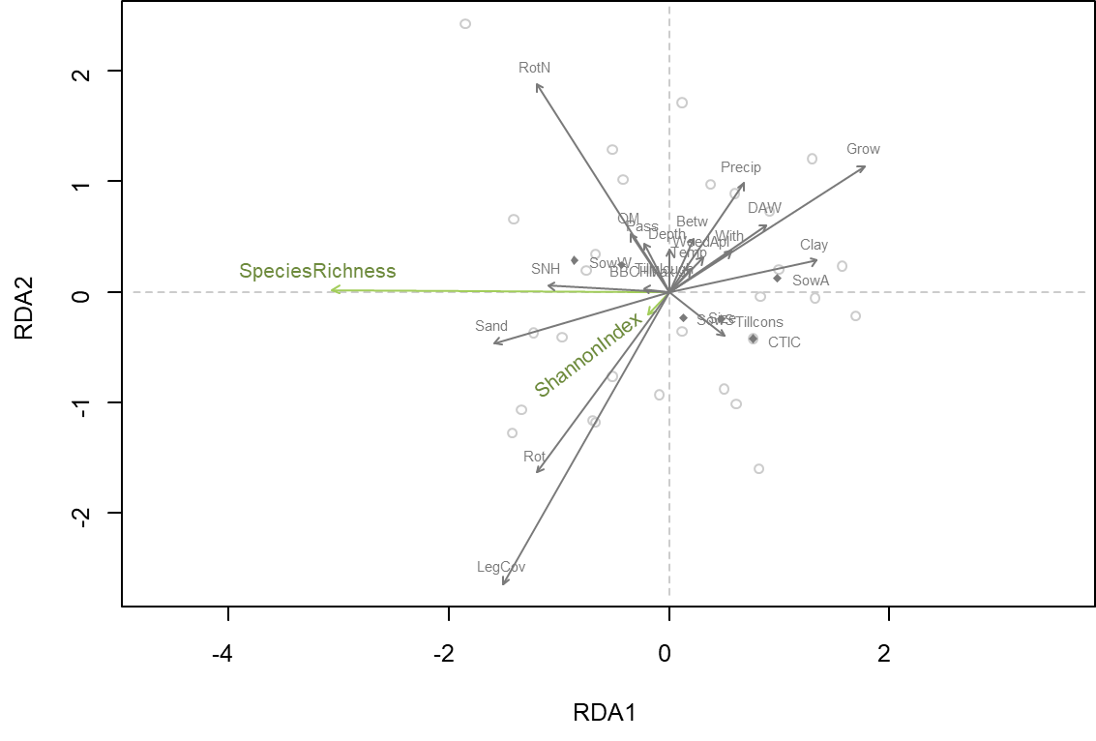
Figure S4: Ordination diagram (scaling 2) of the Redundancy Analysis (RDA) for biodiversity in the field edge. Variable abbreviations in the ordination diagramm are: BBCHMax= maximum BBCH growing stage, Betw= sowing distance between rows, Clay= clay content, CTIC= cropping type intercropping, DAW= days after weeding, Depth= sowing depth, Grow= duration of growing period, LegCov= legume cover, OM= soil organic matter, Pass= number of field passings, Precip= total precipitation, Rot= number of crops in the rotation, RotN= total nitrogen applied during crop rotation, Sand= sand content, ShannonIndex= arable flora Shannon index, Size= field size, SNH= Shannon index of semi-natural habitats, SowA= autumn sowing, SowS= spring sowing, SowW= winter sowing, SpeciesRichness= arable flora species richness, Temp= average temperature, Tillcons= conservation tillage, WeedApl= number of weeding operations, With= sowing distance within rows.
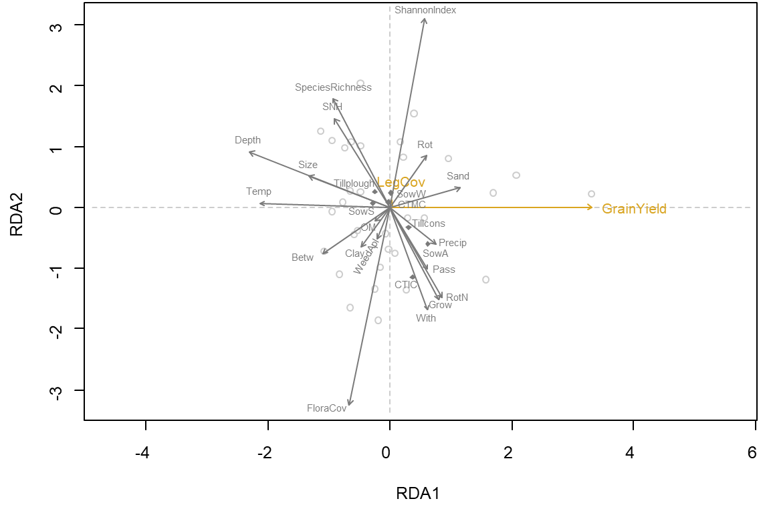
Figure S5: Ordination diagram (scaling 2) of the Redundancy Analysis (RDA) for provisioning services in the whole field. Variable abbreviations are: Betw= sowing distance between rows, Clay= clay content, CTIC= cropping type intercropping, Depth= sowing depth, Depth= sowing depth, FloraCov = arable flora cover, GrainYield= legume grain yield, Grow= duration of growing period, LegCov= legume cover, OM= soil organic matter, Pass= number of field passings, Precip= total precipitation, Rot= number of crops in the rotation, RotN= total nitrogen applied during crop rotation, Sand= sand content, ShannonIndex= arable flora Shannon index, Size= field size, SNH= Shannon index of semi-natural habitats, SowA= autumn sowing, SowS= spring sowing, SowW= winter sowing, SpeciesRichness= arable flora species richness, Temp= average temperature, Tillcons= conservation tillage, Tillplough= ploughing, WeedApl= number of weeding operations, With= sowing distance within rows.
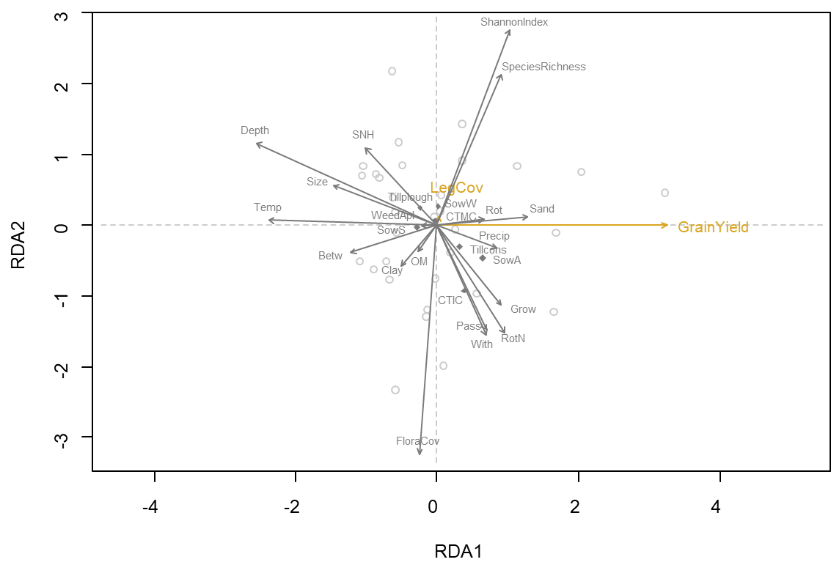
Figure S6: Ordination diagram (scaling 2) of the Redundancy Analysis (RDA) for provisioning services in the field center. Variable abbreviations are: Betw= sowing distance between rows, Clay= clay content, CTIC= cropping type intercropping, Depth= sowing depth, Depth= sowing depth, FloraCov = arable flora cover, GrainYield= legume grain yield, Grow= duration of growing period, LegCov= legume cover, OM= soil organic matter, Pass= number of field passings, Precip= total precipitation, Rot= number of crops in the rotation, RotN= total nitrogen applied during crop rotation, Sand= sand content, ShannonIndex= arable flora Shannon index, Size= field size, SNH= Shannon index of semi-natural habitats, SowA= autumn sowing, SowS= spring sowing, SowW= winter sowing, SpeciesRichness= arable flora species richness, Temp= average temperature, Tillcons= conservation tillage, Tillplough= ploughing, WeedApl= number of weeding operations, With= sowing distance within rows.
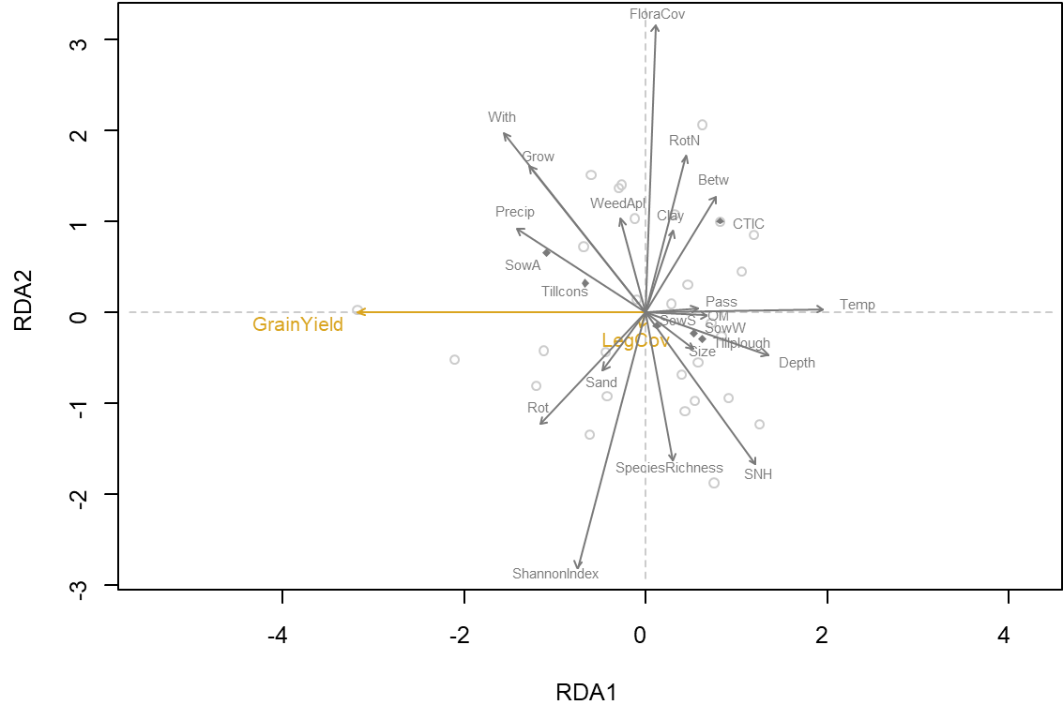
Figure S7: Ordination diagram (scaling 2) of the Redundancy Analysis (RDA) for provisioning services in the field edge. Variable abbreviations are: Betw= sowing distance between rows, Clay= clay content, CTIC= cropping type intercropping, Depth= sowing depth, Depth= sowing depth, FloraCov = arable flora cover, GrainYield= legume grain yield, Grow= duration of growing period, LegCov= legume cover, OM= soil organic matter, Pass= number of field passings, Precip= total precipitation, Rot= number of crops in the rotation, RotN= total nitrogen applied during crop rotation, Sand= sand content, ShannonIndex= arable flora Shannon index, Size= field size, SNH= Shannon index of semi-natural habitats, SowA= autumn sowing, SowS= spring sowing, SowW= winter sowing, SpeciesRichness= arable flora species richness, Temp= average temperature, Tillcons= conservation tillage, Tillplough= ploughing, WeedApl= number of weeding operations, With= sowing distance within rows
.
References
Borenstein M, Higgins JPT (2013) Meta-analysis and subgroups. Prev Sci 14:134–143. https://doi.org/10.1007/s11121-013-0377-7
Borenstein M, Hedges LV, Higgins JP, Rothstein HR (2009) Introduction to Meta-Analysis, 1st edn. Wiley & Sons, Chichester, UK
Harrer M, Cuijpers P, Furukawa TA, Ebert DD (2022) Doing meta-analysis with R: A hands-on guide. Taylor & Francis eBooks. CRC Press Taylor & Francis Group, Boca Raton, London, New York. https://doi.org/10.1201/9781003107347
Hester J, Bryan J (2022) glue: Interpreted String Literals
Higgins JPT, Li T, Deeks JJ (2019) Choosing effect measures and computing estimates of effect. In: Higgins JP, Thomas J, Chandler J, Cumpston M, Li T, Page MJ, Welch VA (eds) Cochrane Handbook for Systematic Reviews of Interventions. John Wiley & Sons, Ltd, Cichester, pp 143–176. https://doi.org/10.1002/9781119536604.ch6
Higgins JP, Thompson SG (2002) Quantifying heterogeneity in a meta-analysis. Statistics in Medicine 21:1539–1558. https://doi.org/10.1002/sim.1186
Jost L (2006) Entropy and diversity. Oikos 113:363–375. https://doi.org/10.1111/j.2006.0030-1299.14714.x
Li Y, Chang SX, Tian L, Zhang Q (2018) Conservation agriculture practices increase soil microbial biomass carbon and nitrogen in agricultural soils: A global meta-analysis. Soil Biology and Biochemistry 121:50–58. https://doi.org/10.1016/j.soilbio.2018.02.024
Mengersen K, Gurevitch J, Schmid CH (2013a) Meta-analysis of Primary Data. In: Koricheva J, Gurevitch J, Mengersen KL (eds) Handbook of meta-analysis in ecology and evolution. Princeton University Press, Princeton, NJ, Oxford, pp 300–312
Mengersen K, Schmid CH, Jennions MD, Gurevitch J (2013b) Statistical Models and Approaches to Inference. In: Koricheva J, Gurevitch J, Mengersen KL (eds) Handbook of meta-analysis in ecology and evolution. Princeton University Press, Princeton, NJ, Oxford, pp 89–107
Moral RA, Hinde J, Demétrio CGB (2017) Half-Normal Plots and Overdispersed Models in R : The hnp Package. Journal of Statistical Software 81. https://doi.org/10.18637/jss.v081.i10
Nakagawa S, Yang Y, Macartney EL, Spake R, Lagisz M (2023) Quantitative evidence synthesis: a practical guide on meta-analysis, meta-regression, and publication bias tests for environmental sciences. Environmental Evidence 12:8. https://doi.org/10.1186/s13750-023-00301-6
Pallmann P, Schaarschmidt F, Hothorn LA, Fischer C, Nacke H, Priesnitz KU, Schork NJ (2012) Assessing group differences in biodiversity by simultaneously testing a user-defined selection of diversity indices. Mol Ecol Resour 12:1068–1078. https://doi.org/10.1111/1755-0998.12004
Rosenberg MS, Rothstein HR, Gurevitch J (2013) Effect Sizes: Conventional Choices and Calculations. In: Koricheva J, Gurevitch J, Mengersen KL (eds) Handbook of meta-analysis in ecology and evolution. Princeton University Press, Princeton, NJ, Oxford, pp 61–71
Veroniki AA, Jackson D, Viechtbauer W, Bender R, Bowden J, Knapp G, Kuss O, Higgins JPT, Langan D, Salanti G (2016) Methods to estimate the between-study variance and its uncertainty in meta-analysis. Res Synth Methods 7:55–79. https://doi.org/10.1002/jrsm.1164
Viechtbauer W (2005) Bias and Efficiency of Meta-Analytic Variance Estimators in the Random-Effects Model. Journal of Educational and Behavioral Statistics 30:261–293. https://doi.org/10.3102/10769986030003261
Viechtbauer W (2010) Conducting meta-analyses in R with the metafor package. Journal of Statistical Software 36:1–48. https://doi.org/10.18637/jss.v036.i03
Vollheyde A-L, Rodriguez Navarro D, Los Mozos Pascual M de, Alcántara Ramírez MC, Sikora S, Rajnović I, Hammami I, Trabelsi D, Haaren C von (2024) Dataset on biodiversity and agronomic performance of lentil and chickpea field trials in the Mediterranean Region. Data Brief 54:110528. https://doi.org/10.1016/j.dib.2024.110528
Wickham H (2016) ggplot2: Elegant Graphics for Data Analysis. Springer-Verlag New York

