Supplementary Material
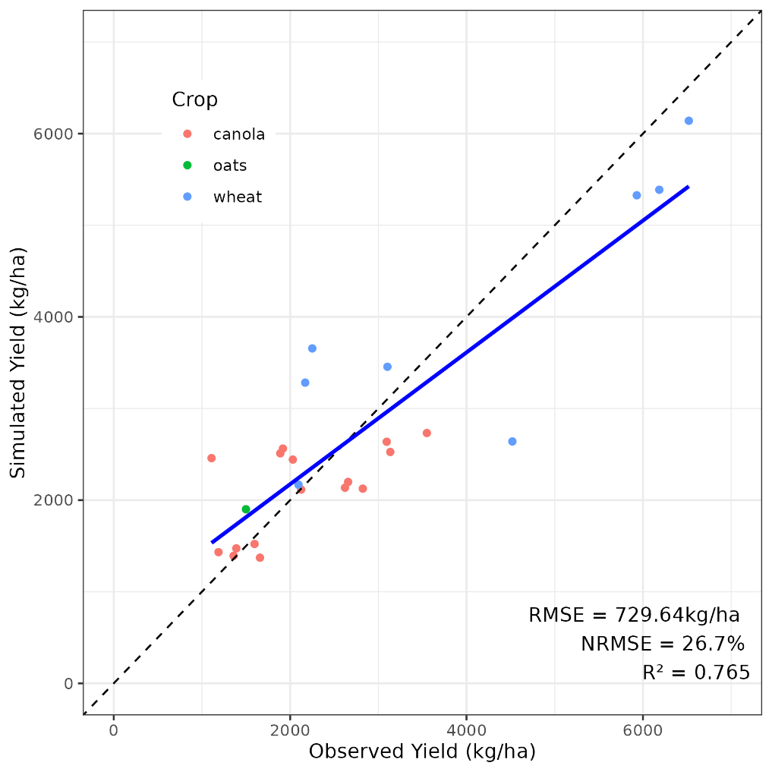
Figure S1 Comparison of simulated crop yield and field-level mean yields derived from yield maps at BARS.

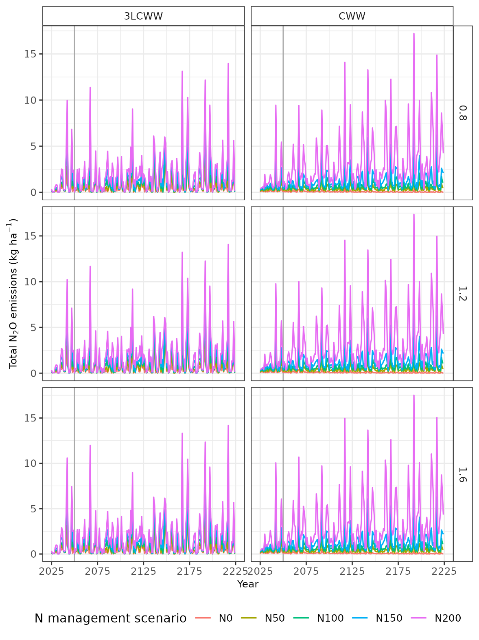
Figure S2. Total N₂O emissions per hectare simulations for lucerne-lucerne-lucerne-canola-wheat-wheat systems (3LCWW) and canola-wheat-wheat systems (CWW) under different nitrogen management practices and three initial soil organic carbon (SOC) conditions (0.8%, 1.2% and 1.6%) from 2025 to 2225. The grey vertical line indicates 2050, the target year for Australia's net zero emissions goal.
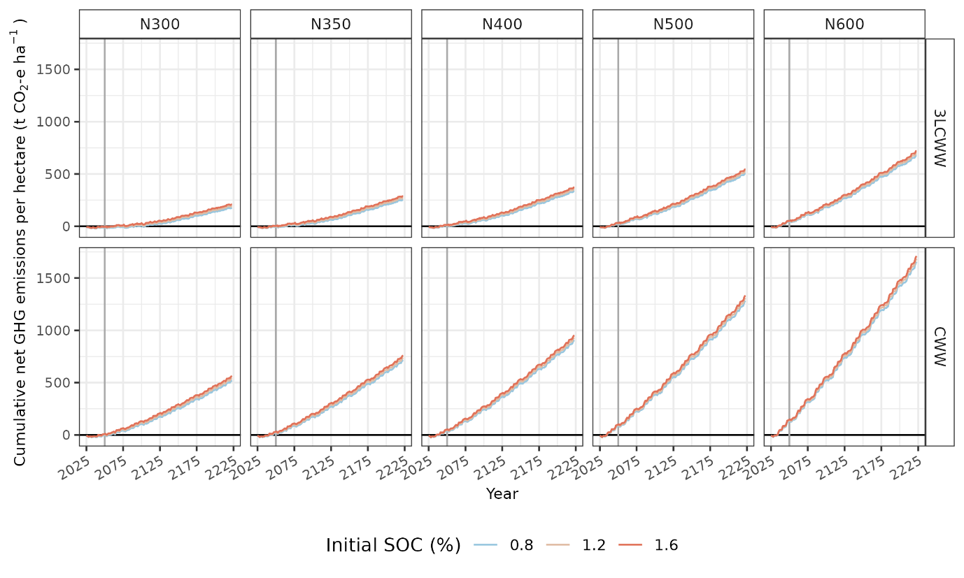
Figure S3 Cumulative cradle-to-farm-gate net emissions per hectare projections for lucerne-lucerne-lucerne-canola-wheat systems (3LCWW) and canola-wheat-wheat systems (CWW) under different nitrogen management (N300-N500) practices from 2025 to 2225. The system is a carbon sink when net GHG emission is less than 0, otherwise it is a carbon source. The grey vertical line indicates 2050, the target year for Australia's net zero emissions goal.
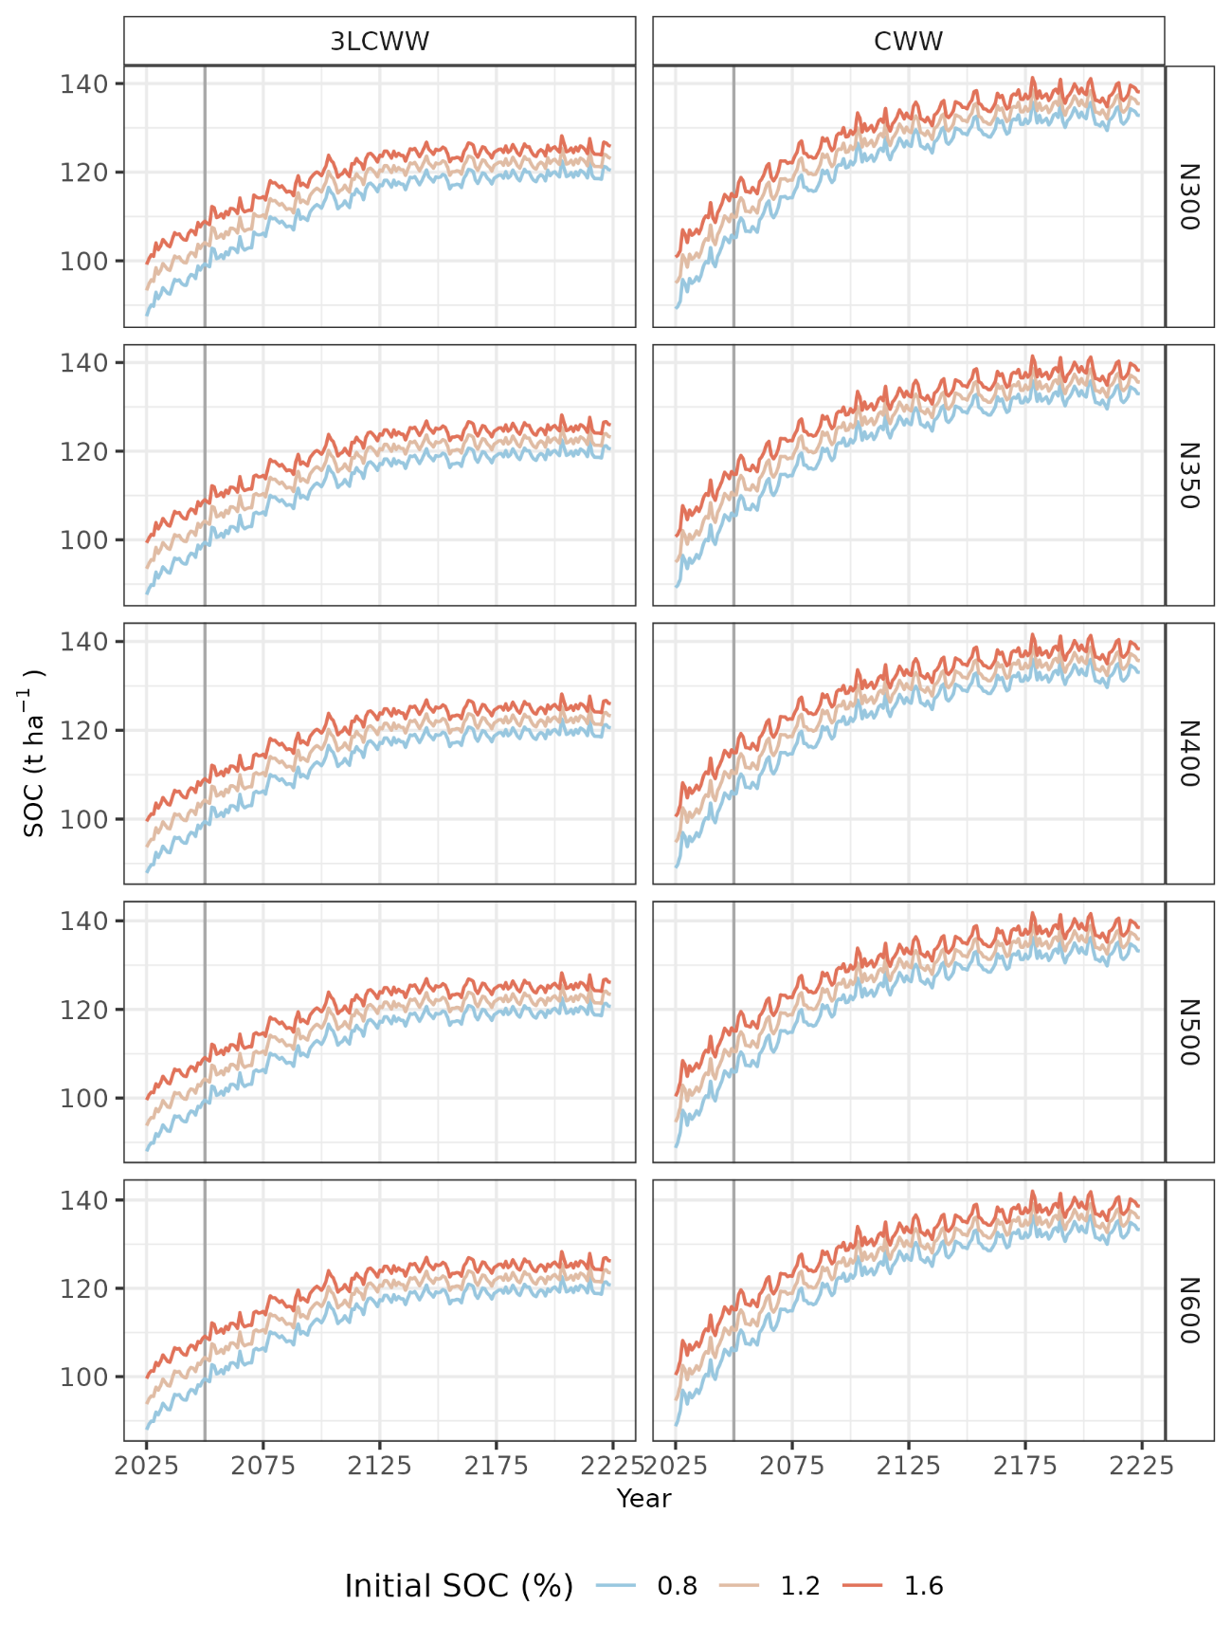
Figure S4 Soil organic carbon (SOC) of the whole soil profile projections for lucerne-lucerne-lucerne-canola-wheat-wheat systems (3LCWW) and canola-wheat-wheat systems (CWW) under different nitrogen management practices (N300-N600) from 2025 to 2225. The N rates refer to fertiliser nitrogen applied to each canola and wheat cultivation season in the rotation. The grey vertical line indicates 2050, the target year for Australia's net zero emissions goal. Note that an increase in SOC equates to a removal of CO₂ from the atmosphere, i.e. a negative emission.

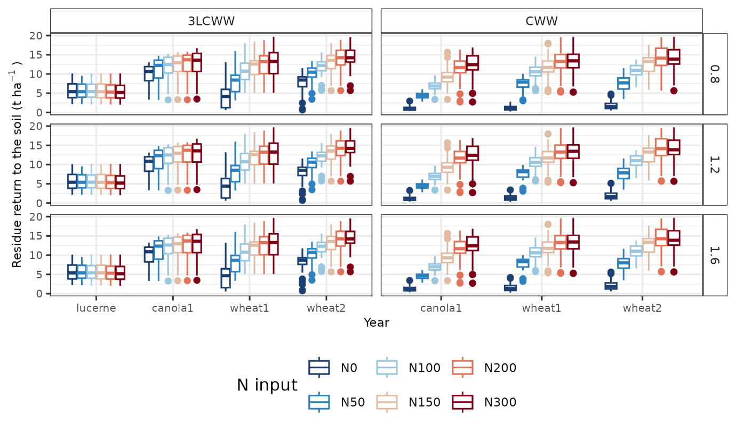
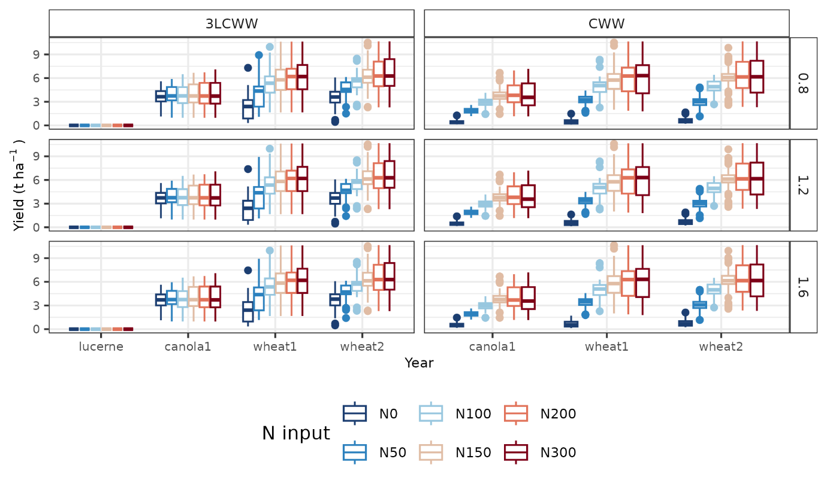
Figure S5 Biomass of lucerne harvested as hay and residue biomass of canola and wheat returned to the field (difference between total aboveground biomass and grain yield), and the yield of canola and wheat.

