Supplementary Material

Pre-sowing and early growing-season rainfall are key drivers of wheat yield change in Australia
Chao Chen^{1*}, Ming Li², Noboru Ota¹, Bin Wang^{3,4,5}, Bangyou Zheng⁶, Andrew Fletcher¹, Yvette Oliver¹

¹CSIRO Agriculture and Food, Private Bag 5, Wembley, WA 6913, Australia
²CSIRO Data61, PO Box 1130, Bentley, WA, 6102, Australia
³NSW Department of Primary Industries, Wagga Wagga Agricultural Institute, Wagga Wagga, NSW, Australia
⁴Hawkesbury Institute for the Environment, Western Sydney University, Richmond, NSW, Australia
⁵Gulbali Institute for Agriculture, Water and Environment, Charles Sturt University, Wagga Wagga, NSW 2650, Australia
⁶CSIRO Agriculture and Food, Queensland Biosciences Precinct, St Lucia, Queensland 4067, Australia

*Corresponding author: chao.chen@csiro.au

1. APSIM-Wheat module
APSIM simulates wheat development, growth, and grain yield in response to inputs of weather (rainfall, temperature, and radiation), soil conditions (water and nitrogen), and management (fertilizer and cultivar) with a daily time step. Wheat phenology is simulated as development progress from sowing to ripening. Phenological development of wheat from emergence towards terminal spikelet is determined by requirement of vernalization and sensitivity to photoperiod of the cultivar, which also determines the final leaf number. The duration from terminal spikelet to flag leaf is directly linked to leaf phyllochron and the number of leaves left to emerge at terminal spikelet. The duration from flag leaf appearance to anthesis is driven by thermal time but is also influenced by photoperiod (Brown et al. 2013). Phenological development from flowering to maturity is driven by accumulation of thermal time. Biomass of wheat is simulated as the product of the amount of solar radiation intercepted by the canopy (through the leaf area index computations) and stage-dependent radiation use efficiency (RUE). The RUE could be reduced by suboptimal nitrogen, temperature, and water stresses. The partitioning of biomass among organs of the plant is a function of the phenological stage (Brown et al. 2019). Wheat yield is calculated from its components of grain number, grain size, and filling rate (Brown et al. 2014).

2. Agronomic management setup
Cultivar and sowing date decisions were based on latitude along the east coast of Australia (i.e. north or south of Dubbo at latitude -32.24), rainfall, and soil water status. For the southern and western wheat belts, the most common wheat cultivar Scepter (Tang 2022) was sown if rain reached ≥ 15 mm over 3 days during April 26–July 15, regardless of soil moisture. While for the northern wheat belt (north of Dubbo), the high yielding cultivar Suntop (Fletcher et al. 2019) was sown if rain reached ≥ 15 mm over 3 days and plant available water at sowing (PAWS) ≥ 30 mm during the same period. If these criteria were not met, a fixed sowing date of July 15 was used, consistent with common practices in Australian wheat simulation studies (e.g., Hochman & Horan 2018; Flohr et al. 2017), representing the latest practical date for crop development under dry conditions. All simulations assumed a plant density of 150 plants m⁻², row spacing of 0.25 m, and sowing depth of 30 mm. Sufficient fertilizer was applied to ensure that climate was the only factor limiting crop growth. Based on Yield Gap Australia (YGA 2024), at sowing, soil nitrate in the top 60 cm was topped up as needed to ensure a minimum of 100 kg ha⁻¹, accounting for existing nitrate in the soil. This means that the net nitrate application rate was not fixed and varied each season depending on the previous year’s climate conditions and soil type. An additional 70 kg ha⁻¹ nitrate was applied if nitrate in the top 60 cm fell below 80 kg ha⁻¹ and PAWS exceeded 30 mm.

Supplementary Fig. 1. Comparison of plant available water at sowing (PAWS) trends under two soil‑water initialization methods at four representative locations across the Australian wheatbelt: (a) Corrigin in the West, (b) Cummins in the South, (c) Wagga Wagga in the South‑East, and (d) Dalby in the East. Blue triangles represent PAWS simulated with soil water initialized at the crop lower limit on January 1, 1990, while orange dots represent PAWS simulated with soil water initialized using the long‑term average plant available water (PAW) on January 1.
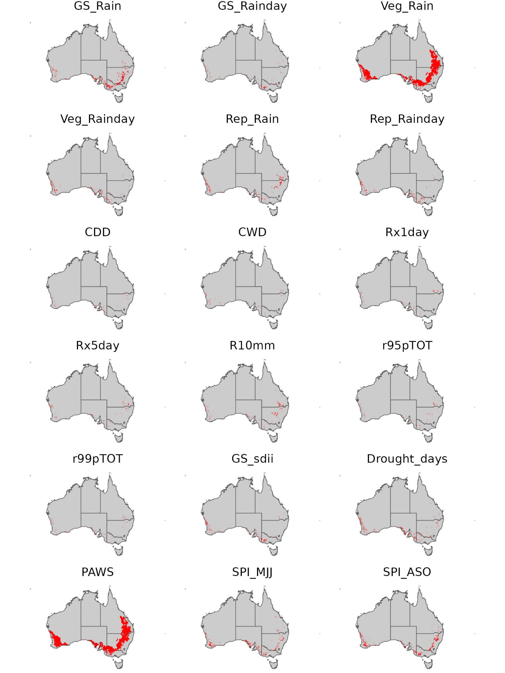
Supplementary Fig. 2. The spatial variation of the importance of rainfall-related variables to the simulated wheat yields.

Supplementary Table S1: Summary of studies evaluating APSIM performance in simulating wheat, including reference sources, tested regions, the coefficient of determination (R²) between observed and simulated yields, root mean squared deviation (RMSD), and the ranges of observed and simulated wheat yields.
Reference | Region | R² | RMSD (kg ha⁻¹) | Observed range (kg ha⁻¹) | Simulated range (kg ha⁻¹)
Probert et al. 1995 | Queensland | 0.30 | 940 | 300–4800 | 900–4900
Asseng et al. 1998 | Western Australia | 0.77 | 400 | 1000–4000 | 1000–4800
Sadras et al. 2003 | South Australia | 0.74 | 190 | 700–3800 | 500–4000
Wang et al. 2003 | Queensland  Western Australia | 0.80 | 740 | 300–7600 | 200–7800
Yunusa et al. 2004 | South Australia | 0.69 | 450 | 1300–4000 | 1300–4500
Oliver et al., 2006 | Western Australia | 0.80 | 300 | 400–3700 | 300–3600
Whitbread and Hancock 2008 | South Australia | 0.66–0.79 | 300-640 | 300–3600 | 100–5300
Anwar et al. 2009 | Victoria | 0.96 | 310 | 100–5200 | 100-4300
Lawes et al. 2009 | Western Australia | 0.86 | 310 | 500–3700 | 400–3600
Hochman et al. 2009 | Victoria  South Australia  New South Wales  Western Australia  Queensland | 0.71 | 800 | 0–8000 | 0–7500
Monjardino et al. 2013 | South Australia | 0.65 | 820 | 500–6600 | 1000–6600
O'Leary et al. 2016 | New South Wales, Queensland | 0.03–0.57 | 1040–1580 | 0–7000 | 300–6200
Fletcher et al. 2020 | Western Australia | 0.69 | 770 | 350–3200 | 500–4000
Feng et al., 2022 | Queensland, New South Wales, Victoria, South Australia, Western Australia |  | 700 | 100–4300 | 200-4900
Lilley and Kirkegaard, 2024 | New South Wales |  | 540 | 1630–8330 | 2000–8350
Richetti et al., 2024 | Queensland, New South Wales, Victoria, South Australia, Western Australia | 0.5–0.89 | 1110–1140 | 100–8500 | 100-8700

Supplementary Table S2. Climate scenarios designed to analyze the effects of the changes in rainfall-related variables on wheat yield in the simulation study.
Scenarios | Time series of rainfall | Time series of Temperature (maximum and minimum) | Time series of solar radiation
1 | 1990-2023 | 1990 | 1990
2 | 1990-2023 | 1991 | 1991
3 | 1990-2023 | 1992 | 1992
4 | 1990-2023 | 1993 | 1993
5 | 1990-2023 | 1994 | 1994
6 | 1990-2023 | 1995 | 1995
7 | 1990-2023 | 1996 | 1996
8 | 1990-2023 | 1997 | 1997
9 | 1990-2023 | 1998 | 1998
10 | 1990-2023 | 1999 | 1999
11 | 1990-2023 | 2000 | 2000
12 | 1990-2023 | 2001 | 2001
13 | 1990-2023 | 2002 | 2002
14 | 1990-2023 | 2003 | 2003
15 | 1990-2023 | 2004 | 2004
16 | 1990-2023 | 2005 | 2005
17 | 1990-2023 | 2006 | 2006
18 | 1990-2023 | 2007 | 2007
19 | 1990-2023 | 2008 | 2008
20 | 1990-2023 | 2009 | 2009
21 | 1990-2023 | 2010 | 2010
22 | 1990-2023 | 2011 | 2011
23 | 1990-2023 | 2012 | 2012
24 | 1990-2023 | 2013 | 2013
25 | 1990-2023 | 2014 | 2014
26 | 1990-2023 | 2015 | 2015
27 | 1990-2023 | 2016 | 2016
28 | 1990-2023 | 2017 | 2017
29 | 1990-2023 | 2018 | 2018
30 | 1990-2023 | 2019 | 2019
31 | 1990-2023 | 2020 | 2020
32 | 1990-2023 | 2021 | 2021
33 | 1990-2023 | 2022 | 2022
34 | 1990-2023 | 2023 | 2023

References
Anwar M, O’Leary G, Rab M et al (2009) Advances in precision agriculture in south-eastern Australia. V. Effect of seasonal conditions on wheat and barley yield response to applied nitrogen across management zones. Crop Pasture Sci 60 (9):901-911. https://doi.org/10.1071/CP08351
Asseng S, Keating B, Fillery I et al (1998) Performance of the APSIM-wheat model in Western Australia. Field Crops Res 57 (2):163-179. https://doi.org/10.1016/S0378-4290(97)00117-2
Brown HE, Huth NI, Holzworth DP et al (2019) A generic approach to modelling, allocation and redistribution of biomass to and from plant organs. in silico Plants 1 (1):diy004. https://doi.org/10.1093/insilicoplants/diy004
Brown HE, Huth NI, Holzworth DP et al (2014) Plant modelling framework: software for building and running crop models on the APSIM platform. Environ Model Softw 62:385-398. https://doi.org/10.1016/j.envsoft.2014.09.005
Brown HE, Jamieson PD, Brooking IR et al (2013) Integration of molecular and physiological models to explain time of anthesis in wheat. Annals of Botany 112 (9):1683-1703. https://doi.org/10.1093/aob/mct224
Carberry P, Hochman Z, Hunt J et al (2009) Re-inventing model-based decision support with Australian dryland farmers. 3. Relevance of APSIM to commercial crops. Crop Pasture Sci 60 (11):1044-1056. https://doi.org/10.1071/CP09052
Feng P, Wang B, Macadam I et al (2022) Increasing dominance of Indian Ocean variability impacts Australian wheat yields. Nat Food 3 (10):862-870. https://doi.org/10.1038/s43016-022-00613-9
Fletcher A, Ogden G, Sharma D (2019) Mixing it up–wheat cultivar mixtures can increase yield and buffer the risk of flowering too early or too late. Eur J Agron 103:90-97. https://doi.org/10.1016/j.eja.2018.12.001
Fletcher AL, Chen C, Ota N et al (2020) Has historic climate change affected the spatial distribution of water-limited wheat yield across Western Australia? Clim Change 159 (3):347-364. https://link.springer.com/article/10.1007/s10584-020-02666-w
Hochman Z, Holzworth D, Hunt J (2009) Potential to improve on-farm wheat yield and WUE in Australia. Crop Pasture Sci 60 (8):708-716. https://doi.org/10.1071/CP09064
Lawes R, Oliver Y, Robertson M (2009) Integrating the effects of climate and plant available soil water holding capacity on wheat yield. Field Crops Res 113 (3):297-305. https://doi.org/10.1016/j.fcr.2009.06.008
Lilley JM, Kirkegaard JA (2024) Validated simulation of a long-term cropping experiment reveals a pathway for improved productivity. Eur J Agron 159:127225. https://doi.org/10.1016/j.eja.2024.127225
Monjardino M, McBeath T, Ouzman J et al (2015) Farmer risk-aversion limits closure of yield and profit gaps: A study of nitrogen management in the southern Australian wheat belt. Agric Syst 137:108-118. https://doi.org/10.1016/j.agsy.2015.04.006
O'leary GJ, Li Liu D, Ma Y et al (2016) Modelling soil organic carbon 1. Performance of APSIM crop and pasture modules against long-term experimental data. Geoderma 264:227-237. https://doi.org/10.1016/j.geoderma.2015.11.004
Oliver Y, Wong M, Robertson M et al (2006) PAWC determines spatial variability in grain yield and nitrogen requirement by interacting with rainfall on northern WA sandplain. In: Turner, N., Acuna, T., Johnson, R. (Eds.), Proceedings of the 13th Australian Agronomy Conference. 10–14 September 2006, Perth, Western Australia. https://agronomyaustraliaproceedings.org/images/sampledata/2006/concurrent/water/4570_oliver.pdf
Probert M, Keating B, Thompson J et al (1995) Modelling water, nitrogen, and crop yield for a long-term fallow management experiment. Aust J Exp Agric 35 (7):941-950. https://doi.org/10.1071/EA9950941
Richetti J, Lawes RA, Whan A et al (2024) How well does APSIM NextGen simulate wheat yields across Australia using gridded input data? Validating Continental-Scale Crop Model Simulations. Eur J Agron 158:127212. https://doi.org/10.1016/j.eja.2024.127212
Sadras V, Baldock J, Roget D et al (2003) Measuring and modelling yield and water budget components of wheat crops in coarse-textured soils with chemical constraints. Field Crops Res 84 (3):241-260. https://doi.org/10.1016/S0378-4290(03)00093-5
Tang A (2022) Molecular Phenotyping of Western Australian Wheat Varieties. [Doctoral Thesis, The University of Western Australia]. https://research-repository.uwa.edu.au/en/publications/molecular-phenotyping-of-western-australian-wheat-varieties/
Wang E, Van Oosterom E, Meinke H et al (2003) The new APSIM-Wheat Model—performance and future improvements. In: Unkovich M, O'Leary G (Eds.), Proceedings of the 11th Australian Agronomy Conference. Australian Society of Agronomy. 2-6 February 2003, Geelong, Victoria. https://www.agronomyaustraliaproceedings.org/images/sampledata/2003/p/2/wang.pdf
Weeks C, Robertson M, Oliver Y et al (2007) Managing seasonal risk is an important part of farm management but is highly complex and therefore needs a ‘horses for courses’ approach. Department of Agriculture and Food, Western Australia. www.agric.wa.gov.au/pls/portal30/docs/FOLDER/IKMP/FCP/2007_farmsystems_part1.pdf
Whitbread A, Hancock J (2008) Estimating grain yield with the French and Schultz approaches Vs simulating attainable yield with APSIM on the Eyre Peninsula. In: Unkovich M, O'Leary G (Eds.), Proceedings of the 14th Australian Agronomy Conference. 21-25 September 2008, Adelaide South Australia. https://www.agronomyaustraliaproceedings.org/images/sampledata/2008/concurrent/assessing-yield-potential/5803_whitbreadhancock.pdf
YGA (2024) Methodology: Nitrogen management and crop simulations. Yield Gap Australia. https://yieldgapaustralia.com.au/about/methodology. Accessed on 2 June 2024.
Yunusa I, Bellotti W, Moore A (2004) An exploratory evaluation of APSIM to simulate growth and yield processes for winter cereals in rotation systems in South Australia. J Exp Agric 44 (8):787-800. https://doi.org/10.1071/EA03121

