Supplementary Materials

Annex 1 - Detailed game rules
Introduction: Players are shown the board, explained what the components are (road, plots, primary and secondary forest) and asked to pick a farm
Initial assets: All players receive 10 coins as initial budget and a parcel (farm) composed of 9 plots (3 of secondary forest, 6 of primary forest). Depending on their parcel, they receive a given number of labor resources (understood as number of family members working on the farm).
Space division: Next to the board is a zone called the “tree-nursery” where players can buy seeds and seedlings of the crops they want to plant, and a zone called the “bank/market” where players can take out a loan (interest rates are specified in Figure S1), sell their harvest, and pay the cost of living at the end of each round (1 coin per labor resource, see Figure S2).
Rules:
    - Clearing of new land costs an initial investment: 2 coins for secondary forest, 3 coins for primary forest (see visual in Figure S3).
    - Annual crops (maize, banana, rice, cassava) are cheaper to plant (1 coin for seeds) and bring income within the next round (4 or 5 coins) but they require replanting (buying new seeds) every year (see Figure S4). Income from annual crop harvest decreases (-1 coin) every time they are planted on a plot that has previously been harvested (soil depletion).
    - Perennial crops (citrus trees, copoazú, cacao) bring more income (2 coins per round) but only after 2 rounds and they are more expensive to plant (2 coins for seedlings) (Figure S4).
    - Timber trees can be planted among perennial crops to create an agroforestry system. Seedlings cost 2 coins and wood can be harvested for 5 coins after 3 rounds (Figure S4).
    - Removal of primary forest allows for +1 coin from harvest in the following round (so only for annual crops) to represent nutrient input in the soil.
    - For a plot to be able to produce, there always needs to be one labor resource per plot. If a player does not count with enough family members, a labor resource can be hired for 1 coin (Figure S5).
    - Starting in round 2, a “fire dice” is introduced. It has to be rolled each time a plot is cleared and has a 1/3 probability of burning the neighboring plot (which could be that of another player).

Game dynamic – ROUND 1: Each player can choose what to plant, pays the bank accordingly (or takes out a loan). This goes at the slower pace of one player at the time, for all participants to witness each-others’ decisions and become familiar with the rules. ROUND 2: Now, all players can play at the same time. Each player harvests, can choose what to plant, pays the bank accordingly (or takes out a loan), and eventually rolls the fire dice. This continues until the end of round 5.
Unexpected events: After the first round, there are news shared by the moderator for each round (Table 4).
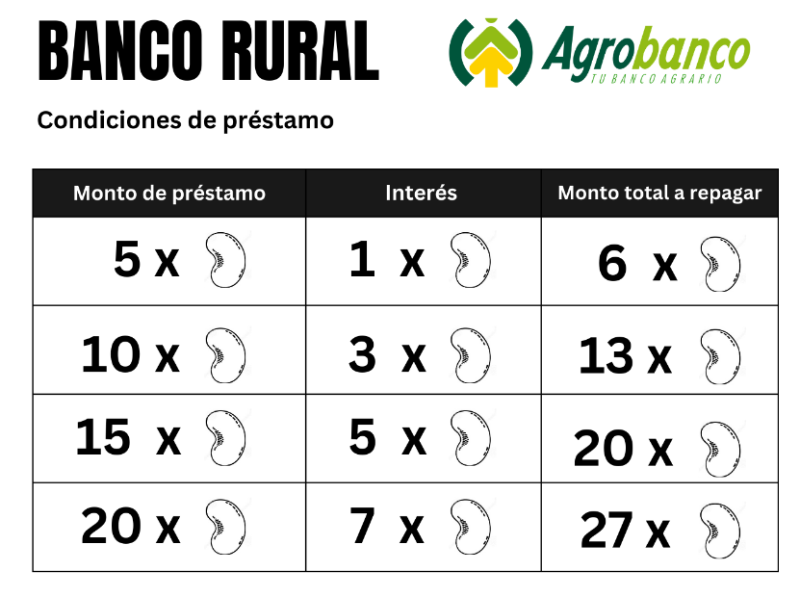
Figure S1: Visual support for players to see how many coins they can take out as a loan and how many coins of interest are associated.
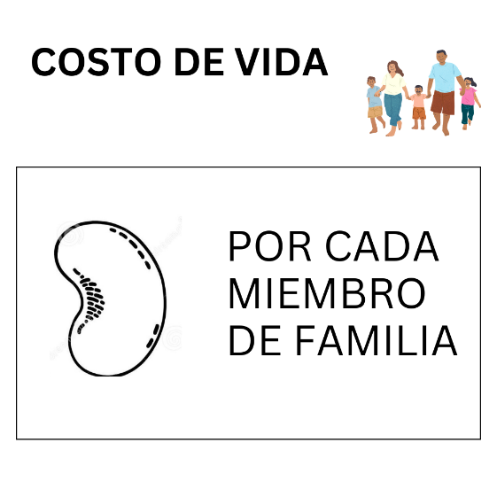
Figure S2: Visual support for players to remember that at the end of each round, they need to pay one coin per number of labor resources they have.
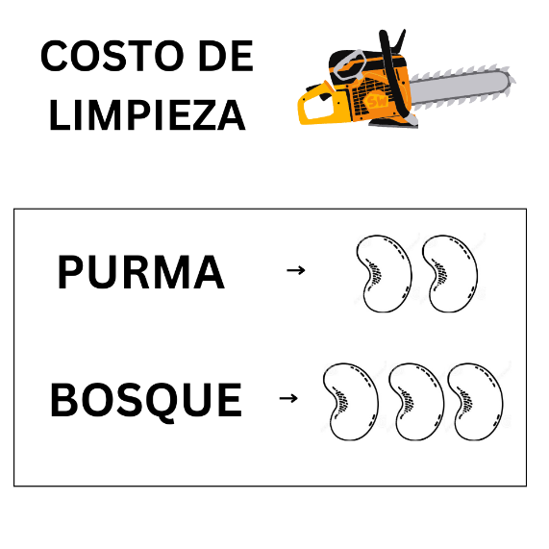
Figure S3: Visual support for game rule about clearing of forest. "Purma" is secondary forest, "bosque" is primary forest.
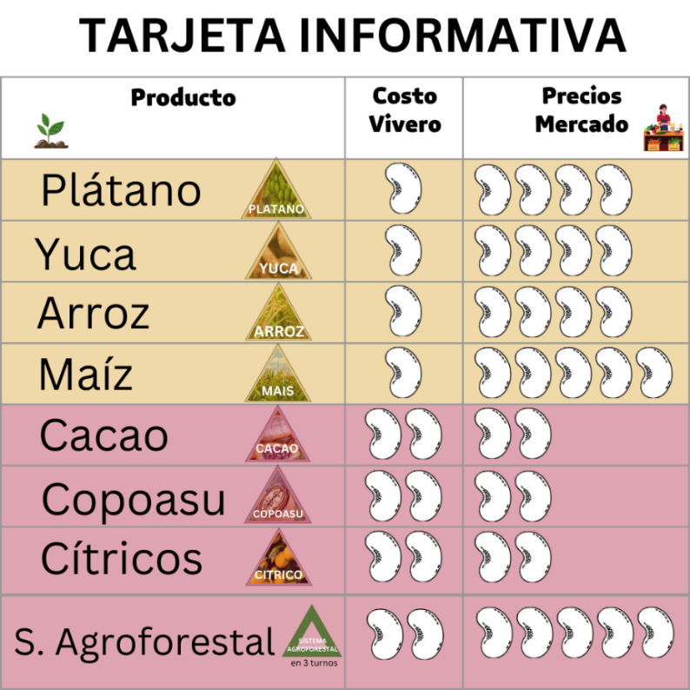
Figure S4: Informative sheet shared with each participant during the game, detailing the costs of specific seeds and seedlings ("costo de vivero") and the price that can be obtained for harvest ("precio de mercado"). Yellow rows indicate annual crops, that produce after one round, red lines indicate perennial crops that produce after two rounds, except for timber (agroforestry) that can be harvested after three rounds.
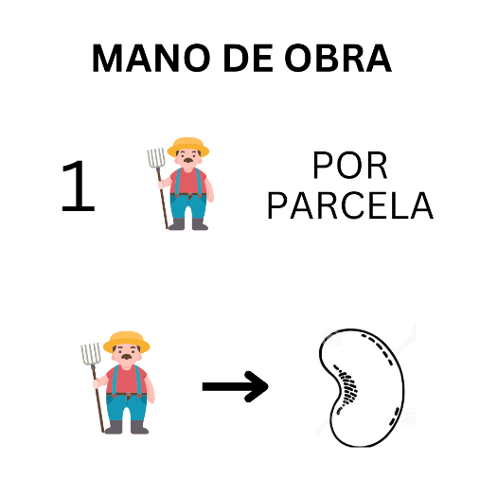
Figure S5: Visual support for players to remember that they need one labor resources per plot they want to cultivate, and that hiring one labor resources costs one coin per round
Fecha: ….. de ……… del 2023
Fecha: ….. de ……… del 2023

Annex 2 - Pre-game individual survey
Name:
Contact:
Size of family:
Age:
Gender:
Place of farm:
Name of closest population center:
Department of origin (if migrant of first or second generation)
What is your principal economic activity?
What is your secondary economic activity?
Are you a part of an association or cooperative? YES/NO
If yes, to which association and/or cooperative do you belong?
Have you participated in a State-, NGO-, or private company-led project in the last 5 years? YES/NO
If yes, which? What is your opinion of the project manager? GOOD/NEUTRAL/BAD
What is the size (in hectares) or your agricultural land?
How many hectares do you cultivate?
How many hectares are pasture?
How many hectares are primary forest?
How many hectares are secondary forest/regrowth?
What are the main crops you grow?
What is your legal land ownership? LAND TITLE/RENTAL/POSESSION CERTIFICATE/OTHER
Original Spanish questionnaire:
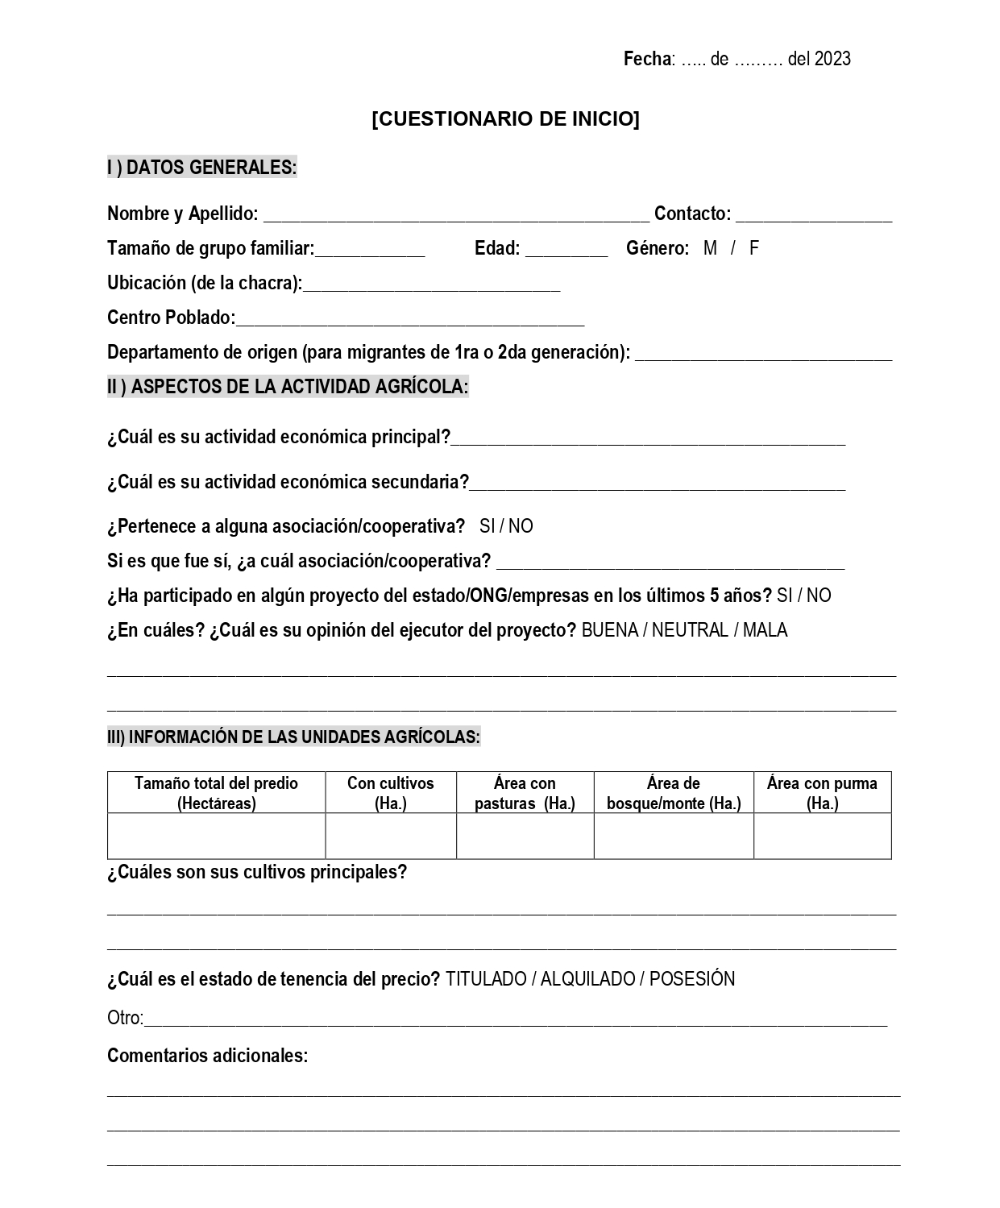

Annex 3 - Post-game group debriefing
How did you feel while playing? What did you think about the game?
What happened ? (ask specific questions about the decisions that were taken and why). What was your strategy? What were key moments?
How does the game relate to reality? Is the game realistic? What is missing to represent reality?
What did you learn? Which messages do you take home?
If you could play another round, which intervention would you have chosen? Which intervention was your favorite?
Original Spanish debriefing guide:
Guia de preguntas post-juego
- ¿Cómo se han sentido jugando? Como les pareció el juego?
- ¿Qué pasó? (preguntar a cerca de las decisiones que tomaron – porqué? Que fue su estrategia? Que fueron momentos clave?)
- ¿Cómo se vincula el juego con la realidad? ¿es realista? ¿qué falta?
- ¿Qué han aprendido? ¿Qué mensaje se llevan?
- Futuro: Si pudieran jugar un turno más, que intervención les hubiera gustado recibir? Cual fue su intervención favorita?

