Supplementary material

Supplementary S1: Conversion of LFMC from a dry weight to a fresh weight basis

Let $W_{d}$ and $W_{f}$ be respectively the dry and fresh weight of the fuel.

LFMC is generally expressed on a dry basis as:
 | $$LFMC=\frac{W_{f}-W_{d}}{W_{d}}=\frac{W_{f}}{W_{d}}-1$$ | (S1-1)

French forest service uses a less common definition (on a fresh mass basis):

 | $${LFMC}_{f}=\frac{W_{f}-W_{d}}{W_{f}}=1-\frac{W_{d}}{W_{f}}$$ | (S1-2)

The conversion from ${LFMC}_{f}$ to $LFMC$ and conversely can be done as:

 | $$LFMC=\frac{{LFMC}_{f}}{1-{LFMC}_{f}}$$ | (S1-3)

 | $${LFMC}_{f}=\frac{LFMC}{1+LFMC}$$ | (S1-4)

Supplementary S2: Distribution of individual measurements of LFMC and mean LFMC computed by the DPFM before and after the applying a manual filter.

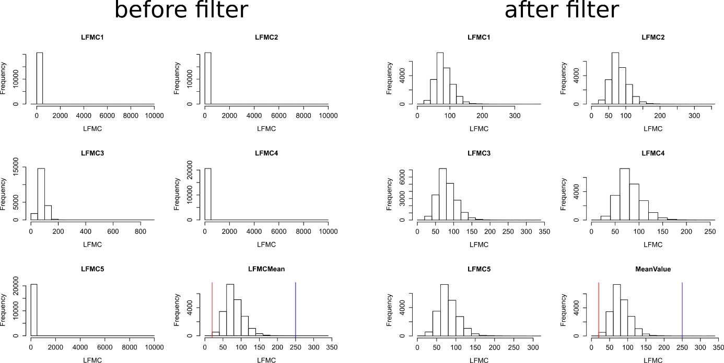

Supplementary S3: Relationship between LFMC estimates computed with a robust mean (Equation 2) and the common median.

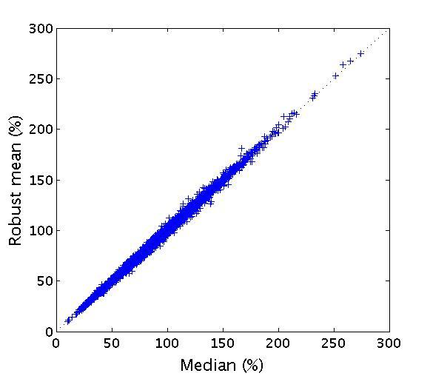

Supplementary S4. Comparison between median-based standard error and the robust standard error

Based on equation (4), the median-based standard error can be computed as:
 | $$\tilde{SE}(t)=\frac{\tilde{σ}(t)}{\sqrt{n(t)}}$$ | (S4-1)
with $n(t)$ the number of individual measurements in sample t ($n(t)≤5)$. Median-based estimators of standard errors show a highly asymmetric distribution (Fig S4A, the inset shows the same asymmetric distribution for error between 0 and 5) : extremely small estimated errors are frequent ($\tilde{SE}(t)<0.2\%$ for 12 % of measurements, Fig. S4A, inset) as well as very large ones (more than 10 %, Fig. S4A). These distributions of the median based errors are not realistic as the variance estimates is expected to follow a χ₂ distribution. By contrast, the distribution of robust standard error (Fig. S4B) exhibit a more realistic pattern as it does not show the high frequency of low values and the long tail. These results demonstrate the benefit our approach for standard error estimation.

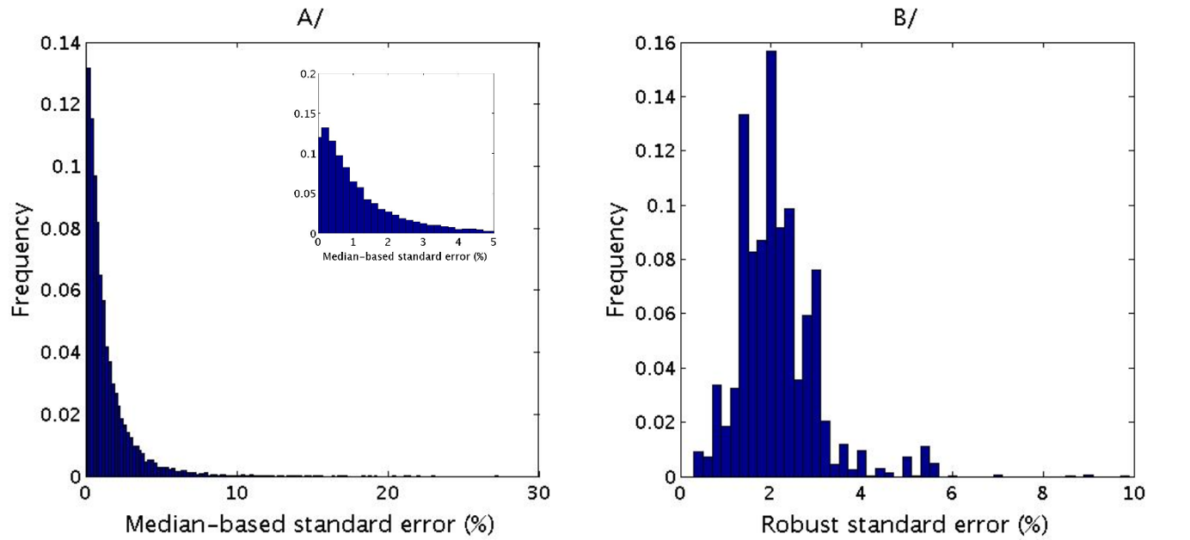
Figure S3: Histograms of standard error frequencies: A/ median-based $\tilde{SE}(t)$ (S3-1); B/ robust $\hat{SE}(t)$ (S2-8). The insert in Fig. S3A shows the histogram truncated for values between 0 and 5.

Supplementary S5: Comparison of the Réseau hydrique’s rainfall measurements with the rainfall from SAFRAN climatic analysis (8 km grid resolution, Vidal et al. 2010), both were annually cumulated over the measurement periods of the Réseau hydrique.

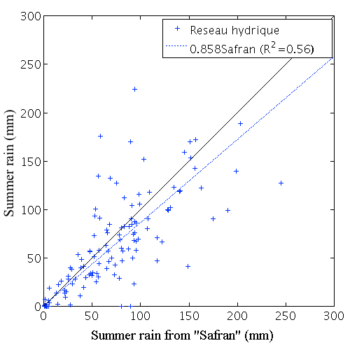

Supplementary S6: details on the linear model applied to explain

Table S6: Coefficients of the linear model applied to explain the yearly minimum $\hat{LFMC}$ reached at each sitexspecies with (i) a linear function of an aridity index (based on the yearly ratio between rainfall and Penman potential evapotranspiration R/ETP for the June to September period, as in Figure 1) (ii) an effect of species regeneration strategy (seeders and resprouters) and a site effect. Regeneration strategy and site effects were set additive. The Figure S6 below is a graphical representation of the different effects. The regeneration strategy for each species was taken from the Brot database (Paula et al. 2009).

 | Estimate | Std. Error | t value | Pr(>|t|)
Global Intercept | 60.0297 | 2.4044 | 24.966 | < 2e-16 | ***
Drought index | 19.8427 | 2.3270 | 8.527 | < 2e-16 | ***
Regeneration strategy | -7.2401 | 0.9316 | -7.772 | 1.93e-14 | ***
D04S2 | -6.4580 | 3.0490 | -2.118 | 0.034416 | *
D05S1 | 18.4664 | 3.1167 | 5.925 | 4.30e-09 | ***
D06S1 | -8.9948 | 2.9960 | -3.002 | 0.002747 | **
D06S2 | -16.8842 | 2.9994 | -5.629 | 2.35e-08 | ***
D06S3 | -14.9572 | 3.0431 | -4.915 | 1.04e-06 | ***
D07S1 | 6.0223 | 6.0712 | 0.992 | 0.321463
D07S2 | 18.0031 | 3.2934 | 5.466 | 5.81e-08 | ***
D11S1 | 3.7672 | 3.0086 | 1.252 | 0.210807
D11S2 | 2.8261 | 3.0169 | 0.937 | 0.349109
D13S1 | -7.3879 | 3.0039 | -2.459 | 0.014086 | *
D13S2 | -4.3816 | 3.0622 | -1.431 | 0.152785
D13S3 | -8.8090 | 5.6325 | -1.564 | 0.118146
D26S1 | -1.6517 | 3.1675 | -0.521 | 0.602175
D2AS1 | -12.1700 | 3.0153 | -4.036 | 5.85e-05 | ***
D2AS2 | -4.5896 | 3.1246 | -1.469 | 0.142186
D2AS3 | -23.8407 | 6.6990 | -3.559 | 0.000390 | ***
D2AS4 | 4.5641 | 3.8143 | 1.197 | 0.231757
D2BS2 | -9.1031 | 3.2162 | -2.830 | 0.004742 | **
D2BS3 | -17.1978 | 3.0310 | -5.674 | 1.83e-08 | ***
D2BS1 | -13.4989 | 3.5597 | -3.792 | 0.000158 | ***
D30S1 | 0.6005 | 3.0058 | 0.200 | 0.841691
D30S2 | -17.3130 | 2.9859 | -5.798 | 8.99e-09 | ***
D34S1 | 16.3934 | 3.0656 | 5.348 | 1.11e-07 | ***
D34S2 | -4.9214 | 3.1316 | -1.571 | 0.116385
D48S1 | 1.8455 | 3.0835 | 0.599 | 0.549640
D66S1 | -12.1486 | 3.1622 | -3.842 | 0.000130 | ***
D66S2 | 0.0944 | 3.0053 | 0.031 | 0.974947
D83S1 | -15.3230 | 2.9922 | -5.121 | 3.65e-07 | ***
D83S2 | -1.6834 | 2.9883 | -0.563 | 0.573338
D83S3 | -1.9645 | 3.0696 | -0.640 | 0.522330
D83S4 | 12.2031 | 4.0200 | 3.036 | 0.002463 | **
D83S5 | 1.3647 | 4.0263 | 0.339 | 0.734726
D84S1 | 0.3852 | 3.0268 | 0.127 | 0.898764
D84S2 | -10.6565 | 2.9920 | -3.562 | 0.000386 | ***

Figure S6: Boxplot of the yearly minimum value of LFMC reached at each site. Species were separated into two functional groups, resprouters and seeders. One species for which we were unable to find its regeneration strategy in the literature is indicated as NA (not available). Only one box per site is plotted when both species from this site belong to a single regeneration strategy. The two horizontal lines indicate two fire danger levels (moderate and extreme).

REFERENCES:
Paula, S., Arianoutsou, M., Kazanis, D., Tavşanoğlu, Ç., Lloret, F., Buhk, C., … Pausas, J. G. (2009). Fire-related traits for plant species of the Mediterranean Basin. Ecology, 90(5), 1420. https://doi.org/10.1890/08-1309.1
Vidal, J.-P., Martin, E., Franchistéguy, L., Baillon, M., & Soubeyroux, J.-M. (2010). A 50-year high-resolution atmospheric reanalysis over France with the Safran system. International Journal of Climatology, 30(11), 1627–1644. https://doi.org/10.1002/joc.2003

